FINAL REPORT

Colorado Advanced Software Institute

WINPLAN: Wireless Information Network Planning

Principal Investigator: C. Edward Chow, Ph.D.
Associate Professor
University of Colorado, Colorado Springs

Graduate Students: Robert Rogers and Xiaolong He
Department of Computer Science
University of Colorado, Colorado Springs

Undergrade Students: Frank Watson
Department of Computer Science
University of Colorado, Colorado Springs

Collaborating Company: Omnipoint Technologies, Inc.
Dean Angelico
Senior Manager

PROJECT TITLE: WINPLAN: Wireless Information Network Planning

PRINCIPAL INVESTIGATOR: C. Edward Chow, Ph.D.

UNIVERSITY: University of Colorado, Colorado Springs

COLLABORATING COMPANY: Omnipoint Technologies, Inc.

REPRESENTATIVE OF

COLLABORATING COMPANY: Dean Angelico, Senior Manager

As authorized representative of the collaborating company, I have reviewed this
report and approve it for release to the Colorado Advanced Software Institute.

SIGNATURE:________________________________________________________

DATE:______________________________________________________________

Table of Contents

1. Introduction 1
2. Objectives 2
2.1 Potential for Broad-based Technology Transfer 2
3. Approach 4
3.1 Definition Phase 4
3.2 Modeling Phase 4
3.3 Design and Analysis Phase 4
3.4 Integration Phase 4
3.5 Detailed plan for the WINPLAN system 5
4. Results 6
4.1 Wireless Information Network Model for Antenna Placement (WINMAP) 6
4.1.1 Related systems and tools 6
4.1.1.1 Geological Information System (GIS) Data 6
4.1.1.2 Software Tools 7
4.1.1.3 University Activities in GIS 11
4.1.1.4 Summary of background investigation 11
4.1.2 WINMAP Design 11
4.1.2.1 Reading the DEM Data 12
4.1.2.2 Using User-supplied Antenna Data 13
4.1.2.3 Reading the TIGER/Line Data 16
4.1.2.4 Extracting the Road Data 16
4.1.2.5 Generating the VRML File 18
4.1.2.6 Generating a timed 3D mobile user position data file 21
4.2 AntennaPlacer: An Antenna Placement Tool 22
4.2.1 Metrics for Evaluating Antenna Placement Algorithm 22
4.2.2 Optimal Antenna Placement Algorithm 23
4.2.2.1 Examples 23
4.2.3 Heuristic algorithm 24
4.2.4 Coverage() Function 27
4.3 VUTMOST: Virtual-Reality User Traffic Model and Simulation Tool 29
4.3.1 Future work. 31
5. Evaluation 33
6. Intellectual property developed under sponsorship of this grant. 35
7. Technology Transfer 37
8. References 39
9. Appendix A. Digital Elevation Model (DEM) Data Dictionary. 44
10. Appendix B. TIGER/Line Data Dictionary. 47
11. Appendix C. World Wide Web Sites of Related Products. 50
12. Appendix D. WINMAP User’s Guide. 51
12.1 How to use WINMAP. 51
12.2 Open DEM file. 51
12.3 Enter antenna characteristics. 52
12.4 Open TIGER/Line file. 53
12.5 Select road. 53
12.6 Save VRML file. 54
12.7 Save “position/time” data file. 55
12.8 Viewing the VRML file. 55
12.9 Example Runs 55
12.9.1 An I-25 example. 56
12.9.2 A US Hwy 50 example. 56
12.10 WINMAP Source Files 57
13. Appendix E: Man Page for AntennaPlacer 59
13.1 NAME: 59
13.2 SYNTAX: 59
13.3 Description: 59
13.4 OPTIONS 59
13.5 Data files used by ANTENNA 60
13.5.1 File example: 62

Abstract

The proposed research deals with the development of efficient algorithms and simulation tools for Wireless Information Network Planning and Management. A software design system called Wireless Information Network Planning (WINPLAN) was built to facilitate the design and evolution of wireless information networks with tools for reading GIS terrain and highway data and displaying them in VRML 3D models, optimal and heuristic algorithms for antenna placement, tools for displaying antenna coverage and animating mobile user traffic along highway over the VRML 3D models. The WINPLAN system will assist the network administrators in their network planning and management tasks. It will facilitate the network designers to improve the network efficiency and reliability.
.
WINPLAN provides a Java-based tool called WINMAP for reading GIS terrain and highway data, and displaying them in VRML models, an antenna placement tool called AntennaPlacer, and a Virtual-Reality User Traffic Model and Simulation tool called VUTMOST. WINMAP reads in public domain 3 arc second GIS terrain data and builds the corresponding 3D VRML models using the ElevationGrid node. It extracts the highway data from the Tiger CD-ROM database and overlays them over the terrain VRML model using the IndexLineSet node. It implements a ray-tracing algorithm for displaying the antenna coverage area given the antenna location. It can generate the sequence of the timed-3D mobile user location data given the highway, the traversing direction and speed. WINMAP provides a simple Java-based GUI for specifying the files of GIS data, antenna location, and parameters for the mobile user traffic data generation. Its output is the VRML file containing the terrain, highway and antenna coverage information. The VRML model can be displayed by the web browser with VRML browser plug-in.

AntennaPlacer implements an optimal algorithm for placing a minimum set of antennae that cover the desired coverage area, avoids exclusion zone for antenna placement, and given the same number of antennae, tries to cover as much area outside the desired coverage area. It is based on the branch and bound paradigm. For larger area, AntennaPlacer implements an efficient heuristic antenna placement algorithm. The output of AntennaPlacer is a text file indicating the locations of the antennae, and the receiving powers and the assigned antenna at each elevation grid point.

VUTMOST displays the result of AntennaPlacer in a VRML model with color coding in the terrain representing the coverage areas of different antennae, and the receiving powers. It also animates the mobile traffic along a highway and displays a beam between the mobile user and the current assigned antenna. The hand-over can be easily displayed as the beam switched from one antenna to another. VUTMOST helps to verify the antenna placement results generated by the AntennaPlacer and can serve as an effective education and training tool for wireless network design.

By integrating with discrete event simulators which model the wireless network resources, WINPLAN can be used for studying the resource allocation and QoS of a wireless network under different traffic loads and patterns, and for the antenna location determination. By providing realistic timed 3D traffic data to optimization packages for dynamic channel assignments and by graphically displaying and verifying the results generated, WINPLAN can help improve those optimization packages. It can also be extended to study mobile user locating methods. WINPLAN can serve as an important module for wireless information network planning and management and help improve the efficiency and reliability of wireless information networks.

Introduction
Personal Communications Service (PCS) has been referred to as a concept that will make it possible to communicate with anyone-anytime-anywhere. The FCC has defined PCS as “radio communications that encompass mobile and ancillary fixed communications that provide services to individuals and businesses and can be integrated with a variety of competing networks.” [1] Furthermore, the FCC characterized PCS as encompassing “a broad range of new radio communications service that will free individuals from the limitations the wireline public switched telephone network and will enable individuals to communicate when they are away from their home or office telephones.” [2] In 1994, the PCIA predicted that there will be 167 million subscriptions to PCS services in the United States by 2003 with many users subscribing to multiple wireless services [3].
Since the radio spectrum is limited, future wireless systems will have macro/micro/picocellular architectures in order to provide the higher capacity needed to support higher number of users and wide range of services from narrowband voice to broadband multimedia applications. The design of the future multi-tier cellular networks involves the selection of cell size at each tier and the design of efficient admission control, bandwidth assignment and handoff procedures. Each is a challenging network design and management problem [4,5,6]. Reduced size coverage zones like micro and pico cells will offer higher traffic handling capability but will induce an increase in handover activity [7,8,9,10]. Distributed control may increase call handling capability and therefore the possibility of further cell size reduction. It is also a challenging research issue to make the design trade-off among the inter-related network parameters [6].
After discussed with researchers at Omnipoint Technologies earlier in the project, we have focused on the creation of an antenna placement tool for wireless information networks. Since the traffic data are very important for the planning and evolution of wireless information networks, we also work on generating realistic mobile traffic data, based on the GIS highway and terrain data.
Section 2 discusses the objectives. Section 3 lists the approaches. Section 4 discusses the results. Section 5 is the evaluation. Section 6 summarizes the technology exchange between Omnipoint Advanced Technologies and UCCS. Appendices include the man pages, the file formats, and the user guide of the WINPLAN system.

Objectives
The general objective of the proposed research is to develop a set of design and simulation tools for wireless network planning that utilize network resources efficiently and satisfy the customer’s quality of service requirements.
First, we propose to extend our existing literature survey for the related works on wireless information network planning and focus on urban area network planning problems. We will define network parameters to be considered in the wireless information network design and evolution problems. The parameters include at least: 1) network topology, 2) cell size, 3) cell bandwidth, 4) cell antenna location, 5) user traffic patterns, 6) processing power of base stations and switches, and 7) handover rate. We will also define a set of metrics for evaluating the wireless information network designs and evolution choices. They include the network cost, the capacity of the network, the number of calls served per hour per cell, the bandwidth utilization of the system, the number of customers in the system, the response time, call blocking probability, handover blocking probability, and duration of interruption of user service.
Second, we propose to build network models that simulate different wireless network architectures. For each network model we will design and analyze the network design and planning procedures. This research will be based upon work we have been doing on network simulation, optimization algorithms for spare usage in network restoration [12,13,14,15] and ATM resource allocation and traffic management [16], and RACEWIN graphical user interface [17] and power and cell site assignment algorithms.
Third, with the help of Omnipoint research and field engineers, realistic traffic patterns, and signal fading, interference, and cell antenna location choices will be modeled. An extensible network planning system, called WINPLAN, with an enhanced graphic user interface will be built to compare different wireless network designs and evolution plans. It will facilitate the design trade-off and the analysis of the handover rate, call/handover blocking probability, and service interrupt duration. WINPLAN will be based Java with GUI to facilitate the presentation of network planning results.
The algorithms and the network planning prototype created in the proposed research will form a technology and knowledge base to enable and facilitate network designers to design efficient and reliable wireless networks. They will provide network administrators with efficient tools to plan or utilize more efficiently the available bandwidth in the future wireless networks and to provide reliable network services to the users.

Potential for Broad-based Technology Transfer
The software modules developed in this project can serve as a rich library that can foster the research, education, and development efforts in the areas of network design and traffic modeling.
The WINPLAN can also serve as a vehicle for exchanging the network models and algorithms developed at UCCS and Omnipoint. This allows the researchers at UCCS to gain access to information about real wireless network equipment, characteristics of various traffic sources, network topologies, and realistic network planning scenarios. It enables the researchers and field engineers at Omnipoint to compare their existing network planning approaches with those reported in the literature and implemented in the WINPLAN.
The WINPLAN can be extended as a wireless information network planning tool for the selection of cell sizes in a multi-tier architecture. It can also help network designers or administrators choose the proper dynamic channel assignment and handover procedures. It can serve as a module for the study of network integration and interface issues involved with mixed wireless and wired networks.

Approach
The proposed project will proceed with the following four phases:

Definition Phase
Based on the survey of the general characteristics of wireless networks and our research on network design and planning techniques, we will define a common terminology and a set of quantitative measures on the efficiency of network designs.

Modeling Phase
We will define a network model which includes various wireless network architectures and the following parameterized variables:
- Channel type and priority.
Future wireless networks will support a wide variety of channel types, including voice, data, and video. The network model should be able to handle various channel types and priority classes.
- Source traffic characteristics include call originating time, call duration, routes of mobile users, travel speed and direction, peak/average bit rates, burst duration, and distribution of active and silent periods.
- Location and processing speed of the base stations at different tiers.
- Transmission speed of network management channels between base stations.
- Location and speeds of transmission, switching, and processing equipment.
- Signal fading and interference.

Design and Analysis Phase
We will build WINPLAN based on the proposed network model. The network planning software modules will be implemented based on the performance measures established in Phase 1.
Analytical formula will be derived for cell sizes of wireless networks, taking into the consideration of network parameters established in Phase 2. The user traffic modeling tool developed at RACEWIN will be extended to model realistic urban traffic patterns. In [15] we presented a general purpose resource allocation system called RAS, which is capable of setting up multiparty connections with bandwidth and special circuit constraints. It integrates several optimal and heuristic resource allocations algorithms. The optimal algorithm was implemented using the dynamic programming technique. It also implemented a distributed version of the resource allocation algorithm. The algorithms implemented in RAS will be extended for bandwidth planning and allocation in wireless network. The power control and cell site assignment tool, called POCAT, will be improved with realistic signal fading and interference models developed by the Omnipoint engineers.

Integration Phase
A discrete event simulator will be designed, which reads the network design and the traffic events generated by the user traffic modeling tool, simulates the wireless network operation, and collect the QoS statistics. A front end graphical user interface will be designed to facilitate the display and comparison of the simulation results. With the help of WINPLAN, we will explore the relationship among the network planning, the cell sizes, the network control procedures, and the traffic patterns. We will also explore the hot spot in wireless networks and study the network evolution strategies.

Detailed plan for the WINPLAN system
WINPLAN will be built using the algorithms, software libraries, and tools provided by the Computer-Aided Network Design & Analysis Research Environment, CANDARE, which was developed at UCCS and was used successfully to develop a generalized resource allocation system, RAS[15], NETRESTORE [13], and RACEWIN[17]. CANDARE will facilitate us to construct the network models and the network design algorithms. We will design the proposed algorithms with the needed controllable parameters for modeling the message processing delays, message transmission delays, and network throughput, and for collecting the statistics of the objective measures mentioned above. Omnipoint will involve in the design and implementation process, provide information about wireless switch and transmission equipment, network topologies, signal fading and interference data, and traffic patterns, and provide the important feedback to improve the accuracy, functionality and performance of the WINPLAN system.

Results

Wireless Information Network Model for Antenna Placement (WINMAP)
This WINMAP is one of the tools provided by the WINPLAN system and is an investigation into developing a graphical user interface and prototype tool for other phases of the overall project. The goal of the WINMAP design were (1) to research existing GIS databases for data on land formation information, (2) to determine a suitable 3D file format to be used for displaying a 3D model of the terrain, and (3) to build a tool which could determine the coverage area of a telecommunications antenna tower based on the terrain surrounding the tower. The tool would visually indicate blind spots in a coverage area that were due to blockage by hills, valleys, and other land formations.

The goals for the WINMAP tool listed that the tool will be able to: (1) load 3D terrain data, (2) take user input on antenna locations, (3) add antenna representations to the output data file, (4) alter (either through shading or coloring) the terrain around the antenna to reflect the communication coverage of that antenna, (5) display a percentage comparison of this antenna’s coverage capability versus an ideal antenna coverage (i.e., an antenna tower on flat land), and (6) use roadway information to track the location of a traveling mobile user.

Related systems and tools
We investigated available information on the related data files and software tools. Much of the information needed existed in the worlds of geography, geology, and cartography.

Geological Information System (GIS) Data

Types of Data Files

The United States Geological Survey (USGS) organization provides much of their GIS data either for free or inexpensively. There are other sources of this same information that either just repackage the data (Micropath Corp. data) or enhance the data (TIGER/Line). The elevation data needed for this project were found in Digital Elevation Model (DEM) data files, described in [48]. USGS only provides free download of their 1-degree DEM data files in the older format. They are converting their other DEM data files over to a new Spatial Data Transfer Standard (SDTS) format [49], and they charge for these files. Luckily, the 1-degree DEM files in the older format are actually easier to read, and the data points are organized such that they are easier to use for our purposes than the other types (e.g., 7.5-minute).

For the highway data that we required for the WINMAP tool’s capability to track the location of a traveling mobile communications user, we first looked at the USGS Digital Line Graphs (DLGs) [50]. They contain three type of data elements: nodes, lines, and areas. A node is a single geological point; a line is defined by an ordered set of nodes which precede in a direction of travel; and an area is a region enclosed by lines. The problem with the DLG data files is that a single highway could actually be defined by many unrelated lines, and that none of the lines had names associated with them. The best that we could accomplish would be to graphically display all of the lines to the user and have the user determine which lines define the road the user desired. The user would have to choose every line of the road individually. We had no way of providing satisfactory information (i.e., the name of the road) back to the user to help confirm that the correct line had been chosen. Thus we were prodded to look for some “processed” data, data from a third-party vendor. By contacting Dr. John Harner of the Department of Geology at UCCS, he introduced us to TIGER/Line data, data that is widely used, usually with a software tool called ArcInfo by Environmental Systems Research Institute (ESRI), Inc. (http://www.esri.com). Access to TIGER/Line data is available from at UCCS computer labs in the Department of Geology or in CD-ROM format.

Data Sources
Some digital cartographic data is available for free from USGS web sites (http://edcwww.cr.usgs.gov/ dsprod/prod.html). Other data can either be purchased from USGS or from third party vendors like, MapInfo Corp. or Micropath Corp. Microsoft Corp. has a large repository available for viewing on their Terra Server system.

TIGER/Line data is available from the U.S. Department of Commerce. (http://www.census.gov/geo/www/
tiger/index.html)

Software Tools

GIS Tools

The following are a few of the GIS tools we found during our investigation. Some of the tools listed are general purpose, others have some specialized functions for telecommunications analysis. Some have the capability to perform 3D analysis, but we did not find any that currently perform a 3D analysis in the area of telecommunications.

ArcInfo is one of many tools available, but it seems to be the one most widely used by many companies, including public utilities companies, and by USGS. ArcInfo is a general-purpose tool that has built-in functions for reading DLG, DEM, and TIGER/Line data files, among others, and is being upgraded to read the SDTS format[50]. Many organizations use ArcInfo for everything from displaying the distribution of ethnic groups, to tracking changes in the paths of rivers. Another ESRI tool called ArcView, now has a 3D Analyst feature for providing functional analysis of three dimensional data like DEMs. These tools also provide the capability to fly through the terrain and save data in VRML format. We could not find any specific telecommunications functions available for either ArcInfo or ArcView.

MapInfo Professional 5.0 is one of a myriad of products and data available from MapInfo Corporation. (http://www.mapinfo.com) They provide tools for applications ranging from desktop to client/server to internet/intranet and more. They offer tools and data specifically for telecommunications needs, including free on-line seminars like “Mapping and GIS for Wireless Telecom Engineers”. These tools appear to be limited to 2D analysis only, though. Some of their customers include: Pinnacle Towers, Powertel, Bell South Mobility, SkyTel, and Thrucomm. Their telecommunications tools can help with: customer service, trouble tracking, problem resolution, RF propagation modeling, signal analysis, network planning, market analysis, competitive analysis, and customer analysis and profiling. One example they used to have at their web site stepped through an wireless sample application, showing the capabilities of: overlaying trouble reports, creating antenna symbols, frequency reuse grid setup, locating trouble areas, running a blockage test, and examining cell site attributes.

Idrisi for Windows by Clark Labs is a raster-based geographic information and image processing system with strong analytical functionality. Its companion tool, CartaLinx, is a spatial data builder and digitizing package to generate vector data. Although we could view GIS data with these tools, we did not find any telecommunications applications examples or functions available.

VisAD is a tool written in Java and developed by The Visualization Project at the University of Wisconsin-Madison Space Science and Engineering Center (SSEC), and the University Corporation for Atmospheric Research (UCAR) Unidata Program Office. The tool is freely distributed from their web site. Although this tool is not currently used for analyzing telecommunications cell site engineering, the source code is freely available, and the graphical user interface could prove useful in developing such a telecommunications tool. The code from this WINMAP project could be integrated with VisAD, to provide a more complete tool. The following is an excerpt from the VisAD web site and describes VisAD's capabilities:

- "The use of pure Java for platform independence and to support data sharing and real-time collaboration among geographically distributed users. Support for distributed computing is integrated at the lowest levels of the system.
- A general mathematical data model that can be adapted to virtually any numerical data, that supports data sharing among different users, different data sources and different scientific disciplines, and that provides transparent access to data independent of storage format and location (i.e., memory, disk or remote).
- A general display model that supports interactive 3-D, data fusion, multiple data views, direct manipulation, collaboration, and virtual reality.
- Data analysis and computation integrated with visualization to support computational steering and other complex interaction modes.
- Support for two distinct communities: developers who create domain- specific systems based on VisAD, and users of those domain-specific systems. VisAD is designed to support a wide variety of user interfaces, ranging from simple data browser applets to complex applications that allow groups of scientists to collaboratively develop data analysis algorithms.
- Developer extensibility in as many ways as possible. "

Rapid Imaging Software, Inc. has two tools (LandForm Gold and LandFormC3) for viewing and overlaying several cartographic data files at one time. It has limited editing capabilities, but it has the capability of flying through the terrain and saving data in various formats, including VRML format. The ability to view layered data files, turning them on and off without having to open and close the files, was interesting and could be used if we had WINMAP build a separate data file that depicted the antenna coverage.

Visual Explorer '98 by WoolleySoft is another tool with the capability of flying through the terrain. It can import digital terrain data from ASCII, USGS DEM, UK OS NTF, Japanese SEM, Vistapro DEM and XYZ formats and export the data in ASCII, DXF, BMP, PGM, UK OS NTF, TIN, Vistapro DEM, XYZ and VRML2 formats. It provides interfaces to Vistapro, Bryce2, MapInfo, AutoCAD and many other programs, and it generates cross section information in graphic and data height/distance series. Our interest in this tool was for viewing capabilities only. It also had no capabilities or functions for telecommunications planning.

Our conclusions on 3D analysis tools for telecommunications cell site engineering were that this area of specialty still had many needs that are not meet by today's tools. As described in Handbook of Land-Mobile Radio System Coverage [51], Garry Hess explains the complexity involved in performing an adequate analysis. Hess says he knows of only one effort that set out to build such a competent software tool, but the project was never completed.

Virtual Reality Modeling Language (VRML) browsers:

We investigated what type of format we should use for the 3D output data file, and what we found was a current push towards VRML (although there are others who champion that Java3D is the new format to use - see Java3D below). There are many VRML browsers available, including Worldview by Intervista (Error! Bookmark not defined.download/worldview.html) and Cosmo Player by Silicon Graphics, which are plug-ins for popular HyperText Markup Language (HTML) browsers like Microsoft's Internet Explorer and Netscape's Navigator. Other tools like Pioneer by Caligari and Cosmo Worlds by Silicon Graphics, have the added capability of authoring or building VRML worlds. We chose VRML because of the ease of changing from the DEM data format to the ElevationGrid format of VRML 2.0, described in [52], and the ubiquitous delivery of the VRML files over web systems.

Java

Java Plug-ins

Object/FX Corporation offers the SpatialX 1.2 Java Developer's Toolkit, which includes JavaBeans and Java classes for quickly building a graphical user interface. It has a 2D map area, a compass rose, zoom-in/zoom-out/navigation buttons, and other data selection capabilities.

Java3D Application Programming Interface (API)

According to one proclamation from Sun Microsystems, Java3D is purported to be the new 4th generation 3D graphics application programming interface (API) that will replace OpenGL [53]. We did not use it because it was still in beta testing during the first half of this project and it was not as easy to use as VRML was for our implementation. The model is created as a program and not as a data file. It does not have ElevationGrid in its core API.

Java2D API

Java's Java2D API was in beta testing during the first half of this project. We looked at its Raster and Point2D objects as possible improvements to the control GUI for WINMAP in the future.

VRML97 API
Java's VRML97 API looks promising, but was not used for this project since it currently does not support the ElevationGrid node which is available in VRML 2.0.

Deprecated methods
One of the major problems with Java right now is that it is still a maturing language, and many of its capabilities and features are still being developed. What Sun Microsystems is doing as they move from one version of Java to the next is that they do away with superseded functions in the previous versions. These obsolete functions are what they call deprecated methods. Although Java provides the ability to identify deprecated methods during compilation of an application or applet, many programmers are finding that to recompile their code under a newer compiler they have to rewrite portions of the software that they wrote only six months before.

Other tools

USGS provides some data conversion tools at their ftp site (ftp://ftp.blm.gov/pub/gis/sdts/dem/000-index.txt), that convert from the new SDTS format to other older formats like XYZ, ASCII grid, row-column-zvalue (rcz), and ArcInfo ASCII grid. They also freely distribute a tool called SDTS++, a C++ toolkit for reading and writing SDTS data sets. Developers can use the SDTS++ library classes to access and manipulate the SDTS data without having to understand how to interpret the logical structure of the data.

USGS provides a free viewer for viewing USGS digital cartographic data. The DLG viewer, dlgv32, will actually read DLG (optional and SDTS format) and DEM (SDTS, GeoTiff, and old format) data, plus digital raster graphic (DRG), digital orthophoto quadrangles (DOQ), and other formats. This tool is very limited and has no editing capabilities.

University Activities in GIS
Baylor University in Texas is the official home of the public domain Geographic Resources Analysis Support System (GRASS), a GIS tool developed in conjunction with the U.S. Army Construction Engineering Research Laboratories (CERL) branch of the U.S. Army Corps of Engineers as a tool for land management and environmental planning by the military. GRASS is a public-domain raster-based GIS, vector GIS, image processing system, graphics production system, and spatial modeling system. Although this tool does not provide analysis in the area of telecommunications, it could provide useful information on environmental impacts when deciding where to locate telecommunication facilities.

Summary of background investigation

We found the data files (DEM and TIGER/Line) that we needed to build the WINMAP tool, and we found two existing software packages (ArcInfo and ArcView) that could be programmed to have the capabilities that we required. ArcInfo and ArcView have their own programming languages for users to build their own functions to manipulate data. These two packages already have the capability to read the data files that we needed, and ArcView now has a 3D Analyst component that may provide the functionality we required. These tools were left for further studies. We are interested in public standards for delivering the results and low cost development environment. Through the site licensing we do have a copy of these packages in our server. But the proprietary file format and delivery mechanism used by the packages make us decide not use them as first set of tools in our investigation.

WINMAP Design

Based on our findings during the initial investigation and during the design phase of the WINMAP tool, we decided to use the DEM and TIGER/Line data files as input and the VRML format for our output data file. We designed a very simplistic graphical user interface (GUI) for the prototype, just to provide bare-bones functionality, and we implemented very little error-handling. We decided on implementing the tool in Java, due to its possible future flexibility and ability to be deployed on many platforms without the need to be rewritten. Initially we looked at making the tool an applet in an HTML page and embedding a VRML browser window in the page also. Instead, we decided to first develop the tool as a stand-alone application for ease in running and debugging the tool. We would determine later whether to change it to an applet.

We designed the WINMAP tool using an object-oriented approach. The main driver class is Winmap, which is contain the main() function, creates a window and frame, and creates a WinmapFrame object. WinmapFrame creates the GUI, which has drop-down menus and buttons for the user to operate the tool. The major operational parts of the WINMAP tool are broken down to: (1) reading the DEM data, (2) using user-supplied antenna data, (3) reading the TIGER/Line data, (4) extracting road data, (5) generating the VRML output file, and (6) generating the position/time output file. The following subsections attempt to describe the details of the various WINMAP classes

Reading the DEM Data

To read the DEM data files, we built a Dem class that has a load() method for opening and reading 1-degree DEM files from USGS. When the user selects the "Open DEM file..." option under the File drop-down menu, the WinmapFrame object uses a Filer object to present the user with a special dialog box. The user can then select the DEM data file to open. Using the user's input, the WinmapFrame object then uses a Dem object to read the data file.

The format of these DEM data files is listed in Appendix A. The tables listed there are abbreviations of the detailed information that can be found in [50], but they list the information that we needed to build the load() method. The DEM files do not have delimiters, and the information must be read in bytes, then translated to the appropriate value. We built special reader functions to translate these bytes into integers and double-precision real numbers. Each 1-degree DEM file contains one type A record, which has general information used to determine the geographical locations of the data points taken, and several type B record profiles, which have the elevation values for those data points. The number of type B profiles can be determined from the last value read from the type A record. The longitude and latitude spacing used in the 1-degree DEM files were 3 arc-seconds (1200 x 3 arc-seconds = 3600 arc-seconds or 1 degree. Therefore there are 1201 by 1201 data points in 1-degree area. For the example data files we used, there were 1201 columns of type B profiles, each containing 1201 elevations (one value per row).

Since these DEM files are so large (~9.6 MB per 1-degree DEM file), we tried several types of Java input reader classes, trying to shorten the read time. Based on our research into Java documentation [54-58], we used the BufferedReader class, because the buffering feature is said to enhance the performance. To avoid problems with Java's Unicode data format and possible platform differences between the development environment (an Pentium-based, Windows 98 environment) and the deployed environment, we have also used the InputStreamReader class so that we can specify that "UTF8" encoding be used to read the data file.

While the load() method is reading the DEM file, it also generates, using the toColorIndex() method, a two-dimensional array of integers that are indices corresponding to color bands associated with different ranges of elevation. The minimum and maximum elevations for the DEM file are read from the type A record and are used to create eight bands or ranges of elevation, each range being assigned a color. This color information is used in generating the VRML output file and is used by the Antenna object to indicate the coverage area of the antenna. We initially used a two-dimensional array of Color objects to store this color information, but we found that the method used a considerable amount of memory. Therefore, we resorted to the indexing method.

The Dem class also has a toColor() method, which translates the colorIndexArray of indices, described above, into Color objects. This method is used by the vrmlOutput class described later.

After WINMAP is finished reading the DEM file, the status bar of the GUI is updated with a message indicating that the file has been opened.

Using User-supplied Antenna Data
After the DEM file has been opened and the Dem load() method is completed, the user is presented with a dialog box for entering antenna characteristics. The user also has the ability to define more than one antenna by selecting the "Add antenna..." option from the File drop-down menu.

The WinmapFrame object uses a AntennaDialog object to get the following input from the user: tower height, antenna coverage area radius, and geographical location of the tower (longitude and latitude in degrees). The WinmapFrame object passes an Antenna object to the AntennaDialog object so that the antenna characteristics can be entered directly into the Antenna object. After the user has entered this information, the WinmapFrame object uses the showCoverage() method of the Antenna object to determine the coverage area of the antenna. Further improvement can be done on selecting antenna location directly on the 3D terrain model or its equivalent 2D map.

During the testing phase of this project, we used information from [59] and [60] to provide a reasonable representation of typical telecommunication antenna towers.

The Antenna object's showCoverage() method determines which areas around the antenna will be capable of receiving the signal and which areas will not receive the signal due to blockage by high terrain, resulting in blind spots. Antenna uses the setToAntennaColor() method of the Dem object to paint the area around the antenna location, to indicate which areas would be capable of receiving the signal.

The model we considered for the antenna radiation pattern was that of an upright cone, with antenna array being depicted as the point of the cone and the ground coverage area being depicted as the circular base of the cone. This is a very simplistic model, but we were concerned about first looking at the direct line of sight situation between the antenna array and the mobile user's location. In order to determine the coverage area covered by the antenna, we had to determine the spacing between the elevation data points. To determine whether a location is "covered" or capable of receiving a signal, a line-of-sight method is used. We also investigated an alternate method of determining coverage area by having the user define the antenna power output level and mobile-user reception signal strength. Multipath fading models are being investigated in the other effort of the WINPLAN project, and results will be integrated into the WINMAP tool.

Determining the Longitude and Latitude Spacing

The example 1-degree by 1-degree USGS DEM data files used in this project, use a latitude-longitude geographic coordinate system called the World Geodetic System 1984 (WGS 84). The lengths of a degree of WGS 84 geodetic latitude and longitude are listed in Tables 4-1 and 4-2, taken from [61]. The equation used to obtain these values is:
“distance = a/(1-e²sin²(φ))^{1/2} ⋅ cos(φ) ⋅ δλ,
where a and e are the semi-major axis and eccentricity of the ellipsoid, φ is the geodetic latitude of the parallel, and δλ is the difference in longitude [in radians].”[61]

Table 4-1. Length of One Degree of Latitude (on WGS 84 Ellipsoid).
Latitude | Kilometers | Miles
0º | 110.57 | 68.71
10 º | 110.61 | 68.73
20 º | 110.70 | 68.79
30 º | 110.85 | 68.88
40 º | 111.04 | 68.99
50 º | 111.23 | 69.12
60 º | 111.41 | 69.23
70 º | 111.56 | 69.32
80 º | 111.66 | 69.38
90 º | 111.69 | 69.40

Table 4-2. Length of One Degree of Longitude (on WGS 84 Ellipsoid)
Latitude |  | Kilometers |  | Miles
0 º | 111.32 |  | 69.17
10 º | 109.64 |  | 68.13
20 º | 104.65 |  | 65.03
30 º | 96.49 |  | 59.95
40 º | 85.39 |  | 53.06
50 º | 71.70 |  | 44.55
60 º | 55.80 |  | 34.67
70 º | 38.19 |  | 23.73
80 º | 19.39 |  | 12.05
90 º | 0.00 |  | 0.00
The 1-degree DEM files used in this project had 3 arc-second spacing between both the latitude and longitude data points. To translate that arc-second spacing to meters depends on the longitude and latitude of the data and can be calculated using the equation above. For simplicity in implementing the WINMAP prototype, we did not use the equation above but chose approximated values for the latitude and longitude spacing for the example DEM files used. Since we were concentrating on the small area of Denver-Colorado Springs-Pueblo (all within 38º-40ºN latitude), we used the standard latitude value from [61] of 111,320 meters per 1 degree, and the simplified equation: longitude = 111320.0 * cos(latitude in degrees). For the latitude value in this equation, we used the latitude of the southern edge of the rectangle of land under consideration.

Determining Line of Sight Blocking

The Antenna object's showCoverage() method determines whether there is an obstruction blocking a direct line of sight between the antenna and each of the elevation data points within the ideal area of coverage. As shown in Figure 4-1, showCoverage() first determines whether the point of interest is within the circle defining the coverage area of an ideal antenna (i.e., an antenna that is surrounded by flat land). Then for each valid point of interest, showCoverage() defines the line of sight from the antenna to that point, as depicted in Figure 4-2. Working outward from the antenna location in increments of latitude, if the line of sight passes through an elevation data point, showCoverage() checks whether the elevation at that point blocks the line of sight. If the line of sight does not pass through an elevation data point at that latitude increment, then showCoverage() checks the elevation data points at the longitude increments above and below the line at that latitude increment, to see if they would block the line of sight. If showCoverage() determines that the line of sight is not blocked for a particular elevation data point, showCoverage() will "color" the point using the Dem object's setToAntennaColor() method. Once showCoverage() determines that the line of sight to a point of interest is blocked, it will stop the analysis for that point.

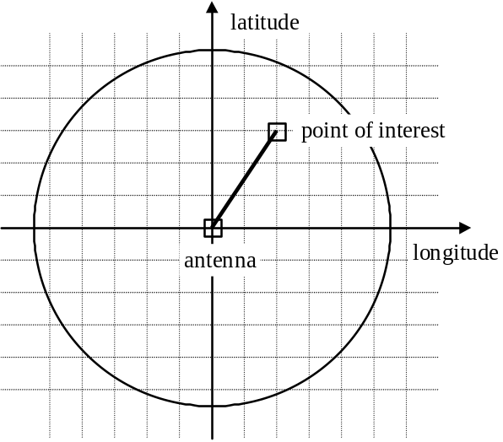

Figure 4-1. Determine Antenna Line of Sight (circle view).

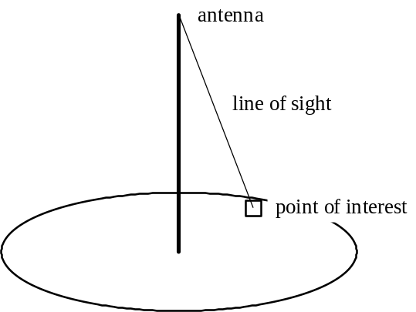

Figure 4-2. Determining Antenna Line of Sight (cone view).
When showCoverage() is finished, the status bar will state a message that the antenna had been located at the selected point.

Determining the indirect paths between the antenna and a location is being investigated in the effort of the WINPLAN project. It involves with determining whether the normal vector of the surface of the reflective point lies in the plain formed by the antenna, the reflective point, and the point being studied.

Determining the Radius of the Antenna Coverage Area
We investigated an alternate method of determining antenna coverage area by having the user input the antenna power output level and the mobile-user’s reception power cutoff level (below this power cutoff value, the transmitted signal is not distinguishable from the noise). The equation used to determine the circular area of coverage was taken from [62]:

P_{Rx} = G_{AT} * (P_{Tx} / 4πd²) * (A_{e})_{Rx} ,
where P_{Rx} is the signal power into the receiver, G_{AT} is the transmitting antenna power gain, P_{Tx} is the signal power into the transmitting antenna, d is the distance from the transmitting antenna, and (A_{e})_{Rx} is the effective area of reception by the receiving antenna. The radius of the circle depicting the area of coverage is found by solving this equation for d.

For simplicity reasons, we did not use this method but chose to have the user input the radius value directly.

Reading the TIGER/Line Data

To read the TIGER/Line data files, we built a Tiger class that has a load() method for opening and reading a file. When the user selects the “Open TIGER file…” option under the File drop-down menu, the WinmapFrame object uses a Filer object to present the user with a special dialog box. The user can then select the TIGER/Line data file to open. Using the user’s input, the WinmapFrame object then uses the Tiger object to read the data file.

Extracting the Road Data

The Tiger object can extract all records from the TIGER/Line that are associated with a road name. For this prototype WINMAP, we set the road name choices to “I-25” and “US Hwy 50”, but the tool could be modified to present the user with a listing of all of the roads in the TIGER/Line file.

Like the DEM files, the TIGER/Line files do not have delimiters, and the information must be read in bytes, then translated to the appropriate value. Unlike the DEM data files, the TIGER/Line data files consist of 17 record types, each having its own separate file [63]. For the data we needed, we only used the ".rt1" and ".rt2" files. Appendix B has an abbreviated listing of the information contained in these record type 1 and 2 data files. Each set of TIGER/Line files represents a different county.

To better understand how the data is extracted, we will step through an example for constructing the road "I-25". From the ".rt1" file for El Paso county in Colorado "tgr08041.rt1", we first extracted the records with an "I-25" feature name. Looking at an example record in Figure 3-3, there are six fields that we needed. The FENAME (Feature Name) field is what we check to find the "I-25" string. Next we need the TLID (TIGER/Line ID, Permanent Record Number) field, which we will later use to find the corresponding records in the ".rt2" file. The other four fields we need are FRLONG and FRLAT, which denote the starting point of this segment of the road, and TOLONG and TOLAT, which denote the ending point. This record can be one of many ( in this case, over 200) records that must be combined to form the entire "I-25" road defined for the county represented by this ".rt1" file.

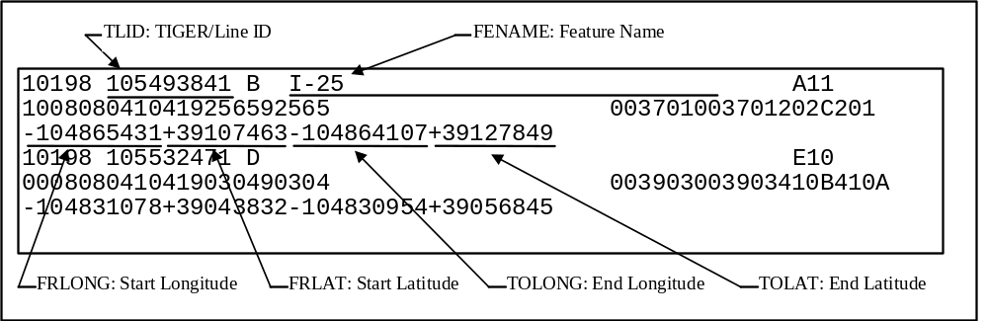

Figure 4-3. Excerpt from TIGER/Line file: tgr08041.rt1.

After we have extracted all of our information from the “.rt1” file, we open the corresponding “.rt2” file and look for TLID fields that match our first set of records. The “.rt2” file provides more geographic points to better define the entities in the “.rt1” file. Not all entities in the “.rt1” file have corresponding “.rt2” data though. For those matching records that we do find, there can be up to ten geographic points in a record, and there can be more than one record. Figure 3-4 shows one possible “.rt2” record; this one matches the “.rt1” record in Figure 3-3. The geographical points are defined by their longitude and latitude; Figure 3-4 points out only those entries for the first point. As you can see, the record fills in with “+000000000+00000000” entries when it has no more points. All of this information is stored with its corresponding record information from the “.rt1” file.

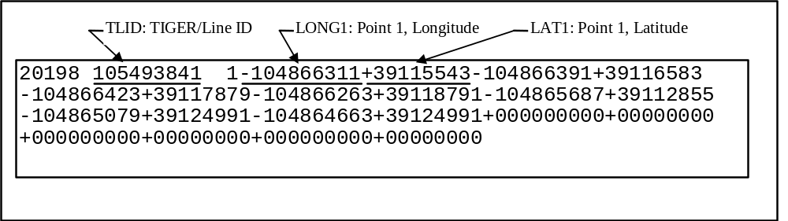

Figure 4-4. Excerpt from TIGER/Line file: tgr08041.rt2.

After this step is complete, we build the road by creating a list of geographic points. First we match up the endpoints of the “.rt1” file. We start with the first record found when reading the “.rt1: file. Internal to WINMAP, we can specify the general direction that we expect the road to head. Using the start and end points from the first record, we select one of the points as determined by the direction that this road segment is heading. Working from that point, we attempt to find another record with a matching endpoint, adding these points (including the “.rt2” points) to the list as we find, until we cannot find any more matches. We then start back at the first record and continue this process in the opposite direction. The result of this processing is the list of geographical points for the road.

When WINMAP has completed this step, the status bar displays a message stating that the road has been found.

Generating the VRML File

When the user opens a DEM file and a TIGER/Line file and has successfully selected a road using the “Find road…” option, the user can select the “Save VRML output…” option under the Save drop-down menu. The WinmapFrame object will display a Filer class dialog box for the user to select a directory and enter a filename, and it will then use a vrmlOutput object to store the 3D data from the Dem object.

The vrmlOutput object provides an output() method that uses the elevation data from the Dem object and the road data from the Tiger object to construct the VRML output file. The vrmlOutput object uses the Dem’s toColor() method to translate the colorIndexArray of the Dem object into (red, green, blue) (RGB) tri-tuples, one for each elevation in the object.

The VRML format used by WINMAP takes advantage of the new ElevationGrid object in the VRML 2.0 specification. Other tools that read DEM files currently only output data files in VRML 1.0 or VRML 2.0 format, using the IndexedFaceSet object. Using the new ElevationGrid object is significantly easier to use, since it is simply an array of elevation values for each point in the rectangle defining the picture of the terrain. A Color array, which is an optional part of the ElevationGrid object, is also output by the vrmlOutput object’s output() method to visually distinguish eight ranges of elevation values and to identify the antennas’ coverage areas. See the following figures as examples of the VRML output files.

The road data from the Tiger object is translated into a IndexedLineSet object in the VRML file. When viewing the VRML file with a browser/viewer, the road will appear as a line (either red or white, depending on the VRML browser used).

When the output() method is complete, the status bar displays a message stating that the file is saved.

Example VRML Files.

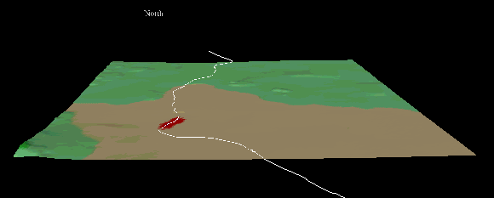

Figure 4-5. Colorado Springs 3D view.

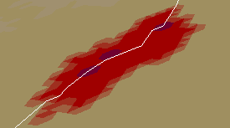

Figure 4-5a. Colorado Springs antenna coverage close-up.

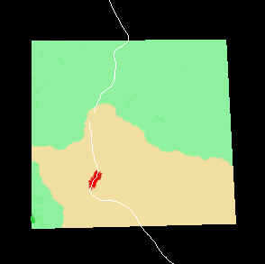

Figure 4-6. Colorado Springs 2D view.

Figure 4-5 shows an example of a VRML picture of the Colorado Springs area and Interstate 25 (I-25). Downtown Colorado Springs is just north of the L-shaped bend in the road, and Cheyenne Mountain is in the southwest corner. The shaded area (red area, if viewed in color) along I-25 is a depiction of the coverage area of antennas that we entered into WINMAP. (See Figure 4-5a for a close-up of the area.) The darker spots in these coverage areas are the locations of the antenna towers. Figure 4-6 is a 2D view of the same area shown in Figure 4-5; it was obtained by rotating the image in Figure 4-5 with the VRML browser, until we are looking directly down on the terrain. The color scheme of the terrain is as described in section 4.2.1.

Figures 4-7 and 4-8 are views of Pueblo West and U.S. Highway 50 (Hwy 50). The right (or east) end of the road segment shown is at the intersection of Hwy 50 and I-25 in Pueblo. The road extends to the left (or west) until it reaches the Pueblo county boundary. These views also shows an area covered by the antennas we entered into WINMAP.

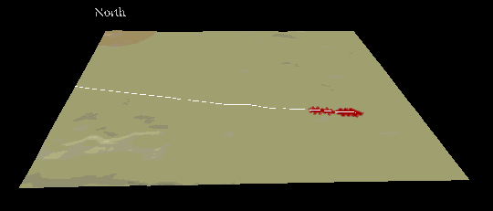

Figure 4-7. Pueblo 3D view.

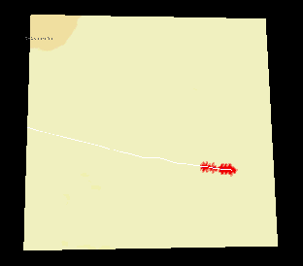

Figure 4-8. Pueblo 2D view.

Generating a timed 3D mobile user position data file

For simulating the mobile user traffic along the highway, the WINMAP reads in the DEM elevation and Tiger/Line highway data, then given the starting point and the specific traveling speed and direction, generates the snapshots of the mobile user’s timed 3D position data. The data can be used to drive simulators for hand-off algorithms and wireless network resource allocation algorithms.

After the user has opened a DEM file and a TIGER/Line file and has selected the “Find road…” option, the user can then select the “Save position/time file…” option under the Save drop-down menu. The WinmapFrame object that will display a Filer class dialog box, for the user to defined the name of the output file. The WinmapFrame object will use the Tiger object’s output() method to generate the file. As depicted in Figure 4-9, the format of the output data is rows of time increment (in seconds), longitude (in degrees), latitude (in degrees), and elevation (in meters) values for each point. The points are equi-spaced based on a defined time interval and car speed.

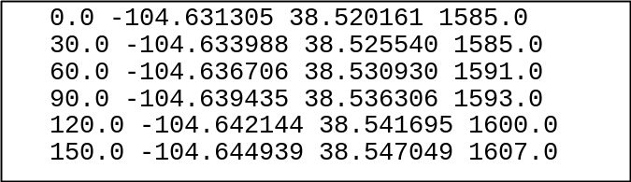

Figure 4-9. Output file of time increment and 3D location data using user-specified file name.

As shown in Figure 4-10, WINMAP also generates an additional file for use with the VRML file. This is the same location data in Figure 4-9, but the format is in terms of the VRML (x, y, z) coordinate system for the file described in the preceding section.

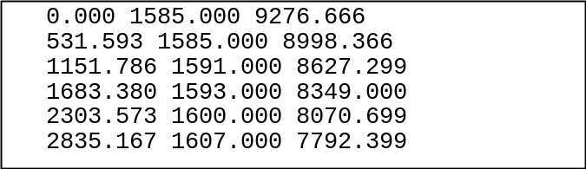

Figure 4-10. Output file 3D location grid data using modified user-specified file name.

When the output() method is complete, the status bar displays a message stating that the file is saved.

AntennaPlacer: An Antenna Placement Tool

We have implemented an antenna placement tool in C called AntennaPlacer. We choose to implement in C due to the concerns of the size of the map and the speed of algorithm processing. The input data of AntennaPlacer include the VRML file of the area generated by the WINMAP, the text file that specifies the desired coverage area, the text file that specifies the exclusion zone where the antennae should not be placed. The output of the AntennaPlacer is a text file that includes information about the locations of the antennae in terms of the x and y coordinates of the grid points, the receiving power and antenna assignment of each grid point. AntennaPlacer implements a version of the optimal antenna placement algorithm based on the branch and bound paradigm. Since the optimal solution for this problem is np-hard, we also implement an efficient heuristic algorithm that perform well for larger map in polynomial time.
Since recently the wireless network providers ran into problems with communities which opposes the erection of antenna towers in certain area, we take this practical consideration into consideration and include an exclusion zone data as input. It actually reduces the search space for the antenna placement algorithms and makes it execute faster. Since certain areas in the geographical map may not need to be covered, we include a desired coverage bitmap data as input. The algorithms will try to place antennae that cover all the desired coverage area specified by the bitmap.
Given an antenna choice, both algorithms call a coverage function that performs calculation similar to the Ray-Tracing, returns the bitmap of grid points that will not be blocked over the line of sight and their receiving powers exceed certain threshold.

Metrics for Evaluating Antenna Placement Algorithm
The choices of antenna locations depend on the cost and the coverage area. Since we do not have cost data available, we choose to examine more closely the metrics for comparing the antenna placement algorithms solely based on the number of antennae used and the coverage area. The most important metric is the number of antennae. Given the same coverage area, the fewer the antennae the better. Given the same coverage area and the same number of antennae, we propose another metric that is the number of grid points covered that are outside of the desired coverage area, since there is a possibility the wireless population may extend or traverse to those areas.

Optimal Antenna Placement Algorithm

This algorithm first uses the possible_point ( ) function to get all the possible points of antenna placement. Once we have these potential areas, it is possible to use the branch and bound method, to go through all the possible positioning. First by placing an antenna on the possible area then progress though. While we’re going through all the different possibilities, have formal parameters that can keep track of the lowest number of antennas needed. After the first possible antenna placement is calculated and the lowest number of antennas for this candidate is calculated, we use this value as a bound for all future calculations. For example, if the first possible point returns the lowest numbers of antennas to be 3, then the branch should not have to go down any further than three. This bounding technique will save a large percentage of calculations. This method covers all possibilities and returns the smallest number of antenna coverage. The result of the optimal algorithm served as a base line data for comparing different heuristic algorithms and see how far their computation results deviated from the optimal solutions.

Examples
Figure 4-11 shows a 4x5 area with 7 possible antenna locations indicated by the x sign.
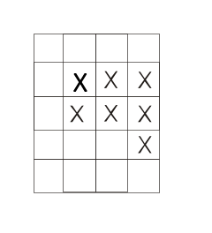
Figure 4.11 Candidate Locations for Placing Antenna

There are seven possible locations to start. Choose the first location and recursively take the result and choose the remaining locations. Continue this process recursively until all the desired coverage areas are covered. For this simple example, we assume that an antenna will cover the surrounding 8 areas and include the area it occupies, and the desired coverage area happens to be the candidate zone for placing the antenna.
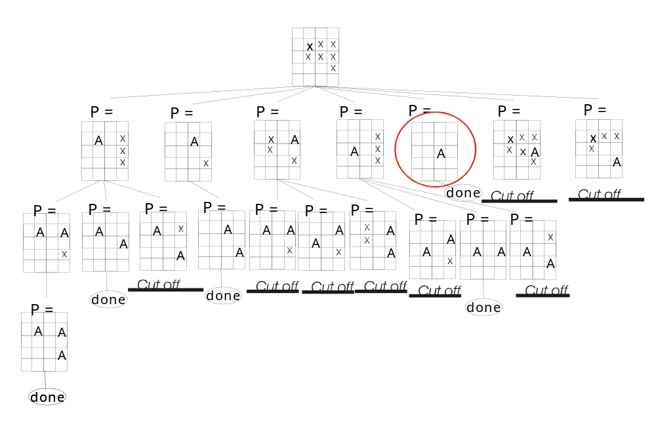
Figure 4.12 shows the search space of the branch and bound.

The optimal algorithm first follows the left branch for the above search space graph. The first branch node from the root along the left branch shows the first antenna was placed at the location (1,1) and it covers four of the desired coverage areas. The x signed of the four covered locations are removed from the map. The map shows that after the first antenna is placed, there are only three locations on the right yet to be covered.
The second branch node from the root along the left branch shows the second antenna was placed at the location (1,4) and it covers two of the remaining three uncovered locations. The leave node of the left branch shows the third antenna was placed in location (3,4) and all desired coverage area are covered. The number of antennae used for the current solution is 3 and it was used to bound and screen the other branches in the search space.
The second left branch put second antenna at location (2,4) and with just two antennae, this solution covers all desired coverage areas. From this point on, any branch with antennae more than two will be “cut off” from the search.

Heuristic algorithm

The heuristic algorithm places an antenna using the greedy method. It looks at all the positions and what the maximum coverage would be for each candidate position. It stores these values in an array and chooses the largest value. If there is more than one largest value, the algorithm then chooses the value that has the smallest value of summed in the antenna coverage area.

Given the following data representing desired antenna coverage positions:
...xxxx.................................
...xxxx.................................
...xxxx.................................
........................................
..xxxx..................................
..xxxx..................................

The heuristic algorithm checks each position and lists the number of desired antenna covered. Here for illustration purpose, we simplify the coverage of an antenna to the surrounding 8 locations and its current locations. The following matrix shows the numbers of desired coverage locations at each antenna location. Location (1,5) yields the most coverage area.

0 0 2 3 4 4 2 1 0
0 0 2 3 5 6 4 3 1
0 0 1 2 4 5 4 3 1
0 1 1 1 2 2 2 2 1
0 2 3 4 4 2 1 0 0
0 1 2 4 5 4 3 1 0
0 0 0 1 2 2 2 1 0

In this scenario the 6 in position (1, 5) would be selected.

For efficiency in storage space, the calculations are done with bitmaps. In the current version, a bit map limit of 1208 x 1208 has been set. It should be able to handle one degree map size with the 3 arc second format, since there will be a corresponding 1201 x 1201 bitmap. The program can run any size of bitmap as long as it is smaller than 1208 x 1208.

There are three different bitmaps used.
- The PosGrid is used to store the candidate positions of where an antenna can be placed.
- The MainGrid stores the locations where antenna coverage is desired.
- The AttennaGrid stores the final results.

The heuristic algorithm operates as follows:
First take a bitmap with the desired positions marked as input.
...xxxx.......
...xxxx.......
...xxxx.......
..............
..xxxx........
..xxxx........

Here x’s represent 1’s and . represents 0’s in a bitmap of characters.
The bitmap is processed by a function called pos_pnts(). Based on the antenna coverage radius in a plane, it looks at all points within the radius of an potential antenna location and see if they contains a desired coverage location. If there are, marks the potential antenna location on the bitmap PosGrid. It allows us to consider cases where antenna can be placed outside of the desired coverage area.
With the bitmap in (a), the result after executing pos_pnts () would be:
..xoooox......
..xoooox......
..xoooox......
..xxxxxx......
.xxxxxx.......
.xoooox.......
.xoooox.......
.xxxxxx.......
where ‘o’ represents desired positions and ‘x’ represents all positions that can cover the desired positions.
For each position, a multi-dimensional dynamic array stores a numerical value of the area of coverage.
0 2 4 6 6 4 2
0 3 6 9 9 6 3
0 2 4 6 6 4 2
1 3 5 6 5 3 1
2 4 6 6 4 2 0
2 4 6 6 4 2 0
1 2 3 3 2 1 0
The algorithm then looks for the largest number in the set:
0 2 4 6 6 4 2
0 3 6 9 9 6 3
0 2 4 6 6 4 2
1 3 5 6 5 3 1
2 4 6 6 4 2 0
2 4 6 6 4 2 0
1 2 3 3 2 1 0
In this case, it happens to be 9. If there is only one 9 (highest value in the matrix), then the algorithm would select the 9, set the surround values of the chosen location to be zero, and rescan the data. The algorithm would continue until there is an empty grid with no non-zero value.
If two values are the same, the algorithm adds the surrounding values up. The antenna location with the small number is chosen. For example, the sum of the surrounding values for location (1,3) is 4 + 6 +6 +9 +6 +6 + 4 + 6 = 57. In this example both locations with 9’s add up to the same surrounding values. The algorithm would just select the first value. But if there was another location with nine value and the following surrounding pattern,
6 2 0
2 9 6
3 2 0
the sum of the surrounding values would be 6 + 2 + 0 +6 + 0 + 2 + 3 +2 + 6 = 27 and it will not be chosen.

Continue and rescan the data until no values in the matrix are left, except for zeros. Every time a value selected the AttennaGrid is updated to indicate the new antenna location.
This algorithm is fairly fast and accurate:
- The heuristic algorithm computes at a rate of n², where n is the size of the map, so it is much quicker the optimal algorithm based on the branch and bound method.
- For the test cases we generated, the number of antennae is off by about 7-10 percents.

- Figure 4-13 displays the execution times of a series of test runs with different desired coverage area sizes and show the time complexity of the optimal algorithm vs. the heuristic algorithm. The test runs were carried out on a Dual Pentium 500MHz 512MB machine running Redhat Linux.
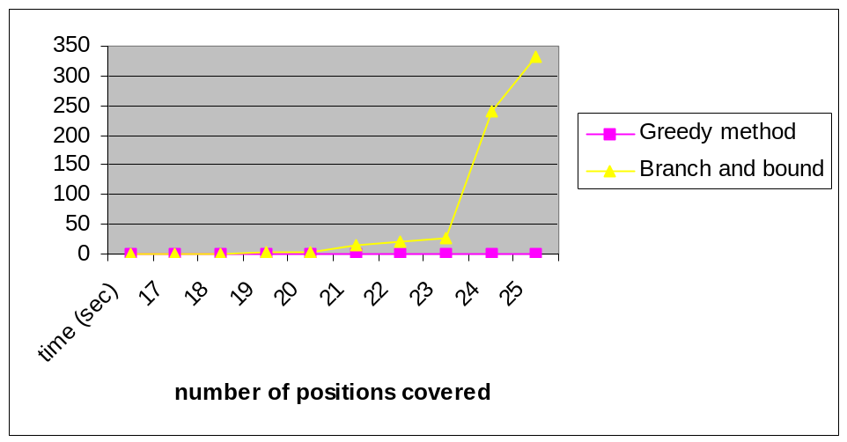Figure 4-13. Execution time of heuristic and optimal antenna placement algorithms.

Coverage() Function
Coverage() is a function that finds the coverage of an antenna. The terrain information will be stored in a two-dimensional structure arrays. In the following figure, you get the array definition:
struct Terrain {
float x; // longitude
float y; // latitude
float z; // elevation
float power; // the receiving power
int covered_or_blocked;}
terrain[x_size][y_size];

The covered_or_blocked field indicates that the number of grid points whose receiving powers exceed the threshold.
The coverage function, coverage(int x_val, int y_val, char pic[][], int antenna_label), which has four arguments: x_val and y_val give the antenna locations. Character array pic[][] represents the bit map which is used in finding the best position for each antenna. Antenna_label is an antenna ID. If antenna_label is zero, it means that the call is just an ordinary one for finding the final antenna location. If antenna_label is positive, it means that the call is used to find the final coverage map, which is used to generate the VRML file. We use different antenna_label values to distinguish the different coverage of each antenna. The coverage function will return a value which indicates the number of actual covered points by the antenna.
Receiving power is the main factor for deciding whether a point is covered by an antenna. It is related to the distance between a point and the antenna. We only need to consider those points whose distances to the antenna are within the range of R, where P=f(R), in our case, we assume that P = 1/ R⁴, P is the antenna transmission power. We call those points, the possibly covered points. For each possibly covered point, say P, we need to consider all the intermediate points between the antenna and P. Only if all intermediate points do not block P, P can receive signal from the antenna. For the receiving power, we set a threshold. If the receiving power of a point exceeds the threshold, it is said to be covered by the antenna.
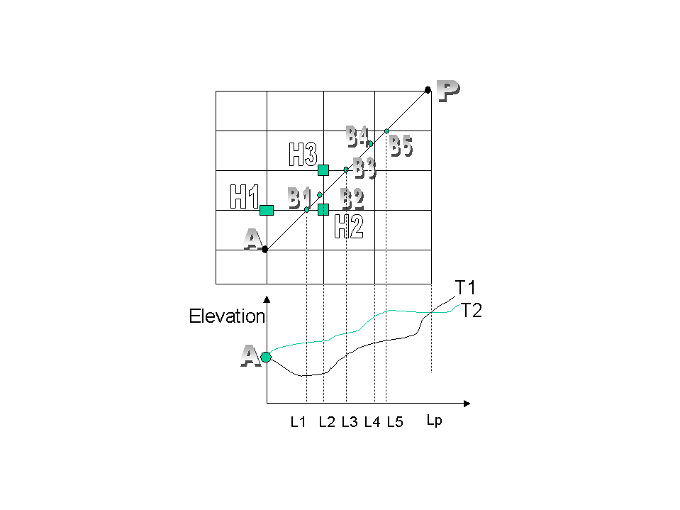
We explain this algorithm through the following example: In Figure 4-14, A represents an antenna; P represents the point to be considered; Bn represent the intermediate points that may block P. T1 and T2 are two different terrain environments. The intersect point T_{B1} between L1 and T1 is the elevation of B1 in terrain T1, same for T_{B2}, T_{B3}, T_{B4} and T_{B5}.
Figure 4-14. Antenna Signal Blockage Computation
When checking these intermediate points, we always start at the point which is closest to the antenna A.? One way to estimate the height of these Bn points is based on: 1) the distances proportion to the neighboring grid points. 2) the heights of the neighboring grid points. For instance, we need to use the heights of H1 and H2 in order to estimate B1’s height.
If we draw a line between A and T_{B1}. We extend this line to intersect with L_{p} and get a point T_{p1}. According to the heights of A and T_{B1}, we can get the height of T_{p1} proportionally, we call it H _{p1}. If the actual height of P is not less than H _{p1}, B1 can not block P, otherwise P is blocked by B1. If the current intermediate point can not block P, we need to check the next intermediate point until the last one. Only if all the intermediate points can not block P, P can get signals from A. In the example of terrain T1: B1, B2 and B3 do not block P, but B4 will block P. In the example of terrain T2, all the Bn points do not block P, so P can get signals from A. Next, we calculate the receiving power of P from A. Only if the receiving power is greater than the threshold, P is said to be covered by A.

VUTMOST: Virtual-Reality User Traffic Model and Simulation Tool
VUTMOST displays the result of AntennaPlacer in VRML models with color coding in the terrain representing the coverage areas of different antennae, and the receiving powers. It also animates the mobile traffic along a highway and displays a beam between the mobile user and the current assigned antenna. The hand-over can be easily displayed as the beam switched from one antenna to the other. VUTMOST helps to verify the antenna placement results generated by the AntennaPlacer and can serve as an effective education and training tool for wireless network design.
VUTMOST is written in Java. It reads in the text file generated by the AntennaPlacer, generates the VRML file with different colors for different antenna coverage areas and different color saturation for different receiving powers within in the same antenna coverage area. The current version also generates a highway across the terrain and animates a mobile vehicle traversing along the highway. The following snapshot shows a test data file where there are thee antennae located at three mountain tops. With a shining red ball representing the mobile vehicle and a red beam displaying it is currently communicating with the antenna located at the nearest mountina top. 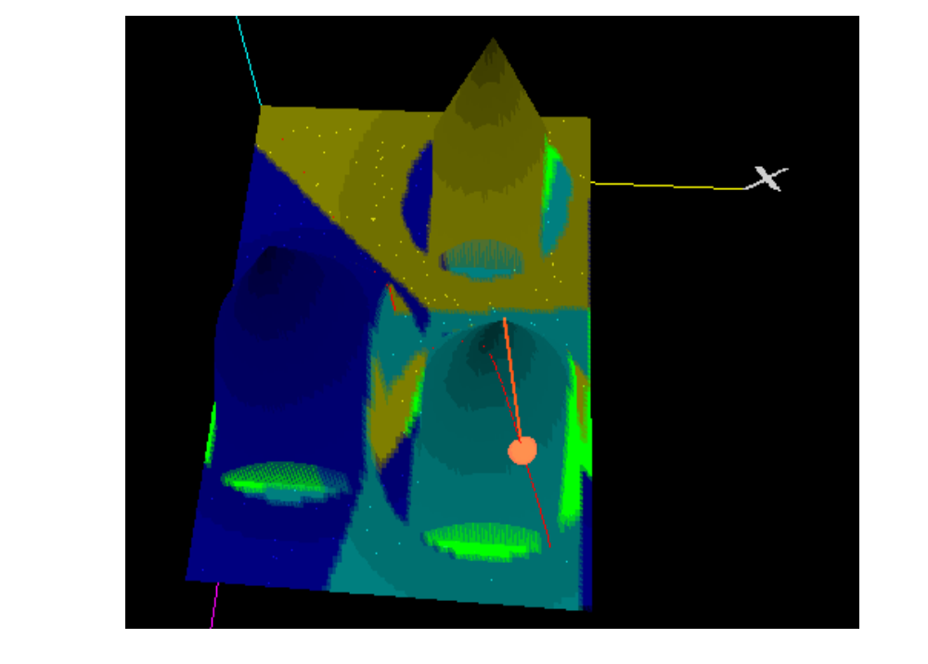
Figure 4-15. VRML for Animating Mobile Vehicle and Showing Antenna Placement Results
In order to test our AntennaPlacer, we have created three cone shap mountains with its based shaved into a square, i.e., the four sides near the foot hill are cliff and can not receive the signal from the mountain top. With three antennae on the mountain tops, we found the color patterns correctly match the signal reception condition in the terrain. We have found VRML very useful in help verifying the results generated by the AntennaPlacer. To facilitate the view and understand the orientation, we draw the axis with their label.
Animation is created using the animation facility provided by the VRML and its script node interface to Javascript. A Clock node generates timing signal with a fraction number increasing from 0 to 1. The Clock signal is routed to PositionInterpolator for the current 3D location of the mobile vehichle. The 3D position is then routed to set the translation vector of the mobile vehicle node, which is represented as a shining sphere. The 3D position is also routed to a Javascript which calculates the index of nearest grid point, uses the index to retrieve the assigned antenna of this location in an array, and returns the line segment information of the beam with the 3D position in one end and the antenna location on the other end. The return line segment information was expressed as MFvec3f data type and is routed to the beam node, which is represented as an extrusion object with a square cross area and a spline.
Shape {
appearance Appearance {
material DEF SphereM Material {
emissiveColor 1.0 0.0 0.0
ambientIntensity 0.4
specularColor 0.71 0.70 0.56
shininess 0.16
diffuseColor 0.22 0.15 0.00
}
}
geometry DEF Beam1 Extrusion {
creaseAngle 0.785
crossSection [
# Square
-10.0 10.0, 10.0 10.0,
10.0 -10.0, -10.0 -10.0,
-10.0 10.0
]
spine [
# Straight-line
0.0 1000.0 0.0,
800.0 3000.0 2100.0
]
}
}

The spline is a Mfvec3f field and actually consists of only a straight line and will be replaced with the line segment computed by the Javascript with the current mobile location and the current assigned antenna location as two end points.
The following VRML code shows the routing of signals for animating the mobile vehicle.

ROUTE Clock.fraction_changed TO Road1.set_fraction
ROUTE Road1.value_changed TO BallTransform.set_translation
ROUTE Road1.value_changed TO Beam.set_loc
ROUTE Beam.value_changed TO Beam1.set_spine
ROUTE Clock.fraction_changed TO Colorer.set_fraction
ROUTE Colorer.value_changed TO SphereM.set_emissiveColor

We use the extrusion object for the beam here, since the IndexLineSet is just to thin to be visible on the VRML model.
DEF Beam Script {
url "javascript:
function set_loc(p){
zIndex = Math.round(p.z/40.0);
xIndex = Math.round(p.x/30.0);
b=Coverage[xIndex*100+zIndex];
if (b<=0)
sv1=p;
else
sv1 = node.point[b-1];
value_changed[0]=p;
value_changed[1]= sv1;
}"
field SFNode node USE BSLoc
eventOut MFVec3f value_changed
eventIn SFVec3f set_loc
field MFInt32 Coverage […]
}

Since there is no two dimension array support, we put the antenna coverage data in a vector using MFInt32 field. We use row major order to calculate the equivalent index.
We found the access of coverage array for the ID of the assigned antenna takes a lot of computation time and results in skipping in the display of mobile vehicle locations. The javascript that assigns the antenna based on the relative distances among the antennae and the mobile perform the animation smoothly. We also found that Array object is not supported by the VRML+Javascript interface. We are investigate the reason why the access of vector data are so slow. The VRML file that generates the above snapshot in test33.wrl and is located the data directory of the distribution archive. The version of VRML file that assigns the antenna based on the simple distance is in test33dist.wrl.

Future work.
We are exploring the Java 3D for possible improvement on the animation speed. The current AntennaPlacer use a simple bitmap for the desired coverage area. It works OK with the wide area, which does not require the coverage on multiple elevation points on the same grid point. For antenna placement in multiple floor building, we need to extend the data structure in 3D so that it can represent the coverage in 3D space.
The current coverage function only implements the line-of-sight signal blockage computation and does not involve with multipath signal interference. Even though the computation of indirect signal paths from an antenna to a reception point can be extensive, with precomputed normal vector at each grid point and with maximum antenna coverage distance to limit search space, we believe the multipath signal interference can be computed within acceptable time period. It will give more accurate receiving power data and antenna coverage patterns.
The current version of VUTMOST provides VRML+Javascript animation code for animating a single mobile vehicle and their antenna assignment. Future release will focus on the simulating multiple mobile users with viewpoint follows one of the mobile vehicle.
To verify the antenna placement results and fine tune the receiving power formula, we would like to compare the results generated by the AntennaPlacer with those data measured by Omnipoint and improve the accuracy of the formula.

Evaluation
The success of the proposed project can be assessed by the usefulness and performance of software modules provided by the WINPLAN system. Based on the results presented in Section 4, the project is quite successful, since we now have VUTMOST tool that can generate VRML files for visualizing and analyzing the antenna placement results. We also have the WINMAP tool that can read in GIS terrain and highway data, build VRML model, and generate more realistic traffic events and data for analyzing the optimization packages for power and cell site assignments. The data generated can also be used for driving the discrete event simulators that model the wireless network resources, admission control and handoff procedures, and collect statistics on the QoS for cell size determination and network planning or improvement We also implement antenna placement algorithms in the tool called AntennaPlacer which given a desired coverage area and the exclusion zone of the antenna placement, generate the locations of smallest number of antennae that cover the desired coverage area. These tools can assist network planners or managers to plan or evolve wireless networks. They augment the library of tools that can foster the research, education, and development efforts in the area of wireless network planning and traffic analysis.
Omnipoint will provide feedback on the WINPLAN usage in their research and network management organizations and the usefulness of the report. Those feedback will further indicate the degree of success of the project.

Intellectual property developed under sponsorship of this grant.
We have designed and implemented WINPLAN software system with modules that can be used to generate, graphically display and verify the antenna placement results and wireless network traffic data. They can be licensed to companies in telecommunications industry that operate or plan wireless networks. To obtain the Java byte code or source code of the WINPLAN system, send email to chow@cs.uccs.edu.

Technology Transfer
We have given presentations of our research results to researchers Omnipoint Technologies and got valuable feedback from them. Based on that, we have emphasized on the design of antenna placement tool for visualizing and verifying antenna placement results. They also brought to our attention the need for multipath signal interfere. We have delivered the WINPLAN software to Omnipoint Technologies.

Acknowledgment
We would like to thank Mr. Dean Angelico for initiating and guiding the project and Prof. Roger Ziemer for providing information about wireless information network. We also would like to thank Dr. Sherwin Wang and Justin Chuang for answering tedious questions on wireless network equipment and signal fading models. Ms. Chung Ngan Nguyen for testing and designing portion of VUTMOST java program.

References
- FCC, “Amendment of the Commission’s Rules to Establish New Personal Communications Services,” GEN Docket No. 90-314, Oct. 22, 1993.
- FCC, “Amendment of the Commission’s Rules to Establish New Personal Communications Services,” GEN Docket No. 90-314, June 13, 1994.
- “1994 PCS Market Demand Forecast,” Personal Communications Industry Association, Washington, DC, Jan. 1994.
- Lon-Rong Hu and S. S. Rappaport, “Personal Communications Systems Using Multiple Hierarchical Cellular Overlays,” IEEE JSAC, Vol. 13, No. 2, Feb. 1995, pp. 406-415.
- Chih-Lin I, L. J. Greenstein, and R. D. Gitlin, “A Microcell/Macrocell Cellular Architecture for Low- and High-Mobility Wireless Users,” IEEE JSAC, Vol. 11, No. 6, Aug. 1993, pp. 885-891.
- Mischa Schwartz, “Network Management and Control Issues in Multimedia Wireless Networks,” IEEE Personal Commun., Vol. 2, No. 3, June 1995, pp. 8-16.
- Vinko Erceg and J. F. Whitehead, “Microcell Size and Architecture Analysis From the Propagation and Capacity Point of View,” Proceedings of IEEE 44th Veh. Tech. Conf., VTC 94, pp. 215-218.
- Miltiades E. Anagnostou, G. C. Manos, “Handover Related Performance of Mobile Communication Networks,” Proceedings of IEEE 44th Veh. Tech. Conf., VTC 94, pp. 111-114.
- Rajiv Vijayan and J. M. Holtzman, “A Model for Analyzing Handoff Algorithms,” IEEE Trans. on Vehicular Technology, August, 1993.
- Djamal Zeghlache, “Aggressive Handover Algorithm for Mobile Networks,” Proceedings of IEEE 44th Veh. Tech. conf., VTC 94, pp. 87-90.
- C.-H. Chow, “On Multicast Path Finding Algorithms,” Proceedings of INFOCOM’91, pp. 1274-1283, Miami, Florida, April 7-11, 1991.
- C.-H. E. Chow, J. Bicknell, S. McCaughey, and S. Syed, “A Fast Distributed Network Restoration Algorithm,” Proceedings of 12th International Phoenix Conference on Computers and Communications, March 24-26, 1993, Scottsdale, Arizona.
- C.-H. E. Chow, J. Bicknell, and S. Syed, “Performance Analysis of Fast Link Restoration Algorithms,” Journal of Digital and Analog Communication Systems, 1995. Part of the research results published in Proceedings of Globecom 93.
- C.-H. E. Chow, J. Bicknell, S. McCaughey, and V. Narasimhan, “NETRESTORE: A network simulation system,” to be published in 1996 on Journal of Computer and Software Engineering.
- C.-H. E. Chow, “NETSIM: A network simulation system for the design and analysis of network survival techniques,” CASI proposal, November, 1993.
- C.-H. E. Chow, “Resource Allocation for Multiparty Connections,” IFIP 3rd International Workshop on Protocols for High-Speed Networks, May 1992, pp. 121-136.
- C.-H. E. Chow, “ATMROS: A Network Design System for ATM Network Optimization and Traffic Management,” CASI proposal, November, 1994.
- FCC, “Amendment of the Commission’s Rules to Establish New Personal Communications Services,” GEN Docket No. 90-314, Oct. 22, 1993.
- Mischa Schwartz, “Network Management and Control Issues in Multimedia Wireless Networks,” IEEE Personal Communications, Vol. 2, No. 3, June 1995, pp. 8-16.
- Leung, Kin K., “Traffic Models for Wireless Communications Networks,” IEEE JSAC, Vol. 12, No. 8, Oct. 1994.
- Miltiades E. Anagnostou, G. C. Manos, “Handover Related Performance of Mobile Communication Networks,” Proceedings of IEEE 44th Veh. Tech. Conf., VTC 94, pp. 111-114.
- Djamal Zeghlache, “Aggressive Handover Algorithm for Mobile Networks,” Proceedings of IEEE 44th Veh. Tech. Conf., VTC 94, pp. 87-90.
- Rajiv Vijayan and J. M. Holtzman, “A Model for Analyzing Handoff Algorithms,” IEEE Trans. On Vehicular Technology, August, 1993.
- Lon-Rong Hu and S. S. Rapport, “Personal Communications Systems Using Multiple Hierarchical Cellular Overlays,” IEEE JSAC, Vol. 13, No. 2, Feb. 1995, pp. 406-415.
- Chih-Lin I, L. J. Greenstein, and R. D. Gitlin, “A Microcell/Macrocell Cellular Architecture for Low- and High-Mobility Wireless Users,” IEEE JSAC, Vol. 11, No. 6, Aug. 1993, pp. 885-891.
- Katzela, I. and M. Naghshineh, Channel Assignment Schemes for Cellular Mobile Telecommunication Systems: A Comprehensive Survey, IEEE Personal Communications, June 1996, pp. 10-31.
- Lemay, Laura and Charles L. Perkins, Teach Yourself Java in 21 Days, Sams.net Publishing, 1996.
- Geary, David M. and Alan L. McClellan, Graphic Java - Mastering the AWT, The Sunsoft Press, 1996.
- Jackson, Jerry R. and Alan L. McClellan, Java By Example, The Sunsoft Press, 1996.
- Cornell, Gary and Cay S. Horstmann, Core Java, 2nd Edition The Sunsoft Press, 1997.
- van der Linden, Peter, Just Java, 2nd Edition, The Sunsoft Press, 1997.
- Foley, James D., et. al. Computer Graphics, Principles and Practice, 2nd edition, 1990, Addison-Wesley Publishing Company, Inc.
- Hodgman, Charles D., Mathematical Tables from Handbook of Chemistry and Physics, 7th edition, 1941, Chemical Rubber Publishing Co. Cleveland, Ohio.
- Heller, Paul, Instructor for an advanced Java programming class offered by Sun Microsystems in Denver, March 3 - 8, 1997.
- Web Page: National Geologic Map Database, USGS, National Cooperative Geologic Mapping Program, National Geologic Mapping Act of 1992.
- Brown, Ronald H, et. al. TIGER/Line (TM) Files, 1992, Technical Documentation, Washington, D. C. 1993, U. S. Department of Commerce.
- Lee, William C. Y., Mobile Cellular Telecommunications, 2nd Edition, McGraw-Hill, Inc., 1995
- Stephen V. Hanly, “An Algorithm for Combined Cell-Site Selection and Power Control to Maximize Cellular Spread Spectrum Capacity”, IEEE Journal on Selected Areas in Communication, VOL 13. NO 7. September 1995
- Roy D. Yates and Ching-Yao Huang, “Integrated Power Control and Base Station Assignment”, IEEE Transactions on vehicular Technology, VOL. 44, NO. 3, August 1995.
- I. Katzela and M. Naghshineh, “Channel Assignment for Cellular Mobile Telecommunication Systems: A Comprehensive Survey”, IEEE Personal Communications, June 1996.
- Rappaport, T. S., “Wireless Communications: Principles and Practice” Upper Saddle River, New Jersey: Prentice Hall, 1996
- K. Feher, “Wireless Digital Communications”, Upper Saddle River, New Jersey: Prentice Hall, 1995.
- K. Pahlavan and A. H. Levesque, “Wireless Information Networks”, Wiley-Interscience, John Wiley & Sons, 1995.
- Jerry D. Gibson, “The Mobile Communications Handbook”, CRC Press (Published in Cooperation with IEEE Press), 1996.
- TIA/EIA Interim Standard, “Mobile Station-Base Station Compatibility Standard for Dual-Mode wideband Spread Spectrum Cellular System”, Telecommunications Industry Association, July 1993.
- M. Heidi McClure, “UTMOST: A Traffic Modeling Tool in Java”, Master Thesis from University of Colorado at Colorado Springs, May, 1997.
- V. K. Garg and J. E. Wilkes, “Wireless and Personal Communications Systems” Prentice Hall, 1996.
- U.S. Geological Survey, Digital Elevation Models - Data Users Guide 5, 3rd Printing, Reston, Virginia: U.S. Geological Survey, 1993.
- PlanGraphics, Inc, The Spatial Data Transfer Standard, Handbook for Technical Staff,
- PlanGraphics, Inc..U.S. Geological Survey, Digital Line Graphs from 1:24,000-Scale Maps - Data Users Guide 1, 2nd Printing Reston, Virginia: U.S. Geological Survey, 1990.
- Hess, Garry, Handbook of Land-Mobile Radio System Coverage, Boston: Artech House, 1998.
- Ames, Andrea L.; Nadeau, David R.; and John L. Moreland, VRML 2.0 Sourcebook, 2nd ed., New York: John Wiley & Sons, 1997.
- Mohan, Subra, "The Fourth Generation of 3D Graphics APIs has arrived!", Sun Microsystems, Inc., March 22, 1998.
- Horstmann, Cay S., and Gary Cornell, Core Java 1.1 - Volume I - Fundamentals, Mountain View, CA: Sun Microsystems Press (Prentice Hall Title), 1997.
- Geary, David M., Graphic Java 1.1 - Mastering the AWT, 2nd ed., Mountain View, CA: Sun Microsystems Press (Prentice Hall Title), 1997.
- Chan, Patrick; Lee, Rosanna; and Douglas Kramer, The Java Class Libraries, 2nd ed., Vol. 1, Reading, MA: Addison Wesley, 1998.
- van der Linden, Peter, Just Java, 2nd ed., Mountain View, CA: Sun Microsystems Press (Prentice Hall Title), 1997.
- Chan, Patrick and Rosanna Lee, The Java Class Libraries - An Annotated Reference. Reading, MA: Addison Wesley, 1997.
- Doble, John, Introduction to Radio Propagation for Fixed and Mobile Communications, Boston: Artech House, 1996.
- Faruque, Saleh, Cellular Mobile Systems Engineering, Boston: Artech House, 1996.
- Robinson, Arthur H., et.al., Elements of Cartography, 6th ed., New York: John Wiley & Sons, 1995, pp. 46-49.
- Couch II, Leon W., Digital and Analog Communications Systems, New York: MacMillan, 1983, p.253.
- U.S. Department of Commerce, 1997 TIGER/Line Files Technical Documentation, U.S. Department of Commerce: 1998.

Appendix A. Digital Elevation Model (DEM) Data Dictionary.

The following tables are excerpts from the USGS Digital Elevation Models – Data Users Guide 5. This is the data that was used for the WINMAP project. For full details on this or the rest of the DEM data files, refer to the DEM data users guide. [1]

Table 9-1. DEM Type A Record.
Data Element |  | Format | Description
1 | File name | Char[40] | Bytes 1-40, authorized DEM quadrangle name.
 | Free Format Text | Char[40] | Bytes 41-80, free format textual information.
 | Filler |  | Bytes 81-135, reserved for future use.
 | Process Code | Char[1] | Byte 136, code translation: 1=GPM, 2=Manual Profile,  3=DLG2DEM, 4=DCASS
 | Filler |  | Byte 137
 | Sectional Indicator | Char[3] | Bytes 138-140, used for 30-minute DEM’s
2 | MC origin code | Char[4] | Bytes 141-144, mapping center codes: EMC, WMC, MCMC, RMMC, FS, GPM2
3 | DEM level code | Int[6] | Bytes 145-150, code translation: 1=DEM-1, 2=DEM-2, 3=DEM-3
4 | Elevation pattern code | Int[6] | Bytes 151-156, code translation: 1=regular, 2=random
5 | Ground Planimetric Reference System (GPRS) code | Int[6] | Bytes 157-162, code translation: 0=geographic (latitude/ longitude) system for 30-minute 1-degree and Alaska DEM’s, 1=UTM system for 7.5-minute DEM’s, 2=state plane
6 | Zone in GPRS | Int[6] | Bytes 163-168, code is set to zero if element 5 is also set to zero defining data as geographic
7 | Map projection parameters | 15Real[24] | Bytes 169-528, all 15 fields of this element are set to zero and should be ignored when geographic, UTM, or State plane coordinates are coded in data element 5
8 | Unit of Measure for ground planimetric coordinates throughout the file | Int[6] | Bytes 529-534, code translation: 0=radians, 1=feet, 2=meters, 3=arc-seconds. Normally set to code 2 for 7.5-minute DEM’s. Always set to code 3 for 30-minute, 1-degree, and Alaska DEM’s.
9 | Unit of Measure for elevation coordinates throughout the file | Int[6] | Bytes 535-540, code translation: 1=feet, 2=meters. Normally code 2, meters, for 7.5-minute, 30-minute, 1-degree, and Alaska DEM’s.
10 | Number of sides | Int[6] | Bytes 541-546, always 4
11 | A 4x2 array of the ground coordinates of the four corners of the DEM | 4x2Real[24] | Bytes 547-738, Quadrangle corner coordinates ordered in a clockwise direction beginning with the southwest corner. The array is stored row-wise as pairs of eastings and northings.
12 | Minimum and Maximum elevations for the DEM | 2Real[24] | Bytes 739-786, see element 9 for unit of measure.
13 | Counterclockwise angle (in radians) from the primary axis of ground planimetric reference to the primary axis of the DEM local reference system | Real[24] | Bytes 787-810, set to zero to align with the coordinate system specified in element 5.
14 | Elevation accuracy | Int[6] | Bytes 811-816, code translation: 0=unknown accuracy, 1=accuracy information is given in logical record C.
15 | x,y,z spatial resolution | 3Real[12] | Bytes 817-852, usually set to:  30, 30, 1 for 7.5-minute DEM’s,  2, 2, 1 for 30-minute DEM’s,  3, 3, 1 for 1-degree DEM’s,  2, 1, 1 for high resolution DEM’s in Alaska,  3, 2, 1 for low resolution DEM’s in Alaska. Units of measure are given in elements 8 and 9.
16 | Rows and Columns (m,n) of profiles | 2Int[6] | Bytes 853-864, When the row value is set to 1, the n value describes the number of columns in the DEM file. Raw GPM data files are set to m=16, n=16.

Table 9-2. DEM Type B Record.
Data Element |  | Format | Description
1 | Row and Column identification number for this profile | 2Int[6] | Bytes 1-12, Row and column numbers range from 1 to the values in element 16 of record A. The row number is usually set to 1.
2 | Two numbers reflecting the total number of elevations in this profile | 2Int[6] | Bytes 13-24, The first number is the number of rows and columns in this profile. The second number is 1, indicating this profile contains 1 column.
3 | Ground Planimetric coordinates (X_{go}, Y_{go}) of the first elevation in the profile | 2Real[24] | Bytes 25-72
4 | Elevation of local datum for the profile | Real[24] | Bytes 73-96, Units of measure are defined in element 9 of record A.
5 | Minimum and Maximum elevations for this profile | 2Real[24] | Bytes 97-144, Units of measure are defined in element 9 of record A.
6 | A m-by-n array of elevations for this profile. Units of resolution are defined in element 15 of record A. | (mxn)Int[6] | The value is multiplied by the spatial resolution value and added to the elevation of the local elevation datum for the profile (element 4) to obtain the elevation.

Appendix B. TIGER/Line Data Dictionary.

The following tables are excerpts from the 1997 TIGER/Line Files Technical Documentation. This is the data that was used for the WINMAP project. For full details on this or the rest of the TIGER/Line data files, refer to the TIGER/Line documentation. [16]

Table 10-1. TIGER/Line Record Type 1 – Complete Chain Basic Data Record.
Field | Type | Description
RT | Char[1] | Byte 1, Record Type
Version | Int[4] | Bytes 2-5, Version Number
TLID | Int[10] | Bytes 6-15, TIGER/Line ID, Permanent Record Number
SIDE1 | Int[1] | Byte 16, Single-Side Complete Chain Code
SOURCE | Char[1] | Byte 17, Source or First Source Code of Update
FEDIRP | Char[2] | Bytes 18-19, Feature Direction, Prefix
FENAME | Char[30] | Bytes 20-49, Feature Name
FETYPE | Char[4] | Bytes 50-53, Feature Type
FEDIRS | Char[2] | Bytes 54-55, Feature Direction, Suffix
CFCC | Char[3] | Bytes 56-58, Census Feature Class Code
FRADDL | Char[11] | Bytes 59-69, Start Address, Left
TOADDL | Char[11] | Bytes 70-80, End Address, Left
FRADDR | Char[11] | Bytes 81-91, Start Address, Right
TOADDR | Char[11] | Bytes 92-102, End Address, Right
FRIADDL | Int[1] | Byte 103, Start Imputed Address Flag, Left
TOIADDL | Int[1] | Byte 104, End Imputed Address Flag, Left
FRIADDR | Int[1] | Byte 105, Start Imputed Address Flag, Right
TOIADDR | Int[1] | Byte 106, End Imputed Address Flag, Right
ZIPL | Int[5] | Bytes 107-111, ZIP Code, Left
ZIPR | Int[5] | Bytes 112-116, ZIP Code, Right
FAIRL | Int[5] | Bytes 117-121, FIPS 55 Code (American Indian/Alaska Native Area), Current Left
FAIRR | Int[5] | Bytes 122-126, FIPS 55 Code (American Indian/Alaska Native Area), Current Right
TRUSTL | Char[1] | Byte 127, American Indian Trust Land Flag, Current Left
TRUSTR | Char[1] | Byte 128, American Indian Trust Land Flag, Current Right
CENSUS1 | Char[1] | Byte 129, Census Internal Use
CENSUS2 | Char[1] | Byte 130, Census Internal Use
STATEL | Int[2] | Bytes 131-132, FIPS State Code, Current Left
STATER | Int[2] | Bytes 133-134, FIPS State Code, Current Right
COUNTYL | Int[3] | Bytes 135-137, FIPS County Code, Current Left
COUNTYR | Int[3] | Bytes 138-140, FIPS County Code, Current Right
FMCDL | Int[5] | Bytes 141-145, FIPS 55 Code (MCD/CCD) Left, Current
FMCDR | Int[5] | Bytes 146-150, FIPS 55 Code (MCD/CCD) Right, Current
FSMCDL | Int[5] | Bytes 151-155, FIPS 55 Code (Sub-MCD), Current Left
FSMCDR | Int[5] | Bytes 156-160, FIPS 55 Code (Sub-MCD), Current Right
FPLL | Int[5] | Bytes 161-165, FIPS 55 Code (Incorporated Place), Current Left
FPLR | Int[5] | Bytes 166-170, FIPS 55 Code (Incorporated Place), Current Right
CTBNAL | Int[6] | Bytes 171-176, Census Tract/BNA Code, Current Left
CTBNAR | Int[6] | Bytes 177-182, Census Tract/BNA Code, Current Right
BLKL | Char[4] | Bytes 183-186, Block Number, Current Left
BLKR | Char[4] | Bytes 187-191, Block Number, Current Right
FRLONG | Int[10] | Bytes 192-200, Start Longitude
FRLAT | Int[9] | Bytes 201-209, Start Latitude
TOLONG | Int[10] | Bytes 210-219, End Longitude
TOLAT | Int[9] | Bytes 220-228, End Latitude

Table 10-2. TIGER/Line Record Type 2 – Complete Chain Shape Coordinates.
Field | Type | Description
RT | Char[1] | Byte 1, Record Type
Version | Int[4] | Bytes 2-5, Version Number
TLID | Int[10] | Bytes 6-15, TIGER/Line ID, Permanent Record Number
RTSQ | Int[3] | Bytes 16-18, Record Sequence Number
LONG1 | Int[10] | Bytes 19-28, Point 1, Longitude
LAT1 | Int[9] | Bytes 29-37, Point 1, Latitude
LONG2 | Int[10] | Bytes 38-47, Point 2, Longitude
LAT2 | Int[9] | Bytes 48-56, Point 21, Latitude
LONG3 | Int[10] | Bytes 57-66, Point 3, Longitude
LAT3 | Int[9] | Bytes 67-75, Point 3, Latitude
LONG4 | Int[10] | Bytes 76-85, Point 4, Longitude
LAT4 | Int[9] | Bytes 86-94, Point 4, Latitude
LONG5 | Int[10] | Bytes 95-104, Point 5, Longitude
LAT5 | Int[9] | Bytes 105-113, Point 5, Latitude
LONG6 | Int[10] | Bytes 114-123, Point 6, Longitude
LAT6 | Int[9] | Bytes 124-132, Point 6, Latitude
LONG7 | Int[10] | Bytes 133-142, Point 7, Longitude
LAT7 | Int[9] | Bytes 143-151, Point 7, Latitude
LONG8 | Int[10] | Bytes 152-161, Point 8, Longitude
LAT8 | Int[9] | Bytes 162-170, Point 8, Latitude
LONG9 | Int[10] | Bytes 171-180, Point 9, Longitude
LAT9 | Int[9] | Bytes 181-189, Point 9, Latitude
LONG10 | Int[10] | Bytes 190-199, Point 10, Longitude
LAT10 | Int[9] | Bytes 200-208, Point 10, Latitude

Appendix C. World Wide Web Sites for Related Software Products.
Table 11-1. WWW Sites for Products Reviewed.
Manufacturer/Developer | Product | Web Site
Collaboration effort headed by Baylor University in Texas | Geographic Resources Analysis Support System (GRASS) | http://www.baylor.edu/~grass
Clark Labs | Idrisi for Windows | http://www.idrisi.clarku.edu
Environmental Systems Research Institute (ESRI), Inc | ArcInfo and ArcView | http://www.esri.com
MapInfo Corporation | MapInfo Professional 5.0 | http://www.mapinfo.com
Micropath | Micropath 2001 | http://www.micropath.com/mp2001.htm
Object/FX Corporation | SpatialX 1.2 Java Developer’s Toolkit | http://www.objectfx.com
Rapid Imaging Software, Inc. | LandForm Gold and LandFormC3 | http://www.landform.com
U.S. Census Bureau | TIGER/Line GIS data | http://www.census.gov/geo/www/tiger/index.html
U.S. Geological Survey (USGS) | dlgv32 | http://mcmcweb.er.usgs.gov/ viewers
The Visualization Project at the University of Wisconsin-Madison Space Science and Engineering Center (SSEC), and the University Corporation for Atmospheric Research (UCAR) Unidata Program Office | VisAD | http://www.ssec.wisc.edu/~billh/visad.html
WoolleySoft | Visual Explorer ’98 | http://www.woolleysoft.co.uk/ve98.html

Appendix D. WINMAP User’s Guide.

The WINMAP tool is a simple tool for investigating how obstacles, such as mountainous terrain and buildings, effect antenna placement when setting up a wireless network. The WINMAP tool is a bare-bones prototype that depicts a simple model of coverage area that one could expect from an antenna tower used in areas where the surrounding area is not flat.

This user’s guide briefly describes how to use the WINMAP tool. It does not describe how to use Java compilers or Virtual Reality Model Language (VRML) browsers. That information can be found in the reference material in the WINMAP report associated with this guide.

The WINMAP graphical user interface (GUI) consists of a close-able frame with a tool bar, a button bar, a map area, and a status bar. The map area is a place-holder feature for possible future use in displaying a two-dimensional (2D) map of the terrain and roads. It is not use in this prototype tool and appears as a large gray rectangle in the middle of the GUI.

This tool was compiled using Borland’s JBuilder 2 and the Java Development Kit (JDK) 1.1.6. The WINMAP program files are listed in Table 12-1 at the end of this guide. Additional files used by the program are listed in Table 12-2.

How to use WINMAP.

Open DEM file.

The terrain data files used by this WINMAP tool are the USGS standard-format Digital Elevation Model (DEM) files. To have WINMAP read these DEM files, select the “File” option on the tool bar. From the drop-down menu, select “Open DEM file…”. When the file dialog box will appears, type in the name of the DEM file you want to open and either press the Enter key or use the mouse to click on the “Enter” button.

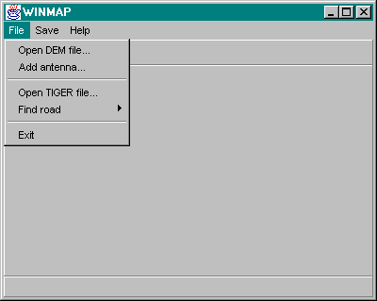

Figure 12-1. WINMAP main window.

Enter antenna characteristics.

When the status bar indicates that the DEM file is open, an antenna characteristics dialog box will appear. You can also choose the “Add antenna…” option from the “File” drop-down menu to add more antennas.

In the antenna characteristics dialog box, type in the desire antenna height, coverage radius, and antenna location (longitude and latitude). When you are finished, use the mouse to click on the “Enter” button. If you want to abort this operation, click on the “Cancel” button.

With each successful entry of antenna characteristics, the status bar will confirm the status with a message indicating the location of the antenna and its percentage coverage area, compared to an ideal coverage area.

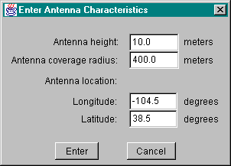

Figure 12-2. Antenna Characteristics Dialog Box.

Open TIGER/Line file.

After you have finished entering all information for your antennas, the next step is to open a TIGER/Line data file to access road information. From the “File” drop-down menu, choose the “Open TIGER file…” option. When the file dialog box appears, type in the name of the TIGER/Line file you want to open and either press the Enter key or use the mouse to click on the “Enter” button.

Select road.

After the status bar posts a message stating that the TIGER/Line file has been successfully opened, select a road name found under the “Find road” option from the “File” drop-down menu. WINMAP will then extract the road information from the TIGER/Line file and build the requested road. When the tool has completed this operation, the status bar will display a message stating that the road had been found and will give a general heading for the road.

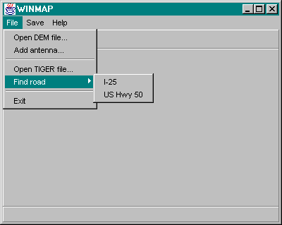

Figure 12-3. WINMAP File Menu Options.

Save VRML file.

After opening the DEM and TIGER/Line files and selecting a road, the information can now be stored in a VRML file, which can be later viewed using a VRML browser. To save the file, chose the “Save VRML file…” option from the “Save” drop-down menu. After the file dialog box will appear, type in the name for the VRML file and either press the Enter key or use the mouse to click on the “Enter” button.

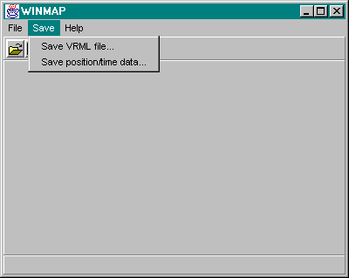

Figure 12-4. WINMAP Save Menu Options.

Save “position/time” data file.

An option of the tool is to save a data file containing location data of positions along the road that are equally-spaced according to a set car speed (22.2 km/h) and time interval (30 sec). To generate and save this file, chose the “Save position/time data…” option under the “Save” drop-down menu. After the file dialog box appears, type in the name for the “position/time” file and either press the Enter key or use the mouse to click on the “Enter” button.

Viewing the VRML file.

Shown in Figure 12-5 is an example VRML file of US Highway 50 when viewed using the Platinum WorldView 2.0 VRML browser. The road appears as a white line that start near the center of the terrain and trails off to the lower right corner. The antenna coverage areas can be seen as red areas at the beginning of the road. When you zoom in to examine the antenna coverage areas (Figure 12-6), you will notice that the actual antenna tower location is depicted by a blue dot at the center of a red coverage area.

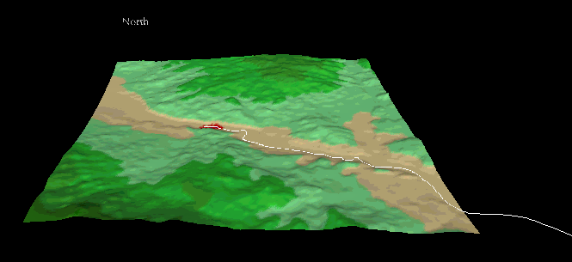

Figure 12-5. An Example VRML File.

Example Runs

In this section, we will cover two examples of how to run the WINMAP tool.

An I-25 example.

a. Using the instructions described in section 1, open the DEM file named “pueblo-e.dem”.

b. Enter in the following antenna characteristics in the antenna dialog box:

 | Antenna 1 | Antenna 2 | Antenna 3 | Antenna 4
Antenna height | 20.0 | 20.0 | 20.0 | 20.0
Antenna coverage area radius | 1000.0 | 1000.0 | 1000.0 | 1000.0
Antenna location (longitude) | -104.632 | -104.634 | -104.637 | -104.642
Antenna location (latitude) | 38.52 | 38.53 | 38.531 | 38.542

c. Next open the TIGER/Line file named “tgr08041.rt1”.

d. When that is completed, select “I-25” from the sub-menu under “Find road”.

e. Then save the VRML file under the name “vrml25.wrl”.

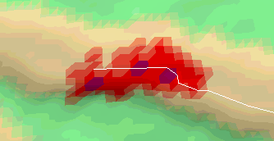

Figure 12-6. Antenna Coverage Pattern.

f. Save the “position/time” data under the name “road25.txt”.

A US Hwy 50 example.

a. Using the instructions described in section 1, open the DEM file named “pueblo-w.dem”.

b. Enter in the following antenna characteristics in the antenna dialog box:

 | Antenna 1 | Antenna 2 | Antenna 3 | Antenna 4
Antenna height | 20.0 | 20.0 | 20.0 | 20.0
Antenna coverage area radius | 1000.0 | 1000.0 | 1000.0 | 1000.0
Antenna location (longitude) | -105.939 | -105.933 | -105.928 | -105.922
Antenna location (latitude) | 38.501 | 38.502 | 38.499 | 38.497

c. Next open the TIGER/Line file named “tgr08043.rt1”.

d. When that is completed, select “US Hwy 50” from the sub-menu under “Find road”.

e. Then save the VRML file under the name “vrml50.wrl”.

- Save the “position/time” data under the name “road50.txt”.

WINMAP Source Files

Table 12-1. WINMAP program files.
File Name | Description
Antenna.java | Antenna description.
AntennaDialog.java | Dialog box for user input of antenna characteristics.
Circle.java | Circle description.
closeFile.gif | Used for close file button.
Dem.java | DEM data reader.
Direction.java | Compass direction.
help.gif | Used for help button.
openFile.gif | Used for open file button.
PointD.java | 2D point in (x, y) using double values.
Point2DG.java | 2D point in (lon, lat) using double values.
Point3DG.java | 3D point in (lon, lat, elev) using double values.
RoadRecord.java | Stores road information from a TIGER/Line record.
Tiger.java | TIGER/Line road data reader.
vrmlOutput.java | Formatter of data for VRML output.
winmap.html | HTML page used by Jbuilder.
Winmap.java | Main WINMAP program.
winmap.jpr | Jbuilder project file.
WinmapFrame.java | Main window of WINMAP GUI.
WinmapFrame_AboutBox.java | About box.

Table 12-2. Additional files required to run WINMAP.
File Name | Description
Deque.java | Interface describing a deque.
List.java | Interface describing a list.
Stack.java | Interface describing a stack.
LLCell.java | Object used as building block for Llist.java.
Llist.java | Implementation of deque, list, and stack.

Appendix E: Man Page for AntennaPlacer
Man page for AntennaPlacer

NAME:
AntennaPlacer - antenna location and coverage tool.

SYNTAX:
AntennaPlacer [/OPTIONS] (parameter lists: vrmlFile parameterFile
deserveCoverageAreaFile unsuitableAntennaPlacementPointFile
antennaReplacementResultFile)

The Options Section below explains available options.

The Parameter list Section explains each parameter.

Description:
ANTENNA is a antenna location and coverage finding tool based on the given deserved covered area. It is intended to use with WINMAP, which is a tool reading data from geometric data file and generating the input elevation data for ANTENNA.

ANTENNA reads elevation data generated by WINMAP and implements two different algorithms (heuristic and optima) for finding how many antennas are needed to cover the whole given area, where are these antennas' best location and what is the coverage map if these antennas are placed in these locations.

OPTIONS
Options supported by ANTENNA are listed below.

T - open the timing debug mode. Tell user how long the heuristic or optima algorithm find the antenna numbers and locations and generate the coverage map file.

H - call the heuristic algorithm

O - call the optima algorithm

Parameter lists
The first argument-"vrmlFile" is the data file name came from WINMAP. We retrieve the elevation data from this file. For example: "vrml50.wrl". When we open this file, we get the data matrix size x and y , the one grid distance between latitude and longitude in the field "ElevationGrid". We get all the grid elevation data in field "height", in which the format of data is ten elevation data one line.

The second argument-"parameterFile" is a parameter file name. There are some parameters used by ANTENNA in this file. For example: "parameters.txt".

The third argument-"deserveCoverageAreaFile" is the bit map data file used by heuristic and optimal algorithms. The data indicate which grid point is deserved to be covered by antenna. For example: "point1.txt".

The fourth argument-"unsuitableAntennaPlacementPointFile" is the data file used by heuristic and optimal algorithms. The data indicate which grid point is not suitable to be placed by antenna on it in your deserve covered points. For example: "unput1.txt".
The fifth argument-" antennaReplacementResultFile" is the data file name for generating the VRML coverage map file which is showed in VRML browser.

Data files used by ANTENNA

Example of VRML source file as the first argument: we only need retrieve part of the data in this file, so we just show the used part.

geometry ElevationGrid
{
xDimension 200
zDimension 200
xSpacing 88.598
zSpacing 92.766
......
}

xDimension, yDimension gives us the data size; xSpacing give us the latitude distance between two adjacent grid points. zSpacing give us the longitude distance between two adjacent grid points.

height [
3300.000 , 3311.000 , 3321.000 , 3330.000 , 3338.000 , 3343.000 , 3347.000 , 3350.000 , 3349.000 , 3347.000 ,
3345.000 , 3341.000 , 3336.000 , 3331.000 , 3323.000 , 3312.000 , 3297.000 , 3278.000 , 3257.000 , 3232.000 ,
3202.000 , 3174.000 , 3149.000 , 3120.000 , 3100.000 , 3091.000 , 3089.000 , 3097.000 , 3113.000 , 3136.000 ,

.................................................................................. ]

Each data represent the elevation of each grid point. We require that there are ten data each line except the last line.

Example of parameter file as the second argument:

antenna_height 50.0
x_init 2000.0
y_init 1000.0
power_threshold 1.0e-7
antenna_power 1.0e+5

Antenna_height indicates the height of antenna tower. X_init and y_init are used to initialize the x and y values in the terrain array. power_threshold gives the threshold in receiving power. antenna_power indicates the transmission power of the antenna.

Example of data file as the third argument:

1 1 2 3 4 5
2 1 2 3 4 5
3 1 2 3 4 5
4 1 2 3 4 5
5 1 2 3 4 5

The data above tell us the x and y size is 5. Each point deserves to be covered by antenna. Whichever point does not deserve to be covered by antenna, just set that point value to zero.

Example of data file as the fourth argument:

2 1
3 2 5
4 1

The first number in each line represents the y location, each number of the rest in the same line represents the x location, respectively. The data above tell us that points (1,2), (2,3), (5,3) and (1,4) are not suitable to be placed by an antenna on them.

Format of data file for generating the VRML coverage map file as the fifth argument:

Data_scenario: data file name
xspacing: the latitude distance between two adjacent grid points
zspacing: the longitude distance between two adjacent grid points
Elevation_Data: give the x and y size
Data: each point elevation data using space to separate them. Format is X * Y.
Antenna_Location: give each antenna location
Singal_strength_formula: p = antenna_power * (1 / distance power of 4)
Note: distance stand for the distance between the current point to antenna location
Antenna_Power_Value: antenna transmission power
Power_Threshold_Value: receiving power threshold
Receiving Signal Power Data: give the x and y size
Data: each point receiving power data using space to separate them. Format is X * Y.
Covered_points_number: how many points are covered by antenna.
Coverage_Data: give the x and y size
Data: each point is covered or not. Non_zero value means it is covered and indicates which antenna give this point the strongest receiving power. Negitive value means this point is the labeled antenna location. Format is X * Y.

File example:

Data_scenario: 1_mountain__50_50
xspacing: 30.00 zspacing: 40.00
Elevation_Data: 5 5
1795.00 1835.00 1874.00 1914.00 1954.00
1743.00 1781.00 1819.00 1857.00 1895.00
1495.00 1527.00 1559.00 1589.00 1620.00
1245.00 1272.00 1299.00 1325.00 1350.00
1000.00 1000.00 1000.00 1000.00 1000.00

Antenna_Location: 5 5
Singal_strength_formula: p = antenna_power * (1 / distance power of 4)
Note: distance stand for the distance between the current point to antenna location
Antenna_Power_Value: 1.0e+005
Power_Threshold_Value: 1.0e-009

Receiving Signal Power Data: 5 5
2.7e-009 2.8e-009 2.9e-009 3.1e-009 3.2e-009
2.8e-009 3.0e-009 3.1e-009 3.3e-009 3.4e-009
1.2e-006 9.8e-007 8.1e-007 6.1e-007 5.2e-007
3.5e-006 2.7e-006 2.1e-006 1.6e-006 1.3e-006
0.0e+000 0.0e+000 0.0e+000 0.0e+000 0.0e+000

Covered_points_number: 15
Coverage_Data: 5 5
0 1 1 0 0
1 -1 1 2 0
0 1 1 2 0
0 1 2 -2 2
0 0 2 2 2

