AMI/AMR Security

Prepared for

Dr. Edward Chow

by

Raymond Cordova

AMI/AMR Security

Raymond Cordova
UCCS Graduate Student Candidate
rcordova@uccs.edu

ABSTRACT
Several of the most critical systems in the world include the power grid, an intelligent, self-healing, real-time system. The smart grid will encompass the integration of communications networks with the power grid. In order to create a communications superhighway capable of monitoring its own health at all times, the grid must be capable of alerting authoritative entities immediately when problems arise. The ongoing effort to develop communications products and technologies specifically designed to operate reliably in harsh environments around the world must be proven for use in mission critical applications. These efforts to develop new products include power grid system security, system protection and control using a variety of media and technologies. Many commercial venders have recognized the demand for specialized products such as hardened servers, routers and Ethernet switches, Encrypted Receiver Transmitter (ERT) Meters, and a variety of other devices to complete the communications backbone solution for the smart grid. The development of a Smart Grid has focused on Security, being that the new Industrial Control Systems (ICS) will inherently have all of the vulnerabilities of Internet and computer based systems. It will be critical for the smart grids to provide confidentiality, integrity and availability to ensure the critical infrastructure is not compromised in the event of a malicious hacker, catastrophic failure, cyber event or and unforeseen disaster. Of particular concern is of the Advanced Meter Infrastructure and Reading (AMI/AMR) solutions. Authoritative entities have produced the NIST 800-82 Guide to Industrial Control Systems Security (ICSS) in an effort to provide guidance to establish secure Industrial Control Systems (ICS). The methodology and prevention of attacks to ICS networks is by far one of the most important projects since the creation of the Internet. It should be noted that the number of vulnerabilities can be exploited and the critical nature of an exploit is much more than that of Internet and computer based vulnerabilities. Instead, not only does the development of Supervisory Control And Data Acquisition (SCADA) systems, ICS or Smart Grids take conventional computer based vulnerabilities into account, but also new and ambiguous vulnerabilities that are being identified are unique to the critical security of the smart grid industry. There can only be strict adherence to the requirements and ongoing System Development Life Cycle to continually ensure security in the ICS networks. In this manner, security can be built into the systems that are critical to the safe operation of critical infrastructure components. The AMI/AMR solution is discussed herein as the emerging technology evolves with a focus on Security for the small leaf products connected to the ICS. The AMI/AMR solution must be as secure as any other component of the Supervisory Control And Data Acquisition (SCADA) system. For anyone interested in a better understanding of SCADA security, information on AMI/AMR security is only one aspect of the ongoing emerging effort to employ security in compliance with homeland security initiatives and the National Institute of Standards and Technology (NIST).
Subject Descriptors
ICS - Industrial Control Systems
NIST - National Institute of Standards and Technology
SCADA - Supervisory Control and Data Acquisition
SDL - Secure Development Lifecycle
ANSI - American National Standards Institute
NERC - North American Electric Reliability Corporation
FERC - Federal Energy Regulatory Commission
OMS – Open Metering System

INTRODUCTION
Organizations must implement tactical security solutions and meet compliance in several core areas. Among the most common organizations are the municipal and rural utility companies. The experience of creating both general and customized security engineering solutions must be developed for new and existing security technology deployments. Solutions must be developed by leveraging field experience in security engineering by focusing on environmental constraints, including, accounting for the technical overview of Control System cyber security, threats, vulnerabilities, and mitigation strategies. The vendors and organizations must comply with all standards set forth by the National Institute of Standards and Technology (NIST) and Homeland Security initiatives. Security solutions have been designed to deal with the security issues in AMI/AMR solutions, with special precautions taken to protect the devices and technology implementations. As these AMI/AMR solutions are implemented, there must be a controlled effort to ensure security is built in so as not to produce results similar to the problems encountered by the staggering growth of the Internet which produced undesirable circumstances in which exploited services evolved to be the most important factor to deal with.

AMI/AMR
The implementation of AMI/AMR solutions within the infrastructure focuses on three components; availability, integrity, and confidentiality. Security is of the utmost concern to preserve these components. The implementation of security in the leaf products of the various AMI/AMR devices becomes a major task of providing a reliable and safe solution of gathering information from millions of end points. As is the case with any emerging technology, new solutions have inherent vulnerabilities, and the Advanced Metering Infrastructure/Advanced Metering Readers (AMI/MR) is not an exception to attacks from hostile governments, terrorist groups, disgruntled employees, malicious intruders, complexities, accidents, natural disasters and malicious or accidental actions by insiders. These smart meters are considered as a device that can be used to gain access to the larger infrastructure, the SCADA power grid. Therefore, every precaution must be taken to protect the meters since these smart meters are a potential gateway to the more critical SCADA power grid infrastructure.
There have been many problems associated with the securing of smart meters. These meters must update usage statistics, which include but are not limited to several resources such as gas, water, and electricity. It is critical that every effort to maintain security for these devices becomes a normal practice in order to provide a safe and secure system. See Figure 2.1 for the scope of the smart metering system.

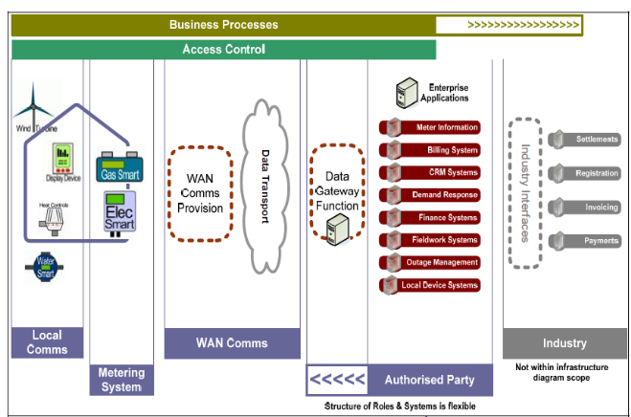
Figure 2.1 Smart Metering Scope

Wireless AMI/AMR
The use of radio technology to provide wireless solutions for AMI/AMR device technology is a feasible option for a solution to provide the capabilities of remote access to ICS. These applications are based upon silicon radio transceivers to relay data to collectors connected to the SCADA power grid. Silicon transceivers and specific protocol stacks allow devices, meters and sensors to be networked by using applications such as ZigBee, Bluetooth and ZWave. Many other commercial applications for low power radio have been specifically developed as viable solutions for utility organizations to communicate usage statistics. Implementations include the M-Bus standards being used for smart metering in northern Europe, the Wavenis solution used for water metering in France and the Trilliant platform being used by some utilities in Canada. Utilities in America and Australia are using a specific Smart Energy profile with ZigBee which was developed to provide smart metering connectivity to home area networks. Low power radio systems operate using a mesh network design that bounces packets of data through a series of nodes to reach their targeted collection point. Critical in the design of the solution is avoiding potential single points of failure in a network where each node must receive and transmit data to and from other close proximity nodes. These mesh based devices are configured with redundancy to ensure availability, confidentiality or integrity. There are no fixed design solutions for the infrastructure, and Low power radio signals can be affected by line of sight, co-existence and signal interference issues. As with all low power radio signals, they are susceptible to interception, and thus the need for security, and the physical access to the device is a major concern. Tampering with the device or altering the programming can have disastrous effects. There must be a mechanism to ensure valid data is collected and that no tampering has occurred in the device or the collectors. There must be a SCADA control system with threat and risk assessment mechanisms to mitigate penetration testing, vulnerability analysis, gap analysis, security assessments, and risk methodologies. The control system must account for cyber security training, forensics and contingency planning. Separate Advanced Meter Infrastructure / Advanced Meter Reading (AMI/AMR) security analysis must be performed to gather the information required to analyze and evaluate functional security strategies security plans.

Vulnerabilities
Millions of homes and businesses are using smart meters that are riddled with security bugs that could bring down the power grid. Of particular concern, these new smart electricity meters are being implemented despite vulnerabilities that can open the door to power -grid botnets that have been identified in several vendor smart meter devices. The smart meters provide two-way communications between electricity users and collection devices that ultimately connect to the power plants that serve them. Utilities in Seattle, Houston, Miami, and elsewhere are hurriedly implementing them as part of a plan to make the power grid more efficient. Funded by billions of dollars from President Obama's economic stimulus package, utility organizations have continued to install the smart meters. Other organizations throughout Europe are also spending heavily on the new technology. The problem becomes evident when meters needed to make the smart grid work are built on buggy software that's easily hacked. Mike Davis, a senior security consultant for IOActive has identified several issues with the smart meter software [3]. These issues are critical to the security of the smart grid with the vast majority of them use no encryption and ask for no authentication before carrying out sensitive functions. There is no validation or authentication when performing software updates or severing customers from the power grid. Mike Davis has said the vulnerabilities are ripe for abuse. The smart meters have the capability to switch on/off hundreds of thousands of homes at the nearly the same time. This can introduce problems with the power company being able to gracefully deal with power demands or surges. The vulnerability in the devices is susceptible to a worm designed by Mike Davis and IOActive colleagues. The worm self-propagates across a large number of one manufacturer's smart meter. Once the device becomes infected, the device is under the control of the malware developers similar to the way infected PCs are under the spell of bot herders. It is at this point that the attackers can “own” the devices and send instructions to turn power on or off and divulge power usage statistics or sensitive system configuration settings. The worm is able to spread quickly and exploits an automatic update feature in the meter that runs on peer-to-peer technology. The peer-to-peer technology doesn't use code signing or any other measure to ensure the update is authorized, but instead uses a routine known as interrupt hooking, which adds additional code to the device's operating system. There has been no public disclosure of verified models of smart meters that are designed with these vulnerabilities. Researchers and engineers decline to identify the models or the manufacturers but will only elaborate to state that most of the models suffer from the same poor design. Companies manufacturing the smart meter devices for smart grids include GE Energy, The ABB Group, Sensus Metering, Itron and Landis+Gyr. The embedded platforms are not designed for security. One deficiency that has been identified as common among many of the meters is the use of well-known insecure programming functions, such as memcpy() and strcpy(). Developers aspire to secure coding in the Smart Meters by removing memcpy() and similar commands that have been responsible for an untold number of security vulnerabilities over the years, not just in Windows but in countless other applications based on the C
language. Also, Microsoft plans to formally banish the

popular programming function effective later this year.
Microsoft will add memcpy(), CopyMemory(), and RtlCopyMemory() to its list of function calls banned under its secure development lifecycle. Although memcpy() has provided a simple way to copy the contents from one portion of memory to another, problems arise when the source to be copied contains more bytes than its destination. This creates overflows that provide attackers with opportunities to remotely execute code in the underlying application. Like memcpy(), other risky functions such as strcpy() and strcat(), are also banned after causing untold misery over the years. SDL compliant developers instead replace memcpy() functions with memcpy_s, a newer command that takes an additional parameter to delineate the size of the destination buffer. These are two of the most common sources of exploitable software bugs. In many cases, the devices use general purpose hardware and software that aren't designed for highly targeted or mission critical systems. This is the nightmare of the smart grid security initiative. One only needs to envision a malicious hacker that has the unique identifier that's printed on your meter. According to the Edison Electric Institute, power company utilities in more than two-dozen states expect nearly 52 million customers using bidirectional smart meters by the year 2015. Some of those deployments have been completed and many more will be completed in the next few years. There is still the security concern with “buggy” meters from nearly every vendor and manufacturer. Several questions surface: Why are these “buggy” meters being installed when there are known vulnerabilities? What will be the cost to retrofit? What will be the timeframe? Why is there no oversight by a regulating authority? Why would the President of the United States reserve billions of dollars to upgrade our power grid and have no real control over utilities that ignore the critical security issues involved within the project? Why does the stimulus package specify implementation of security strategies but real security solutions are ignored while vulnerable meters are being installed? Why haven’t utilities, power distribution engineers and consultants taken action to correct the issues in the vulnerabilities of the smart meters? And the questions go on and on and on. Answers are elusive but as of October, 2009, IOActive consultants met with the Committee of Homeland Security and made recommendations for the Smart Grid. The presentation by IOActive attempted to answer many of these questions with Security as one of the main issues presented. Also, discussion on the plans to complete the upgrade to the Smart Grid was presented. See Figure 4.1 for Smart Meter Deployment Plans.
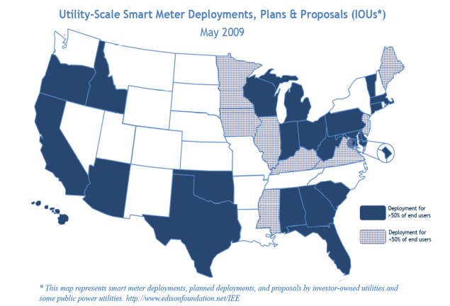

Figure 4.1 Smart Meter Deployment Plans

The new generation of smart meters will enable real-time computerized networked smart power grids which have the ability to make automated decisions in real time based on data collected from millions of sensors. The smart grid could raise or lower rates hour by hour depending on the supply of available power. The rates are based on the reports of millions of individual smart meters. These smart meters could respond to power shortages by commanding smart appliances such as clothes driers and dish washers to shut off until power resources are replenished and have become plentiful. The plan to complete the installation of smart grid meters would virtually eliminate the need for meter readers to visit each customer to know how much electricity has been consumed. The computing and communications technology industries have made the electrical system more interactive, efficient and robust but at the cost of vulnerabilities in security.

Vulnerabilities Ignored
As the smart grid progresses, a new era of problems and issues arise. Concerns about security have been ignored since the urgency to upgrade has only increased since the passage of Barack Obama's stimulus package. Without much doubt the iconic image of what a smarter grid will mean is the smart meter. There have been billions of dollars reserved for smart-grid spending [4]. Utilities companies must meet aggressive deadlines to qualify only to have companies' upgrade plans accelerated with no regard whatsoever to security. Mike Davis of IOActive's security consultant group has said that before the incentives were announced, several utilities approached him and asked if he would perform penetration tests on meters they planned to roll out. "As soon as the stimulus bill came out, everybody just clammed up," he said. "It's almost impossible for us to get new devices to look at now" [3] [5]. Utilities are essentially responsible for policing themselves. History appears to repeat itself with the similar regulatory arrangement of the credit card industry, in which merchants are required to comply with rules set by other companies in the industry. Additionally, the history of the staggering growth of the Internet and the inherent security problems is all the more reason to proceed with security standards, especially in a critical system such as the power grid. With a grid-burrowing worm that replicates quickly and possesses the ability to issue high-level commands, it becomes a certainty that the vulnerability will be exploited. Obviously, rebuilding the electrical transmission smart grid with smart meters will require fundamental regulatory reform at all levels, especially when entrepreneurs, operators, and regulators to bend and stretch rules almost to the breaking point. Radical reform of management and regulation will be required if the smart grid is ever implemented with the critical security strategy that is being ignored. Earlier this year, the U.S. stimulus legislation adopted allocations of $4.5 billion in grants for Smart grid projects, $6 billion to support loan guarantees of $50-60 billion for renewable energy and transmission, and $6.5 billion in loan guarantees for the Bonneville Power Administration (BPA) and the Western Area Power Administration (WAPA) to expand transmission to accommodate renewably generated energy.

The Need for Regulation and Management
On June 18, 2009 the National Institute of Standards and Technology (NIST) were scheduled to issue a draft on Smart Grid Interoperability Standards Framework in September, 2009. Perhaps this is the beginning of the critical need for regulation and management of the power grid. Only then can the power industry avoid problems similar to those experienced in the unregulated staggering growth of the Internet, the inter-state highway industry, and private power organizations such as the Newton, Mass.-based First Wind Power Company. The Maine Public Service Company (MPS) informed the First Wind generator company that it could no longer accommodate the generated power from the wind farm. Although there is no direct connection to the smart grid, First Wind exports the power to Canada. Canada then exports it right back to power lines in New England in an awkward and peculiar solution. Regulation and Management may have been able to avoid this type of situation. However, the need to regulate and manage can become a downfall. Several examples of regulatory mistakes can be discussed. History reveals the problems.
The transcontinental railroad was completed in May 1869. For over 20 years the railways were built out for the main line. In 1886, The Sears Catalog Company began to capitalize on this railway with 2-page flyers sent all over the country. By 1895, large Sears Roebuck catalogs were sent. This railway infrastructure enabled Sears Roebuck to undercut the prices of general stores. Sears dominated the mail order retailing industry for approximately 50 years by taking advantage of the new way to connect to customers, conduct commerce, and introduce a new competitive advantage. Perhaps Smart meter vendors can capitalize on the demand for Smart Meters. There will be a great demand since the United States has only completed about 5 percent of the upgrade to the power grid.
Another example in contrast is the telecommunications network industry. Regulation and incentives basically had the industry at a standstill for nearly 30 years. In 1982, the Telecommunications Act was enforced in 1984. Investors ventured into the market and within a few years, new digital products were rolled out that included cell phones, Blackberries, iPhones, MP3 players and a whole host of Personal Digital Assistants (PDAs). Too much regulation can be a bad thing. By opening up the infrastructure to innovation, rapid development and progress can be realized. Several thousand jobs are created and billions in revenue can be realized.
Finally, a few words about the Internet should be discussed. In its infancy, there were no real regards for security, future growth, performance, scalability and reliability. There was no real planning or enforced regulation in the infancy of the Internet. No one could have predicted what the Internet was to become. With estimations of up to 60 times additional cost incursions to correct problems after the fact, it is a hard lesson learned. Although there is a whole wealth of information that can be related to the need for regulation on the Internet, and although there is an extreme large amount of information about the management aspect, history shows that as the Internet grew at alarming rates with little or no regulation or management and has been a disaster in terms of cost. Patching up a network infrastructure with security after the fact has a cost associated with it that is staggering.
With at least $20 billion at stake, and another $100 billion by the year 2030, all entities must recognize the vital role of the Smart Grid. It is the grid that makes the connections to tie everything together and it is the Smart Grid that is so far behind the rest of the international community that steps need to be taken to catch up.

Make the Smart Meters Secure
History has taught us that early-to-market technologies are often ideal targets for malicious attacks. Shown in figure 7.1 is a retrofitted power meter with a Programmable Logic Controller (PLC) Circuit board. Technology solutions for the smart grid continue to evolve and high speed PLC chips offer alternatives for retrofitting meters at list price of $8.50 per unit. The low price of the retrofit module may have a high cost in the sense of a security breach. For a determined hacker, information on the programming code, OS, vulnerabilities’ and exploit techniques are available from a variety of sources. The determined hacker can be successful in exploiting these vulnerable meters. All PLC deployments will require some network infrastructure equipment and are therefore vulnerable in a variety of ways. Figure 7.2 shows the block diagram of the PLC with network interfaces.

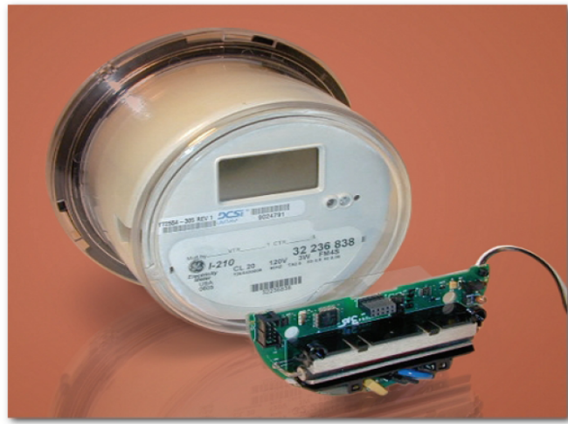

Figure 7.1 PLC Circuitry to Retrofit Meter

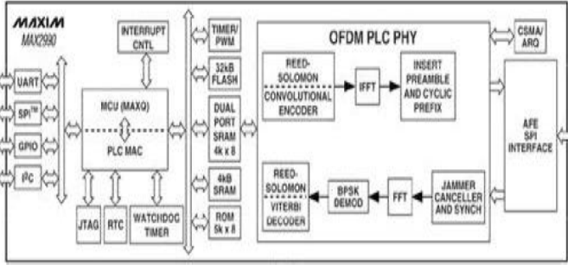

Figure 7.2 High Speed 100Kb/s PLC Transceiver Chip

The Smart Grid utility infrastructure shows promise to save money and resources while providing better accounting of energy usage. Energy distribution and transmission is becoming as technologically sophisticated as the rest of the Internet and it is critical to fully examine the implications and risks of the Smart Grid and its component parts. A quote from a recent presentation to the Committee of Homeland Security summed up the problem.
"The Smart Grid infrastructure promises to deliver significant benefits for many generations, but first we need to address its inherent security flaws. Based on our research and the ability to easily introduce serious threats, we believe that the relative security immaturity of the Smart Grid and AMI markets warrants the adoption of proven industry best practices, including the requirement of independent third-party security assessments of all Smart Grid technologies that are being proposed for deployment in the Nation's critical infrastructure. We are also recommending that the Smart Grid industry follow a proven formal Security Development Lifecycle, as exemplified by Microsoft's Trustworthy Computing initiative of 2001, to guide and govern the future development of Smart Grid technologies."
This is a quote from Joshua Pennell, President and founder of IOActive in a presentation to the Committee of Homeland Security and DHS on March 16, 2009. [4]
It certainly seems like the quote from Joshua Pennel has defined the problem and provided the solution. As the effort moves forward, adherence to regulations and guidelines will be critical. There is also the problem of existing vulnerable smart meters that have already been implemented that will require expedited action. Undoubtedly, following a proven Security Development Lifecycle will provide the needed regiment to properly build a secure smart grid.
The smart grid reaps the benefits of distributed computing and fault-tolerant communications. It delivers real-time information and enables near-instantaneous balance of supply and demand at the device level. A critical component of the Smart Grid is the Advanced Metering Infrastructure (AMI), or smart meter network, which acts as both a distribution point and an endpoint for communication and sensor nodes. The meters include a wireless network interface and mesh networking software which provides a two-way flow of electricity and information. Smart meters monitor everything from power plants to customers’ individual appliances. This capability enables utility companies to automatically update the software running the devices and allows them to remotely disconnect and shut off a customer’s electricity over the network. There are over two million smart meters in use in the US today with an estimated 73 participating utilities with orders of17 million additional smart meter devices, fueled by the recently-approved $4.5 billion economic stimulus package that is pushing many utility companies to roll out the devices at a staggering pace. As the grid grows and matures, a new frontier for cyber-attackers is identified. The history of the internet has demonstrated that malicious users will find and exploit vulnerabilities to wreak havoc and make money, so it is critical to develop and enforce strict privacy controls. Terrorists can and will target weaknesses in the Smart Grid to shut off power to large areas in demand for ransom from the utility. Petty criminals can and will exploit weaknesses to disconnect power to individual homes in order to break into the residence or to simply to be a nuisance. Whatever the reason, the Smart Grid must be protected from the vulnerabilities.
Although many benefits can be reaped from the smart grid, there are the many negative aspects introduced from the similarity of the infrastructure of the Internet. Smart meters are essentially mini-computers that lack the protection to ensure security. Extensive research has revealed a range of vulnerabilities and programming errors. Many of the smart meters are vulnerable to common attack techniques, including buffer overflows, and persistent and non-persistent root kits that could be assembled into self-propagating malicious software. An alarming vulnerability is that the smart meter’s chipset used for radio communication is publicly available in a developer kit. Malicious code execution on standard smart meters can be achieved and the radio interface’s lack of authentication can be exploited to produce a worm. A malicious program on one meter, could issue commands to the internal firmware on adjacent meters until all devices within an area were infected with the malicious firmware. The worm, once executed can:
• Connect and disconnect customers at predetermined times
• Change metering data and calibration constants
• Change the meter's communication frequency
• Render the meter non-functional
In a worst-case scenario, normal wireless update mechanisms would fail, the meters calibration would be changed, and services to customers’ homes could be disconnected with the remote disconnect capability. To recover, the utility company needs to take time to understand the vulnerability and develop a patch, update the meter and then restore power to the customer. For the best case scenario, the utility company would simply push a firmware update across the wireless network to all the affected meters and overwrite the worm to return the meters to normal operation, that is, if the remote flashing capability has not been compromised. It is interesting to note that IOActive performed “black-box” penetration testing on smart meters with “zero knowledge”. Testing is done with an attack by someone with no detailed knowledge about the device, the electronics or functionality. The objective is to breach the devices and obtain binary level code execution capability. The process is performed to breach the devices. Several strategies are used that include modeling and exploring potential attack vectors; reverse engineering device binaries; deeply inspecting hardware and software functions; and use fuzzing protocol segment executions. Research was conducted in a controlled lab environment. Modeling was conducted to demonstrate the severity of a worm attack in the real world. Mike Davis, an IOActive’s Senior Security Consultant, simulated a 22,000-node smart meter worm propagation scenario with real-life variables using GPS points created from geo-coded home addresses. The simulation is run with parameters that would affect a worm attack including the radio range, signal strength, radio noise, and Smart Grid network packet collisions. The simulation period showed that approximately 85% of homes would be infected with the worm in 24 hours. The simulation illustrates vulnerabilities in software and firmware.
Determined attackers have an easier time attacking Smart Meters since no real consideration for physical security has been implemented. The meters can be stolen easily and although they have anti-tamper mechanisms, access to the device is still possible to modify usage information. The poor physical tamper resistance mechanism allows an attacker to easily reverse engineer and uncover the many exploitable security vulnerabilities. The attacker does not need to invest much money, does not need a background in power systems and have just enough curiosity to carry through with the exploit.
If such an attack as that simulated in the IOActive laboratory did take place, the Department of Energy reported it would take approximately 131 days to patch, recover and implement a solution to the vulnerabilities. This staggering report form a lab from the Department of Energy implies a large window of opportunity for exploitation, especially when approximately 250 exploits for control systems exist on any given day for the years 2006-2007.
Although many argue that an attack is doubtful, a determined attacker cannot be under-estimated, especially when considering the consequences of a successful exploit. It is likely to occur notably for an attacker that may be curious. Terrorism is another likely reason that an attack can occur. It is an attractive target that has a relatively easy threat to exploit and could cause the utilities to lose system control of their metering infrastructure to unauthorized third parties. Additionally, if the vulnerabilities in the Smart Grid are left unchecked, it could result in the utilities exposed to fraud, extortion attempts, lawsuits, widespread system interruption, and massive blackouts.
8.0 Secure the Smart Grid
Not everyone accepts change but when change is required and readily apparent, utilities companies must be held accountable to tight security practices, A new measure aims to protect the new networks that have been introduced into controlling electric power distribution grids throughout North America. Organizations responsible for keeping electricity flowing throughout the United States and Canada began to take the first step in May 2003 to implement cybersecurity on the Byzantine computer networks that control electric power distribution. Up until this time there was no real security strategy. It has been known that several partitions of the power grid have been vulnerable to hack attack since at least 1997. Basic security flaws in the computerized systems that control generators, switching stations and electrical substations. The findings were surprising. Operational networks controlling critical portions of the grid were accessible through electric utility companies' corporate LANs, digital circuit breakers could be remotely tripped by anyone with the right phone number, and passwords for remote vendor access went unchanged for years.
The White House's National Security Telecommunications Advisory Committee reported that physical attacks against utilities pose a greater threat than cyber attacks. After September 11, and the Federal Energy Regulatory Committee (FERC) began talking about imposing security requirements on power companies to close holes in critical infrastructures. It is interesting to note there are still no known cases of hackers causing service outages. The power companies prefer to regulate themselves but the North American Electrical Reliability Council (NERC) has proposed mandatory security standards for the electric industry. NERC security rules have implemented basic security development lifecycle processes such as companies would have to sponsor cyber security training programs, write security policies, identify their critical cyber assets, etc. Of the utmost concern is to avoid a catastrophe, like the catastrophic 1965 blackout that knocked-out power to 30 million people in the northeastern United States.
How can the security of the Smart Grid be guaranteed so we do not experience the problems inherent in new designs and implementations, such as those encountered in the Internet? How can distribution engineers and designers mitigate the inherent security vulnerabilities to realize the benefits of “smart” power distribution? How can the stipulations for utilities to have a plan for due diligence in cyber security be regulated and managed? The government stimulus money given to utilities puts them in a powerful position. Utilities can apply pressure to meter vendors to produce more secure devices and can drive competition in the smart meter market. Tests on the security, quality, and reliability of the products from various vendors can ensure that meter vendors continually improve their security protocols, devices and physical anti-tamper mechanisms.
A formal Secure Development Lifecycle (SDL) advocated by the Smart Grid AMI vendors to guide and govern the release of products will be better equipped to withstand malicious attacks. Security and privacy measures are taken into account during each stage of development. The SDL will require that a final review occur before the software is released. By layering the defenses and applying basic security practices, such as authentication and encryption, the devices would be much more difficult to exploit sensitive functions like running software updates and severing customers from the power grid. Implementing encryption requires that the keys are protected and strong enough so that an attacker cannot easily take the meter apart, locate and decipher the key.
The Smart Meters must authenticate early and often to ensure that any proliferation of a worm is stopped or at the very least made very difficult for the worm to grow. Authentication best practices need to be enforced just as it is in networking and Internet systems. By employing the best practices for authentication, the threat from exploiting no authentication can be minimized.
Researchers have also shown that attacks to the radio interface vulnerability of no authentication is a dangerous vulnerability that if exploited can produce a worm that spreads to other meters at an alarming rate. This type of worm can have a devastating result on the grid and disrupt service to customers. In addition, some researchers have been able to cause problems with the use of radio jamming. And again, another solution must be implemented for this problem, perhaps frequency hopping in the radio transceivers.
There is still time to repair the Smart Grid infrastructure. The government, utility companies and vendors, security and privacy experts, need to assume their roles as the expert in Smart Grid security and protect the Smart Grid energy ecosystem. The SDL protocol also will help these Security entities to correct the design flaws in the smart meter devices. Taking these preliminary steps to secure the Smart Grid the right way the first time provides the benefit that is realized in lower overall project costs. Without these security strategies built in to the system with the SDL, research statistics show costs are 60 times higher when gaps in information security controls are addressed late in the development phase.
Vendors can now be held responsible for the security in the products they produce. The benefits of the Smart Grid and AMI technologies are bountiful and utilities can begin to focus on the safety and privacy protocols of this critical infrastructure.
When all the planning is done and a clear and concise plan of action has been approved, it is time for action. Strict adherence to the regulations, management and implementation must be followed. Upgrading the Smart Grid in the United States is far behind other countries. How does the United States compare to other countries in terns of implementation? See Figure 8.1.
Note: This map shows the extent of smart meter deployments by electric utilities companies. The deployments are completed, underway, or planned with a completion date on or before 2015. Smart meters are defined as advanced meters that allow for two-way communication and real-time analysis of electricity consumption. Figure 8.1 does not include automatic meter reading (AMR) installations. Information was compiled using the latest public data available as of May 20, 2009. 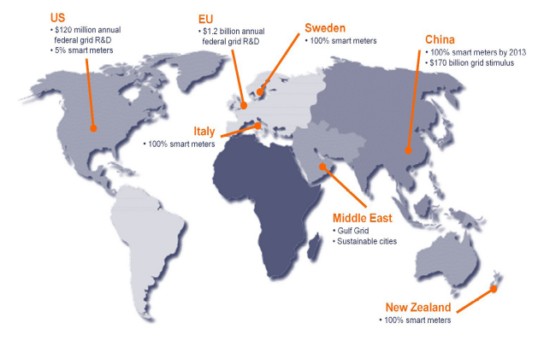
Figure 8.1 Smart Meter Implementation
Percentages by Country

8.1 Notable Projects in the United States
As the United States plays catch-up to the rest of the International community, there are many projects underway that have gained attention. Some projects are kept confidential, however, there are some that have become the topic of discussion in many forums interested in the upgrade of the Smart Grid. Some notable projects are noted as follows:
- In California and Texas, utilities are spending around $6 billion to install meters that can tell them how much electricity they are using at any given time, where time-of-day real-time pricing is in effect, and how much they are paying for it. Utilities can receive real-time outages alerts and site-specific information useful for diagnostics.
- Smart metering is a big enough trend to have substantial spin-off benefits for related businesses. Gartner estimates that 150 million meters may be installed in the next five years, generating $2 billion in orders from semiconductor makers. Texas Instruments believes the chip demand could go as high as $7.5 billion.
- All of the four major mobile telephone providers in the United States and several overseas are highly involved in developing inexpensive communications systems with smart meters. Google has devised a free Web-based service, Google PowerMeter, to help consumers track and analyze their energy use. Additionally, Siemens is among the companies working on a special XML communications standard suitable for meters under the aegis of the World Wide Web Consortium.
- Baltimore Gas and Electric Co. is experimenting with customers equipped with smart meters. They will be rewarded for reducing peak-load usage at a rate of $1.50 per kilowatt-hour cut.
- One of Denmark’s five largest electricity distributors, EnergiMidt, and a customer-owned cooperative is installing Smart Meters in all of its 170,000 residential users. A partner of Echelon Corp. in San Jose, Calif., Finland’s Eltel Networks, has the contract to provide IP-based meter data management systems.
- Florida utility FPL is installing 1 million smart meters in Miami and may eventually install as many as 4.5 million throughout the state. The upgrade program will include trials of home dashboards, smart thermostats and appliances, and energy-saving software. GE is supplying meters and appliances and networking technology comes from Silver Spring Networks and Cisco.
- Pacific Gas and Electric (PG&E) has a budget of $2.2 billion to install more than 5 million smart electric meters in California by 2012. Another smaller group received programmable thermostats, showing impressive reductions in peak electricity demand.
- Pepco Holdings plans to install advanced smart metering solutions for all of its customers in the District of Columbia, Delaware, Maryland, and New Jersey by 2013.
- The Texas–New Mexico Power Co. (TNMP) is installing 10,000 meters with technical assistance from SmartSynch and T-Mobile. Residence and utility communications will be handled by AT&T Mobility.

8.2 Selected Vendor Smart Meters
Several vendors have recently released enhanced versions of their smart meter products. These vendors have been developing Smart Meters in compliance with the Security Development Lifecycle and several guidelines adopted by the regulatory and management agencies involved with the process of safely securing the Power Grid.
8.2.1 Itron OpenWay®
Itron [1] has recently released its OpenWay® Collection Engine with Enhanced Security Features. Itron released the new Smart Meter February 11, 2009 is leading the industry with enhance Smart Meter security. The release and initial shipments of an enhanced security Smart Meters enables strong authentication and enhanced security for use in Advanced Metering Infrastructure (AMI) deployments. The current version of OpenWay software is fully compliant with security and encryption to meet industry and American National Standards Institute (ANSI) C12.22 standards. The optional enhanced security version exceeds these requirements by providing security consistent with the North American Electric Reliability Corporation (NERC) Critical Cyber Asset requirements. Based on elliptic curve cryptography (ECC), Itron is shipping Certicom's AMI 7000® series meters with communication encryption and key management appliances in OpenWay to secure end-to-end network messages. The AMI infrastructure receives and passes information from the OpenWay Collection Engine down to the OpenWay CENTRON® meter. The OpenWay security architecture, combined with enhanced signing and encryption capabilities, is designed to meet the two-way command and control requirements for AMI and Smart Grid network platforms. Itron boasts that their solution provides strong integrity of control, non-repudiation, availability and confidentiality. Also, Itron states that they now offer unparalleled network and metering system security with the release of their optional enhanced security version, enhancing the energy management and measurement technologies as efforts progress toward the development of the Smart Grid. Interestingly, the meter provides strong authentication to support enhanced security, a critical option required for secure communication.

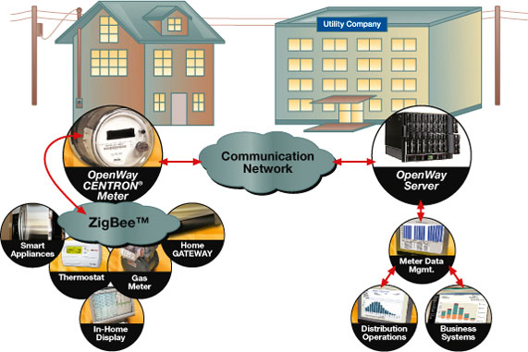

Figure 8.2.1.1 Itron OpenWay® Solution

8.2.2 Texas Instruments Smart Meters with Secure Pre-Payment
Smart electricity, water and gas meters are undergoing extensive development upgrades to ensure security. Additionally, a new revolution has surfaced for payment. A contactless radio frequency (RF) chip Transponder IC, the Secure Multi-Purpose Contactless IC/Module RF-HCT-WRC5-KP22, has been incorporated into the smart meter with a new capability for a consumer payment card or token. This idea is transforming smart meters into secure [7] AMI/AMR and pre-payment devices. The meters are built on high-speed, low-power, secure smart IC platform with industry-standard secure encryption. Several desirable features are included with the meters listed as follows.
- Triple DES, SHA-1 crypto-algorithms, ANSI X9.63 session key
- Mutual authentication – authorized tag and reader complete transaction
- Flexible and configurable memory
- Supports up to five applications on one card or token
- ISO/IEC 14443 with ISO/IEC 7816 command set support
Radio Frequency enabled pre-paid smart meters give utilities access to a broader customer base. RF enabled meters with Pre-Payment reduces the risk of non-payment and offers consumers a new, fast and convenient way to control and pay for services. Reduction in billing administration costs can be realized with this revolutionary new idea. Two models of the reader are available, the TRF7960 and TRF7961 TI-RFid™ HF Reader IC. Both offer the following features.
- High level of integration and performance
- Low-power and small size
- Configurable and flexible architecture
- Eases hardware and software system design
- Low total Bill of Materials (BOM)
- ISO/IEC 14443, ISO/IEC 15693 and Tag-it
Several advantages of Contactless RF Pre-Payment can be realized for consumers. Consumers can now control utility usage and not have utilities turned off unexpectedly. It is expected that consumers will embrace the convenience of “24/7 wave and pay as you go”. Major credit card companies and banks worldwide are deploying secure contactless technology. It is a fast and convenient “tap-and-go” credit, debit and stored-value payment application at the retail point of sale. The technology securely stores and transmits data over short ranges, typically less than 2 inches. Consumers need only purchase contactless cards from a kiosk or the utility company. The cards contain a secure contactless RF chip loaded with a pre-paid amount. The consumer waves the card in front of the meter to activate it and the amount is loaded into the smart meter and debited from the card. Texas Instruments offers a complete contactless RF pre-payment solution for Smart Meters, including tag and reader integrated circuits and microcontrollers. It is an easy and efficient solution to RF-enable the latest generation of smart utility meters.
8.2.3 MBUS3
On September 28, 2009 in Oslo, Norway, a new firmware feature set was introduced as MBUS3 to comply with the Open Metering System (OMS) Specification for advanced metering applications. It has been launched by the compact RF module provider Radiocrafts AS. The new firmware runs on the Wireless M-Bus module (RC1180-MBUS) for use in AMI/AMR applications. It is the first completely embedded module solution compliant with the new OMS specification available in the market in addition to the well established NTA 8130 compliant feature set (MBUS2).The OMS primary communication interface is based on the Wireless M-Bus standard (EN 13757-4:2005). It specifies the communication between a multi-utility communications (MUC) controller or gateway and electricity, gas, water and heat meters. The specification is becoming widely accepted in Europe. The new MBUS3 module can be configured for use as a master (in the MUC), a slave (in the meter or an actuator), or as a repeater. Several desired features are capable in the MBU3 set.
- supports S1, S2, T1 and T2 modes
- handles encryption (AES-128) all time critical communication between the MUC and the meter
- power saving features gives battery lifetimes in excess of 14 years
- master module can support up to 64 slaves, all with unique encryption keys
- unique auto-message generation feature
- message mailboxes supporting individual communication with several slaves in parallel
- repeater functionality makes up a complete and autonomous repeater that will store and retransmit slave messages in order to increase the coverage area of one master (MUC)
The new RC1180-MBUS3 is a surface-mounted high performance transceiver module measuring only 12.7 x 25.4 x 3.3 mm, and can easily be integrated into any meter. Serial communication is facilitated by a UART interface that is used for configuration. An antenna connects directly to the RF pin. When used with quarter-wave antennas a line-of-sight range of 800 m can be achieved. The new module supports two-way communication and is capable of valve control and data acknowledgement. The RC1180-MBUS module has been certified for operation under the European radio regulations for license-free use in the rapidly growing smart metering market. This solution provides a complete Wireless M-Bus solution compliant with the OMS specification in a small compact module form factor that is easy to integrate into meters and gateways. The Wireless M-Bus stack makes it easy to add a fully compliant OMS solution to space limited and battery operated meters. It significantly reduces time-to-market, development, and compliance testing cost.
9. Conclusion
As the utility power grid catches up to technology, several inherent problems surface that are apparently not as visible as most would think. The essential feature of every smart electricity distribution system is the smart meter though it may not look like much and does not at first glance appear like one of the most critical components. The problems arise from the cyber net infrastructure that introduces common vulnerabilities that have evolved from the Internet communication system and computer/network operating systems. While the power grid was using wired meters and control systems were isolated from the wireless and cyber systems, most of the problems being addressed today did not exist. Ever since the introduction of the Internet and wireless technology to the Smart Grid, security has become a critical concern for distribution and power engineers. The Committee of Homeland Security and various other regulatory agencies have heard recommendations from security consultants that have researched the problems and the devised solutions for the security vulnerabilities in wireless and cyber infrastructures.
Research performed by security consultants have proved that of the available smart meters are insufficient in security mechanisms to protect the smart grid from what are common Internet and Operating System vulnerabilities . The existing smart meters that have been deployed will need to “reworked” to meet the requirements for a secure smart meter.
The United States is one of the countries in the process of upgrading the power grid infrastructure. Many other countries have completed the upgrade of the Smart Grid. The identified vulnerabilities are of a critical concern to the Smart Grid distribution and electrical engineers and controllers. As with all new rollouts, there are always unidentified vulnerabilities that need attention. Many of the utilities that have subscribed to the stimulus plan sponsored by President Obama have taken advantage of the benefit of billions of dollars. As a result, Smart Meters have been installed but the majority of meters are riddled with vulnerabilities. In the effort to upgrade the Smart Grid, the vulnerabilities in the Smart Meters have basically been ignored, even though the stimulus benefit stipulates security measures should be enforced.
The need for regulation and management has never been greater. This is a worldwide undertaking and needs strict adherence to the Secure Development Lifecycle (SDL). Vendors need to ensure their Smart Metering products are secure. The process involves removing the memcpy() and strcpy() instructions in most of the meters. Also, authentication and encryption must be implemented in the Smart Meters and controllers. These are only a few of the numerous vulnerabilities that have been identified. All vulnerabilities will need to be resolved since many are well known common issues that have evolved from the Internet. Additionally, all new products need thorough testing before implementation and those existing meters in the field will need to be reworked or replaced to ensure that no Smart Meter can provide a vulnerability to potentially cripple a region of the Smart Grid, or in a worst case scenario, propagate a worm that can grow an alarming rate to cripple a all or a majority of the Smart Grid.
It is important to note that change is difficult to create and the acceptance of change for the most part is always resisted. With no real centralized command and control, policy makers are experiencing an extremely hard task to facilitate the change. Of the utmost concern is that correct policies for change must be agreed on quickly and any debate must be completed quickly. Any regulatory inconsistencies or uncertainty must be resolved if the Smart Grid is to come together as a cohesive unit with all the required security strategies in place. Impeding change is all the red tape of a democratic society that is riddled with politics chaired by politicians with different mentalities and ideas.
Planning together is the only way that the separate regions can gain the interoperability and scale up the infrastructure to secure the Smart Grid. The electric power grids face unprecedented challenges in the future. Not only do meters for the electric power grid need to be secure, but meters for the water and gas industry must also be included. They are a leaf node that is connected to the AMI infrastructure and must therefore ne protected. The same idea holds true for all renewable energy sources such as the wind farms that will be connected to the power grid.

ACKNOWLEDGEMENTS
I would like to take the opportunity to sincerely thank Dr, Edward Chow for the support, his tireless efforts, the valuable time he spends in consultation and the encouragement he provides to guide students through the challenging coursework at UCCS. His dedication to providing for students is greatly appreciated.

REFERENCES
[1] http://www.itron.com/pages/ news_press_individual.asp?id=itr_016976.xml
[2] http://loftyperch.com/index/use_lang/EN/page/408.html
[3] http://www.theregister.co.uk/ 2009/06/12/smart_grid_security_risks/
[4] http://earth2tech.files.wordpress.com/ 2009/10/sgigselections_category1.pdf
[5] http://www.ensec.org/index.php?option= com_content&view=article&id= 218:making-a-secure-smart-grid-a-reality&catid=100:issuecontent&Itemid=352
[6] http://www.metering.com/node/16162
[7] http://www.ti.com/rfid/shtml/apps-smartmetering.shtml

