Mobile Development
Cross Platform Development Techniques
CS526 – Advanced Internet & Web Systems
Adam Best

ABSTRACT

Mobile development is increasingly growing and expanding. More and more consumers want to own a device that has mobile capability. This ranges from iPods and Zunes, iPads and other tablets, and numerous phones including Windows, iPhone, and Android phones. More and more applications (apps) are added to the marketplace every day. These apps include functionality anywhere from a simple flashlight that uses the flash on your smart phone’s camera or an advanced game that becomes a top hit. Everyone wants a piece of the pie. Even young kids want to develop apps. The problem lies in making your app available across all of the marketplaces. An application that is built for a specific operating system such as iOS (Apple’s operating system), Android, or Windows Mobile will not function similarly the same on each specific device. Cross platform development faces many difficult paths. I plan to address what these difficulties are and how they could be addressed.

Introduction

Mobile development is growing beyond a few customers to a large majority of consumers. It has grown from mobile computers to iPods, to tablets, and to phones. Even televisions are consuming apps that mobile development has become so popular for. Mobile development has expanded in a sense that it no longer involves only games and a calculator. The mobile world now includes location based apps such as a GPS unit in your phone. This has even expanded into social networking apps, more advanced mobile games, as well as lifestyle apps like the mint.com app that helps you manage your finances. As more and more apps get uploaded more and more individuals attempt to create their own “unique” mobile application.
When an application is developed it requires modifications to be made to match the specific operating system. You run into scenarios now where a game comes out for Apple’s iOS such as Jetpack Joyride and Android users sit and wait for the game to be modified and re-released for the Android operating system. There are more and more techniques coming out that provide the ability to develop the functionality of an application in a single language and compile it to work in multiple operating systems.
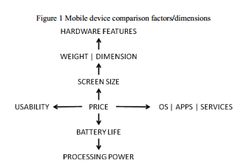
When a mobile device is designed they keep the consumers in mind. Many consumers request larger screens, faster processors, and longer lasting batteries. Figure 1 shows a comparison of the actors and dimensions for a mobile device.
Figure 1 - Mobile device comparison. [2]

Mobile Development Advancements

Mobile development has progress through history with some magnificent changes. A Smartphone is more capable than any ordinary phone based on its email client, internet browser, GPS functionality, and organization abilities. [5] GPS has significantly increased throughout the mobile phone’s functionality. It has caused a drop in standalone GPS sales because it is standard in all Smartphones and is predicted to be standard in all phones in the near future. Once the mobile network was provided it expanded pieces to include the email functionality. As time progressed it allowed consumers to reach out and access data on the internet and share information. Developers have even taken something as simple as a shopping list and now allow users to add on to a list dynamically while another user is at the store. There are even large corporations that use this functionality. Companies can now have a mobile network that will allow their sales people to go from one client site to another and fulfill orders on the go. They could even host an event outside of any network and still be able to fulfill the orders and process the credit card on the spot.
With this accessibility of the network on the go many users have found it to be an entertainment ready device. Users can connect to their favorite social networking sites and utilize the GPS feature to “Check In” to various locations to show their friends where they are at. Predictions are that future users will select their mobile device based on entertainment features such as the camera or a mobile game console and no longer demand the functionality of a phone primarily. [5]
As time has gone on, so has the development of mobile devices. Below is a sample timeline from Andrew Charlesworth’s article called “The Ascent of Smartphone.”[5]
In 1973 the first commercial mobile phone was launched by Motorola. This was then followed in 1979 with the first citywide cellular network. It was released by a Japanese Telecoms operator NTT. In 1981 the first generation of new mobile telephony service was launched in Denmark, Sweden, Finland, and Norway. Ten years later in 1991 the second generation of mobile telephony packet was released and a digital network was launched in Finland. Shortly after, 1993, Finland demonstrated the first short message service. In 1998 the first wireless application protocol standards brought web and internet services. One year later, 1999, Japan launched the first push email service. That same year, Research in Motion launched the first two-way pager device. In 2001 3G mobile was introduced to the consumers. In 2002 the early stages of Smartphones were created with Microsoft’s Pocket PC Operating system supporting mobile telephony. Finally in 2007 Android phones were released by The Open Handset Alliance and promised in depth integration of web services. [5]
We have further progressed from this timeline. 3G is closer upon becoming a standard mobile network. 4G has been introduced to consumers. Finally Android and Apple have further established the grounds of integrated web services into a mobile phone.

Mobile Development Challenges

Multiple operating systems provide a vast amount of difficulties that one must surpass in order for the application to be compatible across them all. Mobile development is similar to that of web development. It is built of similar components and can be handled through JavaScript. This supports the XMLHttpRequest-object method and this allows you to retrieve information from a web service in XML format. [1] Other challenges include a lack of standardization, multiple device modules, interface development, and connection challenges. [2]
The lack of standardization is spread across the multiple operating systems. Each contains their own code base and SDK. Each of these SDKs contains libraries, development tools, and emulators for their respective operating system. All of these are applied to a specific platform and code base. Examples of these are xCode for Apple’s operating system and C++ for Windows mobile. [2] Figure 2.1 – 2.5 show examples of the different languages and how the structures differ. These are further explained in Section III.

Multiple Operating Systems
In figure 2.1 you will see a sample of the Symbian OS code structure for a Hello World application. This operating system is designed for the Nokia Series 60. [2]
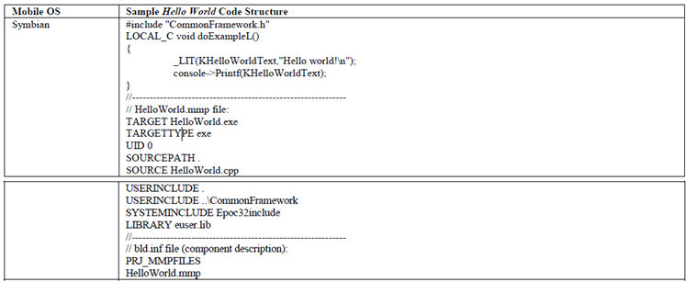
Figure 2.1 - Symbian Code Structure [2]
Symbian is defined by Cinque, Controneo, Kalbarczyk, and Iyer as the following.
“Symbian [8] is a light-weight operating system developed for mobile phones and carried out by several leading mobile phone’s manufacturers. The design of Symbian is based on a hard real-time, multithreaded microkernel. All system services are provided by server applications. Clients access servers using kernel supported message passing mechanisms.” [3]
In the Symbian OS there are threads and active objects. These two levels contribute to multitasking ability of Symbian. Threads are the lower level and operate on a time sharing system. There is an OS thread scheduler that handles these threads and the runs them based off of priority. Then there are active objects. These are the upper level tasks that are event driven and operated by the active scheduler.
In figure 2.2 you will see a similar example developed for the Windows Mobile operating system. 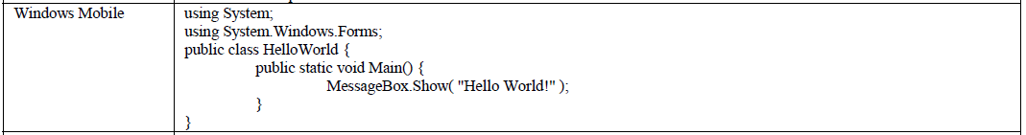
Figure 2.2 - Windows Mobile Structure [2]
Windows mobile is based on Windows CE. It has been used in devices such as the PDAs and Windows mobile phones. The Windows CE operating system (WinCE) has been referred to by Savoldi, Gubian, and Echizen as the following:
“A modular operating system that serves as the foundation of several classes of devices, which can be referred to as embedded devices.” [4]
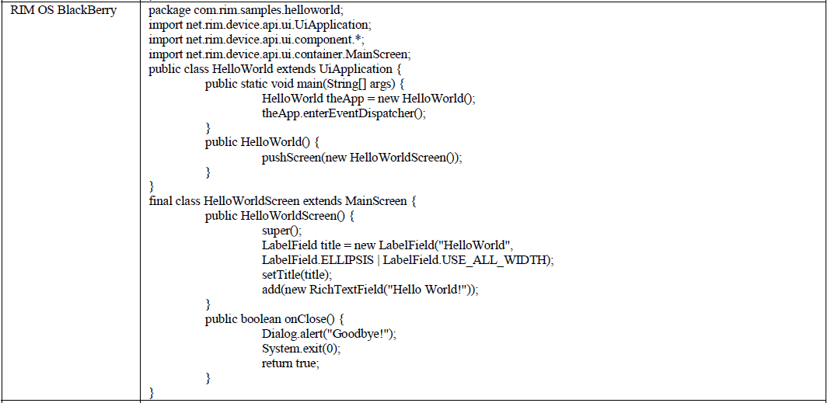
Figure 2.3 - RIM OS Structure [2]
RIM OS was one of the early players of the game. Back when the Smartphone and PDAs were beginning to make a difference RIM released the Blackberry 4270. This contained the functionality of a phone, PDA, and email in one. [5] The traditional consumer has since moved on from the Blackberry phones. Many of these devices are used in a business environment. Throughout time
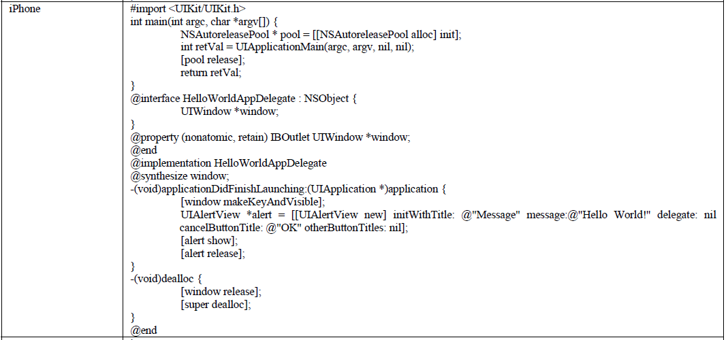
Figure 2.4 - Apple OS Structure [2]
Apple’s operating system (iOS) is one that took the tech world by storm. Apple has hit multiple top releases. It took over the entertainment technology when it introduced the iPods. Then it further progressed when it advanced into the iPod Touch. This set the mark for the iPhone. The iPhone is to this day one of the top selling smart phones. And finally, Apple came out with the iPad and setting a new standard for tablet devices. Apple is dominant in the way it handles their software distribution process. The way this process works is through Apple’s App store. [2] They set the standard where Google Play soon followed.
Figure 2.5 - Android OS Structure [2]
Google’s Android operating system soon followed in the Smartphone storm. When they released their Android it quickly became a contender for a top seller. They even had a similar style App store as Apple did. Where Android opened the doors was its open source code. This is greatly appealing to those looking to expand into the application development field.

Cross Platform Development Solutions

With all of these systems and their different application structures and code bases, businesses have been providing solutions to help new developers achieve a release to multiple platforms. In a search I have located a few companies that handle this type of development. They include RhoMobile, Appcelerator, WidgetPad, Phonegap, and MoSync. [6]
RhoMobile is a Ruby based framework. It provides you the ability to code in Ruby and compile your program into multiple operating systems. When you download RhoMobile you are provided with some sample applications that show you some base syntax and how to plug into Java development tooling.
Appcelerator currently allows a developer to build an application using the Java Syntax. This similarly compiles the application into the desired mobile operating system. It is currently working on expanding into allowing users to develop in PHP, Python, Ruby, and HTML.
WidgetPad allows development to be done in CSS3, HTML5, and Java. It includes project management, debugging, and source code editing. It is currently a Beta program.
PhoneGap made its name at Web 2.0 Expo San Francisco’s 2009 launch pad event. It won the winning pitch. This allows you to develop in Java and HTML. Where PhoneGap accelerate is in their offering of online training sessions.
MoSync is an eclipse based IDE that allows you to develop in C and C++. It as well is planning on adding support for Java, Ruby, PHP, and Python. Upon download of this system you are provided with a large amount of sample applications. These range anywhere from a “Hello World” application to a Facebook app demo. [6]
These applications provide a developer options to improve their chances of a fast paced, single development effort in order to release to multiple platforms. When choosing these platforms, there are some considerations to keep in mind. First the user must determine their area of expertise. If a user is more knowledgeable with C++ then MoSync could potentially be their best option. Another consideration is budget. If a developer is under budget constraints it is important to evaluate each and every option and determine if there are any hidden costs for the use of the product. Finally, what type of operating systems and devices are you shooting for? It is important to make sure that the tool you use will provide you with access to all of the operating systems as well as a device emulator in order to fully test and develop your program.

Conclusion

Throughout all of the progress Mobile Development has become, there are still so many channels left to be discovered. Further analysis on cross platform development of user interfaces can still be enhanced. Tools and techniques to establish a good foundation to handle the different devices and their functionality can still be accessed. The applications for mobile devices continue to grow. In this paper you have learned about a handful of the multiple operating systems. Sample code was provided in order to show the differences between the foundations of the operating systems. Finally potential solutions were shown in order to understand what types of possibilities are out there and how one might potentially enhance the existing cross platform mobile development.

References

- Bin Zhang; Tian-gang Xu; Wei Wang; Xia Jia; , "Research and implementation of cross-platform development of mobile widget," Communication Software and Networks (ICCSN), 2011 IEEE 3rd International Conference on , vol., no., pp.146-150, 27-29 May 2011
doi: 10.1109/ICCSN.2011.6014238
URL: http://ieeexplore.ieee.org/stamp/stamp.jsp?tp=&arnumber=6014238&isnumber=6013532
- Gasimov, A.; Chuan-Hoo Tan; Chee Wei Phang; Sutanto, J.; , "Visiting Mobile Application Development: What, How and Where," Mobile Business and 2010 Ninth Global Mobility Roundtable (ICMB-GMR), 2010 Ninth International Conference on , vol., no., pp.74-81, 13-15 June 2010
doi: 10.1109/ICMB-GMR.2010.20
URL: http://ieeexplore.ieee.org/stamp/stamp.jsp?tp=&arnumber=5494784&isnumber=5494761
- Cinque, M.; Cotroneo, D.; Kalbarczyk, Z.; Iyer, R.K.; , "How Do Mobile Phones Fail? A Failure Data Analysis of Symbian OS Smart Phones," Dependable Systems and Networks, 2007. DSN '07. 37th Annual IEEE/IFIP International Conference on , vol., no., pp.585-594, 25-28 June 2007
doi: 10.1109/DSN.2007.54
URL: http://ieeexplore.ieee.org/stamp/stamp.jsp?tp=&arnumber=4273009&isnumber=4272935
- Savoldi, A.; Gubian, P.; Echizen, I.; , "A Comparison between Windows Mobile and Symbian S60 Embedded Forensics," Intelligent Information Hiding and Multimedia Signal Processing, 2009. IIH-MSP '09. Fifth International Conference on , vol., no., pp.546-550, 12-14 Sept. 2009
doi: 10.1109/IIH-MSP.2009.314
URL: http://ieeexplore.ieee.org/stamp/stamp.jsp?tp=&arnumber=5337370&isnumber=5337075
- Charlesworth, A.; , "The ascent of smartphone," Engineering & Technology , vol.4, no.3, pp.32-33, 14-28 February 14 2009
URL: http://ieeexplore.ieee.org/stamp/stamp.jsp?tp=&arnumber=4913985&isnumber=4808094
- Odell, J.; “5 Cross-Platform Mobile Development Tools You Should Try”; URL: http://mashable.com/2010/08/11/cross-platform-mobile-development-tools/

