WiMAX 802.16 Study Through OPNET Modeler

Michael J. Menozzi
CS_526, Computer Science Department
University of Colorado at Colorado Springs
Colorado Springs, CO 80923
mmenozzi@uccs.edu

Abstract—Worldwide Interoperability for Microwave Access (WiMAX) is an emerging technology for use in the last-mile/first-mile solution for service providers to connect to residential customers and also portable and mobile Internet users. Research into this subject will be done through the use of exploring the practicality of using this technology in certain situations. To further expand on this study and provide a deep-dive analysis of this subject the tool OPNET Modeler will be used along with the WiMAX module.
Keywords-WiMAX, last-mile, first-mile, OPNET

Introduction
Worldwide Interoperability for Microwave Access (WiMAX) was formed in June 2001 by the WiMAX Forum which was established to provide continuity, interoperability and uniformity for the standard.
There are currently two types of WiMAX, fixed and mobile WiMAX. The latter is 802.16d is the earlier development of WiMAX with the mobile (802.16e) being the more advanced of the two. Mobile WiMAX has a much larger coverage area than fixed since it employs low gain-high portability Omni-directional antennas versus high gain-low portability uni-directional antenna [1].
The covereage area for a WiMAX network to provide broadband speeds is over 30 miles with a single base station. Of course this is a theoretical number, done in ideal conditions, with a 4-5 mile realistic value when dealing with no Line-of-Site (LOS), negligible attenuation and no real-time data being sent [1]. With LOS conditions, the coverage can go up to 10 miles [1].
Simplistically speaking a WiMAX network consists of two parts. They are a WiMAX tower and a WiMAX receiver. The WiMAX tower is similar in concept to a cell-phone tower where it can provide coverage to a very large area – in the neighborhood of 3,000 square miles [2]. The WiMAX receiver can be a small box or a PCMCIA card or could be built into the computer in a similar fashion that WiFi is incorporated. The WiMAX tower can connect directly to the Internet using a terrestrial connection or by way of a LOS microwave link.
WiMAX is definitely a technology that is coming into its own with 475 WiMAX networks deployed in 140 countries [1]. This establishes the fact the technology is not something that is a phenomenon or to be discarded as a fad that will not see full realization in the marketplace.

Components
With WiMAX you can essentially provide two types of service depending on the customer need. They are either non-line-of-sight, basically a WiFi type of service, or line-of-sight service, where the signal is received via a fixed dish antenna that points directly to the WiMAX tower [2]. One of the significant differences between these two solutions is the

frequency range. With the non-line-of-sight solution the frequency range is 2 GHz to 11 GHz (similar to WiFi) [2]. Using the lower frequencies allows the signal to conform to the environment around it without disruption. With the line-of-sight solution the frequency range is much higher, 66 GHz at the maximum, which provides a very strong signal, fewer errors and less interference.
 | 802.16-2004 (d) | 802.16e
Multiple Access Method | OFDM / OFDMA | S-OFDMA
Bandwidth Supported (MHz) | 1.75/3/3.5/5.5/7 (OFDM) 1.25/3.5/7/14/28 (OFDMA) | 1.25/2.5/5/10/20 1.75/3/3.5/5.5/7
Mobility /Handoff Support | No | Yes
Sleep Modes | No | Yes
Sounding Channel | No | Yes
Multicast /Broadcast Support | No | Yes
FTT Size | 256 (OFDM) | 128, 256, 512, 1024, 2048
As mentioned previously in regard to the maximum range for WiMAX, the maximum range can be achieved by using the LOS solution in optimal situations or conditions. Otherwise the range will be more in the 4-5 mile neighborhood.

Table 1, Comparison Chart, shows several key areas of comparison with 802.16d and 80216e. In regard to the access methods 802.16d uses Orthogonal Frequency Division Multiple Access (OFDMA) and Orthogonal Frequency Division Multiplexing (OFDM) while 802.16e uses Scalable Orthogonal Frequency Division Multiple Access (S-OFDMA). In regard to the Fast Fourier Transform (FFT), 802.16d does support 2048, but WiMAX has selected to specify OFDM with 256 FFT for the physical layer profile instead of OFDMA with 2048 FFT [4]. FFT is an efficient algorithm to compute the discrete Fourier transform (DFT) and its inverse [5]. For both OFDM and S-OFDMA, usable bandwidth is divided into a large number of smaller bandwidths that are mathematically orthogonal using FFT. Reconstruction of the band is performed by the inverse FFT [6]. These bands are referred to as subcarriers and are typically on the order of 10 kHz.
Table 1; Comparison Chart
The threat of WiMAX to other technologies is a very issue for WiFi providers, cable operators and the local phone services. This is because the WiMAX technology has the capability of providing Voice Over Internet Protocol (VoIP), cable television, and of course the internet. This means WiMAX providers can offer the “triple-play” package often offered by your local carriers. In this sense the technology is very viable to the everyday consumer. In the following picture you can see the illustration of what a consumer can expect in the near future where everything from broadband internet access, landline telephone, cable television and mobile data and phone services will all be done through WiMAX technology.
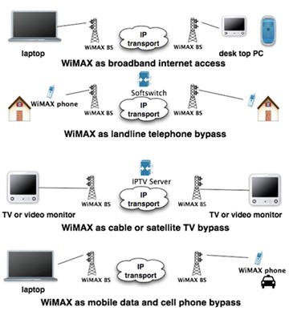
Figure 1, WiMAX Capability Overview [11]

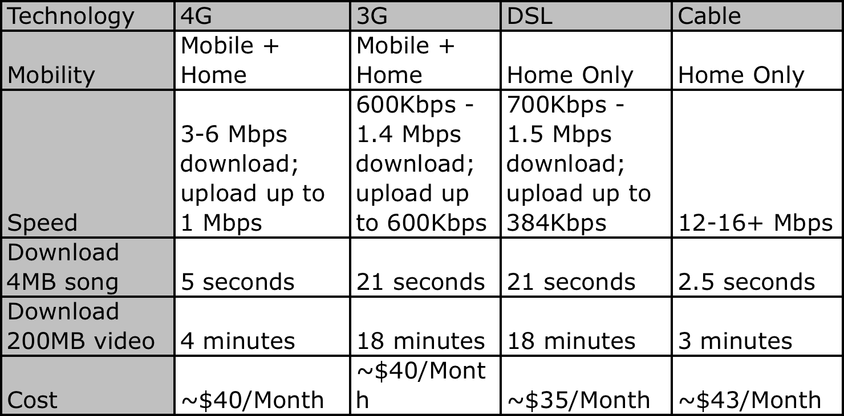
For example, Clearwire is a company offering WiMAX technology originally at the 3G range, but now it is launching 4G service in selected areas. Another example of WiMAX coming into its own, it will now be offered in the newly released iPad with 4G wireless speeds [7]. This will include the capability of creating on the go hotspots for up to eight users. Further, there are 30 different 4G-ready Intel® Centrino® Advanced-N + WiMAX 6250 embedded netbooks and notebooks from leading manufacturers [7].

As you can in the comparison chart of 4G service to 3G, DSL and cable, it is clear that 4G has some distinct advantages to DSL and even to a degree cable since 4G service via WiMAX has the mobility aspect and at very fast speeds [8]. Another interesting fact is the cost for 4G and 3G, which is about the same and awfully similar to the other services offered so if you want complete mobility and all of the other services, if WiMAX is available, that is undoubtedly your best option based upon this comparison. 3G is very close in all aspects to DSL to include cost, with 4G right behind Cable in speeds for the most part.

Colorado Springs Plan
Colorado Springs explored providing a citywide solution for Internet access via WiFi but decided in 2007 to wait for a more advanced wireless broadband network. The belief was that providing a citywide solution for WiFi at this time was not financially viable and the business case could not support the implementation since no vendor would engage in this endeavor without some aid from the city [9]. Finally it was announced in late 2009 that Clearwire would be offering WiMAX service in Colorado Springs to provide broadband Internet access beginning in late 2010. Of course this could be jeopardized by comments such as “This is good news, although I am surprised they are doing it so soon in a market the size of Colorado Springs,” as stated by Marshall Tuttle, a member of the city’s Telecommunications Policy Advisory Committee (TPAC) [10]. TPAC is supposed to be bring in services to the Springs, and hopefully not detracting from it; however, some of the committee members are cable and DSL providers so that would lend to the statements such as this since WiMAX does seriously impact the ability of other technologies to maintain an sudo monopoly on the market. This service can provide the “triple-play” benefit and offer an alternative to the local providers.
In a conversation with Wayne Heilman, a Gazette newpaper reporter, he relayed that by the end of the year Clear should be deploying their WiMAX solution. This is based upon the fact Clear has been posting legal documentation in the newspaper for their towers that will be installed in the city and it’s surroundings.

Antenna
There are three types of antennas for WiMAX. Omni-directional, Sector and Panel. The omni-directional antenna offers a broadcast of 360 degrees for a point-to-multipoint configuration useful if you have your subscribers located very near the base station since the range and signal strength is somewhat weakened by offering the capability of a 360 degree broadcast. The Sector antenna option allows coverage of approximately 60 degrees from the antenna. This configuration is much more focused than multi-directional, and also uses less energy and offers greater range and throughput. The Sector configuration can be used for a 360 degree coverage by using several Sector antennas and covering the same area or farther with a much more superior performance than multi-directional. Finally there is the Panel antennas that provide point-to-point application and are powered by Ethernet cable with a power source of Power over Ethernet (PoE). The following graphic shows all three types of antennas.
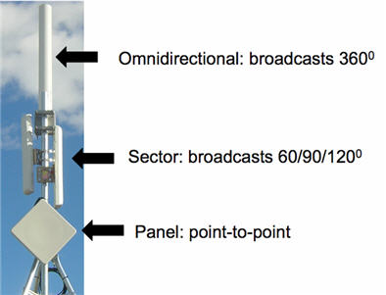
Figure 2, WiMAX Antennas [12]

The Experiment
This paper is going to explore a generic deployment of a WiMAX solution, apply some traffic to the model and produce some analysis products in order to demonstrate the initial capabilities of the OPNET in regard to WiMAX and the deployment of those types of solutions.
Due to some compile issues with the OPNET Modeler software I was not able to actually compile any traffic to run across my WiMAX network that I created which was somewhat the main focus of this research. Several attempts and many hours went into the troubleshooting with negative results.

Future Work
One of the areas that would require more future research would be in the area of IEEE 802.20, global area network (GAN) [2]. This technology would be similar to current cell phone capabilities in that it will be able to provide nationwide coverage for your mobile device and similar to your current cable provided network by providing speeds equivalent to the cable modem.

Summary

It was unfortunate that I was not able to route any traffic across the simulated WiMAX network which would have been good to have for simulation of how to apply WiMAX to Colorado Springs and the surrounding area. This will be something that I pursue this summer with the availability of the OPNET software

References
- http://www.techpluto.com/wimax-in-detail/
- http://computer.howstuffworks.com/wimax1.htm, page 1
- http://computer.howstuffworks.com/wimax1.htm, page 2
- http://www.motorola.com , WiMAX_E_vs._D__White_Paper.PDF
- http://en.wikipedia.org/wiki/FFT
- http://www.networksystemsdesignline.com/howto/199202160
- http://newsroom.clearwire.com/phoenix.zhtml?c=214419&p=irol-newsArticle&ID=1404906&highlight=
- http://www.clear.com/discover/compare-clear
- http://findarticles.com/p/articles/mi_qn4191/is_20070919/ai_n21036084/
- http://findarticles.com/p/articles/mi_qn4191/is_20091210/ai_n45771414/
- http://www.wimax.com/education/wimax/what_is_wimax
- http://www.wimax.com/education/wimax/antennas

