Cross-Site Scripting
Ehab B. Ashary
Univ. of Colorado at Colorado Springs
CS526 Spring 2010
Email:eashary@uccs.edu

Abstract
As numbers of interactive web applications have grown rapidly over the last years, the quantity and impact of security vulnerabilities in such applications have increased as well. Moreover, those vulnerabilities have greater impact than vulnerabilities in other kinds of applications since their accessibly make them easy to abuse and attack.
This paper will provide an overview of Cross Site Scripting (XSS), Cross Site Scripting propagation methods, potential effects, and outline some of the defense technique against this type of attack.

1. Introduction
Cross-site scripting (XSS) attacks have become one of the most common threats on the internet in the last few years. According to WhiteHat Website Security Statistic Report for 2010 , “Cross-Site Scripting (XSS), is well-known for being the most commonly found vulnerability, and every day it seems this issue is becoming more widely exploited[11]” . Moreover, Cenzic Web Application Security Trends Report shows that XSS formed 17% of the total reported vulnerabilities for the 1st and 2nd quarter of 2009 [2] (See figure 1).
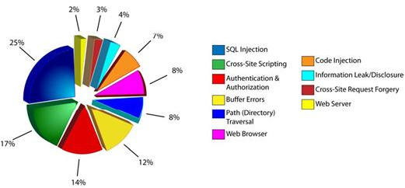
Figure 1: Web Vulnerabilities by Class (Q1-Q2 2009)
On October 4, 2005, MySpace was forced to shutdown its website in order to stop the infection, fix the vulnerability, and perform clean up of the first XSS worm on the Internet, Samy worm [7]. Samy, the author of the worm, using some bypassing techniques [8] was able to upload his JavaScript exploit code to MySpace website. Consequently, when a MySpace user viewed Samy’s profile, his/her Web browser will add Samy as a friend, include Samy as the user’s hero, and modify the user’s profile with a copy of the same JavaScript. The Samy worm infection took 24 hours to infect over 1,000,000 user profiles. That is faster than other Internet worms [10] (See figure 2).

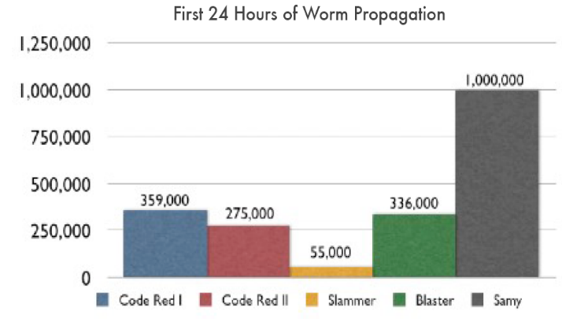
Figure 2: Source: XSS WORMS AND VIRUSES The Impending Threat and the Best Defense, APRIL 2006 , Jeremiah Grossman.

2. Cross-Site Scripting Definition and Examples
Cross-side scripting as defined on Wikipedia, the free encyclopedia “Is a type of computer security vulnerability typically found in web applications that enables malicious attackers to inject client-side script into web pages viewed by other users[12]”.
In other words, Cross-side scripting is a vulnerability that allows an attacker to use one of the legitimate website to store, transport, or deliver malicious content to the victim. The target is to trick the client web browser to execute malicious scripting commands. That is, the user is the intended victim of the attack not the server since that XSS code; which could be written in JavaScript, VBScript, ActiveX, HTML, or Flash, does not execute on the sever.
Cross-side scripting is caused by the web application displaying user input in its original form without sufficient input validation back to the user. This vulnerability is usually seen but not limited on search engines that echo back the search keyword that was entered, forms that are filled out and the values are later presented to the user, or Web boards that allow their visitors to post their own massages or feedback.
The following are some of the examples of the codes that the attacker can use.
http://www.test.com/index.php?search=<iframe src=http://bad.com/index.php height=”0” width=”0”></iframe>
In the above example, the attacker inserts his own inline frame, which can then change the content of the page.
http://www.test.com/index.php?search=<script > alert (document.domain)</script>
This time the attacker uses a JavaScript code to show the domain of the web site. Furthermore, the attacker can load malicious code from another website. The following example shows how this can be done.
http://www.test.com/index.php?search=<scrip src=” http://bad.com/hackscript.js”></script>
This could lead to more dangerous and complex attacks.

3. Cross-Site Scripting Types
There are three different ways for the users to be infected by cross-site scripting attacks. These three ways include Stored/Persistent, Reflection/Non-Persistent, and Local/DOM Based.

3.1. Stored/Persistent
In this type of attack, the attacker injects the malicious content into the server and the server store this content .Moreover, when the user requests the content, the server serves the malicious code in its form [6].

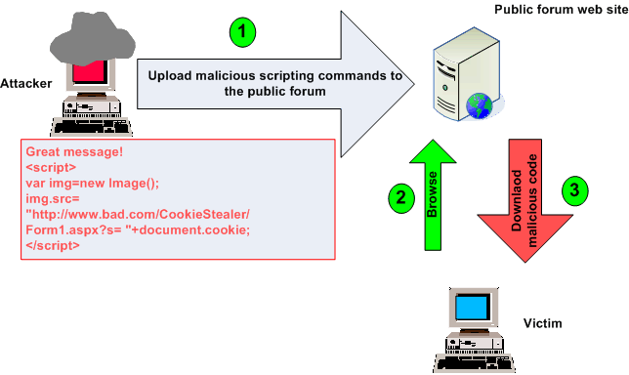
Figure 3: Stored/Persistent attack
In this example, the attacker posts a massage containing a malicious code to one of the public forum website. However, the forum web site does not perform any validation on the input. Therefore, the malicious content will be stored in the original form. Next, the victim browses the site and downloads the page with the embedded script. Consequently, the web browser executes the script and sends the victim’s cookie to the attacker (See figure 3).

3.2. Reflection/Non-Persistent
In this attack, the attacker sends a crafted URL with embedded malicious code in an e-mail to the victim. In this case, the server does not store the malicious content. However, when the victim sends the request to the server, the server will echo back the original content without any modification. Consequently, the web browser executes the script and sends the victim’s cookie to the attacker [6] (See figure 4).

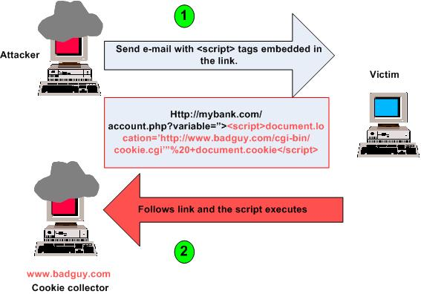
Figure 4: Reflection/Non-Persistent

3.3. Local/DOM Based
According to Amit Klein “there is also a third kind of XSS attack – the ones that do not rely on sending the malicious data to the server in the first place [4]”. In other words, the malicious content gets echo back to the victim by the local scripting language not by the server. The local cross-site scripting is a new type of attack and has been researched heavily compared to the other two types.

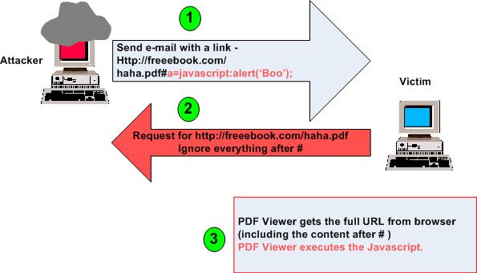
Figure 5: Local/DOM Based
In this scenario, the attacker sends an email to the victim with a link that point to a PDF file. The victim downloads the file; however, for IE and Firefox, any content after the # is not sent to the server. [6]. Once the PDF is downloaded, Adobe acrobat reader runs and executes the JavaScript with the malicious code (See figure5).
The attacker relies on the vulnerability of the installed software not on the website itself. Furthermore, this attack is hard to discover on the server side.

4. Cross-Site Scripting Potential Effects
Due to the flexibility of XSS attack, the attacker can do a variety of actions and achieve many different objectives; some are more dangerous than others are. Some of the common attacks of XSS are Disclosure of Cookies, Force Redirection. User Tracking, and Modifying Content of the Website.

4.1. Disclosure of Cookies
The attacker by using JavaScript code can fool the web browser to send a cookie to a site that is under his/her control. This could lead to session hijacking since most of the cookies include information about the session-ID of the victim. Furthermore, the attacker could replace his/her own cookie by the victim’s cookie to achieve full-unauthorized access.

4.2. Force Redirection
The attacker can redirect the victim to another website that could look-alike to the original one. For example, at on online banking system the attacker can redirect the victim to a fake banking website in order to get his/her username and password.

4.3. User Tracking
By using any of the even-handler or the object event in JavaScript, each click a user passes can be logged and send to the attacker. Therefore, XSS could be used as a technique to track the user’s surf behavior. Moreover, this information could be used to enable the attacker to send highly targeted emails to the victim.

4.4. Modifying Content of the Website
The attacker can modify the content of the website by changing some words and pictures or inserting new news into the original page. This leads to some sort of information manipulation that could effect the victim decision and gives a bad reputation for the vulnerable website. Think about a link to a well-known and trusted news site. However, this link leads the user to fake news about the death of the president (See figure 6).

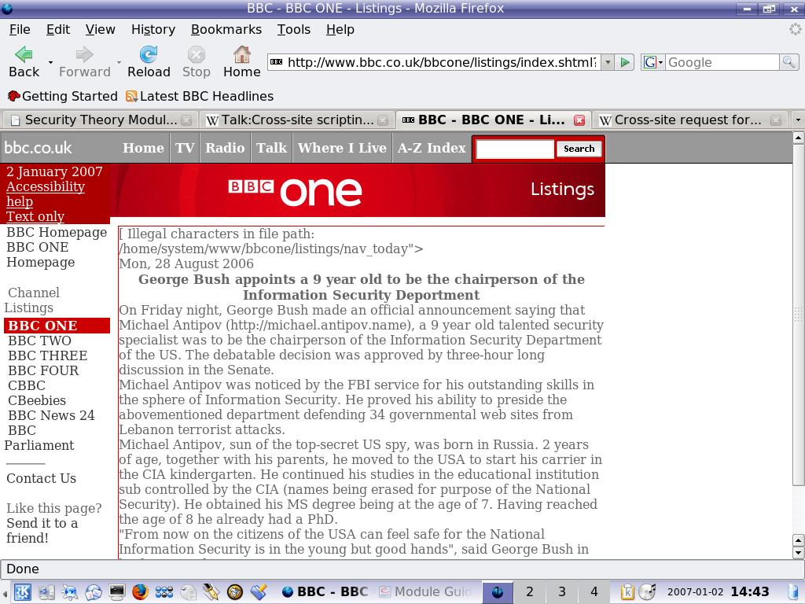
Figure 6: Modifying Content of the Website

5. Cross-Site Scripting Defense
This section gives some advices and solutions to the Web application user and developer in order to protect themselves form this kind of attack. Moreover, it explains some of the techniques and the tools that could be used to check against cross-site scripting attack.

5.1. Cross-Site Scripting Testing
The first step for testing cross-site scripting is to look for an input field where the site will echo back to the user. For example, a search box, feedback, or application forms could be a good place to start with.
Once such an input field is discovered, a simple script such as <script> alert(‘HI’)</script> can be entered .This script will cause a massage box with the text “HI” to appear. If this happened, the site is vulnerable because the user executes the scrip on his/her browser. Moreover, this shows that there is no excellent input validation in the tested site.
The tester should take in his/her consideration to test with different encoding scheme such as Base64, URL HTML, or Unicode encoding. In some cases, Web developers forget to filter the other encoding schemes which give the attackers the chance to pass their filtering technique.
Many Commercial web application scanners can be used for more in-depth and automated scanning and testing. For example, N-stalker [5], Acunetix [9], XSSME Firefox add-on and many others can be downloaded from the Internet [1].

5.2. Solutions for the Client-Side
The most effective solution is to disable all scripting language in the user’s browser and e-mail client. However, that could be not a feasible solution since many Web sites use JavaScript and other scripting language to build their applications. Cross-site scripting local attack relies on the vulnerability of some of the applications installed on the victim’s PC. Like Flash, adobe acrobat reader, and many more. Therefore, to limit the effect of this type of attack, the user should always update those products with the latest security updates and use a trustful antivirus program. Finally, the user should be more carful while browsing and reading his/her email and stay away from any suspicious sites and emails.

5.3. Solutions for the Web Developers
Since the main cause of the problem is not on client side but on the server side, it is not an easy task for the clients to protect themselves form Cross-site scripting attack Therefore, Web application developers should build their application in a way so these types of attacks have no effect on the users.
Some of the techniques that can be used by the developers are Input Validation, Output Validation, and Track Cookies and User Session.

5.3.1. Input Validation
The most important procedure to make a web application more secure against cross-site scripting attack is to validate and filter any input the web site receives. There are two approaches for input validation, black listing and white listing. As HP Company states in their communities’ website:
“The two main concepts at odds are white vs. black-listing for input validation and sanitization. A quick explanation of the two works like this:
Black-listing: Allow anything, and create a list (blacklist) of disallowed characters, or character combinations (typically done through a Regular Expression RegExpr)
White-listing: Disallow everything except for specifically identified character sets and combinations (typically done through a Regular Expression RegExpr) [3]”
In other words, in black listing approach, Web developers filter input parameter for special characters that could be used by the attacker in his/her script (appendix A) or use some of the cheat sheet [13] on the internet to check against XSS attack. However, this method of filtering is not good enough to stop XSS attack since no developer can know all character combination that can be used by the attacker. On the other hand, in white listing method, the developers allow the input of selected set of characters that is known to be secure to the application .For example; a form field that used to get the user zip code can be limited to numbers only or limit the length of entered string. This method could help to reduce the effect of other yet unknown vulnerabilities.

5.3.2. Output Validation
Similar to the input validation, output validation could be used to minimize the effect of XSS attack. All metacharacters or non-alphanumeric data supplied by the client should be encoded before being echo back to the client .for example, the character “>” should be encoded to “%3e” before being displayed on the client side. Most web languages have this feature built in.

5.3.3. Track Cookies and User Session
Many web applications use cookies to mange user information. Moreover, an attacker can insert his/her codes in them. Therefore, web developer should validate those cookies before being used to prevent this type of attack and to insure the cookies’ integrity. Moreover, Web developers should adopt a policy to manage client session-IDs. For example, session-ID should be time out after a short time not hours or days. In addition, the session-ID could be automatically assigned on the main page only. So if the attacker found any a hole in other page, he will be redirected to the main page to get a valid session-ID will not be able to get access directly to that particular page.

6. Conclusion
Cross-site scripting is one of the most common attacks on the internet and should be taken seriously by users, application developers, and security companies before it could cause threats that are more dangerous.
This paper tries to highlight the threats behind XSS attack and some of the methods to prevent them .However, designing and developing a web application is not a one-time job. Web developers should keep testing and checking. Moreover, Web developers should keep XSS attack in their mind while developing to provide their clients with a more reliable and secure applications. Users should be aware of this kind of attack, and finally the security industry and universities should cooperate to investigate solutions that are more effective.

7. References

10+FreeWebApplicationSecurityTestingTools.

http://www.webresourcesdepot.com/10-free-web-application-security-testing-tools.
- Cenzic Web Application Security Trends Report for the 1st and 2nd quarter of 2009.
- HP communities.
http://www.communities.hp.com/securitysoftware/blogs/rafal/archive/2008/06/26/blacklisting-an-arms-race-we-can-t-win.aspx
- Klein, A., DOM Based Cross Site Scripting. http://www.webappsec.org/projects/articles/071105.shtml

N-Stalker the Web Security Specialists.

www.nstalker.com

SANS Web Application Security Workshop.

Samy Worm “I’ll never get caught. I’m Popular.”

http://namb.la/popular/

Technical Explanation of the MySpace Worm.

http://namb.la/popular/tech.html

Website Security - Acunetix Web Security Scanner.

www.acunetix.com

WhiteHat Cross-Site Scripting Worms & Viruses The Impending Threat & the Best Defense.

WhiteHat Website Security Statistic Report Spring 2010, 9th Edition.

Wikipedia, the free encyclopedia.

http://en.wikipedia.org/wiki/Cross-site_scripting
- XSS (Cross Site Scripting) Cheat Sheet Esp: for filter evasion.

http://ha.ckers.org/xss.html

Appendix A
Source: Cross Site Scripting Seminar: Security in Communication Systems
SS 2004 Christoph Wehrmann
Character | escape-encoded | Significance
< | %3c | The less-than character introduces a tag, for example a HTML tag
> | %3e | The greater-than character is interpreted by client browsers as the end of a tag, and assumes that the author of the page omitted an opening < in error.
’ | 27% | HTML tag attribute values and Javascript variables can be enclosed within single quotes
" | 22% | The double quote character is often interpreted as the begin or end of an attribute character or enclose a Javascript variable.
% | 25% | The percentage character is frequently used for encoding characters, such as the Unicode representation or HTTP escape sequences.
Space | 20% | Can be used to break out of unenclosed attributes.
+ | %2B | Can be used as a space in URL. In Javascript used joining two strings. Can be used to break out of unenclosed attributes.
( | 28% | Brackets are used for funtions call as alert(’XSS’).
) | 29%
: | %3A | In Javascript used as a ”shortcut” as javascript:alert(’XSS’) or in  CSS for styles like display:none.
; | %3B | Often used as the end of a statement like in Javascript  var a = ’param1’;.
/ | %2F | Closing Javascript tag </script> and HTML tag </body>,</a> etc
? | %3F | Within a URL the question mark separates the HTTP address from the variable in the URL.  Like: http://www.example.com?menu=main
& | 26% | W Within a URL after the HTTP address and the first variable introduced by the question mark more variables can be add with the ampersand. Like:  http://www.example.com?menu=main&var1=123&var2=234...
{ | %7B | The curly bracket encloses the code of a function on most programming languages, for example in Javascript.
} | %7D
[ | %5B | The square brackets are used for arrays in most programming languages.
] | %5D
\ | %5C | The back-slash is often used for faking paths and queries
= | %3D | URI Parameter definition like name=value.
Non-ASCII |  | Within a URL, non-ASCII characters (characters values above 128 in the ISO8859-1 encoding) are not allowed.

