Semester Project
CS526
Spring 2009
Peter Torres
Tim Poley
SQL Injection

Abstract
SQL Injection is a code injection technique that exploits a security vulnerability at an applications database access layer. It can be used to steal, destroy, or alter an applications data and database tables. We will discuss how SQL Injection works, reviewing several real world instances as well as several examples created by the authors. Defensive techniques and trends will also be reviewed.
Section 1: What is SQL Injection?
SQL injection is an attack in which malicious code is inserted into strings that are later passed to an instance of a database for parsing and execution. Any procedure that constructs SQL statements should be reviewed for injection vulnerabilities because databases will execute all syntactically valid queries that it receives. Even parameterized data can be manipulated by a skilled and determined attacker. [2]
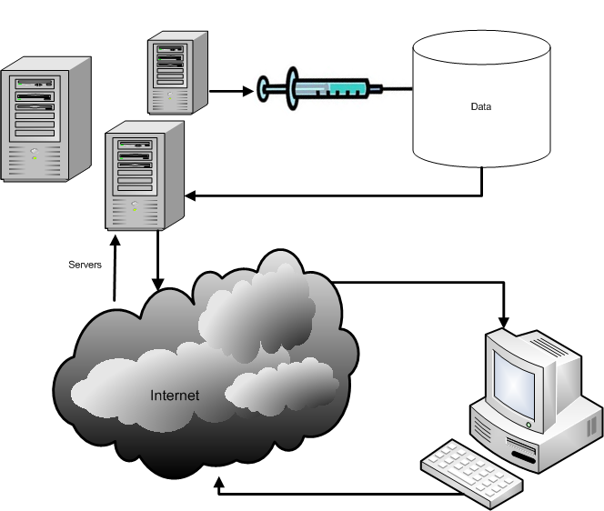
Figure 1. System Overview Diagram with SQL Injection
Section 2: Case Studies

Case Study: University of Southern California

July 2005, Eric McCarty used SQL injection to access data at the University of Southern California. Eric found the vulnerability in the web server and database server used to accept online applications from prospective students. He discovered that he could send commands directly to the database using the user name and password text boxes.
“It wasn’t that he could access the database and showed that it could be bypassed,” said Michael Zwieback, an assistant US Attorney for the US department of Justice’s cyber crime and intellectual property crimes section. “He went beyond that and gained additional information regarding personal records of the applicant. I you do that you are going to face, like he does, prosecution.”
McCarty could face up to 10 years in Federal prison. His initial appearance in US District court was on April 25, 2006.
“The vulnerability in USC’s online web application is a relatively common and well known software bug known as database injection or SQL injection. A lack of security checks on the user input allows a hostile user to submit a database command rather than a login name. The command could cause the database send its information back to the attacker or aid the attacker in compromising the computer system hosting the database.” [1]
Eric McCarty sent an email to Security Focus, a vendor neutral ,community driven web site that provides security information to millions of subscribers. “The flaw put at risk records containing personal information, including names, birth dates, addresses and social security numbers.” McCarty also wrote, “The authentication process can be bypassed, and you can find the information for any student who has filled out an application online. From there you can view or change profile information, (and get) the persons user name and password combo. Entire tables can be exposed, remote command execution, you name it. Basically, they are owned.” Security Focus, contacted the University of Southern California once they received the email. Security Focus said they were working closely with USC on this issue.
Case Study: The U.N. vs. SQL Injection
On the twelfth of August, 2007, the United Nations was given a brief lesson on SQL Injections. This attack was not malicious in nature. No precious data was destroyed or stolen. It was simply public defacement, the online equivalent of tagging. What makes this case interesting is that it demonstrates how your own system can be used against you, and how even the system of an international body, like the United Nations, which most people would assume is fairly secure, can be compromised by simple mistakes.
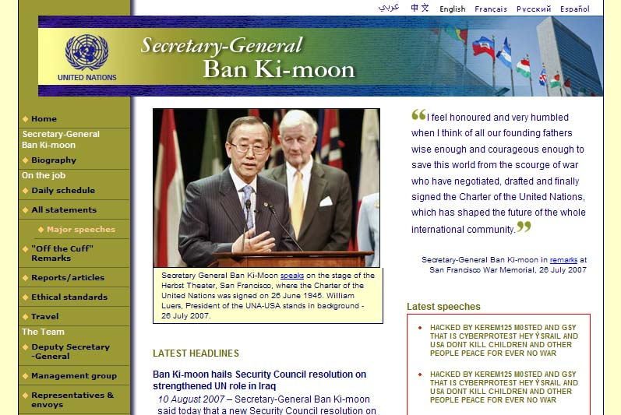
Figure 2. United Nations Website after being defaced using SQL Injection[4]
In this particular incident, the section of the website which was supposed to display the speeches of Secretary-General Ban Ki-moon, as well as several other pages on the site, was replaced by a political message from the hackers reading “HACKED BY KEREM1125 M0STED AND GSY THAT IS CYBERPROTEST HEY YSRAIL AND USA DON’T KILL CHILDREN AND OTHER PEOPLE PEACE FOR EVER NO WAR”. These hackers used sql injections to insert their message into the UN database, causing it to appear at this and many other locations across the U.N. website.
Section 3: Mechanics
Typical web application. User types his user and name and password and hits the submit button.
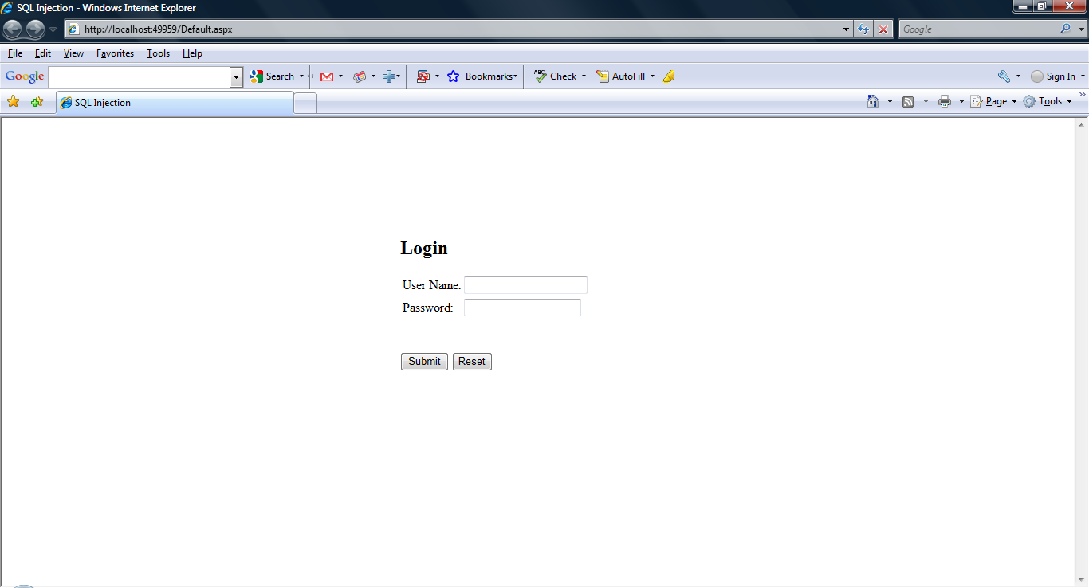
Figure 3. Typical User Login Page

After hitting the submit button, the user has access.
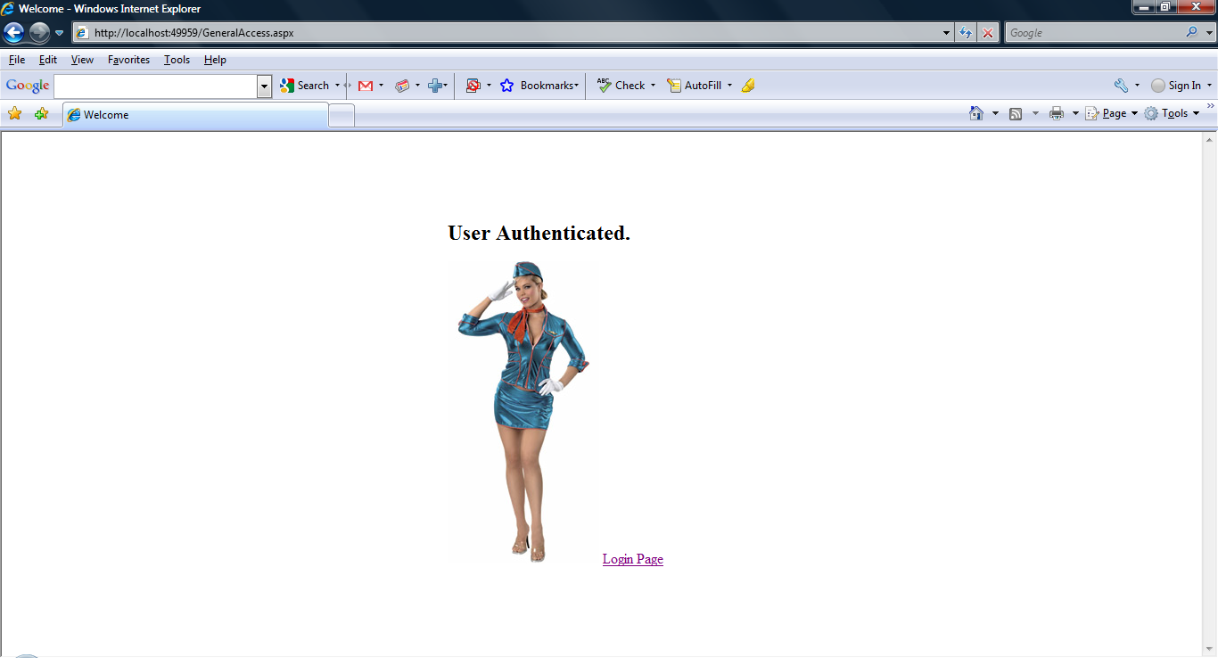
Figure 4. System response from a successful login

Vulnerablities exploited: Inadequate constraints for query parameters.
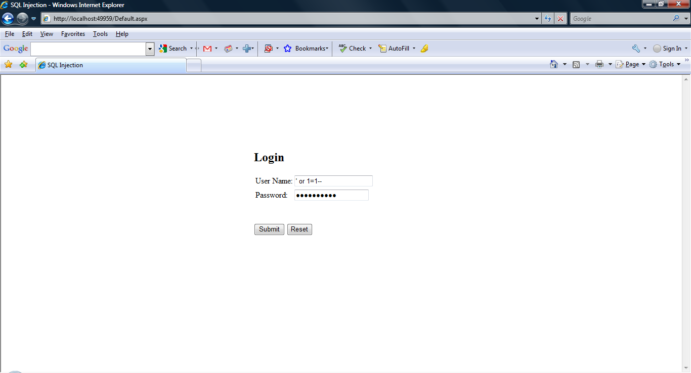
Figure 5. Single Quote trick entered into login page
The single quote trick is a well known, simple, and easy way to gain access to a vulnerable site.
Flawed code (C#):
public static DataTable get(string UserName, string Password)
{
SqlDataAdapter oAdapter = null;
DataTable dt = new DataTable();

try
{
DataAccessType dat = new DataAccessType();

SqlCommand oCmd = new SqlCommand();
oCmd.CommandText = "Select loginId,
UserName,Password
From dbo.logins
where UserName = " + "'" + UserName + "' and Password = '" + Password + "'";
//execute request
oAdapter = dat.ExecuteDataSetRequest(oCmd);

//test
if (oAdapter != null)
{
oAdapter.Fill(dt);
}
}
catch (SqlException sqex)
{
throw new Exception(sqex.GetBaseException().ToString());
}
//output
return dt;
}
When we look closely at the Get method, we see it has 2 string input parameters called Username and Password. These variables get sent back to the database via an instance of the SQLCommand object called, oCmd. The contents of the variables will be embedded into the command text property of the oCmd instance. The command text property will be evaluated by the database engine as a data request. If it is syntactically correct, the database engine will execute the command.
According to plan:

get(UserName,Password)
oCmd.CommandText = "Select loginId,
UserName,Password
From dbo.logins
where UserName = " + "'" + UserName + "' and Password = '" + Password + "'";

This what the Database engine will evaluate:

Select loginId, UserName, Password
From dbo.logins
Where UserName = ‘UserName’ and Password = ‘Password’

The database will return a record that meets the conditions set in the where clause.

Not According to plan:

get(‘ or 1=1--,‘ or 1=1--)
oCmd.CommandText = "Select loginId,
UserName,Password
From dbo.logins
where UserName = " + "'" + ‘ or 1=1-- + "'
and Password = '" + ‘ or 1=1--, + "'";

This what the Database engine will evaluate:

Select loginId, UserName, Password
From dbo.logins
Where UserName = ‘’ or 1=1-- and Password = ‘’or 1=1--‘

The database will return ALL records in the table!
Why? The empty quote string will result in a empty set but the or statement tells the database engine to evaluate the next part to see if it is true. If it is true use that logic to see if we find a match. In this case, one will allways equal to one. Thus returning all values in the table. The 2 dashes tell the database engine to disregard all characters after the 1=1.

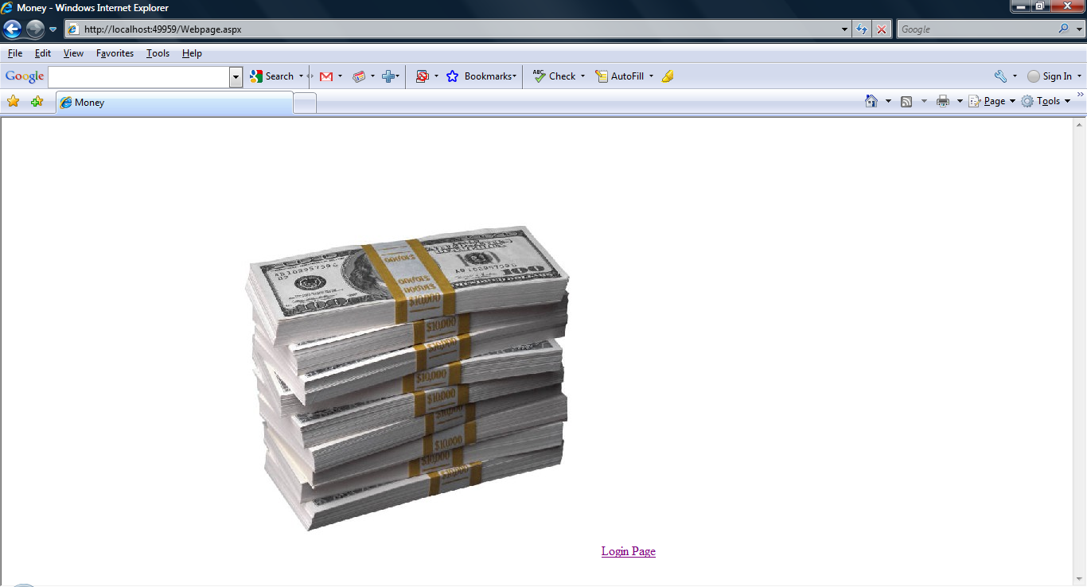
Figure 6. Unintended Access

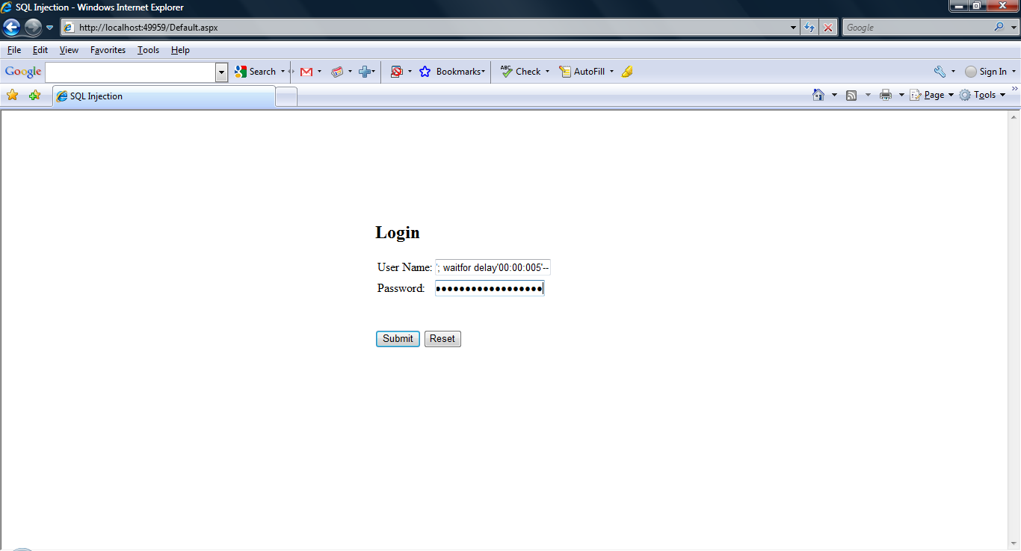
Figure 7. Attack and destroy
First step is to establish communication with the database.
‘; waitfor delay ’00:00:05’—
The above command asks the database to “respond if you can hear me.” If you can wait 5 seconds before sending an error message.

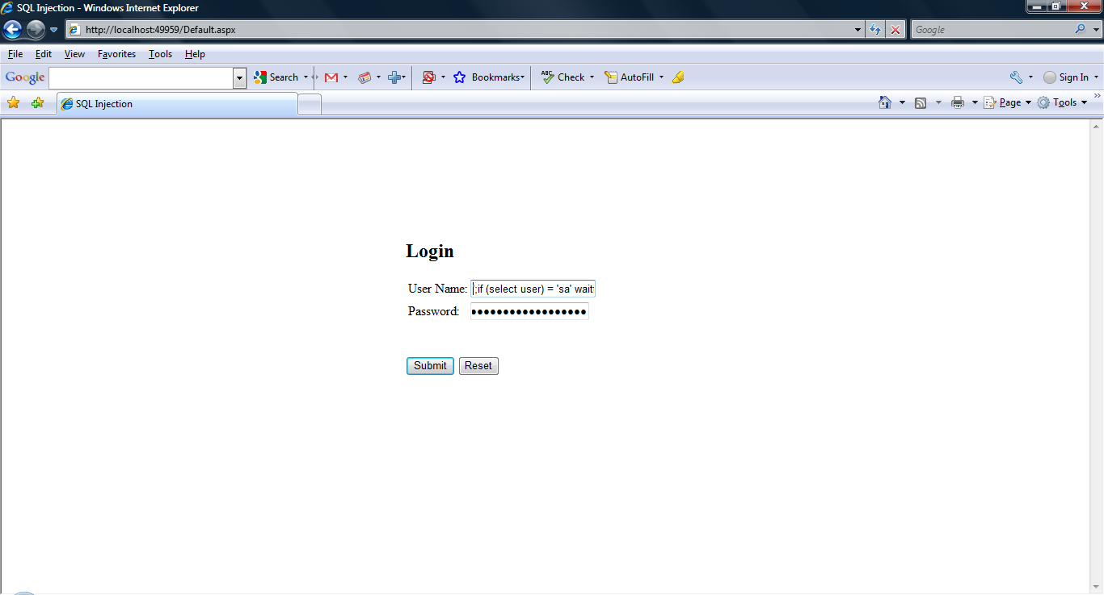
Figure 8. Discovering user permissions for common account name sa
Ask the database, what kind of rights do I have? If this was a blog where I could see my results in a text box or label, I could ask different questions. However this page only has input controls, so I can only ask yes or no questions.
'; if (select user) = 'sa' waitfor delay '00:00:05'—
I am saying: if I have system administrator rights, wait 5 seconds before showing me an error message.
In this case, the database responded in less than 5 seconds, so, I don’t have systems administrator rights.

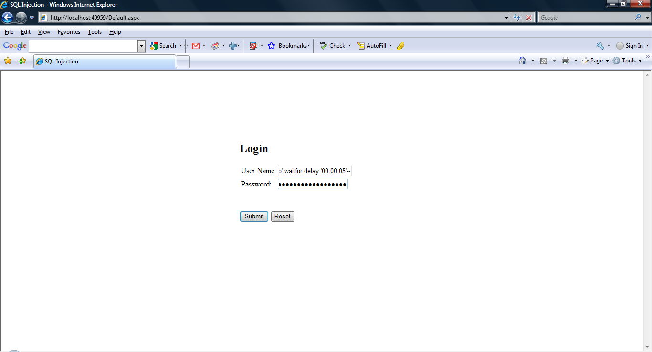
Figure 9. Discovering user permissions for common account name dbo
My next question to the database is, do I have database owner permissions? If yes, wait 5 seconds before sending me an error message.
'; if (select user) = 'dbo' waitfor delay '00:00:05'—
This time the database responded in 5 seconds. I am using an account with database owner permissions. Time for some fun….
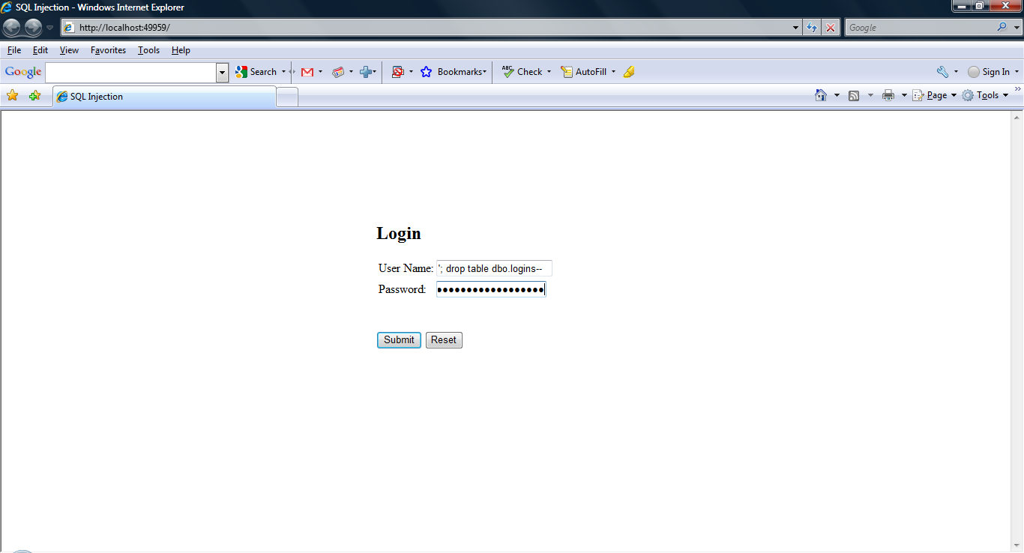
Figure 10. Destroying a system table with SQL Injection
In this screen shot we send in the following command:
‘; drop table dbo.logins—
The above command drops the login table in the database owner schema.

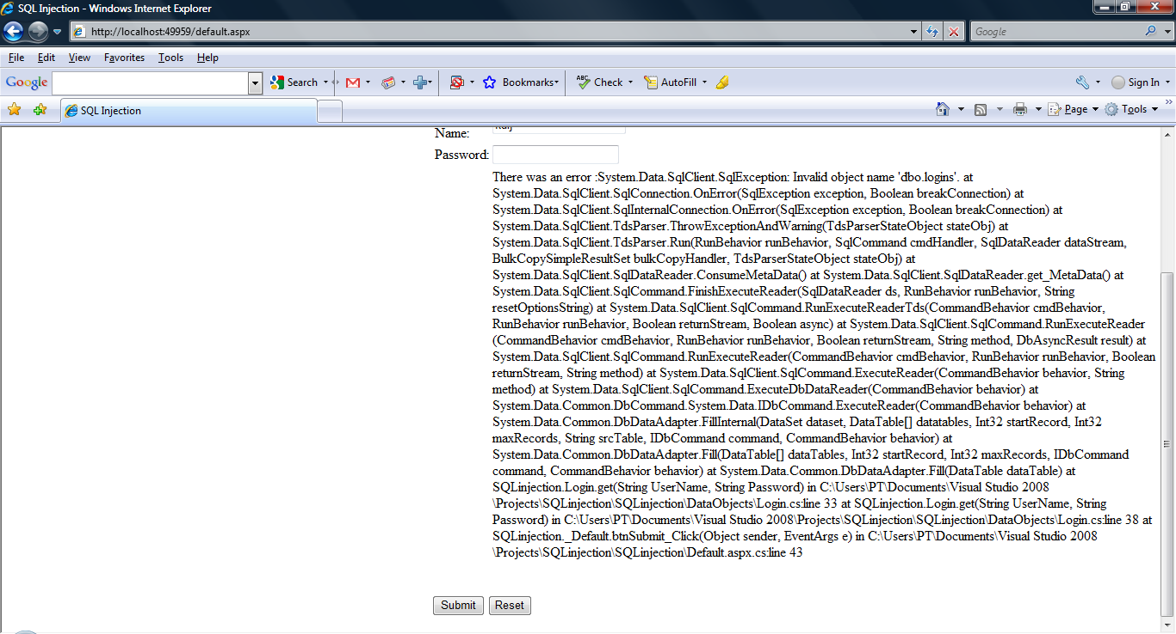
Figure 11. Login attempt after logins table is lost
Here we have a user try to login. The error message basically says, cannot execute the login because the table does not exist.
Create script. The create script was used to simulate the database and user logins.
use SecurityDemo
go

/*
* This script is used to create the objects to simulate SQL injection
* Created By Peter Torres
* April 28, 2009
*/

--drop the table if it exists
if(OBJECT_ID('logins','U')is not null)
drop table [dbo].[logins]
go

--create the login table
create table [dbo].[logins]
(
[loginID] int identity(1,1)
constraint pk_loginID primary key(LoginID),
[UserName] varchar(50),
[Password] varchar(50)
)
go

--add some mock data
insert into [dbo].[logins]
(
[UserName],
[Password]
)
select 'Admin','Admin1'
union select 'Me','Me2'
go

Section 4: Trends and Defensive Techniques
Type Checking and Escaping Special Characters – Most sql injection attacks can be solved by simply checking the data entered by the user. Escaping special characters, like ; or ‘, can prevent an attacker from adding additional statements or conditions. Type checking the data is also an important preventative measure. When expecting a number, or data with size limitations, ensure that data matches that type before sending it to the database.
Password and Key Hashing – Some database systems save keys and passwords as hashed values to maintain some data security, even if the entire database where to fall into the wrong hands. This makes it necessary to send data thru a hashing algorithm before sending it to the database, thereby removing the ability to send malicious commands to the database.
Error Suppression – An effective SQL Injection attack requires some structural knowledge about the database that the attacker is attempting to manipulate. This is why Insider attacks often use this technique, since the attacker is someone from inside the company or institution and has the necessary knowledge to manipulate the system. So how do hackers from the outside pull off sql injection? Simple, they read the error messages. Hackers will typically probe a system w/ various statements, not to implement a particular effect, but to simply see what kind of a feedback they get from the system. A well designed system will simply inform a user that they’re attempt failed, and please try again. However, a poorly designed system will return error messages, from server side code or perhaps the database itself. While this information is useful to system developers and debuggers, a hacker not only learns that the system is vulnerable to sql injection, but information about that database. This can included table names which can then be used to make more effective attacks, or database type and version, which can be used lookup and exploit known weaknesses. Giorgio Maone, a blogger writing about the U.N. incident, showed the U.N.s vulnerabilities by posting this response he got with a simple probe:
ADODB.Recordset.1 error '80004005'
SQLState: 37000
Native Error Code: 8180
SQLState: 37000
Native Error Code: 170
[MERANT][ODBC SQL Server Driver][SQL Server]Line 1: Incorrect syntax near ''.
[MERANT][ODBC SQL Server Driver][SQL Server]Statement(s) could not be prepared.
/apps/news/infocus/sgspeeches/statments_full.asp, line 28 [4]
By feeding the system a simple double quote, we already know that the U.N. is using SQL Server.
Parameterized/Prepared Statements – Parameterized statements can be used that work with parameters (sometimes called placeholders or bind variables) instead of embedding user input in the statement. [5] For example, the java JDBC api provides a PreparedStatement class. When you prepare a statement w/ a parameterized sql command, for example “SELECT * FROM users WHERE id = ?”, the database already parses the sql and prepares a query plan. The code may set the parameter and run the command as many times as it wants, with the added efficiency of the database already having a query plan built. In addition, since the database already has a query plan, that plan cannot be altered. As a result, injecting additional commands into the parameter will cause an error. [6]
Combinational Approach – Three techniques can be combined to effectively combat SQL injection: intrusion prevention (IPS), query level access control (see Excessive Privilege Abuse), and event correlation. IPS can identify vulnerable stored procedures or SQL injection strings. However, IPS alone is not reliable since SQL injection strings are prone to false positives. Security managers who rely on IPS alone would be bombarded with “possible” SQL injection alerts. However, by correlating a SQL injection signature with another violation such as a query-level access control violation, a real attack can be identified with extreme accuracy. It’s unlikely that a SQL injection signature and another violation would appear in the same request during normal business operation. [3]

Section 5: Conclusion
SQL Injection is a technique used by hackers to inject malicious sql commands into a systems database. It can be used by malicious hackers to steal or destroy valuable data, disable a system, and deface websites. A variety of sql injection techniques exist, each with a different goal. These include viewing more data than the system designer intended to return, alter database tables, and probing for vulnerabilities and view user access information. However, a variety of simple techiniques, including type checking and prepared statements, can be used to successfully defend against these attacks.

References
- Security Focus – “Man charged with accessing USC student data”, http://www.securityfocus.com/brief/191
- MSDN SQL Server Developer Center – SQL Injection, http://msdn.microsoft.com/en-us/library/ms161953.aspx
- Top Ten Database Security Threats, by Amichai Shulman
- Hackademix.net – “United Nations VS SQL Injection”, http://hackademix.net/2007/08/12/united-nations-vs-sql-injections/
- Wikipedia – SQL Injection, http://en.wikipedia.org/wiki/Sql_injection
- Database Programming with JDBC and Java 2nd Edition; George Reese, O’Reilly

