Abstract— A Zigbee network based wireless heart rate monitoring system for the premature babies who are under the constant monitoring system of hospital is discussed in this paper. The main focus of this project is to study the existing heart monitoring systems in different physical situations, search the feasibility for wireless heart monitoring systems for premature babies in the hospital and then develop an unconstrained monitoring system that can monitor babies' heart rates continuously so that it gives the medical staff an early warning in real time if necessary. The system consists of the Zigbee transmitters in each room of the hospital where the babies are kept and a central receiver in the central monitoring system (CMS) and they are linked via zigbee network and Ethernet LAN.
A ZigBee Network based Heart Rate Monitoring System for Pre-Mature babies
Archana Sapkota, Deepti Reddy, Palden Lama

Index Terms—ZigBee, Remote Monitoring, Wireless Sensor Network.

INTRODUCTION
It is crucial to keep a close look on the development of premature baby. Every year, in the United States, up to 1,300 babies are born prematurely and most of these babies are going to spend weeks or even months in the neonatal intensive care unit (NICU). The baby needs to receive special care in the NICU before he/she is able to go home. Some times, the babies may have to be kept in the incubator, nourished intravenously and placed on oxygen. Blood pressure, breathing levels, heart rate and also oxygen levels need to be observed closely. Currently most hospitals use ECG (Electrocardiography) for monitoring a baby’s heart rate. However, a reliable remote monitoring system is usually absent. Our project proposes a solution to upgrade existing health monitoring systems in hospitals by providing remote monitoring capability. This solution may be applicable to any kind of patients apart from pre-mature babies. For example, monitoring the vital information such as heart rate, blood pressure, etc of the inmates of an old age home could be a potential application.

In this project, we develop a heart rate monitoring system for the babies who are kept in the incubators in different rooms. The system will allow hospital personnel to remotely monitor the heart rate from the center monitoring system so that a baby can be given immediate assistance in case her/his heart rate falls or goes beyond limit. Wireless devices collect the heart

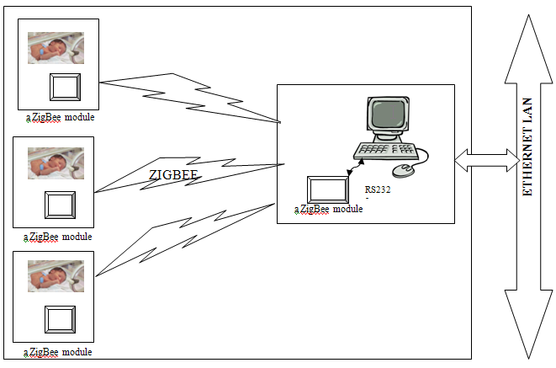
Fig 1 ZigBee network in an incubator room.

rate information for babies kept in various incubators and transmit the heart rate information to the central wireless device which is kept in the incubator/hospital room through the wireless communication network. The central wireless device then sends the information to the central monitoring room over LAN. The central monitoring system along with the central wireless device in each incubator room is connected to the same LAN.

Fig 1 illustrates a ZigBee protocol based wireless sensor network of nodes which measures the heart rate of pre-mature babies inside incubators. The information sensed by each
ZigBee node is sent periodically to a ZigBee coordinator device in the same incubator room. The ZigBee coordinator is responsible for initiating the ZigBee network and collecting heart-rate information from each sensor nodes. The coordinator sends the collected information to a computer through RS 232 serial communication. A software running on the computer parses the information and passes on the data to a central monitoring system through LAN. The software maps the unique device ID of ZigBee sensor nodes to various incubators placed in the room. Fig 2 shows a LAN based remote monitoring architecture, in which each incubator room has a ZigBee based wireless sensor network.

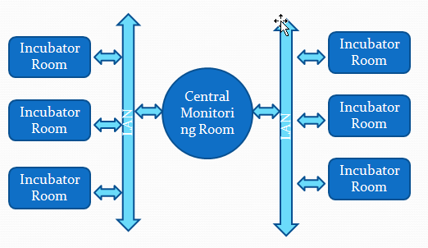
Fig 2 Remote monitoring architecture

The structure of this report is as follows. Section 2 reviews related work. Section 3 briefly presents a case for using ZigBee based sensor network as opposed to other wireless protocols. Section 4 provides some background information on ZigBee technology. Section 5 describes reliability and fails safe measures. Section 6 shows experimental setup and results. Section 7 concludes the paper with remarks on future work.

RELATED WORK
T.W..Nam et al.[1] developed a wireless heart rate monitoring system for rehabilitation patients who are taking physical therapy inside a rehabilitation center. a monitoring system that can monitor patients’ heart rates so that it gives physical therapist early warning if necessary. The whole system consists of the patient’s side device (PSD) and central monitoring system (CMS). The PSD was designed to be wearable and low power consumption. The CMS was designed to monitor multiple patients simultaneously and generate a warning signal if necessary. They used the RF module based on the Nextronics's NEXAR_3A (receiver) and NEX-AT-3A (transmitter) for communication between PSD and CMS. Then the information was passed to the PC though RS-232C interface. The communication speed was found to be slow. Junho Park et al. [2] also proposed the similar approach replacing the wireless network with Zigbee. Jovanov et al. [3] developed a Wireless Body Area Network of Intelligent Sensors for Patient Monitoring using standard ZigBee compliant radio and a common set of physiological, kinetic, and environmental sensors.

WHY ZIGBEE?
We conducted a survey of various wireless technologies available today. Zigbee technology clearly has a lot of advantages over other wireless technologies. Some of the key advantages of ZigBee include the following
- Low power consumption
- Low cost
- High density of nodes in any network. Zigbee uses the IEEE 802.15.4 PHY MAC and networks can handle any number of devices.
- Zigbees protocol stack is very simple. Zigbees protocol stack is estimated to be 1/4th the size of blue tooth’s stack.
- Dual PHY (2.4GHz and 868/915 MHz)
- Data rates - 250 kbps (@2.4 GHz), 40 kbps (@ 915 MHz), and 20 kbps (@868 MHz)
- CSMA-CA channel access
- Uses 64 bit IEEE address which creates an address space for 18,450,000,000,000,000,000 devices. It supports up to 65,535 networks
- Flexible range between 5- 500m
- Supports periodic, intermittent and repetitive data
- AES encryption for security
- Rapid leaving and joining of the network by devices. In the order of milliseconds. Joining takes places in less than 30ms.
A survey of heart rate monitors available in market is shown in TABLE 1. Most of these products use Bluetooth technology. They are costly and only few of these products have the capability of providing remote monitoring. TABLE II shows a comparison of various features of ZigBee with other wireless technologies.

TABLE I
HEART RATE MONITORS IN MARKET

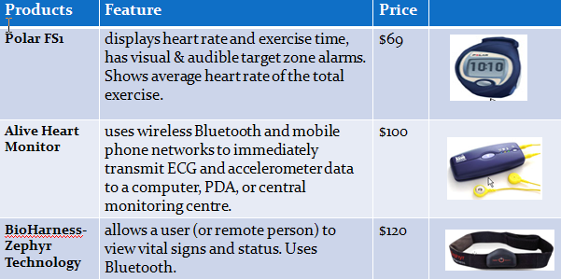

TABLE II
COMPARING ZIGBEE WITH OTHERS

Features | IEEE 802.11b | Bluetooth | ZigBee
Power Profile | Hours | Days | Years
Complexity | Very Complex | Complex | Simple
Ndes/Master | 32 | 7 | 64000
Latency | Enumeration up to 3 seconds | Enumeration up to 10 seconds | Enumeration 30ms
Range | 100m | 10m | 70m-300m
Extendibility | Roaming possible | No | Yes
Data Rate | 11Mbps | 1Mbps | 250Kbps usually
Security | Authentication Service Set (SSID) | 64 bit, 128 bit | 128 bit AES

Since most heart rate monitoring products in market use Bluetooth technology, we conducted an extensive comparison between Bluetooth and ZigBee in the following subsections.

Battery Drain
Packet length can affect battery drain. Typically the shorter the packet the quicker the device can go to sleep. Bluetooth is a slotted protocol. Communication can occur in either: 625 µS, 1875 µS, or 3125 µS slots. The following graph in Fig 3 showing effective data rate was based upon the transmissions speeds stated in Bluetooth v1.1 and IEEE 802.15.4 draft 18, using the 250 kb/s rate. The general trend is that at larger packet sizes the effective data rate approaches the raw data rate. The peaks for the Bluetooth rate are a result of the three slot sizes, when a packet becomes too big for one slot it must increment to the next slot even though it doesn’t fill the whole slot allocation. IEEE 802.15.4 was designed for small packets so it is no surprise it is more efficient at those small packets resulting in a higher effective rate despite its lower raw data rate. From this graph we can see that for packets less than 75 bytes ZigBee has a higher effective data rate than Bluetooth. Having a lower rate for small packets means that BT needs longer transmit and receive times and therefore current drain is higher for small data packets. Although these numbers do not represent retransmissions or multiple devices requesting the bandwidth; the same traits will probably be exhibited in these other cases.

Timing Considerations
ZigBee
• New slave enumeration = 30ms typically
• Sleeping slave changing to active = 15ms typically
• Active slave channel access time = 15ms typically
Bluetooth
• New slave enumeration = >3s, typically 20s
• Sleeping slave changing to active = 3s typically
• Active slave channel access time = 2ms typically

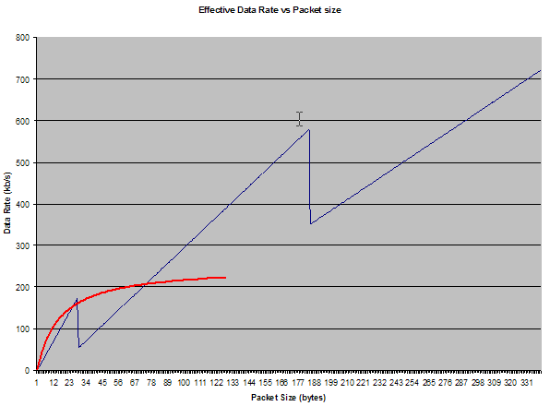
Fig 3. Effective Data Rate Vs Packet Size

ZigBee devices can quickly attach, exchange information, detach, and then go to deep sleep to achieve a very long battery life. Bluetooth devices require about ~100X the energy for this operation.

Power Considerations
ZigBee
– 2+ years from ‘normal’ batteries
– Designed to optimize slave power requirements

Bluetooth
– Power model as a mobile phone (regular daily charging)
– Designed to maximize ad-hoc functionality

ZigBee and Bluetooth are two solutions for two different application areas. The differences are from their approach to their desired application. Bluetooth has addressed a voice application by embodying a fast frequency hopping system with a master slave protocol. ZigBee has addressed sensors, controls, and other short message applications by embodying a direct sequence system with a star or peer to peer protocols.

ZIGBEE STANDARD
ZigBee is an open and global standard for WSN. The first version v1.0 was ratified in December 2004 by the ZigBee Alliance that is an association of 186 companies. The standard is a part of the Low Rate Wireless Personal Area Network (LR-WPAN). The aim of the standard is to define low cost, low effect, wireless networks for short range and embedded applications. The purpose is that products based on ZigBee will, independent of implementer and manufacturer, produce interoperable, low cost and highly usable devices.

ZigBee Stack
Fig 2.1 shows the ZigBee Stack. It is divided in layers for the functions that are performed at specific level. The functions are called services. The architecture is based on the standard Open System Interconnection (OSI) seven layers model. The OSI model was developed for multi vendor equipment interoperability. It is intended for communication between hardware and software systems independent of underlying architecture. The first two layers, the physical (PHY) and Medium Access Control (MAC) are defined in the IEEE 802.15.4 standard. The other layers that build on they PHY and MAC layers are defined by the ZigBee alliance. Each layer has a defined set of services, a service entity. The Data Entity (DE) performs the data transmission and the Management Entity (ME) performs all other services. The service entity communication between layers is performed through Service Access Points (SAP) that supports service primitives to perform the required functionality.

The PHY layer contains the RF transceiver and access to the other hardware and control mechanisms. The function of the PHY is to activate and deactivate the radio transceiver and other hardware specific services such as radio frequency quality indicators and access to the channels. The PHY layer supports the IEEE 802.15.4 standard that can use three frequency bands. The three frequency bands are 868MHz, 916MHz and 2.4GHz. The 2.4GHz band reaches the maximum data rate of 250Kbps. The MAC layer is as described by the name a controlling device for the radio medium. It controls access to the physical radio channel and other services defined by the PHY service. It is also responsible for a reliable transmission system through its services. The services are about channel access and transmission techniques and validation of data packets.

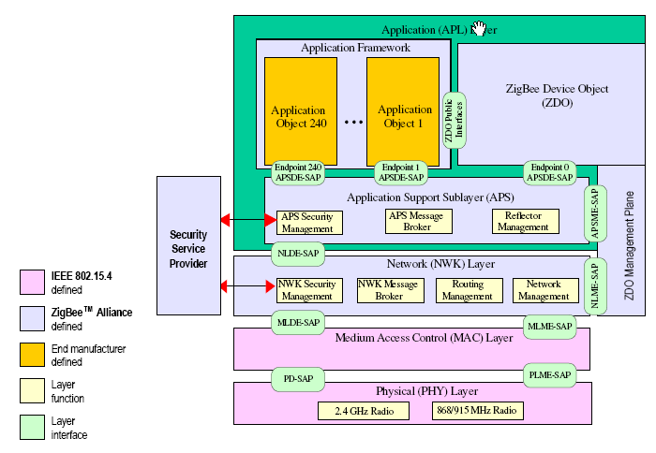
Fig 3. ZigBee Stack

The network layer is responsible to do the following:
- It forms the network.
- It allows devices to leave and join the network
- When a new device joins the network, the network layer is responsible for configuring the stack of the new device to enable the device to operate as required.
- A new and unique address should be assigned to the device that joins the network
- The network layer should apply AES encryption(encrypt) to outgoing frames and decrypt incoming frames.
- It routes packets from a device to the intended destination device.
- It allows the ability for a device to achieve synchronization with another device. This is accomplished either by polling or tracking beacons.

The ZigBee application layer consists of the APS sub-layer, the ZDO and the manufacturer-defined application objects. The responsibilities of the APS sub-layer include maintaining tables for binding, which is the ability to match two devices together based on their services and their needs, and forwarding messages between bound devices. Another responsibility of the APS sub-layer is discovery, which is the ability to determine which other devices are operating in the personal operating space of a device. The responsibilities of the ZDO include defining the role of the device within the network (e.g., ZigBee coordinator or end device), initiating and/or responding to binding requests and establishing a secure relationship between network devices. The manufacturer-defined application objects implement the actual applications according to the ZigBee-defined application descriptions.

ZigBee Devices
There are two types of logical devices that can be defined in any ZigBee network. One is a full function device and the other is a reduced function device. The full function device can be used in any type of topology and this device can communicate with any device in the network. This device can be used as a Coordinator or a Router. A coordinator is responsible for initiating a ZigBee network. Router may be used for routing in Tree or Mesh network. The reduced function device can only be used as an End Device. This device communicates with the coordinator or a router depending on the network topology. An IEEE 802.15.4/ZigBee network requires at least one full function device as a network coordinator, but endpoint devices may be reduced functionality devices to reduce system cost.

All devices must have 64 bit IEEE addresses

Short (16 bit) addresses can be allocated to reduce packet size

Addressing modes:

Network + device identifier (star)

Source/destination identifier (peer-peer)

Network Topologies

Fig. 4 Network Topologies
STAR
MESH
CLUSTER TREE

- PAN
coordinator
(FFD)
- Router (FFD)

- End Device
(RFD)

ZigBee allows Star, Mesh and Cluster Tree network topologies. In this project, we have used a Star topology with
one coordinator and three end-devices.

Frame Structure
The frame structures have been designed to keep the complexity to a minimum while at the same time making them sufficiently robust for transmission on a noisy channel. Each successive protocol layer adds to the structure with layer-specific headers and footers.
The IEEE 802.15.4 MAC defines four frame structures:
• A beacon frame, used by a coordinator to transmit beacons.
• A data frame, used for all transfers of data.
• An acknowledgment frame, used for confirming successful frame reception.
• A MAC command frame, used for handling all MAC peer entity control transfers.

Fig.5 shows the data frame. The Physical Protocol Data Unit is the total information sent over the air. As shown in the illustration above the Physical layer adds the following overhead:

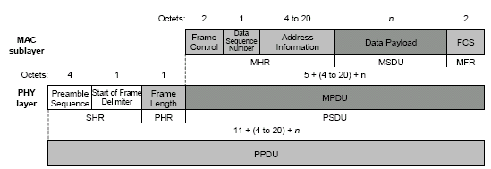

Fig. 5 IEEE 802.15.4 Frame format.

Preamble Sequence 4 Octets
Start of Frame Delimiter 1 Octet
Frame Length 1 Octet

The MAC adds the following overhead:
Frame Control 2 Octets
Data Sequence Number 1 Octet
Address Information 4 – 20 Octets
Frame Check Sequence 2 Octets

In summary the total overhead for a single packet is therefore 15 -31 octets (120 bits); depending upon the addressing scheme used (short or 64 bit addresses). Please note that these numbers do not include any security overhead.

Reliability and fail safe measures
Some of the main concerns of the wireless heart rate monitoring system are:

- Failure of either an end device or the coordinator in the wireless network
- Determining when a node is losing its battery life so the battery of the node can be replaced.
- Interference with other devices or networks

The following steps can be taken to make sure the above two concerns are met. The heart rate of each baby will be sent to the coordinator in the incubator room periodically. If the coordinator does not receive a heart-rate from a particular end-device, the coordinator will send an alert to the central monitoring room via the LAN network. There will be a watch dog daemon on the computer in the monitoring room that will periodically check if the coordinators in each of the incubator rooms are alive. This can be done by sending a specific message to the coordinator and expecting a specific message back from the coordinator periodically.

The nodes in the network will never sleep. This means a node is always consuming power from the battery to transmit, receive or even stay in idle state. Depending on the type of battery used on each end device and coordinator, the battery life for each device is very specific. The coordinator will keep track of the last time a new battery was installed on an end device. Knowing this, the coordinator can alert the remote monitoring room that the battery on a particular end device may die out soon. The coordinator will also keep track of when a new battery was installed on the coordinator itself and will report the remote monitoring room if the life-time of the battery is coming close. The coordinator can check for battery usage on all the nodes in the network (incubator room) periodically.

Other wireless devices such as Wi-Fi, Bluetooth, etc could cause significant RF interference with the ZigBee communication depending on the signal strength of those devices. A possible solution is to use a non-interfering ZigBee channel.The 802.15.4 specification defines 16 channels in the 2.4 GHz frequency range. These channels are assigned numbers 11 through 26. Z-Stack initially defaults to channel 11, but the user can select a different channel by changing DEFAULT_CHANLIST. This parameter is a bit map field, with each bit representing a single channel. As shown in Figure 6, the initial default channel 11 (0xB) is represented by 0x00000800 (11th bit in the field, starting from bit 0). Our experiments showed that carefully adjusting the ZigBee channel avoids RF interference with other wireless devices which are in close proximity.

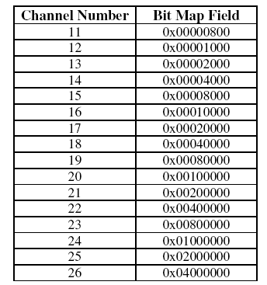

Fig. 6 Channel selection.

EXPERIMENTS AND RESULTS

Hardware
We implemented a ZigBee wireless network using 1 ZigBee Coordinator and 3 end-devices. The hardware setup consisted of CC2430 development and evaluation boards as shown in Figs 7 (a),(b) and (c). These boards provide CC2430 system on a chip with 8051 microcontroller, an RS232 interface, a USB Slave interface, an open A/D converter line plus an integrated accelerometer, light sensor, LEDs, a joystick and buttons. CC2430 System-on-Chip (SoC) is specifically tailored for IEEE 802.15.4 and ZigBee™ applications. Combined with the industry leading ZigBee™ protocol stack (Z-Stack) the CC2430 provides the market’s most competitive ZigBee™ solution. The Coordinator was connected to a Windows XP machine using RS 232 serial communication. Ideally, heart rate sensor would be based on electrodes attached to a baby. An analog input on the Zigbee device would collect electric signals from the sensor and Analog-to-Digital converter would provide digital data. In our experiment, we have used a random number generator on the Zigbee device to simulate baby’s heart rate.

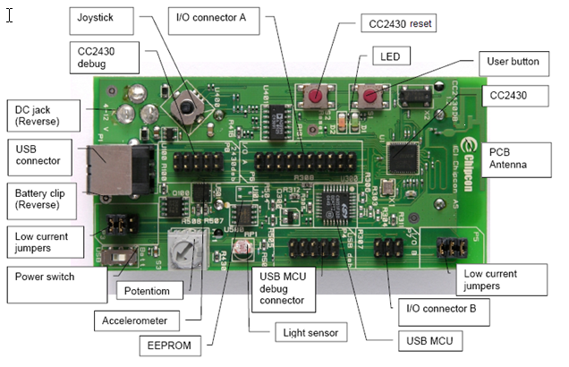

Fig. 7 (a) CC2430 Development Board

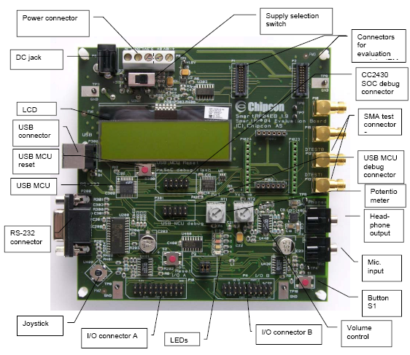 Fig. 7 (b) CC2430 Evaluation Board
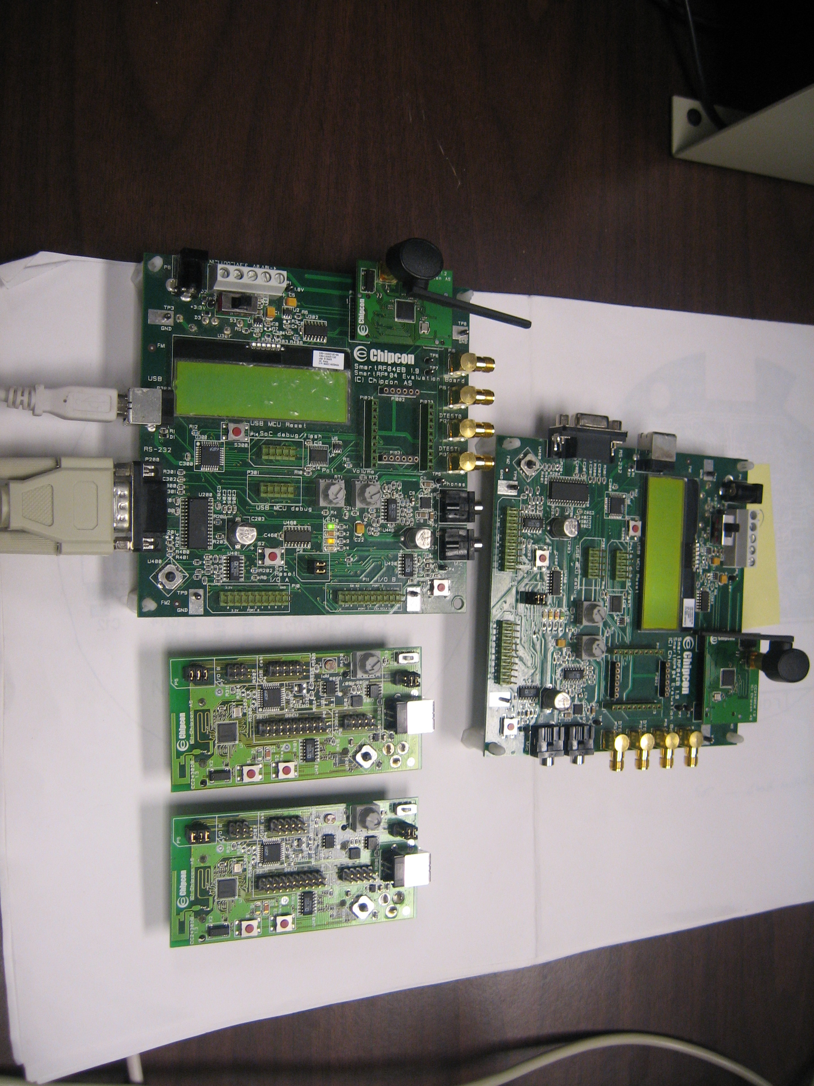

Fig. 7 (c) Experimental setup

Software tools
In order to debug and monitor wireless communication between the ZigBee nodes, we used an extra CC2430 board as a packet sniffer. This board was connected via USB to a Windows XP machine running Texas Instrument Chipcon’s Packet Sniffer software. The Packet Sniffer software automatically downloads the required firmware into the CC2430 device when connected via USB. Fig. 8 (a) shows the graphical display of ZigBee packets as seen in the Packet Sniffer. The packet sniffer allows us to filter the packets based on its type, source address, destination address, etc. The packets are color coded as shown in Fig. 8 (b). The three main categories of packets that we were interested in are Command Packet (Red), Data Packet (Yellow) and Acknowledgements (White).

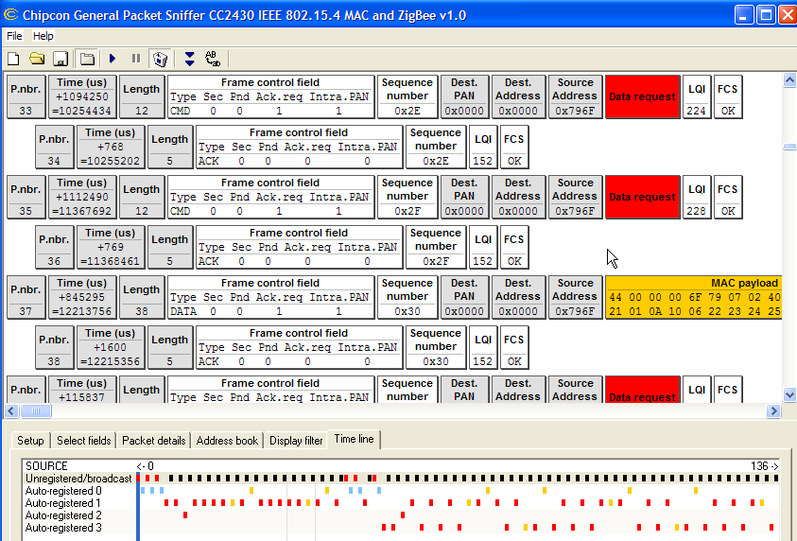
Fig. 8 (a) Packet Sniffer

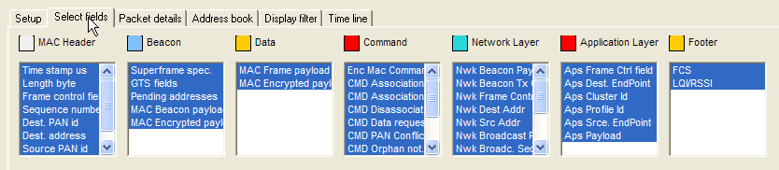

Fig. 8 (b) Color Code of packets

We used IAR Embedded Workbench tool for our ZigBee application development. The workbench tool provides an Integrated Development Environment with facilities to debug, trace and also to download the executable/firmware to CC2430 devices. It allows us to use different configurations within the same project to program different ZigBee logical devices, such as end-device, coordinator and router. We used the Z-Stack library to handle ZigBee stack services. It also allows us to select a particular ZigBee channel for communication among the ZigBee nodes.

Results

One important trace feature of the workbench allowed us to parse the ZigBee packets received by the Coordinator and display the data contained in the packet into log files or the graphical display of the workbench. We used trace macros for this purpose. The log files obtained in such a way, showed that the ZigBee coordinator successfully received the heart-rate information sent by the End-Devices (sensor nodes).

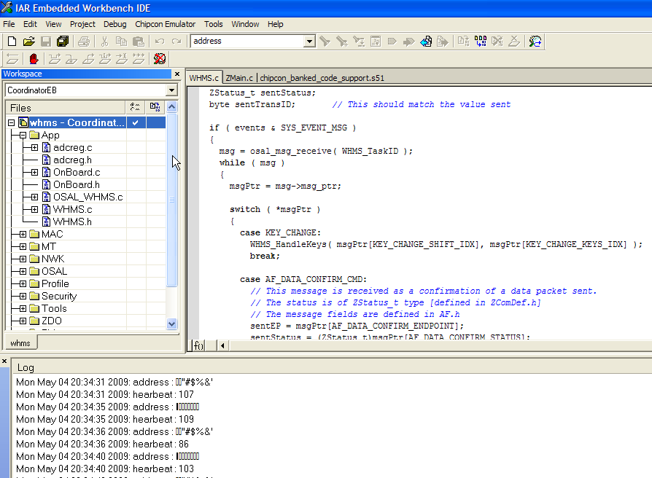

Fig. 9 IAR Embedded Workbench

In our experiment, the ZigBee packet contained ZigBee Device Address and simulated heart-rate. The total payload size allowed by ZigBee is 104 bytes.

CONCLUSION

We have proposed a low-cost solution to enhance the remote monitoring capability of existing health care system. We conducted a feasibility study of using ZigBee network based heart rate monitoring system. It is cheap, secure, robust and low-power consuming. It can operate on multiple channels so as to avoid interference with other wireless devices or equipments in the hospital. An extension of this work would be to develop a software that transmits heart rate information to a central monitoring system over Ethernet LAN. The interface between the ZigBee Coordinator and a computer in LAN, could be developed using IEEE 1451, which is a smart transducer interface standard. It makes it easier for transducer manufacturers to develop smart devices and to interface those devices to networks, systems and instruments by incorporating existing and emerging sensor and networking technologies.

references
- T. W. Nam3, J. M. Cho3 and Hee-Jung Noh, Design of a Wireless Heart Rate Monitoring System for Rehabilitation Patients, IFMBE Proceedings, Volume 15, 625-627
- Junho Park; Jongman Cho; Junghyeon Choi; Taewoo Nam, A zigbee network-based multi-channel heart rate monitoring system for exercising rehabilitation patients, TENCON 2007 - 2007 IEEE Region 10 Conference Oct. 30 2007-Nov. 2 2007 Page(s):1 - 4 Digital Object Identifier 10.1109/TENCON.2007.4428927
- Mienkovic M, Jovanov E, Chapman J, Raskovic D, Price J A wireless body area network of intelligent motion sensors for computer assisted physical rehabilitation Electrical and Computer Engineering Department, University of Alabama in Huntsville, Huntsville, Alabama 35899, USA
- F8W-2004-0007, ZigBee Implementer’s Guide. Texas Instruments Inc. San Deigo, California USA (619) 542-1200
- CC2430DK Development Kit User manual. SWRU133. Texas Instruments Inc. San Deigo, California USA (619) 542-1200
- CC2430 PRELIMINARY Data Sheet (rev. 1.03) SWRS036A
Texas Instruments Inc. San Deigo, California USA (619) 542-1200

APPENDIX A. – Code WHMS.c

/*********************************************************************

WHMS(Wireless Heart Rate Monitoring System) implementation
---------------------------------------------------------

Authors:
- Palden Lama, UCCS <plama@uccs.com>
- Archana Sapkota, UCCS <asapkota@uccs.edu>
- Deepti Reddy, UCCS <sreddy@uccs.edu>
/*********************************************************************
* INCLUDES
*/
#include "OSAL.h"
#include "AF.h"
#include "ZDApp.h"

#include "WHMS.h"
#include "DebugTrace.h"

#if !defined( WIN32 )
#include "OnBoard.h"
#endif
#include "stdlib.h"
/*********************************************************************
* MACROS
*/

/*********************************************************************
* CONSTANTS
*/

/*********************************************************************
* TYPEDEFS
*/

/*********************************************************************
* GLOBAL VARIABLES
*/

// This is the Cluster ID List and should be filled with Application
// specific cluster IDs.
const byte WHMS_ClusterList[WHMS_MAX_CLUSTERS] =
{
WHMS_CLUSTERIDX, // KVP Cluster ID
WHMS_CLUSTERIDY // MSG Cluster ID
};

const SimpleDescriptionFormat_t WHMS_SimpleDesc =
{
WHMS_ENDPOINT, // int Endpoint;
WHMS_PROFID, // uint16 AppProfId[2];
WHMS_DEVICEID, // uint16 AppDeviceId[2];
WHMS_DEVICE_VERSION, // int AppDevVer:4;
WHMS_FLAGS, // int AppFlags:4;
WHMS_MAX_CLUSTERS, // byte AppNumInClusters;
(byte*)WHMS_ClusterList, // byte *pAppInClusterList;
WHMS_MAX_CLUSTERS, // byte AppNumInClusters;
(byte*)WHMS_ClusterList // byte *pAppInClusterList;
};

// This is the Endpoint/Interface description. It is defined here, but
// filled-in in WHMS_Init(). Another way to go would be to fill
// in the structure here and make it a "const" (in code space). The
// way it's defined in this sample app it is define in RAM.
endPointDesc_t WHMS_epDesc;

/*********************************************************************
* EXTERNAL VARIABLES
*/

/*********************************************************************
* EXTERNAL FUNCTIONS
*/

/*********************************************************************
* LOCAL VARIABLES
*/
byte WHMS_TaskID; // Task ID for internal task/event processing
// This variable will be received when
// WHMS_Init() is called.
devStates_t WHMS_NwkState;

byte WHMS_TransID; // This is the unique message ID (counter)

afAddrType_t WHMS_DstAddr;

int heartbeat; //heart beat rate

typedef struct
{
char address[8];
int heartbeat;
}data;

data DATA,display;
//char display[sizeof(data)];

/*********************************************************************
* LOCAL FUNCTIONS
*/
void WHMS_HandleKeys( byte shift, byte keys );
void WHMS_MessageKVPCB( afIncomingKVPPacket_t *pckt );
void WHMS_MessageMSGCB( afIncomingMSGPacket_t *pckt );
void WHMS_SendTheMessage( void );

/*********************************************************************
* NETWORK LAYER CALLBACKS
*/

/*********************************************************************
* PUBLIC FUNCTIONS
*/

/*********************************************************************
* @fn WHMS_Init
*
* @brief Initialization function for the Generic App Task.
* This is called during initialization and should contain
* any application specific initialization (ie. hardware
* initialization/setup, table initialization, power up
* notificaiton ... ).
*
* @param task_id - the ID assigned by OSAL. This ID should be
* used to send messages and set timers.
*
* @return none
*/
void WHMS_Init( byte task_id )
{
WHMS_TaskID = task_id;
WHMS_NwkState = DEV_INIT;
WHMS_TransID = 0;

// Device hardware initialization can be added here or in main() (Zmain.c).
// If the hardware is application specific - add it here.
// If the hardware is other parts of the device add it in main().

//WHMS_DstAddr.addrMode = (afAddrMode_t)AddrNotPresent;
//WHMS_DstAddr.endPoint = 0;
//WHMS_DstAddr.addr.shortAddr = 0;
WHMS_DstAddr.addrMode = afAddr16Bit;
WHMS_DstAddr.endPoint = WHMS_ENDPOINT;
WHMS_DstAddr.addr.shortAddr = 0;

// Fill out the endpoint description.
WHMS_epDesc.endPoint = WHMS_ENDPOINT;
WHMS_epDesc.task_id = &WHMS_TaskID;
WHMS_epDesc.simpleDesc
= (SimpleDescriptionFormat_t *)&WHMS_SimpleDesc;
WHMS_epDesc.latencyReq = noLatencyReqs;

// Register the endpoint description with the AF
afRegister( &WHMS_epDesc );

// Register for all key events - This app will handle all key events
RegisterForKeys( WHMS_TaskID );

#ifndef ZD_COORDINATOR
DATA.address[0] = IEEE_ADDR0;
DATA.address[1] = IEEE_ADDR1;
DATA.address[2] = IEEE_ADDR2;
DATA.address[3] = IEEE_ADDR3;
DATA.address[4] = IEEE_ADDR4;
DATA.address[5] = IEEE_ADDR5;
DATA.address[6] = IEEE_ADDR6;
DATA.address[7] = IEEE_ADDR7;
#endif

// Update the display
#if defined ( LCD_SUPPORTED )
WriteLCDString( 2, "WHMS" );
#endif
}

/*********************************************************************
* @fn WHMS_ProcessEvent
*
* @brief Generic Application Task event processor. This function
* is called to process all events for the task. Events
* include timers, messages and any other user defined events.
*
* @param task_id - The OSAL assigned task ID.
* @param events - events to process. This is a bit map and can
* contain more than one event.
*
* @return none
*/
UINT16 WHMS_ProcessEvent( byte task_id, UINT16 events )
{
osal_msg_received_t *msg;
afIncomingKVPPacket_t *KVPpkt;
afIncomingMSGPacket_t *MSGpkt;
byte *msgPtr;
byte dstEP;
zAddrType_t *dstAddr;

// Data Confirmation message fields
byte sentEP;
ZStatus_t sentStatus;
byte sentTransID; // This should match the value sent

if ( events & SYS_EVENT_MSG )
{
msg = osal_msg_receive( WHMS_TaskID );
while ( msg )
{
msgPtr = msg->msg_ptr;

switch ( *msgPtr )
{
case KEY_CHANGE:
WHMS_HandleKeys( msgPtr[KEY_CHANGE_SHIFT_IDX], msgPtr[KEY_CHANGE_KEYS_IDX] );
break;

case AF_DATA_CONFIRM_CMD:
// This message is received as a confirmation of a data packet sent.
// The status is of ZStatus_t type [defined in ZComDef.h]
// The message fields are defined in AF.h
sentEP = msgPtr[AF_DATA_CONFIRM_ENDPOINT];
sentStatus = (ZStatus_t)msgPtr[AF_DATA_CONFIRM_STATUS];
sentTransID = msgPtr[AF_DATA_CONFIRM_TRANSID];

// Action taken when confirmation is received.
if ( sentStatus != ZSuccess )
{
// The data wasn't delivered -- Do something
}
break;

case AF_INCOMING_KVP_CMD:
case AF_INCOMING_GRP_KVP_CMD:
// convert to incoming packet format
KVPpkt = (afIncomingKVPPacket_t *)&(msgPtr[1]);

// Process the incoming message
WHMS_MessageKVPCB( KVPpkt );

// Release the data buffer
osal_mem_free( KVPpkt->cmd.Data ); //Data buffer first
break;

case AF_INCOMING_MSG_CMD:
case AF_INCOMING_GRP_MSG_CMD:
// convert to incoming packet format
MSGpkt = (afIncomingMSGPacket_t *)&(msgPtr[1]);

// Process the incoming message
WHMS_MessageMSGCB( MSGpkt );

// Release the data buffer
osal_mem_free( MSGpkt->cmd.Data ); //Data buffer first
break;

case ZDO_NEW_DSTADDR:
dstEP = msgPtr[1];
dstAddr = (zAddrType_t *)&msgPtr[2];

WHMS_DstAddr.addrMode = (afAddrMode_t)dstAddr->addrMode;
WHMS_DstAddr.endPoint = dstEP;

if ( dstAddr->addrMode == Addr16Bit )
WHMS_DstAddr.addr.shortAddr = dstAddr->addr.shortAddr;
else
{
osal_memcpy( WHMS_DstAddr.addr.extAddr,
dstAddr->addr.extAddr, Z_EXTADDR_LEN );
}
break;

case ZDO_STATE_CHANGE:
WHMS_NwkState = (devStates_t)msgPtr[1];
if ( (WHMS_NwkState == DEV_ZB_COORD)
|| (WHMS_NwkState == DEV_ROUTER)
|| (WHMS_NwkState == DEV_END_DEVICE) )
{
// Start sending "the" message in a regular interval.
#ifndef ZD_COORDINATOR
osal_start_timer( WHMS_SEND_MSG_EVT,
WHMS_SEND_MSG_TIMEOUT );
#endif
}
break;

default:
break;
}

// Release the memory
osal_msg_deallocate( msgPtr );

// Next
msg = osal_msg_receive( WHMS_TaskID );
}

// return unprocessed events
return (events ^ SYS_EVENT_MSG);
}

// Send a message out - This event is generated by a timer
// (setup in WHMS_Init()).
if ( events & WHMS_SEND_MSG_EVT )
{
//Generate random heart beat rate
heartbeat = rand()%50+70;
osal_memcpy(&DATA.heartbeat,&heartbeat,sizeof(int));

// Send "the" message
WHMS_SendTheMessage();

// Setup to send message again
osal_start_timer( WHMS_SEND_MSG_EVT,
WHMS_SEND_MSG_TIMEOUT );

// return unprocessed events
return (events ^ WHMS_SEND_MSG_EVT);
}

// Discard unknown events
return 0;
}

/*********************************************************************
* Event Generation Functions
*/
/*********************************************************************
* @fn WHMS_HandleKeys
*
* @brief Handles all key events for this device.
*
* @param shift - true if in shift/alt.
* @param keys - bit field for key events. Valid entries:
* EVAL_SW4
* EVAL_SW3
* EVAL_SW2
* EVAL_SW1
*
* @return none
*/
void WHMS_HandleKeys( byte shift, byte keys )
{
// Shift is used to make each button/switch dual purpose.
if ( shift )
{
if ( keys & EVAL_SW1 )
{
}
if ( keys & EVAL_SW2 )
{
}
if ( keys & EVAL_SW3 )
{
}
if ( keys & EVAL_SW4 )
{
}
}
else
{
if ( keys & EVAL_SW1 )
{
}

if ( keys & EVAL_SW2 )
{
// Initiate an End Device Bind Request for the mandatory endpoint
ZDApp_SendEndDeviceBindReq( WHMS_epDesc.endPoint );
}

if ( keys & EVAL_SW3 )
{
}

if ( keys & EVAL_SW4 )
{
// Initiate a Match Description Request (Service Discovery)
// for the mandatory endpoint
ZDApp_AutoFindDestination( WHMS_epDesc.endPoint );
}
}
}

/*********************************************************************
* LOCAL FUNCTIONS
*/

/*********************************************************************
* @fn WHMS_MessageKVPCB
*
* @brief Data message processor callback. This function processes
* any incoming data - probably from other devices. So, based
* on cluster ID, perform the intended action.
*
* @param none
*
* @return none
*/
void WHMS_MessageKVPCB( afIncomingKVPPacket_t *pkt )
{
byte responseData;

switch ( pkt->clusterId )
{
case WHMS_CLUSTERIDX:
// Example of sending reply message
// Attribute should be same as the received message

if ( afFillAndSendMessage( &(pkt->srcAddr), WHMS_epDesc.endPoint, WHMS_CLUSTERIDX,
1, FRAMETYPE_MSG, &pkt->cmd.TransSeqNumber,
CMDTYPE_GET_RESP, DATATYPE_UINT8, WHMS_CLUSTERIDX_ATTR1,
ERRORCODE_SUCCESS, sizeof(byte), &responseData,
AF_MSG_ACK_REQUEST, true, AF_DEFAULT_RADIUS ))
{
// Error occurred in request to send
}
else
{
// Successfully requested to be sent
}

break;
}
}

/*********************************************************************
* @fn WHMS_MessageMSGCB
*
* @brief Data message processor callback. This function processes
* any incoming data - probably from other devices. So, based
* on cluster ID, perform the intended action.
*
* @param none
*
* @return none
*/
void WHMS_MessageMSGCB( afIncomingMSGPacket_t *pkt )
{

switch ( pkt->clusterId )
{
case WHMS_CLUSTERIDY:
// "the" message
#if defined( LCD_SUPPORTED )
// WriteLCDScreen( (char*)pkt->cmd.Data, "rcvd" );
#elif defined( WIN32 )
WPRINTSTR( pkt->cmd.Data );
#endif
osal_memcpy (&display, &pkt->cmd.Data[0], sizeof(data));

break;
}
}

/*********************************************************************
* @fn WHMS_SendTheMessage
*
* @brief Send "the" message.
*
* @param none
*
* @return none
*/
void WHMS_SendTheMessage( void )
{
char theMessageData[sizeof DATA];
osal_memcpy(theMessageData,&DATA,sizeof(DATA));

if ( afFillAndSendMessage( &WHMS_DstAddr, WHMS_epDesc.endPoint, WHMS_CLUSTERIDY,
1, FRAMETYPE_MSG, &WHMS_TransID,
NULL, NULL, NULL, ERRORCODE_SUCCESS,
(byte)osal_strlen(theMessageData) + 1, (byte*)&theMessageData,
AF_MSG_ACK_REQUEST, true, AF_DEFAULT_RADIUS ))
{
// Error occurred in request to send
}
else
{
// Successfully requested to be sent
}
}

/*********************************************************************
*********************************************************************/

 

