Securing Dynamic Websites using LAPP and ModSecurity

Brad Baker
University of Colorado, Colorado Springs
1420 Austin Bluffs Pkwy
Colorado Springs, CO 80918
bbaker@uccs.edu

ABSTRACT
This paper addresses web server security topics for dynamic database-driven web applications, specifically using experimentation with the LAPP (Linux, Apache, Postgresql, and PHP) platform and the ModSecurity (Copyright © Breach Security, Inc. http://www.breach.com) web application firewall modification for Apache web servers. The experimentation included the development of a custom web application as a testing method for system security configuration. Configuration topics and test results are summarized.

Categories and Subject Descriptors
- [Computer-Communication Networks]:General – Security and protection

General Terms
Experimentation, Security

Keywords
ModSecurity PHP Linux Apache Postgresql Security

INTRODUCTION

The popularity of dynamic database-driven web applications is increasing as the Internet becomes more sophisticated. Over time, fewer websites serve static pages and documents, and more serve dynamic content with a back-end database system, which may or may not include authorization and login functionality.

Dynamic web applications are subject to a wide variety of security threats and exploits. These security threats exist in several layers of the web server, including the server software, the operating system and the web applications that provide content to the client. Securing dynamic web systems is an unending process that must involve all aspects of a system, including the development and implementation of web applications, the patching and updating of server software, the hardening of the system configuration and the monitoring of malicious activity.

This project investigated options for securing a LAPP (Linux, Apache, Postgresql, and PHP) web server. A custom login-based web application was constructed to use Postgresql and PHP, and the Apache module ModSecurity was installed and tested as a web application firewall (WAF) to both log HTTP traffic and protect against external security threats. The ModSecurity Console software was used as a log file analysis tool for the ModSecurity installation. This test environment was tested against basic malicious requests and was benchmarked for performance analysis.

WEB APPLICATION SECURITY

Web Application Security Issues

The security threats that dynamic websites face exist in multiple levels within a system. Some vulnerabilities are found within the operating system and server software such as the Apache server process, the SSH service, administration tools such as Webmin, and other software. Other vulnerabilities exist within the web applications that handle client requests.

In a dynamic website environment, a web server is typically configured to accept user input through HTML forms, file uploads, POST data and GET requests. Additionally a web server such as Apache supports a wide range of data encodings such as ASCII, Unicode, and URL-encoded data. Considering the range of options for data input to a web server, there are many ways that a client can send malicious data to a dynamic web application. If appropriate protections are not in place, then malicious data can lead to unpredictable results, leakage of critical information, or exploitation of the system. Specific examples of common exploit methods include SQL injection and cross-site scripting.

There are numerous sources of security vulnerabilities in web applications. These sources include poorly coded custom applications, the use of popular third-party applications that may contain vulnerabilities and are common targets for exploits, un-patched and slowly patched server software, and unknown exploits for server software. Often in custom coded web applications secure development practices and standards are not properly used. This can be due to a lack of knowledge on the part of the application developer or a lack of appropriate tools to effectively secure the application.

Popular third party packages such as phpBB and VTCalendar are common on Linux systems running Apache web servers. Third party applications such as these have been the target of exploits in the past, and may contain vulnerabilities that could be exploited in the future.

The underlying server software used on a web server, including the operating system, the web server process, network file transmission tools, and administration tools may all contain vulnerabilities that could be used by an attacker to gain control of the system. These exploits may occur through flaws in the web server itself, or other services provided by the system. Any program that takes input from an external user can be a source of vulnerabilities and may ultimately lead to exploitation of the system.

Potential Solutions

Proper administration and maintenance of a system can help mitigate some of the security issues presented in the preceding section. These solutions to vulnerabilities take a varying amount of time and resources, and are not always practical in a real world implementation.

Considering custom developed web applications, quality development practices and applied knowledge of secure methods will decrease the number of common vulnerabilities. In general, dynamic web applications should validate user input, catch error conditions and implement rigorous methods to maintain authentication session information. Unfortunately, real world implementations of web applications often do not include proper security considerations.

Securing third party application software is difficult because this type of software can contain many lines of code and often includes a complicated design. It is infeasible for system administrators to find and fix exploits in these third party applications due to the scale of open source projects and the possibility of proprietary closed-source applications. Because many of these programs are open source software, attackers have the benefit of analyzing and testing exploits on the system in a closed environment. There are few solutions for closing vulnerabilities in third party web applications, and using some of these packages can cause a system to become a target for malicious users.

The underlying software that comprises a web server is the most critical component, since web applications rely on a stable operating environment to work effectively. In general, system services can be protected with hardening and firewalls, followed by prompt patching. Unneeded system services should be disabled and important ports should be behind a firewall, allowing only approved machines through. These basic steps are not always followed, as some systems do not have full time administrators, and mission critical systems may require a testing phase for software updates before they are applied to the system. During this testing phase, it could be possible for an attacker to launch an exploit. In addition, there is a constant threat of unknown vulnerabilities being targeted by malicious users.

There is a wide range of other possible solutions for these security problems, just a few of which include Intrusion Detection Systems (IDS), a chroot jail for the web server process, the Suhosin mod for the PHP installation, and the ModSecurity module for the Apache web server.

Intrusion Detection Systems are excellent tools for an overall security solution, but most IDS systems are not ideally suited to protecting a web application. Typically, IDS systems are based on identifying threats through signature definitions. In addition, these systems are designed to protect a variety of system services and overall network security. Attacks on web applications are usually customized for the specific application and are not applicable to signature analysis. Another limitation is that IDS systems cannot analyze encrypted SSL traffic due to their location on the network.

The chroot jail method is a way to protect a Linux operating system from an exploited Apache server process. The Apache process is given strict access restrictions to a particular location within a server's file system. Rather than “/” representing root, “/chroot/” may represent root. In this way, Apache can not reference any files outside of its jail. This solution can protect a system from a compromised Apache process, but it does not help secure the web application layer.

Suhosin is a mod for the PHP scripting language which defends it from a wide range of vulnerabilities and unknown flaws. The module enforces various limits on the processing done by PHP, and blocks risky activity that can allow an attacker to gain control of a system through PHP scripting. This solution is good for PHP installations, but does not specifically protect the Apache web server, the database, or other system services.

The ModSecurity module is a well balanced solution which operates between the Apache process and the remote client. ModSecurity's location within the system allows it to inspect SSL encrypted content after decryption and before encryption. This module is specifically designed to work with web traffic and is capable of filtering different encodings and data transmission methods used by websites. ModSecurity is a proactive defense that blocks malicious requests before they can attack the web application.

TEST ENVIRONMENT

Operation Summary

In this project, the configuration and security analysis of a custom developed web application on a LAPP web server was performed. This web server used ModSecurity as the primary method of securing the application. The test environment used two machines connected on a small network. The first machine acted as the LAPP web server hosting the web application. This machine used Ubuntu 7.10, Apache 2.2.4, PHP 5.2.3, and Postgresql 8.2.3. Additionally, the modules mod_unique_id, mod_php, and mod_security were used with Apache. The packages Curl, Lua and Libxml2 were used to support ModSecurity. The Webmin package was used for remote administration of the overall system and the Postgresql and Apache services. PgadminIII was used for building Postgresql objects and executing SQL.

The second machine acted as the client and the log aggregation server. This machine used Windows Vista and both the Firefox and Internet Explorer browsers to send basic malicious requests to the web server to test the security configuration. Also, the ModSecurity Console software was installed on this machine for log file analysis. The Console software collected the published log files from the web server and provided a front end for attack analysis.

Web Application for the Project

An application was developed with the premise of tracking user submitted information about local hiking trails. This application served as a mechanism to test the security features of the web server configuration and ModSecurity, and it allowed exploration into possible website authentication and session tracking methods.

The trail update page of the application is shown in Figure 1. This page allows users to update or delete existing trail records. The application stores authentication data including username and password in a Postgresql table. A login page accepts these credentials, and if they are correct, a PHP script creates a session ID number in a tracking table, and a corresponding cookie in the client's browser. The cookie and login session are given an expiration time of 30 minutes. On each page access, the PHP script checks for the existence of a valid session ID number in the client's unexpired cookie. If this unexpired cookie exists, the user is given access to the page and the session is refreshed for an additional 30 minutes. If the cookie does not exist or the time has expired, the user is directed back to the login page.
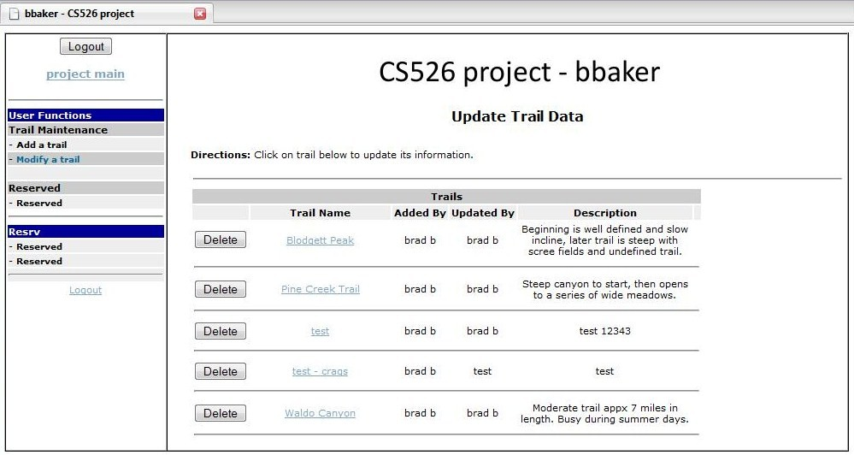Figure 1. Project web application, trail update page

The login process was enhanced to include a mechanism to enforce a maximum number of incorrect login attempts. The application itself includes two basic functions: Adding trail records to the system, and updating or deleting trail records. A trail record is comprised of a name, a location and a description, all free form text fields. When adding and updating records, user input text data is submitted to the appropriate PHP script for insertion into the database using the POST method. The GET method is used only in the trail update page to direct the update PHP script which of the trails the user wishes to update. For example, each of the trail name Hyperlinks shown in Figure 1 use the GET method to notify the following page of the user's selection. Overall, the database consists of five tables, one for tracking trails and four for tracking users and login history.

This web application provides an adequate method for testing the ModSecurity addition to Apache. The functions used by the application are common in web applications and this test case demonstrates the impact that ModSecurity might have on a typical system.

Once the test environment was fully functional, ModSecurity was enabled within the Apache process on the web server. At this point, the Windows Vista client machine was used to submit both simple malicious requests and valid requests to the application, and the response was observed.

Following the initial tests of malicious activity against the web application, the ModSecurity Console was enabled on the Windows Vista machine to observe attack activity. In addition, the Apache “ab” benchmarking tool was used to study performance differences with the ModSecurity module enabled.

MODSECURITY

Overview of the module

The primary security method investigated in this project was the ModSecurity module for the Apache process. ModSecurity (Copyright © Breach Security, Inc. http://www.breach.com) is a Web Application Firewall (WAF) for Linux and Apache installations. The current version of ModSecurity is 2.5.3, released on April 24th, 2008. Although ModSecurity is owned by Breach Security, it is provided as an open source product under the General Public License, Version 2 (GPLv2). As an open source product, ModSecurity is beneficial for the security of Apache web servers because access is improved and use is encouraged by an open license.

The module operates within the Apache process but is able to act on client requests before the request data reaches scripts and before response data is served to the client. The basic operation uses robust rule-based pattern matching against both request and response data. The rules are specified in regular expression syntax. The use of regular expressions for rule definition provides a very powerful method for describing patterns in data. Because of ModSecurity's location in the processing stream of Apache, it is able to analyze SSL traffic after the request is decrypted and before the response is encrypted.

ModSecurity's processing of request and response data falls into four phases, with a fifth phase for logging. Each cycle of request and response data that ModSecurity processes executes rules in the order of phase number one through phase number five. In phase number one, the request header is analyzed. In phase number two, the request body is analyzed. In phase number three, the response header is analyzed, and in phase number four, the response body is analyzed. The logging of all messages generated in phases one through four is performed in phase number five. The module analyzes all request header data, and three types of request body encoding: Application/x-www-form-urlencoded (used for form data), multipart/form-data (used for file transfers), and text/xml (used for XML data). By intercepting different types of request data, ModSecurity can filter many possible exploit methods. The analysis and interception of response header and body data prevents the server from responding with critical data in the form of error messages. Often an attacker can focus exploit attempts using information about server software, scripts, or databases that is returned in error messages. In addition to blocking data that fails the rule checks, the module can allow data to pass and simply log the potential error. This function has several advantages. An administrator can implement logging before implementing blocking, to see how existing web applications will be affected by the ModSecurity rules. Also, a web application honey pot can be created, and a logging instance of ModSecurity can become a website intrusion detection system.

The power of ModSecurity comes from its rules. Rules are complex regular expressions and creating them effectively requires an optimization process. Fortunately, Breach Security provides regular updates of a Core Rule set, which will protect a system from a wide variety of generic attacks. Because the rules are less like signatures and more like enforcement of proper data patterns, they require less updating than traditional IDS systems. In addition to the Core Rules, an administrator can create custom rules to enforce the request patterns that are valid for a particular application. A regular expression optimization tool is suggested for in-depth custom rule creation.

Rule Syntax

The full syntax for ModSecurity rules is very large and robust, as summarized in approximately 70 pages within the ModSecurity documentation provided by Breach Security. The following is a basic summary of rule construction and some example rules.

The basic structure of a rule is:

SecRule VARIABLES OPERATOR [ACTIONS]

The “variables” parameter specifies what data is checked, the “operator” parameter specifies how this data is checked, and the optional “actions” parameter specifies what action is performed if a match between the “variables” and “operator” values is found. The “action” value is optional because the system allows default actions to be configured. Following that format, a simple rule is:

SecRule REQUEST_URI "attack"

This rule will match on a request URI value that contains the string “attack”, and perform the default action. In this case, “attack” can be considered to be a simple regular expression. In the following example, the default action is set to “pass” for rules defined in phase number two. The “pass” value continues processing when a successful match is found. The rule is defining its own action to “deny” which stops all rule processing and blocks transmission.

SecDefaultAction "log,pass,phase:2"
SecRule REQUEST_HEADERS:Host "!^$" "deny,phase:1"

This rule will match an empty host header value and block transmission. The rule is executed in phase number one, and is performed before the default action for phase number two takes effect.

The following rule checks the response body for a sign of a PHP error message. This type of error can give an attacker important clues into the operation of the targeted script. In this rule, the client is provided with an error code 500 from the server, and the request is denied. Additional arguments such as “auditLogParts”, “log”, and “auditlog” control the logging behavior.

SecRule RESPONSE_BODY "<b>Warning<\/b>.{0,100}?:.{0,1000}?\bon line\b" "phase:4,t:none,ctl: auditLogParts=+E, deny,log,auditlog,status:500, msg:'PHP Information Leakage', id:'970009', tag:'LEAKAGE/ERRORS',severity:'4'"

The following rule checks data in the request header during phase number two for non-printing ASCII characters which are outside of the range 32-126. The transformation “urlDecodeUni” is used to decode URL-encoded characters. The “@validateByteRange” is an operator that directs ModSecurity to enforce the 32-126 value ASCII data.

SecRule REQUEST_FILENAME| REQUEST_HEADERS_NAMES| REQUEST_HEADERS| !REQUEST_HEADERS:Referer "@validateByteRange32-126" "phase:2,deny, log,auditlog,status:400,msg:'Invalid character in request',id:'960018',tag:'PROTOCOL_VIOLATION/EVASION', severity:'4',t:none,t:urlDecodeUni"

As a final rule example, the following will block all requests with a numeric host address in the request header. A numeric host is not a security threat on its own, but could be a sign of a bot or scanner accessing the system.

SecRule REQUEST_HEADERS:Host"^[\d\.]+$" "phase:2,t:none,deny,log,auditlog,status:400,msg:'Host header is a numeric IP address', severity:'2', id:'960017',tag:'PROTOCOL_VIOLATION/IP_HOST'"

Logging Capabilities

ModSecurity includes a detailed logging mechanism which can record a large amount of useful information on each transaction that fails the defined processing rules. ModSecurity creates entries in both the Apache logs and in its own audit log. ModSecurity keeps one entry per transaction in the normal Apache logs, but in a default configuration a typical blocked request will generate approximately 50 lines of audit log entries per transaction. Much of the information in the audit log is useful and can help an administrator understand the rule that caused the error, the request that triggered the rule, and some information about the client. This information can help an administrator study the pattern of attack traffic, or it can help debug false positives that are blocked by the system.

The audit logging feature is enabled using “log parts”, a collection of nine sections of log data, two of which are mandatory. These log parts can include the client address, the requested URI, the request header and body, the response header and body, and a listing of the rule or rules which matched. Each log entry is indexed with a four byte hexadecimal boundary code, followed by a letter indicating log part being displayed. The boundary code is the same for all parts within a transaction. An example boundary code with log part “F” is “--5c468c14-F--”.

One important feature of ModSecurity logging is the use of the Apache module mod_unique_id. This module provides a unique 24-character ID code for each request. This ID is included in the log file, and can provide a method to research specific blocked requests. In this project, a custom error PHP script was used to inform the user of the unique ID of the request. When provided with the unique ID number, a system administrator can research why the request was blocked.

Below is an example of three log parts from a basic SQL injection attempt. The log parts shown are “A”, the log header, “C”, the request body, “H”, the audit log trailer, and “Z”, the end of the entry.

--a0c36e2a-A--[03/May/2008:09:13:03 --0600] 71TDcMCoAWQAABuUA9gAAAAD 192.168.1.101 49828 192.168.1.100 80--a0c36e2a-B--POST /main/modTrail2.php?trailid=7 HTTP/1.1

--a0c36e2a-C--tname=1&tlocate=1+%27%3Binsert+into%0D%0A%0D%0A&tdesc=&trailid=7&adduser=1&addtime=2008-04-30+22%3A30%3A11.423323

--a0c36e2a-H--
Message: Access denied with code 501 (phase 2). Pattern match "(?:\b(?:(?:s(?:elect\b(?:.{1,100}?\b(?:(?:length|count|top)\b.{1,100}?\bfrom|from\b.{1,100}?\bwhere)|.*?\b(?:d(?:ump\b.*\bfrom|ata_type)|(?:to_(?:numbe|cha)|inst)r))|p_(?:(?:addextendedpro|sqlexe)c|(?:oacreat|prepar)e|execute(?:sql)?|makewebtask)|ql_(? ..." at ARGS:tlocate. [file "/etc/apache2/conf/modsecurity/rulesAll/modsecurity_crs_40_generic_attacks.conf"] [line "66"] [id "950001"] [msg "SQL Injection Attack"] [data "insert into"] [severity "CRITICAL"] [tag "WEB_ATTACK/SQL_INJECTION"]
Action: Intercepted (phase 2)
Stopwatch: 1209827583116144 3646 (490* 2404 -)
Producer: ModSecurity for Apache/2.5.3 (http://www.modsecurity.org/); core ruleset/1.6.1.
Server: Apache/2.2.4 (Ubuntu) PHP/5.2.3-1ubuntu6.3

--a0c36e2a-Z--

In the above log file section, part “A” contains the unique ID, “71TDcMCoAWQAABuUA9gAAAAD”, the client address and the request URI. The header data shown in log part “C” displays the “insert into” syntax which matched the SQL injection rule. Log part “H” displays several pieces of information including the action taken, a small portion of the regular expression which matched, and various server information. Section “Z” signifies the end of the transaction.

Error transactions also appear with useful information in the Apache error log, using only one line for each transaction. Below is an example of an Apache error log entry that ModSecurity generated.

[Fri May 02 21:24:42 2008] [error] [client 192.168.1.101] ModSecurity: Access denied with code 400 (phase 2). Pattern match "^[\\d\\.]+$" at REQUEST_HEADERS:Host. [file "/etc/apache2/conf/modsecurity/rulesAll/modsecurity_crs_21_protocol_anomalies.conf"] [line "60"] [id "960017"] [msg "Host header is a numeric IP address"] [severity "CRITICAL"] [tag "PROTOCOL_VIOLATION/IP_HOST"] [hostname "192.168.1.101"] [uri "/"] [unique_id "Y6V@mMCoAWUAABySUOgAAAA6"]
Much of the same information is contained in the Apache error log, including a timestamp, the client address, the pattern matched by the rule, the source of the rule, the error message, and the unique ID. For complicated rejection cases, the single line entry can become very long, over 700 characters in some situations.

In summary, the detailed logging features are useful, but due to the volume of information produced, it is not feasible to review logs manually. This is the role of the next piece of software, the ModSecurity Console.

MODSECURITY CONSOLE

Overview of the Software

The ModSecurity Console is an important tool to improve the administration of systems protected with the ModSecurity Apache module. ModSecurity Console (Copyright © Breach Security, Inc. http://www.breach.com) is a log file analysis and display tool which can help manage and automate the defense of a web server protected with ModSecurity. The current version of the ModSecurity Console is 1.0.4, released on April 25th, 2008. The ModSecurity Console is owned by Breach Security, and is typically a commercial product, however limited licenses are provided at no charge for personal use.

Using the ModSecurity Console requires enabling an optional component in the ModSecurity installation on Apache, the “mlogc” component. This component allows the publication of log file data to a service provided by the Console software. In addition to “mlogc”, concurrent logging must be enabled in the ModSecurity configuration. In a concurrent logging method, ModSecurity creates a new log file for each transaction. The log files are organized in a series of sub-folders based on the date and time of each transaction. Within each folder, the filename is based on the unique ID of the transaction. One transaction file, one queue file, and one error log file exist in the folder tree. These files inform the “mlogc” service about which log files exist in the sub-folder structure.
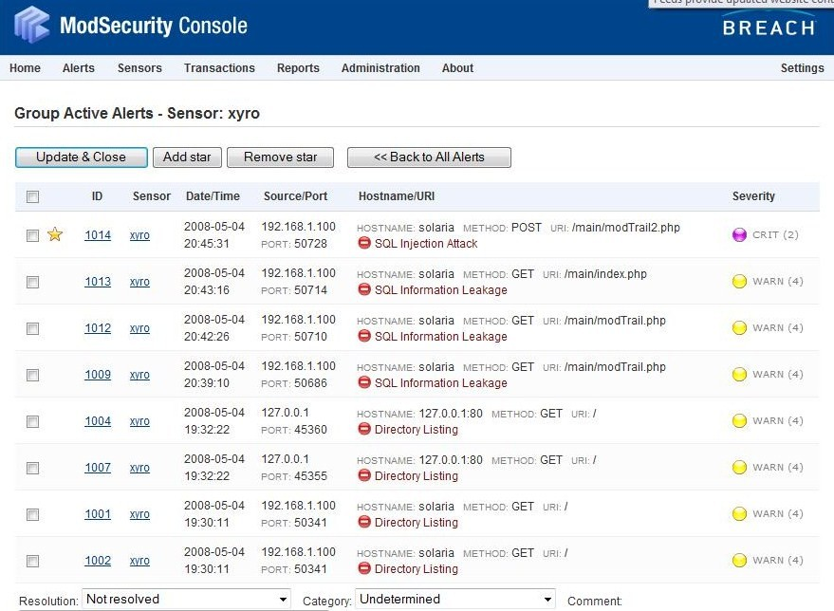Figure 2: Summary view within ModSecurity Console
The “mlogc” configuration files provide the receiving computer name, port, URI, and login credentials. This information is used to connect and transmit log file data, and this design encourages using an external server as a log collector. The ModSecurity Console software is installed on the log collecting machine, where it provides a web based interface on a special port, such as http://localhost:8888/. An administrator can use this interface to configure the software, view processed log files, and manage alert information. The ModSecurity process and the “mlogc” service on the web server publish log file data to a location on the receiving machine such as http://192.168.1.100/rpc/auditLogReveiver/. The Console software then copies the files to the local file system, parsing them and displaying alerts to the user (see Figure 2).

User Interface

As displayed in Figure 2, the overview display shows the event time, the client address, the error type and the severity level of each logged transaction. Events are automatically archived after several days but they are still accessible with the searching and reporting functions.

From the alert summary page, individual alerts can be accessed and displayed on the detail page, as shown in Figure 3. The detail page shows information about the request and response data including the user agent, supported encoding and transmission formats, etc. This page also shows data about the web server and the ModSecurity installation which produced the output. The “RAW data download” link provides access to the entire log entry for the transaction, which may include the detailed request body data depending on configuration settings.

Administrators can review, set a resolution status, set a category and add comments for these alerts. Additional features of the Console software include report generation based on alerts, automatic email notification (with a provided SMTP server), and charts indicating the volume of alerts and transactions over time.

In summary, the ModSecurity Console software provides a useful interface for a system administrator to monitor the status of a web server that uses ModSecurity. This tool can be used to easily check for intrusion attempts and unusual spikes in certain types of malicious activity. Using the ModSecurity Console in conjunction with ModSecurity on Apache can create an effective web intrusion detection system. A honey pot can be created by enabling logging without blocking on the ModSecurity installation, with unprotected web applications running as targets for exploit attempts. By setting up a ModSecurity Console server to gather logs from the honey pot system, an administrator can easily gather information about intrusion attempts.
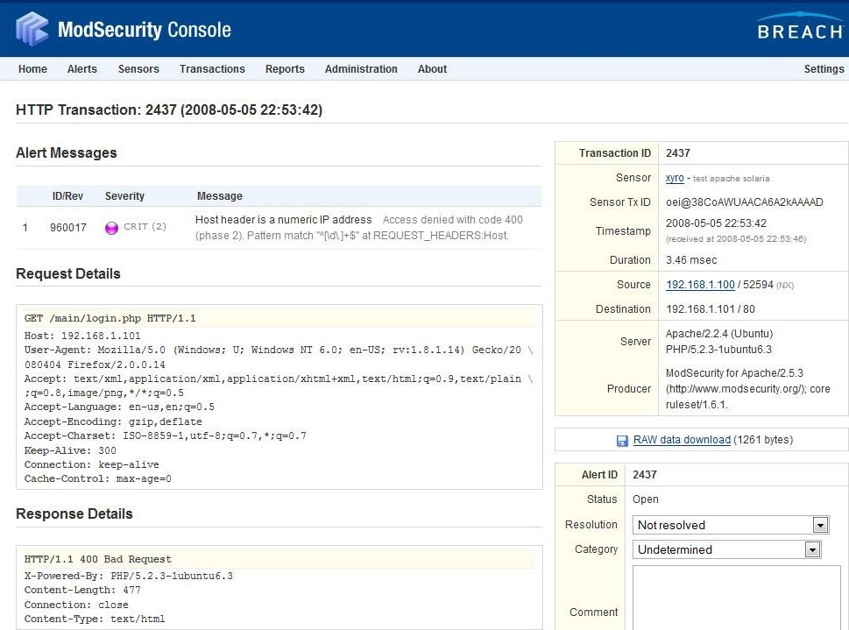Figure 3. ModSecurity Console detailed alert page

TEST RESULTS

Summary of testing

During the course of the project, simple malicious requests and legitimate requests were sent to the custom web application as tests and benchmarking was performed to study the performance impact of ModSecurity.

Using the delivered Core Rule set in the testing environment showed that ModSecurity blocked many requests that are traditionally allowed by web servers. Primary examples include directory listing and numeric host name values in the request. These two types of requests are typically not security threats, but they can be indications of malicious scanning attempts. Also it is possible that an administrator did not correctly disable access to directory listings. Luckily, because of the modular configuration of ModSecurity, an administrator can identify these negative impacts on existing processes and disable the rules that cause the errors, if these features are needed.

A very common method for exploiting database driven web servers is SQL injection. On an unprotected system with a web application that does not correctly check user input it could be possible for a user to enter a string that closes the current SQL statement and initiates another. For example, if a web application takes a user name from the client and executes:

SELECT * FROM users WHERE username='.$inputUser.';

Then it could be possible for an attacker to inject the string:

'; DELETE FROM users;'

In this string, the single quote and semicolon end the scripted query, and the DELETE keyword begins a second query. This new query would delete records in the “user” table. Traditional defenses include filtering out the SQL keywords and converting special characters in the request so that quotes and variable names do not have a detrimental impact. However, with the possibility for many unusual input values this is not always a safe solution. Filtering for certain special characters can leave the door open for other types of input, such as hexadecimal characters or Unicode characters.

The ModSecurity Core Rules use a complex regular expression to identify potential SQL injection attempts. This regular expression is designed to match the various forms that SQL statements can take. This matching method is generic so it can catch and block false positives, however this method is safe because it filters based on the SQL syntax rather than special characters alone. If the pattern matching did require special characters such as embedded quotes to precede the SQL syntax, it could be possible for an attacker to send malicious SQL code to the database using another injection method. As an example of possible false positives generated by the generic match, consider the sentence: “Select the image that you want to insert into your document”. Using the Core Rule configuration files, this sentence would cause a blocked transmission, due to the “insert into” text. Because of the possibility of false positives such as this, some administrators would be interested in providing a customized error page for users, so they can report the problem and take corrective action.
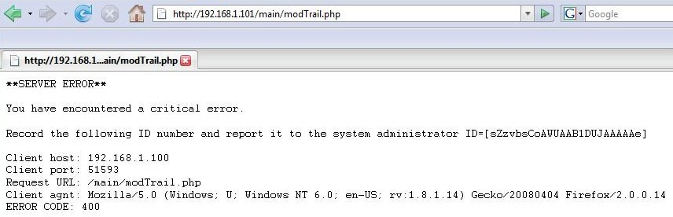Figure 4: Custom error page served on ModSecurity transmission blocking

In the testing for this project, a custom error page was developed, as shown in Figure 4. This custom error page indicates the unique ID code, information about the client, and the error code provided by the web server. These values are server variables directly accessible to a PHP script.

Another feature for systems that don't specify alternative error documents is ModSecurity's ability to overwrite part of the delivered Apache error pages. As shown in Figure 5, the Apache server version line was changed to mimic an Oracle web server. This method may not deter a dedicated attacker, but it does suppress the version of Apache and the OS that it is running on. The output shown in Figure 5 is from a malicious request that was blocked by ModSecurity.
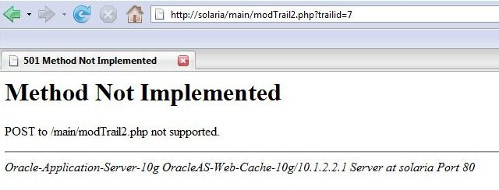Figure 5: Generic error page with configuration to overwrite server string

Benchmarking

In addition to tests of malicious activity, simple benchmarking was performed against the web server. The primary variable for benchmarking was enabling or disabling the ModSecurity module. Also, response page size was considered for its effect on processing. Benchmarking was performed in six tests, each using the Apache “ab” benchmarking tool with 50,000 requests and a concurrency level of 50. All benchmarks were either static page requests or PHP scripts with no GET or POST input. The POST method was not used as this is difficult to benchmark using the “ab” program.

The first three tests compare a successful response and an error response without ModSecurity against an error response with ModSecurity, for small response datasets. The second three tests compare a successful response and an error response without ModSecurity against an error response with ModSecurity, for larger response datasets. Below is a summary of the tests that were used:

Test #1: Disabled ModSecurity – requested directory listing. Small data transfer. This was a successful response.

Test #2: Disabled ModSecurity – requested non-existent page. Small data transfer. This was an Apache error response.

Test #3: Enabled ModSecurity – requested blocked content. Small data transfer. This was a ModSecurity error response.

Test #4: Disabled ModSecurity – requested PHP info page. Larger data transfer. This was a successful response.

Test #5: Disabled ModSecurity – requested non-existent page. Larger data transfer. This was an Apache error response.

Test #6: Enabled ModSecurity – requested blocked content. Larger data transfer. This was a ModSecurity error response.

Table 1: Table captions should be placed above the table
Test | Has ModSec | Doc Length | Time per request | Percent vs. Base
#1 | No | 1087 bytes | 88.7 ms | 0%
#2 | No | 1113 bytes | 141.1 ms | 59%
#3 | Yes | 1099 bytes | 117.7 ms | 33%
#4 | No | 42670 bytes | 156.7 ms | 0%
#5 | No | 43288 bytes | 163.9 ms | 5%
#6 | Yes | 43377 bytes | 452.0 ms | 188%

These values show that ModSecurity encounters a decrease in performance compared to successful requests, which grows as response size grows. In the group of responses that are approximately 1000 bytes, the ModSecurity errors are returned faster than the non-existent document errors. This is probably because the error is determined earlier in processing, before Apache searches for the document. In these cases, Mod Security's error is about 33% slower than a successful page response, and Apache's error is 59% slower than a successful page response.

When we consider the situation with a document approximately 40,000 bytes in length, ModSecurity becomes more inefficient. This large document was the output generated from the PHP command “phpinfo()”. In these cases, a non-existent document error had an average response time much closer to that of a successful response, but ModSecurity spiked up to 188% of the successful response time. This is probably due to the large amount of pattern matching and regular expression processing against the response body. As document sizes increase, response time can increase at a much faster rate.

During the benchmark testing, when requesting 50,000 transactions that were blocked by ModSecurity, the ModSecurity Console started having errors processing new log files. It is possible that the Console software cannot process a large number of log transactions in a short period of time, or there could be a problem with the test environment implementation and machine capacity. The source of this problem is of interest, because it is critical that the logging features can keep up with large volumes of malicious requests. When an attacker targets a web server, many thousands of malicious requests can be generated as the system and scripts are probed by automated tools. In this situation, the administrator monitoring the ModSecurity Console should still be able to review attack information.

In conclusion, the performance of ModSecurity can decrease greatly as data transmission sizes increase. It could be possible to mitigate this by limiting the number of rules that process against the response body data, so that processing time is not lost on server output. Because the main benefit of scanning server output is to limit information leakage, it is possible that some of these rules can be disabled for performance reasons.

Conclusions

Overall, the ModSecurity module for Apache is an effective mechanism for general website security. The configuration is simplified with the use of the Core Rule set, so this tool can be deployed on the majority of systems with little custom coding. The module provides many protections including HTTP protection, common web attacks protection, automation detection, Trojan protection and error hiding. Although large request or response data may experience a decrease in performance, the rules can be modified in these situations to accommodate business needs. The ideal configuration of ModSecurity includes the Core Rule set, with a method to update rules with new releases. This ideal configuration will also include custom rules to enforce specific processing patterns used by the system and its web applications.

If possible, ModSecurity installations should be configured to use the ModSecurity Console as a log file collector and alert management system. The ModSecurity Console is helpful at finding and managing false positives, at detecting patterns of attacks, and organizing log file information.

Regarding the security of LAPP dynamic web applications, a comprehensive layered approach is ideal. Proper research into secure programming methods should be used as a starting point, and web applications should implement secure designs. As an example, a system which authenticates users should store each user connection time and client address, it should automatically close idle sessions, and it should enforce a maximum number of incorrect login attempts. The cookie based session ID authentication mechanism used for the custom web application worked well in the test environment. This method can be employed in production environments if controls are in place to ensure that cookie values and session records are not forged by client systems.

Administrators should be proactive in hardening and configuring firewalls on systems, disabling unneeded services and limiting access to critical services. Patching and updates must be applied promptly to systems, even with protection such as ModSecurity enabled. In addition to ModSecurity, the other options discussed including chroot jail, Suhosin and Intrusion Detection System are all valid and can be included in a LAPP installation to maximize security.

Future research

ModSecurity is a well developed product which performs according to design. However, some improvements to the configuration and use of ModSecurity can be explored in future projects.

One challenge with customizing a ModSecurity implementation is the development of correct and optimized regular expressions for rule development. A future improvement would be an automated rule development tool that would take as input a text pattern to be matched, and would output an optimized regular expression. This tool would speed up regular expression development and increase the accuracy of new regular expressions.

The issue with the ModSecurity Console encountering errors and slow response times after ModSecurity blocked a large number of transactions should be researched further. It is important to identify the cause of this error, and to discover a solution. This problem is a possible denial of service (DoS) vulnerability. If an attacker sends enough fake attacks, an administrator could be blinded to actual attacks. It is possible that this error is related to the configuration of the test environment and the capacity of the web server and the Console server. However, it is also possible that this is a flaw in the ModSecurity Console software.

Regarding LAPP security in general, a comprehensive set of modules and configurations should be developed to implement a best practice of dynamic web application security. This set of configurations would include database system security, scripting language security and overall web server security. Additionally, future research should be focused on more robust methods of authenticating users in a web based system, including client and server certificates and a simplified method for distributing and updating these records.

REFERENCES

- Breach Security, Inc (http://www.breach.com). ModSecurity source, core rules and associated documentation. Originally referenced April 5th, 2008. URI= http://www.modsecurity.org/index.php
- Breach Security, Inc (http://www.breach.com). ModSecurity reference documentation. Originally referenced April 5th, 2008. Most recent version provided. URI= http://www.modsecurity.org/documentation/modsecurity-apache/2.5.4/modsecurity2-apache-reference.html
- Ivan Ristic, 11/26/2003. Introducing mod_security. Originally referenced April 12th, 2008. URI= http://www.onlamp.com/pub/a/apache/2003/11/26/mod_security.html
- Ivan Ristic, 10/21/2003. Web Security Appliance with Apache and mod_security. Originally referenced April 12th, 2008. URI= http://www.securityfocus.com/infocus/1739
- Mick Bauer, 1/26/2006.. Getting Started with mod_security. Originally referenced April 12th, 2008. http://www.linuxjournal.com/article/8708
- Gerhard Mourani and Madhusudan, 2000. Securing and Optimizing Linux: RedHat Edition – A hands on guide. Chapter 29, section 17. Apache in a chroot jail. Originally referenced April 27th, 2008. URI= http://www.faqs.org/docs/securing/chap29sec254.html
- Unknown author, 10/22/2007. Have your own (Chrooted) Debian LAMP server while running the perfect Ubuntu desktop. Originally referenced April 27th, 2008. URI = http://howtoforge.com/chrooted_debian_sarge_lamp_on_ubuntu_desktop
- Stefan Esser, 2007. What is Suhosin? Originally referenced April 27th, 2008. URI= http://www.hardened-php.net/suhosin/
- Swa Frantzen, 2/4/2007. Securing Apache/PHP. Originally referenced April 21st, 2008. URI=http://isc.sans.org/diary.html?storyid=2163
- Steve Kemp , 12/28/2004. Intrusion detection and prevention for Apache with mod-security Originally referenced April 29, 2008. URI = http://www.debian-administration.org/articles/65
- Nick Maynard, 11/29/2006. Improve LAMP security with Apache Proxy's directive (mod_proxy). Originally referenced April 27th, 2008. URI = http://www.ibm.com/developerworks/web/library/wa-lampsec/?ca=dgr-lnxw07LampSecurity
- askApache, Unknown Author. 2008. Originally accessed April 29th, 2008. URI = http://www.askapache.com/htaccess/mod_security-htaccess-tricks.html
- Postgresql global development group, 2008. Originally accessed April 3rd, 2008. URI = http://www.postgresql.org/

