1. INTRODUCTION

This paper documents the author’s research performed to enhance the radio signal obstruction plugin for TinyViz.

The remainder of this paper is organized as follows. Section 2 provides background information on wireless sensor networks; the hardware; the software; and communication protocol. Section 3 summarizes the research performed by Jeff Rupp and identifies the problem whose solution is the focus of this paper. Section 4 provides a primer on radio signals. Section 5 outlines the design of the proposed solution. Section 6 lists implemented classes derived for prototyping. Section 7 discusses problem areas and continued research opportunities. Finally, section 8 provides the conclusion.

2. BACKGROUND

Wireless sensor networks (WSN) provide a much needed solution to provide critical environment data to first responders, i.e. fire department, police department, paramedics. The problem domain involving the first responders has been given the term First Responders Sensor Network (FRSN).

The critical information the first responders need are building design information such as floor plan; structural integrity readouts; accessibility of building pathways; and location of first responders. The spatial location of emergency location is important as communicated by the Colorado Springs Fire Department.

2.1 Communication

The means of communicating the information will take place over a network of wireless sensors, also called motes. The motes embody a significant portion of the hardware involved in this architecture. The sensor motes are composed of the mote platform with an independently mounted sensor board. Crossbow Technology manufactures the Mica2 mote that has a CPU running the Tiny Operating System (TinyOS)—this is the software. Crossbow Technology also manufactures the Fireboard which has the sensors aggregated on a printed circuit board.

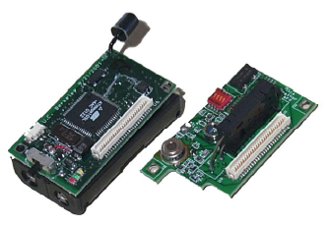

Figure 1 – Mica2 mote and sensor board

A sensor board can be configured to collect barometric pressure, temperature, relative humidity, acceleration, light intensity, and GPS tracking information. Physically the board connects to the Mica2 mote using a 52 pin connector. Figure 1 shows the Mica2 mote at left and the sensor board at right. Note the battery pack on the bottom side of the Mica2 mote.

The motes transmit information directly to the first responders or relay information [inter-mote] to a gateway or base station. The central location can be used to sift through the raw data in order to provide a concise message to the first responder’s mobile ad hoc network (MANET) device, such as a PDA.

First Responder – Orange Team
base station
mote
0101
First Responder – Green Team
First Responder – Blue Team

Figure 2 – Example Architecture of FRSN

2.2 TinyOS and Active Message

The sensor network is constrained by power and therefore computational complexity is limited. The widely used TCP/IP network protocol cannot be used because the sensor network requires simplicity in computation, implementation, routing algorithms. Recall, above the Mica2 mote is running an operating system for sensor networks. This operating system, TinyOS, is event driven; it uses low power, has a small memory footprint, and supports Active Message (AM) message-based communication protocol. Sensor nodes send messages whose header contains the handler to be invoked on the destination node and a data payload. The handler extracts the message from the network, performs the computation, and if necessary will send a response message to sender node. The reader should refer to available references for precise, low level detail.

2.3 Applied Technology

To the credit of the pioneers of WSN technology are the real world applications and documented case studies. WSN currently assist in habitat monitoring, wildfire prevention and monitoring, and soon to be first responder’s ‘lifeline’.

The FRSN, or lifeline, similar to all engineering problems can be decomposed into smaller units. The unit that is under analysis deals with the inter-mote communication. The wireless communication is achieved via radio signal transmission. Because radio signals are low powered, the signals are easily obstructed by solid objects such as walls, floors, and ceilings.

And now the problem presents itself: where to spatially place the motes in locations that allow inter-mote communication to allow successful message propagation to the first responder.

Of course, the infinite conditions that exist for mote placement with respect to obstruction make simulation more attractive. Fortunately, a toolset exists for computer scientists to use: the TinyOS simulator, TOSSIM, compiles directly from TinyOS code and can be run natively on a PC. Thousands of nodes can be simulated under a variety of conditions that cost nothing more than computational time and resources which is arguably cheaper than actual construction and implementation. TinyViz provides a graphical user interface layer to the TOSSIM simulations and allows the computer scientist to visually inspect debug messages, radio messages, radio connectivity, and mote placement. In addition, TinyViz is highly extensile via a plugin application programming interface. The aforementioned radio message, radio connectivity visualizations are built-in TinyViz plugins.

3. RADIO SIGNAL OBSTRUCTION

Jeff Rupp extended the built-in TinyViz radio model plugin to include obstructions, i.e. walls, and their impact on inter-mote communication. The plugin allows observations in a 2-D space. Refer to the screenshot below and note the floor plan is similar to an architect’s blueprint. The values shown above the green lines represent the probability of successful packet transmission through the wall. Obstructions are defined with an input file that can be loaded into the simulator using the Load Obstructions button. The obstructions are two dimensional line segments with a specific attenuation. Motes attempting to send and receive messages that intersect with the obstruction experience radio signal loss proportional to the defined obstruction attenuation. Indeed, this is an enhancement of the radio model plugin which simulates message passing with distance as the only constraint.

Distance is still a factor and can be tuned using the Fixed Radius and Empirical propagation models. The former allows all motes within a fixed distance to have perfect connectivity and no connectivity for other motes. The latter is based on an outdoor trace of packet connectivity with the RFM1000 radios.

Rupp’s plugin extension is successful because it provides an additional real-world variable that would need to be addressed when deriving mote deployment strategies.

Rupp’s plugin can be modified further to account for radio signal reflection or signal distortion. In the next section, the basics of radio signal transmission: attenuation, reflection, and signal distortion are presented.

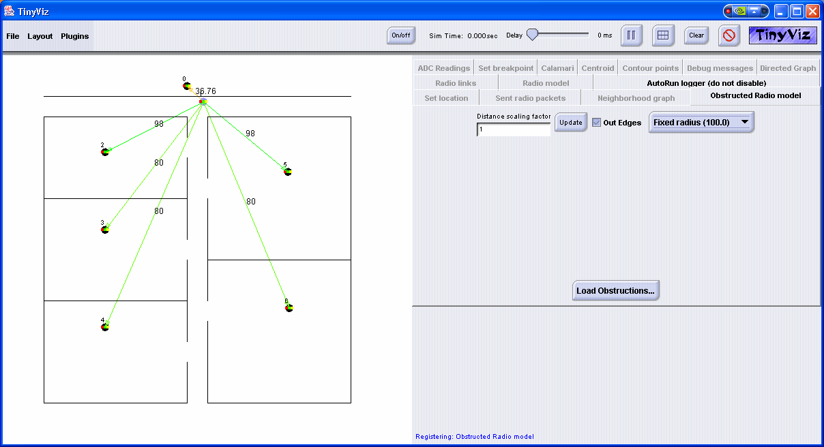

Figure 3 – TinyViz with Radio Signal Obstruction Plugin

4. RADIO SIGNALS – A PRIMER

Radio frequency (RF) signals lose strength over distance and through physical obstructions. The reduction in signal strength is called attenuation; it is rated in decibels and is defined mathematically as:

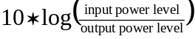

An example, a wall represents approximately 4db of attenuation if the input signal strength is 500 milliwatts and reduces to 250 milliwatts after passing through. An excessive amount of attenuation will lead to signal loss and consequently loss of information. In the application of the FRSN, signal loss translates to message loss that could endanger the lives of first responders and the lives needing rescue assistance.

Attenuation of indoor RF signals is complex to calculate. As the signals encounter obstacles they are reflected, diffracted, and scattered. Fortunately, the attenuation of common indoor obstructions is known. For example,

Material | Attenuation
Plasterboard wall | 3dB
Glass wall with metal frame | 6dB
Cinder block wall | 4dB
Office window | 3dB
Metal door | 6dB
Metal door in brick wall | 12.4dB

Table 1 – Known attenuation values

Another factor is distance: as a general rule of thumb, 802.11b radio signals operating at 11Mbps encounter 100dB of attenuation at 200 feet distance between sender and receiver. Note that the distance of this path decreases if obstacles are encountered; that is, 100dB attenuation will be reached at a distance less than 200 feet if obstructions intersect RF signal.

Realizing this real-world constraint, computer scientists need to be able to provide simulations that allow this variable to be tested against mote placement to improve mote placement. The type of RF signal transmission, i.e. 802.11b, represents another variable. The table below summarizes the variables that can be tuned with the included radio model plugin and Rupp’s obstruction radio model plugin.

Variables | Radio Model Plugin | Obstructed Radio Model Plugin
Distance | Yes | Yes
RF signal type | No | No
Obstruction attenuation | No | Yes
2D Obstructions | No | Yes
3D Obstructions | No | No

Table 2 – Plug-in variable coverage

Coverage of these variables can contribute to a more effective analysis, design, and implementation of mote placement strategies to discover optimal locations to increase successful inter-mote communication.

Now that the basics are covered, the precise goals for this research paper can be stated: discover solutions to enhance the Obstruction Radio Model plugin to provide tuning knobs for the following variables:
- RF signal type
- 3D obstructions, floor, ceilings, and walls (compound computation)
- More robust obstruction attenuation specification (signal type, distance)

5. ENHANCING

The first step is to understand the algorithms used in the radio model plugin. Here is the algorithm for the updateModel method.

1 Get all motes
2 Store in data structure. Call it sender.
3 While (sender has more elements) {
4 Get all motes
5 Store in data structure. Call it receiver.
6 While (receiver has more elements) {
7 Look at sender mote (x,y) coordinates
8 Look at receiver mote (x,y) coordinates
9 Calculate the distance. Call it D.
10 Calculate the packet loss rate for empirical/disc model
11 Store value in hashtable. SenderReceiver as key.
12 End inner while
13 End outer while

Figure 4 – updateModel algorithm

Line 10 calculates the probability of transmission using the propagation model, i.e. empirical, fixed radius, with distance and scaling factor as parameters. The empirical model implementation contains static values representative of historical data, on distances. The stored distances are part of a three-tuple that include a standard deviation and mean. Given a scaled distance between motes, the closet approximation to the stored distance tuple is selected. This 3-tuple is used in a Box-Muller transformation to derive a sample whose value represents the packet loss rate. Finally, on Line 11, the bit loss rate is calculated using the packet loss rate. The disc model is much simpler. The packet loss rate is all or nothing. If the scaled distance exceeds the fixed radius, then entire packet loss is experienced, else packet loss is not experienced. And the bit loss rate is equal to the packet loss rate.

Here is the algorithm for the publishModel method.

1 Get all motes
2 Store in data structure. Call it sender.
3 While (sender has more elements) {
4 Get all motes
5 Store in data structure. Call it receiver.
6 While (receiver has more elements) {
7 Lookup value in hashtable. SenderReceiver as key.
8 Value is packet loss rate
9 Use packet loss rate to calculate bit loss rate
10 Publish value for user
11 Lookup value in hashtable. ReceiverSender as key.
12 Value is packet loss rate
13 Use packet loss rate to calculate bit loss rate
14 Publish value to model
15 End inner while
16 End outer while

Figure 5 – publishModel algorithm

This method simply looks up the sender-receiver mote pair in the hashtable to find the packet loss rate. Then the bit loss rate is calculated and the value is made available to the model.

The user will see the packet loss rate as a probability of successful transmission by selecting one or more motes on the TinyViz GUI.

Rupp has modified the updateModel and publishModel methods to adjust the bit loss rate to account for obstructions. The algorithm for the adjustForObstructions method is stated.

1 For all obstructions
2 If sender mote and receiver mote intersect obstruction, sum attenuation
3 End For Loop
4 Computation Math.pow(10, (attenuation sum/20)) * 10;
5 Add this value to the bit loss rate
6 Return adjusted bit loss rate value

Rupp has also modified the draw method to draw the obstructions onto the TinyViz GUI. This method uses the Java 2D routines to draw a line given two XY coordinates.

5.1 Moving from 2D to 3D

Inspection of the Java3D API revealed enormous capabilities for expansion of the TinyViz GUI, though the scope to port this feature was beyond the scope of this single semester research project. If anything, this author was able to determine that major revisions would need to take place. Specifically, the motes coordinate system works in 2 dimensions and this seemed to be roadblock.

This author did not give up, instead tried to simulate 3-dimensional space in a 2-dimensional world. The best way to visualize this concept is drawing a cube on a piece of paper. We can trick the eye to a 3rd dimension of depth and we can even work in this model to a great extent. Recall, volumes in calculus? With this as a motivator, additional endpoints are specified in the data file, to include diagonals to give the z, or depth, dimension.

Now given a Line, the two endpoints are known. Furthermore, the two endpoints forming the line lie in exactly two planes. A table lookup determines the two planes and return the third endpoint. Now having three endpoints I can correctly define the plane and determine if the segment created by the two nodes intersects the plane.

A line-plane intersection algorithm has been implemented and tested for correctness. At a high level, the algorithm is stated.

1 Given three points, P0, P1, P2,
2 Calculate coefficients A,B,C,D
A) Vector0 = P1 - P0
B) Vector1 = P2 - P0
C) Normal = Vector0 x Vector1
D) A = Normal.x, B = Normal.y, C = Normal.z
E) D = -(A*P0.x + B*P0.y + C*P0.z)
3 from plane equation Ax + By + Cz + D = 0
4 calculate intersection

And refer to the following for implementation.

private void LinePlaneIntersectionTest() {
// Algorithm from http://www.cs.berkeley.edu/~hling/courses/cs284/final.html
// Consistent with algorithm from http://mathworld.wolfram.com/Line-PlaneIntersection.html

// (1) given three points, P0, P1, P2, calculate coefficients A,B,C,D
// from plane equation Ax + By + Cz + D = 0
// (2) calculate intersection

// (1a) Vector0 = P1 - P0
// (1b) Vector1 = P2 - P0
// (1c) Normal = Vector0 x Vector1
// (1d) A = Normal.x, B = Normal.y, C = Normal.z
// (1d) D = -(A*P0.x + B*P0.y + C*P0.z)

ThreeTuple P0, P1, P2;
P0 = new ThreeTuple(5,30,0);
P1 = new ThreeTuple(65,30,0);
P2 = new ThreeTuple(10,10,0);

ThreeTuple Vector0, Vector1;
Vector0 = P1.subtract(P0); // (1a)
Vector1 = P2.subtract(P0); // (1b)

ThreeTuple Normal;
Normal = Vector0.cross(Vector1); // (1c)

double A = Normal.x; // (1d)
double B = Normal.y; // (1d)
double C = Normal.z; // (1d)
double D = -(A*P0.x + B*P0.y + C*P0.z); // (1d)

//------

ThreeTuple endpoint1, endpoint2;
endpoint1 = new ThreeTuple(5,0,-1);
endpoint2 = new ThreeTuple(5,0,-1);

double distance1 = endpoint1.x*A + endpoint1.y*B + endpoint1.z*C - D;
double distance2 = endpoint2.x*A + endpoint2.y*B + endpoint2.z*C - D;
double flag = distance1 * distance2;

if (flag > 0f)
System.out.println("the line does not intersect plane"); // the two points are in the same side of the plane, no intersection
else { // the two points are in different sides of the plane, so there MAY be an intersection
double t = distance1 / ( distance1 - distance2);

double tempx = endpoint1.x + t * ( endpoint2.x - endpoint1.x );
double tempy = endpoint1.y + t * ( endpoint2.y - endpoint1.y );
double tempz = endpoint1.z + t * ( endpoint2.z - endpoint1.z );
System.out.println("the calculated intersection is (" + tempx + "," + tempy + "," + tempz + ")");
}
}

Figure 6 – Line-Plane Intersection Algorithm, Implemented and Tested

The algorithm above is successful but recall that the place is finite because we are dealing with walls. So really the question has become how to determine if a point is on a finite plane. This is where the virtual 3-D space was becoming cumbersome and scope of the project took precedence. Still though, it should be noted that this exploration has not hit a dead-end—a lot of ground work has been established and with time a solution will be determined.

Indeed a lot of time spent trying to move from 2 dimensions to three dimensions.

5.2 New Radio Signal Propagation Models

Both the TinyViz built-in and Rupp’s plugins use two propagation models: empirical and fixed radius. These have been briefly described above. But it would enhance this plugin to consider how the 802.11 RF signal can be modeled in TinyViz. A starting point has been made by creating a class WifiModel that implements the PropagationModel interface, similar to the empirical and fixed radius models. Further research must be performed in order to understand how bit loss and packet loss fit in the WiFi model.

6. IMPLEMENTATION

Several classes were created, compiled, and tested for some initial prototyping to confirm that the TinyViz plugin feature was as easily extensible as Rupp indicated.
- EnhancedObstructRadioModelPlugin.java is a starting point for extending Rupp’s plugin. It began as a copy of Rupp’s ObstructRadioModelPlugin class.
- WiFiModel.java is a new class that implements the PropagationModel interface, and therefore implements getBitLossRate and getPacketLossRate methods for use in the radio model plugin. The exact implementation of bit and packet loss rate is still under investigation.

Here is a screenshot of the prototyped enhanced radio signal obstruction plugin. Note the modified plugin name; WiFi propagation model; and Load 3D Obstruction button. Again, this is only a prototype ready for implementation of the enhancements stated in this research paper. This research project provides a significant building block once these implementation details have been worked.

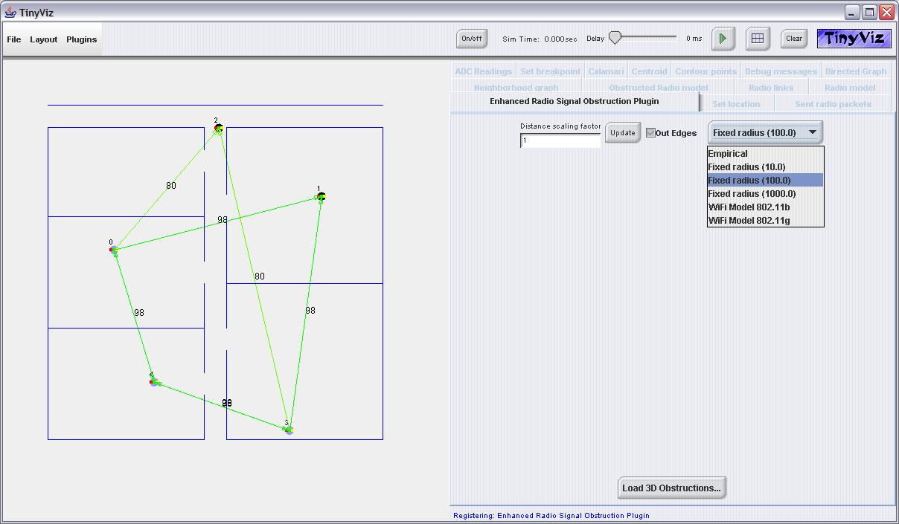

Figure 7 – Plugin Prototype

7. PROBLEM AREAS AND CONTINUED RESEARCH

Porting Java3D to the TinyViz simulator will take more time but significant groundwork has taken place. Recall, the implementation of the line-plane intersection algorithm.

Deriving the implementation details of the new WiFi radio signal propagation model will enhance this obstructed radio model plugin.

8. CONCLUSION

This has been a rewarding research assignment. I appreciate the technical and mathematical investigation that is necessary to understand the physical limitations of radio frequency signals with respect to real-world objects. These obstructions and distances are real factors that must be considered in any wireless sensor network deployment and I feel that this enhanced radio model plugin can become much more robust given more exploration time.

Rupp, Jeff. Radio Signal Obstruction Plug-in for TinyViz. CS526 Fall 2003. Department of Computer Science, University of Colorado at Colorado Springs. 1420 Austin Bluffs Parkway, Colorado Springs, CO 80933-7150.
List Document
Doolin, David M., Sitar, Nicholas. Wireless sensors for wildlife monitoring. Civil and Environmental Engineering, 440 Davis Hall, University of California, Berkeley, CA, 94720
Mainwaring, Alan, Polastre, Joseph, Szewczyk, Robert, Culler, David, Anderson, John. Wireless Sensor Networks for Habitat Monitoring. Intel Research Laboratory, Berkeley. EECS Department, University of California at Berkeley. College of the Atlantic, Bar Harbor, Maine.
Godavari, Ganesh. Chow, Edward, C. First Responders Sensor Network (FRSN). Final Report for NISSC Fall 2003 Project. Department of Computer Science, University of Colorado at Colorado Springs. 1420 Austin Bluffs Parkway, Colorado Springs, CO 80933-7150.
http://www.tinyos.net/tinyos-1.x/doc/tutorial/lesson5.html
Beating Signal Loss in WLANs. http://wi-fiplanet.com/tutorials/article.php/1431101
A. Mainwaring and D. Culler, Active Message Application Programming Interface and Communication Subsystem Organization. Computer Science Division, University of California at Berkeley, Draft Technical Report, 1995.

