Java-Based Adaptive Web Caching

Gregory A. Williams

Department of Computer Science

University of Colorado at Colorado Springs

1420 Austin Bluffs Parkway

Colorado Springs, CO 80933-7150

Email: gawillia@cs.uccs.edu

Keywords: Internet Computing, Proxy Server, Cache Server, Multicast, Java

Abstract

With the exponential growth of the Internet, the World Wide Web has caused traffic overload at origin web servers and along network paths. Modern solutions to this problem have largely been based on placing cache servers at points of traffic aggregation (network access points). This paper deals with the problem of data dissemination to thousands or millions of users on the Internet via some form of multicast delivery. The goal is to design and implement a cache server with protocols for a self-configuring, highly adaptive, globally distributed Web caching system. This paper discusses the use of IP multicasting for adaptive web caching and presents a “proof of concept” implementation of an Adaptive Web Caching Server. The server presented in this paper is based on the ideas discussed in the 1997 paper by Lixia Zhang, Sally Floyd, and Van Jacobson on adaptive web caching [FLOYD97]. This paper also discusses the details of the server’s implementation, setup and configuration. Finally a number of test cases are presented, which attempt to prove the self-configuring adaptive concept of the server.

Table of Contents

- Introduction
- Related Work
- Design
- Server Internals
- Implementation
- Configuration Directives
- Results
- Conclusion

List of Figures

- Figure 1 – Multicast Hierarchy
- Figure 1 – Server Architecture

1. Introduction

The amount of data on the World Wide Web is growing exponentially. Until recently it was believed that the problem of data dissemination to thousands or millions of users on the Internet was simply an issue of adding more resources, bandwidth and processing power to where they were needed. Unfortunately, information access has not been, nor will it likely be evenly distributed. The lessons learnt over the past few years have taught us that caching is the only way to handle the exponential growth of user demands. Floyd et al. [FLOYD97] believe that a multicast based adaptive caching infrastructure can meet this challenging need. In this paper we attempt to prove this “Web Multicasting” concept by developing a prototype proxy server that uses caching and IP multicast as the basic building block for the solution.
The basic idea is that when multiple users are interested in the same web page, the page should be fetched only once from the origin server and then disseminated via a multicast tree to all interested parties. Ideally each web page would travel through each network link no more than once. The main difference between multicast delivery for real-time multimedia applications and web requests is that users request web pages at different times. Thus, “web multicasting” needs to be done via caching. Cache servers store web pages and future requests for those pages are served from cache. The benefits of caching include reduced load at origin web servers and improved performance for end users. IP multicast is the first building block for the solution. IP multicast serves two purposes:
- It is the most efficient way to deliver the same data to multiple receivers.
- An information discovery vehicle. For example, a host can multicast a query to a relevant group when it does not know exactly whom to ask.

The proxy server presented in this paper will be configured to be part of an IP multicast group. Requests received by any server in the group will be multicast to the group in order to locate the nearest cache copy and page responses will also be multicast to the group in order to efficiently disseminate pages that have common interest. The idea is that groups will overlap in a hierarchy as described in Figure-1. Each server will also listen for regular unicast requests from clients. When a proxy server receives an HTTP request from a user, and the server currently has an un-expired copy of the requested content in it's local cache, the content will be immediately delivered to the user. If the server does not have the content in it's local cache, the server will multicast the request to it's neighboring proxy servers. If the server does not receive a reply from any neighboring proxy server within a specified timeout, the server will retrieve the content from the origin web server, dragging the content through its local cache and delivering the response to the user. In addition, these responses will also be multicast to neighboring proxy servers. If a multicast request received from a neighboring proxy server can be resolved, the response will be multicast back to the requesting proxy server. Since responses destined for users and proxy servers are heard by neighboring servers, these neighboring servers are able to receive and cache content requested elsewhere. This is where the Adaptive Caching mechanism comes into effect. Content can be dynamically spread to cache servers throughout the Internet, without those servers having to first request the data from the origin web server.
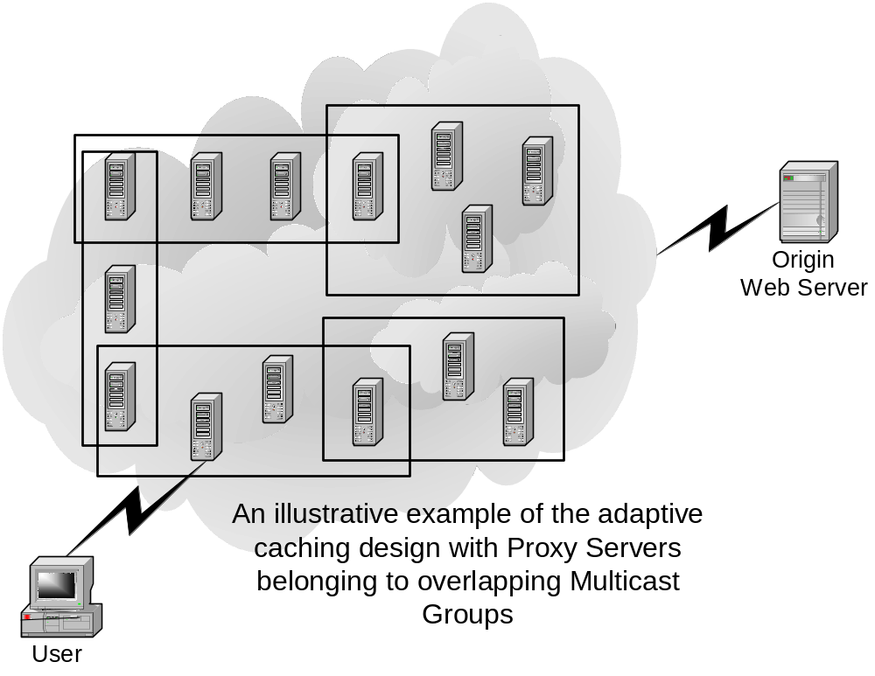
Figure 1- Multicast Hierarchy

2. Related work

The “Adaptive Web Caching” concept described by Floyd et al. [FLOYD97] provides the basic premise for this project. The authors suggest that origin web servers also participate in the multicast delivery of their content. In this project we will not impose that web servers use multicasting for the delivery of content. In this project will limit the multicasting activity to the proxy servers. Any content that cannot be found amongst neighboring proxy servers will be retrieved from the origin web server via unicast. This allows existing web servers on the Internet to be used with the system. Floyd et al. [FLOYD97] also provide bibliographic references to a scalable reliable multicast protocol known as SRM. The authors recommend that the system be built with SRM or its equivalent. Since this project is merely a proof of concept, the system will be developed using Java and rely on the multicast capabilities provided by the Java Platform API Specification [SUN02]. The advantages and possibly an implementation of reliable multicast can be a topic for further research.

The Squid Web Proxy Cache [SQUID02] is likely the most popular proxy cache software because it is freely available and runs on many Unix platforms. Squid acts as an agent, accepting requests from clients (such as browsers) and passes them to the appropriate Internet server. It stores a copy of the returned data in an on-disk cache. The real benefit of Squid emerges when the same data is requested multiple times, since a copy of the on-disk data is returned to the client, speeding up Internet access and saving bandwidth. Small amounts of disk space can have a significant impact on bandwidth usage and browsing speed. Hierarchies of Squid proxies are arranged in complex relationships. Squid has the ability to share data between cache servers in the hierarchy by implementing numerous inter-cache communication protocols, including ICP (Inter-Cache Protocol), Cache-Digests, HTCP (Hyper-Text Cache Protocol) and CARP (Cache Array Routing Protocol). Each of these protocols has specific strengths and weaknesses and administrators can choose which of these protocols to support. The main disadvantage of Squid is that peer configuration needs to be done manually by the administrator. If a new Squid server is added to the network, existing servers need to be configured by the administrator in order to incorporate the new server into the hierarchy. This approach limits the adaptive cache hierarchy proposed in this project where new servers can be added to the network without requiring any changes to existing servers.
There are many other research projects on web. The main reason for the abundance of research is the desire to improve caching systems as they can affect the cost and performance of the web today. Traffic on the web consumes more bandwidth than any other Internet service, and so any method that can reduce the bandwidth requirements is desirable, since this can reduce the cost of connecting to the Internet, especially in parts of the world in which telecommunication services are expensive to end users. Another common end-user requirement is improved performance. Web caching dramatically improves user latency. Brian D. Davison's Web Caching and Content Delivery Resources web site [DAVISON02] is dedicated to providing a comprehensive guide to various web caching research projects and caching resources.

3. Design

The principal design for our “Adaptive Web Caching” server is to have a daemon process that serves HTTP proxy requests on a configurable TCP port. The HTTP requests are serviced either from cache or from the origin web server. The server will behave very much like any HTTP cache server, such as Apache Web Server [APACHE] with “mod_cache” installed, such that web content can be cached locally to improve the performance for end users. Since the primary goal of this project is a proof of concept for the Adaptive Web Caching concepts presented in [FLOYD97], this server will not attempt to provide a complete working set of the Hypertext Transfer Protocol as described in [RFC 2616]. The principal difference between this server and regular cache servers is its “Adaptive” capability, using TCP multicasting.

The server will attempt to service the requests for web content from its local cache. Failing to find an un-expired copy of the requested document in its local cache, the server will first query any neighboring proxy servers in a multicast group for the document before retrieving the document from the origin web server. To determine if a cached document has expired, the “Expires” header field described in [RFC 2616] is checked. If a document is retrieved from a web server and the web server does not provide an “Expires” header field, the document is cached with a default expiry time of 15 minutes. This value can be adjusted in the servers configuration file. Web documents that are successfully retrieved by the server will be stored in the server’s local cache for subsequent client requests.

In addition to populating it’s local cache from content retrieved from either the origin web server or via replies from a neighboring proxy server, the server will also listen on a multicast socket for content being sent amongst proxy servers in the multicast group. Also, whenever a document is retrieved from an origin web server, after the document is sent to the requesting client, the server will share the document with its neighbors via multicast. In effect all servers in a multicast group will snoop web content served by neighboring proxy servers in order to populate their local cache. This is the essence of the server’s Adaptive capability. Even though a server in a group may be idle and not receive requests from clients, its local cache will still be populated from content being shared by other members of the group. In this manner, it is possible for a server to service a request from its local cache without having to first retrieve the document from the origin web server.

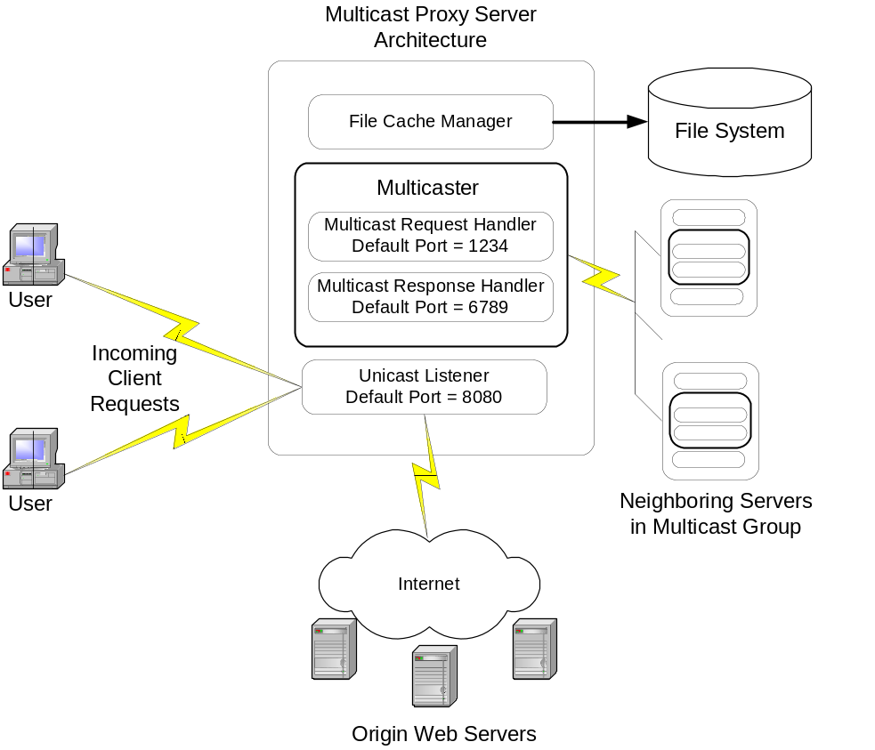
Figure 2 – Server Architecture

4. Server Internals

When the server starts execution, it will read its configuration data from a local file as described in the Configuration Directives section and begin listening for HTTP requests on local port. At startup, the server will also join the multicast group specified in its configuration file and snoop/share web content amongst neighboring proxy servers.

When a new request from a client arrives, the server will process the request in the following manner:
- The server will launch a thread to service the current request and immediately try to accept the next incoming request. In this manner, the server can handle multiple requests in parallel.
- The spawned thread will parse the HTTP headers and determine if the request method is a HTTP GET, as described in [RFC 2616].
- If the request method is anything other than GET, for example HTTP POST, a pass through function will be called to splice the users request with the origin web server without any further processing or caching of the results. The proxy is now simply acting as a bridge between the client and the origin server for the current request.
- If the parsed headers indicate that the request method is a HTTP GET, the server will first check its memory cache to see if the request can be serviced directly from memory. The in memory cache holds small un-expired web documents that are less than 8Kb in size. If the document is found in the servers RAM cache, the document is instantly written to the client and a log message is output to indicate that the document was found in RAM cache.
- If the document is not found in RAM, the server will check its local file cache for the document. A hashed key of the document’s URL indexes documents stored in both the file and memory cache for fast lookups. If an un-expired document is found in the local file cache, the document is read from disk and immediately written to the client. A log message is output to indicate that the document was found in DISK cache.
- If the document is not found in the server’s local file cache, the server multicasts a request packet to its multicast group. Any neighboring proxy server in the multicast group that receives the request packet will check their local cache and if the document is found, immediately send a multicast reply packet containing the un-expired web document. All servers in the group, including the requesting server will snoop the response packet and update their local cache.
- If the server does not receive a reply within a specified timeout, the server will retrieve the document from the origin web server and write the response to the client.
- If the document was retrieved from an origin web server, the response is stored in the server’s local cache and also shared with neighboring proxy servers via multicast.
- An appropriate log message is output for each action including all multicast requests/responses, origin web server requests/responses, local cache updates, etc.

5. Implementation

This section describes how to install and run the server, as well as how to download the application and source code. The code is well documented and the Java class documentation (JavaDoc) is available online at:
http://cs.uccs.edu/~gawillia/project/javadoc/index.html

In order to service many concurrent users, the code makes heavy use of threading, queuing and task scheduling. Instead of developing these primitives from scratch, an excellent third party open source library [LEA02] called “util.concurrent” was used. The source and documentation for this library can be obtained from the author’s web site:
http://gee.cs.oswego.edu/dl/classes/EDU/oswego/cs/dl/util/concurrent/intro.html

The complete working application can be downloaded from the following web page: http://cs.uccs.edu/~gawillia/project/adaptive.tar.gz

The project files contain the compiled and source code for the application together with a few helper files. To install the application, extract the archive into a directory and edit the configuration file conf/proxy.conf. Please refer to the “Configuration Directives” section for detailed documentation of how to edit this file. The application was developed with JavaSoft’s JDK version 1.4.0. In order to execute the server, ensure that the Java runtime 1.4.0 is installed in the current path. The JDK can be downloaded from:
http://www.javasoft.com/

To start the server, execute the following command:
prompt> java -jar adaptive.jar

Log records for the server are sent to standard output. If log records need to be kept for analysis, the server can be started by re-directing standard output to a file. For example:
prompt> java -jar adaptive.jar > logfile.txt

After starting the server, examine the log records to ensure that the server is operating correctly. The current configuration from proxy.conf, as well as some other start up messages will be printed.

In order to use the server, the client browser needs to be configured to point to the proxy server on the specified port. If you are using Internet Explorer, from the menu, select Tools, Internet Options and click on the Connections tab. Click the LAN Settings button, to configure the browser’s proxy settings. Refer to your browser’s documentation for more details. When a URL is retrieved using the server, the log records can be examined to see the server’s activity. Any web documents retrieved that are eligible for caching are stored in the cache directory. Examining the cache directory, to ensure that cache files are being created and that the length of the folders and file names conform to the settings specified in proxy.conf.

When a browser retrieves a web page, any embedded references in the web page are also retrieved. This can make it hard to do testing and makes it rather difficult to wade thru the many log records and cache files that are generated. Therefore, instead of using a web browser to perform tests on the server, a command line utility is included in the zip file to retrieve a single web page. For example, to retrieve the cs.uccs.edu home page, execute the following command:

java -Dhttp.proxyHost=localhost -Dhttp.proxyPort=8080 GetUrl http://cs.uccs.edu/

This utility makes it much easier to find log records associated with a single request and also to examine new entries arriving in the cache folder. This utility was used in the tests described in the “Results” section.

6. Configuration Directives

When the server starts, it will attempt to read configuration from a file called “proxy.conf”. This file must be present in a folder called “conf” in the local directory from where the server executed. The configuration file contains a number of directives, similar to the directives found in Apache Web Server [APACHE].

Port directive
Syntax: Port number
Default: Port 8080

Number is a number from 0 to 65535; some port numbers (especially below 1024) are reserved for particular protocols. See /etc/services for a list of some defined ports; the standard port for the server is 8080.

CacheRoot directive
Syntax: CacheRoot directory
Default: CacheRoot cache

Sets the name of the directory to contain cache files; this directory must be writable by the server.

CacheSize directive
Syntax: CacheSize kilobytes
Default: CacheSize 100000

Sets the desired space usage of the cache, in KB (1024-byte units). This directive is currently ignored.

CacheDirLength directive
Syntax: CacheDirLength size
Default: CacheDirLength 10

CacheDirLength sets the number of characters in proxy cache subdirectory names.

CacheFileLength directive
Syntax: CacheFileLength size
Default: CacheFileLength 10

CacheFileLength sets the number of characters in proxy cache file names.

MulticastGroupAddress directive
Syntax: MulticastGroupAddress ip-address
Default: MulticastGroupAddress 228.5.6.7

The multicast group IP address for the server in accordance with [RFC1112]. Current addresses are listed at Internet Assigned Number Authority [IANA].

MulticastRequestPort directive
Syntax: MulticastRequestPort number
Default: MulticastRequestPort 1234

Number is a number from 0 to 65535; some port numbers (especially below 1024) are reserved for particular protocols. See /etc/services for a list of some defined ports; the standard multicast request port for the server is 1234. This is the port on which the server will send requests to neighboring servers in the same multicast group when requesting web content.

MulticastResponsePort directive
Syntax: MulticastResponsePort number
Default: MulticastResponsePort 6789

Number is a number from 0 to 65535; some port numbers (especially below 1024) are reserved for particular protocols. See /etc/services for a list of some defined ports; the standard multicast request port for the server is 6789. This is the port on which the server will receive web content replies from neighboring servers in the same multicast group.

CacheDefaultExpire directive
Syntax: CacheDefaultExpire minutes
Default: CacheDefaultExpire 15

If the document is fetched and does not support expiry times, then use the specified number of minutes as the expiry time.

ResponseWaitInterval directive
Syntax: ResponseWaitInterval milliseconds
Default: ResponseWaitInterval 50

The time interval in milliseconds used to check if a response has arrived from a neighboring server once a Multicast request has been sent.

MaxResponseWaitTime directive
Syntax: MaxResponseWaitTime milliseconds
Default: MaxResponseWaitTime 500

The maximum time in milliseconds to wait for a response from a neighboring server before retrieving the document from the origin server

7. Results

Many readers may be interested in the performance of the Adaptive Web Caching server proposed in this paper. Specifically, users may wish to see a performance improvement by pointing their web browsers to an instance of this server. However, performance measurements for this server are not readily applicable. The simple premise that web content is cached by the server and therefore the content does not have to be retrieved from the origin web site implies a performance advantage for the user. The actual performance metrics of the server are subject to a number of external factors, such as the hardware platform where the server is running, CPU speed and available memory etc. Also, the application was developed in Java and the server’s performance ultimately comes down to how fast a cached file can be retrieved from disk and sent to the user. For these reasons, tests that extract performance and benchmarking figures were not implemented. Instead, the true success measures for this system, is whether the problem of data dissemination is addressed. If data can be retrieved from an origin server and then be made available to many users without those users all having to retrieve the content from the origin server, then we have a success story.

In order to prove that this system is a viable solution the problem described above, the tests conducted in this project are tailored to conclude that we have a working system. Since this system is merely a proof of concept, the research can be extended to include optimizations for performance.

Test Case 001 – Stand-Alone Server

The first test performed was to run a single instance of the server to see if it works as a stand-alone cache server without being part of a multicast group. The successful outcome of this test is to see if the server successfully populates its cache with web content retrieved from an origin server upon users first request and then delivers the content from its cache on subsequent requests for the same content.

To execute Test Case 001:

- Remove all files from the cache directory
prompt> cd cache
prompt> rm –rf *
prompt> cd ..

- Start the server
prompt> java -jar adaptive.jar

- Configure web browser’s proxy server settings to point to the server’s host and port. Retrieve an arbitrary web page, e.g. http://cs.uccs.edu/. Alternatively, use the utility described in the implementation section as follows:
java -Dhttp.proxyHost=localhost -Dhttp.proxyPort=8080 GetUrl http://cs.uccs.edu/
Check servers log records to see if the content was retrieved from origin server. Search the server log for:
“Retrieving document from origin web site: http://cs.uccs.edu/”.

- Check the cache directory on the server to see if any files have been created.
prompt> ls -lR cache

- Hit Shift-Reload in web browser to retrieve the web page again (or re-run the command line utility)
- Check servers log records to see if the content was retrieved from cache. Search the server log for “Found document in DISK cache: http://cs.uccs.edu/”.

Test Case 002 – Multiple Cache Updates

The next test performed was to run two or more instances of the server to see if the server shares any cacheable content retrieved from an origin server with neighbors via multicast. The successful outcome of this test is to see if the other servers in a multicast group successfully populate their cache with web content received from a neighboring server without explicitly requesting the content. The final measure of success in this test is to see if the other servers deliver the content from their cache on first requests for the content without contacting the origin server.

In this test case, we need to start the server on two separate hosts. It is possible to do these tests on the same host as long as the servers use a different port. In this test we started two servers on hosts “cs.uccs.edu” and “crestone.uccs.edu” respectively.

To execute Test Case 002:

- Start two (or more) servers and retrieve a web document via one of the servers by repeating steps 1 – 4 in Test Case 001
- Check neighboring servers log records to see if the content was received. Search the server log for:
“Received a document from a neighbor: http://cs.uccs.edu/”.
- Check the cache directory of the neighboring servers in the group to see if the document has been stored in their local cache.
- Retrieve the same web page by pointing to a different proxy server in the multicast group and ensure that this server does not retrieve the document from the origin web site. Search the server log for:
“Found document in DISK cache: http://cs.uccs.edu/”

Test Case 003 – Retrieve Content from Group

In this test will ensure that the server requests web content from its neighbors before contacting the origin server. We will add a new server to the multicast group on a different host, sanluis.ccs.edu. If successful, the new server will service a user request without needing to contact the origin server, even though its cache is initially empty as the new server will retrieve the web document from it nearest neighbor.

To execute Test Case 003:

- Start a new servers and retrieve a web document via the new servers by repeating steps 1 – 4 in Test Case 001
- Verify that the server does not retrieve the document from the origin web server. Search the server log for:
“Found document in DISK cache: http://cs.uccs.edu/”

Test Case 004 – Adaptive Caching

The final test is optional, since this concept was already proved in previous tests. In this test we simply add more servers to a group, or add a new multicast group with one server overlapping each group as depicted in Figure-1. The success measure of this test is to realize that there is no need to re-configure or restart any existing servers running.

To execute Test Case 004:

- Simply repeat Test Case 003 for as many hosts and ports you may have available. Try and tweak the timeout values in the various servers’ configuration files to improve performance and the overall scalability of the entire system.

8. Conclusion

Each of the tests described in the previous section were successfully executed. The results show that Multicasting is viable solution to adaptive caching. Future research can extend the test cases presented to create many more multicast groups to see if the system scales beyond the simple scenarios presented in this prototype. Future research can also attempt to include origin web servers in the Multicast conversation and possibly enhance the multicast protocol to work with ICP or CARP used in [SQUID] cache servers. For the purposes of this project, the goal was to provide a proof of concept and this was indeed achieved.

9. References

- [APACHE] Apache Web Server http://www.apache.org/
- [FLOYD97] Lixia Zhang, Sally Floyd, and Van Jacobson, "Adaptive Web Caching," April 25, 1997.
- [RFC 2616] Hypertext Transfer Protocol - HTTP/1.1, Request for Comments http://www.ietf.org/rfc/rfc2616.txt
- [RFC 1112] Host Extensions for IP Multicasting, Request for Comments http://www.faqs.org/rfcs/rfc1112.html
- [IANA]: Internet Assigned Number Authority, Internet Multicast Addresses http://www.iana.org/assignments/multicast-addresses
- [LEA02] Doug Lea, Concurrent Programming in Java http://gee.cs.oswego.edu/dl/classes/EDU/oswego/cs/dl/util/concurrent/intro.html
- [JAVADOC] Adaptive Proxy Servers detailed source code documentation. http://cs.uccs.edu/~gawillia/project/javadoc/index.html
- [SUN02] Java Platform API Specification http://www.javasoft.com/
- [SQUID02] Squid Web Proxy Cache http://www.squid-cache.org/
- [MALPANI95] Radhika Malpani, Jacob Lorch and David Berger, Making World Wide Web Caching Servers Cooperate Proceedings of the Fourth International World Wide Web Conference, Boston, December 1995. http://bmrc.berkeley.edu/research/publications/1995/138/138.html
- [DAVISON02] Brian D. Davison's Web Caching and Content Delivery Resources http://www.web-caching.com/

