Skype and SIP PBX Interoperability

Troy L Hutchison

CS525
DR Chow
Saturday, May 08, 2010

Skype Connecting SIP
Introduction
The purpose of the paper is to research the advantages of using Skype in conjunction with SIP enabled PBX system.
What is Skype
Skype is Voice over IP system that allows the subscriber to make call over the Internet to other Skype subscriber or to regular phone lines. The basic services of Skype are free, the more advanced features of Skype are offered at a cost.
The founders of Skype, Niklas Zennstrom and Janus Friis are not novices to distributed systems. Their first poplar program was the worlds most downloaded peer to peer file sharing program Kaza. They eventaly sold Kaza after being sued the the music and movie industry.
They leveraged their peer to peer systems to develop a peer to peer Voice Over IP phone system. They decided to develop a phone system the did not charge based to the distance between the callers. The business modle they chose would allow the peer to peer calls to be free and charge of additional feature like voice mail and the ability to call regular land and moble phones. The decentrlized model reduces cost by removing the expensive telephone routing equipment and allows the users computers to communcate directly through a peer to peer network. Only the Skype logon server and other premium services are routed through Skypes centerlized servers.
One of the features of Skype that make very attractive is the simplicity of the installation and its ability to work in a NAT environment and behind a firewall. Other reason Skype is very poplar is due to its ability to run on older hardware and a large varity of operating systems.
The ability to route peer to peer calls from NAT-ed clients behind firewall is achived by turning some clients that are not NAT-ed into super clients. Supernodes act as proxies to transmit calls for computers that are behind restrictive firewalls.
Skype call quality are outstanding due to the fact Skype transmits the full human audio range of with frequency between 20 Hz and 20,000 Hz.. This surpasses the quality of the standard land line telephone. The typical telephone line has frequency response of 300 Hz to 3400 Hz.
Skype ordinary node and super nodes
A Skype ordinary node is a any computer running Skype.
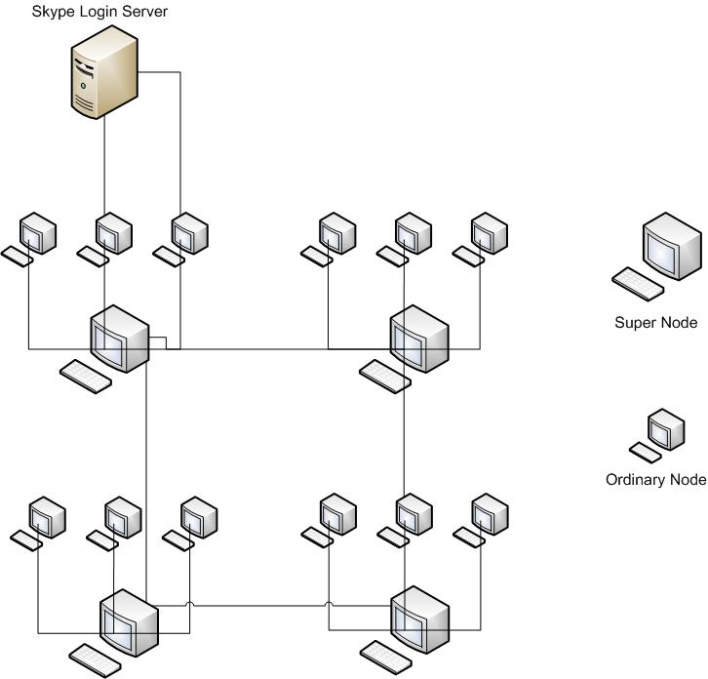

What is SIP PBX system
Session Initiation Protocol (SIP) SIP is a textbased application layer protocol which is easy-to-read and debug. SIP reuses existing protocols such as DNS, RTP, RSD etc.. Because SIP an application layer protocol it is transport layer independent. SIP uses the User Datagram Protocol (UDP) for performance reasons as well as Transmission Control Protocol (TCP). This flexibility allows Internet connection without regard to the underlying infrastructure required to make the connection.

SIP Protocol
SIP is a application layer control network protocol used for Internet communation used for voice over IP, instaint messaging. Voice over IP is not a protocol its self, many different protocols can be used to support voice over IP. The guidelines for SIP were established by the Internet engineering task force irrecoverably transmission of voice video and instant messaging. IETF (Internet Standard) RFC 3261 SIP has become the most popular protocol being used in voice over IP. One of the reasons for this popularity is because sip uses plain text format and allows you to read and troubleshoot it voice over IP call much easier than in other protocol.

SIP supports five facets of establishing and terminating multimedia communications:
User location: Users can move to other locations and access their telephony or other application features from remote locations.
User availability: This step involves determination of the willingness of the called party to engage in communications.
User capabilities: In this step, the media and media parameters to be used are determined.
Session setup: Point-to-point and multiparty calls are set up, with agreed session parameters.
Session management: This step includes transfer and termination of sessions, modifying session parameters, and invoking services.

The Components of SIP
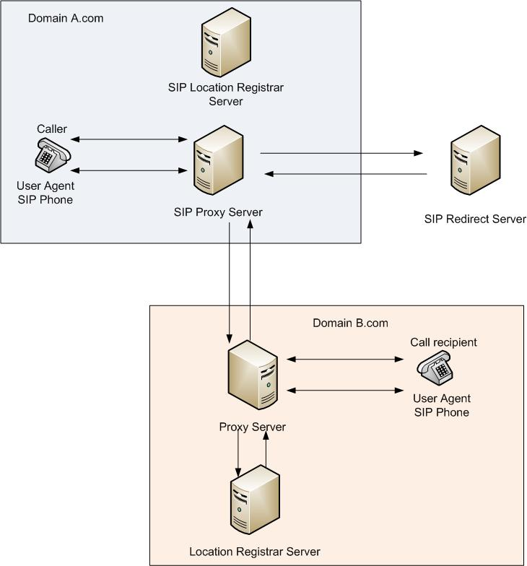

User Agents (UAs)
A user agent is end-user device used by the user to make the connection to the SIP session. End-user devices are classified as hard phones or soft phones. A soft phone is an application running on a user's personal computer. A hard phone is a SIP device that is similar to a traditional telephone that can be programmed to connect to a SIP server.

SIP Proxy Server
The role of the SIP proxy server is similar to that of a network router. The SIP proxy server ensures that the Invite request is sent to another proxy server closer to the receiving user agent. The SIP proxy server is an intermediary entity that acts as both a server and a client for the purpose of making requests on behalf of other clients. Proxies are also used to enforce policy (for example, making sure a user is allowed to make a call). A proxy interprets, and, if necessary, rewrites specific parts of a request message before forwarding it.

SIP Registrar and Location Server
The SIP registrar and location server is a server that contains a database that stores information about the user agents within the domain. The SIP registrar would be similar to the white pages in a phone book. When a SIP hard phone is programmed connected to the network and then booted it will sign in to the register server. The register server collects information about the phone including the phone's location so the server can route calls to the phone when the server receives an incoming request for that phone.
The SIP registrar also provides a location service which registers one or more IP addresses to the SIPS Uniform Resource Indicators SIP URI. The SIPS Uniform Resource Indicators are in the format of sips: username@hostname. When more than one SIP user agent is registered to the same URI, the result is all registered user agents will receive a call to the SIP URI.
SIP Redirect Server
When user agent requests are received by a proxy server and the receiving user agent is outside the domain. The proxy server sends the request to the redirect server. The redirect server will route the sending user agent request to the proxy server in the receiver’s domain.

The distinction between SIP servers is logical and not physical. All server sections (Proxy, Redirect, Location) are typically available on a single physical machine called proxy server, which is responsible for client database maintenance, connection establishing, maintenance and termination, and call directing.

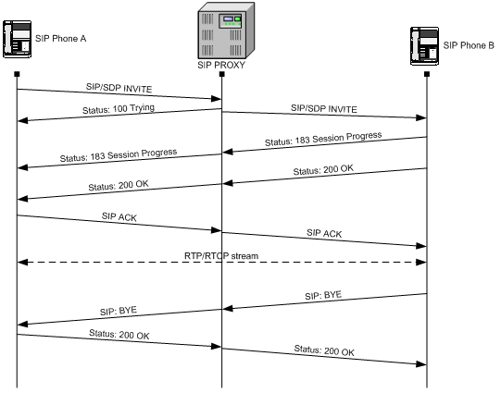
The above diagram demonstrates a typical SIP call. The user agent phone A sends the invite message to the proxy server, the proxy server forwards the invite message to phone B based on information stored in the registrar server. The address for phone B the looks similar to a e-mail address with the user name @ hostname. When phone B. gets the invite request from the proxy server phone B returns a status indicating that the phone is ringing. When the recipient picks up the phone B the status of 200 is returned indicating the connection is made. phone A will then send an. ACK to phone B. Once phone B receives the ACK the communication traffic will pass back and forth between phones A and phone B. When the call is completed and phone B is hung up phone B will send a Bye message. When phone A receives the bye message from phone B a status of 200 to acknowledge the Bye is sent and the session as closed.
SIP is similar to HTTP because it uses a similar request and response transaction model. Each client request invokes a method on the server and at least one response. The table below lists the methods and responses used by SIP.

SIP Methods
Command | Function
INVITE | Start a Call
ACK | Confirm final response
BYE | Terminate a call
CANCEL | Cancel searches and "ringing"
OPTIONS | Features support by other side
REGISTER | Register with location service and login
REFER | Transfer a Call
MESSAGE | Instant messenging
SUBSCRIBE | Notify presence

Response Codes
Response Code Prefix | Function
1xx | Searching, ringing, queuing
2xx | Success
3xx | Fowarding
4xx | Client mistakes
5xx | Server failures
6xx | Busy, refuse, not available anywhere

Connecting Skype to an SIP PBX
Skype establishes several preconditions prior to making the connection between a SIP PBX and Skype. Some of them include the SIP PBX must be Skype certified, a user account must be established in the Skype business control panel and the Internet connection must be capable of handling additional bandwidth.
SIP PBX Must be SKYPE Certified
When determining whether to make the connection between Skype and set a key factor to consider is the sip PBX must be certified for Skype. Skype maintains a list of certified PBX vendors on their website.
Account in Skype Business Control Panel
In order to use Skype for SIP the organization must have a SIP profile in the Skype Business Control Panel. This account is used to manage all the inbound and outbound call management.
To receive inbound calls from Skype a profile must be set up in the business control panel. All inbound calls will be routed to this profile. Skype will route the calls for this profile to the SIP PBX.
Internet connection capable of handling the additional bandwidth
Due to the increased network traffic Skype recommends the business have adequate network bandwidth to handle the additional traffic. Skype specifies that the Internet connection must be capable of handling 200 Mb per second.

Use a specialized SIP QoS-based router
Because of the additional network traffic Skype recommends the use of a quality of service-based router. This is to ensure that voice over IP traffic does not interfere with other network traffic.
A prepayment method
To use Skype for SIP the organization SIP account must have adequate funds to place calls. Skype highly recommends the use of the other charge option this is because Skype for SIP does not allow prepaid subscriptions for outbound calls. Each call will be billed to the SIP account based on the calling rate for that country. To keep the account sufficiently funded, Skype recommends using the auto pay method connected to a Pay Pal account.
Traditional fixed telephone line
It is not recommended to replace the traditional fixed telephone lines with a voice over IP service. Currently voice over IP does not support 911 services and does not work during power outages.
Conclusion
The benefits;
Some of the benefits of connecting Skype to your IP-based PBX are Skype phone rates on international calls are significantly cheaper than traditional phone lines when outbound calls are made through the Skype for PBX profile.
Local Skype international numbers
With a Skype for PBX account businesses can establish a local phone number in international locations for customers to dial locally to contact their business. This allows international customers to contact a business by making a free call in the business pays a substantially lower rate for the call versus an international toll call.
The ability for Skype users to call the Business by clicking on an icon
The biggest advantage is businesses have the ability to place an icon on their website that allows customers with Skype accounts to click on the icon and talk to the business for free.
The Risks;
While there appear to be some benefits by connecting SIP to Skype there are some significant risks that company must evaluate before making that decision.
The SIP PBX must use a public addressable IP
Skype for SIP requires the SIP PBX the assigned a public addressable IP. This makes the SIP PBX extremely vulnerable to hacking. In most organizations this is not a satisfactory configuration. To support this configuration organizations would have to stand up a SIP PBX strictly for use with Skype.
Skype for SIP calls are not encrypted
The biggest risk for companies implementing the SIP PBX /Skype interconnection is Skype for sip calls are not encrypted.

Based on my research I feel the risks are greater than the benefits. I would not recommend this solution. If a company would feel they could use Skype I would recommend they keep the Skype and SIP networks separate.

References
Bert Hayes, Skype: A Practical Security Analysis, October 9 2008
Network Working Group, SIP: Session Initiation Protocol, June 2002
Skype Limited 2009, Skype for SIP IT Requirements. 2009

