CS525 Multimedia Computing and Communications
S2010 Final Exam

Your name:____________________________________________
Attach your answers in this word document.
Email me your answers and make sure I receive your email submission before you leave the lab.

Problem 1. Media Synchronization and SMIL
- 15pts. In terms of synchronization specification categories (Interval-Based, Axes-Based, Control Flow-Based, Event-Based, Script) , how do you classify SMIL?
- 15pts. What is the Lipsync problem? Can we tolerate more if video is ahead of audio according to IBM studies? Should we use audio or video as a reference for synchronization?
The proposed SMIL standard is based on the basic hierarchical specification method and provides the following tags and attributes for specifying the synchronization among multimedia objects:
- Provide the "parallel" tag <par></par> where all the media objects specified within the tag will be played concurrently.
- Provide the "sequential" tag <seq></seq> where all media objects specified within the tag will be played in sequential. For example,
<seq>
<audio src="music.wav">
<video src="animate.mov">
</seq>
specifies that the animation video media object is played right after audio media object is played.
- Provide the "id" attribute in a media object tag for identifying the object and for the cross reference in synchronization. For example, in
<audio id="a" src="voice1.wav"> "a" will be used in other SMIL tags to reference this audio object.
- Provide the "begin" attribute in a media object tag for specifying the delay time that is either relative to the activity specified in the parent tag, or relative to other media objects. For example,
<par>
<audio id="a" begin="6s" src="music1.wav" />
<video begin="id(a)(4s)" src="video1.avi" />
</par>
specifies that the audio media object starts 6 seconds after the whole parallel group activity is scheduled to start. The video starts 4 seconds after the audio media object begins. id(a) denotes the audio media object.
- Provide clipbegin attribute to specify the starting portion of the media content to be played. For example, <audio src="CANYON.MID" clip-begin="3s" clip-end="5s" /> will play the canyon.mid file from third seconds to fifth seconds for a total of 3 seconds.
- 20pts. Use these SMIL tags and attributes to specify the following multimedia presentation: Starting music1.mid first, after 10 seconds of playing music1.mid, start the promotion.mp4 video file from the 15th second to the end, at the end of promotion video playback, start immediately the sound file “goUCCS.wav”.

Problem 2. Laban and Human Motion Specification
Given the following staff convention for specifying the movement, direction and level symbols, and the body signs
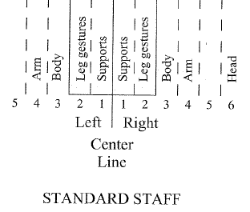 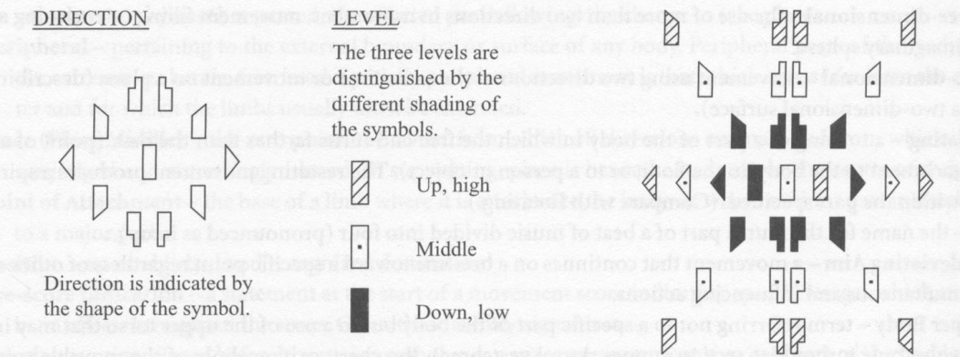 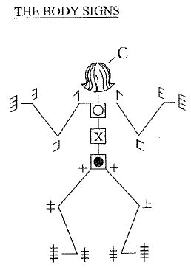 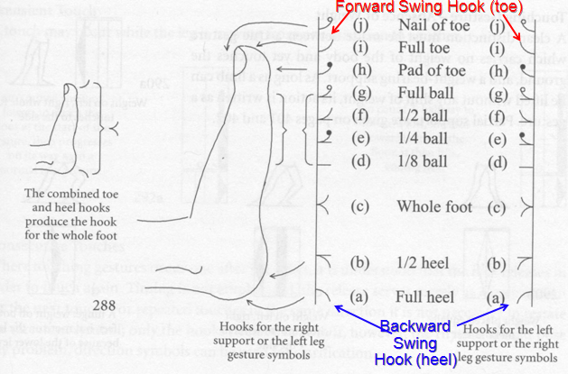
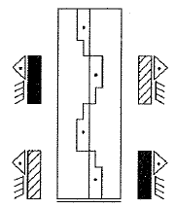 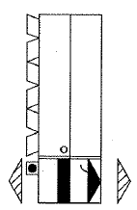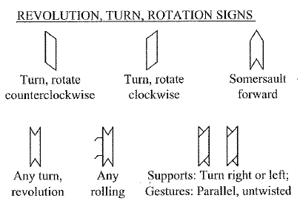
Figure 1. Figure 2.
- 15pts. Describe the dance specified by the Labanotation in Figure 1. What kind of dance is this? (Hint: from a country)
- 15pts. Describe the dance specified by the Labanotation in Figure 2. What kind of dance is this? (Hint: from a US state)
- 10pts. Like the MIDI, Labanotation has potential to become a standard for exchanging human motion data. For that to become a reality, discuss what tools are needed on both sending and receiving ends.
- 10pts. If we were to use a constant bit rate video encoding technique of 1.6 Mbps to capture the equivalent video image of the dance and assume one beat is one second, then we will generate 200kByte video data for just one beat. Make your own assumption about the encoding of labanotation for Figure 1. Based on that assumption, compute how many bits will be need to encode Figure 1 and what will be the compression ratio compared with that of the equivalent constant bit rate video file.
Problem 3. Basic questions in selective semester project presentations (Answer three of the following questions):
- In "Multicast media Streaming" project: What is WHIM? Why we use multicast in media streaming? What algorithm is important in ensuring the efficiency in the multicast streaming network?
- In "Apple iPad" project: What programming language is used in Apple iPad development project? What iPhone SDK Class is used to provide location coordinates an accuracy estimates?
- In "3D Methods in Film and Television" project: What are two recommended 3D methods to used in Theater and Home? What are the reasons?
- In "Speech Recognition using MATLAB" project: What are three major steps in recognizing a voice? What techniques are used to extract feature vectors in a speech? What technique is used to compare the extracted feature vectors to those of a set of known words?
- In "Silverlight" project: What is Silverlight? How it compares with flash?
- In "Audio Signal MIDI Transcription" project: What are the two phases of MIDI transcription processing?
- In "Skype to SIP Interconnection" project: Why we need to interconnect Skype with SIP based PBX? What are the current risks for doing that?
- In "H.264 codec" project: What are two parts of MPEG-4 standards covered in the semester projects? What are the compression ratios achieved in Adam's tests on these two codecs? How are they different from the basic MPEG-1 and MPEG-2 techniques?

