Evaluation of Vista Compared to Windows XP
By Heidi Parsaye

Project Research Paper
CS522
Computer Communications

In this paper I will compare Vista with Windows XP Home Addition based on the following Criteria:
USER EXPERIENCE
SECURITY
PERFORMANCE
NETWORKING
BACKWARD COMPATIBILITY

USER EXPERIENCE: Vista Claims that it uses familiar elements such as the Start Menu which features integrated desktop search through a new feature called Instant Search which can help find and launch almost anything on PC. Microsoft also believes that the new Start Menu makes it very easy to navigate across all of the installed applications. It also provides different information for ordinary people to understand and set up their computers. With new Live Icons (Scalable Thumbnails) which is used throughout Windows Vista, the first page of documents, the actual image of a photo, or the album art for individual songs in music collection, making it easier to find exactly what is user looking for.
Although it is easier to locate some files on Vista, I don’t believe this will give that much advantage to Vista over Windows XP. Changing the appearance is not adding value and I believe users need to learn how to use Vista. This is a draw back, especially for enterprises. I observed that it is easy to use Vista default. I had easier time to set it up as a novice user, but I have also realized that it might be harder for experienced user to use Vista. With Vista everything is at a different place known to a computer administrator. The administrator must relearn it again. Especially the popup messages are not very intuitive. Next I will show how Static IP setting is done on XP and on Vista; this is the how it is done on XP:
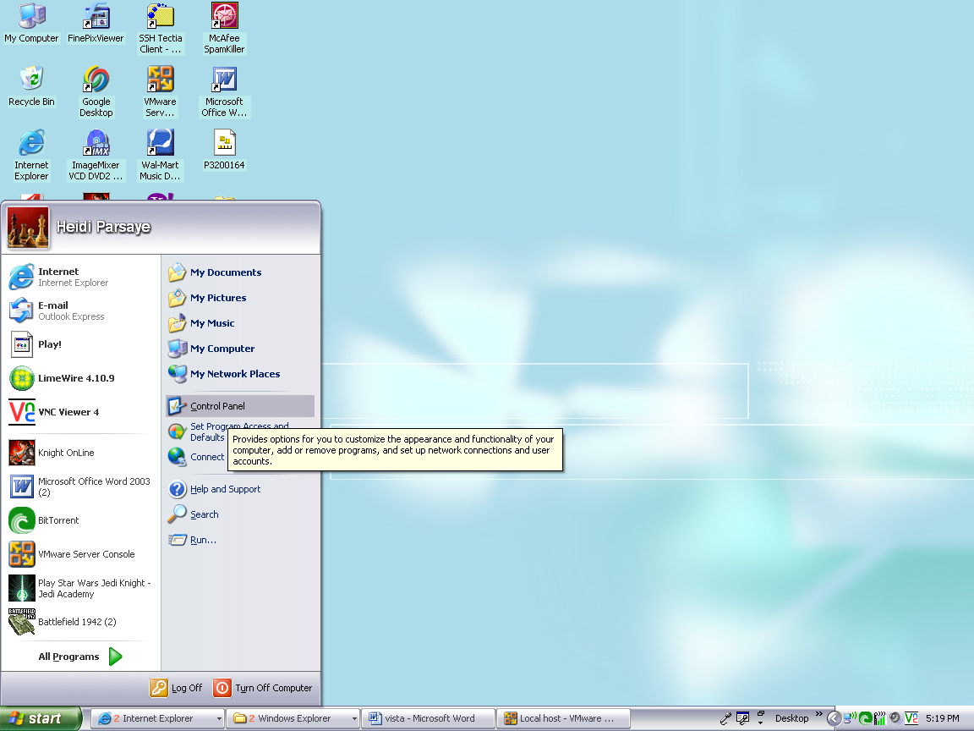
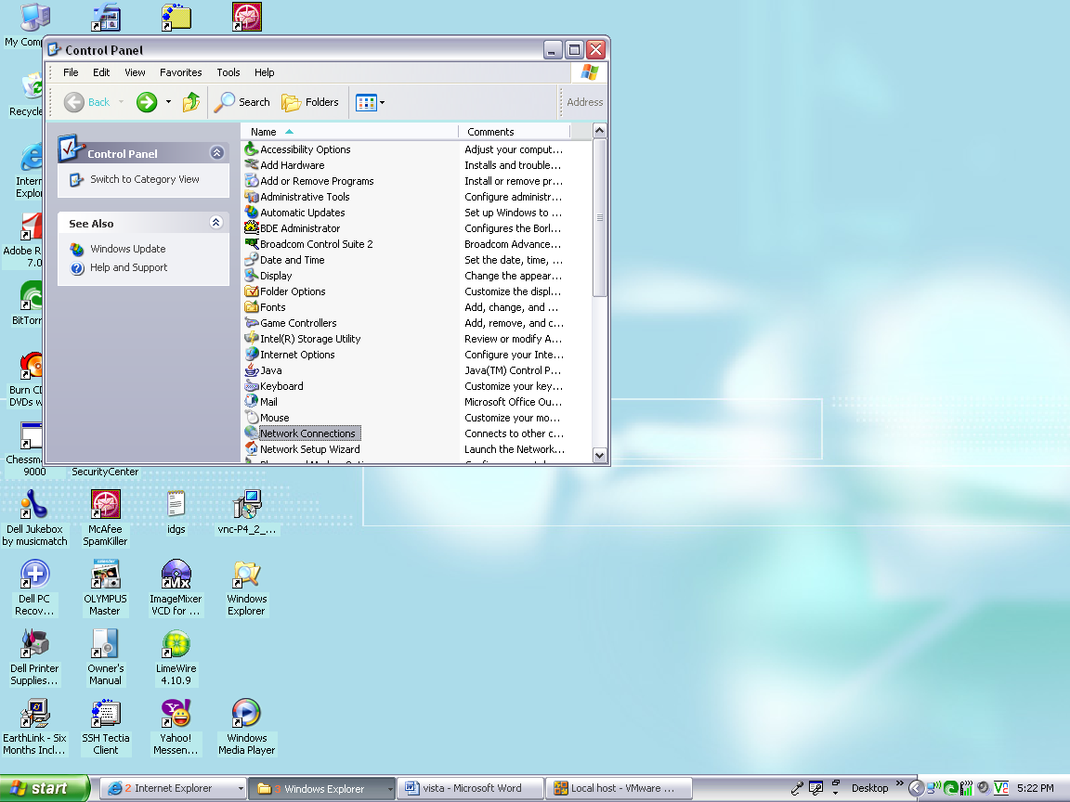
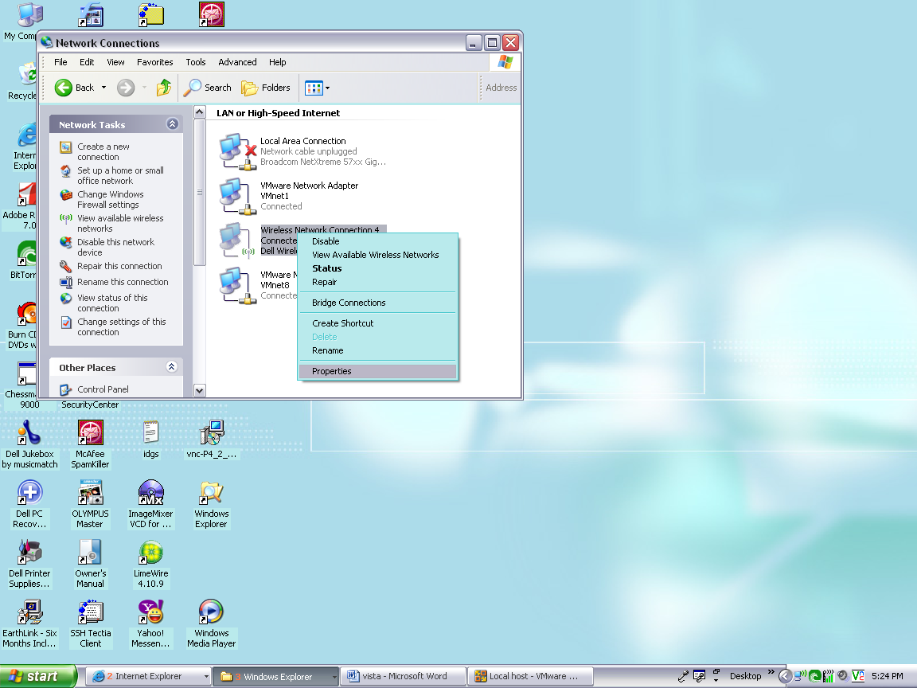

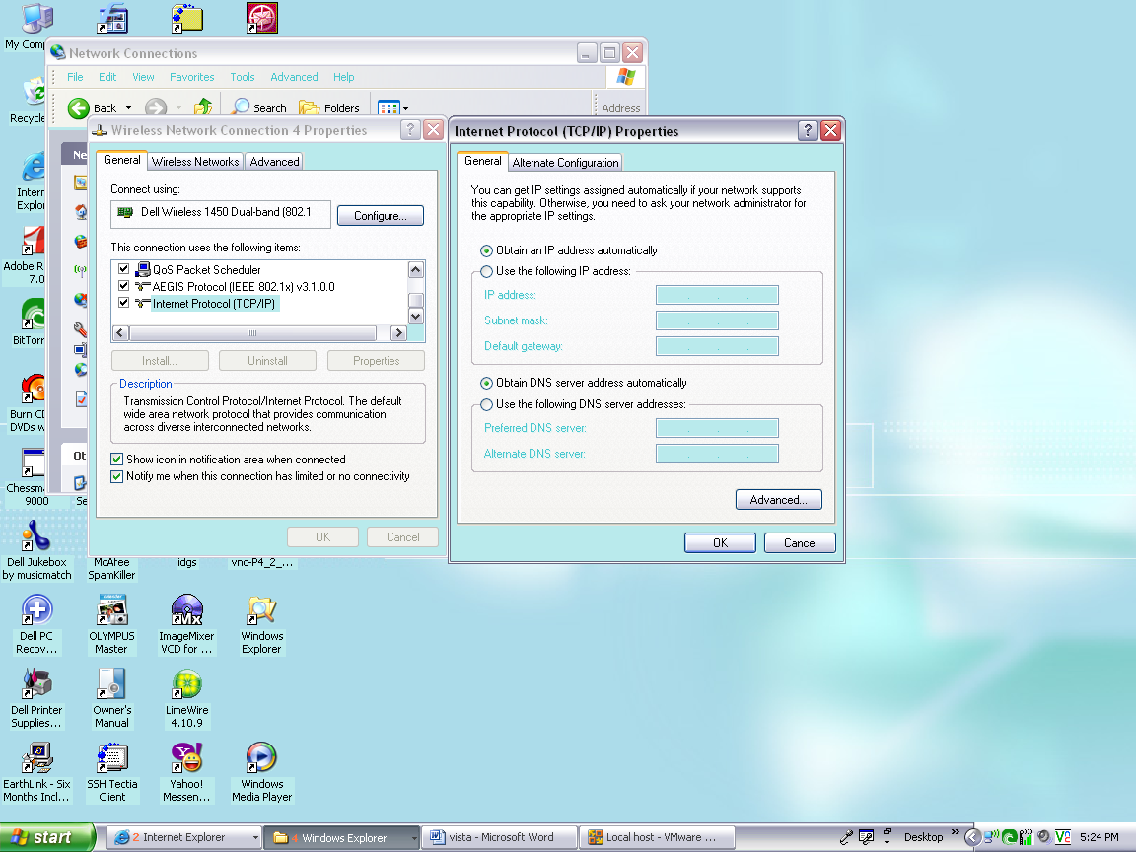

And this is how it is done through Vista:
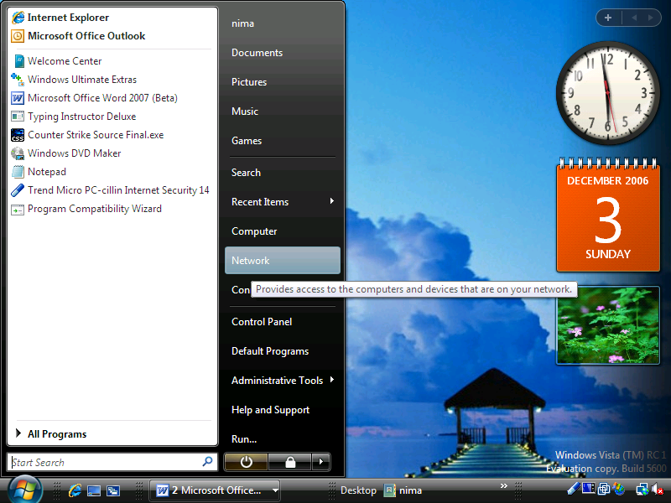
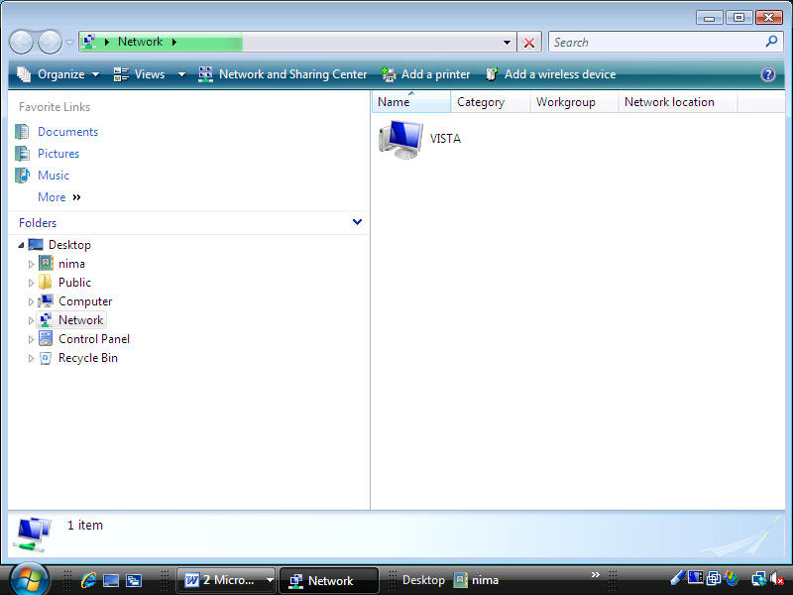
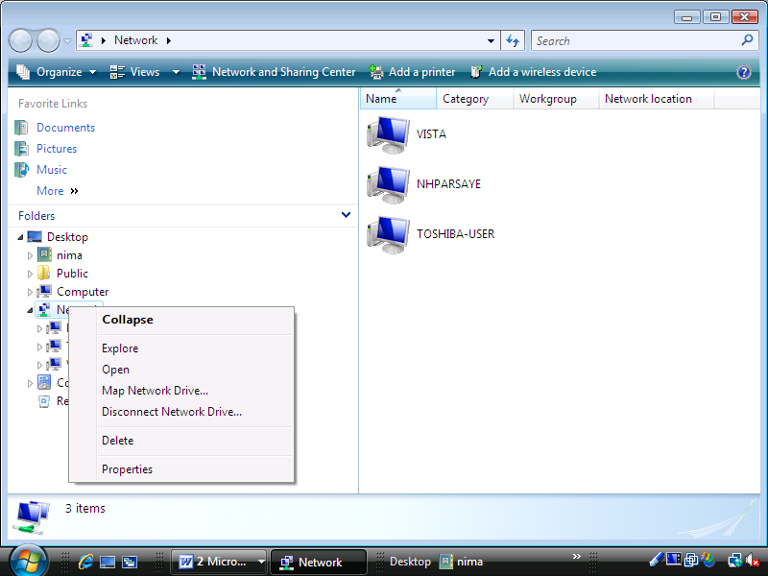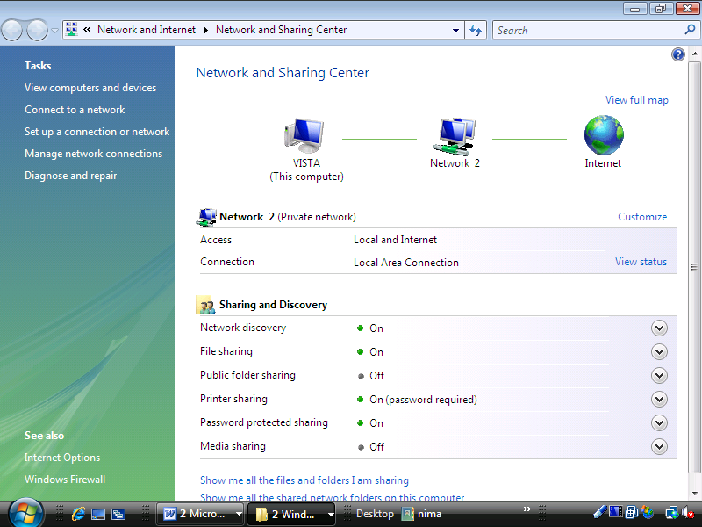
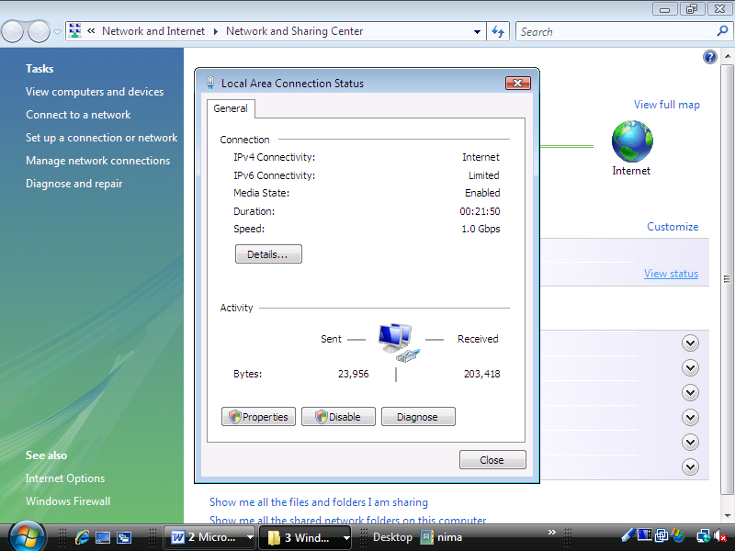
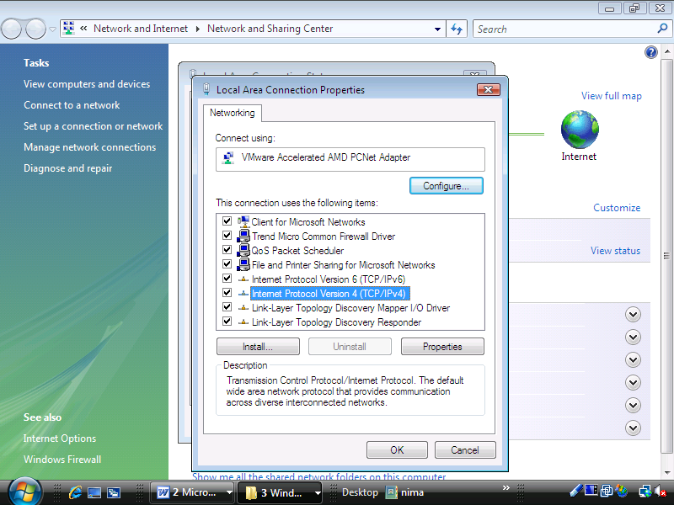
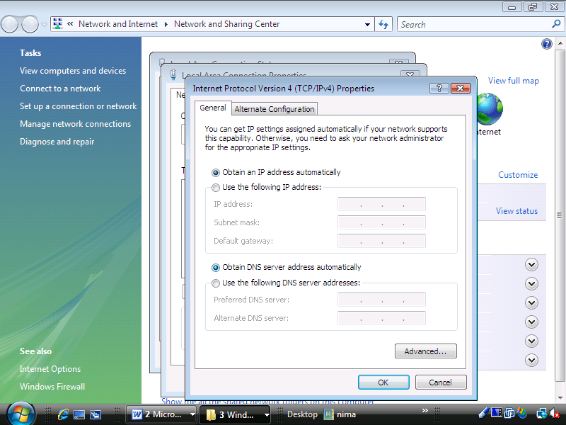

As shown above, Vista is not very intuitive and it might be confusing as well.
SECURITY: Security and stability are the most important features that everybody wants to see, and Vista is promising to deliver it. Vista claims that it is more secure than ever, with its 64-Bit Security Enhancements, Kernel Patch Protection and Mandatory Driver Signing.
The success of Vista is dependent on its security. Unfortunately, I was not able to test the Kernel and most of that has to be proved over time. The draw back is that Windows XP now has some of the features in Vista with the Service Pack and some of the other enhancements might be available outside of Vista like IE 7 and Office 2007 and Windows Defenders.
Microsoft claims that IE7+ is what comes with Vista with features that are only available with Vista.
I like Vista’s Parental Control. It gives a complete set of options for controlling children activities on Web including: Activity Reporting, Web Filtering, Time Limits, Games, Allow and block specific programs.
Window defenders also is a very useful tool which helps protect computer against pop-ups, slow performance, and security threats caused by Spyware and other unwanted software. It features Real-Time Protection, a monitoring system that recommends actions against Spyware when it is detected and minimizes interruptions and helps to stay productive.
Software Explorer in windows Defender help monitor the following functions:
Startup programs, Currently Running programs, and Network-connected programs, which are programs or processes that can connect to the Internet or to home or office network. Vista security is very user friendly and can be set up easily.

PERFORMANCE: I tested Vista using Virtual Machine. If I had to do this test over, I would install Vista on the actual PC to be able to test its performance thoroughly. I encountered many problems which were hard to decide if they were caused by VMware or the Beta Version of Vista. The following are a few quotes from other people regarding Vista performance: “Windows SuperFetch helps manage memory to get the most out of available RAM while Windows ReadyBoost helps make PCs more responsive by using Flash Memory devices (like USB thumb drives) to boost performance. Windows ReadyDrive takes advantage of new hybrid hard disks—hard disks with integrated flash memory—to help improve battery life, performance, and reliability. With Windows Vista, your system is ready when you are.

Windows Vista introduces a new power state called Sleep. The new Sleep State in Windows Vista combines the speed of Standby with the data protection features and low power consumption of Hibernate. Resuming use when PC is in the Sleep state takes just 2-3 seconds. It can be shut down and restarted less often by using the new Sleep State, a simple one-click on and off experience which not only reduces power consumption, but also helps protect data.

Sleep on desktop PCs
Sleep works in a different way on Windows Vista-based desktops than it does on Windows Vista-based laptops. When Windows id turned off, in Vista-based desktop, all the documents, applications, and data that are currently in use are saved in two places. First, they are saved to the memory, or RAM, where they are quickly accessible (in Windows XP this was called Standby). Simultaneously, the information is saved to the computer's hard disk (in Windows XP this was called Hibernate). In Sleep, Windows Vista simultaneously saves the current user information to both memory and the hard disk.
In Sleep, Windows Vista uses the data saved to memory to help restart faster after extended periods of non-use. Simply move the mouse or press any key on the keyboard and the computer starts up within seconds.
The Sleep state uses the data saved to hard disk to protect it in case of power loss. When resuming the use of desktop after a power failure, Windows Vista will quickly restart from Sleep using the data saved to disk, with all of data and applications intact.

Sleep on laptop PCs
On laptop PCs, one can enter the Sleep state by pressing the Power button or closing the laptop lid. Data is saved to memory, allowing restart faster. As battery power winds down, Windows Vista quickly transitions the data to disk to help keep the data safe. Windows Vista allows use of computer more quickly and reliably than previous versions of Windows.

Windows SuperFetch
Windows SuperFetch, a new technology in Windows Vista, allows applications and files to load much faster than on Windows XP-based computers. In previous versions of Windows, system responsiveness could be uneven. User might experience sluggish behavior after booting machine, after performing a fast user switch, or even after lunch. Although too many carbohydrates might slow you down after lunch, computer slows down for different reasons. When not actively using computer, background tasks—including automatic backup and antivirus software scans—take this opportunity to run when they will least disturb user. These background tasks can take space in system memory that applications were using. After starting to use PC again, it can take some time to reload data into memory, slowing down performance.
SuperFetch understands which applications are used most, and preloads these applications into memory, so system are more responsive. SuperFetch uses an intelligent prioritization scheme that understands which applications is used most often, and can even differentiate which applications you are likely to use at different times (for example, on the weekend versus during the week), so that computer is ready to do what you want it to do. Windows Vista can also prioritize applications over background tasks, so that when returning to machine after leaving it idle, it's still responsive.

Windows ReadyBoost
Adding system memory (RAM) is often the best way to improve PC's performance. More memory means applications can run without needing to access the hard drive. However, upgrading memory is not always easy. You need to know what type of memory is needed, purchase the memory, and open computer to install the memory—which sometimes can invalidate support agreements. Also, some machines have limited memory expansion capabilities, preventing addition of RAM.
Windows Vista introduces a new concept in adding memory to a system. Windows ReadyBoost lets users use a removable flash memory device, such as a USB thumb drive, to improve system performance without opening the box. Windows ReadyBoost can improve system performance because it can retrieve data kept on the flash memory more quickly than it can retrieve data kept on the hard disk, decreasing the time you need to wait for PC to respond. Combined with SuperFetch technology, this can help drive impressive improvements in system responsiveness.
Windows ReadyBoost technology is reliable and provides protection of the data stored on device. One can remove memory device at any time without any loss of data or negative impact to the system; however, if you remove the device, performance returns to the level previous level experienced without the device. Additionally, data on the removable memory device is encrypted to help prevent inappropriate access to data when the device is removed.

Windows ReadyDrive
Windows ReadyDrive enables Windows Vista PCs equipped with a hybrid hard disk to boot up faster, resume from hibernate in less time, preserve battery power, and improve hard disk reliability. Hybrid hard disks are a new type of hard disk, with integrated non-volatile flash memory.
The hybrid disk is intended for mobile PCs running Windows Vista. Your data is written to the flash memory, which saves work for the mechanical hard disk—saving the battery power. The hybrid disk helps Windows Vista resume faster from Sleep because data can be restored from flash memory faster than from the mechanical hard disk. And since more data is written to the integrated flash memory than to the traditional hard disk, one has less risk of hardware problems with the hard disk when on the move. Windows Vista takes advantage of hybrid hard disk to save battery life, resume use faster from hibernation, and improve reliability.”
Networking: Windows Vista networking is easier to set up, for ordinarily people which are using mostly the default features. It is not difficult to Connect wirelessly to your company's network, share an Internet connection and printers, copy files between computers.
Network Center—the central place for all your networking needs.
It has more visual display of the network on your computer, Network Center informs about the network computer is connected to and verifies whether it can successfully reach the Internet. It even presents this information in a summary in the Network Map so one can immediately see connectivity to the network and Internet. If a PC on the network loses Internet connectivity, one can graphically see that the link is down, and then use Network Diagnostics to help determine the cause of the problem and get a suggestion for a solution. Personally I how much of it is really a true benefit?
Network Center also allows quickly connecting to other available networks, or creating entirely new connections. User can view and configure most important network settings in one place. And for less frequently accessed settings, Network Center provides direct links so user can easily find what he is looking for.
Network Center also makes it easy to connect workplace network from home.
BACKWARD COMPATIBILITY:
I tried to install three different programs, Auto Cad 2006, Typing instruction and Counter Strike Source Game. I was not able to install any of them, but I am not sure if VMware was the cause, this is how Gamespot.com thinks about Vista compatibility,. “We had to see how our XP and older, classic games worked on Vista. We tested games from GameRanking's top-ten lists from the years 2000 to 2005, and we also tossed in a few notable games that were released prior to 2000 as well as a handful of games released this year.
We started testing with the GeForce 7900 GTX but quickly switched over to the Radeon X1900 XT after all the crashing games revealed that Nvidia's Vista drivers weren't quite mature enough for live testing. Note that this isn't indicative of Nvidia's final Vista performance levels. Overall, only twelve games failed out of the thirty-five we tested. Most games worked fine after we patched all of them in or to bring them up to date. A few games automatically disabled the 3D desktop in order to function, but most didn't require us to fiddle around with any Vista settings to work. We encountered severe issues in a few games that made them difficult to play, but the nature of the bugs and the fact that the games could run leads us to believe that the problems have more to do with the immature state of video card drivers for Vista. “
Compatibility with games is not as important as compatibility with other applications that are essential and not compatible with Vista at this time. These issues are promised to be resolved with the release of first service pack.
Summary: Windows XP is still good enough for most people; Service Pack 3 for Windows XP is long overdue and is expected to be released in 2008. The 64-bit edition of Windows XP will provide support for the accelerating adoption rate of 64-bit workstations. Until Microsoft officially stops supporting Windows XP, many customers may take a wait-and-see approach until Vista is more widely adopted and "proven" in the business market. Three years ago, when features like instant desktop search, integrated RSS capabilities, safe Web browsing, and security, Windows Vista was an easy sell, but today, all of these features and more are available on Windows XP (and in other OSes), so the argument for Windows Vista is somewhat weak, Windows XP is 100 percent compatible with all of the PC hardware and software out there. While you need to upgrade your hardware in order to get the most out of Vista . If you're a gamer, you want to purchase a new game title and not have to worry whether it will run more slowly on Windows Vista, or not at all or if the version of IE 7 included on Windows Vista doesn't work with your work place private Web site, all you'll know is that you can not upgrade to Vista. On the other hand, Windows NT-based OS releases have always pushed the existing hardware standards, and Vista is no exception. All of the requirements for Windows NT 4.0, Windows 2000 and Windows XP seemed steep when they were first announced; but they all became the standard entry-level workstation within a few months of release.
Just as users are finally getting used to Windows XP, Microsoft has made changes to the user interface and menus. It replaced the green start button with a round button with a Vista logo and no text. The Start Menu has been reorganized. Sub-menus have changed throughout the OS. IE 7 has a new look, new features and a new navigation menu that is sure to confuse and frustrate users. And, user access control pop-ups will have users calling the help desk asking what to do.
Like it or not, Windows Vista will be here by next year, and available pre-installed on PC systems. Then, Windows XP will only be available for another two years before it is discontinued.
This timescale means that companies cannot afford to sit on their hands and put off the difficult decision of whether to start an upgrade process to Windows Vista. The second question to ask is a much more problematic one: Do you have any choice?
REFERENCES:
Gamespot.com, Microsoft.com
ISSUES:drivers compatibility and cost.

