UNIVERSITY of COLORADO at COLORADO SPRINGS
IMPLEMENTING SECURE SOCKET LAYER (SSL)
PROTOCOL WITH JAVA’S
SECURE SOCKET EXTENSION
(JSSE)

A PAPER SUBMITTED TO
DR. EDWARD C. SHOW
IN PARTIAL FULFILLMENT OF
THE REQUIREMENT FOR
CS522 COMPUTER COMMUNICATION
DEPARTMENT OF COMPUTER SCIENCE
BY
SIDNEY I. RUBEY
COLORADO SPRINGS, COLORADO
DECEMBER 2002

Abstract
This paper will introduce the topics of Internet security, the Secure Socket Layer (SSL) protocol, public-key encryption, and will then discuss Java’s Secure Socket Extension (JSSE) implementation of SSL. An implementation of a secure server using JSSE, and the environment in which it was implemented, will then be presented. Finally, some benefits of using the pure Java implementation of SSL will be presented.

CONTENTS
ABSTRACT iii
LIST OF ILLUSTRATIONS vii
LIST OF TABLES viii
I. INTRODUCTION 1
II. SECURE SOCKET LAYER (SSL) PROTOCOL 1
OSI Model 2
Security Problems 2
Encryption 3
Keys 3
Digital Signatures & Hash 4
Certificates 5
SSL Handshake 6

III. JAVA’S SECURE SOCKET EXTENSION (JSSE) 8
javax.net.ssl 10
javax.net 10
javax.security.cert 10
IV. IMPLEMENTING “SID’S SECURE SERVER” 11
Introduction 11
Creating a Certificate 11
Importing a Homemade Certificate into the Keystore 11
Implementation of SecureServer.java 12
Establishing a Secure Connection to Sid’s Secure Server 13
V. CONCLUSION 14
Benefits of JSSE 14
WORKS CITED 15
APPENDICES 16
A. SecureServer.java 16
B. HTTPServer.java 17
C. index.htm 20
D. Screen shots from security alert, SecureServer, browser 17

ILLUSTRATIONS
1. Secure Socket Layer in the OSI Model 2
2. Structure of Classes in SSL Session 9

TABLES
1. Core classes & interfaces in javax.net.ssl 10

I. INTRODUCTION
With the growth of the internet and the natural expansion of its use, came the obvious problem of security related concerns. While its beneficial use cannot be denied, transmitting data over the internet without any degree of privacy can be unsettling, if not damaging. Further, as business developed applications for e-commerce and making sensitive personal information available over the internet, and the government’s transmission of sensitive data over the internet, the need for the Secure Socket Layer (SSL) protocol was obvious. Originally, developed by Netscape Communication Corporation as a proprietary product, it has become the industry standard for secure data transmission protocols. The Internet Engineering Task Force (IETF) developed the Transport Layer Security (TLS) in 1996 as a common use, industry standard for secure data transmission protocols. Originally intended to replace SSL, it has not caught on as anticipated because SSL had become used so extensively. In 2001, SunMicrosystems developed its own implementation of the SSL as Java Secure Socket Extension, or JSSE. It was included in the Java 2 development kit, 1.4.0, and available to previous releases of Java 2 as a separate extension. [ANO01]
II. SECURE SOCKET LAYER (SSL) PROTOCOL
The Secure Sockets Layer (SSL) is a commonly used protocol for managing the security of a message transmission on the Internet. SSL uses a program layer located between the Internet's Hypertext Transfer Protocol (HTTP), in the Application layer, and Transport Control Protocol (TCP) layer, in the Network layer. SSL is included as part of both the Microsoft and Netscape browsers and most Web server products. Developed by Netscape, SSL also gained the support of Microsoft and other Internet client/server developers as well and became the de facto standard until evolving into Transport Layer Security. The "sockets" part of the term refers to the sockets method of passing data back and forth between a client and a server program in a network or between program layers in the same computer. SSL uses the public-and-private key encryption system during the SSL handshake, and symmetric key encryption once the secure session has been initiated, and also includes the use of a digital certificate. [HEL02]
OSI Model
As previously mentioned, SSL sits between the HTTP and TCP layers.
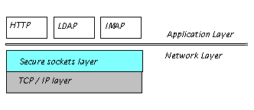
SSL in the OSI Model (Fig. 1) [HEL02]
Security problems
The main security issues as pertaining to the Internet can be grouped in to three general categories. Each of these security issues are addressed in SSL.
- Eavesdropping. Information remains intact, but its privacy is compromised. For example, someone could learn your credit card number, record a sensitive conversation, or intercept classified information.
- Tampering. Information in transit is changed or replaced and then sent on to the recipient. For example, someone could alter an order for goods or change a person's resume.
- Impersonation. Information passes to a person who poses as the intended recipient. Impersonation can take two forms:
  - Spoofing. A person can pretend to be someone else. For example, a person can pretend to have the email address srubey@uccs.edu, or a computer can identify itself as a site called www.freeGift.com when it is not. This type of impersonation is known as spoofing. [ANO98]
  - Misrepresentation. A person or organization can misrepresent itself. For example, suppose the site www.RubeyFurniture.com pretends to be a furniture store when it is really just a site that takes credit-card payments but never sends any goods.
The eavesdropping issue is addressed in SSL using encryption and decryption, which makes use of public-key cryptography; the tampering issue is addressed by the use of a hash function; and the misrepresentation issue is addressed by the concept of certificates. Each of these concepts will be introduced, and how JSSE includes these will specifically be addressed in the discussion of the implementation of the secure server. [ANO98]

Encryption
Encryption is the process of transforming information so it is unintelligible to anyone but the intended recipient. Decryption is the process of transforming encrypted information so that it is intelligible again. A cryptographic algorithm, also called a cipher, is a mathematical function used for encryption or decryption. With most modern cryptography, the ability to keep encrypted information secret is based not on the cryptographic algorithm, which is widely known, but on a number called a key that must be used with the algorithm to produce an encrypted result or to decrypt previously encrypted information. Decryption with the correct key is simple. Decryption without the correct key is very difficult, and in some cases impossible for all practical purposes.
Keys
There are different schemes for the use of keys. One scheme is to use the same key for encryption and decryption, called symmetric key encryption. This scheme is the most efficient, but is only useful if both sender and recipient are able to keep the key private. Symmetric key encryption plays an important role in the SSL protocol. Once the SSL handshake has been completed and a secure communication established, the session transfers to symmetric key encryption for better efficiency. [ANO98]
Public-key encryption (also called asymmetric encryption) involves a pair of keys--a public key and a private key. This scheme lets you freely distribute a public key, and only the originator will be able to read data encrypted using the corresponding private key. In general, to send encrypted data to someone, you encrypt the data with that person's public key, and the person receiving the encrypted data decrypts it with the corresponding private key. This is the scheme used in the SSL handshake portion of the secure transmission.
Digital Signatures and Hashes
The security issue of tampering with a data during transmission is addressed by the digital signature.Tamper detection relies on a mathematical function called a one-way hash. A one-way hash is a number of fixed length with the following characteristics:
- The value of the hash is unique for the hashed data. Any change in the data, even deleting or altering a single character, results in a different value.
- The content of the hashed data cannot, for all practical purposes, be deduced from the hash--which is why it is called "one-way."
As part of the transmission and data checking, the un-encrypted data is sent to the recipient, and the encrypted hash of the data is sent. This, along with some other information, comprises the digital signature. The means by which tamper detection is made is for the recipient to perform the one-way hash function on the un-encrypted data, and check this against the decrypted hash that was originally sent. If the two hashes match, then the the data arrived in it's original form. [HEL02]
Certificates
A certificate is an electronic document used to identify an individual, a server, a company, or some other entity and to associate that identity with a public key. Certificates work much the same way as any familiar form of identification. Certificate authorities (CAs) are entities that validate identities and issue certificates. They can be either independent third parties or organizations running their own certificate-issuing server software. The methods used to validate an identity vary depending on the policies of a given CA--just as the methods to validate other forms of identification vary depending on who is issuing the ID and the purpose for which it will be used. In general, before issuing a certificate, the CA must use its published verification procedures for that type of certificate to ensure that an entity requesting a certificate is in fact who it claims to be.
The certificate issued by the CA binds a particular public key to the name of the entity the certificate identifies (such as the name of an employee or a server). Certificates help prevent the use of fake public keys for impersonation. Only the public key certified by the certificate will work with the corresponding private key possessed by the entity identified by the certificate.
In addition to a public key, a certificate always includes the name of the entity it identifies, an expiration date, the name of the CA that issued the certificate, a serial number, and other information. Most importantly, a certificate always includes the digital signature of the issuing CA. The CA's digital signature allows the certificate to function as a "letter of introduction" for users who know and trust the CA but don't know the entity identified by the certificate. [ANO01]

SSL Handshake
The SSL protocol uses a combination of public-key and symmetric key encryption. Symmetric key encryption is much faster than public-key encryption, but public-key encryption provides better authentication techniques. An SSL session always begins with an exchange of messages called the SSL handshake. The handshake allows the server to authenticate itself to the client using public-key techniques, then allows the client and the server to cooperate in the creation of symmetric keys used for rapid encryption, decryption, and tamper detection during the session that follows. Optionally, the handshake also allows the client to authenticate itself to the server.
The steps involved in the SSL handshake can be summarized as follows:
  - The client sends the server the client's SSL version number, cipher settings, randomly generated data, and other information the server needs to communicate with the client using SSL.
  - The server sends the client the server's corresponding data, and other information the client needs to communicate with the server over SSL. The server also sends its own certificate and, if the client is requesting a server resource that requires client authentication, requests the client's certificate.
  - The client uses some of the information sent by the server to authenticate the server. If the server cannot be authenticated, the user is warned of the problem and informed that an encrypted and authenticated connection cannot be established. If the server can be successfully authenticated, the client goes to the next step.
  - Using all data generated in the handshake so far, the client (with the cooperation of the server, depending on the cipher being used) creates the premaster secret for the session, encrypts it with the server's public key (obtained from the server's certificate previously sent), and sends the encrypted premaster secret to the server.
  - If the server has requested client authentication (an optional step in the handshake), the client also signs another piece of data that is unique to this handshake and known by both the client and server. In this case the client sends both the signed data and the client's own certificate to the server along with the encrypted premaster secret.
  - If the server has requested client authentication, the server attempts to authenticate the client. If the client cannot be authenticated, the session is terminated. If the client can be successfully authenticated, the server uses its private key to decrypt the premaster secret, then performs a series of steps to generate the master secret.
  - Both the client and the server use the master secret to generate the session keys, which are symmetric keys used to encrypt and decrypt information exchanged during the SSL session and to verify its integrity.
  - The client sends a message to the server informing it that future messages from the client will be encrypted with the session key. It then sends a separate (encrypted) message indicating that the client portion of the handshake is finished.
  - The server sends a message to the client informing it that future messages from the server will be encrypted with the session key. It then sends a separate (encrypted) message indicating that the server portion of the handshake is finished.
  - The SSL handshake is now complete, and the SSL session has begun. The client and the server use the session keys to encrypt and decrypt the data they send to each other and to validate its integrity.
A client goes through the following steps to authenticate a server's identity:
  - Is today's date within the validity period?
  - Is the issuing CA a trusted CA?
  - Does the issuing CA's public key validate the issuer's digital signature?
  - Does the domain name in the server's certificate match the domain name of the server itself? [ANO98]
  - The server is authenticated. The client proceeds with the SSL handshake.
JAVA’S SECURE SOCKET EXTENSION (JSSE)
"The Java Secure Socket Extension (JSSE) is a set of Java packages that enable secure Internet communications. It implements a Java version of SSL (Secure Sockets Layer) and TLS (Transport Layer Security) protocols and includes functionality for data encryption, server authentication, message integrity, and optional client authentication. Using JSSE, developers can provide for the secure passage of data between a client and a server running any application protocol (such as HTTP, Telnet, NNTP, and FTP) over TCP/IP." [ANO01]
This is the opening statement of the Products page for JSSE at SunMicrosystems. As its description states, it includes all of the requirements for SSL protocol:
- "data encryption" - addresses eavesdropping
- "server authentication" - addresses misrepresentation
- "message integrity" - addresses tampering
But how, specifically, does JSSE implement the SSL protocol? Below are the packages with the core classes and interfaces that contribute to JSSE.
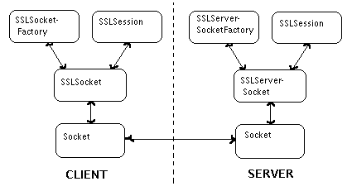Below is a diagram showing the basic relationship of the classes for secure data communication using JSSE.

Structure of classes in SSL session (Fig. 2) [HEL02]
Javax.net.ssl
The key core interfaces and classes in the javax.net.ssl package are listed in the table below:
jaxax.net.ssl | interfaces | classes
 | HandshakeCompletedListener | HandshakeCompletedEvent
 | SSLSession | SSLServerSocket
 | SSLSessionBindingListener | SSLServerSocketFactory
 | SSLSessionContext | SSLSessionBindingEvent
 |  | SSLSocket
 |  | SSLSocketFactory
Key core interfaces and classes in the javax.net.ssl(Table 1)
This package provides classes related to creating and configuring secure socket factories. Of particular importance to this project are SSLServerSocket, and SSLSocket. SSLServerSocket is extended by server sockets which return connections which are protected using the Secure Sockets Layer (SSL) protocol, and which extend the SSLSocket class. The class SSLServerSocketFactory creates SSL server socket instances.

Javax.net
The javax.net package provides optional classes for networking applications. There are only two classes, both important, containing ServerSocketFactory and SocketFactory classes.
Javax.security.cert
This package provides optional classes for public key certificates, and contains the Certificate class. [ANO01]
IMPLEMENTING “SID’S SECURE SERVER”
Introduction
Having laid the groundwork for an SSL connection, the main purpose of the project may be presented. The main accomplishment of the project was modifying a Java class to accept a certificate I had created, and have the server use this certificate to authenticate itself to any client that may be initiating a secure connection to it.
Creating a Certificate
To implement "Sid's Secure Server", I first created a certificate that be used by the server to authenticate itself. keytool is a key and certificate management utility that is included in the Java Development Kit. It enables users to administer their own public/private key pairs and associated certificates for use in self-authentication (where the user authenticates himself/herself to other users/services) or data integrity and authentication services, using digital signatures. keytool stores the keys and certificates in a so-called keystore. The default keystore implementation implements the keystore as a file. It protects private keys with a password.
Importing a Homemade Certificate into the Keystore
The following commands was used to create a file, certssir, with the information about the server in the keystore:
keytool -genkey -keystore certssir -keyalg rsa -alias sirubey -storepass serverkspw -keypass serverpw
from the command line. The basic function of keystores are as follows: keystores are databases of key pairs (one public and one private) and certificates that are used to set up SSL authentication. Truststores are keystores that are used to verify the identities of other clients and servers. When a client or server is setting up an SSL session, it will retrieve its certificates and keys from its keystore. When it verifies the identities of other clients or servers, it will retrieve trusted certification authority (CA) certificates from its truststores. [ANO02]
Implementation of SercureServer.java
SecureServer defines the following field variables:
String KEYSTORE = "certssir";
char[] KEYSTOREPW = "serverkspw".toCharArray();
char[] KEYPW = "serverpw".toCharArray();
boolean requireClientAuthentication;
These variables contain the names of the keystore, the keystore password, and key password. The main() method simply creates a SecureServer object and invokes its run() method. The SecureServer constructor passes the server's name, version, and port values to the superclass constructor (HTTPServer).
The getServerSocket() method is where all of the SSL action takes place. It overrides the getServerSocket() method of HTTPServer to substitute a SSLServerSocket for an ordinary TCP ServerSocket.
The getServerSocket() method begins by registering JSSE as a cryptographic provider.
Security.addProvider(new com.sun.net.ssl.internal.ssl.Provider());
It then accesses the cacerts keystore. JKS stands for Java keystore, which is the type of keystore created by the keytool.
KeyStore keystore = KeyStore.getInstance("JKS");
keystore.load(new FileInputStream(KEYSTORE), KEYSTOREPW);

The Security and KeyStore classes are defined in the java.security package, which is part of the standard Java 2 SDK. A KeyManagerFactory is used to create a X.509 key manager for the keystore.
KeyManagerFactory kmf = KeyManagerFactory.getInstance("SunX509");
kmf.init(keystore, KEYPW);

Now that we have key management out of the way, we need to establish an SSLContext. An SSLContext is an environment for implementing JSSE. It is used to create a ServerSocketFactory, which is used to create an SSLServerSocket.
SSLContext sslc = SSLContext.getInstance("SSLv3");
The SSLContext is set to use SSL 3.0 instead of TLS 1.0. The SSLContext is initialized to work with the key manager.
sslc.init(kmf.getKeyManagers(), null, null);
Next, we create a ServerSocketFactory from the SSLContext.
ServerSocketFactory ssf = sslc.getServerSocketFactory();
And finally, the SSLServerSocket is created.
SSLServerSocket serverSocket = (SSLServerSocket)
ssf.createServerSocket(serverPort);
In the parent class HTTPServer.java, the index.htm file is entered as the homepage for the server. I customized this file to read "Sid's Secure Server". [JAW01]
Establishing a Secure Connection to Sid’s Secure Server
Once the SecureServer.java file has been compiled, it may be run from the command line. The command window will simply list the port number it is listening to. At this point, a browser may address the name, domain name, or IP address of the server, and a secure connection will attempt to be initiated. During the SSL Handshake portion, warning messages will appear because the certificate, which I created for the server, is a self-signed certificate and does not trace back to a Certificate Authority.
The initial warning message, and a detailed viewing of the certificate in the warning message are displayed in Appendix D, as well as the display of an IE Browser with a secure https: connection established to the computer that was running SecureServer, named Pbell.
CONCLUSION
In this paper was presented an introduction to Java Secure Socket Extension, and a secure server was implemented designating JSSE as the SSL protocol provider. Also, this paper introduced the subjects of encryption, certificates, and digital signatures.
Benefits of JSSE
Among others, JSSE 1.0.3 includes the following important features:
- Implemented in 100% Pure Java
- Can be exported to most countries
- Provides API support for SSL versions 2.0 and 3.0, and reference implementation of SSL version 3.0
- Provides API support and a reference implementation for TLS version 1.0
- Includes classes that can be instantiated to create secure channels (SSLSocket and SSLServerSocket)
- Provides support for cipher suite negotiation, which is part of the SSL handshaking used to initiate or verify secure communications
- Provides support for client and server authentication, which is part of the normal SSL handshaking
- Provides support for Hypertext Transfer Protocol (HTTP) encapsulated in the SSL protocol (HTTPS), which allows access to data such as web pages using HTTPS
- Provides server session management APIs to manage memory-resident SSL sessions
- Includes code licensed from RSA Data Security Inc. such as RSA and RC4, important cryptographic algorithms [ANO01]
WORKS CITED
[ANO01] Anonymous. JSSE 1.0.3 API User's Guide. Sun Microsystems. Palo Alto, CA. 2001. http://java.sun.com/products/jsse/doc/guide/API_users_guide.html.
[ANO02] Anonymous. keytool - Key and Certificate Management Tool. Sun Microsystems. Palo Alto, CA. 2002. http://java.sun.com/products/jdk/1.2/docs/tooldocs/solaris/keytool.html.
[ANO98] Anonymous. Introduction to Public Key Cryptography. Netscape Communications Corporation. Sunnyvale, CA. 1998. http://developer.netscape.com/docs/manuals/security/pkin/index.html.
[HEL02] Rich Helton and Johennie Helton. Java Security Solutions. Wiley Publishing, Inc. Indianapolis, IN. 2002.
[LIA01] Y. Daniel Liang. Introduction to Java Programming. Prentice-Hall, Inc. Upper Saddle River, NJ. 2001.
[JAW01] Secure Your Sockets With JSSE. Jamie Jaworski. May 2001. http://www.onjava.com/pub/a/onjava/2001/05/03/java_security.html.

APPENDIX A
SecureServer.java :
/*
Sid Rubey
CS522 Fall 2002 Semester Project
"Implementing SSL with JSSE"

Reference: Jamie Jaworski, www.onjava.com, "Secure Your Sockets with JSSE"
*/

import java.net.*;
import java.io.*;
import java.util.*;
import java.security.*;
import javax.net.*;
import javax.net.ssl.*;
import com.sun.net.ssl.*;

// below are the certificate I created, and the two passwords I defined
public class SecureServer extends HTTPServer {
String KEYSTORE = "certssir";
char[] KEYSTOREPW = "serverkspw".toCharArray();
char[] KEYPW = "serverpw".toCharArray();
boolean requireClientAuthentication;

public static void main(String args[]){
SecureServer server = new SecureServer();
server.run();
}
// if client authentication were required, the forth parameter
// in the constructor would be "true"
public SecureServer(String name, String version, int port,
boolean requireClientAuthentication) {
super(name, version, port);
this.requireClientAuthentication = requireClientAuthentication;
}
public SecureServer() {
this("SecureServer", "1.0", 443, false);
}
ServerSocket getServerSocket() throws Exception {
// Make sure that JSSE is available
Security.addProvider(new com.sun.net.ssl.internal.ssl.Provider());
// A keystore is where keys and certificates are kept
// Both the keystore and individual private keys should be password
// protected
KeyStore keystore = KeyStore.getInstance("JKS");
keystore.load(new FileInputStream(KEYSTORE), KEYSTOREPW);
// A KeyManagerFactory is used to create key managers
KeyManagerFactory kmf = KeyManagerFactory.getInstance("SunX509");
// Initialize the KeyManagerFactory to work with our keystore
kmf.init(keystore, KEYPW);
// An SSLContext is an environment for implementing JSSE
// It is used to create a ServerSocketFactory
SSLContext sslc = SSLContext.getInstance("SSLv3");
// Initialize the SSLContext to work with our key managers
sslc.init(kmf.getKeyManagers(), null, null);
// Create a ServerSocketFactory from the SSLContext
ServerSocketFactory ssf = sslc.getServerSocketFactory();
// Socket to me
SSLServerSocket serverSocket =
(SSLServerSocket) ssf.createServerSocket(serverPort);
// Authenticate the client?
serverSocket.setNeedClientAuth(requireClientAuthentication);
// Return a ServerSocket on the desired port (443)
return serverSocket;
}
}

APPENDIX B
HTTPServer.java
/*
Sid Rubey
CS522 Fall 2002 Semester Project
"Implementing SSL with JSSE"

Reference: Jamie Jaworski, www.onjava.com, "Secure your Sockets with JSSE"

FILE CONTAINS:
class HTTPServer - simple HTTP server
class HTTPInputStream - Handle a single server connection
class HTTPRequest - Handles client's requests
class HTTPServerThread - used to process GET requests
*/

import java.net.*;
import java.io.*;
import java.util.*;

// Small, simple HTTP server
public class HTTPServer {
String NAME;
String VERSION;
int serverPort;

// No command line parameters are required
public static void main(String args[]){
HTTPServer server = new HTTPServer("HTTPServer", "1.0", 80);
server.run();
}
// Create an HTTPServer for a particular TCP port
public HTTPServer(String name, String version, int port) {
this.NAME = name;
this.VERSION = version;
this.serverPort = port;
}
// Display name and version number
public void displayVersionInfo(){
System.out.println(NAME+" version "+VERSION);
}
// Run until interrupted
public void run() {
displayVersionInfo();
try {
// Get a server socket
ServerSocket server = getServerSocket();
int localPort = server.getLocalPort();
// Let us know that you're listening
System.out.println(NAME+" is listening on port "+localPort+".");
do {
// Accept a connection
Socket client = server.accept();
// Handle the connection with a separate thread
(new HTTPServerThread(client)).start();
} while(true);
} catch(Exception ex) {
System.out.println("Unable to listen on "+serverPort+".");
ex.printStackTrace();
System.exit(1);
}
}
// Get a server socket on the hard-wired server port
ServerSocket getServerSocket() throws Exception {
return new ServerSocket(serverPort);
}
}

// Handle a single server connection
class HTTPServerThread extends Thread {
Socket client;
// Keep track of the client socket
public HTTPServerThread(Socket client) {
this.client = client;
}
// Thread entry point
public void run() {
try {
// Display info about the connection
describeConnection(client);
// Create a stream to send data to the client
BufferedOutputStream outStream = new
BufferedOutputStream(client.getOutputStream());
HTTPInputStream inStream = new HTTPInputStream(client.getInputStream());
// Get the client's request
HTTPRequest request = inStream.getRequest();
// Display info about it
request.log();
// Sorry, we only handle gets
if(request.isGetRequest())
processGetRequest(request,outStream);
System.out.println("Request completed. Closing connection.");
}catch(IOException ex) {
System.out.println("IOException occurred when processing request.");
}
try {
client.close();
}catch(IOException ex) {
System.out.println("IOException occurred when closing socket.");
}
}
// Display info about the connection
void describeConnection(Socket client) {
String destName = client.getInetAddress().getHostName();
String destAddr = client.getInetAddress().getHostAddress();
int destPort = client.getPort();
System.out.println("Accepted connection to "+destName+" ("
+destAddr+")"+" on port "+destPort+".");
}
// Process an HTTP GET
void processGetRequest(HTTPRequest request,BufferedOutputStream outStream)
throws IOException {
/* If you want to use this in a secure environment then you should place some
restrictions on the requested file name */
String fileName = request.getFileName();
File file = new File(fileName);
// Give them the requested file
if(file.exists()) sendFile(outStream,file);
else System.out.println("File "+file.getCanonicalPath()+" does not exist.");
}
// A simple HTTP 1.0 response
void sendFile(BufferedOutputStream out,File file) {
try {
DataInputStream in = new DataInputStream(new FileInputStream(file));
int len = (int) file.length();
byte buffer[] = new byte[len];
in.readFully(buffer);
in.close();
out.write("HTTP/1.0 200 OK\r\n".getBytes());
out.write(("Content-Length: " + buffer.length + "\r\n").getBytes());
out.write("Content-Type: text/html\r\n\r\n".getBytes());
out.write(buffer);
out.flush();
out.close();
System.out.println("File sent: "+file.getCanonicalPath());
System.out.println("Number of bytes: "+len);
}catch(Exception ex){
try {
out.write(("HTTP/1.0 400 " + "No can do" + "\r\n").getBytes());
out.write("Content-Type: text/html\r\n\r\n".getBytes());
}catch(IOException ioe) {
}
System.out.println("Error retrieving "+file);
}
}
}

// Convenience class for reading client requests
class HTTPInputStream extends FilterInputStream {
public HTTPInputStream(InputStream in) {
super(in);
}
// Get a line
public String readLine() throws IOException {
StringBuffer result=new StringBuffer();
boolean finished = false;
boolean cr = false;
do {
int ch = -1;
ch = read();
if(ch==-1) return result.toString();
result.append((char) ch);
if(cr && ch==10){
result.setLength(result.length()-2);
return result.toString();
}
if(ch==13) cr = true;
else cr=false;
} while (!finished);
return result.toString();
}
// Get the whole request
public HTTPRequest getRequest() throws IOException {
HTTPRequest request = new HTTPRequest();
String line;
do {
line = readLine();
if(line.length()>0) request.addLine(line);
else break;
}while(true);
return request;
}
}

// Used to process GET requests
class HTTPRequest {
Vector lines = new Vector();

public HTTPRequest() {
}
public void addLine(String line) {
lines.addElement(line);
}
// Is this a GET or isn't it?
boolean isGetRequest() {
if(lines.size() > 0) {
String firstLine = (String) lines.elementAt(0);
if(firstLine.length() > 0)
if(firstLine.substring(0,3).equalsIgnoreCase("GET"))
return true;
}
return false;
}
// What do they want to get?
String getFileName() {
if(lines.size()>0) {
String firstLine = (String) lines.elementAt(0);
String fileName = firstLine.substring(firstLine.indexOf(" ")+1);
int n = fileName.indexOf(" ");
if(n!=-1) fileName = fileName.substring(0,n);
try {
if(fileName.charAt(0) == '/') fileName = fileName.substring(1);
} catch(StringIndexOutOfBoundsException ex) {}
if(fileName.equals("")) fileName = "index.htm";
if(fileName.charAt(fileName.length()-1)=='/')
fileName+="index.htm";
return fileName;
}else return "";
}
// Display some info so we know what's going on
void log() {
System.out.println("Received the following request:");
for(int i=0;i<lines.size();++i)
System.out.println((String) lines.elementAt(i));
}
}
APPENDIX C
index.htm
<?xml version="1.0" encoding="iso-8859-1"?>
<! Sid Rubey CS522 Fall 2002 Implementing SSL w/ JSSE>
<!DOCTYPE html PUBLIC "-//W3C//DTD XHTML 1.0 Transitional//EN" "http://www.w3.org/TR/xhtml1/DTD/xhtml1-transitional.dtd">
<html xmlns="http://www.w3.org/1999/xhtml">
<head>
<meta http-equiv="Content-Type" content="text/html; charset=iso-8859-1" />
<title>Welcome to Sid's Secure Server using JSSE</title>
</head>

<body>
<h1>Welcome to Sid's Secure Server using JSSE</h1>

<p>This page was securely sent using SSL version 3.0.<br>
Java class HTTPServer - parent<br>
Java class SecureServer<br>
</p>
</body>
</html>

APPENDIX D
…. screen shots of Security Alert when accessing SecureServer, because certificate I created for server was not trusted

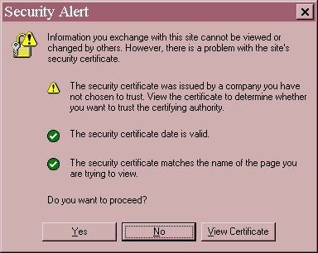
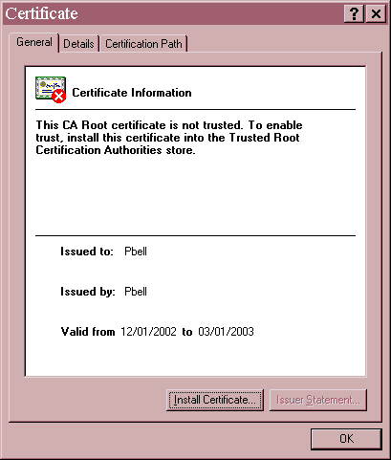
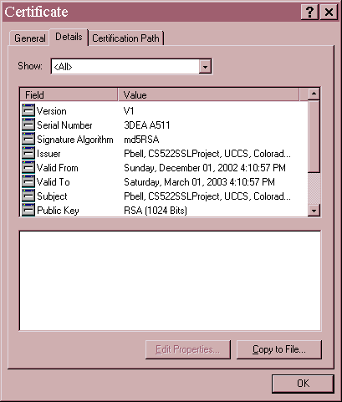

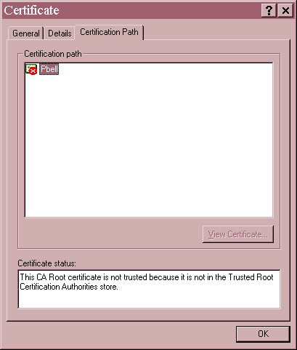

…. screen from (text-based) SecureBrowser window using command
java SecureBrowser https://Pbell/

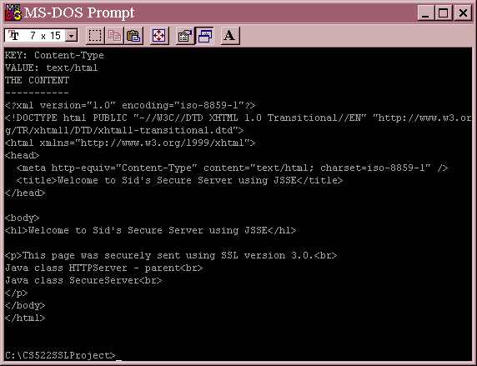
….. screen shot of window running SecureServer; command java SecureServer can be seen

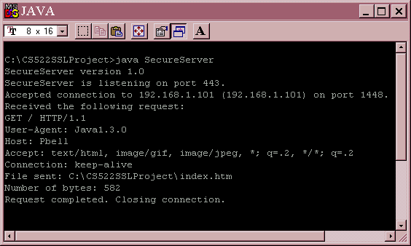

…. screen shot of IE window displaying browser with https connection to my secure server, Pbell



