Getting back to the BASICS

Employing Intrusion Detection Systems
To Combat Against
Distributed Denial of Service Attacks

by
Patrick D. Cook

CS522 Computer Communication
Semester Project

Contents

Getting back to the BASICS 1
Contents 2
Abstract 3
Introduction 4
Denial of Service Attacks 5
Distributed Denial of Service Attacks 6
Intrusion Detection Systems 8
Bayesian Statistics and Classifying Schemes (BASICS) 9
Implementation Details 10
Summary 11
References 12

Abstract

The Distributed Denial of Service (DDoS) attack is a dangerous derivative of the Denial of Service (DoS) attack, which has posed to be the most critical threat facing the Internet today. However, using an Intrusion Detection System (IDS) technique, anomaly detection, can be a first line of defense against this atrocious attack. This anomaly detection technique aims to distinguish normal traffic from abnormal traffic using Bayesian statistical analysis and classifying schemes (BASICS). In this paper, the BASICS will show methods to collect network traffic data to form a probabilistic model, classify normal network behavior and use this known information to predict abnormal network behavior.

Introduction

In late October 2002, a massive Distributed Denial of Service (DDoS) attack struck nine of the Internet’s 13 Domain Name Servers. In February 2000, websites eBay and Yahoo were attacked bringing them to an excruciating halt for nearly a week, causing phenomenal financial damage to both companies. To mitigate these risks, evaluating the effectiveness of defenses becomes an important issue. The purpose of this research is to establish a foundation to develop a statistical model to evaluate “normal” network behavior in order to detect “abnormal” network behavior. Normal network is defined by usage profiles captured over different time spans and abnormal behavior is defined as any deviation from this usage pattern. In particular, this research will establish a basis for future design methodologies by understanding what a DOS and a DDOS comprise; classifying an Intrusion Detection Systems (IDS); dissecting an anomaly detection technique, namely Bayesian Statistical analysis; and finally categorize the behavior using Classifying Schemes.

Denial of Service Attacks

Denial of Service is not a new concept. In fact, most people have experience a temporary outage of phone service, a delay at an airport, or perhaps a power outage at the most inconvenient time. Consequently, an individual that deliberately attempts to prohibit legitimate users of a service is considered a DDOS attack. Moreover, the attacks, as described by CERT® Coordination Center, can be categorized into three basic areas:
- Consumption of scarce, limited, or non-renewable resources
- Destruction or alteration of configuration information
- Physical destruction or alteration of network components [CERT01]
In the first area, consumption of scarce, limited, or non-renewable resources, the attacker begins the process of establishing a connection to the victim machine, but does it in such a way as to prevent the ultimate completion of the connection. In the meantime, the victim machine has reserved one of a limited number of data structures required to complete the impending connection. The result is that legitimate connections are denied while the victim machine is waiting to complete bogus "half-open" connections [CERT01]. The next area, destruction or alteration of configuration information, the culprit may alter or destroy system files. Finally, physical destruction or alteration of network components applies to the malicious activities caused by an individual physically on site.

Distributed Denial of Service Attacks

Distributed Denial of Service (DDoS) attacks are any DoS attacks where tools are employed to rapidly “recruit” and coordinate attacks using a mass number of conspirators from widely diverse systems around the globe [ACERN]. The following is a DDOS architecture and explanation, courtesy of Cisco:
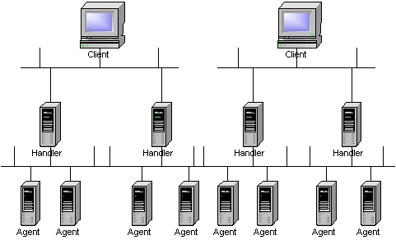

Behind a Client is a person that orchestrate an attack. A Handler is a compromised host with a special program running on it. Each handler is capable of controlling multiple agents. An Agent is a compromised host that is running a special program. Each agent is responsible for generating a stream of packets that is directed toward the intended victim.
Attackers have been known to use the following 4 programs to launch DDoS attacks: Trinoo, TFN, TFN2K and Stacheldraht. In order to facilitate DDoS, the attackers need to have several hundred to several thousand compromised hosts. The hosts are usually Linux and SUN computers; however, the tools can be ported to other platforms as well. The process of compromising a host and installing the tool is automated. The process can be divided into the following steps, in which the attackers:
- Initiate a scan phase in which a large number of hosts (on the order of 100,000 or more) are probed for a known vulnerability.
- Compromise the vulnerable hosts to gain access.
- Install the tool on each host.
- Use the compromised hosts for further scanning and compromises.
Because an automated process is used, attackers can compromise and install the tool on a single host in under 5 seconds. In other words, several thousand hosts can be compromised in under an hour [CISCO].

Intrusion Detection Systems

Intrusion Detection (ID) is the art of detecting inappropriate, incorrect, or anomalous activity. ID systems that operate on a host to detect malicious activity on that host are called host-based ID systems, and ID systems that operate on network data flows are called network-based ID systems [SANSI]. Moreover, host-based ID systems and network-based systems come in two different flavors: anomaly detection and misuse or rule based intrusion detection. Misuse detection identifies well-defined patterns of known exploits and then looks out for the occurrences of such patterns. Intrusion patterns can be any packet features, conditions, arrangements and interrelationships among events that led to a break-in or other misuse [ACERN]. Anomaly detection first quantifies the ‘usual behavior’. System behavior can be login and session activities such as the login frequency by day, time and location, output quantity or session resource utilization. Behavior can also be command or program execution activity such as execution frequency or program resource utilization [ACERN].

Bayesian Statistics and Classifying Schemes (BASICS)

Thomas Bayes, a mathematician who first used probability inductively and established a mathematical basis for probability inference proved a collection of subsets of a given set is a partition if every element of the original set is included in one and only one of the subsets. The events A₀, A₁, ..., A_{n-1}, are mutually exclusive if any two of them are mutually exclusive. Moreover, if a set of events Q₀, Q₁, ..., Q_{n-1} partition a set Q, and E is a subset of Q, then P(E) = P(Q₀)P(E|Q₀) + ... + P(Q_{n-1})P(E|Q_{n-1}). Furthermore, if the events Q₀, Q₁, ..., Q_{n-1} form a partition of Q, and E is some subset of Q then P(Q_{i}|E) = P(Q_{i})P(E|Q_{i}) / [P(Q₀)P(E|Q₀) + ... + P(Q_{n-1})P(E|Q_{n-1})}. Effectively the equation states:
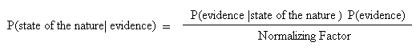
The “state of the nature” is what we want to know, the “evidence” is what we have observed and the “normalizing factor” is obtained by the rule of average probabilities.
The objective of a classifying scheme, in effect, is the most important piece, yet the most complicated. The classification is broken down into two categories, normal behavior and abnormal behavior. Having these two categories are very important because it minimizes false positives. Ironically, false positives occur more often than not, and this is what makes this concept so difficult. The goal would be to detect intrusion with using statistical estimation and the law of large numbers. The law of large numbers broadly states that the average results of many independent observations are stable and predictable. So, this begs the question, how large is large numbers? The law of large numbers says that the actual mean outcome of many trials gets close to the distribution mean μ as more trials are made. It doesn’t say how many trials are needed to guarantee a mean outcome close to μ [IPS3].

Implementation Details

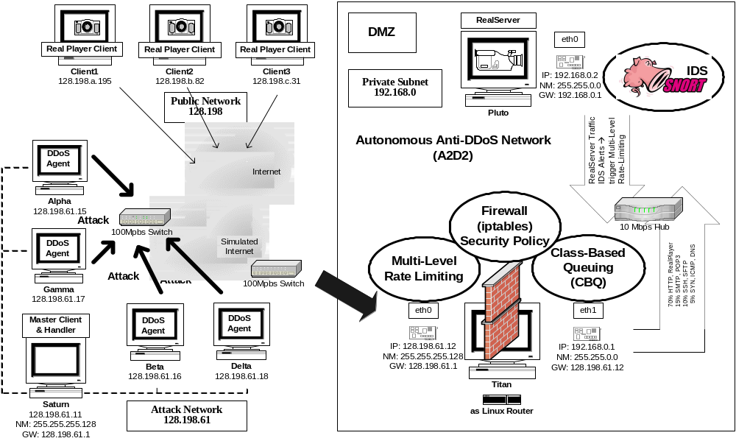

A2D2 Final Design

In order to test this concept, Angela Cearns’ model “A2D2 Final Design” will be used to implement this concept. However, the focus is to design an anomalous detection agent using the BASICS scheme.

Summary

Distributed Denial of Service attacks are serious. However, employing an Intrusion Detection System to combat these atrocious attacks can assist in deterring potential intruders from gaining access to a network. Consequently, using Bayesian Statistics and Classifying Schemes can predict abnormal behavior based on what is determined by this method as normal behavior. In order to test this theory, more work needed, yet this concept is feasible. As this journey continues, the BASICS will discover new innovative ways to detect intruders.

References

[ACERN] Angela Cearns, University of Colorado, Colorado Springs, Master Thesis; “Design of an Autonomous Anti-DDOS Network (A2D2). http://cs.uccs.edu/~chow/pub/master/acearns/doc/angThesis-final.pdf
[CERTO1] CERT® Coordination Center, “Denial of Service Attacks” http://www.cert.org/tech_tips/denial_of_service.html
[CISCO] Cisco Systems, White Paper “Strategies to Protect Against Distributed Denial of Service (DDoS) Attacks” http://www.cisco.com/warp/public/707/newsflash.html#overview
[SANSI] SANS Institute resources, “Intrusion Detection FAQ” http://www.sans.org/newlook/resources/IDFAQ/what_is_ID.htm
[IPS3] David S. Moore, George P. McCabe; Purdue University; W.H. Freeman and Company; “Introduction to the Practice of Statistics”, 3rd Edition

