CVIPRS
Computer Virus Infection Propagation System

By:
Mike May
Zach Thompson
Benjamin Abernathy

Introduction

With the rise of computing technology there has been many security issues with trying to detect intruders and prevent loss of data or corruption of data. With todays widely use of the Internet, hackers and viruses are even more present. There are infinite types of viruses that try to corrupt data, steal data, or even bring entire systems to a standstill. In order to detect a virus in a file or the possibility of a virus within a system, one must first know what a virus will do once in the system and how it affects the host. In order to know exactly what certain viruses do to a host, one must infect a system and be able to observe what occurs within the infected system. This is very hard to do when viruses are meant to ruin or destroy the host system. If a virus could be run in a controlled environment and be observed safely from outside one could find out what line of events occur within the infected system. Once one understands what exactly the virus does, steps can be taken to prevent the infection to occur or to stop the virus from completing its goals.

The Virtual Machine

CVIPRS makes use of a virtual machine in order to ensure the safety of the host
system. The ease and safety provided by the virtual machine makes CVIPRS the best
option. Other options were considered such as using an entire machine as the victim.
The virtual machine was given the name “The Gimp”. The software running the Gimp is VMWare Workstation version 3.2.0 build 2230. The machine was compiled
from the modules provided by the VMWare web page. The host machine is running the latest patched version of Red Hat 8.0. The Gimp itself runs Windows 98 Second Edition
and Norton Antivirus. The hardware itself is a Dell Precision workstation running a Pentium 4 processor.
The initial setup of the virtual machine was problematic due to the fact that the current release of the VMWare binaries does not support the latest Linux kernel. Thus, we were forced to rebuild the workstation using VMWare’s modules. Also, whenever any updates are made to the kernel, VMWare must be recompiled. Also, VMWare currently has a bug in it that emplaces a lock file when the virtual machine is attempting to shut down. The result is that it places a lock file on the virtual machine to warn you whenever it starts up again. This bug proved to be nothing more than a nuisance, as it had no observable affect on the operation of the Gimp. VMWare was originally configured without network support for the Gimp in order to keep viruses from spreading through the network. After initial setup was completed, networking was enabled in the Gimp in order to allow for the installation and updating of anti-virus software. Then the network access was disabled to again prevent the spread of viruses. The default setting is to disable the network options inside the virtual machine.
The setup of Windows 98 Second Edition completed without a problem. The system was originally deprived of network access. Network access was granted only in order to get access to anti-virus software from the network. After that, network access was permanently disabled in the virtual machine, which guarantees that a network aware virus cannot exit the system and infect other computers.

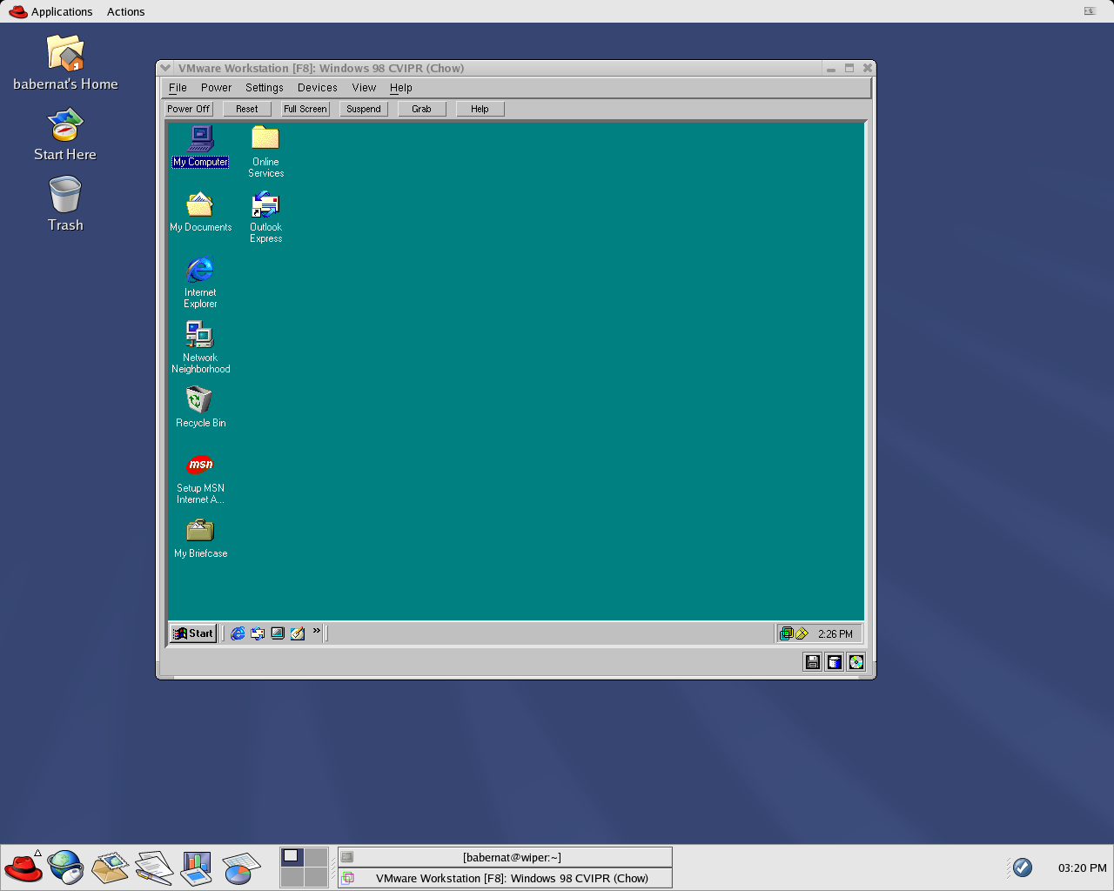
Figure 1: A screen shot of The Gimp running on Wiper.

The Virus Records Java Application
In order to keep track of the large number of collected viruses a java application was created to keep an updated record of each virus’ information. The information contained in this record database would be the official virus name, the filename, the author of the virus’ record, the date the record was created, and lastly a description of events that catalogs the known aspects of what the virus does and what type it is. This application is meant to be run outside of the virtual machine and is meant to be an easy reference to the student for which viruses have been collected and what information is known about them. This is important because of the infinite number of viruses in existence and the large number of viruses that must be studied. The information is stored in a file sequentially. When the application is loaded, the names of all the viruses contained in the file are loaded into the list on the left side of the window. When a name is selected the corresponding information is displayed in the appropriate text boxes. Also when a user would like to add a new record to the file, all he must do is input the information in the text boxes and click the “Add Record” button. Likewise, when a user wishes to delete a record from the record, click the “Delete Record” button after it has selected the name from the list and displayed the related information. These functions are necessary to update the records easily without using a text editor. This will be more useful in future use when more than the present twenty-five viruses are collected and being concurrently studied.
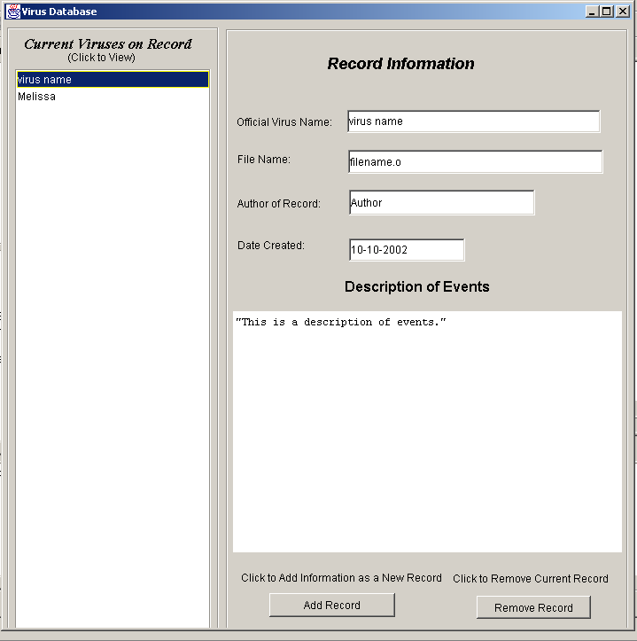
Figure 2: Application screenshot after virus name has been selected to view the
information.

Virus Collection
An essential portion of the CVIPRS project was the collection and identification

of computer viruses. These viruses give us a better understanding of the tactics used by

virus authors. Currently, the collection is small, however the group has some strategies

for increasing the size of the collection.

The gropu found a vast amount of valuable information and downloadable viruses available on the web. One of the most valuable resources I used to download actual live viruses was VX Heaven.
An encyclopedia of I-worm viruses can be found at http://www.viruslist.com/eng/viruslist.html?id=14 ; some of the virus definitions can be found at
http://securityresponse.symantec.com/avcenter/vinfodb.html
Here is a list of just some of the many viruses available to download:
FireBurn
Sircam
Winevar
Hybris
Roron. 12
Tanatos
Klez. a-h
Klez. a-h

Here is another source of viruses:
http://www.phreak.org/archives/The_Collection/source/
Another method of virus collection that has not been employed yet is the use of the school’s own virus scanners. It should be possible to use these scanners to contain and isolate the computer viruses they detect and then pass them on to the CVIPRS database. This has several advantages. First it will increase the size of our collection. Second, it will give us a more accurate view of what types of viruses are making their way through the Internet. It might also be possible to use these collections to make statistical reports on the types of viruses seen and their frequency. The information provided by these statistics could aid in anti-virus research and CVIPRS.

Current Project Status
The CVIPRS project ended the fall semester with the following tasks having been completed. First, the group completed work on the virtual machine “The Gimp” which acts as victim for the viruses. Second, the group completed work on a simple event log program that allows users to enter virus information and data. Finally, the group completed a basic database of computer viruses from the class I-Worm.

Future Work
CVIPRS is in its infancy and the project still has yet to mature into a fully functional system. The virtual machine is complete and does not need to be expanded in any way. The database program should be updated and expanded upon to allow for the collection of more specific data. Along with these changes, CVIPRS has the potential to act as a test bed for anti-virus techniques. In the future, should any anti-virus programs be developed, CVIPRS can serve as an excellent platform for their testing. An agreement with the school should be set up in which the project is allowed to collect, identify and archive wild viruses intercepted by the school. This would provide an adequate means of collecting viruses for anti-virus software testing.

Conclusion
In conclusion, CVIPRS, if continued, will serve as an excellent starting point for computer virus studies at UCCS. This project has proven that its implementation is fairly inexpensive, yet the benefits can be great. All the hardware already exists in the laboratories. Currently, The Gimp runs on Wiper in the graduate lab. However, the virtual machine could be easily reloaded onto any Linux or Windows computer, so no specialized hardware is required. The virus database application was written in Java with portability in mind. It will run on any computer that runs a java virtual machine. The program’s code is fully object oriented allowing components to be easily added and removed. Collection and identification of wild computer viruses is no problem given the fact that the school’s email security programs block and archive many viruses already. The ease of collection provides the project with a more accurate picture of what viruses are in the wild.

Research Links
Virus Research Unit
http://www.uta.fi/laitokset/virus/

A System to Support the Analysis of Antivirus Products’ Virus Detection
http://acta.uta.fi/pdf/951-44-5394-8.pdf

Research/White Papers
http://members.tripod.com/~k_wismer/papers.htm

VX Heavens
http://vx.netlux.org

Other Documents

Cohen 86 - defn of virus
Bontchev 1998 doctoral thesis of computer antivirus research
Brunnstein 1999 classification scheme of malicious software
Virus Intrusion Detection Expert System - Swimmer 1995
Immune System Concept - IBM Kephart et al. 1997
Whalley 2000 - automatic virus replication using the internet.

