NAME: SRIDEVI BELLARY

COURSE: CS522

SEMESTER PROJECT REPORT

FALL 2001

MULTIPATH ROUTING

INTRODUCTION

Multipath routing is proposed as an alternative to single shortest path routing to distribute and alleviate congestion in the networks. In multipath routing, traffic bound to a destination is split across multiple paths to that destination. In other words, it uses multiple ‘good’ paths instead of a single ‘best’ path for routing.

IMPORTANCE
The multipath routing model offers applications the ability to increase their network performance. In multipath routing, the cost of calculating multiple paths is incurred once for a particular network topology, and subsequent path changes to avoid congestion are done by end-hosts and thus do not require routing intervention or routing overhead. Because of its multi-service paths, multi-option paths, and end-hosts’ freedom to use these paths, the model provides a flexible interface to network resources that enables applications with varying network demands to increase their performance.
In general, multipath performance improvements are obtained in two ways. First, multi-service paths allow an application to use paths within a service that best suit the application’s communication needs. Second, multi-option paths provide more network resources per path service, allowing applications to aggregate these path resources. Since network demands vary with applications, the generality of a multi-service paths allows a multipath network to satisfy the needs of different applications.

Multipath Implementation Cost
The advantages of multipath routing come at a cost. Routing is a two-step
process:
- calculating paths and
- forwarding data on those paths.
Implementing these two routing tasks incurs the following three cost categories:
1. The cost of computing multiple paths
2. Per packet path specification overhead in bytes
3. Router overhead of processing and forwarding data packets.
The first category corresponds to the cost of path computation, and the latter two to the cost of forwarding data on the computed paths.

In order to make multipath routing viable, the following questions need to be resolved:

1. What paths should be calculated between nodes and how?
2. How should routers efficiently provide multiple paths in a distributed routing
environment?
3. How should end-hosts use multiple paths to gain higher performance?

1. The first question deals with the potential gains of a multipath network. To address this issue two algorithms are proposed, one maximizing throughput and the other minimizing delay.

Minimizing Delay (for applications like Telnet) - Discount shortest path algorithm - computes all the paths between two nodes whose cost is less than an admissible cost.(Cost is proportional to delay)
The discount shortest path algorithm assumes that for paths between any two nodes, there is an upper bound on the cost of the longest path. Cmax x is used to
denote the maximum admissible path cost between a node pair.

The discount shortest path algorithm calculates paths with the following properties:
from node a to b, the ith path is the least-cost path a to b such that the path’s cost
is less than Cmax. The cost of path i is calculated after adding cost increments to each
link in path j from a to b, 1<=j<i, where the cost increment of a path P is (Cmax – Cost(P))/Length(P).
To calculate discount shortest paths from node a to b, the algorithm first calculates the shortest path P with cost Cp p from a to b. Next, the cost increment for this path
is calculated as P_{incr} = (Cmax + 1)-Cp. That is, a path’s cost is incremented by the smallest amount so that the path exceeds the Cmax and therefore will not be admissible in subsequent computations. This cost increment is then added uniformly to the cost of all
links on path P. That is, for every link in P, the cost is incremented by P_{incr} / Length(P).
To get the next path from a to b, this process is repeated using the newly incremented link costs. The algorithm stops when either K paths are computed or there does not exist
paths from a to b with cost less than Cmax. After computing the paths from a to b, the link costs are restored to their original costs, and the discount shortest path computation begins for another node pair.
To calculate K paths from node a to b, the discount shortest path algorithm iterates
main loop K times. In each iteration, the function GetShortestPath()
is called. Given E edges and n nodes, the function takes O(E*lg(E)). In addition,
on each iteration, each link in the newly calculated path is traversed, which takes O(n). At the end of the loop, the added link costs are restored (O(K*n)). Thus, the complexity
of the discount shortest path algorithm in computing K paths from a to b is O(K*(E*lg(E) + K*n) -> O(K*E*lg(E)). Notice that this is K times the complexity of
calculating the single shortest path between two nodes.

Pseudo code

numPaths = 0;
while(numPaths < K)
{
newPath = Get Shortest Path(Src, Dst);
if (newPath == NULL)
break;
if (numPath == 0)
Max cost = Cost(newPath) * CostBOUND;
if (Cost(newPath)> Max cost)
break;
numPaths++;
StorePath(Src, Dst, newPath);
Cost diff = Max cost - Cost(newPath) +1;
Cost incr = Cost diff / Length(newPath);
forall links l belonging to newPath
l.cost = ll.cost + Cost incr;
}
Restore all link cost additions

Maximizing Throughput (for applications like FTP) - Capacity removal algorithm - computes all the paths between two nodes whose capacity is greater than some threshold.

The capacity removal algorithm calculates successive shortest paths; after calculating a path, the algorithm subtracts the path capacity from every link along that path. The capacity of a path is the minimal capacity of all links on the path. A link capacity threshold is used so that links with capacities below the threshold are eliminated from subsequent path computations.
From node a to b, the ith path is the least-cost path a to b such that the path’s cost is less than Cmax and capacity greater than the capacity threshold, where path i’s capacity is calculated after subtracting the path j’s capacity from every link in path j , 1<=j<i,
Complexity analysis: To calculate K paths from node a to b, the capacity removal
algorithm iterates main loop K times. In each iteration, the function
GetShortestPathCapThresh() is called which takes O(E*lg(E)), and each
link in the newly calculated path is traversed O(n) times. At the end of the loop, link ca-pacities are restored (O(K*n)). Thus, the complexity of the capacity removal algorithm to calculate K paths between a node pair is O(K*(E*lg(E) +n)+K*n) -> O(K*E*lg(E)). The complexity of the capacity removal algorithm to calculate K paths is K times the complexity of calculating the single shortest path between two nodes.

Pseudo code

numPaths = 0;
while(numPaths < K)
{
newPath = Get Shortest PathCapThresh(Src, Dst, CapacityThreshold);
if (newPath == NULL)
break;
if (numPath == 0)
Max cost = Cost(newPath) * CostBOUND;
if (Cost(newPath)> Max cost)
break;
numPaths++;
StorePath(Src, Dst, newPath);
Pathcap = Capacity(newPath);
forall links l belonging to newPath
l.cost = l.capacity - Pathcap;
}
Restore all link capacity subtracions

The function GetShortestPathCapThresh(Src, Dst, Capthresh) returns the shortest path from Src to Dst such that all links in the path have capacity above Capthresh

2. The second question deals with the cost of providing multiple paths between nodes. The main cost of implementing multipath routing is solving the packet forwarding problem: how to efficiently forward packets to the same destination but on different paths?
A novel solution to this problem uses routing overhead linear in the number of paths between nodes and has constant per packet path specification overhead. This low overhead is achieved by requiring that paths calculated by a multipath routing algorithm satisfying the suffix matched property.
Methods of solving the path forwarding problem depend on whether packets are forwarded on paths within the same path service (multi-option paths) or on paths from different path services (multi-service paths). This differentiation is important because it affects the implementation of the packet forwarding method. Path forwarding on different service paths can be implemented in a straightforward manner using a service identifier; however, this encoding scheme is not sufficient for multi-option path forwarding.

Multi-Service Path Forwarding
Forwarding packets on different path services can be accomplished by tagging each packet with a path service identifier. A service ID is an integer that distinguishes one path service from another. Because this identifier disambiguates packets from different services, the forwarding function G can be implemented by switching on service identifiers. That is, upon receiving a packet, a router forwards the packet using the forwarding function G specified by the packet’s service ID.
For example, in a multi-service single-option network, the forwarding function G for each service is the same as a single, shortest path forwarding function. In this scenario,
upon receiving a packet, a router simply forwards the packet to the next-hop returned by
applying the function G specified by the path service.

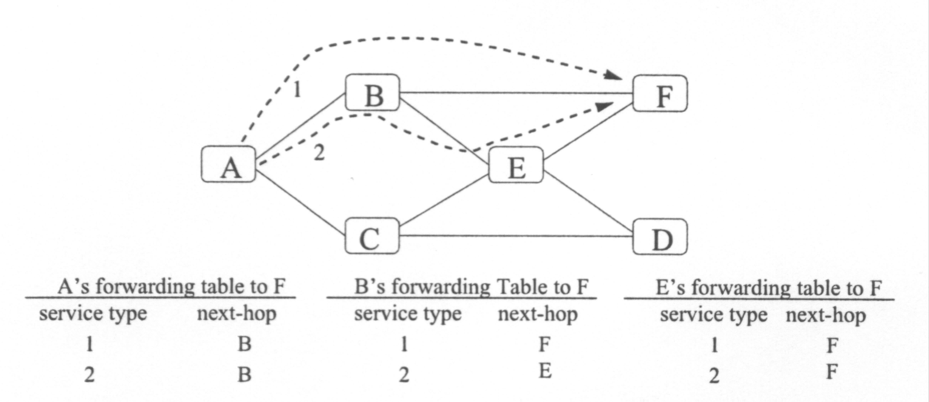

Figure shows selected forwarding tables of a multi-service single-option network.
Here, the forwarding tables of routers A, B, and E show that each router computes two
service paths to F. The dashed lines show A’s two paths to F; the number above the lines
show their path service number. In this setting, the forwarding function guarantees that if A sends a packet to F and tags the packet with the intended path service number, the packet will travel the intended path to F.
For example, assume that A sends a packet on path service 2 to F. This packet is then tagged with the path identifier [F,2] and forwarded, according to A’s forwarding table, to node B. Upon receiving this packet, B looks up its forwarding table for destination F with service 2 and forwards the packet to node EE. E performs the same lookup function and forwards the packet to F.
Path forwarding in this scenario is guaranteed because 1) the packet’s service identifier ensures that every router uses the right forwarding function (e.g. looks up the appropriate forwarding table entry), and 2) because one path is calculated between nodes within each service, the single path forwarding function corresponding to each service guarantees that
packets are forwarded on their specified paths. This example shows that multi-service paths can be distinguished using a simple path service identifier.

Multi-Option Path Forwarding
With multi-option paths, a router calculates multiple paths for the same path service. For the purpose of discussion, we assume that each multi-option path is ranked. That is, when a router computes multi-option paths to a destination, it locally assigns a unique number i to each multi-option path, indicating that the path is the ith path to that destination for a particular path service. For example, the ranking of paths could reflect the ith best path the router calculates within a path service.
Unlike multi-service forwarding, path forwarding for multi-option paths cannot be
solved by simply tagging packets with the path’s rank number. Because multi-service IDs
are consistent and understood by all routers to denote a specific path service, tagging packets with a service ID unambiguously identifies a unique path service. In contrast, tagging a packet with the rank of a multi-option path, in general, does not guarantee that the packet will be forwarded on the specified path because multi-option ranks are not necessarily consistent in all routers. For example, assume that the path (x0,…,xn) is the 2nd best path from x x0 to xn. It is not guaranteed that for all xi, 0<=I<=n, xi’s 2nd best path is (xi,…,xn).

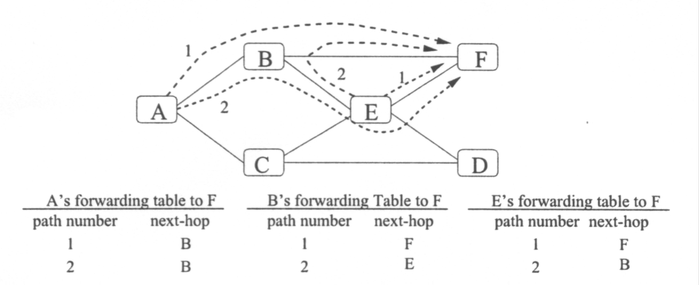

In Figure, routers compute one path service with two multi-option paths, where the
first path denotes the shortest path and the second denotes the second shortest path. The dashed lines show A and E’s paths to node F. The figure demonstrates that a path number
(or multi-option rank number) is not sufficient to ensure path forwarding. For example, if A wishes to send a packet on its second path to F and tags the packet with only the path
number (i.e. path ID [F,2]), the packet will not travel the intended path. To see this, after A sends the packet to B tagged with [F,2], B receives this packet and will forward the
packet to B’s second path’s next-hop, E. E E then forwards the packet on its second path,
which has B as the next-hop. Notice that E should forward the packet on its first path (to
node F). Following the example,B will then forward the packet back to E because E is
the next-hop of BB’s second path. This results in the packet bouncing between E and B.
This example shows that because multi-option path ranks are not necessarily consistent
in all routers, multi-option forwarding is not always guaranteed by simply tagging and
forwarding packets based on rank numbers.

Suffix Matched Path Sets
To implement the G functions in a multi-option environment, one needs a scheme for
constructing path identifiers that unambiguously identify paths between nodes. One common approach, called source routing, is to use the path description itself as the identifier. In this method, path identifiers are of variable length; therefore the overhead of tagging individual packets with these path IDs increases as the size of the network grows and the path length between nodes increases. The implementation of the G functions at each node xi for path (x1,…,xn), 1<=I<n, requires reading the received packet’s path ID [x1,…,xn] and then computing G_{xi}([x1,…,xn]) to be x_{i+1.} No state information (e.g. forwarding table) is needed at intermediate nodes; however complete path information is needed at the sending nodes. Although source routing is a general and flexible forwarding method, it is inefficient because of its variable length, per packet path ID: the variable length path ID increases the per packet path specification overhead, which decreases router forwarding efficiency because routers have to examine a larger packet header to determine the next-hop. In addition, source routing requires that sending nodes know the source routes of every path they wish to use, thereby increases router storage requirements.
Another approach to multi-option forwarding is to establish a consistent set of multi-option IDs. The Compute All method is one such approach. With this approach, if K multi-option paths are maintained between source and destination pairs in an N node network, Compute All uniquely identifies a path by the triple (s,d,i), where s, d belong to source and destination, and i is an integer, 1<=i<=K. To obtain these consistent IDs, each router computes, for each destination, not only its K paths, but every other router’s K paths as well.
The aggregate forwarding table requirement for the Compute All method is O(KN² * N) = O(KN³), which is the size of the mapping from each path identifier to the next-hop
(there are KN² _ paths) and is maintained by each node (there are N nodes). This
requirement can be reduced by observing that a node only needs to maintain paths that
pass through it. Let L be the average path length, then each path passes through L nodes
on average. Therefore it suffices that each node maintains only KNL path identifiers
on average, reducing the total space requirements on forwarding tables to O(KN²L). In contrast, single shortest path routing only require an aggregating forwarding tables space
complexity of O(N²).
The question “Is it possible to efficiently forward packets on multi-option paths where packets are annotated by short fixed-length path identifiers with space overhead for forwarding tables no more than O(KN² ) which is K times the cost for forwarding in single shortest path systems?” is answered in the affirmative for a interesting class of multipath sets called suffix matched path sets.

Suffix matched path sets: A path set P is suffix matched iff for all paths(x1,…,xn) belong to P, then for all i, 1<=i< n, (xi,…,xn) is also in P.
Consider the path set P consisting of the single shortest paths between every pair of
nodes in a network. The Bellman optimality principle ensures that P is suffix matched. If
the shortest path p from node xi to xn is (x1,…,xn), then for 1<i<=n , the shortest path
from xi to xn is the subpath (xi,…,xn) of p.

Using this concept, the proposition: Packets in a N node network with a suffix matched multipath set P can be forwarded correctly with forwarding table space O(KN² ) where no more than K paths are maintained between any pair of nodes, is proved.

3. The third question is how end-hosts should best use a multipath network in order to
increase their performance. A congestion aware multipath transport protocol, MPTCP, is developed that effectively uses multiple paths to increase throughput.
MPTCP protocol is a congestion aware multipath transport protocol that effectively uses multiple paths to increase throughput

The protocol, called MPTCP, aims to maximizes end-to-end throughput. MPTCP
requirements are that it
1. Performs congestion and flow control among multiple paths
2. Provides a reliable bit stream service (same as single path TCP)
The first requirement states that MPTCP must be sensitive to network congestion and
not overrun the receiver. Congestion control allows high effective throughput even at high levels of network utilization. The second requirement states that an MPTCP receiver must receive the same bit stream sent by the MPTCP sender. In using multiple path, this implies that MPTCP need to fragment a sender’s data stream, send data on multiple paths, and reconstruct the original data stream at the receiver.
MPTCP extends TCP very naturally. When a sender opens an MPTCP connection to a destination, MPTCP opens K concurrent and independent TCP connections to the same destination, where K is the number of paths the network provides between the sender and receiver. In MPTCP, the TCP connection establishment procedure is unaltered (e.g. a TCP three-way handshake is performed on each connection). Whenever the sender wishes to send a data stream, it passes it to MPTCP. MPTCP then divides this data stream into MPTCP segments and sequence numbers each segment The size of an MPTCP segment is such that it is no larger than the size of the underlying TCP segment size (i.e. TCP’s minimum transmission unit) minus the length of MPTCP control information such as MPTCP sequence number and MPTCP segment size. Because the MPTCP segment size does not exceed TCP segment size, this ensures that TCP does not fragment an MPTCP segment in order to send the data, increasing MPTCP’s overall efficiency. Notice that MPTCP’s different sub-TCP connections may have different segment sizes; therefore the size of an MPTCP segment size varies depending on the TCP connection it is sent on.
When a destination TCP connection receives segments from its TCP sending peer, it
reconstructs the received messages in the usual manner. The MPTCP receiver then reads the TCP data stream to recover MPTCP control data. Using the control data, MPTCP receiver then reconstructs the original MPTCP data stream from all its sub-TCP connections. This data stream is then returned to the receiving application. Notice that MPTCP does not need to explicitly acknowledge segments because the underlying TCP connections ensure reliable data delivery.
To make maximum use of each TCP connection, MPTCP sends on each of its TCP connection the number of segments allowed by the connection’s congestion and flow control mechanisms. To do this, MPTCP provides the next MPTCP segment to a TCP connection only when the connection is ready to send a new segment of data. This dynamic load balancing allows MPTCP to fully utilize each TCP connection. Because MPTCP uses TCP to transmit data, it inherits TCP’s congestion and flow control mechanisms. For example, when an MPTCP’s sub-TCP connection detects congestion, the sub-connection will decrease its sending rate in the same manner as a normal TCP connection. Thus, MPTCP’s congestion control is as good as TCP’s congestion control.

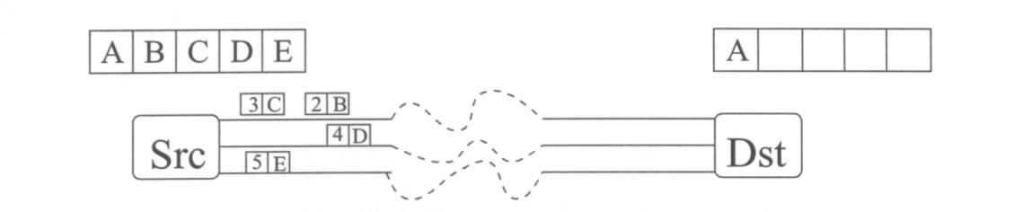

The figure shows that the Src MPTCP opens a TCP connection on each of the three paths provided by the network. The sender passes a message stream to MPTCP which are divided into five segments, labeled A through E. MPTCP sequence numbers each segment and sends them onto the different TCP connections. The number in the box denotes the MPTCP sequence number, and the letter denotes the data segment. In this example, the MPTCP receiver has already received segment A.

Limitations

The MPTCP protocol described in this chapter uses multiple, independent TCP connec-tions. That is, the different TCP sub-connections operate independently and are unaware
of each other. The advantage of this approach is that the MPTCP protocol makes minimal
modification to TCP, which allows MPTCP to easily change and upgrade the underlying
TCP protocol. The disadvantage is that the different connections are not able to work together.
One limitation of non-cooperative sub-connections is that a sub-TCP connection cannot reduce the retransmission duties of another connection. For example, consider an MPTCP connection that opens three TCP sub-connections and that connection 1 has the highest bandwidth path to the destination. Suppose that during data transmission, this connection’s path becomes very congested and subsequently drops many of this connection’s packets. In MPTCP, connection 1 is solely responsible for retransmitting all the lost segments; this may be many segments depending on the congestion window size and the severity of the congestion. In an ideal situation, however, MPTCP should be able to transmit connection’s lost segments on different connections in order to off load the connection’s retransmission duties.
Designing a multipath transport protocol requires a tradeoff between the sophistication of the protocol and its performance. The potential increase in performance comes at the cost of implementing cooperative mechanisms.

Experiments and results: MPTCP effectively increases end-to-end
throughput in large, Internet-like cluster networks and under both light and heavy network utilization levels. The performance improvements achieved by MPTCP do not necessarily come at the expense of other TCP connections, but rather, most of the performance improvements are obtained by using otherwise underutilized network resources. The conclusion is MPTCP effectively utilizes multiple paths to increase end-to-end throughput.

LINK AGGREGATION IN LAN

INTRODUCTION
Link Aggregation is a Method for using multiple parallel links between a pair of devices as if they were a single higher performance channel.
In general, LAN is used to support traffic flows between multiple station pairs, for multiple higher-layer protocols and for multiple application benefits. What is important from the application perspective is that the order of frames be maintained for a given application among a set of communicating stations. What is important from the application perspective is that the order of frames be maintained for a given protocol or application among a set of communicating stations. It is not strictly necessary to maintain the order of frames from one application relative to another.

CONCEPT
A ‘Conversation’ is a set of frames among which ordering must be maintained. The Distributor’s job is to make sure that frames belonging to a given conversation be transmitted across the same link within the aggregation. This will ensure proper ordering of frames for each conversation at the receiver. Different conversations can share the same physical link.
Receiver doesn’t have to keep track of the frame order. Frames arriving on any interface are simply delivered to the higher layer clients in the order received. Frames arriving on separate interfaces can be interspersed among each other in any convenient manner, no particular ordering relationship must be maintained among frames arriving on different interfaces since, through the action of the distributor, they belong to separate conversations.
Constraining the distributor to assign a conversation to a single physical link eliminates
the need to add sequence numbers to the frames.

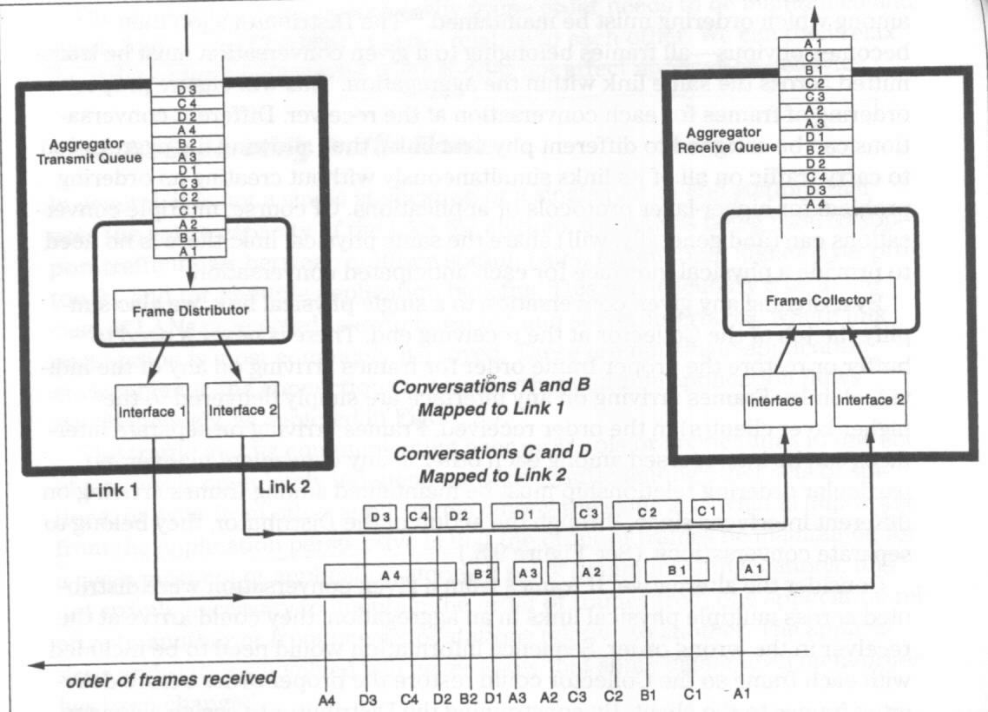
Figure shows that ,though the order of frames received as a whole is not the same as the order in which they were sent, the frames belonging to a particular conversation arrive in order.

Distribution Function
The algorithm for assigning frames to a conversation depends on the application environment and the nature of the devices at the each end of the link. For example, in a switch-to-switch aggregation, a conversation may constitute the set of all frames with the same MAC Destination Address. This is a simple distribution function. In a switch to server aggregation a suitable distribution function might be the MAC Source Address.
When aggregating links in power of 2 quantities(2, 4, 8 etc) an appropriate number of bits form MAC Address can be extracted to map frames to physical links. When aggregating links in other quantities, hash functions, modulo-n arithmetic can be used to map frames to physical links.

Changing the Distribution
In the event of change in the configuration, the distribution mapping will change. There are two approaches to the problem of maintaining frame order during conversation transfer.
- Wait for a period of time longer than the worst-case delay for frame delivery across the link. The Distributor must have some idea of what value to use for the time delay. There will be a hiccup in throughput for conversation being transferred while waiting out the delay time. If conversations are not frequently moved, this effect will not be significant.
- Use an explicit protocol to determine exactly when frames can be sent on the newly-mapped link. If a Distributor knows that it wants to transfer a conversation from one active link to a different active link, it can insert a special Marker message behind the last frame being sent form that conversation on the originally mapped link. The Collector, upon seeing this Marker message can send a response message back to the Distributor. When the Distributor receives the Marker Response, it knows that all of the frames form the conversations in question have been properly delivered, and it can immediately begin sending frames associated with the conversations onto the new link without further delay. This procedure can accelerate the conversation transfer time, which may be useful when the devices involved have highly-variable processing delays and want to get the maximum performance benefit by shifting load as necessary.

Performance : The max throughput for any given application will be limited to the capacity of the single link to which its conversation is assigned.

IEEE IEEE 802.3ad Link Aggregation Standard

IEEE 802.3ad is an official standard for Link Aggregation.

Scope
The standard applies exclusively to Ethernet LANs; no provision is made for aggregation of Token Ring or FDDI LANs either to themselves or to Ethernets.
Aggregation is specified independent of the data rate; it can be used at any standard Ethernet data rate. All links within an aggregation must be operating at the same data rate.
Aggregation is supported on full duplex, point-to-point links only
Only one multiple-link aggregation is supported between a pair of devices.

Features and Benefits
Increased bandwidth by combining the capacity of multiple links into one logical link
Linearly incremental bandwidth by allowing capacity increments in unit multiples as opposed to the order-of-magnitude increases available through physical layer technology.
Increased availability through the use of multiple parallel links.
Load sharing of user traffic across multiple links.
Automatic configuration of aggregations to the highest performance level possible in a given topology and configuration.
Rapid reconfiguration in the event of changes in physical connectivity.
Maintenance of the link invariants during both steady-state operation and reconfiguration.
Support of existing higher-layer protocols and applications without change
Backward compatibility with aggregation-unaware devices.
No change to the Ethernet frame format.
Network management support in the form of management objects for configuration, monitoring and control of aggregations.

Architectural Model
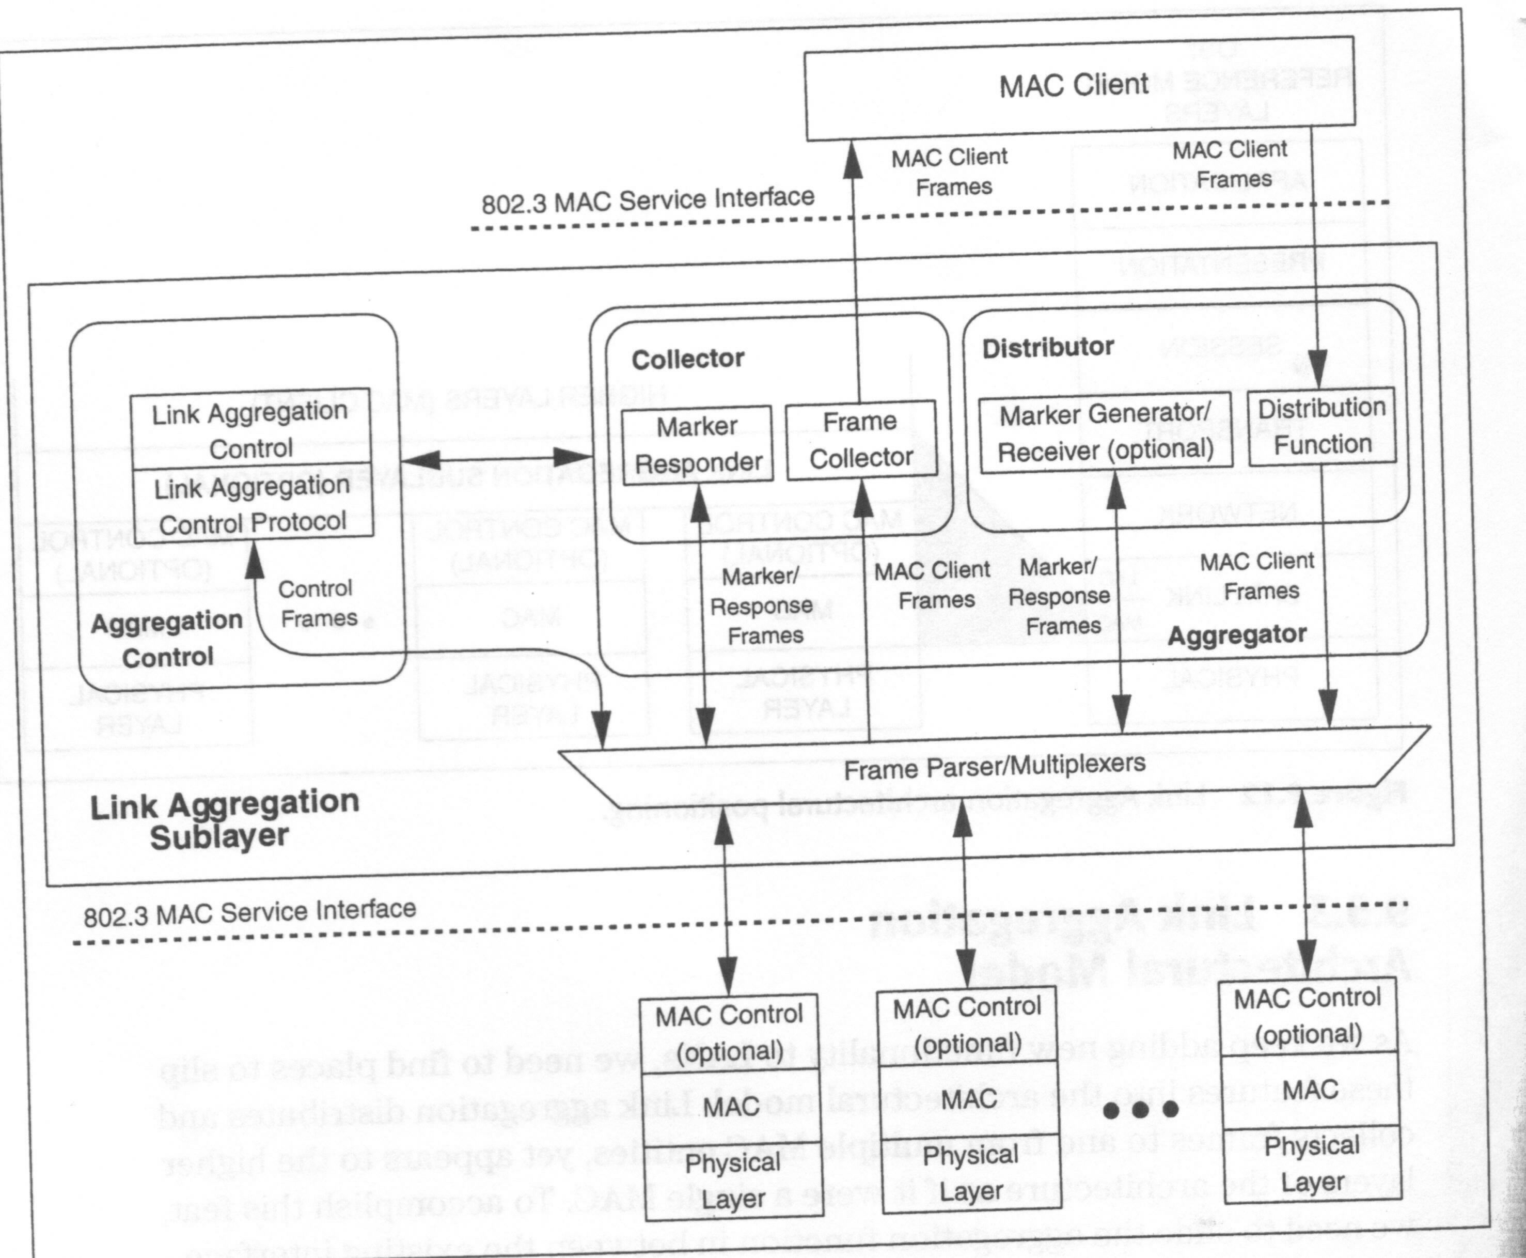

Link aggregation comprises the following modules.

Distributor: The Distributor accepts frames form the MAC client and submits them to on eof the available physical interfaces. The distribution function itself is implemented within this module. Each frame submitted by the client is associated with a particular conversation, mapped to one of the physical interfaces within the aggregation, and submitted for transmission on that link.
The distributor also incorporates a Marker Generator/Receiver. If the distributor needs to move a conversation from one physical link to another, it can generate a Marker message at the appropriate place in the conversation stream and await a response from the collector at the other end of the aggregation. The Marker Generator/Receiver is optional; distributors may choose to use a simple time-out mechanism to move conversations rather than to implement the explicit Marker Protocol.

Collector: The collector processes two classes of frames received from the underlying interfaces. Marker messages are handled by the Marker Responder. This module generates an appropriate response message and submits it for transmission on the same link from which the Marker message was received.

Frame parsers/multiplexers: The frame multiplexer accepts frames from the various modules capable of submitting them for transmission and passes them to the interface associated with the muliplexer.
The frame parser separates received frames into three groups and passes them to the appropriate module for each:
Control protocol messages are passed to the Link Aggregation Control Protocol
Marker messages are passed to the Marker Responder.
Marker Response messages are passed to the Marker Receiver or to the MAC client via the Frame collector.

Aggregation control: This module implements the functionality required to bind together the underlying interfaces into an aggregation. This includes both the capabilities of manual control and management and the automatic Link Aggregation control protocol.

Binding, Distribution, and Collection
The actual binding of physical ports to and Aggregator is performed by Aggregation Control, either through manual configuration or the automatic Link Aggregation Control Protocol. When a conversation is transferred from one physical link to another within an aggregation:
- Distribution of the conversation onto the link is disabled.
- The Distributor waits until it is sure that frames-in-process have passed through the Collector at the other end of the link by using a timeout or Marker Protocol.
- Collection is enabled on the link to which the conversation is being transferred.
- Distribution can be enabled for the conversation on the new link.

Addressing
Each physical interface has associated with it a unique 48-bit address. This address is used as the Source Address when transmitting frames that are constrained by design to remain on a single physical link. In addition to the addresses of the physical interfaces, each Aggregator has a unique 48-bit address associated with it. Higher-layer protocols and applications see this as the address of the logical interface formed by the aggregation. The Aggregator’s address is used as the Source Address for all frames carrying MAC client data, and as the Destination Address for all unicast traffic sent to the aggregation.

Link Aggregation Control Protocol (LACP)
The LACP is used to automatically configure and maintain aggregations among cooperation systems. LACP provides controls that allow network administrators to specify exactly which links in a system may be aggregated to which others.

LACP concepts
- Devices advertise their aggregation capabilities and state information on a regular basis on all aggregatable links. Protocol partners on an aggregatable link compare their own configuration and state information with that of their partner and decide what actions to take.
- Aggregations are maintained in the steady-state by the regular, timely exchange of consistent state information between the partners. If the configuration changes or fails, the protocol partners will time out and take appropriate action based on the new state of the system.
- LACP emits state information independently on each aggregatable link. Even within an aggregation, independent LACP messages are sent on each link to provide link-specific information to the partner system.
- There is no synchronization of LACP messages; partners on an aggregateable link send LACP messages autonomously.
- LACP messages are link-constrained; they are never forwarded by an internetworking device.
- LACP can be overridden with manual controls if desired.

Conclusion :
The multipath routing model offers applications the ability to increase their network performance. The future work is to implement some of the solutions found in this research and build a multipath routing model.

References:
1.“New Approaches to Routing for Large-Scale Data Networks”, Johnny Chen, Rice University, June 1999
2.“The Switch Book: The Complete Guide to LAN Switching Technology” by Rich Seifert, June 2000.
3.IEEE IEEE 802.3ad Link Aggregation Standard at
http://a957.g.akamai.net/7/957/3680/v0002/standards.ieee.org/reading/ieee/std/lanman/802.3-2000_part4.pdf

