Towards Power-Efficient Cluster and Sink Tree Formation

Jeffrey D. Rupp and C. Edward Chow

Department of Computer Science
University Of Colorado at Colorado Springs
Tel: (719)262-3110
{jdrupp, chow}@cs.uccs.edu

Abstract

Power-efficient cluster and sink tree formation improves life-time of the wireless sensor network operation. An efficient sink tree for collecting data from sensors, relaying and aggregating through the cluster headers to the sink node will reduce the overall power consumption. In this paper, formula for calculating the traffic volume generated by such sensor network operation in best case and worst case scenarios were presented. A sensor network analysis tool called SNATOOL was built to help analyze and visualize the effectiveness of the cluster and sink tree formation protocol. A Java-based sensor network simulator, JSENSIM, with enhanced GUI was built to simulate LEACH and other enhanced cluster and sink tree formation protocols. The software architecture and the application of these tools for analyzing the performance of wireless sensor networks are presented. We discuss some of challenging issues in the design of power-efficient cluster and sink tree formation enlightened by the use of these tools.

Keywords: Sensor Networks, Cluster Formation, Sink Tree Formation, Analysis and Simluation

Introduction

Small inexpensive wireless sensors are quickly finding broad application in today’s market place. Wireless sensors are being used by commercial and military customers to monitor a wide array of environmental parameters. As the use of these types of sensors grows, the demand for the sensors to last as long as possible becomes more and more market driven. To satisfy this demand it is critical to have analysis and simulating tools for evaluation and selection of power-efficient cluster and sink tree formation techniques.
There is a great deal of research going on in the area of cluster formation of groups of wireless sensors [1, 2, 3, 4]. The central drive is for quick formation, minimum power consumption, and data transmission delay. The main goals are to improve the longevity of the network, decrease the power needed to get data to the main sink node, get critical data to the sink node as quickly as possible, and quick formation of clusters.
There are currently many network simulators, however none addresses the various aspects of wireless ad-hoc networks I wish to explore. Hence I created a Java based simulator that permits exploration of the cluster forming aspects of a wireless network as well as the longevity and general power consumption.
NS2 (http://www.isi.edu/nsnam/ns/) provides a simulation of network traffic and topology, but not the aspects of particular interest to wireless networks, power consumption and cluster formation. JSim (http://www.j-sim.org/whitepapers/ns.html) is similar to NS2 in that it concentrates more on the topology, not on the constraining factors of a wireless network. NAB (http://nab.epfl.ch/viz.html) is also a topology oriented simulator, concentrating on the flow of data rather than the power needed to achieve this flow.

Sensor Network Architecture and Operation
A typical wireless sensor network can be envisioned to have large number of nodes which are battery powered. Some of the primary network attributes are collision avoidance, energy efficiency, scalability and adaptively. Other attributes like latency, throughput and fairness attributes are generally application dependent. In a battery operated sensor networks energy efficiency is critical for longevity of nodes and system operations. Energy wastage is due to collisions, control packet overhead, overhearing of unnecessary traffic and idle listening. Idle listening is a dominant factor for radio energy consumption in sensor networks.
For conserving the energy, we assume that each node in the sensor network coordinates with its neighbors such that they have the same awakening period for data transmission and collision avoidance similar to that proposed by Ye et al [1]. To reduce the number of packet transmission and reception, we propose to apply LEACH protocol presented in [2] and enhance its inter-cluster communications. The networked sensors form clusters during the initialization phase of the deployment. Each cluster elects a sensor node as a leader. All inter-cluster communications are routed through leaders. Leaders and the sink node form the base of the routing tree. They also serve as fusion nodes to correlate and aggregate packets to be sent to the sink node. We assume sensor nodes are stationary after deployment.
Figure 1.a shows the example of a 100-node sensor network deployed in 50 m x 50 m area and form 10 cluster sensor networks. The coverage of a cluster depends on the signal strength of the leaders at a predetermined threshold. The role of leader is shared among nodes to maximize the overall network life. Nodes in a heavy routing path consume more energy that client nodes.
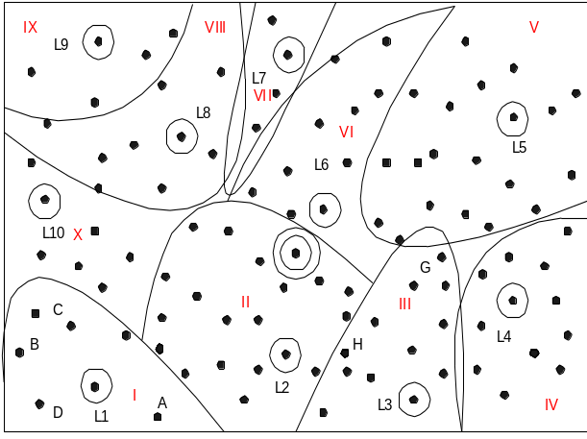
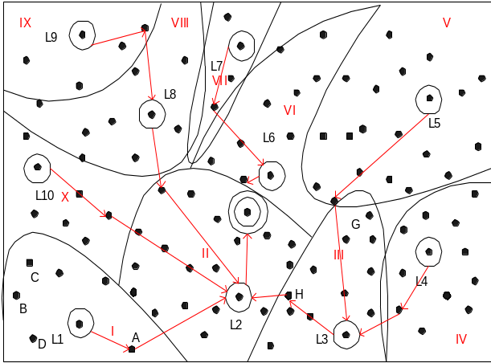
Figure 1a. Sensor Network in Cluster Format Figure 1b. Sensor Network routing in Clusters

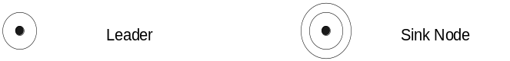

Cluster Formation and Energy Efficient Sensor Network Routing

Cluster Formation Phase. After the initial deployment, based on the configuration parameters such as the number of sensors in the cluster, the sensors decide whether they should compete as leader of the cluster. For example, the node with mod (nodeID, cluseterSize)=0 can be selected to be a leader. An advertisement message (ADV) is sent to the sensor nodes within the signal reach of the advertised node. Any node that receives the advertisement message recognizes the advertised node as the leader. If a node does not receive the advertisement message within a fixed time, it will compete in the next cycle. When a node receives multiple advertisement messages, it will choose the one with stronger signal as the leader. Sensor nodes will report to the leader and all nodes it can receive signal from with a membership report message that includes the list of leaders, which it can receive signals, their respective signal strengths, and its chosen leader.
After each node has decided to which cluster it belongs, it must inform the cluster-head node that it will be a member of the cluster. Each node transmits a join-request message (Join-REQ) back to the cluster leader. Original Leach protocol used non-persistent CSMA protocol for join-request message sending. This creates a possibility for Join-REQ message collision when multiple nodes try to send concurrently. We propose to use p-persistent CSMA protocol to spread out the Join-REQ messages within the membership reporting phase, where p is 1/clusterSize. When the leader receives Join-REQ message, it will send clear-to-send message (CTS) inform others not to collide with the selected sender. Note that a sensor node can adjust the power of Join-REQ message based on signal strength of the received ADV message. On the other hand, the leader does not know the size of its cluster at the beginning and has to use a larger power to reach all potential cluster members.

The leader then sets up a TDMA schedule and broadcasts this schedule in a TDMA schedule message (TS) to the nodes in the cluster. This ensures that there are no collision among the data messages and also allows the radio components of each non-leader node to be turned off at all times except during their transmit time slot. This minimizes the energy dissipated by the individual sensors.
The leader will also select relay nodes for inter-cluster communication with neighboring clusters. A designated-relay-node message (DRN) will be sent to each relay node. Some of these relay nodes can also be used to relay data message to the Sink node and form as part of the sink tree.

For example, in Figure 1(b) since the signal strength from L3 is stronger than that of L4, node G derives that it is in cluster III. A cluster is just a logical partition, based on the signal strength received when the clusters are formed. Some of the nodes at the border of the cluster can talk to one or more clusters. Those nodes can act as relay nodes between the clusters. For example, node H can talk to both L3 and L2 but the signal strength it receives from L3 is high compared to L2; therefore it is in cluster III.
Sink Tree Formation Phase. Based on the cluster size, within finite a time period, the clusters are formed. The sink node then sends a sink-tree broadcast message (STB) to all leader nodes in the sensor network to form the sink tree. Each leader uses selective broadcast to forward the message to other leaders in the neighboring clusters through the designated relay nodes. Duplicated sink-tree broadcast messages should not be forwarded. Note that the sink-tree messages can carry time synchronization information. The leaders of clusters will forward messages destined to the sink node along the sink-tree.
Since the sink node, the leader and relay nodes consume more energy, once their energy reaches certain threshold, alternate sensor node needs to be chosen to replace their roles. The whole sensor network goes through the leader election cycle as before. Ideally those nodes with more power are involved in the leader selection and sink tree formation process. However the ultimate goal is to maximize the network life time as a whole, therefore the threshold will be adjusted over phases and at the end it will reach zero. Once the battery power of the sensor node is reduced to a certain threshold, traffic could be curtailed to high priority only.

Application Scenarios
For normal data collection or system maintenance, the sensors report to the leaders of the clusters on the scheduled time slots. The leader of a cluster then forwards the fused data to the sink node via the inter-cluster connections following the sink tree.

In urgent and low latency operation scenarios, a leader can be given the responsibility of notifying the other leaders. For example in Figure 3, when an enemy tank is detected by the sensor nodes in cluster I, the L1 leader can compute the clusters to be alerted and send a multi-destination message to the leaders of the clusters that may be involved with future actions, say L2, L3, and L4. The multi-destination message will be forwarded and duplicated following a process similar to the initial sink tree multicast. Nodes that route data can employ a second receive window reserved for low latency traffic. This could cut latency in half while reducing the power consumed during overhearing. Figure 3 shows that L1 can forward the message to the sink node and L4.

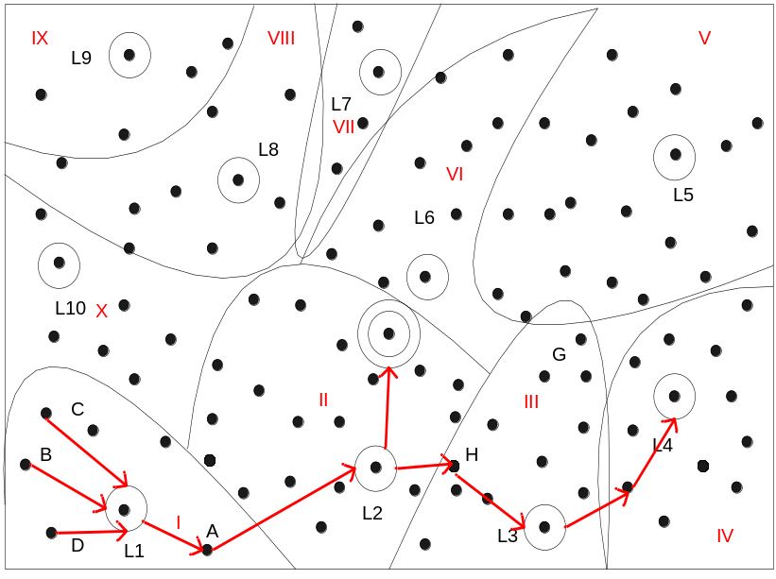
Figure 3. Low Latency Sensor Tracking Applications.

Traffic Model and Traffic Volume Estimation
A model for various sensor modes of operation has been established using these concepts as a baseline. The key modes are:
- Sensor (client) mode, whose mission is primarily collection of data, and periodically receives network maintenance data and command;
- Routing mode involves leaders and nodes whose traffic profile include receiving and forwarding messages across the network; and,
- Synchronization mode that supports network maintenance by forwarding time synchronization messages and routing information.
- Sink mode, this is a unique node(s) that forwards all outbound network traffic.

Traffic Volume Estimation

In following section we estimate the traffic volume generated in the network establishment phase and scheduled sensor status reporting phase. Since the traffic volume generated depends significantly on the sensor location distribution within the network and signal reception patterns, we will only provide an estimation which is based on the simplified assumptions. We will discuss best case and worse case scenarios using the wireless sensor network example presented in Figure 1. The SNATool is used to generate results for the same 50 m by 50 m area with randomly generated sensor locations. Simulation runs with specific network topology and sensor parameters will yield a better understanding of traffic volume and the performance of the proposed wireless sensor protocol.
Let N be the number of nodes in the wireless sensor network; s be the cluster size, i.e., the number of nodes in the cluster; and c be the number of clusters. Ideally, we would like to have same cluster size ⎡N/c⎤ for all clusters. In reality it will be challenging to achieve that.

Traffic Volume Analysis for Cluster Formation and Sink Tree Formation Phase

Best Case Scenario

In the beset scenario, the leaders are spread evenly in the network boundary and each covers exactly s sensor nodes. They only generate c ADV messages. The nodes in the cluster reply with Join-REQ message. Without collision, there will be s-1 Join-REQ messages and s-1 CTS messages in a cluster. With c clusters, there are c*(s-1) Join REQ messages and c*(s-1) CTS messages in the whole network. In best case scenario we assume that there is exactly one node in the cluster that receives a signal from any two adjacent clusters. Assume a cluster has n neighbors, additional n Join-REQ messages are sent to the adjacent cluster. After receiving all Join-REQ messages, the leader sends a TDMA Schedule broadcast message to all cluster members.
The leader also sends designated-relay-node (DRN) messages to the designated relay nodes of its neighboring clusters. The number of DRN messages depends on how many neighboring clusters exist. For example, Figure 1b shows cluster L1 has two neighboring clusters L10 and L2. Nodes A and C may be chosen as designated relay nodes. Cluster L2 on the other hand has five neighboring clusters L1, L10, L8, L6, and L3. Here let n be the ideal number of neighboring clusters. There will be n*c/2 designated-relay-node messages sent, assuming that the two neighboring leaders coordinate to reduce the volume of DRN messages and only a single designated relay node message is sent instead of two.
During the sink tree formation phase, the sink node will broadcast a sink-tree broadcast message (STB) to the n relay nodes within its cluster. These n relay nodes will forward the STB message to the leaders of those neighboring clusters. Those leaders then broadcast a single STB message to all its relay nodes. Ideally it takes n+ 1 message to reach n neighboring clusters. Therefore it takes (n+1)*(1-n^{l})/(1-n) messages to reach all clusters where l is the number of levels in the sink tree.
Let E be the total number of messages sent to establish the wireless sensor network. All messages are encapsulated in the payload of Physical Layer which is of the format
dstID | srcID | Type | payload | crc

Where
dstID - destination node id of 4 bytes
srcID - source node id of 4 bytes
type - payload packet type of 2 bytes
maximum payload is 32 bytes
crc is 4 bytes.
Message | Type | Number of Msgs | Direction | Payload size;Msg size
ADV | 1 | c | Leader to Member | 0;14
Join-REQ | 2 | c*((s-1)+n) | Member to Leader | 28;42 (assume a list of 4 leaders with their ID 4 byte and the signal strength 2 byte, and chosen leader ID 4 byte.4*(4+2)+4=28)
CTS | 3 | c*(s-1) | Leader to Member | 0;14
TS | 4 | c | Leader to Member | 32;46  (up to 8 sending node IDs)
DRN | 5 | n*c/2 | Leader to Relay Node | 4;18 (ID of the neighboring leader)
STB | 6 | (n+1)*(1-n^{l})/(1-n) | Sink Node to Leader | 32;46 (up to 8 upstream node IDs)

E=2cs+1.5cn + (n+1)*(1-n^{l})/(1-n)

In cluster formation phase, a leader sends one ADV message, receive (s+n) Join-REQ message, sends s CTS message, one TS message, n/2 DRN message. In the sink tree formation phase, it receives one STB message and may relay that once. So the total number of messages sent or received by a leader is L= 4+2s+1.5n.
A relay node receives one or more ADV messages, say m, depending how many leaders are within its signal range. It replies with m Join-REQ message.
For a sensor node that does not play the role of a relay node, it only receives one ADV message, sends one Join-REQ (assume no collision) message, and receive one TS message.
Consider the case of 100 node network, N=100. Let s=10. c=N/s=100/10=10. Assume n=3. Two levels of a sink tree can reach 12 leaders, but here we only have 10 leaders. The total number of messages generated to form the cluster and sink tree is E=2cs+1.5cn + (n+1)*(1-n^{l})/(1-n)= 2*10 *10+1.5*10*3+4*(1-3²)/(1-3)=200+45+4*(-8/-2)=261. The total number of messages sent or received by a leader is L= 4+2s+1.5n=4+2*10+1.5*3=28.5.
In terms of total byte transferred, B, during the cluster and sink tree formation, we multiply the number of messages in each type and their message size and we got
B=c*14+c*(s-1+n)*42+c*(s-1)*14+c*46+n*(c/2)*18+(n+1)*(1-n^{l})/(1-n)*46
=10*14+10*12*42+10*9*14+10*46+3*(10/2)*18+4*20*46=140+5040+1260+460+270+736
=7906 bytes.
On average the total byte transferred by a leader is 14+(n+s)*42+s*14+46+1.5n*18+2*46=14+13*42+10*14+46+1.5*3*18+92=919 bytes.
Worst Case Scenario
Here we assume that the nodes are at least connected. Consider the case where the nodes are spread linearly and each node can only reach two neighboring nodes. Assume in the initial round the c nodes that are competing for the leaders happens to be the first c nodes N1, N2, …, Nc on the left side of the network. With p-persistent CSMA, it is possible that the c ADV messages will collide and the nodes will wait for a random period before sensing the channel. Assume that there is only one node finishes waiting early and successfully sends an ADV message. Its neighbor(s) will receive the ADV message and reply with Join-REQ. Depending on the selection of random period, more collision could happens. To simply our calculation, let us assume that the back-off random period is well spread out and no more collision occurs. A possible outcome will be all odd number nodes, N1, N3, …, will become chosen leaders and even number nodes will become a relay node. There will be (c+c/2) ADV messages, (c/2+c/2) = c Join-REQ messages, c/2 CTS messages, c/2 TS messages, and c/2 DRN messages. c/2 clusters are formed after the initial round. The total number of messages in this round is R=4c messages. The above process will repeat for N/c times and result in (N/c)*(4c) =4N messages generated in the cluster formation phase.

In the sink tree formation phase, the worst case is where the sink node is on the edge of the network. It will generate N-1 STB messages.
Based on the above calculation, it takes E=4N+N-1=5N-1 messages to form the clusters and the sink tree.
In general, a leader generates two ADV messages, receives two Join-REQ messages, sends one CTS message, one TS message, one DRN message, receives and relays one STB message. It takes 9 messages to form the cluster and to participate the sink tree formation.
For the relay node, it generates one ADV message, sends two Join-REQ messages, receives one CTS, one TS, and one DRN message. It also receives and relays one STB message. Overall it processes 8 messages.
Consider the case of 100 node network, N=100. Let s=10. c=N/s=100/10=10. Then the total number of messages generated to form the cluster and sink tree is E=5N-1=500-1=499. Almost double that of the best case. Note that however we did not consider additional collisions in each round after the first c ADV collisions.
In terms of total number of bytes transferred, we have N/c round of cluster formation phases and each round with 1.5c ADV messages, c Join-REQ messages, c/2 CTS messages, c/2 TS messages, and c/2 DRN messages. For sink tree formation we have (N-1) STB messages. B=(N/c)*(1.5c*14+c*42+0.5c*14+0.5c*46+0.5c*18)+(N-1)*46
=(100/10)*(15*14+420+5*14+5*46+5*18)+(100-1)*46
=2100+4200+700+2300+900+4554
=14754 bytes.
For the leader, it generates two ADV messages, receives two Join-REQ messages, sends one CTS message, one TS message, one DRN message, receives and relays one STB message. It takes 9 messages to form the cluster and to participate the sink tree formation. Therefore the total number of byte transferred during the cluster and sink tree formation phase for a leader is B=2*14+2*42+1*14+1*46+1*18+2*46=282 bytes.

Random Case Generated by SNATool

Figure 5 shows the cluster formation and sink tree formation result generated by the analysis tool SNATool version 0.1 for 100 nodes randomly located in 50 m x 50 m area. It displays the locations of the nodes, the chosen leaders enclosed in square symbol, and the sink node enclosed in double square symbols. The thin edges show the link from a leader through the chosen relay node to the leader of a neighboring cluster. The thick black lines indicated the sink tree formed.
By default the leader of cluster 0 is chosen as the sink node. The chosen leaders are nodes with ID 0, 10, 20, …, 90. The nodes choose closest leaders based on signal strength and 1/(d²) simplified formula where d is the distance between the leader and the node. The relay node to another cluster is chosen based on its strongest signal to that cluster.

By default, each cluster leader selects 3 paths to reach other clusters which are closer. The number of such redundant paths can be changed as a program variable. Since a neighboring leader may not choose a cluster to be in its top three outgoing paths, we observed, in some case, additional path may be added to a cluster in order for its neighboring cluster to have three redundant paths.
The SNATool allows us to visualize the results of the cluster formation and sink tree formation. Through such observations, we are able to improve the protocol. For example, the cluster formation protocol that joins a sensor node to a cluster based on strongest signal will lead to uneven number of nodes in clusters. Possible remedy is to split the cluster with too many members, or to tell some members to join other clusters if they are reachable. The preliminary analysis result shows that such protocol improvement is achievable but not necessary yields good results in all cases. It is a challenging problem. Note that the cluster size also partially depends on how many sensor data can be aggregated and carry in the payload of the message.

The SNATool also gathers statistics about the message count for the given network configuration. For the above network, it takes 39 Sink Tree Broadcast messages to form the sink tree. Nine of them are broadcast messages from leaders, 30 of them are messages relayed by the relay nodes.
The SNATool output shows the following statistics:
Leader[0]=0 with 10 members: 1 7 12 29 57 68 72 74 76 79
Leader[1]=10 with 10 members: 9 11 18 24 31 36 41 59 62 89
Leader[2]=20 with 3 members: 23 33 51
Leader[3]=30 with 5 members: 49 55 69 77 92
Leader[4]=40 with 12 members: 6 14 21 32 43 44 54 58 65 73 83 97
Leader[5]=50 with 12 members: 13 25 26 27 34 46 53 66 67 85 87 93
Leader[6]=60 with 7 members: 5 8 16 22 39 61 84
Leader[7]=70 with 11 members: 2 17 38 42 48 52 64 71 86 88 98
Leader[8]=80 with 12 members: 4 15 19 45 47 56 63 75 81 82 91 94
Leader[9]=90 with 8 members: 3 28 35 37 78 95 96 99

leader=0 nc=40 50 10 relayNodes=72 79 68
leader=10 nc=30 20 60 relayNodes=59 11 59
leader=20 nc=30 60 10 relayNodes=33 23 33
leader=30 nc=60 20 10 relayNodes=69 77 49
leader=40 nc=0 90 80 relayNodes=43 65 97
leader=50 nc=60 10 0 relayNodes=66 34 25
leader=60 nc=30 50 70 relayNodes=16 8 5
leader=70 nc=60 80 30 relayNodes=38 48 38
leader=80 nc=70 50 60 relayNodes=45 94 56
leader=90 nc=40 0 80 relayNodes=95 95 28

Sink Tree Formed
sinkTreeBroadcastCount=9 sinkTreeBroadcastRelayCount=30
TotalSTBMsgCount=39

Assume no message collision, there are 10 ADV messages, 120 Join-REQ messages, 90 CTS messages, 10 TS messages, 26 DRN messages, and 39 STB messages. Note that compared with the best case, here instead of 25 STB messages, we have 39 STB messages. Also instead of 15 DRN messages to 15 designated relay nodes, here 26 relay nodes are chosen. From output the SNATool, relay node 59 is responsible for relaying message from cluster 1 to clusters 3 and 6; Relay node 33 is for relaying message from cluster 2 to clusters 1 and 3; Relay node 38 is for relaying message from cluster 7 to clusters 3 and 6. Relay node 95 is for relaying message from cluster 9 to clusters 0 and 4. There are 295 total messages and 9162 bytes.
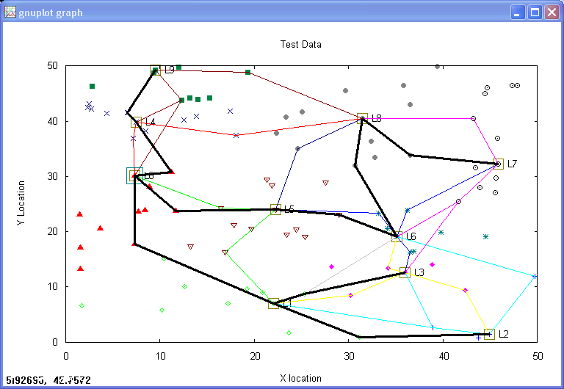
Figure 5. Cluster formation and sink tree formation results generated by SNATool version 0.1.
Table 1 shows the traffic volume comparison of the best, random case (generated by SANTool), and worst case during the cluster formation and sink tree formation phase.
Table 1. Traffic Volume (No. of Messages)
Generated in Cluster/Sink Tree Formation Phase
Msg Type | Best Case | Random Case | Worst Case
ADV | 10 | 10 | 150
Join-REQ | 120 | 120 | 100
CTS | 90 | 90 | 50
TS | 10 | 10 | 50
DRN | 15 | 26 | 50
STB | 16 | 39 | 99
Total | 261 | 295 | 499

Table 2 shows the traffic volume in terms of bytes during the cluster formation and sink tree formation phase. Note that some messages are longer than others.

Table 2. Traffic Volume (No. of Bytes)
Generated in Cluster/Sink Tree Formation Phase
Msg Type | Best Case | Random Case | Worst Case
ADV | 140 | 140 | 2100
Join-REQ | 5040 | 5040 | 4200
CTS | 1260 | 1260 | 700
TS | 460 | 460 | 2300
DRN | 270 | 468 | 900
STB | 736 | 1794 | 4554
Total | 7906 | 9162 | 14754

The above cluster and sink tree formation phase will repeat periodically to even the energy consumption among sensor nodes.

Traffic Volume Analysis for Sensor Status Reporting Phase

The sensor data will be collected by the cluster leader and forwarded along the sink tree to the sink node. Assume each sensor status report is 10 byte payload and the same 14 byte header is used. Also assume the leader aggregates all status reporting within the cluster in a single message to the sink node, and there is no further message aggregation done by other leaders or relay nodes. Assume in the best case scenario we have the sink tree shown in Figure 6.
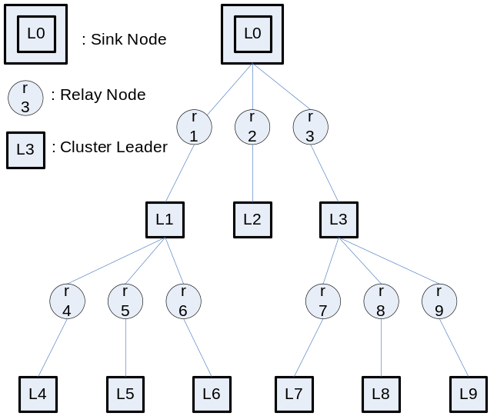
Figure 6. Sink tree in a best case scenario.

Each leader will receive 9 status report message from its members. Each status report message is 24 bytes. The leaders then aggregate the report in a single aggregate report message and send along the sink tree. The size of the aggregate report message is 154 bytes, containing 14 byte header and 10*14 byte payload. The payload contains 10 cluster member reports including that of the leader and their IDs. The six aggregate report messages from L4 to L9 in the second level of the sink tree will appear 4 times. The three aggregate report message from L1 to L3 in the first level of the sink tree will appear only twice through a relay node. In total there are 120 messages including 90 member status report messages and 30 aggregate report messages. Total number of bytes in those messages are R=90*24+30*154=6780 bytes.

For the worst case, there are 50 leaders and 50 relay nodes. Therefore there are 50 status report messages with the same 24 byte message size. The aggregate report message is 42 bytes containing 14 byte header and 2*(14)=28 bytes two reports and their related node IDs. Assume the sink node is the leader on the leftmost side of the network. The aggregate report message sent by the rightmost leader will appear 98 times and relay 97 times. The aggregate report message sent by the closest leader to the sink node will appear twice and only needs to be relayed once. In total there are 2500 messages, including 2450 aggregate report messages and 50 status report messages. Total number of bytes in those messages are R=50*24+42*2450=104100 bytes.

For the above random case generated by the SNATool, the number of member status report messages in each cluster is different. It ranges from 3 to 12. The aggregate report message sent by L7 will appear 8 times since according to Figure 5 the message is forwarded by L8, L6, L5, and four relay nodes. L7 has 11 members, therefore the aggregation message is 14+14*12=182 bytes. The aggregate report message sent by L8 will appear 6 times. Those sent by L2, L3, L6, and L9 will appear four times and those sent by L1, L4, and L5 will be appear twice. Therefore there are 126 messages, including 90 member status report messages and 8+6+4*4+3*2=36 aggregate report messages. Total number of bytes in those messages are R=90*24+8*182+6*14*14+4*(14*5+14*7+14*9+14*10)+2*(14*12+14*14+14*14)=7648 bytes.
Note that if the payload size is small, then those long aggregate report messages may need to be segmented. Tables 3 and 4 show the summary of the traffic volume generated during sensor status reporting phase for those three cases.

Table 3. Traffic Volume (No. of Messages) Generated in Sensor Status Report Phase
Msg Type | Best Case | Random Case | Worst Case
Member Status | 90 | 90 | 50
Aggregate Report | 30 | 36 | 2450
Total | 120 | 126 | 2500

Table 4. Traffic Volume (No. of Bytes) Generated in Sensor Status Report Phase
Msg Type | Best Case | Random Case | Worst Case
Member Status | 2160 | 2160 | 1200
Aggregate Report | 4620 | 5488 | 102900
Total | 6780 | 7648 | 104100

Simulator Architecture

The simulator is written in Java, to facilitate cross platform portability. The core of the simulator is the scheduler, which determines when events are processed. Another aspect of Java is utilized to permit easy integration of the plug-ins. Reflection is the means whereby the plug-in pieces are found and integrated into the GUI’s setup. The simulator traverses the classpath searching for classes that implement the plug-in base interfaces, the classes found are then added to various combo boxes to allow the user to easily select which to use. The simulator then takes the class name from the combo box and employs reflection to instantiate the chosen plug-in. To provide flexibility for future protocols and signal propagation models this simulator utilizes a plug-in architecture. There are many parameters that the user is allowed to graphically configure, several of which can be automatically stepped through a range of values. The simulator also has a wide variety of debug output which is helpful for developing new plug-ins.

Scheduler

The core of the simulator is the scheduler class. All processes must request time from this class. The scheduler maintains a queue of requests along with the time at which they wish to be executed, and a simulation clock.

To simulate parallel processing of events, all increments to the scheduler clock contain an increment amount and the time that the caller wants the increment added to. For example if the caller wants 20 tics added to a time of 100 and the scheduler knows the current tic count time is 110, the resulting increment sets the scheduler clock to 120. Thus the increment takes place, but allows for the passage of time due to other threads also incrementing the clock. All of the scheduler methods are thread safe.

The scheduler queue is sorted by the event’s desired execution time. Thus as events are added to the queue they are placed in order of when they want to be executed, ensuring that earlier events are executed first. The scheduler has a pool of threads in which to execute events. The pool method was used rather than a thread per node to reduce the number of potential context switches for large numbers of nodes. The pool was used instead of a single thread to more accurately simulate the independent nature of all the nodes, hence a node implementation cannot rely on a single thread executing things in sequence. All execution takes place in one of the scheduler’s pool of threads. This means that when a node wants to send a message it must schedule the time at which it wants to be called back with the scheduler, then the scheduler adds the event to its queue. When the event’s time has arrived the scheduler allocates a thread from the pool in which it can execute. The multi-threaded approach allows for very accurate simulation of the 802.11 protocol for example. In the 802.11 implementation the thread initiating a message is blocked during its CTS until the destination node sends the RTS.

The multi-threaded nature allows the simulation to take advantage of multiple CPUs on a system, if the Java Virtual Machine implementation makes use of the available CPUs.

Plug-in classes

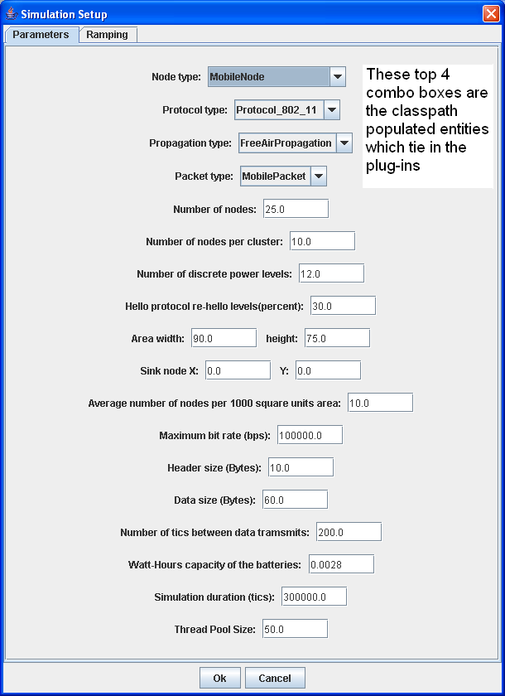The plug-in aspect of the simulator allows for easy expansion of several of the simulated aspects. The plugable pieces are automatically found in the classpath and inserted into combo boxes in the Simulation Setup dialog.
The plug-in interfaces are:

jdr.mobisim.NodeIF
This interface is the base for the nodes. This is utilized to implement the code that one would deploy on the actual nodes.
This interface consists of the following methods:
public interface NodeIF
{
public String GetAlgorithmName();
public void ReceivePacket(PacketIF packet);
public jdr.utils.FloatPoint getLocation();
public int getNodeNumber();
public double GetRemainingPower();

public void DumpNodesHeard();
public void DumpClusterInfo();
public void DumpNodePacketQueue();
public void Draw(java.awt.Graphics2D graphics, java.awt.Rectangle bounds,
double xScale, double yScale);
public String GetClusterInfo();

// methods to set various changable parameters
public void setLocation(jdr.utils.FloatPoint pt);
public void SetNumNodesPerCluster(double nodesPerCluster);
public void SetDataRate(double dataRateBps);
public void SetWattHours(double wattHours);

public void SetHighliteCluster(boolean highlite);
public void SetTransmitRingsOn(boolean ringson);

public void setSensorDataHeaderSizeBytes(int dataheaderSize);
public void setSensorDataSizeBytes(int dataSize);
public void setSensorDataTicsBetweenTransmits(int dataInterval);
public void setNumberOfHelloTransmitLevels(byte numLevels);
public void setRehelloPercent(double rehelloPercent);

}

These methods are primarily for configuring the variable aspects of the nodes (data rate, data header size, etc.) There are also several method used by the simulator for the graphical representation and for various debug purposes.

jdr.mobisim.PacketIF
This interface is the base for the generic packets that flow through the network. It is a concrete class, with abstract methods. The concrete methods provide a few utilities, such as insertInt, and extractInt which use a consistent method to insert and extract an integer to/from a byte array. The other concrete methods provide a standard way to get new instances of the specific derived class, so that the simulator architecture can call the same static method on any of the reflection created types to get new instances of the current concrete packet class.
The abstract methods are:

public abstract byte[] getData();
public abstract void setData(byte[] data);
public abstract double getTransmitedBitCount();
public abstract long getTransmitTime();
public abstract long getArrivalTime();
public abstract void setPacketArrived();

These methods are utilized to set parameters used by the simulator architecture to track transit time of a packet. The byte[] affected by setData and getData is the data that would be transmitted in an actual network. The nodes in the simulation use only this data to communicate.
jdr.mobisim.PropagationIF
This interface determines how the radio signal is propagated. This is also an abstract class, with concrete methods to provide for consistent access. This plug-in provides the capacity to change how the radio signal travels from one node to another, e.g. 1/d^4 attenuation, or a derived class could provide an obstacle interface that would allow the simulator to illustrate signal loss with objects blocking the signal path. The basic function is to determine a set of nodes that will detect the transmission from a given node.
The abstract methods are:
public abstract boolean TransmitData(long xmitTime,
int lengthInBits,
PacketIF packet,
jdr.utils.FloatPoint source,
double powerLevel);
public abstract boolean TransmitData(long xmitTime,
int lengthInBits,
PacketIF packet,
jdr.utils.FloatPoint source,
double powerLevel,
boolean doLogs);

public abstract boolean CarrierDetect(long xmitTime, jdr.utils.FloatPoint source);

public abstract double GetReceiveSignalStrengthDbm(jdr.utils.FloatPoint source,
jdr.utils.FloatPoint dest,
double transmitPwrDbm);

public abstract void DrawTransmitHistory(int historyCount, java.awt.Graphics2D graphics,
java.awt.Rectangle bounds,
double xScale, double yScale);
public abstract void DrawTransmitsAtTime(java.awt.Graphics2D graphics,
java.awt.Rectangle bounds,
double xScale, double yScale, long simTime);

These methods provide the basic communication for the network. The Draw… methods are used by the GUI portion of the simulator to render the communications that are in progress.
jdr.mobisim.ProtocolIF
This interface is the basis for the protocol the network uses to negotiate traffic in the network. The propagation interface determines which nodes a radio signal will reach, the protocol interface determines what is necessary for a packet to travel from its source node to its destination node. e.g. in the 802.11 implementation a single TransmitData command results in carrier detect, RTS, CTS, MSG, ACK. This interface is also an abstract class, with several concrete methods that deal with the queue of packets being transmitted.
The abstract methods are:
public abstract boolean TransmitData(long xmitTime,
int lengthInBits,
PacketIF packet,
jdr.utils.FloatPoint source,
double powerLevel);

public abstract boolean TransmitData(long xmitTime,
int lengthInBits,
PacketIF packet,
jdr.utils.FloatPoint source,
double powerLevel,
boolean doLogs);

public abstract boolean AddPacket(PacketIF packet);

public abstract void AddNodeHeard(NodeHeard hrd);

public abstract void setNodeEventCallbackIf(EventCallbackIF nodeEvtIf);

public abstract void Draw(java.awt.Graphics2D graphics, java.awt.Rectangle bounds,
double xScale, double yScale);
Once the propagation has determined which nodes will hear a given transmission the protocol class performs the steps necessary to allow the packet to arrive at its destination node as determined by the protocol being simulated.

Settable parameters
There are many configurable parameters in the simulator. They are all set in the Simulation Setup dialog.

- Number of Nodes: determines how many nodes to place in the simulated environment.
- Number of Nodes Per Cluster: if the cluster forming algorithm utilizes it, this sets the number of nodes desired per cluster
- Number of Discrete Power Levels: if the cluster forming algorithm utilizes it, this sets the number of different power levels to utilize during cluster formation
- Hello Protocol re-hello levels (percent): if the cluster forming algorithm utilizes it, this sets the percentage of the Discrete Power levels at which the cluster formation will transition from ‘join this cluster’ to ‘form your own cluster’.
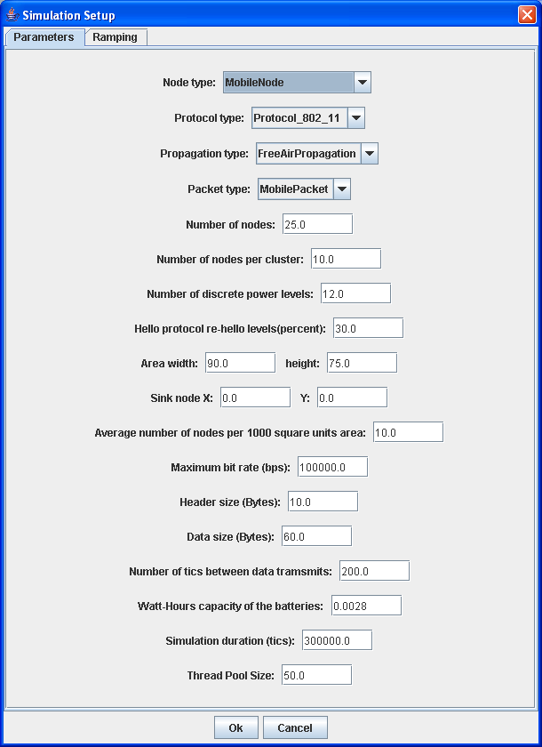
- Area Width & Area Height: the desired 2 dimensional size in unspecified units into which the nodes will be placed.
- Sink Node X & Y: The location of the sink node in the simulated topography
- Average number of nodes per 1000 square units area: When placing the nodes randomly this will help to reduce high densities of nodes in some areas with low density in others.
- Header size (Bytes): the size of the message header used during the normal data transmission phase of the network.
- Data size (Bytes): the size of the data used during the normal data transmission phase of the network.
- Number of tics between transmits: the ‘sleep time’ of the nodes between transmitting data during the normal data transmission phase of the network.
- Watt-Hours capacity of the batteries: this is used to determine how long the nodes will be alive and able to transmit. All nodes are assigned this value to start, and it is decremented by transmission of data.
- Simulation duration (tics): The total number of simulator tics to run the normal data transmission phase of the network.
- Thread Pool Size: This is used by the scheduler of the simulator to set the number of threads the simulation will use

Automatically varied parameters
The simulation provides a set of parameter that can be varied one at a time by the simulator automatically. This functionality allows easy comparison of how a particular algorithm performs with a single parameter varied throughout a range. When enabled, the single chosen parameter will step through the range for the full duration of the simulation, as chosen in the Simulation Setup dialog. The data gathered from this will be presented in a graph, available through the Graphing menu.
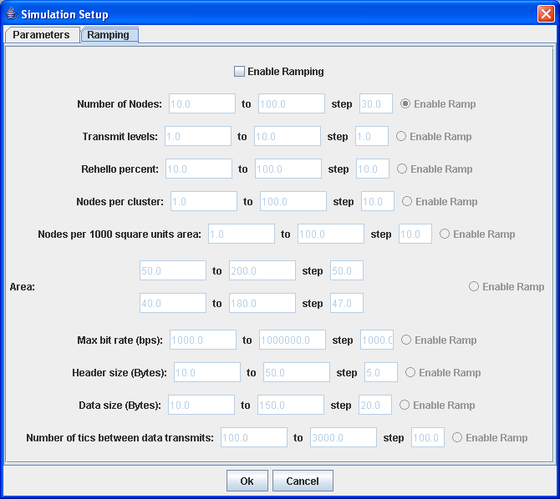
- Number of Nodes: Varies the Number of Nodes parameter in the Simulation Setup dialog
- Transmit Levels: Varies the Number of discrete power levels parameter in the Simulation Setup dialog
- Rehello percent: Varies the Hello protocol re-hellos levels (percent) parameter in the Simulation Setup dialog
- Nodes per cluster: Varies the Number of nodes per cluster parameter in the Simulation Setup dialog
- Nodes per 1000 square units: Varies the Average number of nodes per 1000 square units area parameter in the Simulation Setup dialog
- Area: Varies the Area width & height parameter in the Simulation Setup dialog
- Max bit rate (bps): Varies the Maximum bit rate (bps) parameter in the Simulation Setup dialog
- Header size (Bytes): Varies the Header size (Bytes) parameter in the Simulation Setup dialog
- Data size (Bytes): Varies the Data size (Bytes) parameter in the Simulation Setup dialog
- Number of tics between data transmits: Varies the Number of tics between data transmits parameter in the Simulation Setup dialog

Simulator Main GUI
The main simulator GUI window contains the tools that control the running of the simulation, and a grid that shows the node positions and communication as it takes place.

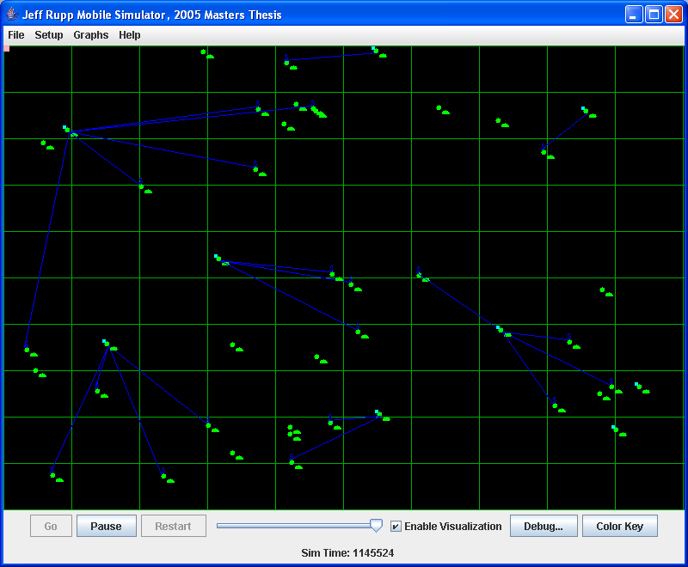
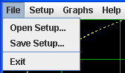The File menu has the ability to save and restore the values in the Simulation Setup & Ramping dialogs. This saves all the settable parameters and the ramp values so that a simulation can be re-run.
The random positioning uses the same seed every time, so the positions will be the same. However the Java Virtual Machine controls the context switching on the threads in the pool, so no two simulation runs will be exactly identical.
The Setup menu brings up the Simulation Setup dialog.

The Graphs menu opens the graphing dialog (shown later)
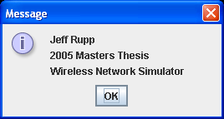

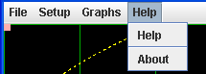The Help menu has the About dialog providing information on the simulator author.

The Restart button resets the simulation to initial values and re-runs.

The Pause button causes the scheduler to stop processing the queue.
The Go button resumes after a Pause.

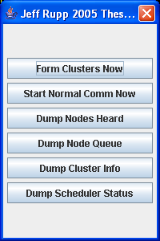
The Debug button opens a dialog that allows various debug actions to be taken (discussed later).

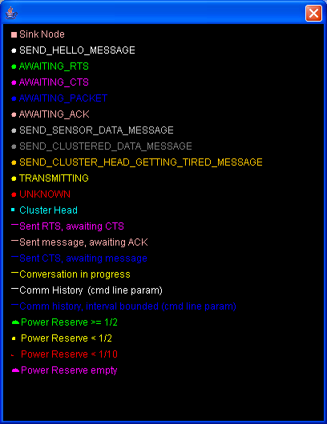
The Color Key button opens a dialog showing what all the colors mean.

The Enable Visualization check box turns on the drawing of the communication lines, disable this if you want the simulation to run faster. The GUI is updated with the simulation values every 400 milli seconds.
The Sim Time at the bottom shows the current simulation time in tics.
Optionally, if Ramping is enabled, the ramped value name, and current value are displayed to the left of the Sim Time.
The slider above the Sim Time causes the scheduler to sleep between processing events on the schedule queue. All the way to the right is zero delay, all the way to the left equates to 100 milli-seconds delay between each event.
Each of the nodes is represented by a circle and has an associated ½ circle ‘fuel gauge’ that shows the percentage of power remaining to that node.
Cluster heads have a cyan (light blue) square attached at their upper left corner.
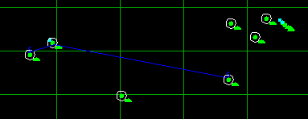Clicking on a node draws a white circle around that node and all the other nodes in its cluster.

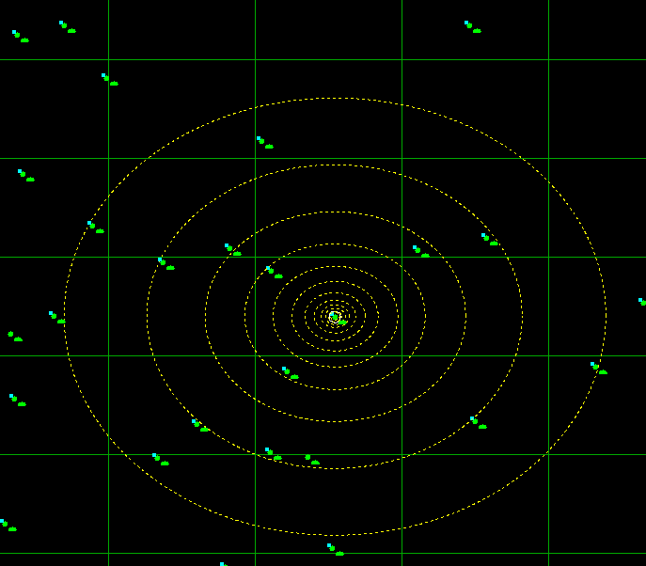CTRL + click shows the transmit range at each of the discrete power levels.

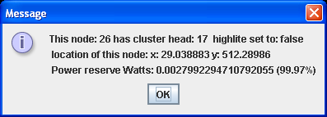
ALT + click shows information on the node.

The graphing function shows the values of various parameters at the end of a simulation run, and graphs them in an auto-scaled graph. The X axis of the graph is the parameter that was Ramped, the Y axis is different for each of the graphed values, but is scaled such that each graphed value has the maximum resolution.
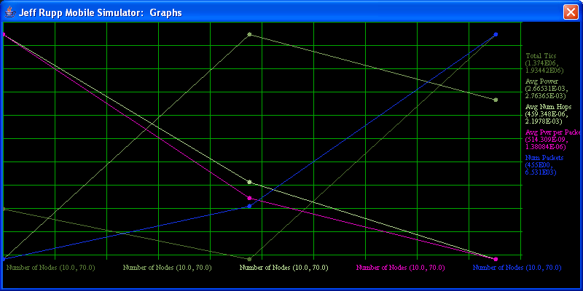

The metrics collected are:
- Total tics the simulation ran
- Average power left to each node at the end of the simulation
- Average number of hops of all of the packets transmitted during the simulation.
- Average power consumed by each packet transmitted during the simulation.
- Total number of packets transmitted during the simulation.

Debug Output

All of the classes have various logging output available. Some of these logs are compile time flags to reduce the runtime overhead. All of the output is logged to a Log4j log manager. For the fastest possible running it is recommended that no logger be used, second best is to use a file appender. When using the LogFactor5 graphical appender the logging process slows the simulation significantly.
Some example log output to the file appender:
246422 DEBUG Thread-28 jdr.mobisim.MobileNode (1150)- node: 17 telling node: 96 to form its own cluster, power level: 8
246422 DEBUG Thread-2 jdr.mobisim.MobileNode (1150)- node: 33 telling node: 47 to form its own cluster, power level: 9
246422 DEBUG Thread-21 jdr.mobisim.MobileNode (1150)- node: 3 telling node: 8 to form its own cluster, power level: 9
246422 DEBUG Thread-45 jdr.mobisim.MobileNode (1150)- node: 96 telling node: 87 to form its own cluster, power level: 9
246422 DEBUG Thread-4 jdr.mobisim.MobileNode (1150)- node: 46 telling node: 74 to form its own cluster, power level: 9

Experimental Results
For comparison below are the graphs generated for 10-100 nodes for the LEACH cluster forming algorithm and a no-clustering algorithm.
LEACH:
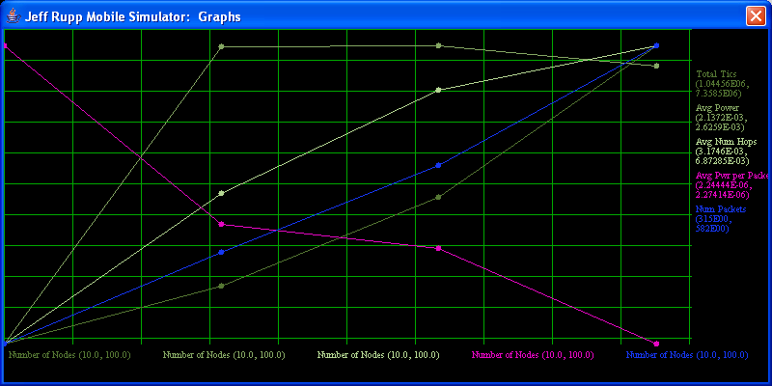

No Clustering:
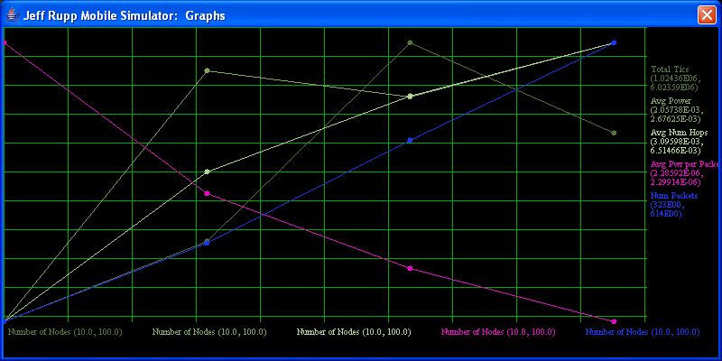

Conclusion
We have presented two software tools for the analysis and simulation of cluster formation and sink tree formation techniques in wireless sensor networks. We also presented the formula for estimating the traffic volume generated by such sensor network operation in best case and worst case scenarios. The SNATool and JSenSim Simulator enable use to gain insight on the critical issues involved with the design of power-efficient cluster formation and sink tree formation. These tools will be made available for research and development.

References
- Wei Ye; Heidemann, J.; Estrin, D., “An energy-efficient MAC protocol for wireless sensor networks,” INFOCOM 2002. Twenty-First Annual Joint Conference of the IEEE Computer and Communications Societies. Proceedings of IEEE, Volume 3 , 23-27 June 2002 Pages:1567 - 1576 vol.3.
- Wendi Beth Heinzelman, “Application-Specific Protocol Architectures for Wireless Networks,” Ph.D. Dissertation, MIT, June 2000.
- Wang, Yu; Wang, Weizhao; Li, Xiang-Yang, “Distributed Low-Cost Backbone Formation for Wireless Ad Hoc Networks,” Proceedings of the 6th ACM international symposium on Mobile ad hoc networking and computing 2005, pp. 2-13.
- Gaurav Gupta, Mohamed Younis, Fault-Tolerant Clustering of Wirelses Sensor Networks Dept. of Computer Science and Electrical Engineering 2001
http://axp1.csie.ncu.edu.tw/local/research/conf/WCNC/WCNC2003/DATA/59_01.PDF
- Katayoun Shorabi, William Merrill, Jeremy Elson, Lewis Girod, Fredric Newberg, William Kaiser “Scaleable Self-Assembly for Ad Hoc Wireless Sensor Networks” Sensoria Corporation
http://www.sensoria.com/pdf/ad-hoc-networks.pdf
- Xiaohua (Edward) Li, N. Eva Wu, “Power Efficient Wireless Sensor Networks with Distributed Transmission-Induced Space Spreading,” Department of Electircal and Computer Engineering State University of New York at Binghamton 2003
http://ucesp.ws.binghamton.edu/~xli/old/papers/asi2003.pdf
- Koen Langendoen, Niels Reijers, “Distributed localization in wireless sensor networks: a quantitative comparison,” Faculty of Information Technology and Systems, Delft University of Technology
http://www.isa.its.tudelft.nl/~reijers/documents/compnw.pdf
- Bhaskar Krishnamachari, Deborah Estrin, Stephan Wicker, “Impact of Data Aggregation in Wireless Sensor Networks,” 2004
http://ceng.usc.edu/~bkrishna/research/papers/DataAggregationSensorNetworks2.pdf
- Suman Banerjee, Samir Khuller, “A Clustering Scheme for Hierarchical Control in Multi-hop Wireless Networks,”University of Wisconson 2001
http://www.cs.wisc.edu/~suman/pubs/infocom01.pdf
- M.J. Handy, M. Haase, D. Timmermann, “Low Energy Adaptive Clustering Hierarchy with Derterministic Cluster-Head Selection,” Institute of Applied Microelectronics and Computer Science University of Rostock 2002
http://www-md.e-technik.uni-rostock.de/veroeff/MWCN2002.pdf
- Enrique J. Duarte-Melo, Mingyan Liu, “Energy Efficiency of Many-to-One Communications in Wireless Networks,” Electrical Engineering and Computer Science Department University of Michigan
http://www.eecs.umich.edu/~mingyan/pub/mwscas.pdf
- Arati Manjeshwar, Dharma P. Argawal, “TEEN: A Routing Protocol for Enhanced Efficiency in Wireless Sensor Networks,” Center for Distributed and Mobile Computing ECECS Department University of Cincinnati 2001.
http://axp1.csie.ncu.edu.tw/local/research/conf/ipps/2001/DATA/PDC_12.PDF
- Sohell Ghiasi, Ankur Srivastava, Xiaojian Yang, Mjid Sarrafzadeh, “Optimal Energy Aware Clustering in Sensor Networks,”Computer Science Department University of California Los Angeles 2002
http://crewman.uta.edu/~choi/senssor_clustering.pdf
- Murat Demirbas, Anish Arora, Vineet Mittal, “FLOC: A Fast Local Clustering Service for Wireless Sensor Networks,”Department of Computer Science and Engineering The Ohio State University 2004
ftp://ftp.cis.ohio-state.edu/pub/tech-report/2004/TR18.pdf
- Kemal Akkaya Mohamed Younis, “A Survey on Routing Protocols for Wireless Sensor Networks,” Department of Computer Science and Electrical Engineering University of Maryland
http://www.cs.umbc.edu/~kemal1/mypapers/Akkaya_Younis_JoAdHocRevised.pdf
- S. Lindsey and C. S. Raghavendra, “PEGASIS: Power Efficient GAthering in Sensor Information Systems,” Proceedings of the IEEE Aerospace Conference, Big Sky, Montana, March 2002.

