CHAPTER 4
INTERNET WEB SERVER WORKLOAD CHARACTERIZATION ANALYSIS

For the load balancing algorithm simulation, we must know the workload characterization of the network so we can choose simulation parameters to simulate the real workload of the network and the load balancing algorithms. The workload characterization includes the request frequency, the document, document size distribution, the individual access pattern, and the aggregated access pattern. In this chapter, we will analyze the workload of the web servers and clients based on our collected data.

We have collected the experimental data from the following five web servers.

- Department wide server at UCCS run on an Alpha workstation owl.uccs.edu.
- Campus wide server at UCCS run on an Alpha workstation www.uccs.edu.
- ClarkNet WWW server, which is a full Internet access provider for the Metro Baltimore-Washington DC area.
- EPA WWW server located at Research Triangle Park, NC.
- BU-Web-Client in the Boston University Computer Science Department.

We downloaded ClarkNet-HTTP, BU-Web-Client and EPA-HTTP Log files from the web site http://www.acm.org/sigcomm/ITA, which is a public Internet traffic archives. The owl-HTTP and uccs-HTTP log files were obtained from the web servers at the UCCS.

Our analysis focus on the following activities.

- Client request frequency distribution.
- Document type distribution.
- Document size distribution.
- Aggregate and individual access statistics and their relationship.

First the workload of each web sites is analyzed. Then two clients from each web site is randomly picked to analyze their workload statistics. We will combine the aggregate and individual access characterizations to get the general workload characterization. We will also compare the workload statistic characterizations with those documented in [5].

4.1 EXPERIMENT DESCRIPTION

The web server can be configured to record information on all of the requests and responses processed by the server in an access log [5]. Each line from the access log contains information on a single request for a document. The log entry for a normal request include following items:

- The host making the request, which is a domain name when available, otherwise the internet address if the domain name could not be found through the reverse-lookup in DNS. For efficiency reason, some web sites may turn off the reverse domain name lookup.
- Date in the format [DD:HH:MM:SS], where DD is the day, and HH:MM:SS is the time of day using a 24-hour clock format.
- Document type.
- HTTP reply code.
- Bytes in the reply (document size).

From each log entry, it is possible to determine the name of the host machine making the request, the time that the request was made, the URL of the requested document. The entry also provides information about the server response to this request, such as if the server was able to satisfy the request (it not, a reason why the response was unsuccessful is given) and the number of bytes transmitted by the server, if any. We downloaded five log files from the web servers mentioned above and Table 4-1 summarizes the raw statistic data.

Table 4-1 Summary of Access Log Characteristics (Raw Data)
Item | owl.uccs.edu | www.uccs | EPA-HTTP | ClarkNet-HTTP | Bugs-HTTP
Access Log Duration | 20 days | 1 day | 1 day | 5 hours | 1 month
Access Log Start Date | Sept. 23 –Oct. 13 | Oct. 26, 6:40:03 --  20:39:20 | August 29, 1995  23:53:07 –  August 30, 1995  (total 24 hours) | August 28,1995  23:59:59— | April, 1995
Total Requests | 39767 | 61183 | 47748 | 49972 | 5560
Ave Requests /Day | 1788,35 | 61183 | 1989.5 | 239865.6 | 185.3
Ave Request / Hour | 74.514 | 2549.29 | 82.875 | 9994.4 | 7.72
Total Bytes Transferred (MB) | 427.66768 | 430.7348 | 238.87825 | 425.34975 | 30.84647
Ave Bytes/Day (MB) | 21.3833 | 430.7348 | 238.87825 | 425.34975 | 1.028215
Ave Bytes/Min (MB) | 0.037123 | 0.747800 | 0.414719 | 3.54458 | 0.001785

(chow: something wrong with the Ave. Requests/Day owl.uccs.edu. Please let me know where you put the data. Create a data directory in ~chow/pub/master/yzhang/data and move all data over there.)
The five access logs provide information on servers with very different workloads. Table 4-1 shows that the Bugs-HTTP server had lightest workload, the OWL and EPA had more requests to handle (10 times workload than Bugs), and the clarknet and UCCS servers had even heavier workload (100 times workload than Bugs). Our workload characterization analysis covers light, medium, and heavy workloads. The logs also span different time duration, so that we can analyze short term, medium term, and long term aspects of the web server activity.

4.2 FILE TYPE AND ITS DISTRIBUTION CHARACTERIZATION

According to the types of frequently used documents, such as images, sound, HTML, we divide the documents into the following 14 types based on the suffix used in file names.

- .gif
- .mpg
- .html
- .au
- .ps
- .pl
- .jpg
- .avi
- .wav
- .mid
- .mpeg
- .jpeg
- .pdf
- other (all files that do not belong to the above types).

The .gif, .jpg, .jpeg, .mpg, .mpeg, .avi are image documents. .jpg and .jpeg are extensions for the same JPEG still image format. .mpg and .mpeg are extensions for the same MPEG moving picture format. .avi is Microsoft Audio Video Interleave file format. The .ps is for Postscript document. The .pl indicates Perl CGI scripts. The .pdf is for Adobe PDF documents. The .au and .wav are sound documents.

Table 4-2 summarizes the percentage of each document type based on requests. Figure 4-1 shows the document type distribution on the five web servers.

Table 4-2 Distribution of Document Types on Different Web Servers
 | OWL | UCCS | EPA-HTTP | ClarkNet HTTP | BU-Web-Client
.gif | 40.32% | 53.72% | 47.00% | 46.62% | 71.30%
.mpg | 0.018% | 0.003% | 0.004% | 0.000% | 0.09%
.html | 24.611% | 16.459% | 18.883% | 18.75% | 15.54%
.au | 0.309% | 0.144% | 3.673% | 0.510% | 0.144%
.ps | 0.591% | 0.350% | 0.063% | 0.086% | 1.331%
.pl | 6.817% | 1.149% | 0.532% | 0.214% | 1.133%
.jpg | 9.852% | 14.646% | 0.057% | 29.171% | 0.270%
.avi | 0.101% | 0.007% | 0.002% | 0.006% | 0.000%
.wav | 0.141% | .083% | 0.044% | 0.222% | 0.342%
.mid | 1.760% | 0.021% | 0.00% | 0.052% | 0.054%
.mpeg | 0.005% | 0.00% | 0.000% | 0.000% | 0.000%
.jpeg | 0.279% | 0.00% | 0.000% | 0.108% | 0.072%
.pdf | 1.609% | 0.309% | 0.000% | 0.002% | 0.000%
.others | 13.587% | 13.113% | 29.765% | 4.232% | 9.712%
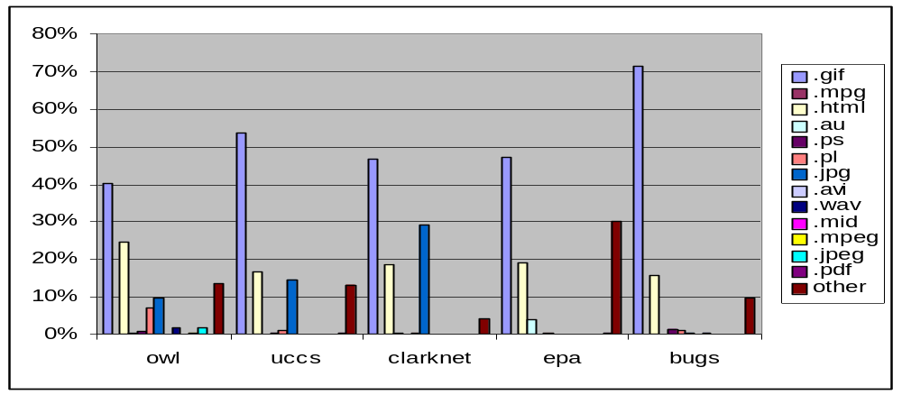
Figure 4-1 Distribution of File Types on Different Web Sites

Table 4-3 only gives the percentage of the image and HTTL documents calculated from Table 4-2 for all five web servers.

Table 4-3 Distribution of Image and HTTL Documents
 | Owl | Uccs | epa | Clarknet | Bugs | Average
Image | 50.474% | 68.376% | 47.898% | 75.899% | 71.732% | 62.875%
HTML | 24.611% | 16.459% | 18.883% | 18.750% | 15.540% | 18.849%
Other | 24.915% | 15.165% | 33.219% | 5.3510% | 12.728% | 18.276%
Total request | 39767 | 61183 | 47748 | 49972 | 5560 | 40846

Except for the document type distribution on different web servers, we also need the document type distribution on different clients. We randomly pick two clients from each web site. Figures 4-2 and 4-3 show the document type distribution of those clients.

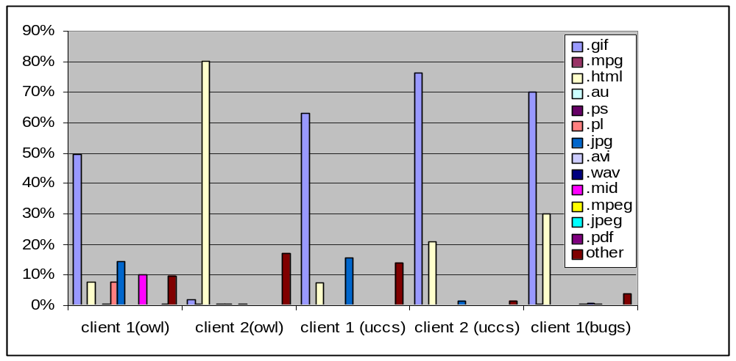Figure 4-2 Distribution of Document Types on Different Clients
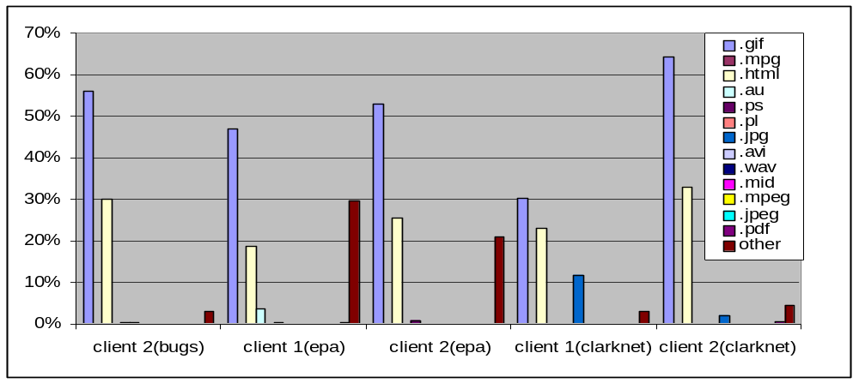
Figure 4-3 Distribution of Document Types on Different Clients

Table 4-4 summaries the percentage of the image and HTTL documents for the ten clients based on total requests.

Table 4-4 Distribution of Image and HTTL Documents for Different Clients
 | Image | HTML | Other
Client 1 (OWL) | 64.010% | 7.7450% | 28.245%
Client 2 (OWL) | 2.2270% | 80.170% | 17.603%
Client 1 (UCCS) | 78.519% | 7.4070% | 14.074%
Client 2 (UCCS) | 77.698% | 20.863% | 1.4390%
Client 1 (EPA) | 53.077% | 25.385% | 21.538%
Client 2 (EPA) | 51.007% | 12.081% | 36.913%
Client 1 (CLARKNET) | 42.927% | 22.936% | 34.862%
Client 2 (CLARKNET) | 66.189% | 74.675% | 0.6760%
Client 1 (BUGS) | 33.108% | 23.145% | 2.1800%
Client 2 (BUGS) | 57.812% | 34.005% | 8.1830%
Average

From Figures 4-1 to 4-3 and Tables 4-1 to 4-4, we can see that the documents most frequently requested by the clients are image and HTML documents, which account over 70% of all requested documents. This observation is consistent with results reported in [6] and [7].

4.3 DISTRIBUTION OF DOCUMENT SIZE

Table 4-5 lists the maximum, minimum, average size of the documents requested by the clients on different web sites. Figure 4-4 shows the document size distribution on different web sites.

Table 4-5 Summary of Document Size on Different Web Sites
 | Max (KB) | Min (Byte) | Average ( KB ) | Median (KB) | Number of Files
OWL | 887.046 | 14 | 12.29 | less 1 | 33939
UCCS | 928.099 | 7 | 10.88 | 1 | 38638
CLARKNET | 789.456 | 10 | 8.90 | Less 1 | 46015
EPA | 825.700 | 19 | 6.35812 | 2 | 36691
BUGS | 600.6152 | 6 | 9.027 | less1 | 2240
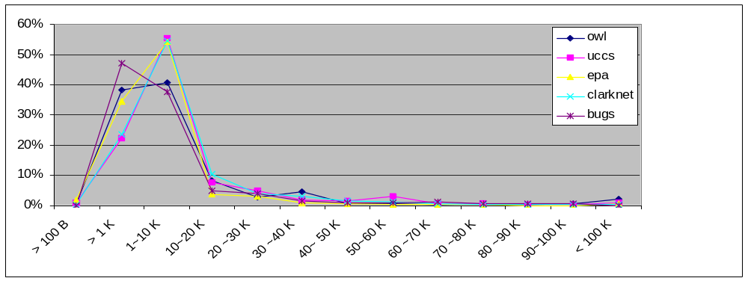

Figure 4-4 Distribution of Document Size on Different Web Sites

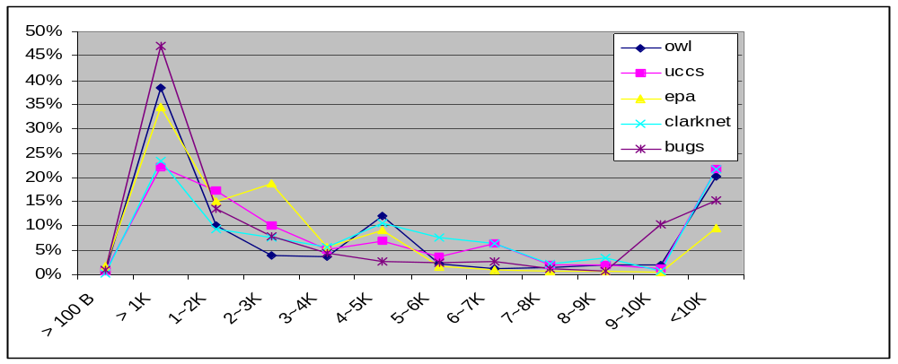Figure 4-5 shows the distribution for the document size between less than 100 Bytes to 10K on distinct web servers.

Figure 4-5 Distribution of Document Size on Different Web Servers

Table 4-6 lists the statistics of documents with size between less than 100 B to 10KB on the five web servers.

Table 4-6 Statistics of Document Size for Five Web Sites
Size (KB) | < 0.1 | 0.1 ~ 1 | 1 ~ 2 | 2 ~ 3 | 3 ~ 4 | 4 ~ 5 | 5 ~ 6 | 6 ~ 7 | 7 ~ 8 | 8 ~ 9
Percentage | 0.84 | 29.95 | 12.8 | 10.0 | 5.10 | 9.54 | 4.08 | 1.66 | 1.14 | 1.25
Total Requests | 1326 | 46124 | 19234 | 15823 | 8050 | 15037 | 6436 | 2626 | 1741 | 1917

In Table 4-7, we list in detail the statistics of the document with size in the range from less than 100 B to larger than 300 KB. Table 4-8 gives the statistics of the documents with size in the range from less than 100 B to 30 K. We can see that there are only small number of files with size less than 100 bytes on each of the web sites. Most documents appear to be in the range between 1 KB and 5 KB. Above 50% documents requested by clients in the range between 1 KB and 5 KB. Less than 10% documents requested by clients are larger than 10 KB. This distribution is consistent with the file size distribution reported by Martin F. and Carey L. Williamson [5]

Table 4-7: Raw Statistics Data of Document Size
Size (K) | OWL | UCCS | EPA | CLARKNET | BUGS
< 0.1 | 250 | 306 | 630 | 138 | 2
<1 | 13001 | 8600 | 12672 | 10798 | 1053
1 - 10 | 13166 | 21353 | 14054 | 20539 | 519
10 - 20 | 3442 | 2947 | 1162 | 4648 | 104
20 - 30 | 785 | 1960 | 982 | 1624 | 74
30 - 40 | 451 | 735 | 230 | 1379 | 36
40 - 50 | 171 | 541 | 132 | 666 | 20
50 - 60 | 87 | 1187 | 103 | 484 | 18
60 - 70 | 198 | 257 | 100 | 204 | 24
70 ~ 80 | 103 | 191 | 58 | 142 | 12
80 - 90 | 205 | 121 | 98 | 69 | 13
90 - 100 | 43 | 22 | 6 | 43 | 2
110 - 120 | 26 | 29 | 19 | 28 | 5
120 - 130 | 53 | 76 | 36 | 19 | 2
130 - 140 | 62 | 16 | 24 | 32 | 3
140 - 150 | 11 | 23 | 7 | 9 | 4
150 - 160 | 25 | 14 | 25 | 18 | 2
160 - 170 | 19 | 10 | 6 | 9 | 1
170 - 180 | 8 | 16 | 3 | 2 | 2
180 - 190 | 52 | 8 | 14 | 7 | 1
190 - 200 | 14 | 6 | 13 | 1 | 0
200 - 210 | 178 | 7 | 6 | 2 | 0
210 - 220 | 21 | 6 | 10 | 3 | 0
220 - 230 | 24 | 13 | 21 | 6 | 1
230 - 240 | 1 | 3 | 5 | 1 | 1
240 - 250 | 16 | 8 | 6 | 0 | 2
250 - 260 | 1 | 3 | 4 | 1 | 0
260 - 270 | 13 | 3 | 2 | 0 | 3
270 - 280 | 0 | 3 | 3 | 4 | 0
280 - 290 | 0 | 3 | 2 | 3 | 0
290 - 300 | 24 | 1 | 1 | 1 | 0
>300 | 14 | 81 | 65 | 13 | 6
Total | 32464 | 38549 | 30499 | 40893 | 1910

Table 4-8 Raw Statistics of Document Size
Size (B) | OWL | UCCS | EPA | CLARKNET | BUGS
< 100 | 250 | 306 | 630 | 138 | 2
100 ~ 200 | 487 | 408 | 3126 | 492 | 335
200 ~ 300 | 3608 | 2594 | 1615 | 1058 | 57
300 ~ 400 | 6528 | 1077 | 623 | 2041 | 39
400 ~ 500 | 199 | 366 | 719 | 408 | 62
500 ~ 600 | 502 | 354 | 1253 | 387 | 45
600 ~ 700 | 397 | 526 | 1657 | 1231 | 92
700 ~ 800 | 180 | 530 | 381 | 1583 | 24
800 ~ 900 | 208 | 1367 | 612 | 2515 | 26
900 ~1000 | 828 | 972 | 2318 | 882 | 4
1000 ~ 1100 | 64 | 406 | 368 | 201 | 369
1 ~ 2 K | 3425 | 6638 | 5570 | 4298 | 303
2 ~ 3 K | 1360 | 3891 | 6854 | 3541 | 177
3 ~ 4 K | 1256 | 1966 | 2109 | 2618 | 101
4 ~ 5 K | 4123 | 2620 | 3330 | 4903 | 61
5 ~ 6 K | 750 | 1403 | 672 | 3557 | 54
6 ~ 7 K | 443 | 2453 | 367 | 2927 | 61
7 ~ 8 K | 461 | 796 | 312 | 1032 | 25
8 ~ 9 K | 657 | 722 | 244 | 1606 | 17
9 ~ 10 K | 691 | 506 | 166 | 355 | 23
10 ~ 11 K | 657 | 358 | 219 | 288 | 19
11 ~ 12 K | 417 | 354 | 117 | 1013 | 16
12 ~ 13 K | 458 | 372 | 189 | 1245 | 17
13 ~ 14 K | 778 | 183 | 112 | 291 | 17
14 ~ 15 K | 231 | 828 | 238 | 755 | 18
15 ~ 16 K | 48 | 304 | 185 | 162 | 11
16 ~ 17 K | 445 | 259 | 100 | 187 | 7
17 ~ 18 K | 152 | 130 | 69 | 582 | 7
18 ~ 19 K | 60 | 191 | 51 | 156 | 6
19 ~ 20 K | 196 | 151 | 101 | 257 | 5
20 ~ 21 K | 56 | 175 | 151 | 134 | 4
21 ~ 22K | 82 | 119 | 36 | 294 | 12
22 ~ 23 K | 112 | 154 | 48 | 111 | 22
23 ~ 24 K | 210 | 96 | 31 | 328 | 20
24 ~ 25 K | 137 | 1114 | 232 | 74 | 3
25 ~ 26 K | 58 | 72 | 66 | 140 | 1
26 ~ 27K | 3 | 54 | 238 | 266 | 3
27 ~ 28 K | 48 | 61 | 132 | 132 | 3
28 ~ 29 K | 56 | 114 | 33 | 140 | 4
29 ~ 30 K | 23 | 82 | 166 | 139 | 6
Total | 30644 | 38638 | 35440 | 46015 | 2240

Except the aggregate access logs that we have analyzed, 10 distinct clients were chosen from five web servers, two clients for each web server. Table 4-9 summarizes the distribution characteristics for the ten individual clients. Figure 4-6 shows the statistic data about documents with size in the range from less than 100B to 30 KB for each client.

Table 4-9 Summary of Document Size for Each Client
 | Max (KB) | Min (B) | Average ( KB ) | Median (KB) | Number of Files
Client 1 (OWL) | 130 | 48 | 10.08 | 1 | 3890
Client 2 (OWL) | 123 | 89 | 6.89 | 2 | 1245
Client 1 (UCCS) | 89.9 | 100 | 11.9 | 5 | 3450
Client 2 (UCCS) | 90.99 | 78 | 8.78 | 3 | 4590
Client 1 (EPA) | 150.4 | 10 | 7.89 | 3 | 6780
Client 2 (EPA) | 88.90 | 50.9 | 5.78 | 2 | 213
Client 1 (CLARKNET) | 56.3 | 56.4 | 15.78 | 3 | 489
Client 2 (CLARKNET) | 33.8 | 60.0 | 13.67 | 1 | 1207
Client 1 (BUGS) | 67.78 | 100.90 | 10.90 | 2 | 70
Client 2 (BUGS) | 89.45 | 59.89 | 5.89 | 1 | 68

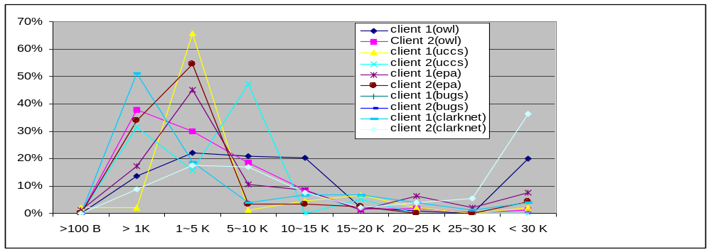

Figure 4-6 Document Size Distribution of Different Individual Client

Table 4-10 summarizes the statistic characters of the document size for different clients.

Table 4-10 Whole Characters of Document Size for Ten Clients
Size (KB) | < 0.1 | 0.1 ~ 1 | 1 ~ 2 | 2 ~ 3 | 3 ~ 4 | 4 ~ 5 | 5 ~ 6 | 6 ~ 7 | 7 ~ 8 | 8 ~ 9
Percentage | 0.48 | 15.89 | 20.89 | 20.67 | 10.67 | 5.27 | 3.64 | 1.67 | 1.59 | 1.02

From Figure 4-6, Tables 4-9 and 4-10, we can see that the sizes of most documents requested by clients appear to be in the range between 1 KB and 5 KB. Less than 20% of requested documents are larger than 10 KB, or smaller than 1 KB. This distribution is consistent with the whole distribution on different web servers shown in Figures 4-3 and 4-4 and Tables 4-5 and 4-6.

4.4 REQUEST TIME INTERVAL DISTRIBUTION

Since the time is the log is recorded with resolution up to a second, two access records may show the same time stamp. We represent time differnces in those situations as <1. Table 4-11 summarizes the distribution of the request frequency on the five web sites. Figure 4-7 shows the distribution of the request frequency

Table 4-11 Distribution Summary of Request Frequency on Different Web Site
 | Max interval (s) | Min interval (s) | Median interval (s) | Average interval (s)
OWL | 200 | < 1 | < 1 | < 1
UCCS | 100 | 1 | < 1 | < 1
EPA | 300 | < 1 | < 1 | < 1
CLARKNET | 100 | 1 | < 1 | < 1
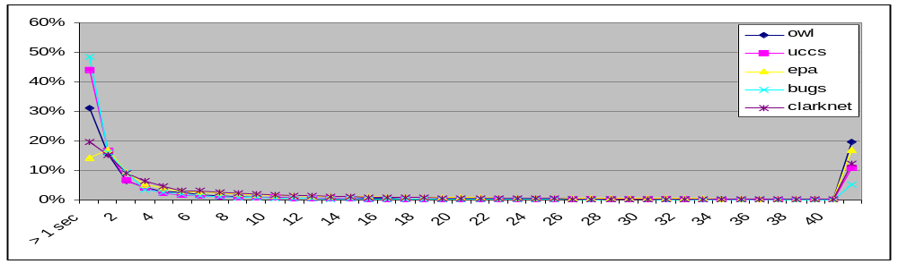BUGS | 400 | < 1 | < 1 | < 1

Figure 4-7: Distribution of Request Interval on Different Web Sites

Table 4-12 gives the statistic characterization of the request time interval on the five web servers

Table 4-12 Statistic Characterization of Request Time Interval
Interval (s) | < 1 | 1 | 2 | 3 | 4 | 5 | 6 | 7 | 8 | 9 | 10
Percentage | 28.66 | 16.25 | 8.00 | 3.50 | 2.62 | 2.20 | 1.86 | 1.57 | 1.23 | 1.09 | 1.04
Total Requests | 54345 | 30821 | 15180 | 6629 | 4958 | 4178 | 3533 | 2970 | 2328 | 2060 | 1976

From Figure 4-7 and Table 4-12, we can see that most request intervals are less than 1 second, and only 10% of request intervals are larger than 2 seconds.

We also analyzed five client data provided in Characteristics of WWW Client Traces, Carlos A. Cunha, Azer Bestavros and Mark E. Crovella, Boston University Department of Computer Science, Technical Report TR-95-010, April 1995. Those data were downloaded from http://ita.ee.lbl.gov/html/contrib/. Table 4-13 summarizes the characterizations of the five clients and Figure 4-8 shows the distribution of the request time interval for the five clients.

Table 4-13 Summary of Statistic Characterizations of Clients
 | Duration | Total Requests | Max. Interval | Min. Interval | Median Interval
Client 1 | April, 1995 | 758 | >50 s | <1 s | < 1 ~ 1s
Client 2 | Feb., 1995 | 1603 | >50 s | <1 s | < 1 s
Client 3 | Jan., 1995 | 190 | >50 s | <1 s | < 1 ~ 1s
Client 4 | Mar., 1995 | 202 | >50 s | <1 s | 1 ~ 2s
Client 5 | May, 1995 | 1936 | > 50 s | <1 s | <1 ~ 1s

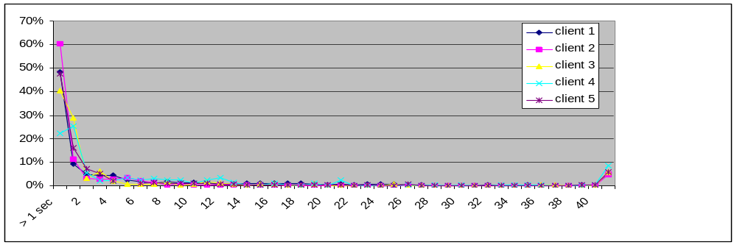
Figure 4-8 Distribution of Request Time Interval

From Figures 4-7 and 4-8, we can see that they have similar distribution of request time interval.

We have also selected some clients from different web sites to analyze their statistic characterization. Table 4-14 lists the characterizations of request interval for different clients. Figure 4-9 shows their distribution of request interval frequency.

Table 4-14 Distribution of Request Interval
 | Duration | Total Request | Max Interval | Min Interval | Median Interval
Client 1 (OWL) | April, 1995 | 758 | >50 s | <1 s | 1 ~ < 1s
Client 2 (OWL) | Feb., 1995 | 1603 | >50 s | <1 s | < 1 s
Client 1 (UCCS) | Oct., 1995 | 343 | >50 s | < 1 s | 1
Client 2 (UCCS) | Oct., 1995 | 546 | >50 s | < 1 s | < 1 s
Client 1 (EPA) | Jan., 1995 | 190 | >50 s | <1 s | 1 ~ < 1s
Client 2 (EPA) | Mar., 1995 | 202 | >50 s | <1 s | 1 ~ 2s
Client 1 (CLARKNET) | Jan., 1995 | 300 | >50s | <1 s | > 1 s
Client 2 (CLARKNET) | Jan., 1995 | 289 | >50s | <1 s | 1 s

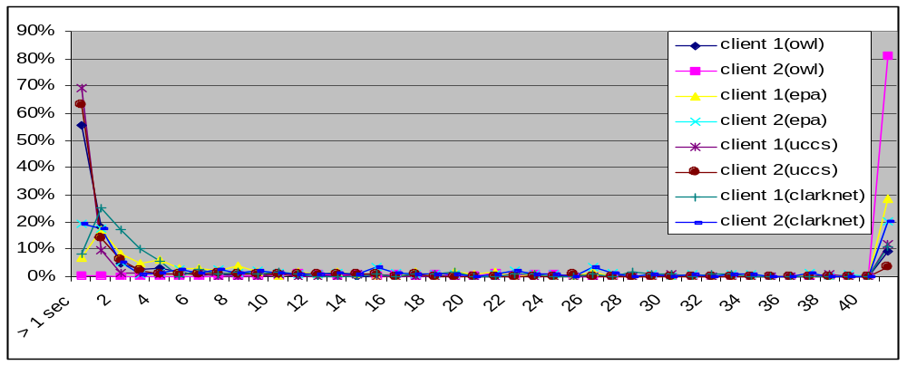

Figure 4-9 Distribution of Request Interval

Table 4-15 summarizes the statistic characterization of the 8 distinct clients.

Table 4-13 Statistic Characterization of Request Time Interval
Interval (s) | < 1 | 1 ~ 2 | 2 ~ 3 | 3 ~ 4 | 4 ~ 5 | 5 ~ 6 | 6 ~ 7 | 7 ~ 8 | 8 ~ 9 | 9~10 | > 10
Percentage | 52.18 | 22.41 | 12.52 | 3.73 | 3.53 | 2.59 | 1.35 | 1.97 | 1.35 | 1.35 | 1.56
Total Requests | 503 | 216 | 77 | 36 | 34 | 25 | 13 | 19 | 13 | 13 | 15

4.5 SUMMARY

Based on the above analysis, we can get the following conclusion about the web and client characterization.

- The size of most web server documents requested by clients is less than 5 KB.
- HTML and images documents account for over 80% of documents transferred by web servers.
- Most of request interval is less than 1 second.

