CHAPTER 7

NWTWORK DESIGN SIMULATION

In Chapter 6, we simulated and analyzed the load balancing algorithms. In this chapter, we will simulate and analyze the network design issues, e.g., how many web servers for a network with the load-balancing algorithm may achieve reasonable, how many clients in a network are allowed for the load balancing algorithm to achieve acceptable performance. In next chapter, we will summarize the statistic characterization of the load balancing algorithms.

In this chapter, we will use algorithm LBA-I, LBA-I-1, LBA-I-2 and network r50 for the simulation.

7.1 Size and Frequency of Request

In Chapter 6, we use the distribution of the document size shown in Figure 6-1, which is based on the statistic analysis results in Chapter 4. For the following simulation we use the distribution of the request size shown in Figure 7-1 and the distribution of the request interval time shown in Figure 6-2:

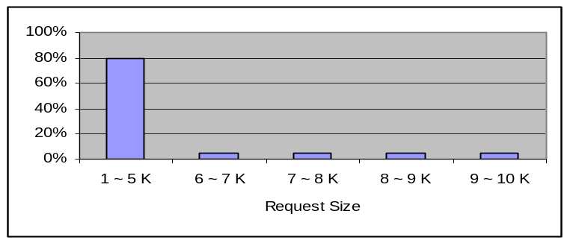
Figure 7-1 Distribution of Request Size

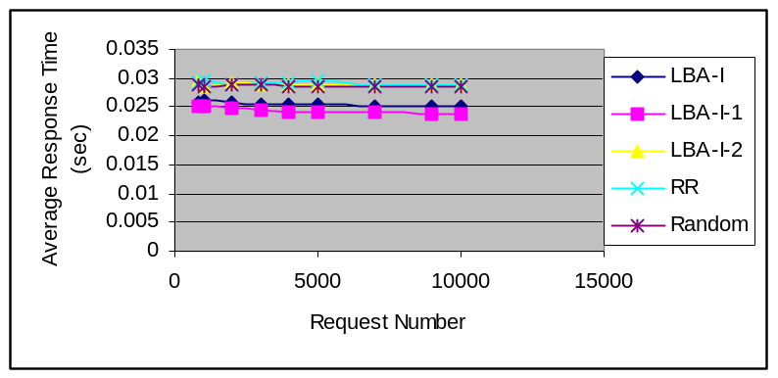In Figure 7-1, the size of 80% requests is from 1 to 5 KB, and 20 % requests are of size over 5 K. Figure 7-2 shows the average response time of algorithms LBA-I, LBA-I-1, LBA-I-2, RR, and Random. Table 7-1 lists the simulation data.

Figure 7-2 Average Response Time

Table 7-1 Simulation Data of Algorithm on r50 Network with Request Size Distribution
in Figure 7-1 and the Frequency of the Request in Figure 6-2

 | LBA-I | LBA-I-1 | LBA-I-2 | RR | Random
Average Response Time(s) | 0.0254703 | 0.024389 | 0.0289212 | 0.0291010 | 0.0286526
Average Web Queuing Delay (s) | 0.0011805 | 0.001213 | 0.0004722 | 0.0003448 | 0.0003288
Average Router Queuing Delay (s) | 0.0000115 | 0.000008 | 0.0000016 | 0.0000013 | 0.0000035
Average Transmission Delay (s) | 0.0213733 | 0.0202210 | 0.02377087 | 0.0241247 | 0.0236436
Average Propagation Delay (s) | 0.0022715 | 0.0023254 | 0.00398512 | 0.0039567 | 0.0039744
Average Processing Delay (s) | 0.0006911 | 0.0006968 | 0.0007083 | 0.0007101 | 0.0007012
From Table 7-1 and Figure 7-2, we can see that the load balancing algorithms LBA-I and LBA-I-1 still have better performance than algorithms LBA-I-2, RR and Random Comparing to algorithm RR, algorithms LBA-I and LBA-I-1 reduces 12.48% and 16.19% of the average response time, respectively. Comparing to the Random algorithm, algorithm LBA-I and LBA-I-1 reduces 11.12% and 14.88% of the average response time, respectively. Comparing to algorithm LBA-I-2, the algorithm LBA-I and LBA-I-1 reduces 11.93 % and 15.67% of response time, respectively. Comparing Table 7-1 to Table 6-7, we can see that the transmission time is significantly reduced in this case, 12.44% for algorithm LBA-I, and 11.62% for algorithm LBA-I-1. The average response time is also significantly reduced, 11.79% for algorithm LBA-I and 10.91% for algorithm LBA-I-1. Therefore we can make the comments based on above simulation that both the transmission delay and the average response time will be reduced if the average document size is smaller.

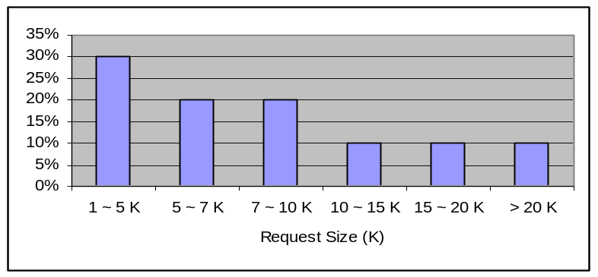Next we use the distribution of the request size shown in Figure 7-3. Which has longer trailer and bigger request size than that shown in Figure 7-1.

Figure 7- 3 Distribution of Request Size

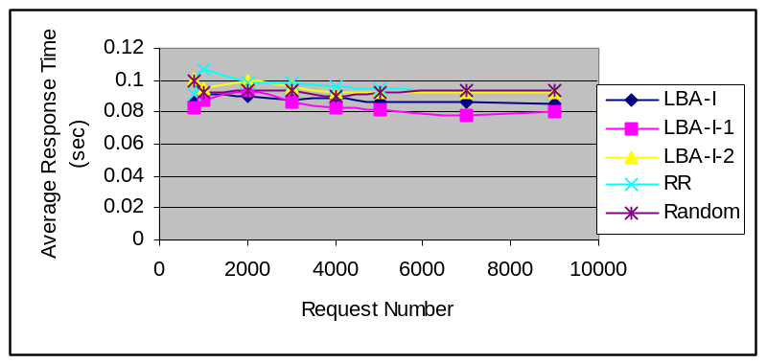Figure 7-4 shows the average response time in this case, where we still use the distribution of the request interval shown in Figure 6-2. Table 7-2 lists the simulation data.

Figure 7-4 Average Response Time

Table 7-2 Simulation Data of Algorithm on r50 Network with Request Size Distribution
in Figure 7-3 and the Frequency of the Request in Figure 6-2

 | LBA-I | LBA-I-1 | LBA-I-2 | RR | Random
Average Response Time(s) | 0.0877636 | 0.084151 | 0.0953667 | 0.0968225 | 0.0937486
Average Web Queuing Delay (s) | 0.0079097 | 0.0082428 | 0.0054666 | 0.0047294 | 0.0049087
Average Router Queuing Delay (s) | 0.0000174 | 0.000013 | 0.0000135 | 0.0000091 | 0.0000134
Average Transmission Delay (s) | 0.0752515 | 0.0714115 | 0.0842800 | 0.0858857 | 0.0825485
Average Propagation Delay (s) | 0.0022974 | 0.002313 | 0.0039790 | 0.0039624 | 0.0039438
Average Processing Delay (s) | 0.0024712 | 0.0025441 | 0.0026295 | 0.0026650 | 0.0025763

In this case, comparing to the Random algorithm, algorithms LBA-I and LBA-I-1 reduces 6.35% and 10.237% of average response time, respectively. Comparing to algorithm RR, algorithms LBA-I and LBA-I-1 reduces 9.356% and 13.08% of average response time, respectively. Comparing to algorithm LBA-I-2, algorithms LBA-I and LBA-I-1 reduces 7.97% and 11.76% of average response time, respectively. Comparing Table 7-2 to Table 6-7, we can see that the transmission delay and average response time have increased. Therefore at the same request interval, the larger document size will result in the longer response time and transmission delay.

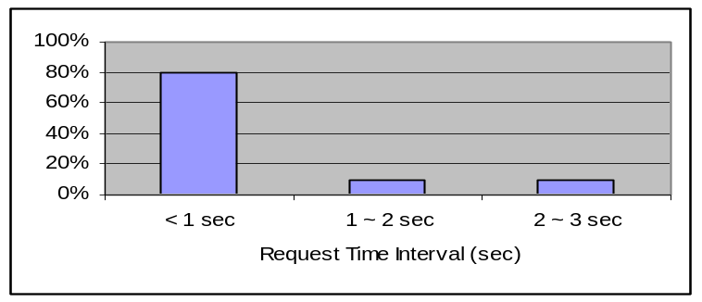Now we change the distribution of the request interval and use the distribution shown in Figure 7-5. The request interval shown in Figure 7-5 is faster than that in Figure 6-2

Figure 7-5 Distribution of Request Interval.

Figure 7-6 shows the performance of different algorithms with the distribution of the request size shown in Figure 7-3. Table 7-3 lists the simulation data.
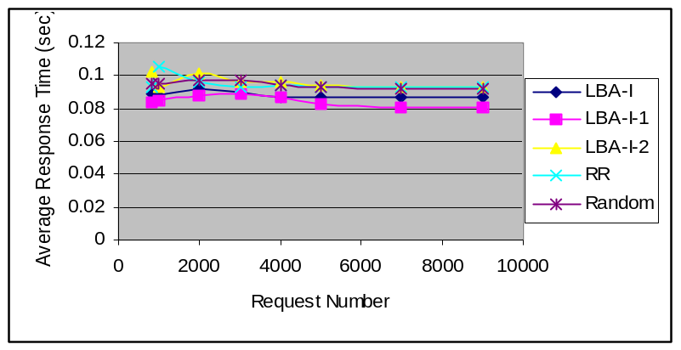
Figure 7-6 Algorithm Average Response Time

Table 7-3 Simulation Data of Algorithm on r50 Network with Request Size Distribution
in Figure 7-3 and the Distribution of the Request interval in Figure 7-5

 | LBA-I | LBA-I-1 | LBA-I-2 | RR | Random
Average Response Time(s) | 0.088883 | 0.085484 | 0.0970951 | 0.0957011 | 0.0952325
Average Web Queuing Delay (s) | 0.009251 | 0.009401 | 0.0056195 | 0.0051190 | 0.0053696
Average Router Queuing Delay (s) | 0.000015 | 0.000027 | 0.0000185 | 0.0000153 | 0.0000161
Average Transmission Delay (s) | 0.074854 | 0.071207 | 0.0847895 | 0.0839980 | 0.0832902
Average Propagation Delay (s) | 0.002304 | 0.002312 | 0.0039870 | 0.0039638 | 0.0039557
Average Processing Delay (s) | 0.002456 | 0.002537 | 0.0026792 | 0.0026381 | 0.0025993

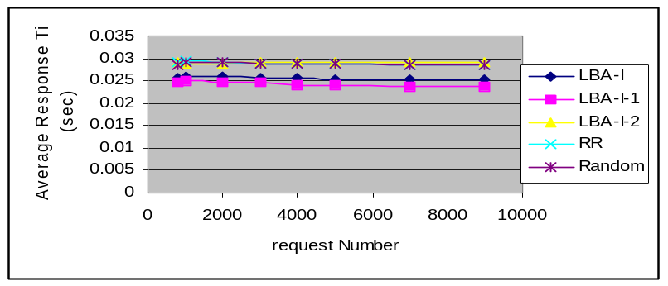Figure 7-7 shows the average response time of algorithm LBA-I, LBA-I-1, LBA-I-2, RR and Random with the distribution of request interval shown in Figure 7-5 and the distribution of request size shown in Figure 7-1. Table 7-4 lists the simulation data.

Figure 7-7 Average Response Time

Table 7-4 Simulation Data of Algorithm on r50 Network with Request Size Distribution
in Figure 7-1 and the Distribution of the Request Interval in Figure 6-5

 | LBA-I | LBA-I-1 | LBA-I-2 | RR | Random
Average Response Time(s) | 0.025672 | 0.024569 | 0.029058 | 0.029062 | 0.028974
Average Web Queuing Delay (s) | 0.001356 | 0.001378 | 0.0005538 | 0.000402 | 0.000411
Average Router Queuing Delay (s) | 0.000009 | 0.0000078 | 0.000002 | 0.000002 | 0.0000028
Average Transmission Delay (s) | 0.021320 | 0.0201688 | 0.023808 | 0.024003 | 0.023895
Average Propagation Delay (s) | 0.002303 | 0.00232016 | 0.003982 | 0.003880 | 0.0039626
Average Processing Delay (s) | 0.000691 | 0.00069466 | 0.000711 | 0.000707 | 0.0007025
Comparing Table 7-3 and 7-4, we can see that for the same distribution of the request interval, the smaller document size will reduce the transmission time and average response time.

7.2 Number of Web Servers

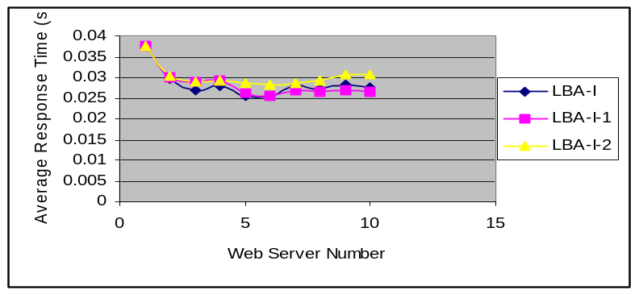Figures 7-8 shows the average response time of algorithm LBA-I, LBA-I-1, and LBS-I-2 when the number of web servers changes from 1 to 10, respectively.

Figure 7-8 Average Response Time of Algorithm LBA-I, LBA-I-1 and LBA-I-2

From Figures 7-8, we can see that when the number of the web server is increased, the average response time is reduced.

Tables 7-5 to 7-9 lists the transmission delay, propagation delay, web queuing delay, router queuing delay, and total processing delay when the number of web servers changes from 1 to 10, respectively.

Table 7-5 Transmission Delay on r50 Network with the Distribution of the Request Size in Figure 6-1 and the Distribution of the Request Interval in Figure 6-2

Number of Webs | Number of Webs/Number of LBAs | LBA-I | LBA-I-1 | LBA-I-2
1 | 2.5% | 0.022255 | 0.022255 | 0.022255
2 | 5.0% | 0.021478 | 0.021660 | 0.021958
3 | 7.3% | 0.020649 | *0.022556 | 0.022556
4 | 10.0% | 0.022539 | *0.023487 | 0.023487
5 | 12.5% | 0.025398 | 0.021894 | 0.023549
6 | 15.0% | 0.021708 | 0.021703 | 0.023271
7 | 17.5% | 0.023799 | 0.022882 | 0.023876
8 | 20.0% | 0.023211 | 0.022576 | 0.024499
9 | 22.5% | 0.028106 | 0.023389 | 0.025915
10 | 25.00% | 0.023537 | 0.022717 | 0.025811

Table 7-6 Propagation Delay on r50 Network with the Distribution of the Request Size in Figure 6-1 and the Distribution of the Request Interval in Figure 6-2

Number of Webs | Number of Webs/Number of LBAS | LBA-I | LBA-I-1 | LBA-I-2
1 | 2.5% | 0.004183 | 0.004183 | 0.004183
2 | 5.0% | 0.003575 | 0.003650 | 0.003959
3 | 7.3% | 0.003239 | *0.003925 | 0.003925
4 | 10.0% | 0.002848 | *0.004004 | 0.004004
5 | 12.5% | 0.002090 | 0.002360 | 0.003690
6 | 15.0% | 0.002143 | 0.002436 | 0.003805
7 | 17.5% | 0.002177 | 0.002348 | 0.003819
8 | 20.0% | 0.002239 | 0.002280 | 0.003868
9 | 22.5% | 0.002259 | 0.002226 | 0.003883
10 | 25.00% | 0.002321 | 0.002353 | 0.003979

Table 7-7 Web Queuing Delay on r50 network with the Distribution of the Request Size in Figure 6-1 and the Distribution of the Request Interval in Figure 6-2

Number of Webs | Number of Webs/Number of LBAs | LBA-I | LBA-I-1 | LBA-I-2
1 | 2.5% | 0.010609 | 0.010609 | 0.010609
2 | 5.0% | 0.004053 | 0.004021 | 0.003631
3 | 7.3% | 0.002470 | 0.001941 | 0.001941
4 | 10.0% | 0.001764 | 0.001080 | 0.001080
5 | 12.5% | 0.001595 | 0.001263 | 0.000781
6 | 15.0% | 0.000974 | 0.000819 | 0.000544
7 | 17.5% | 0.001151 | 0.001036 | 0.000271
8 | 20.0% | 0.001295 | 0.001014 | 0.000263
9 | 22.5% | 0.000871 | 0.000716 | 0.000186
10 | 25.00% | 0.000925 | 0.000817 | 0.000153

Table 7-8 Router Queuing Delay on r50 Network with the Distribution of the Request Size in Figure 6-1 and the Distribution of the Request Interval in Figure 6-2

Number of Webs | Number of Webs/Number of LBAs | LBA-I | LBA-I-1 | LBA-I-2
1 | 2.5% | 0.000016 | 0.000016 | 0.000016
2 | 5.0% | 0.000007 | 0.000010 | 0.000004
3 | 7.3% | 0.000004 |  | 0.000004
4 | 10.0% | 0.000004 |  | 0.000004
5 | 12.5% | 0.000002 | 0.000002 | 0.000009
6 | 15.0% | 0.000004 | 0.000004 | 0.000007
7 | 17.5% | 0.000003 | 0.000002 | 0.000005
8 | 20.0% | 0.000005 | 0.000001 | 0.000003
9 | 22.5% | 0.000003 | 0.000004 | 0.000003
10 | 25.00% | 0.000002 | 0.000005 | 0.000002

Table 7-9 Processing Delay on r50 Network with the Distribution of the Request Size in Figure 6-1 and the Distribution of the Request Interval in Figure 6-2

Number of Webs | Number of Webs/Number of LBAs | LBA-I | LBA-I-1 | LBA-I-2
1 | 2.5% | 0.000650 | 0.000650 | 0.000650
2 | 5.0% | 0.000628 | 0.000629 | 0.000629
3 | 7.3% | 0.000643 |  | 0.000639
4 | 10.0% | 0.000637 |  | 0.000627
5 | 12.5% | 0.000646 | 0.000646 | 0.000653
6 | 15.0% | 0.000637 | 0.000636 | 0.000638
7 | 17.5% | 0.000647 | 0.000641 | 0.000649
8 | 20.0% | 0.000629 | 0.000630 | 0.000635
9 | 22.5% | 0.000648 | 0.000647 | 0.000653
10 | 25.00% | 0.000640 | 0.000639 | 0.000632

From the above discussion, we can see that the web server number and location are two important factors in network design. If we add the new web server, meanwhile, concern the location of new web server, then the algorithms will have the better performance.

7.3 Number of Clients

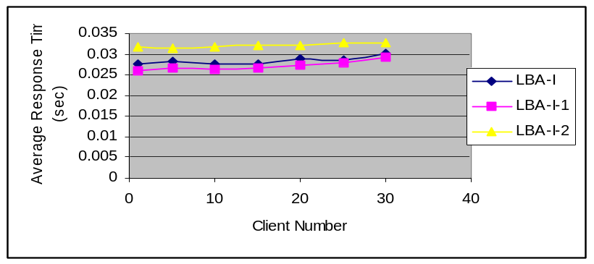In this section, we will analyze the effect of the ration of the number of clients to the number of web servers on performance. Figure 7-9 shows the average response time of

Figure 7-9 Average Response Time
algorithms LBA-I-1, LBA-I-1 and LBA-I-2 when the number of clients changes from 1 to 30 and the number of requests is 4000.

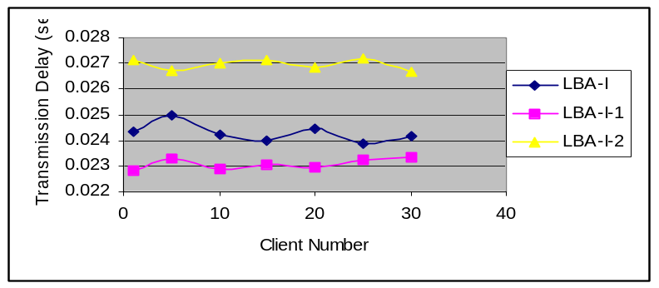From Figure 7-9, we can see that as the number of the client increases, the average response time of the algorithm increases. Figure 7-10 shows the average transmission delay of the algorithms LBA-I, LBA-I-1 and LBA-I-2 when the number of the client changes from 1 to 30.

Figure 7-10 Average Transmission Delay

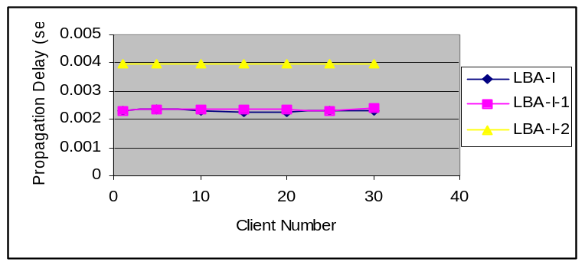Figures 7-11, 7-12, and 7-13 show the propagation delay, web queuing delay and router queuing delay of algorithms LBA-I, LBA-I-1 and LBA-I-2 when the number of clients changes from 1 to 30, respectively.

Figure 7-11 Propagation Delay
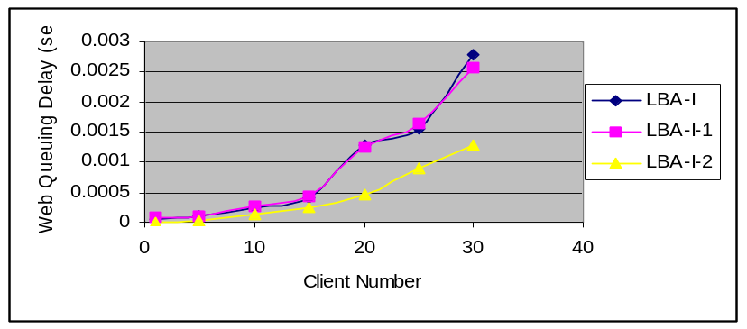

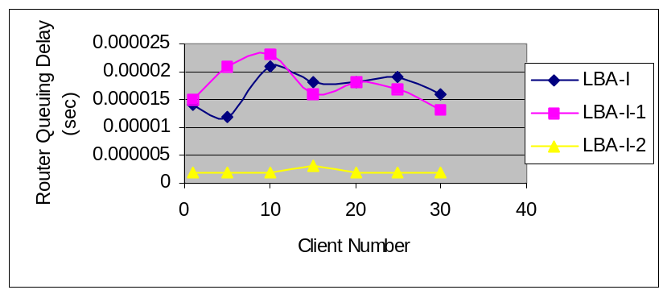Figure 7-12 Web Queuing Delay

Figure 7-13 Router Queuing Delay

From Figures 7-11,7-12, and 7-13, we can see that as the number of the client increases, the web queue delay and the average response time will increase.

7.4 Web Server Resource and Bandwidth

In this section we analyze the effect of the ration of the web server processing power to the bandwidth on the load balancing performance so that we can fully use the network resource.

Figure 7-14 shows the average response time of the algorithm LBA-I, LBA-I-1 and LBA-I-2 when the processing power of each web servers is increased by 5 times. Table 7-10 lists the simulation.
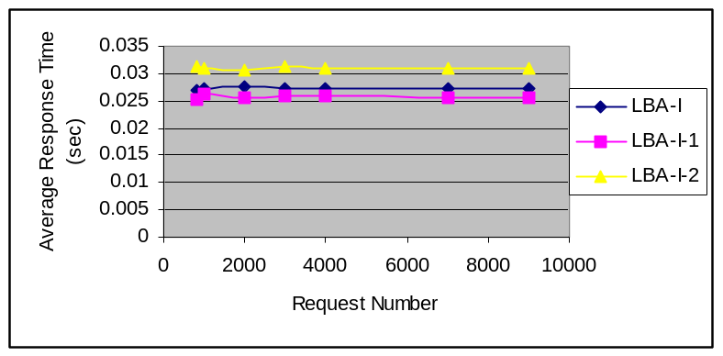
Figure 7-14 Average Response Time

Table 7-10 Simulation Data with the Processing Power Increased by 5 Times
 | LBA-I | LBA-I-1 | LBA-I-2
Average Response Time(s) | 0.02727957 | 0.025753800 | 0.03105870
Average Web Queuing Delay (s) | 0.00009428 | 0.000394167 | 0.00000657
Average Router Queuing Delay (s) | 0.00001700 | 0.000017000 | 0.00000200
Average Transmission Delay (s) | 0.02433014 | 0.022781667 | 0.02651610
Average Propagation Delay (s) | 0.00227742 | 0.002319833 | 0.00397314
Ave Processing Delay (sec) | 0.00055985 | 0.000554667 | 0.00056014

Comparing Table 7-10 to Table 6-7, we can see that the average response time of the algorithms LBA-I, LBA-I-1, and LBA-I-2 is reduced by 5.55%, 5.92%, and 3.22%, respectively.

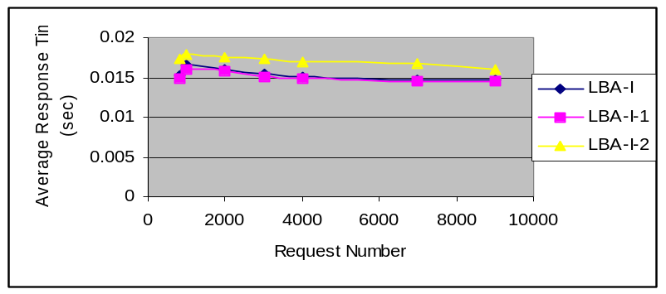Figure 7-15 shows the average response time of the algorithms LBA-I, LBA-I-1 and LBA-I-2 with the bandwidth increased by 5 times and the processing power of the web server does not changed. Table 7-11 lists the simulation data.

Figure 7-15 Average Response Time

Table 7-11 Simulation Data with the Bandwidth Increased by 5 Times
 | LBA-I | LBA-I-1 | LBA-I-2
Average Response Time(s) | 0.0155533 | 0.0152255 | 0.0173048
Average Web Queuing Delay (s) | 0.001589 | 0.001323 | 0.0008125
Average Router Queuing Delay (s) | 0.00001183 | 0.000044 | 0.0000138
Average Transmission Delay (s) | 0.0111215 | 0.010915 | 0.0117966
Average Propagation Delay (s) | 0.0020395 | 0.002191 | 0.0039751
Average Processing Delay (s) | 0.00079116 | 0.000781 | 0.0008081

Comparing Table 7-11 to Table 6-7, the average response time of the algorithms LBA-I and LBA-I-1 is reduced by 46.12% and 44.38%, respectively. Comparing Table 7-11 to Table 7-10, we can see that increasing bandwidth can more efficiently reduce the average response time than increasing processing the power of the web server.

Figures 7-16 shows the average response time of the algorithms LBA-I, LBA-I-1, and LBA-I-2 when the processing power of the web server changes from 1 MB to 40 MB, respectively.
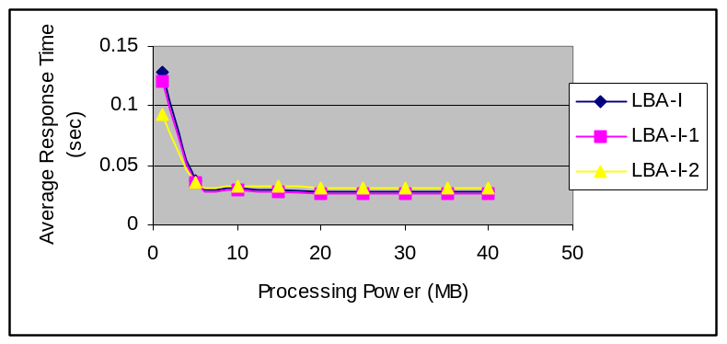
Figure 7-16 Average Response Time

From Figures 7-16, we can see that when the processing power of the web server increases from 1 MB to 8 MB, the average response time is decreased quickly. However when the processing power of the web server continually increases from 8 MB to 40 MB, the curve of the average response time is almost flat, which means that increasing the processing power of the web server does not reduce the average response time much. Therefore, we can make comments based above simulation data that when the processing power of the web server is increased to a range, the average response time is slowly reduced.

Figures 7-17 to 7-21 show the transmission delay, propagation delay, web queuing delay, router queuing delay, and processing delay of the algorithm LBA-I, LBA-I-1 and LBA-I-2, respectively, when the processing power of the web server increases from 1 MB to 40 MB.
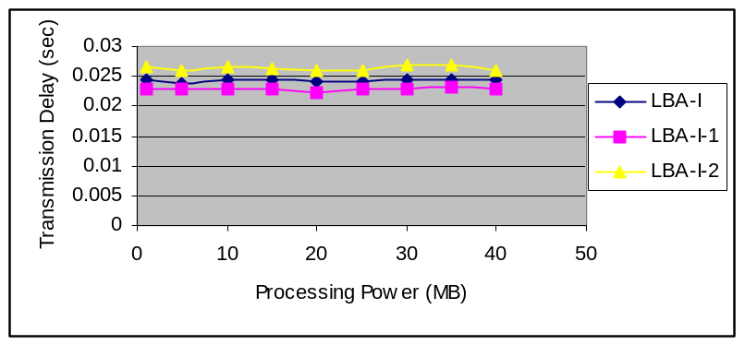

Figure 7-17 Transmission Delay

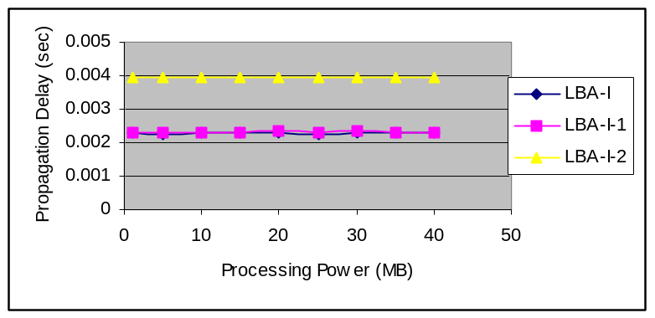
Figure 7-18 Propagation Delay

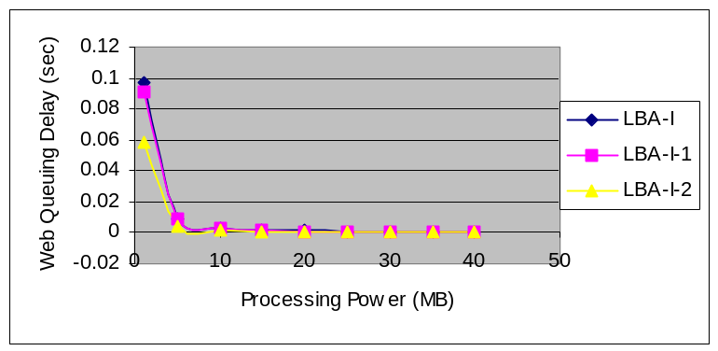
Figure 7-19 Web Queuing Delay
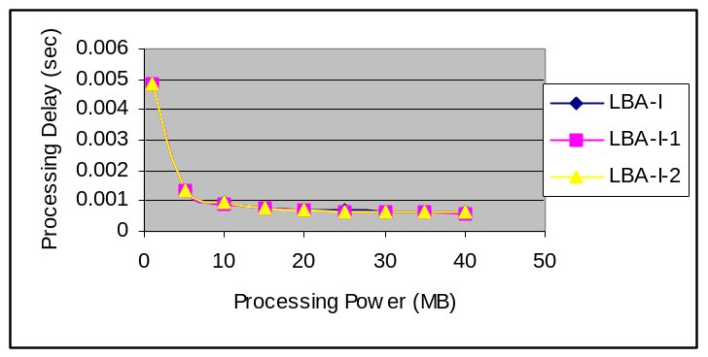
Figure 7-20 Processing Delay

From Figures 5-17 to 5-20, we can see that increasing the process power of the web servers can reduce the web queuing delay and processing delay. As we have mentioned, when the processing power of the web servers is increased from 1 MB to 8 MB, the web queuing delay and processing delay are quickly reduced. However when the process power of the web servers are increased from 8 MB to 40 MB the web queuing delay and processing delay are reduced slowly.

7.5 Web Server Location

In this section, we will analyze the effect of the web server location on the performance of the algorithm. We randomly choose four sets of the web location given in Table 7-12.

Table 7-12 Web Location Set
Set ID | Web Server ID
1 | N01, N09, N13, N15, N18, N20, N25, N29, N35,N42
2 | N04, N05, N19, N22, N27, N32, N44, N45, N48, N49
3 | N05, N08, N18, N28, N32, N38, N39, N40, N42, N45
4 | N07, N11, N14, N20, N26, N35, N36, N37, N42, N47

Figure 7-21 shows the average response time of the algorithm LBA-I for these different web server locations. Table 7-13 lists their average response time.
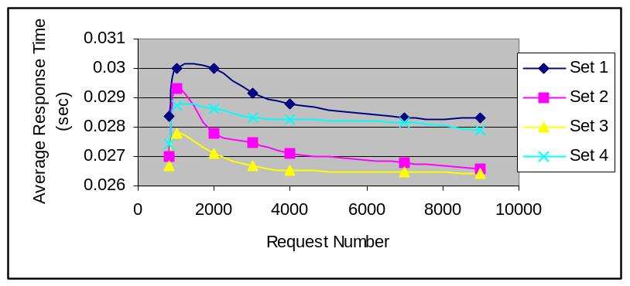
Figure 7-21 Average Response Time

Table 7-13 Average Response Time for Different Web Locations
 | Set 1 | Set 2 | Set 3 | Set 4
Average Response Time (s) | 0.028994 | 0.0274428 | 0.0268087 | 0.0282094

From Table 7-13, we can see that the difference between the best case whose average response time is 0.0268087 second and the worst case whose average response time is 0.028994 second is 0.00218 second, about 7.518%. Therefore the web server location does affect the average response time of the algorithm.

Figures 7-22 to 7-26 shows the transmission delay, propagation delay, web queuing delay, and processing delay.

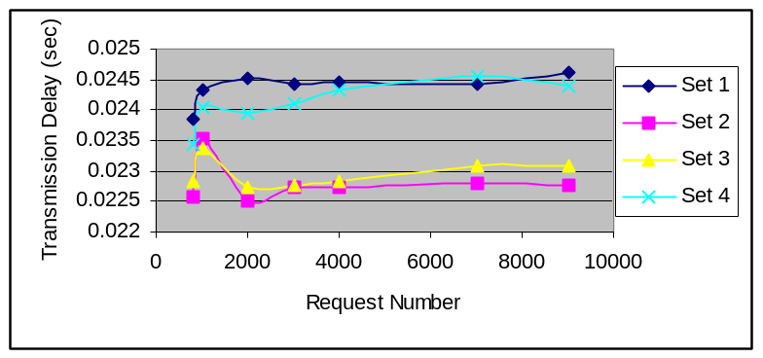
Figure 7-22 Transmission Delay

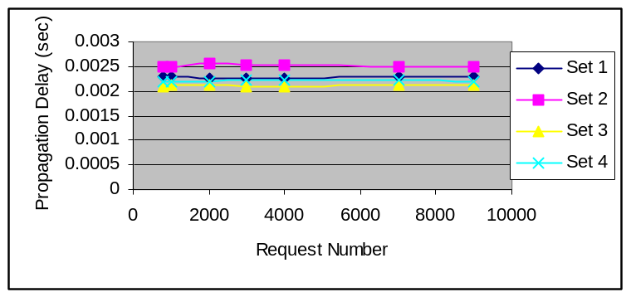
Figure 7-23 Propagation Delay

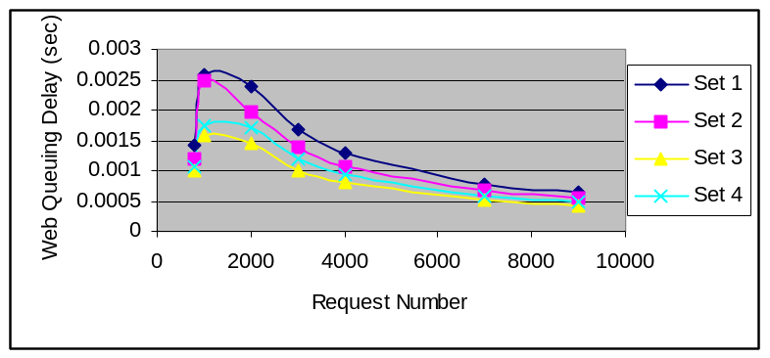

Figure 7-24 Web Queuing Delay

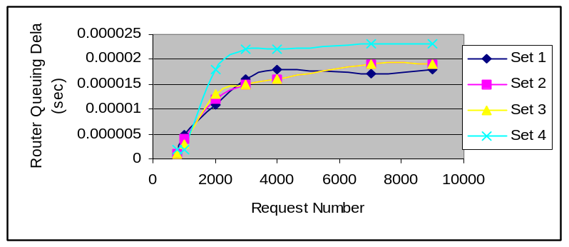

Figure 7-25 Router Queuing Delay

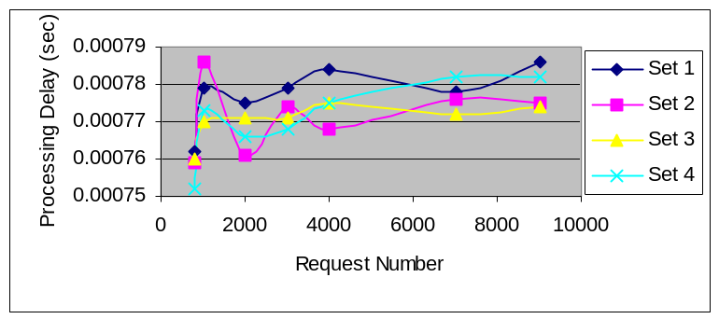
Figure 7-26 Processing Delay

From Figures 7-22 to 7-26, we can see that if dominating the balancing performance is the transmission delay, we can reduce the transmission delay by locating the web server at proper position, and by decreasing the transmission delay, the average response time of the request can be reduced.

Figure 7-27 shows the average response time of algorithm LBA-I-1. Table 7-14 lists the average response time for different web sets.

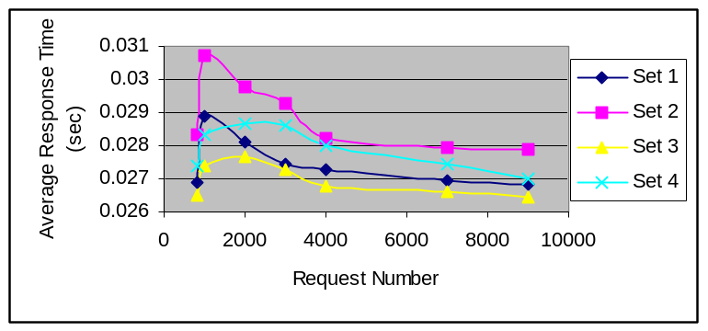
Figure 7-27 Average Response Time of LBA-I-1

Table 7-14Average Response Time of Algorithm LBA-I-1
Web Server Location | Set 1 | Set 2 | Set 3 | Set 4
Average Response Time (s) | 0.0274894 | 0.0288814 | 0.0269585 | 0.027938

From Table 7-14, we can see that the best case can reduce the average response time by 6.65% relative to the worst case.

Figures 7-28 to 7-32 shows the transmission delay, propagation delay, web queuing delay, router queuing delay, and process delay, respectively.
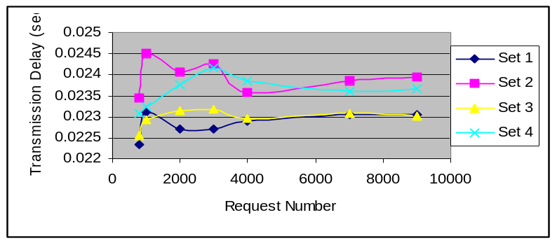
Figure 7-28 Transmission Delay of LBA-I-1

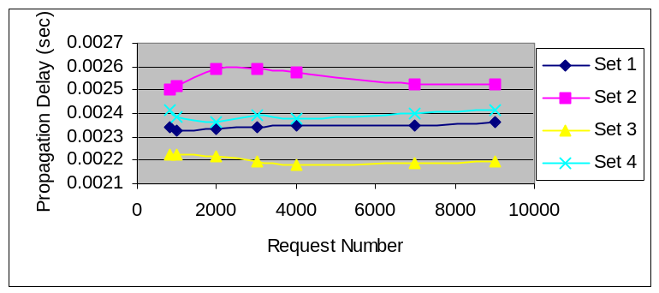
Figure 7-29 Propagation Delay of LBA-I-1

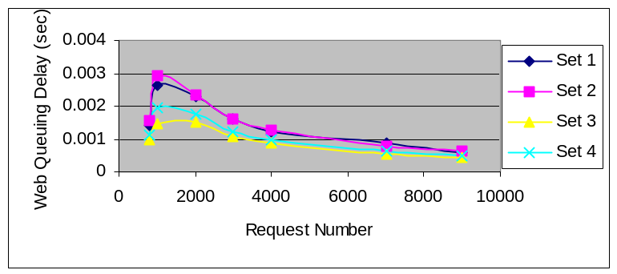
Figure 7-30 Web Queuing Delay of LBA-I-1

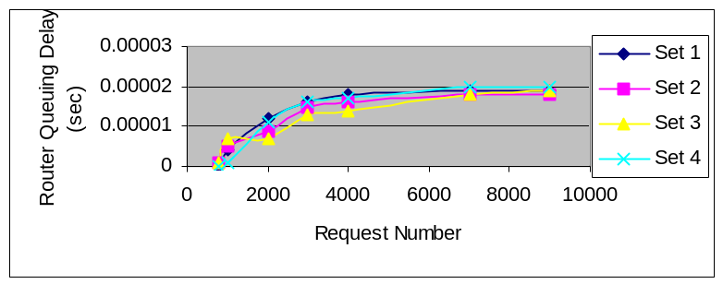
Figure 7-31 Router Queuing Delay of LBA-I-1
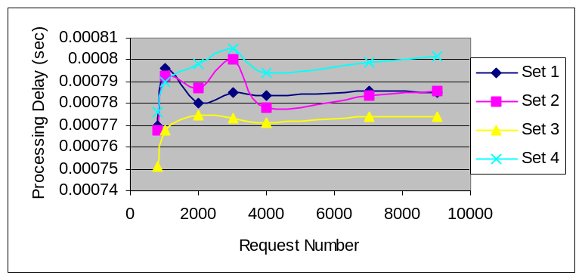
Figure 7-32 Processing Delay of LBA-I-1

Figure 7-33 shows the average response time of the algorithm LBA-I-2 for the different web server location. Table 7-15 lists the average response time.

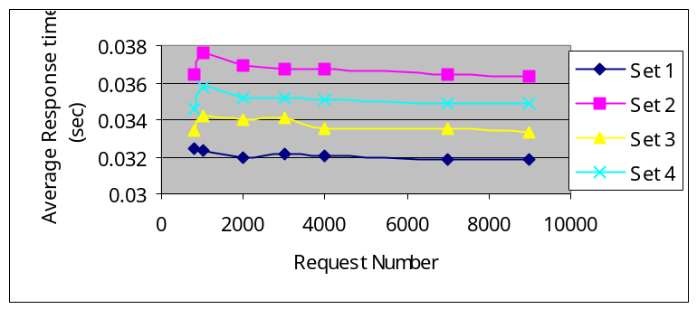
Figure 7-33 Average Response Time of LBA-I-2

Table 15 Average Response Time of LBA-I-2 for Different Web Location4
Set ID | Set 1 | Set 2 | Set 3 | Set 4
Average Response Time (s) | 0.03208514 | 0.03633857 | 0.0337187 | 0.035085

From Table 7-15, we can see that the best case can reduce the average response time by 11.7% relative to the worst case.

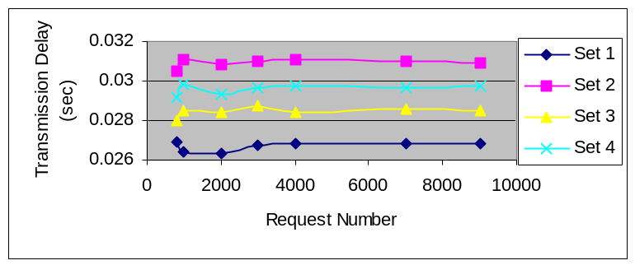Figures 7-34 to 7-38 show the transmission delay, propagation delay, web queuing delay, router queuing delay, process delay, respectively.

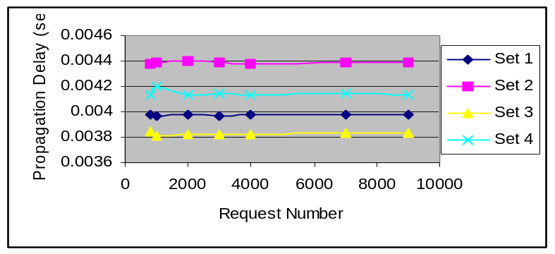Figure 7-34 Transmission Delay of LBA-I-2

Figure 7-40 Propagation Delay of LBA-I-2

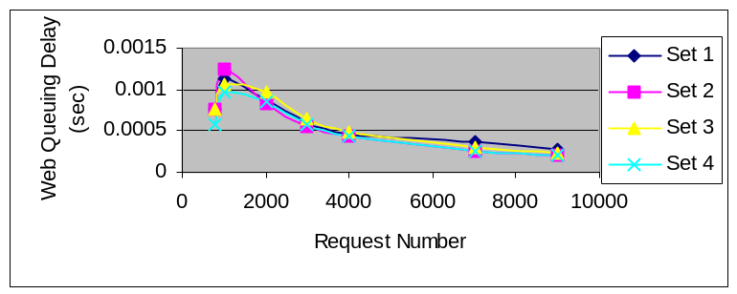
Figure 7-41 Web Queuing Delay

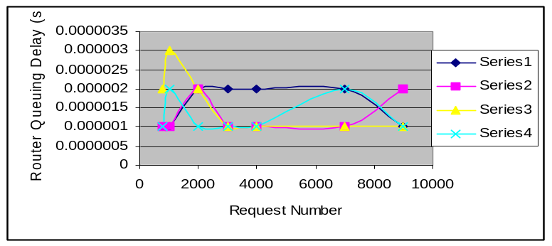

Figure 7-42 Router Queuing Delay of LBA-I-2
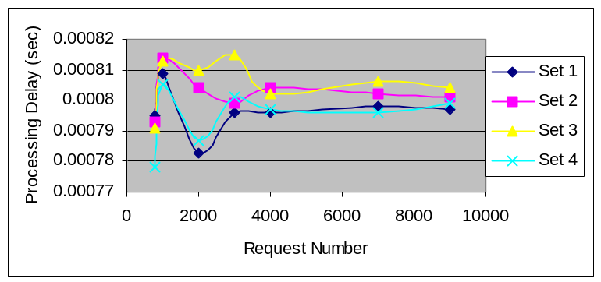

Figure 7-43 Processing Delay of LBA-I-2

From the above discussion, we can see that web server location does affect the average response time of the algorithms.

7.6 Summary

In this chapter, we discuss some network design issues by simulation experimental. We have the following suggestions for the network design.

- Design small document size. We can not control the interval of the request, but we have the control of the document size. By using small the document size, we can reduce the response time of the request.

- Choose proper ratio of the web servers to clients and LBAs. By selecting proper ratio, we can fully utilize the resource of the network and also reduce the response time of clients.

- Choose proper process power of web server.
- Set web servers at proper locations.
- Increasing the bandwidth will get better efficiency than increasing the process power of web server.

