CHAPTER 6

LOAD-BALANCING ALGORITHM SIMULATION

We have developed the load balancing algorithms in Chapter 2, analyzed the web and client workload characterizations in Chapter 4 and designed the simulation parameters and simulation program in Chapter 5. In this chapter we will present and evaluate the algorithm’s performance, in addition, we will discuss the range of algorithm’s application, and investigate the impact on the performance of the algorithms by varying parameters, the impact on the performance of the algorithms for different workload characterizations of the network. We will use the following criterions developed in Chapter 2 to evaluate the performance of the algorithms.

- The end-end average response time.
- Queuing delays such as the delay at the web server and the router.
- Transmission delay.
- Propagation delay.
- Processing delays at web server and router.
- Imbalance rate.

6.1 LBA-I Load-Balancing Algorithm

In this section, we simulate the performance of LBA-I, LBA-I-1, LBA-I-2 algorithms using Jew Jersey and r50 networks. We will compare LBA-I, LBA-I-1, LBA-I-2 algorithm results with the random and RR--Round-Robin algorithm.

6.1.1 New Jersey Network

The topology of the New Jersey LATA Network is shown in Figure 5-1. Table 6-1 lists its simulation parameters.

Table 6-1 Simulation Parameters of New Jersey LATA Network
Number of Nodes | 116
Number of Clients | 100
Number of Web | 3
Web Processing Power | 10MB ~ 30 MB
Number of Subnets | 5
Number of Routers | 8
Router Processing Power | 1000 Mb
Average Client processing Power | 10MB
Range of Request Size | 1 ~ 10 KB
Range of Request Interval | < 1 ~ 4 s

Figure 6-1 shows the distribution of the document size used for the simulation, which is generated based on the analyzing results of the web workload characterization.

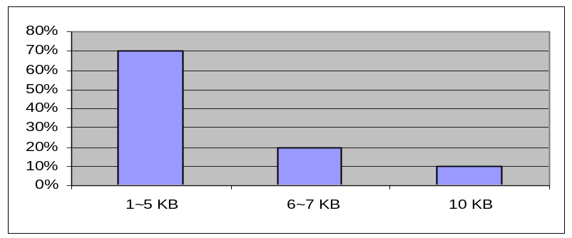

Figure 6-1 Distribution of Document Size

Figure 6-2 shows the distribution of request interval used for the simulation, which is set based on the analyzing results of the client workload characterization.
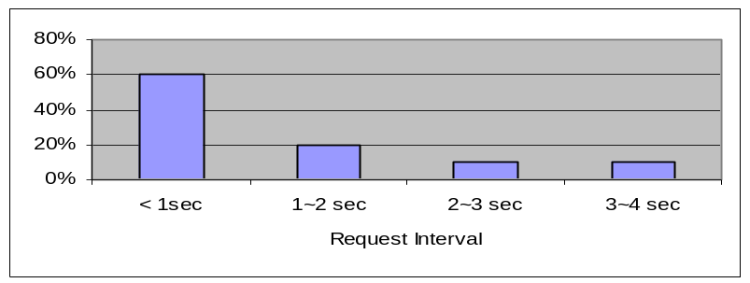

Figure 6-2 Distribution of Request Interval

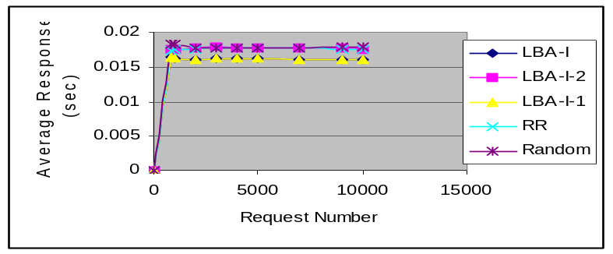Figure 6-3 shows the average response times in seconds when the number of requests varies from 800 to 10000 using the above simulation parameters.

Figure 6-3 New Jersey LATA Network Average Response Time

Table 6-2 lists the simulation data of the algorithms LBA-I, LBA-I-1, LBA-I-2, RR and Random
Table 6-2 Simulation Data of Algorithms LBA-I, LBA-I-1, LBA-I-2, RR and Random on the New-Jersey Network

 | LBA-I | LBA-I-1 | LBA-I-2 | RR | Random
Average Response Time (s) | 0.016226 | 0.016226 | 0.017708 | 0.017663 | 0.017924
Average Web Queuing Delay (s) | 0.000308 | 0.000308 | 0.000035 | 0.000037 | 0.000053
Average Router Queuing Delay (s) | 0.000012 | 0.000012 | 0.000007 | 0.000011 | 0.000015
Average Transmission Delay (s) | 0.014775 | 0.014775 | 0.016528 | 0.016483 | 0.016706
Average Propagation Delay (s) | 0.000238 | 0.000238 | 0.000324 | 0.000321 | 0.000328
Average Processing Delay (s) | 0.000894 | 0.000894 | 0.000814 | 0.000813 | 0.000824
Average Imbalance Rate | 0.120399 | 0.120399 | 0.001294 | 0.001358 | 0.001242

Table 6-3 shows the percentage of each delay in the average response time.

Table 6-3 Percentage of Each Delay in Average Response Time

 | LBA-I | LBA-I-1 | LBA-I-2 | RR | Random
Average Response Time (s) | 1.8980% | 1.8980% | 0.19760% | 0.2095% | 0.2956%
Average Router Queuing Delay (s) | 0.0739% | 0.0739% | 0.0395% | 0.06227% | 0.0836%
Average Transmission Delay (s) | 91.057% | 71.057% | 93.363% | 93.3193% | 93.205%
Average Propagation Delay (s) | 1.4667% | 1.4667% | 1.8296% | 1.8174% | 1.8299%
Average Processing Delay (s) | 5.5096% | 5.5096% | 4.9567% | 4.6028% | 4.5972%

From Table 6-3, we can see that the transmission delay is the most important factor for the response time. Over ninety percent of response time comes from the transmission delay. LBA-I, LBA-I-1 algorithms reduce the transmission delay since the algorithm takes the path performance into account. On the other hand, the LBA-I-2, RR and Random algorithms do not improve the transmission delay since they do not take the path performance into account, therefore, the algorithms LBA-I, LBA-I-1 have the better performance than the algorithms LBA-I-2, RR and Random. Figure 6-4 shows the 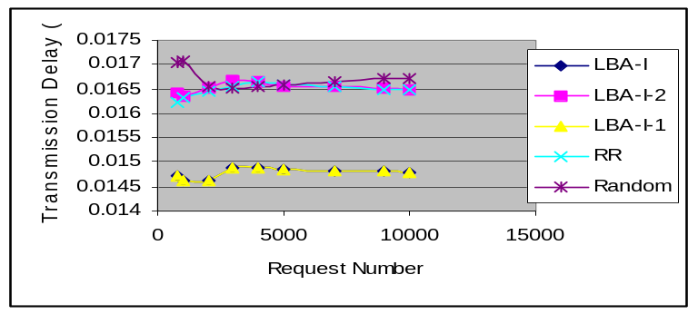transmission delay of the algorithm LBA-I, LBA-I-1 and LBA-I-2, RR, Random.
.
Figure 6-4 Transmission Delay of Algorithms LBA-I, LBA-I-1, LBA-I-2, RR, Random

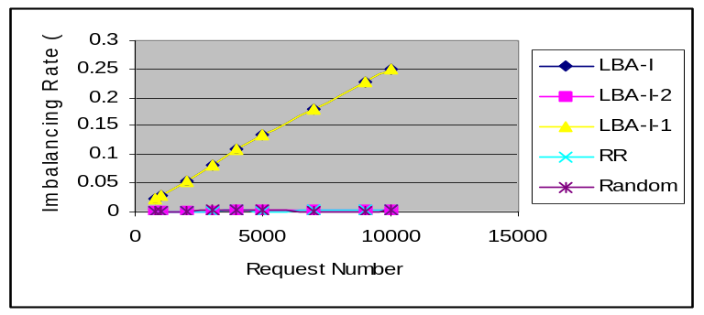Figure 6-5 shows the load imbalance rates of algorithm LBA-I, LBA-I-1, LBA-I-2, RR and Random when the number of request numbers is from 800 to 10000.

Figure 6-5 Imbalance Rates of Algorithm LBA-I, LBA-I-1 and LBA-I-2

From Figure 6-5, we can see that the algorithm LBA-I-2 has the smaller imbalance rate. However this algorithm has the longer response time, which means that just considering balancing web server load is not a good load-balancing metrics if the dominating factor of the end-end response time is the transmission delay. The metrics 1 that we discuss at Chapter 2 only concern the web load balancing status, and does not concern the path performance. So that the algorithms derived from metrics 1 -- LBA-I-2 can not maximally shorten the end-end response time of the requests when the dominating factor of the response time is the transmission delay. And, the average response time metric is a more reasonable one when the dominating factor of the response time is the transmission delay.

6.1.2 Random r50 Network

The r50 network topology is given in Appendix A and its simulation parameters are listed in Table 6-4:

Table 6-6 Simulation Parameters for Network r50
Number of Nodes | 890
Number of Clients | 800
Number of Webs | 10
Number of Subnets | 40
Maximum Link Degree | 11
Average Link Degree | 8
Distance | 100 km ~ 1000 km
Number of Routes | 40
Router Processing Power | 1000 Mb
Average Client Processing Power | 10MB
Range of request Size | 1 ~ 10 KB
Range of Request Interval | Less 1 ~ 4 sec
Processing Power of Web Server | 10 MB ~ 30 MB

The distribution of the document size is shown in Figure 6-1, and the distribution of the request interval is plotted in Figure 6-2. Figure 6-6 shows the average response time of algorithm LBA-I, LBA-I-1, LBA-I-2, RR and Random when the number of requests varies from the 800 to 10000.
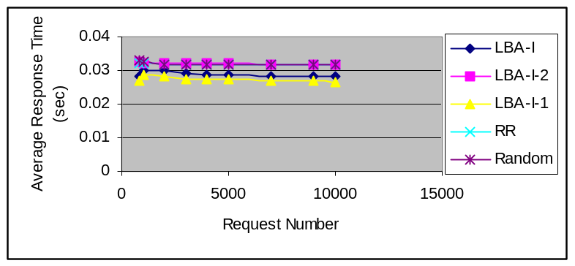
Figure 6-6 Average Response Time of Network: r50

Table 6-5 lists the simulation data of the algorithms LBA-I, LBA-I-1, LBA-I-2, RR and Random.
Table 6-5: Simulation Data of Algorithm LBA-I, LBA-I-1, LBA-I-2, RR and Random on r50 Network.

 | LBA-I | LBA-I-1 | LBA-I-2 | RR | Random
Average Response Time (s) | 0.0288746 | 0.027373 | 0.0320930 | 0.0319824 | 0.032012
Average Web Queuing Delay (s) | 0.0013823 | 0.001351 | 0.0005428 | 0.0004043 | 0.000417
Average Router Queuing Delay (s) | 0.0000138 | 0.0000138 | 0.0000014 | 0.0000013 | 0.000003
Average Transmission Delay (s) | 0.0244098 | 0.0228792 | 0.0267744 | 0.0266921 | 0.026793
Average Propagation Delay (s) | 0.0022811 | 0.0023441 | 0.0039747 | 0.0039906 | 0.004000
Average Processing Delay (s) | 0.0007877 | 0.0007844 | 0.0007978 | 0.0008031 | 0.000799
Average Imbalance Rate | 0.0400846 | 0.0314438 | 0.0017195 | 0.0012844 | 0.002602

Table 6-6 shows the percentage of each delay in the average response time. For example, the average transmission delay of algorithm LBA-I is 0.0244098 seconds and the average response time is 0.0288746 seconds, the average transmission delay holds 84.537% (0.0244098/0.0288746=84.537%) of the average response time.

Table 6-6 Percentage of Each Delay in Average Response Time
 | LBA-I | LBA-I-1 | LBA-I-2 | RR | Random
Average Web Queuing Delay | 4.78725% | 4.93575% | 1.69133% | 1.26770% | 1.3026%
Average Router Queuing Delay | 0.04779% | 0.05070% | 0.00436% | 0.00407% | 0.00937%
Average Transmission Delay | 84.5372% | 83.5803% | 83.4275% | 83.6942% | 83.6967%
Average Propagation Delay | 7.90002% | 8.56337% | 12.3849% | 12.51269% | 12.4953%
Average Processing Delay | 2.72800% | 2.86516% | 2.48590% | 2.51815% | 2.4959%

From Table 6-6 we can see that the transmission delay still is the most important factor for response time. Over eighty percent of response time comes from the transmission delay. The algorithms LBA-I and LBA-I-1 reduce the transmission delay since the algorithms take the path performance into account. On the other hand, the LBA-I-2, RR and Random algorithm do not improve the balancing effect since they do not take the path performance into account. Algorithm LBA-I-1 has better performance for this case, because when the network gets bigger, the path from the LBA to web servers will go through more hops and has more transmission delay. The algorithm LBA-I-1 takes the hop number along the path into account, which will guide to select the path that has the smaller transmission delay.

Algorithm LBA-I-1 reduces 14.705%, 14.168%, 14.4893% of response time compared to algorithm LBA-I-2, RR, and Random, respectively. Algorithm LBA-I reduces 10.028%, 9.4624%, 9.8006% of response time compared to algorithm LBA-I-2, RR, and Random, respectively.
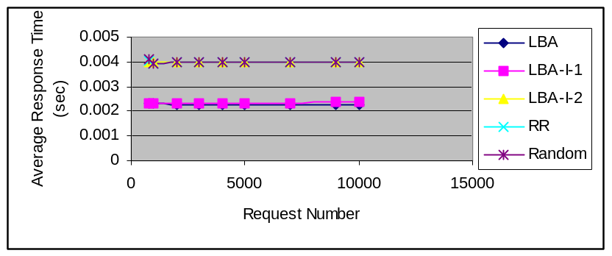Figure 6-7 shows the propagation delay for algorithm LBA-I, LBA-I-1, LBA-I-2 , RR and Random.

Figure 6-7 Propagation Delay of Algorithms on r50 Network

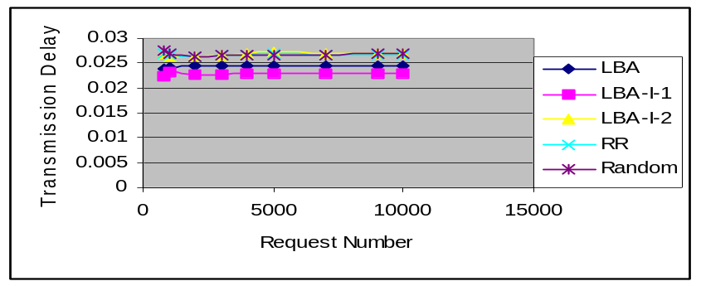Figures 6-8 and 6-9 show the transmission delay and imbalance rate of algorithm LBA-I, LBA-I-1, LBA-I-2, RR and Random.

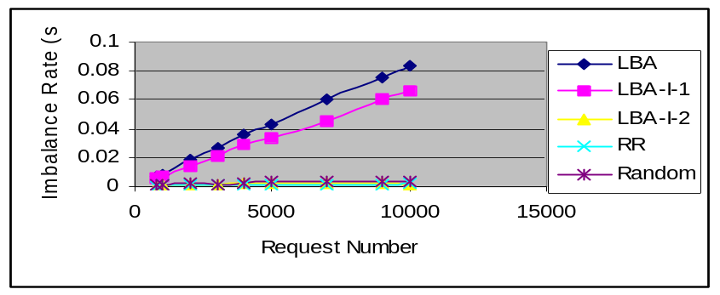 Figure 6-8 Transmission Delay of Algorithms on r50 Network

Figure 6-9 Imbalance Rate of Algorithms on r50 Network
Figure 6-9 shows the algorithm LBA-I-2 has the smaller imbalance rate. However this algorithm has longer transmission delay and propagation delay. Once again it shows that a load-balancing algorithm that only balances the load of the web server will not be a good one if the dominating factor of the response time is the transmission delay.

6.2 LBA-II Load-Balancing Algorithm

The algorithm LBA-II requires the communication among LBAs. When a LBA made an assignment decision, it reports this assignment decision to other LBAs and other LBAs update their assignment table, therefore the algorithm LBA-II has more accurate the load information of the web server than the algorithm LBA-I. There are two variations of the LBA-II algorithm: LBA-II, LBA-II-1.

6.2.1 Algorithm LBA-II(I), LBA-II(I-1) AND LBA-II(I-2)

Algorithm LBA-II (I), LBA-II (I-1) and LBA-II (I-2) are the different from algorithm LBA-I, LBA-I-1 and LBA-I-2 since algorithm LBA-II (I), LBA-II (I-1) and LBA-II (I-2) will generate extra packets and have very heavy communication overhead between LBAs. For example, the r50 network has 40 LBAs. If each LBA processes 1000 requests, it will generate 1000*39*40 extra packets and the overhead is (1000*39*40)/(1000*40) ≈ 400%. Too much communication overheads will increase the overhead traffic, slow down the transmission and increase the response time of the request. Figure 6-10 shows the average response time of the algorithm LBA-II (I), LBA-II (I-1) and LBA-II (I-2) when the requests varies from 800 to 10000 on New-Jersey Network. Table 6-7 lists the simulation data and Table 6-8 shows the percentage of each delay in the average response time.
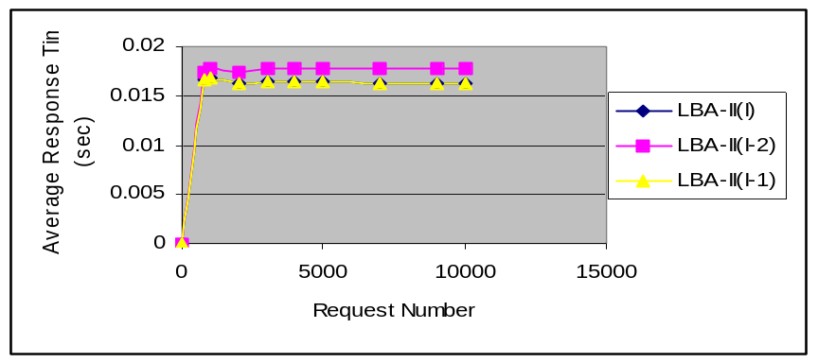
Figure 6-10 Average Response Time of Algorithms LBA-II

Table 6-7 Simulation Data of Algorithm LBA-II
 | LBA-II(I) | LBA-II(I-2) | LBA-II(I-1)
Average Response Time (s) | 0.016425 | 0.017688 | 0.016425
Average Web Queuing Delay (s) | 0.000292 | 0.000027 | 0.000292
Average Router Queuing Delay (s) | 0.000014 | 0.000009 | 0.000014
Average Transmission Delay (s) | 0.015014 | 0.016582 | 0.015014
Average Propagation Delay (s) | 0.000236 | 0.000325 | 0.000236
Average Process Delay (s) | 0.000868 | 0.000744 | 0.000868

Table 6-8 Percentage of Each Delay in Average Response Time

 | LBA-I | LBA-I-1 | LBA-I-2
Average Web Queuing Delay | 1.777344% | 0.152645% | 1.7%
Average Router Queuing Delay | 0.085235% | 0.0508% | 0.08%
Average Transmission Delay | 91.50944% | 93.7% | 91.5%
Average Propagation Delay | 1.4% | 1.837% | 1.4%
Average Processing Delay | 5.284627% | 4.2% | 5.2%

Table 6-9 lists the communication overhead of algorithm LBA-II (I) when the number of requests varies from 800 to 10000.
Table 6-9 Communication Overhead of Algorithm LBA-II (I)
Number of Requests | Number of Overhead Events | Number of Overhead Events/Number of Requests
800 | 3200 | 400%
1000 | 4000 | 400%
2000 | 8000 | 400%
3000 | 12000 | 400%
5000 | 20000 | 400%
7000 | 28000 | 400%
9000 | 36000 | 400%
10000 | 40000 | 400%

Comparing Table 6-7 and 6-2, Table 6-3 and 6-8, we can see that the algorithm LBA-II (I), LBA-II (I-1) and LBA-II (I-2) are not good than the algorithms LBA-I, LBA-I-1 and LBA-I-2 on the performance. Here two probable reasons are 1) The communication overhead increases the transmission delay when the dominating factor of the response time is the transmission delay, and 2) The when the LBA receives the message, the web server load has already vary, this will mislead the LBA makes wrong assigning decision. In order to reduce the communication overhead between LBAs, and reduce the transmission time of the message, we have developed algorithm LBA-II-1.

6.2.2 Algorithm LBA-II-1(I), LBA-II-1(I-1) AND LBA-II-1(I-2)

For algorithms LBA-II-1 (I), LBA-II-1 (I-1) and LBA-II-1 (I-2), the LBA communicates only to its neighbor LBA, and this can reduce the communication overhead comparing to algorithms LBA-II (I), LBA-II (I-1) and LBA-II (I-2) and speed up the transmission of the message. Table 6-10 lists the simulation data of algorithms LBA-II-1 (I), LBA-II-1 (I-1) and LBA-II-1 (I-2) with New-Jersey network. Table 6-11 lists the percentage of each delay in the average response time. Table 6-12 lists the simulation data of algorithms LBA-II-1 (I), LBA-II-1 (I-1) and LBA-II-1 (I-2) with the r50 network.

Table 6-10 Simulation Data of Algorithm LBA-II-1 (I), LBA-II-1 (I-1) and LBA-II-1 (I-2) on New-Jersey Network

 | LBA-II-1(I) | LBA-II-1(1-2) | LBA-II-1(I-1)
Average Response Time(s) | 0.016565 | 0.017686 | 0.016565
Average Web Queuing Delay (s) | 0.000291 | 0.000046 | 0.000291
Average Router Queuing Delay (s) | 0.000014 | 0.000016 | 0.000014
Average Transmission Delay (s) | 0.015160 | 0.016559 | 0.015159
Average Propagation Delay (s) | 0.000235 | 0.000323 | 0.000235
Average Processing Delay (s) | 0.000866 | 0.000741 | 0.000866

Table 6-11 Percentage of Each Delay in Average Response Time

 | LBA-II-1(I) | LBA-II-1(I-2) | LBA-II-1(I-1)
Average Web Queuing Delay | 1.75% | 0.26% | 1.75%
Average Router Queuing Delay | 0.08% | 0.09% | 0.08%
Average Transmission Delay | 91.5% | 93.6% | 91.5%
Average Propagation Delay | 1.418% | 1.82% | 1.418%
Average Processing Delay | 5.22% | 4.18% | 5.22%

Table 6-12 Statistic Data of Algorithm LBA-II-1(I), LBA-II-1(I-1) and LBA-II-1(I-2)
 | LBA-II-1(I) | LBA-II-1(1-2) | LBA-II-1(I-1)
Average Response Time(s) | 0.028976 | 0.03572 | 0.027604
Average Web Queuing Delay (s) | 0.001109 | 0.000123 | 0.001023
Average Router Queuing Delay (s) | 0.000013 | 0.000013 | 0.000011
Average Transmission Delay (s) | 0.024747 | 0.03456 | 0.023402
Average Propagation Delay (s) | 0.002320 | 0.000245 | 0.002373
Average Processing Delay (s) | 0.000787 | 0.000787 | 0.000795

Table 6-13 lists the communication overhead of the algorithm LBA-II-1 when the requests increase
Table 6-13 Overhead of Algorithm LBA-II-1 (I)
Number of requests | Number of Overhead Events | Number of Overhead Events/Number of Requests
800 | 1600 | 200%
1000 | 2000 | 200%
2000 | 4000 | 200%
3000 | 6000 | 200%
5000 | 10000 | 200%
7000 | 14000 | 200%
9000 | 18000 | 200%
10000 | 20000 | 200%

Comparing Table 6-13 and 6-9, the algorithm LBA-II-1 really reduces the communication overhead. But it sacrifices the estimated precision of the web load, and the communication overhead still is heavy comparing to the algorithm LBA-I and LBA-I-1. Therefore comparing to algorithms LBA-I and LBA-I-1, the algorithm LBA-II-1 still is not good on the performance in this case.
6.3 LBA-III Algorithm
In LBA-I and LBA-II algorithms, we measure the path performance by the distance, bandwidth and the number of hops, and those data is from static information. In fact, the path performance changes over time. It is possible that the path with the short distance and high bandwidth may have the long transmission delay due to traffic and queuing delay. In Chapter 2, we have developed algorithm LBA-III that periodically probes the path traffic status, and makes the allocating decision based on the dynamic path information and static web information.
Table 6-14 gives the average response time and number of overhead messages when the probing period varies from 1 second to 10 seconds. For this test, we fixed the number of requests to 5000.
Table 6-14 Statistic Data of the Algorithm LBA-III
Probing Period  (s) | Average Response Time  (s) | Number of Overhead Messages | Web Queuing Delay  (s)
1 | 3.582742 | 306 | 3.564264
2 | 0.396743 | 150 | 0.379877
3 | 0.270639 | 102 | 0.253463
4 | 0.196267 | 75 | 0.178587
5 | 0.153156 | 60 | 0.135803
6 | 0.131132 | 45 | 0.114159
7 | 0.116244 | 39 | 0.098135
8 | 0.123360 | 30 | 0.105984
9 | 0.099853 | 30 | 0.082210
10 | 0.058134 | 30 | 0.075272

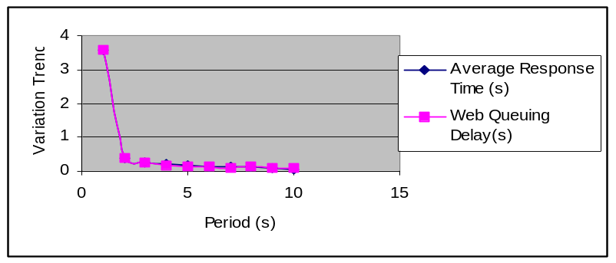Figure 6-11 shows the variation trend of the average response time and web queuing delay as the period varies.
Figure 6-11 Variation Trend of Average Response Time and Web Queuing Delay
From Table 6-14 and Figure 6-11, we can see that the algorithm LBA-III generates the very heavy overhead messages that increase the web queuing delay and increase the average response time.

Table 6-16 gives the average response time and number of overhead messages when the probing period varies from 1 to 6 seconds on the r50 network.
Table 6-16 Statistic Data of the Algorithm LBA-III
Probing Period  (s) | Average Response Time  (s) | Number of Overhead Messages | Web Queuing Delay  (s)
1 | 12.376431 | 2030 | 12.345385
2 | 3.726521 | 820 | 3.695399
3 | 1.796477 | 450 | 1.765105
4 | 0.644835 | 400 | 0.613600
5 | 0.207723 | 360 | 0.176451
6 | 0.032875 | 50 | 0.001619

6.4 LBA-IV Algorithm

For LBA-I, LBA-II and LBA-III algorithms, the LBA and web server do not communicate each other and the LBA does not know the real loads of the web sites. LBA estimates the load status of the web servers. The estimate used in these algorithms may not always reflect the actual load of the web server. In algorithm LBA-IV, the web servers report their left load information periodically so that the LBA can periodically update their assignment tables based on the real loads.

In Chapter 2, we have derived algorithm LBA-IV-1, LBA-IV-2, and LBA-IV-3. For algorithm LBA-IV-1, the LBA allocates new requests only based on the web server left load information and do not take the web processing power and the path information into account. Algorithm LBA-IV-2 makes assignment decision by combining the web processing power and the left load information. Algorithm LBA-IV-3 makes assignment decision based on static path information, web processing power and the left load information.

We use the New-J network to test algorithm LBA-IV-1, LBA-IV-2 and LBA-IV-3. Figure 6-12 shows their balancing effect when the period of load information report is 2 seconds. Table 6-17 lists the simulation data of the algorithms LBA-IV-1, LBA-IV-2 and LBA-IV-3
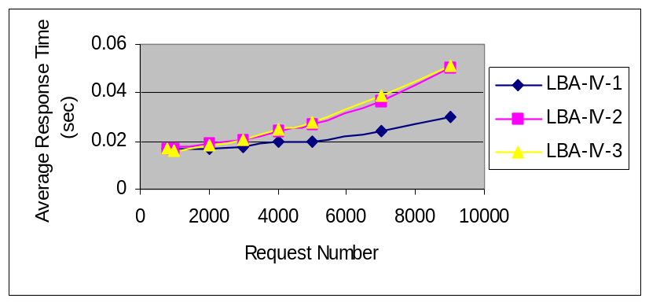
Figure 6-12 Average Response Time of Algorithm LBA-IV-1, LBA-IV-2 and LBA-IV-3

Table 6-17 Simulation Data of Algorithms LBA-IV-1, LBA-IV-2 and LBA-IV-3 on New-Jersey Network.

 | LBA-IV-1 | LBA-IV-2 | LBA-IV-3
Average Response Time(s) | 0.020262 | 0.026393 | 0.027869
Average Web Queuing Delay (s) | 0.004340 | 0.010626 | 0.011021
Average Router Queuing Delay (s) | 0.000033 | 0.000056 | 0.000067
Average Transmission Delay (s) | 0.014357 | 0.014236 | 0.014293
Average Propagation Delay (s) | 0.000257 | 0.000251 | 0.000250
Average Processing Delay (s) | 0.001275 | 0.001223 | 0.001239

Table 6-18 summarizes the overhead information of algorithm LBA-IV-1, LBA-IV-2 and LBA-IV-3

Table 6-18 Overhead Messages of Algorithm LBA-IV-1 on New-Jersey Network
Number of Requests | Number of Extra Events | Number Extra Events/Number of Requests
800 | 75 | 9.98 %
1000 | 100 | 9.99 %
2000 | 195 | 9.745 %
3000 | 270 | 8.99 %
4000 | 360 | 8.99 %
5000 | 450 | 8.99 %
7000 | 615 | 8.78 %
9000 | 790 | 8.75 %

From Figure 6-12, Tables 6-17 and 6-18, we can see that algorithm LBA-IV-1, LBA-IV-2, and LBA-IV-3 have very poor balancing effect comparing to the algorithms LBA-I and LBA-I-1. There are probably three reasons: 1) big overhead, 2) starting error, before the first report, we allocate all requests to web server 1, 3) the report period. Longer report period can reduce the extra messages, but between reports, the loads of web servers have already be changed and the algorithm still use the old load data.
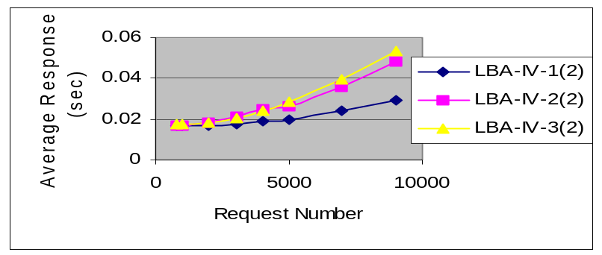The LBA-IV-1 (2), LBA-IV-2 (2) and LBA-IV-3 (2) eliminate the starting error by randomly assigning the requests before the first report comes. The algorithms LBA-IV-1 (3), LBA-IV-2 (3) and LBA-IV-3 (3) eliminate the starting error by assigning all requests to the web server with maximum process power before the first report comes. Figure 6-12 shows the balancing effect of algorithm LBA-IV-1 (2), LBA-IV-2 (2) and LBA-IV-3 (2) when the report period is 2 seconds. Table 6-19 lists the simulation data of the algorithms LBA-IV-1 (2), LBA-IV-2 (2) and LBA-IV-3 (2).
.
Figure 6-12 Average Response Time of Algorithms

Table 6-19 Simulation Data of Algorithms LBA-IV-1 (2), LBA-IV-2 (2), LBA-IV-3 (2)

 | LBA-IV-1(2) | LBA-IV-2(2) | LBA-IV-3(2)
Average Response Time(s) | 0.020096 | 0.026088 | 0.027453
Average Web Queuing Delay (s) | 0.004185 | 0.010231 | 0.011767
Average Router Queuing Delay (s) | 0.000073 | 0.000080 | 0.000078
Average Transmission Delay (s) | 0.014305 | 0.014295 | 0.014133
Average Propagation Delay (s) | 0.000253 | 0.000260 | 0.000254
Average Processing Delay (s) | 0.001281 | 0.001221 | 0.001219

The overhead is given in Table 6-20. From Tables 6-19 and 6-20, we can see that the average response time of algorithm LBA-IV-1 (2), LBA-IV-2 (2) and LBA-IV-3 (2) is improved.
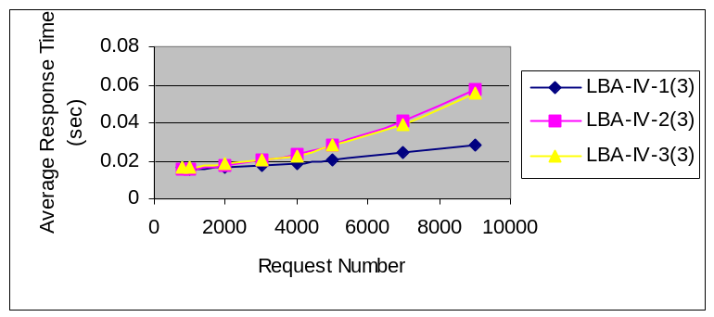Figure 6-13 shows the average response time of the algorithm LBA-IV-1 (3), LBA-IV-2 (3), and LBA-IV-3 (3). Table 6-21 lists the simulation data of algorithm LBA-IV-1 (3), LBA-IV-2 (3) and LBA-IV-3 (3).

Figure 6-13 Average Response Time of Algorithms

Table 6-21 Simulation Data of Algorithm LBA-IV-1(3), LBA-IV-2(3) and LBA-IV-3(3)
 | LBA-IV-1(3) | LBA-IV-2(3) | LBA-IV-3(3)
Average Response Time(s) | 0.019813 | 0.027384 | 0.027217
Average Web Queuing Delay (s) | 0.003938 | 0.011747 | 0.011464
Average Router Queuing Delay (s) | 0.000043 | 0.000052 | 0.000049
Average Transmission Delay (s) | 0.014300 | 0.014105 | 0.014221
Average Propagation Delay (s) | 0.000256 | 0.000249 | 0.000251
Average Processing Delay (s) | 0.001275 | 0.001232 | 0.001233

Their overheads are given in Table 6-22. Comparing Table 6-17 and 6-21, we can see the algorithmLBA-IV-1 (3) and LBA-IV-3 (3) improve the average response time. But comparing Table 6-2, the algorithms LBA-IV-1 (3), LBA-IV-2 (3) and LBA-IV-3 (3) still are not good on the performance.

Next we analyze the effect of the report period on the load balancing. Figure 6-14 shows the average response time of algorithm LBA-IV-1 (3) when the report period varies from 1 second to 10 seconds. Table 6-22 lists the corresponding overhead variations.

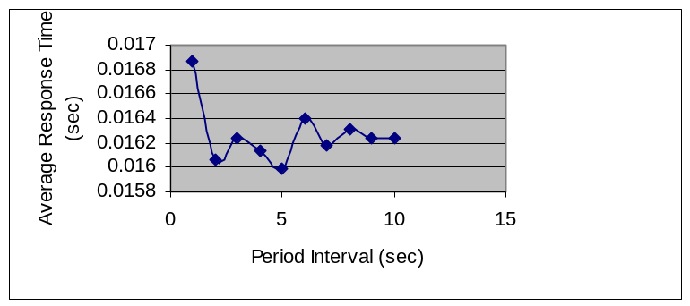
Figure 6-14 Average Response Time of Algorithm LBA-IV-1 (3)
Table 6-22 Overhead of Algorithm LBA-IV-1 (3)
Report Period (s) | Number of Extra Events | Number of Extra Events/Number of requests
1 | 210 | 20.97%
2 | 105 | 10.48%
3 | 60 | 5.990%
4 | 45 | 4.490%
5 | 30 | 2.490%
6 | 30 | 2.490%
7 | 15 | 1.990%
8 | 15 | 1.490%
9 | 10 | 0.990%
10 | 10 | 0.990%

From Figure 6-14 and Table 6-22, it is clear that the report period has significant effect on the average response time. Both too small report period and too long report period worsen the balancing effect. If the report period is too long, the load information of web servers can not be timely updated and the allocating decision is made based on too old load information. This will degrade the algorithm performance. On the other hand, if the report period is too small, the heavy overhead communication between the LBA and web will slow down the transmission and worsen the balancing effect. How to reduce the overhead generated by the algorithm is the key to improve the balancing effect. We use the following methods to improve the algorithm balancing effect.
- Estimate the load of web server using mathematical model
We use a longer report period, and between reports, we use the first order random walking model to estimate the load of the web server. This kind of algorithm is called as LBA-IV-1 (E), LBA-IV-2 (E), and LBA-IV-3 (E). For algorithm LBA-IV-1 (E), LBA-IV-2 (E), and LBA-IV-3 (E), we have
Load estimate = old load + document size with highest probability
Because we already had the statistic characterization of document size, we choose the document size that has the highest probability plus the old load as the estimated value of web server load.
- Set overload alarming threshold
We can set the overload warning threshold for web server. When a web server finds its load is over its threshold, it sends warning message to all LBA, so all LBA will stop assign new request to this web server. We combine this strategy with algorithm LBA-IV-1, LBA-IV-2 and LBA-IV-3 to develop the algorithm LBA-IV-1 (Tc), LBA-IV-2 (Tc) and LBA-IV-3 (Tc), respectively.

Figure 6-15 shows the average response time of algorithm LBA-IV-1 (E), LBA-IV-2 (E) and LBA-IV-3 (E) when the report period is 10 seconds. Before the first report comes, we use algorithm LBA-IV-1 (3), LBA-IV-2 (3) and LBA-IV-3 (3), respectively. Table 6-23 lists the statistic data of algorithm LBA-IV-1(E), LBA-IV-2(E) and LBA-IV-3(E). Table 6-24 lists the overhead of algorithm LBA-IV-1 (E), LBA-IV-2 (E) and lBA-IV-3 (E) when the number of requests varies from 800 to 10000.
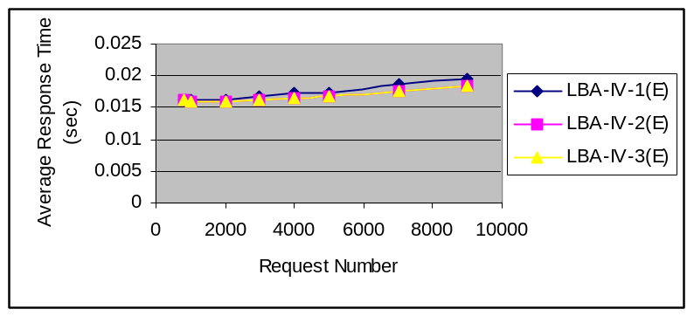
Figure 6-15 Average Response Time of Algorithms

Table 6-23 Statistics of Algorithm LBA-IV-1(E), LBA-IV-2(E) And LBA-IV-3(E)
 | LBA-IV-1(E) | LBA-IV-2(E) | LBA-IV-3(E)
Average Response Time(s) | 0.017276 | 0.016729 | 0.016728
Average Web Queuing Delay (s) | 0.001288 | 0.000944 | 0.000944
Average Router Queuing Delay (s) | 0.000045 | 0.000042 | 0.000042
Average Transmission Delay (s) | 0.014422 | 0.014235 | 0.014235
Average Propagation Delay (s) | 0.000257 | 0.000258 | 0.000258
Average Processing Delay (s) | 0.001265 | 0.001249 | 0.001249

Table 6-24 Overhead of Algorithm LBA-IV-1(E), LBA-IV-2(E) and LBA-IV-3(E)
Number of Requests | Number of Extra Events | Number of Extra Events/Number of Requests
800 | 10 | 0.99%
1000 | 10 | 0.99%
2000 | 20 | 1.248%
3000 | 45 | 1.499%
4000 | 65 | 1.624%
5000 | 85 | 1.699%
7000 | 120 | 1.714%
9000 | 150 | 1.725%

From Tables 6-17 and 6-24, we can see that the average response time of the algorithm LBA-IV-1 (E), LBA-IV-2 (E) and LBA-IV-3 (E) is reduced. Comparing Table 6-18 with Table 6-24, it is clear that the overhead of algorithm LBA-IV-1(E), LBA-IV-2(E) and LBA-IV-3(E) are significantly decreased.

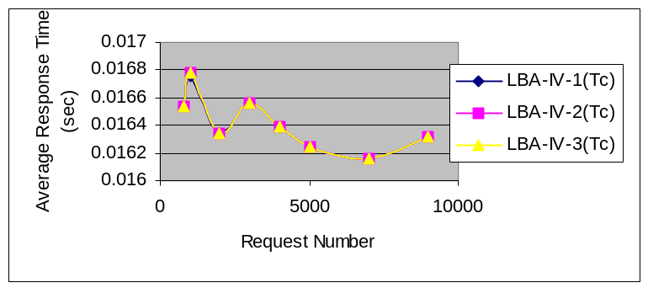Now we test algorithm LBA-IV-1(Tc), LBA-IV-2(TC) and LBA-IV-3(Tc). We set the overload and underload alarm threshold as 10 and 2, respectively. Therefore, when the number of requests of a web is over 10, it sends an overload message to LBA. On the other hand, when the number of requests of a web is under 2, it send a message to the LBA and the LBA will start to allocate new requests to this web site. Figure 6-16 shows the average response time of algorithm LBA-IV-1(Tc), LBA-IV-2(Tc) and LBA-IV-3(Tc). Table 6-25 lists the simulation data of the algorithms LBA-IV-1(Tc), LBA-IV-2(Tc) and LBA-IV-3(Tc). Table 6-26 gives the overhead information of algorithm LBA-IV-1(Tc).

Figure 6-16 Average Response Time

Table 6-25 Statistics of Algorithm LBA-IV-1(Tc), LBA-IV-2(Tc) And LBA-IV-3(Tc)
 | LBA-IV-1(Tc) | LBA-IV-2(Tc) | LBA-IV-3(Tc)
Average Response Time(s) | 0.016313 | 0.016313 | 0.016313
Average Web Queuing Delay (s) | 0.000335 | 0.000335 | 0.000335
Average Router Queuing Delay (s) | 0.000015 | 0.000015 | 0.000015
Average Transmission Delay (s) | 0.015454 | 0.015454 | 0.015454
Average Propagation Delay (s) | 0.000256 | 0.000256 | 0.000256
Average Processing Delay (s) | 0.000753 | 0.000753 | 0.000753

Table 6-26 Overhead of Algorithm LBA-IV-1(Tc)
Number of Requests | Number of Extra Events | Number of Extra Events/Number of Requests
800 | 10 | 0.47%
1000 | 10 | 0.47%
2000 | 10 | 0.47%
3000 | 10 | 0.47%
4000 | 10 | 0.47%
5000 | 10 | 0.47%
7000 | 10 | 0.47%
9000 | 10 | 0.47%

From Tables 6-25 and 6-26, we can see that algorithm LBA-IV-1(Tc) and LBA-IV-2(Tc), LBA-IV-3(Tc) has the lowest overhead and their balancing effect is better than the algorithms LBA-IV-1, LBA-IV-2 and LBA-IV-3.

Tc (Threshold) is an important factor of the algorithm LBA-IV-1(Tc), LBA-IV-2(Tc) and LBA-IV-3(Tc). Figure 6-17 shows the average response time of the algorithm LBA-IV-1(Tc) when the overload alarm threshold changes from 5 to 20. Table 6-27 lists the corresponding overhead data.

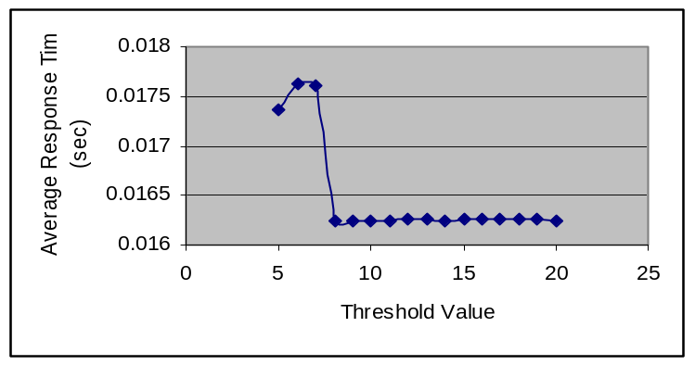

Figure 6-17 Average Response Time of Algorithm LBA-IV-1 (Tc)

Table 6-27 Overhead of Algorithm LBA-IV-1(Tc)
Threshold | Number of Extra Events | Number of Extra Events/Number of Requests
5 | 30 | 2.997%
6 | 30 | 2.997%
7 | 20 | 1.998%
8 | 10 | 0.999%
9 | 10 | 0.999%
10 | 10 | 0.999%
11 | 10 | 0.999%
12 | 10 | 0.999%
13 | 10 | 0.999%
14 | 10 | 0.999%
15 | 10 | 0.999%

From Figure 6-17 and Table 6-27, we can see that the small threshold will generate big overhead and has poor balancing effect. Therefore we can not set the threshold too small.

6.5 Other Case

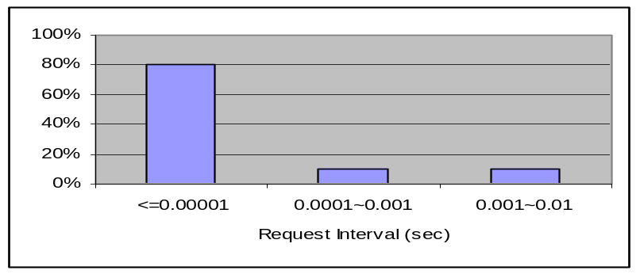Above we discuss the performance of the all algorithms based on network performance that the transmission delay dominate the response time of the request, new we consider the another case, here the web queuing delay dominates the response time of the requests. Figure 6-18 shows the distribution of the request interval. The distribution of the document size is as shown in Figure 6-1.

Figure 6-18 Distribution of Request Interval

Following we discuss the performance of the all algorithms with the distribution of the request interval as Figure 6-18 and the distribution of the document size as Figure 6-1, and the bandwidth varies from 10Mb ~ 2400 Mb.

6.5.1 Algorithms LBA-I, LBA-I-1 and LBA-I-2

Table 6-28 ~ 37 show the simulation data of the algorithm LBA-I, LBA-I-1, LBA-I-2, RR and Random on the New-J network.
Table 6-28 Simulation Data of the Algorithm RR on New-Jersey Network
 | 10 Mb ~ 45 Mb | 45 Mb ~ 155 Mb | 155 Mb ~ 2400 Mb
Average Response Time(s) | 0.058280 | 0.056884 | 0.055883
Average Web Queuing Delay (s) | 0.046959 | 0.047092 | 0.046708
Average Router Queuing Delay (s) | 0.000127 | 0.000120 | 0.000143
Average Transmission Delay (s) | 0.010118 | 0.008589 | 0.007956
Average Propagation Delay (s) | 0.000325 | 0.000328 | 0.000327
Average Processing Delay (s) | 0.000751 | 0.000754 | 0.000749

Table 6-29 Percentage of Each Delay in Average Response Time on Algorithm RR
 | 10 Mb ~ 45 Mb | 45 Mb ~ 155 Mb | 155 Mb ~ 2400 Mb
Average Web Queuing Delay (s) | 80.57% | 82.786% | 83.58%
Average Router Queuing Delay (s) | 0.2179% | 0.2109% | 0.255%
Average Transmission Delay (s) | 17.361% | 15.099% | 14.23%
Average Propagation Delay (s) | 0.55765% | 0.5766% | 0.585%
Average Processing Delay (s) | 1.2886% | 1.320% | 1.34%

Table 6-30 Simulation Data of the Algorithm Random on New-Jersey Network
 | 10 Mb ~ 45 Mb | 45 Mb ~ 155 Mb | 155 Mb ~ 2400 Mb
Average Response Time(s) | 0.058544 | 0.057002 | 0.056074
Average Web Queuing Delay (s) | 0.047286 | 0.047252 | 0.046946
Average Router Queuing Delay (s) | 0.000114 | 0.000121 | 0.000124
Average Transmission Delay (s) | 0.010064 | 0.008552 | 0.007931
Average Propagation Delay (s) | 0.000330 | 0.000326 | 0.000327
Average Processing Delay (s) | 0.000749 | 0.000750 | 0.000747

Table 6-31 Percentage of Each Delay in Average Response Time on Algorithm Random
 | 10 Mb ~ 45 Mb | 45 Mb ~ 155 Mb | 155 Mb ~ 2400 Mb
Average Web Queuing Delay (s) | 80.77% | 82.89% | 83.72%
Average Router Queuing Delay (s) | 0.195% | 0.212% | 0.2211%
Average Transmission Delay (s) | 17.19% | 15.00% | 14.14%
Average Propagation Delay (s) | 0.564% | 0.572% | 0.583%
Average Processing Delay (s) | 1.279% | 1.316% | 1.332%

Table 6-32 Simulation Data of the Algorithm LBA-I on New-Jersey Network
 | 10 Mb ~ 45 Mb | 45 Mb ~ 155 Mb | 155 Mb ~ 2400 Mb
Average Response Time(s) | 0.202547 | 0.199157 | 0.198754
Average Web Queuing Delay (s) | 0.191662 | 0.189516 | 0.189617
Average Router Queuing Delay (s) | 0.000063 | 0.000065 | 0.000065
Average Transmission Delay (s) | 0.009676 | 0.008425 | 0.007928
Average Propagation Delay (s) | 0.000244 | 0.000247 | 0.000242
Average Processing Delay (s) | 0.000903 | 0.000905 | 0.000903

Table 6-33 Percentage of Each Delay in Average Response Time on Algorithm LBA-I
 | 10 Mb ~ 45 Mb | 45 Mb ~ 155 Mb | 155 Mb ~ 2400 Mb
Average Web Queuing Delay (s) | 94.63% | 95.16% | 95.40%
Average Router Queuing Delay (s) | 0.031% | 0.033% | 0.032%
Average Transmission Delay (s) | 4.777% | 4.230% | 4.016%
Average Propagation Delay (s) | 0.121% | 0.124% | 0.122%
Average Processing Delay (s) | 0.445% | 0.454% | 0.454%

Table 6-34 Simulation Data of the Algorithm LBA-I-2
 | 10 ~ 45 Mb | 45 ~ 155 Mb | 155 ~ 2400 Mb
Average Response Time(s) | 0.058024 | 0.056475 | 0.055977
Average Web Queuing Delay (s) | 0.046689 | 0.046730 | 0.046801
Average Router Queuing Delay (s) | 0.000103 | 0.000119 | 0.000122
Average Transmission Delay (s) | 0.010152 | 0.008546 | 0.007973
Average Propagation Delay (s) | 0.000330 | 0.000330 | 0.000329
Average Processing Delay (s) | 0.000751 | 0.000749 | 0.000752

Table 6-35 Percentage of Each Delay in Average Response Time on Algorithm LBA-I-2
 | 10 Mb ~ 45 Mb | 45 Mb ~ 155 Mb | 155 Mb ~ 2400 Mb
Average Web Queuing Delay (s) | 80.46% | 82.74% | 83.075%
Average Router Queuing Delay (s) | 0.177% | 0.211% | 0.2179%
Average Transmission Delay (s) | 17.49% | 15.13% | 14.243%
Average Propagation Delay (s) | 0.568% | 0.584% | 0.5877%
Average Processing Delay (s) | 1.294% | 1.326% | 1.343%

Table 6-36 Simulation Data of the Algorithm LBA-I-1 on New-Jersey Network
 | 10 Mb ~ 45 Mb | 45 Mb ~ 155 Mb | 155 Mb ~ 2400 Mb
Average Response Time(s) | 0.202547 | 0.199157 | 0.198754
Average Web Queuing Delay (s) | 0.191662 | 0.189516 | 0.189617
Average Router Queuing Delay (s) | 0.000063 | 0.000065 | 0.000065
Average Transmission Delay (s) | 0.009676 | 0.008425 | 0.007928
Average Propagation Delay (s) | 0.000244 | 0.000247 | 0.000242
Average Processing Delay (s) | 0.000903 | 0.000905 | 0.000903

Table 6-37 Percentage of Each Delay in Average Response Time on Algorithm LBA-I-1
 | 10 Mb ~ 45 Mb | 45 Mb ~ 155 Mb | 155 Mb ~ 2400 Mb
Average Web Queuing Delay (s) | 94.63% | 95.16% | 95.40%
Average Router Queuing Delay (s) | 0.031% | 0.033% | 0.032%
Average Transmission Delay (s) | 4.777% | 4.230% | 4.016%
Average Propagation Delay (s) | 0.121% | 0.124% | 0.122%
Average Processing Delay (s) | 0.445% | 0.454% | 0.454%

Table 6-38 ~ 47 show the simulation data of the algorithm LBA-I, LBA-I-1, LBA-I-2, RR and Random on the r50 network.

Table 6-38 Simulation Data of the Algorithm RR on r50 Network
 | 10 Mb ~ 45 Mb | 45 Mb ~ 155 Mb | 155 Mb ~ 2400 Mb
Average Response Time(s) | 0.032546 | 0.029299 | 0.028171
Average Web Queuing Delay (s) | 0.015304 | 0.015462 | 0.015531
Average Router Queuing Delay (s) | 0.000027 | 0.000025 | 0.000030
Average Transmission Delay (s) | 0.012448 | 0.009063 | 0.007853
Average Propagation Delay (s) | 0.003982 | 0.003964 | 0.003971
Average Processing Delay (s) | 0.000785 | 0.000784 | 0.000787

Table 6-39 Percentage of Each Delay in Average Response Time of Algorithm RR on r50 Network

 | 10 Mb ~ 45 Mb | 45 Mb ~ 155 Mb | 155 Mb ~ 2400 Mb
Average Web Queuing Delay (s) | 47.024% | 52.77% | 55.13%
Average Router Queuing Delay (s) | 0.0829% | 0.085% | 0.106%
Average Transmission Delay (s) | 38.247% | 30.93% | 27.87%
Average Propagation Delay (s) | 12.234% | 13.53% | 14.09%
Average Processing Delay (s) | 2.4119% | 2.675% | 2.793%

Table 6-40 Simulation Data of the Algorithm Random on r50 Network
 | 10 Mb ~ 45 Mb | 45 Mb ~ 155 Mb | 155 Mb ~ 2400 Mb
Average Response Time(s) | 0.032773 | 0.029378 | 0.028361
Average Web Queuing Delay (s) | 0.015432 | 0.015386 | 0.015548
Average Router Queuing Delay (s) | 0.000027 | 0.000030 | 0.000030
Average Transmission Delay (s) | 0.012476 | 0.009147 | 0.007949
Average Propagation Delay (s) | 0.004042 | 0.004023 | 0.004038
Average Processing Delay (s) | 0.000796 | 0.000793 | 0.000796

Table 6-41 Percentage of Each Delay in Average Response Time of Algorithm Random on r50 Network

 | 10 Mb ~ 45 Mb | 45 Mb ~ 155 Mb | 155 Mb ~ 2400 Mb
Average Web Queuing Delay (s) | 47.08% | 52.37% | 54.82%
Average Router Queuing Delay (s) | 0.082% | 0.102% | 0.106%
Average Transmission Delay (s) | 38.067% | 31.13% | 28.03%
Average Propagation Delay (s) | 12.333% | 13.69% | 14.24%
Average Processing Delay (s) | 2.429% | 2.69% | 2.807%

Table 6-42 Simulation Data of the Algorithm LBA-I on r50 Network
 | 10 Mb ~ 45 Mb | 45 Mb ~ 155 Mb | 155 Mb ~ 2400 Mb
Average Response Time(s) | 0.037605 | 0.034282 | 0.033220
Average Web Queuing Delay (s) | 0.022694 | 0.022400 | 0.022521
Average Router Queuing Delay (s) | 0.000020 | 0.000026 | 0.000024
Average Transmission Delay (s) | 0.012063 | 0.009030 | 0.007853
Average Propagation Delay (s) | 0.002031 | 0.002031 | 0.002031
Average Processing Delay (s) | 0.000798 | 0.000795 | 0.000791

Table 6-43 Percentage of Each Delay in Average Response Time of Algorithm LBA-I on r50 Network

 | 10 Mb ~ 45 Mb | 45 Mb ~ 155 Mb | 155 Mb ~ 2400 Mb
Average Web Queuing Delay (s) | 60.34% | 65.34% | 67.236%
Average Router Queuing Delay (s) | 0.053% | 0.0758% | 0.0722%
Average Transmission Delay (s) | 32.078% | 26.34% | 23.639%
Average Propagation Delay (s) | 5.400% | 5.924% | 6.113%
Average Processing Delay (s) | 2.122% | 2.319% | 2.381%

Table 6-44 Simulation Data of the Algorithm LBA-I-1 on r50 Network
 | 10 ~ 45 Mb | 45 ~ 155 Mb | 155 ~ 2400 Mb
Average Response Time(s) | 0.034726 | 0.031543 | 0.030653
Average Web Queuing Delay (s) | 0.020006 | 0.019608 | 0.019733
Average Router Queuing Delay (s) | 0.000019 | 0.000022 | 0.000023
Average Transmission Delay (s) | 0.011692 | 0.008907 | 0.007890
Average Propagation Delay (s) | 0.002227 | 0.002227 | 0.002227
Average Processing Delay (s) | 0.000781 | 0.000777 | 0.000778

Table 6-45 Percentage of Each Delay in Average Response Time of Algorithm LBA-I-1 on r50 Network

 | 10 Mb ~ 45 Mb | 45 Mb ~ 155 Mb | 155 Mb ~ 2400 Mb
Average Web Queuing Delay (s) | 57.611% | 62.162% | 64.375%
Average Router Queuing Delay (s) | 0.0547% | 0.0697% | 0.0750%
Average Transmission Delay (s) | 33.669% | 28.237% | 25.739%
Average Propagation Delay (s) | 6.413% | 7.0602% | 7.2652%
Average Processing Delay (s) | 2.249% | 2.4633% | 2.538%

Table 6-46 Simulation Data of the Algorithm LBA-I-2 on r50 Network
 | 10 ~ 45 Mb | 45 ~ 155 Mb | 155 ~ 2400 Mb
Average Response Time(s) | 0.032871 | 0.029751 | 0.028319
Average Web Queuing Delay (s) | 0.015581 | 0.015871 | 0.015708
Average Router Queuing Delay (s) | 0.000024 | 0.000028 | 0.000032
Average Transmission Delay (s) | 0.012485 | 0.009074 | 0.007804
Average Propagation Delay (s) | 0.003988 | 0.003988 | 0.003988
Average Processing Delay (s) | 0.000792 | 0.000791 | 0.000787

Table 6-47 Percentage of Each Delay in Average Response Time of Algorithm LBA-I-2 on r50 Network

 | 10 Mb ~ 45 Mb | 45 Mb ~ 155 Mb | 155 Mb ~ 2400 Mb
Average Web Queuing Delay (s) | 47.422% | 53.346% | 55.468%
Average Router Queuing Delay (s) | 0.0730% | 0.0941% | 0.113%
Average Transmission Delay (s) | 37.981% | 30.499% | 27.55%
Average Propagation Delay (s) | 12.132% | 13.405% | 14.08%
Average Processing Delay (s) | 2.4094% | 2.6587% | 2.779%

From above discussing, we can see that when the dominating factor of the response time is the web queuing delay, then the path performance is an ignored factor, and the loads and the processing power of the web server are the key factors to guide the performance of the algorithms. The algorithm LBA-I and LBA-I-1 still take path performance into account, which have the worse performance than the algorithm LBA-I-2, Random and RR. Because the algorithm LBA-I-2 can not get the precisely estimated information of the web server load, therefore this algorithm is not good than the algorithm RR.

6.5.2 Algorithms LBA-II(I), LBA-II(I-1) and LBA-II(I-2)

Table 6-48 ~ 53 show the simulation data of the algorithm LBA-II (I), LBA-II (I-1), LBA-II (I-2) on the New-Jersey Network.
Table 6-48 Simulation Data of the Algorithm LBA-II (I)
 | 10 Mb ~ 45 Mb | 45 Mb ~ 155 Mb | 155 Mb ~ 2400 Mb
Average Response Time(s) | 0.173958 | 0.177856 | 0.171150
Average Web Queuing Delay (s) | 0.162056 | 0.167125 | 0.160913
Average Router Queuing Delay (s) | 0.000083 | 0.000078 | 0.000074
Average Transmission Delay (s) | 0.009247 | 0.008078 | 0.007597
Average Propagation Delay (s) | 0.000219 | 0.000222 | 0.000218
Average Processing Delay (s) | 0.000854 | 0.000855 | 0.000845

Table 6-49 Percentage of Each Delay in Average Response Time of Algorithm LBA-II (I)

 | 10 Mb ~ 45 Mb | 45 Mb ~ 155 Mb | 155 Mb ~ 2400 Mb
Average Web Queuing Delay (s) | 93.158% | 93.966% | 94.0186%
Average Router Queuing Delay (s) | 0.0477% | 0.0438% | 0.0432%
Average Transmission Delay (s) | 5.3156% | 4.5419% | 4.4387%
Average Propagation Delay (s) | 0.1258% | 0.1243% | 0.1273%
Average Processing Delay (s) | 0.491% | 0.4807% | 0.4937%

Table 6-50 Simulation Data of the Algorithm LBA-II (I-2)
 | 10 Mb ~ 45 Mb | 45 Mb ~ 155 Mb | 155 Mb ~ 2400 Mb
Average Response Time(s) | 0.054626 | 0.053118 | 0.052731
Average Web Queuing Delay (s) | 0.042309 | 0.042272 | 0.042461
Average Router Queuing Delay (s) | 0.000088 | 0.000091 | 0.000101
Average Transmission Delay (s) | 0.009703 | 0.008215 | 0.007625
Average Propagation Delay (s) | 0.000316 | 0.000315 | 0.000316
Average Processing Delay (s) | 0.000716 | 0.000717 | 0.000715

Table 6-51 Percentage of Each Delay in Average Response Time of Algorithm LBA-II (I-2)

 | 10 Mb ~ 45 Mb | 45 Mb ~ 155 Mb | 155 Mb ~ 2400 Mb
Average Web Queuing Delay (s) | 77.452% | 79.5813% | 80.534%
Average Router Queuing Delay (s) | 0.1610% | 0.17136% | 0.1915%
Average Transmission Delay (s) | 17.762% | 15.4655% | 14.461%
Average Propagation Delay (s) | 0.5784% | 0.59302% | 0.5992%
Average Processing Delay (s) | 1.3107% | 1.34982% | 1.3559%

Table 6-52 Simulation Data of the Algorithm LBA-II (I-1)
 | 10 Mb ~ 45 Mb | 45 Mb ~ 155 Mb | 155 Mb ~ 2400 Mb
Average Response Time(s) | 0.173958 | 0.177856 | 0.171150
Average Web Queuing Delay (s) | 0.162056 | 0.167125 | 0.160913
Average Router Queuing Delay (s) | 0.000083 | 0.000078 | 0.000074
Average Transmission Delay (s) | 0.009247 | 0.008078 | 0.007597
Average Propagation Delay (s) | 0.000219 | 0.000222 | 0.000218
Average Processing Delay (s) | 0.000854 | 0.000855 | 0.000845

T able 6-53 Percentage of Each Delay in Average Response Time of Algorithm LBA-II (I-1)

 | 10 Mb ~ 45 Mb | 45 Mb ~ 155 Mb | 155 Mb ~ 2400 Mb
Average Web Queuing Delay (s) | 93.158% | 93.966% | 94.0186%
Average Router Queuing Delay (s) | 0.0477% | 0.0438% | 0.0432%
Average Transmission Delay (s) | 5.3156% | 4.5419% | 4.4387%
Average Propagation Delay (s) | 0.1258% | 0.1243% | 0.1273%
Average Processing Delay (s) | 0.491% | 0.4807% | 0.4937%

Comparing Table 6-48, 6-50 and 6-52, we can see that algorithm LBA-II (I-2) has the better the performance than the algorithms LBA-II (I), LBA-II(I-1), LBA-I, LBA-I-1, LBA-I-2, RR and Random in this case that the web queuing delay dominates the response time of the requests. We have already discuss that the algorithm LBA-II (I-2) can improve the estimated precision of the web loads, but when the transmission delay dominate the response time of the request, the heavy overhead generated by this algorithm degrades the performance of the algorithm. But when the transmission delay can be ignored and the web load dominates the response time, the algorithm show its advantage.

6.5.3 Algorithms LBA-II-1 (I), LBA-II-1 (I-1) and LBA-II-1 (I-2)

Table 6-54 ~ 56 show the simulation data of the algorithm LBA-II-1 (I), LBA-II-1 (I-1), LBA-II-1 (I-2) on the New-Jersey Network.
Table 6-54 Simulation Data of the Algorithm LBA-II-1(I) with New-Jersey network
 | 10 Mb ~ 45 Mb | 45 Mb ~ 155 Mb | 155 Mb ~ 2400 Mb
Average Response Time(s) | 0.177193 | 0.177966 | 0.172983
Average Web Queuing Delay (s) | 0.166294 | 0.166175 | 0.163023
Average Router Queuing Delay (s) | 0.000089 | 0.000086 | 0.000082
Average Transmission Delay (s) | 0.009250 | 0.0091413 | 0.0076217
Average Propagation Delay (s) | 0.000218 | 0.000219 | 0.000221
Average Processing Delay (s) | 0.000842 | 0.000849 | 0.0008503

Table 6-55 Simulation Data of the Algorithm LBA-II-1 (I-1) with New-Jersey network
 | 10 Mb ~ 45 Mb | 45 Mb ~ 155 Mb | 155 Mb ~ 2400 Mb
Average Response Time(s) | 0.177193 | 0.177966 | 0.172983
Average Web Queuing Delay (s) | 0.166294 | 0.166175 | 0.163023
Average Router Queuing Delay (s) | 0.000089 | 0.000086 | 0.000082
Average Transmission Delay (s) | 0.009250 | 0.0091413 | 0.0076217
Average Propagation Delay (s) | 0.000218 | 0.000219 | 0.000221
Average Processing Delay (s) | 0.000842 | 0.000849 | 0.0008503

Table 6-56 Simulation Data of the Algorithm LBA-II-1 (I-2) with New-J network
 | 10 Mb ~ 45 Mb | 45 Mb ~ 155 Mb | 155 Mb ~ 2400 Mb
Average Response Time(s) | 0.055099 | 0.05333 | 0.0531713
Average Web Queuing Delay (s) | 0.04366 | 0.043375 | 0.043736
Average Router Queuing Delay (s) | 0.0000823 | 0.000102 | 0.0001046
Average Transmission Delay (s) | 0.009725 | 0.0082216 | 0.007694
Average Propagation Delay (s) | 0.0003153 | 0.000316 | 0.0003153
Average Processing Delay (s) | 0.00072 | 0.0007186 | 0.0007226

Comparing Table 6-50 and 6-56, we can see that the algorithm LBA-II (I-2) has the better performance than the algorithm LBA-II-1 (I-2), it is because the algorithm LBA-II-1 (I-2) sacrifices the estimated precision of the web loads to reduce the overhead traffic. But for the situation that The web queuing delay dominates the response time of the request, the communication overhead between LBAs dose not cost trouble, oppositely the estimated precision of the web server load dominates the performance of the algorithms, therefore the algorithm LBA-II-1 (I-2) is not good than the algorithm LBA-II(I-2), but it is better than the algorithm LBA-I-2, RR and Random because it has the better estimated precision of the web server load than the algorithm LBA-I-2,RR and Random.

Table 6-57 ~ 59 show the simulation data of the algorithm LBA-II-1 (I), LBA-II-1 (I-1), LBA-II-1 (I-2) on the r50 Network.

Table 6-57 Simulation Data of the Algorithm LBA-II-1 (I) with r50
 | 10 Mb ~ 45 Mb | 45 Mb ~ 155 Mb | 155 Mb ~ 2400 Mb
Average Response Time(s) | 0.037001 | 0.0340716 | 0.033101
Average Web Queuing Delay (s) | 0.021645 | 0.021783 | 0.021808
Average Router Queuing Delay (s) | 0.000013 | 0.00001566 | 0.00001567
Average Transmission Delay (s) | 0.012479 | 0.00940566 | 0.0082153
Average Propagation Delay (s) | 0.00203 | 0.002029 | 0.002028
Average Processing Delay (s) | 0.0008213 | 0.0008240 | 0.0008216

Table 6-58 Simulation Data of the Algorithm LBA-II-1 (I-1) with r50 network
 | 10 Mb ~ 45 Mb | 45 Mb ~ 155 Mb | 155 Mb ~ 2400 Mb
Average Response Time(s) | 0.03271 | 0.031166 | 0.030096
Average Web Queuing Delay (s) | 0.018747 | 0.018843 | 0.018842
Average Router Queuing Delay (s) | 0.00001266 | 0.000014 | 0.00001366
Average Transmission Delay (s) | 0.012013 | 0.009268 | 0.008205
Average Propagation Delay (s) | 0.00022233 | 0.00022231 | 0.00022230
Average Processing Delay (s) | 0.000802 | 0.000805 | 0.000803

Table 6-59 Simulation Data of the Algorithm LBA-II-1(I-2) with r50 network
 | 10 ~ 45 Mb | 45 ~ 155 Mb | 155 ~ 2400 Mb
Average Response Time(s) | 0.030871 | 0.029651 | 0.028119
Average Web Queuing Delay (s) | 0.014581 | 0.014871 | 0.014708
Average Router Queuing Delay (s) | 0.000024 | 0.000028 | 0.000032
Average Transmission Delay (s) | 0.011485 | 0.009874 | 0.007994
Average Propagation Delay (s) | 0.003988 | 0.003988 | 0.003988
Average Processing Delay (s) | 0.000792 | 0.000791 | 0.000787

6.5.4 Algorithms LBA-III

Table 6-60 shows the performance of the algorithm when the period varies from 0.001 ~ 0.005 and the request number is 5000 on the New-Jersey network.
Table 6-60 Simulation Data of the Algorithm LBA-III with New-Jersey network
Bandwidth  (Mb) | Period | Average Response Time (s) | Web Queuing  Delay (s) | Transmission Delay (s) | Overhead  Messages
10 ~ 45 | 0.001 | 4.240694 | 4.228521 | 0.010032 | 90
45 ~ 155 | 0.001 | 4.117503 | 4.106628 | 0.008453 | 90
155 ~ 2400 | 0.001 | 4.024945 | 4.014464 | 0.007919 | 90
10 ~ 45 | 0.005 | 0.592967 | 0.561779 | 0.010113 | 15
45 ~ 155 | 0.005 | 0.575025 | 0.517339 | 0.008498 | 15
155 ~ 2400 | 0.005 | 0.558549 | 0.465999 | 0.007962 | 15

Table 6-61 shows the performance of the algorithm when the period varies from 0.001 ~ 0.005 and the request number is 5000 on r50 network.
Table 6-61 Simulation Data of the Algorithm LBA-III on r50 Network
Bandwidth  (Mb) | Period | Average Response Time (s) | Web Queuing  Delay (s) | Transmission Delay (s) | Overhead  Messages
10 ~ 45 | 0.001 | 11.967754 | 11.950274 | 0.012649 | 3230
45 ~ 155 | 0.001 | 10.848847 | 10.834827 | 0.009244 | 3230
155 ~ 2400 | 0.001 | 10.494249 | 10.481267 | 0.008072 | 3230
10 ~ 45 | 0.005 | 0.954040 | 0.931649 | 0.012614 | 710
45 ~ 155 | 0.005 | 0.906500 | 0.886122 | 0.009253 | 710
155 ~ 2400 | 0.005 | 0.887492 | 0.868160 | 0.008055 | 710

From above the simulation data, we can see that the algorithm LBA-III generates too much overhead message that results in the high web queuing delay, and because the web queuing delay dominates the average response time of the request. Therefore this algorithm has the worse performance comparing to the algorithms LBA-I, LBA-I-1, LBA-I-2and RR, Random. And also the web queuing delay is affected by the period. Comparing to the algorithm LBA-II, although the algorithm LBA-II also generates the heavy overhead message, but the algorithm LBA-II can improve the estimated precision of the web server. But the algorithm LBA-III only can improve the estimated precision of the path performance, it is nothing to do for the estimated precision of the web server load. Therefore this algorithm is not good when the web queuing delay dominates the response time of the request.

6.5.4 Algorithms LBA-IV

Table 6-62 shows the simulation data of the algorithm LBA-IV-1 (3) when the report period is 0.0005 and the request number is 5000.
Table 6-62 Simulation Data of Algorithm LBA-IV-1 (3)
Bandwidth  (Mb) | Period | Average Response Time (s) | Web Queuing  Delay (s) | Transmission Delay (s) | Overhead  Messages
10 ~ 45 | 0.0005 | 0.054954 | 0.043394 | 0.010429 | 5005
45 ~ 155 | 0.0005 | 0.053111 | 0.043364 | 0.008617 | 5005
155 ~ 2400 | 0.0005 | 0.052375 | 0.043365 | 0.007864 | 5005

Table 6-63 shows the simulation data of the algorithm LBA-IV-2 (3) when the report period is 0.0005 and the request number is 5000.
Table 6-63 Simulation Data of Algorithm LBA-IV-2 (3)
Bandwidth  (Mb) | Period | Average Response Time (s) | Web Queuing  Delay (s) | Transmission Delay (s) | Overhead  Messages
10 ~ 45 | 0.0005 | 0.054952 | 0.043393 | 0.010429 | 5005
45 ~ 155 | 0.0005 | 0.053110 | 0.043363 | 0.008617 | 5005
155 ~ 2400 | 0.0005 | 0.052375 | 0.043364 | 0.007864 | 5005

Table 6-64 shows the simulation data of the algorithm LBA-IV-1 (2) when the report period is 0.0005 and the request number is 5000.
Table 6-64 Simulation Data of Algorithm LBA-IV-1 (2)
Bandwidth  (Mb) | Period | Average Response Time (s) | Web Queuing  Delay (s) | Transmission Delay (s) | Overhead  Messages
10 ~ 45 | 0.0005 | 2.997274 | 2.958671 | 0.009969 | 5005
45 ~ 155 | 0.0005 | 2.832990 | 2.795576 | 0.008491 | 5005
155 ~ 2400 | 0.0005 | 2.781165 | 2.772261 | 0.007856 | 5005

Table 6-65 shows the simulation data of the algorithm LBA-IV-2 (2) when the report period is 0.0005 and the request number is 5000.
Table 6-65 Simulation Data of Algorithm LBA-IV-2 (2)
Bandwidth  (Mb) | Period | Average Response Time (s) | Web Queuing  Delay (s) | Transmission Delay (s) | Overhead  Messages
10 ~ 45 | 0.0005 | 2.997273 | 2.958672 | 0.009969 | 5005
45 ~ 155 | 0.0005 | 2.832991 | 2.795576 | 0.008491 | 5005
155 ~ 2400 | 0.0005 | 2.781165 | 2.772261 | 0.007856 | 5005

From above simulation data, we can see that the algorithm LBA-IV-1 (3) and LBA-IV-2 (3) have the better performance.

6.6 Summary

In this Chapter, we simulation algorithm LBA-I, LBA-I-1, LBA-I-2, LBA-II(I), LBA-II(I-1), LBA-II(I-2), LBA-II-1(I), LBA-II-1(I-1), LBA-II-1(I-2), LBA-III, LBA-IV-1, LBA-IV-2, LBA-IV-3, LBA-IV-1(2),LBA-IV-2(2),LBA-IV-3(2), LBA-IV-1(3),LBA-IV-2(3),LBA-IV-3(3),LBA-IV-1(E),LBA-IV-2(E),LBA-IV-3(E),LBA-IV-1(Tc),LBA-IV-2(Tc),LBA-IV-3(Tc).

Algorithm LBA-I, LBA-I-1 have the better performance when the transmission delay dominates the response time of the request because those algorithm take the path performance into account. The algorithms LBA-II, LBA-II-1 and LBA-IV have the better performance when the web queuing delay dominates the response time of the request, because those improve the estimated precision of the web server loads. Figure 6-19 show the average response time when the bandwidth change from 5 Mb to 2400 Mb
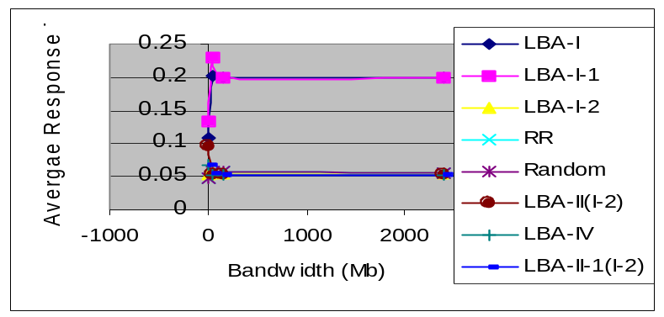

Figure 6-19 Average Response Time

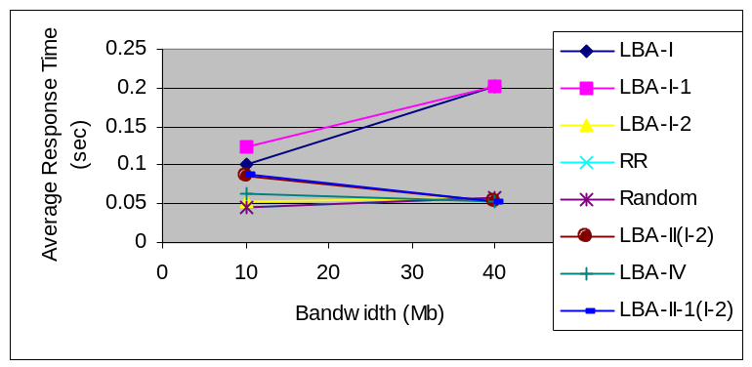
Figure 6-20 Average Response Time

From Figure 6-19 and 6-20, we can see that when the bandwidth varies, the algorithm Random, RR, LBA-II, LBA-II-1, LBA-IV do not varies rapidly, the algorithm LBA-I-1, LBA-I varies rapidly, so that the algorithm LBA-I, LBA-I-1 is more sensitive to the bandwidth.

