Multiple Path Connection through a Set of Connection Relay Servers

by

Syama S Kosuri

A thesis submitted to the Graduate Faculty of the

University of Colorado at Colorado Springs

in partial fulfillment of the

requirements for the degree of

Master of Science

Department of Computer Science

2005

This thesis for the Master of Science degree by

Syama S Kosuri

has been approved for the

Department of Computer Science

by

_________________________________
Dr. Edward C. Chow

_________________________________
Dr. Jugal K. Kalita

_________________________________
Dr. Sudhanshu K. Semwal

_______________________
Date

Chapter 1
Introduction
1.1 Overview
The Internet, as we know, has been evolving for over thirty-five years, starting with the ARPANET in 1969 [3]. Its initial use was mainly for researchers to exchange information through email and UseNet groups. It is no more an exaggeration when we say that internet has become a very essential component of our day to day life. Internet carries traffic from both consumers as well as business users. According to a research report by IDC, the premier global market intelligence and advisory firm in the information technology and telecommunications industries, in 2002, the traffic volume was 180 petabits per day (one petabit = 1 million gigabits). This will increase to 5,175 petabits per day by 2007 .The amount of information transmitted globally over the Internet will continue to double each year over the next five years. (www.nwfusion.com/news/2003/0306idcinter.html)
So a key challenge in today’s Internet is to improve the network bandwidth and reliability for potentially vast numbers of heterogeneous clients. However, the network connections between two network nodes in current Internet are mostly single path connections, limiting the bandwidth of the connection to the lowest of all links (Refer to figure). The single path connection model is simple and easy to implement. But it may under-utilize network resources, and does not always provide good and reliable network performance, especially when the intermediate links become congested or broken. [1]

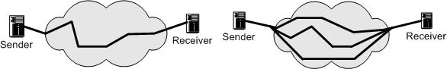

Figure : Single path connection vs. multipath connections

Multiple path connections provide potentially multiple paths between network nodes, so that the traffic from a source can be spread over multiple paths simultaneously and transmitted in parallel through the network [1]. Multiple connections utilize the network resources more efficiently, improve the effective bandwidth of network nodes, increase the packet delivery liability, provide quality-of-service guarantee, and cope well with network congestion, link breakage and burst traffic.
Multiple path connections are an alternative to single shortest path routing to distribute and alleviate congestion in the networks. In multiple path connections, traffic bound to a destination is split across multiple paths to that destination. In other words, it uses multiple ‘good’ paths instead of a single ‘best’ path for routing.
The multipath-routing model offers applications the ability to increase their network performance. In multipath-routing, the cost/overhead of calculating multiple paths is incurred once for a particular network topology, and subsequent path changes to avoid congestion are done by end-hosts and thus do not require routing intervention or routing overhead. The model provides a flexible interface to network resources, because of its multi-service paths, multi-option paths, and end-hosts’ freedom to use these paths. The model enables applications with varying network demands to increase their performance.
In general, multipath performance improvements are obtained in two ways. First, multi-service paths allow an application to use paths within a service that best suit the application’s communication needs. Second, multi-option paths provide more network resources per path service, allowing applications to aggregate these path resources. Since network demands vary with applications, the generality of a multi-service path allows a multi-path network to satisfy the needs of different applications.
Some work has been done in this area. Some of them require changes to either the client or the server or both. Some of them involve complicated configuration requirements. Some of them require customized intermediate nodes. For the detailed taxonomy on multipath connections, please refer to Chapter2.
So a solution that is constrained by none of the above requirements is required. The solution that is proposed is to use the multiple path connections through a set of connection relay servers. In this solution no changes are required either to the client or the server. The intermediate connection relay servers and the client side and the server side proxy servers run the code at the application layer and hence no complicated configurations or customization is required to set up the system.

The key idea is that by using a set of connection relay proxy servers, we could set up indirect routes via the proxy servers, and transport packets over the network through the indirect routes. By efficiently distributing and reassembling packets among multiple paths at two end nodes, end-to-end TCP throughput can be increased. The approach offers applications the ability to increase the network performance, efficiency, stability, availability and security.

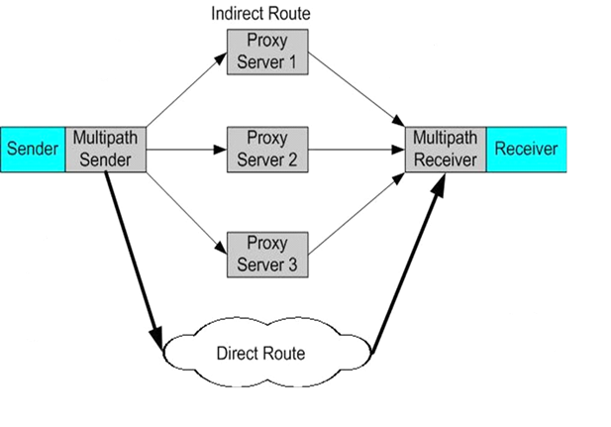
Figure : Multiple path connections through a set of Connection Relay Servers (MPCCRS)

Figure XX is the diagram that illustrates the multiple path connections through connection relay servers (MPCCRS). There are three basic components in a MPCCRS network. The multipath sender, or distributor, is responsible to select the best paths, from among the available paths and distribute packets over the selected multiple paths. All the packets will go through the alternate indirect routes via the proxy servers. The intermediate connection relay servers or forwarders forward them to the receiver. The multipath receiver, or collector, collects the packets arrived from multiple paths, reassembles them in order and delivers them to the user.

For convenience, from now on, we refer to our approach of “Multiple path connections through a set of Connection Relay Servers as “MPCCRS”. We use the phrase “direct route” to refer to the network route whereby a packet normally takes when it travels between the client and the server through the internet. The phrase “indirect route” is used to refer to the network route which utilizes the connection relay server (CRS).
Compared with other types of multipath connections approaches, MPCCRS not only has the generic benefits of multipath connections like others, but also has the following unique advantages:
a) Flexibility: MPCCRS can be more conveniently deployed in various network environments. Unlike some multipath connections approaches that require changes on physical network infrastructure, MPCCRS only requires some feasible changes at the application layer software. MPCCRS also gives the end users more control and flexibility on how to set up multipath connections.
b) Compatibility: MPCCRS utilizes existing TCP/IP and HTTP protocols and network infrastructure to distribute, transport and reassemble packets. This ensures the compatibility with current Internet. It also ensures the performance, efficiency, reliability, and hides the complexity from end-users.
The rest of the document is organized as follows ------ to be filled

Chapter 2
Related Work
This chapter surveys the related work of MPCCRS.
The system of multiple path connections is referred to by many names like multiple path routing, alternate path routing and traffic dispersion. And sometimes the same name is used in literature to refer to different ideas.
The rest of the chapter is organized as follows—to be filled at the end
2.1 Multipath connections
The IBM Systems Network Architecture (SNA) network in 1974 [66] is probably the first wide area network which provides multiple paths connections between nodes. However, in the SNA network, only one path is used at a time, and the purpose of multiple paths is to provide fault-tolerance mechanisms. Also, SNA multiple paths are predefined and pre-computed.
N. F. Maxemchuk [12] in 1975 used channel sharing to provide multipath connections and reduce queuing delay in store and forward network. He called the technique “dispersity routing”. The research was extended to virtual circuit networks [13] and ATM network [27] to deal with busty traffic data, where both redundant and non-redundant dispersity routing techniques were described. A literature survey on traffic dispersion was presented in [28]. The author illustrated various strategies, such as packet-by-packet or string mode, to give dispersion in different network configurations.
According to the Open System Interconnection (OSI) Network Reference Model [67], we differentiate multiple path connections between physical layer, data link layer, network layer, transport layer and application layer based on the network layer. This is only a rough classification. Some approaches might be multiple layers implementation. Figure 2.X illustrates the classification of multipath connections.
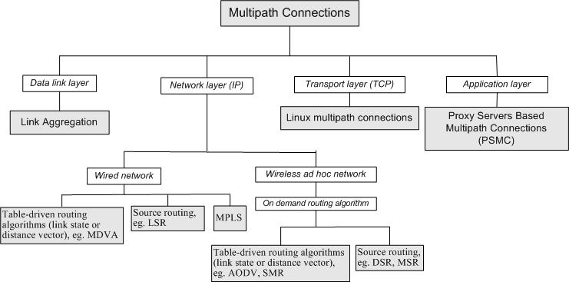
Figure 2.X: diagram of multipath connections.
2.1.1 Physical layer
Multipath connections in physical layer are not something that we always want. Signal transmission by multiple paths some times causes, what is called, interference. The most crucial point in signal transmission by multiple paths is to ensure that the pieces of signal are synchronized properly. For example, sometimes FM radio sounds static and bad because of “multipath interference” [68]. Multipath (often called picket fencing or flutter) happens when FM signals bounce around between the buildings in a city, or other large obstructions. This bounce causes a reflection and the FM radio tries to lock onto the original signal as well as the reflection!
2.1.2 Data link layer
Multiple path connections in data link layer has been implemented as Link Aggregation or Trunking, defined in IEEE 802.3ad [3]. It is a method of combining multiple physical network links between two devices into a single logical link for increased bandwidth. The upper layer applications or protocols, such as a MAC client, can treat the link aggregation group as if it were a single link. Link Aggregation requires special network interface hardware/software support, for example, Link Aggregation based on Sun Quad Fast Ethernet Adapter Card and Sun Link Aggregation software [14]. Therefore, it is only suited for high-end hosts.
.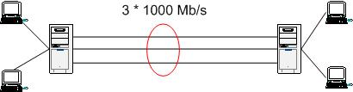
Figure 2.2: Two servers interconnected by an aggregation of three 1000 Mb/s links
2.1.3 Network layer
In network layer, multiple path connections have been studied extensively. It is referred to by multipath routing. Various protocols have been designed for wired networks.
Based on the routing mechanism, they can be differentiated between Table-driven algorithms (link state or distance vector) and Source Routing.
Table-driven algorithms
S. Vutukury et al. [2] proposed a multipath distance vector routing algorithm, named MDVA that uses a set of loop-free invariants to prevent the count-to-infinity problem. The computed multiple paths are loop-free at every instant.
Johnny Chen, in his Ph.D. dissertation at Rice University [3], proposed a complete multiple path network model that includes the following three components: routing algorithms that compute multiple paths, a multipath forwarding method to ensure that data travel their specified paths, and an end-host protocol that effectively use multiple paths.
Other works in similar area include [15], [16], [17], [18], [19], and [20]. These protocols use table-driven algorithms to compute multiple routes. These protocols require fundamental changes on Internet routers and routing protocols.
Source Routing
Source Routing [4] is a technique whereby the sender of a packet can specify the route that the packet should take when the packet travels through the network. In today’s Internet, when a packet travels through the network, each router will examine the “destination IP address” and choose the next hop to forward the packet to. In source routing, the sender makes some or all of these decisions. If the sender makes only some of these decisions, it is called Loose Source Routing. Source routing could be used to implement multiple path routing. But, because of security concerns of source routing, most routers in today’s Internet have disabled the source routing. J. Saltzer et al. [21] implemented source routing in campus-wide network environment.

Multi Protocol Label Switching (MPLS)
Multi Protocol Label Switching (MPLS) [70] provides a mechanism for engineering network traffic patterns that is independent of routing tables. MPLS assigns short labels to network packets that describe how to forward them through the network. MPLS is independent of any routing protocols and can be used for unicast packets.
In the traditional Level 3 forwarding paradigm, as a packet travels from one router to the next, an independent forwarding decision is made at each hop. The IP network layer header is analyzed, and the next-hop is chosen based on this analysis and on the information in the routing table. In an MPLS environment, the analysis of the packet header is performed just once, when a packet enters the MPLS cloud. The packet then is assigned to a stream, which is identified by a label, a short (20-bit) fixed-length value, at the front of the packet. Labels are used as lookup indexes in the label forwarding table. For each label, this table stores forwarding information. We can associate additional information with a label, such as class-of-service (CoS) values, that can be used to prioritize packet forwarding. MPLS could be used to set up multiple path connections for traffic engineering and quality of service [69, 70].
2.1.4 Transport layer
Linux has its own implementation of multipath connections [9, 64]. For convenience, we refer to it as “Linux multiple path connections”. It is a solution for using multiple ISP connections (multi-homing) at the same time. Linux kernel needs to be patched to support “Advance Router” and “Multiple Path Routing” options. The Linux kernel distributes packets between multiple network connections in TCP layer. The solution’s configuration is complicated, and it fails to provide fail-over mechanism in case of failure of a connection. Also, it requires the host machine to have multiple network interfaces with multiple ISP connections.
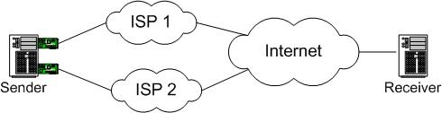
Figure 2.4: Linux multipath connections for multiple ISP connections

2.2 Parallel download from multiple mirror sites
A related problem to multiple path connections is the problem of parallel download from multiple mirror sites. Rodriguez et al. [10] studied how to use the existing HTTP 1.1 byte range header protocol to retrieve documents from multiple mirror sites in parallel to reduce the download time and to improve the reliability. J. Byers [11] proposed a feedback-free protocol to access documents from multiple mirror sites in parallel. The protocol is based on erasure codes (Tornado codes). It can deliver dramatic speedups at the expense of transmitting a moderate number of additional packets into the network.

Design and implementation

Components in the MPCCRS

- Client: Web browser
- Client Proxy: A prefork server capable of handling multiple HTTP requests from multiple clients
- Server Proxy: A prefork server capable of handling multiple HTTP requests from multiple client proxies and capable of sending data through multiple connection relay servers.
- Server: A web server capable of handling HTTP requests
- Connection Relay Server (CRS): A prefork server capable of receiving data from multiple server proxies and capable of sending data to multiple collectors
- Bandwidth relay server(BWS): A prefork server used to determine the bandwidth of the network between the CRS and client collector and relay that information to the server proxy.
- Client Collector: A prefork server capable of handling data from many connection relay servers

Client

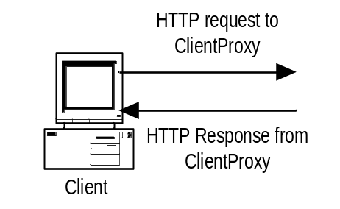

Fig: Client communication

The request to get the data from a desired site is initiated by the user using the client. The client browser is set, through the settings option, to route the request through the client proxy, using the machine name on which the client proxy server software program is running and the port number. Once the request is routed to the client proxy, client sits waiting for the response from client proxy.
Client Proxy

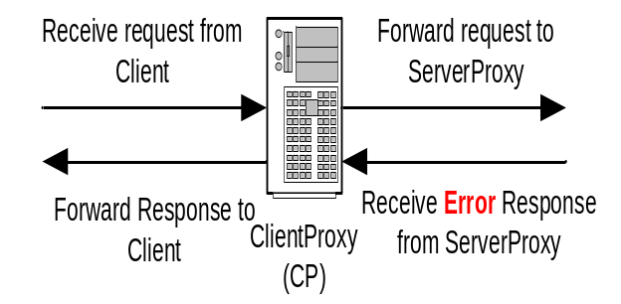

Fig: Client Proxy communication

Client proxy receives requests from client. The client proxy then creates an MD5 digest using the host name and the URI of the destination from the HTTP request header. The key generated in this way is used to identify the file, created with the same name and loaded by the client collector, from among the many files that the client collector writes with the response data from different requests. It then checks in the cache to see if the file it is looking for (file with the name of the MD5 digest key) already exists. If the file already exists the file will be read and the data will be sent to the client. If the file does not exist then the request will be forwarded to the server proxy. Once the request is forwarded to the server proxy, it starts checking for the MD5 digest key entry, in a key entry text file. The entry in the text file will be written by the client collector when writing into the response data file is completed. Client proxy starts reading the file, once it senses that the file is written completely and available for reading. Then the data will be sent to the client.

Server proxy

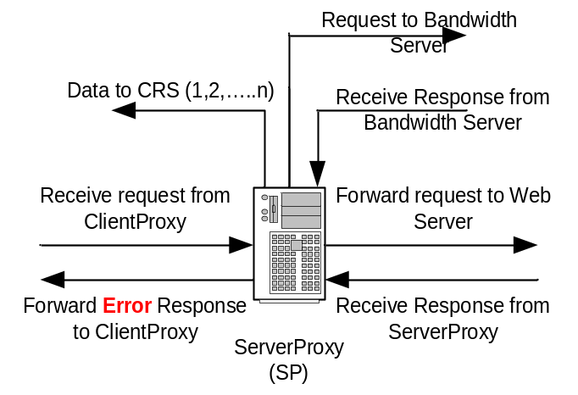

Fig: Server Proxy communication

Server proxy receives the request from the client proxy. It forwards the request to the web server and waits for the response from the web server.

If the server proxy receives an HTTP error response from the web server, the response will be sent back to the client proxy. The response ultimately reaches the client through the client proxy and will be displayed on the web browser client.

If the response is normal from the web server then the data received will be sent over multiple CRS’ to reach the client collector. Server proxy contains the details of all connection relay servers that it can use for routing the data simultaneously. Also through the configuration settings it knows how many parallel connections it is supposed to use at any given time. When the server proxy is started, it calculates the bandwidth between itself and the client collector through all the available paths using the bandwidth calculation algorithm, respectively. It then sorts the network paths in descending order based on the respective bandwidths and then selects the number of connections that it is supposed to send the data in parallel from top. The number of packets to be sent on each connection is decided using the load distribution algorithm. The packets are sent in the determined ratio in a round-robin fashion (for example 5:4:3) on each connection.

CRS

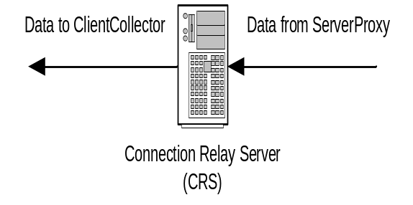

Fig: CRS communication

A CRS receives the packets from the server proxy and sends them to the client collector. It works as a basic relay server. The only purpose of a CRS is to break the path between the server proxy and the client proxy into multiples.

Bandwidth Relay Server

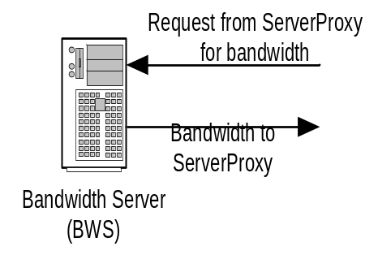

Fig: BWS communication

This is run on the same machine that houses the CRS. So each machine that houses a CRS also houses a bandwidth relay server. It is used to get the bandwidth between the CRS and the client collector. When the server proxy contacts the bandwidth relay server to find the bandwidth between CRS and the client collector, the BWS runs the “cptest.prl” script with client collector as the destination. It then returns the bandwidth value between the CRS and the client collector to the server proxy.

Client Collector

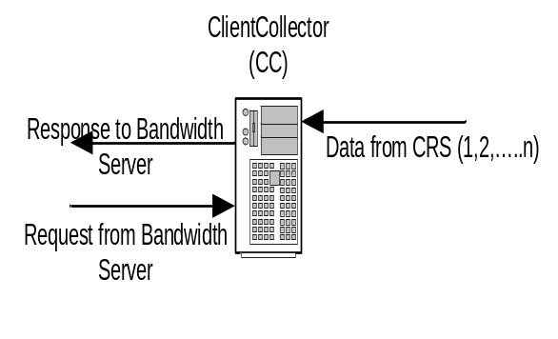
Fig: Client Collector interaction

This runs on the same machine that houses the client proxy. It collects all the packets, from a unique destination, that arrive over multiple connections, into a file. The name of the file to be created is obtained from the “file name” header field of the packet. It uses the byte range field of the packet header and assembles all the packets, depending on their byte ranges, into the file. When it receives the last packet of the response, it creates a file name entry into the key entry text fie, which is a shared file between client proxy and client collector processes.

Fig.XX shows the complete interaction diagram between the components of the MPCCRS

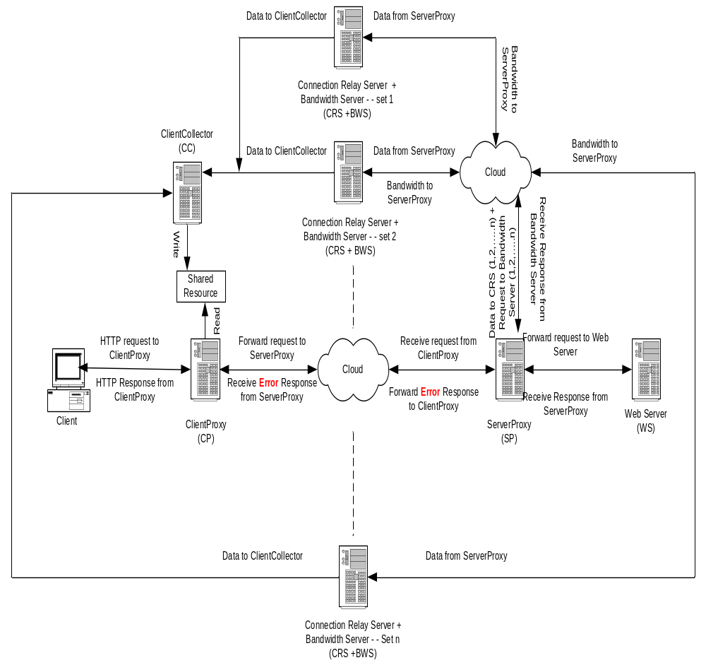
Fig XX: Complete interaction diagram for MPCCRS

Fig X.X shows the sequence diagram for the MPCCRS

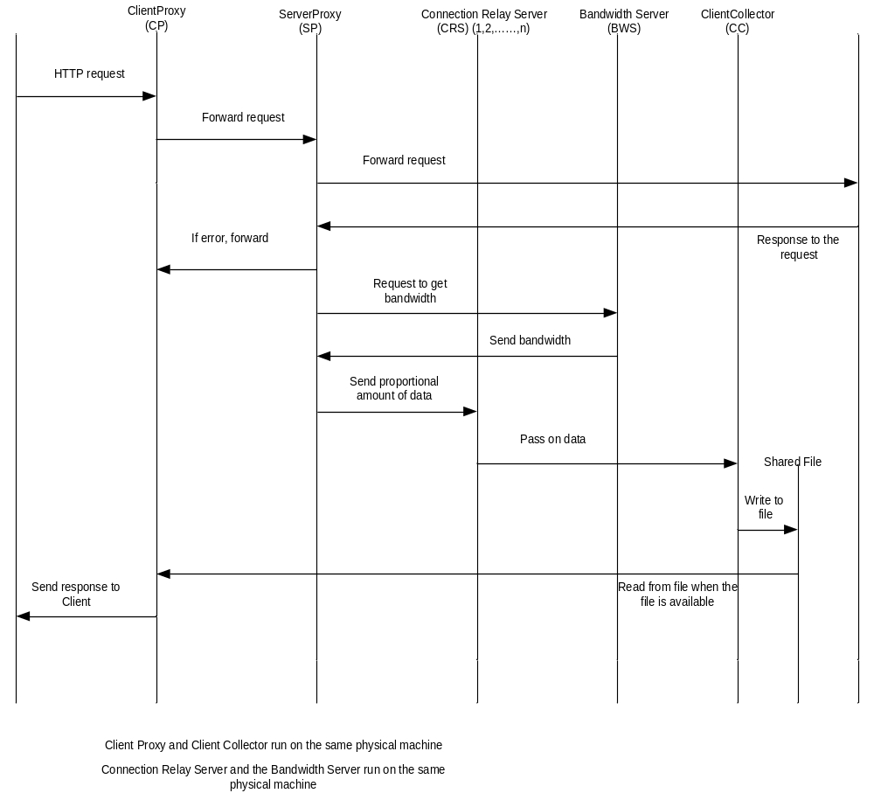
Fig X.X: Complete sequence diagram of MPCCRS

Algorithm for finding the network bandwidth between the server proxy and the client collector through one path:

The algorithm consists of the following steps.
1.The server proxy runs the “cptest.prl” (perl script) using the CRS’ address as the destination address. cptest.prl requires a destination address and the number of sampling times. The command to run the cprobe is as follows
Command----
Cprobe returns the network bandwidth between the host machine and the destination address.
2. Server proxy contacts the bandwidth relay server running on the same machine as CRS. The bandwidth relay server in turn runs the cptest.prl script with a destination address of the machine running the client collector.
Once the bandwidth relay server gets the network bandwidth between the CRS and the client collector, it communicates that value to the server proxy.
3. Now server proxy has the network bandwidths for the two legs (Server proxy to CRS; CRS to client collector) between itself and the client collector. Because a network with multiple legs in series can carry only the minimum bandwidths of all of the legs, the server proxy selects the minimum of the two bandwidths and assigns that value as the network bandwidth between itself and the client collector.

Algorithm for load distribution on multiple paths

- Server proxy has the knowledge of the network bandwidths of all the paths over which it can transmit packets.
- For efficient transmission, each path should be loaded in proportion to its bandwidth so that no one path becomes the bottle neck and affects the performance
- Assumption: All packets are similar in size and the CRS’ are evenly distributed physically between the server proxy and the client collector, so that the network travel time is same across all paths. This results in the conclusion that the packets should be sent on each path in proportion to the bandwidth ratios.
- Server proxy determines the ratio of bandwidths and starts sending the packets on each path in that ratio in round robin fashion.

Data collection and performance evaluation:

The test bed was set up exactly like the one shown in the design diagram except for one difference. The design diagram shows that various proxy servers are connected by internet. But due to the practical limitations, all the proxy servers are connected to the University internal network.
The test bed was set up as follows:

Proxy server | Physical Machine
Client Proxy | NCDCRX1.UCCS.EDU
Server Proxy | VINCI.UCCS.EDU
Client Collector | NCDCRX1.UCCS.EDU
Connection Relay Server1 | BLANCA.UCCS.EDU
Bandwidth Relay server1 | BLANCA.UCCS.EDU
Connection Relay Server2 | CRESTONE.UCCS.EDU
Bandwidth Relay server2 | CRESTONE.UCCS.EDU
Connection Relay Server3 | SANLUIS.UCCS.EDU
Bandwidth Relay server3 | SANLUIS.UCCS.EDU
Client | Mozilla web browser on GANDALF.UCCS.EDU
Web Server | CS.UCCS.EDU

The configurations of the machines used in test bed setup are given in the below table:

 | Ncdcrx1 | Vinci | Sanluis | Blanca | Crestone
CPU |  |  | Dual PentiumIII  1.5GHz | Dual PentiumIII  933.4MHz | PentiumIII  1.5GHz
Memory |  |  | 1.5GB | 1.5GB | 1GB
Network |  |  | 100Mbps | 100Mbps | 100Mbps
OS |  |  | Redhat 9 Linux Kernel  2.4.20-31.9smp | Redhat 9 Linux Kernel  2.4.20-31.9smp | Redhat 9 Linux Kernel  2.4.20-31.9smp

The main objective of data transmission through multiple paths is effective utilization of network bandwidth. In other words the goal is to transmit data at higher rates than possible with a single path between the client and the server.. In summary if we can transmit higher amounts of data over multiple paths when compared to the transmission rate on a single path with the same set up, then we have achieved the goal of MPCCRS.

To evaluate the performance of MPCCRS, response times are collected for transmitting different sizes of data over 1, 2 and 3 paths respectively. To minimize the variance in the collected test data, only image files of one type are used. Each collected response time is, in reality, an average of more than three samples. This is done to take care of the transient conditions, if any that occur during testing.

The response times are captured using “ethereal” packet analyzer tool. For each request from the client the beginning and end times of the HTTP packets were measured. Then the total response time is the elapsed time between the two events.

All the proxies and client and server in the test bed are connected to the internal network of the University. The university runs on a 100Mbps network. So the effective bandwidth of the MPCCRS test bed network is 100 Mbps.

The MPCCRS is written entirely at application layer level and hence the overheads will be more. Keeping this in mind the MPCCRS can be tested in two ways:
One way is to restrict the network bandwidth either using the hardware controls (router configuration) or using software network bandwidth rate limiters. Either way we have to bring down the bandwidth level such that the network bandwidth becomes a bottle neck when transferring data over direct connection. Once that condition is reached we can test the MPCCRS with multiple paths and measure the performance improvement.

The other way is to run the MPCCRS, set to one path, and see what the possible data rate is. In this case either the network could become a bottle neck or the implementation of MPCCRS itself could become the bottleneck. If we get the same effective transfer rate through MPCCRS, when it is set to one path, as we get with a direct connection then the network becomes the bottle neck. And we can expect much higher transfer rates through MPCCRS. If the other way then we an conclude that the MPCCRS implementation with one path on this network becomes a bottle neck and we should get some performance improvement when we run MPCCRS with multiple connections on the same network.

When the above test is performed it is found that the MPCCRS, written entirely on application layer, has become the bottleneck on this 100Mbps network. So the response times with one proxy connection is used as a bench mark to evaluate the performance of the MPCCRS.

Data collected is shown in Table XX.

Data Size (Kb) | Response times (milli sec)
 | Over 1 CRS | Over 2 CRS’ | Over 3 CRS’
103 | 1449 | 1540 | 1323
192 | 2615 | 2640 | 2492
233 | 3240 | 3149 | 2700
369 | 5004 | 4889 | 4335
733 | 9709 | 9879 | 8542
1200 | 16826 | 15695 | 13309
2900 | 39397 | 33535 | 32839
8600 | 122341 | 101121 | 98306
15000 | 217000 | 186498 | 175534

To evaluate the performance of MPCCRS over 2 and 3 paths when compared to transmission over 1 path, the data is plotted as shown in the chart below.

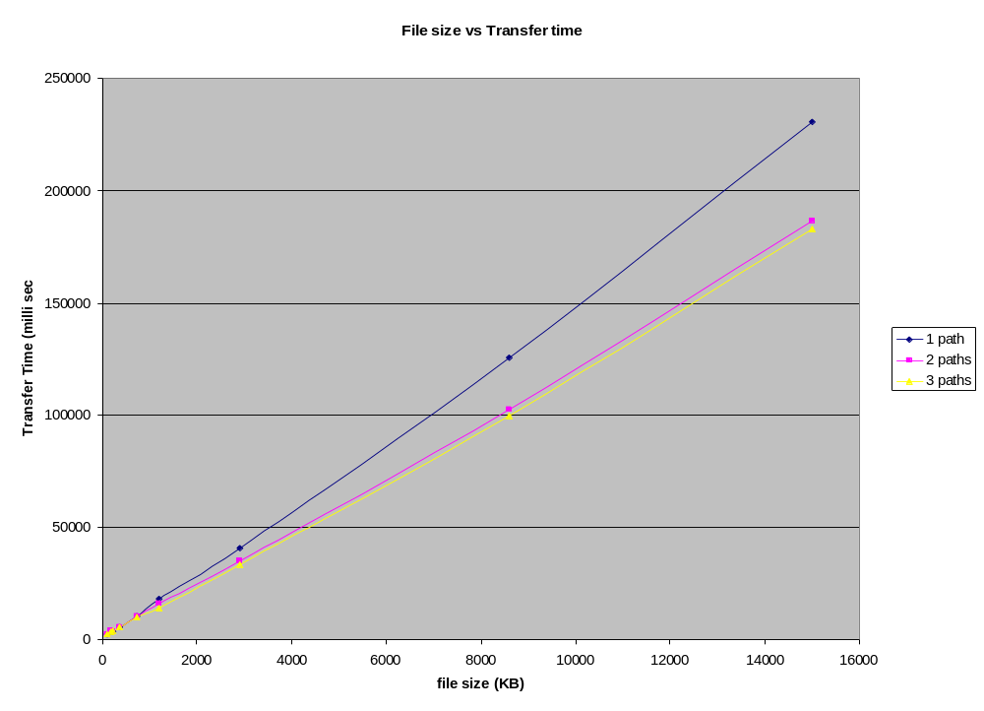

From the chart above it is clear that there is definite performance improvement when the data is transmitted over multiple paths. However the improvement in the performance is not uniform with the increase in the number of paths. There is a sizable improvement in the performance when the data s transmitted over two paths. But then there is a very marginal improvement when the data is transmitted over three paths.

Also the average transfer rates with multiple paths is shown in the below chart.

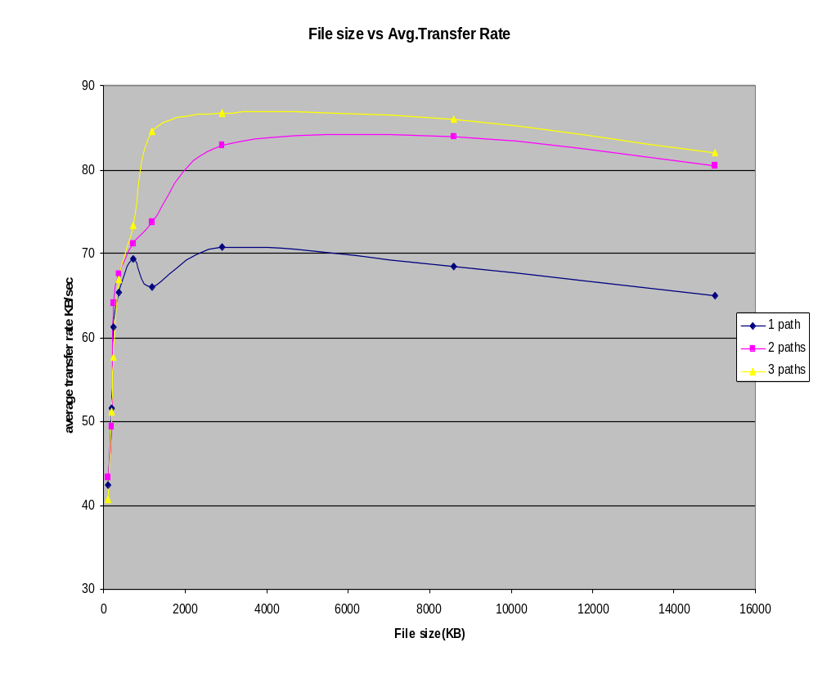

This chart shows that the performance was very poor over any number of paths for files below certain sizes. This could be due to the overhead involved with the MPCCRS, especially when all the routing is done at application layer. As the file size increases the performance improves across all paths. As noted in the previous chart, again the performance improvement was much better with two paths than when compared with the improvements over three paths. The most probable reason could be the server proxy reaching its capacity saturation.

Also to analyze the performance of client collector, the other major overhead in the MPCCRS, the data is plotted as shown in the chart below.

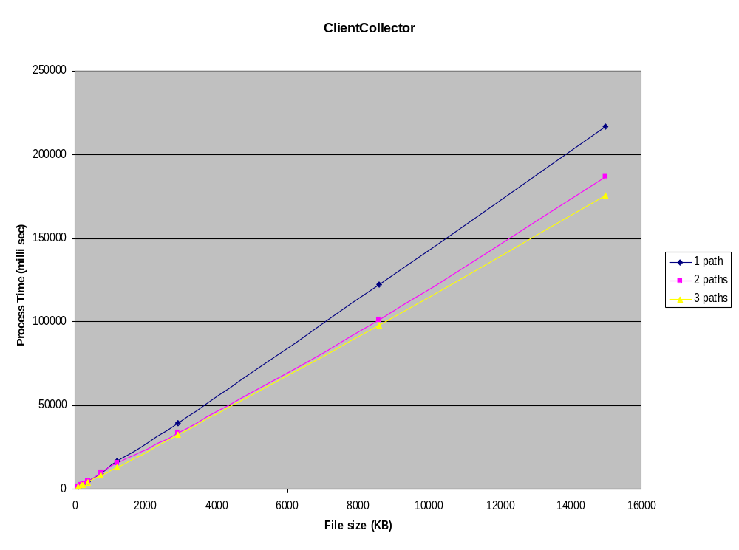
It shows the similar performance results. Similar to the other chart again the client collector is showing better performance with more number of paths. It has shown good amount of performance improvement when transmitting over two paths. But over three paths it is only a marginal improvement.

Conclusions:
Future works:
Lessons Learnt:
References:

APPENDIX A

SETUP GUIDE

This appendix explains how to setup, configure and run this application to transfer data through multiple path connections from a web browser.

Set up client proxy

The object module client_proxy should be copied to the machine on which user wants to run the client proxy server. When the module is run, it displays the port number to which the server is bound and is ready for receiving the requests. This port number should be used when the client is set to use this proxy.

Configurations:
Set up client collector
Client collector server runs on the same physical machine as the client proxy. The object module client_collector should be copied to the machine on which the client_proxy is running. When the module is run, it displays the port number to which the server is bound and is ready for receiving the requests.
Configurations:
Set up server proxy
The object module server_proxy should be copied to the machine on which user wants to run the web server side proxy server. When the module is run it displays the port number to which it is bound and is ready for receiving the requests.
Server proxy configuration files define the rest of the machines the system will be referring to. If any of the configuration files are changed the source code needs to be recompiled to reflect the changes in the resulting object code.
Set up CRS
The object module CRS_proxy should be copied to all the machines that will be used as connection relay servers. When the module is run on each of those machines, it displays the port number to which the CRS_server is bound and is ready for receiving the requests.
Set up Bandwidth relay server
The object module bw_relay_proxy should be copied to all the machines that will be used to run the bandwidth relay servers. When the module is run on each of those machines, it displays the port number to which the bandwidth relay server is bound and is ready for receiving the requests.
Set up client
The client is the Microsoft’s Internet Explorer web browser running on the user’s machine. The browser needs to be set up to use a proxy server, which should be mapped to our client proxy server. To set up user needs to go to the tools → internet options → connections from the menu bar of the browser. Then click on “LAN settings” and enter the values as shown in the screen shot below. Then click on OK.

“Use a proxy server for your LAN” option should be checked. “Address” field should be filled with the machine name on which the client proxy server is running (for example: ncdcrx1.uccs.edu). “Port” field should contain the port number on which the client proxy server is running (for example: 8080)


