VIEW COHERENCE ACCELERATION
FOR RAY TRACED ANIMATION

by
Philip Glen Gage
B.S., University of Colorado at Colorado Springs, 1983

A thesis submitted to the Graduate Faculty of the
University of Colorado at Colorado Springs
in partial fulfillment of the
requirements for the degree of
Master of Science
Department of Computer Science
2002

This thesis for the Master of Science degree by

Philip Glen Gage

has been approved for the

Department of Computer Science

by

____________________________________
Sudhanshu K. Semwal, Chair

____________________________________
Marijke F. Augusteijn

____________________________________
C. H. Edward Chow

__________
Date

Gage, Philip Glen (M.S., Computer Science)
View Coherence Acceleration for Ray Traced Animation
Thesis directed by Professor Sudhanshu K. Semwal

Ray tracing generates realistic images but is computationally intensive, especially for animation. Many techniques have been developed to accelerate ray tracing, including exploitation of temporal coherence between successive frames to accelerate animation. This thesis extends earlier work on ray traced animation to add efficient pan and zoom from a fixed viewpoint and other capabilities. A generalized ray tracing method that integrates an object animation acceleration technique by David Jevans with the new pan and zoom algorithms is presented, providing accelerated object animation and field of view changes by maximizing reuse of previous frame data. The algorithms were implemented in Java for both animation and virtual reality interaction and results are presented showing an order of magnitude performance improvement for typical pan and zoom operations.

CONTENTS

CHAPTER

INTRODUCTION 1
PREVIOUS WORK 4
Ray Tracing 5
Geometry 6
Shading 8
Aliasing 9
Extending ray tracing limitations 10
Acceleration 11
Bounding volumes 12
Spatial subdivision 13
Other techniques 16
Animation 18
Image Space versus Object Space 18
Object Space Temporal Coherence (OSTC) 20
Interaction 22
DESIGN 24
New Pan Animation (Panimation) Algorithm 25
Standard viewing projection 26
Cylindrical viewing projection 28
New Zoom Ray Sample Viewport (RSVP) Algorithm 32
Viewports 33
Integrating the Algorithms 35
Algorithm Summary 36
Integrating OSTC and RSVP 37
Integrating Panimation and RSVP 37
Integrating OSTC and Panimation 40
IMPLEMENTATION 41
Development Process 41
Java 41
Ray Tracer 42
Uniform Spatial Subdivision Grid 43
Temporal Coherence Animation Acceleration 44
Pan and Zoom 45
Java Classes 45
The Panimation camera 46
The Ray Sample Viewport (RSVP) 50
Lights, Cameras, Action! 51
RESULTS 54
Animation 54
Virtual reality 58
FUTURE WORK 60
Autopan and Autozoom 60
View projections 62
Command language 62
Interaction 63
Compression 63
Postprocessing 64
Testing 64
Cached image blocks 64
Spatial subdivision 65
Generalized acceleration 66
CONCLUSION 68
BIBLIOGRAPHY 69
APPENDIX A. PROGRAMMER’S REFERENCE 74
Operation 74
Examples 75

TABLES
Table

Table 1. Animation Acceleration Algorithms 25
Table 2. Class Names and Descriptions 53
Table 3. Acceleration Results 55

FIGURES
Figure

Figure 1. Example Ray Traced Image 5
Figure 2. Ray Tracing Geometry 7
Figure 3. Whitted Ray Tracing Shading Equation 9
Figure 4. Uniform Spatial Subdivision Grid 13
Figure 5. Moving Object Shadow and Reflection 19
Figure 6. Object Space Temporal Coherence 21
Figure 7. Pan by Image Shift and Retrace 26
Figure 8. Standard View Projection 27
Figure 9. Spherical View Projection 28
Figure 10. Cylindrical Equirectangular View Projection 29
Figure 11. Standard and Cylindrical Projections 31
Figure 12. Zoom 2:1 Mapping 32
Figure 13. Example Viewports 34
Figure 14. Cylindrical Projection and Inverse 37
Figure 15. Integrated Panimation and RSVP Algorithms 38
Figure 16. Correcting Cylindrical Distortion 39
Figure 17. Class Hierarchy 46
Figure 18. Camera panImage Method 48
Figure 19. Camera panImage Geometry 48
Figure 20. Render Area Pseudocode 49
Figure 21. Camera Render Pseudocode 50
Figure 22. Viewport Render Pseudocode 51
Figure 23. World Data Structure 52
Figure 24. World Animate Pseudocode 52
Figure 25. Simultaneous Pan and Animation Image 56
Figure 26. Camera and Viewport Images 57
Figure 27. Interactive Camera and Viewport Windows 59
Figure 28. Viewport Autopan and Autozoom 60
Figure 29. View Frustrum Grid 66

CHAPTER I

INTRODUCTION

Computer graphics is widely used in applications including advertising, art, video games, data visualization, and recently, full-length motion pictures. Advances in realistic rendering make it difficult to determine whether some images are real or computer-generated. In a few years, computer-generated images may be almost indistinguishable from reality.
Ray tracing is an elegant computer graphics technique that produces realistic images, but runs slowly due to the extensive calculations required. Newer, faster computers and better algorithms support more complex image generation. Even low-end PCs are now capable of rendering not only single images, but long animations composed of thousands of images, called frames. Users push the limits towards greater scene complexity and realism, so there is always a need for more speed and improved ray tracing acceleration schemes.
The two main research areas in computer graphics are realism and speed. There is a tradeoff between the two, but careful optimization can improve efficiency while retaining realism. The focus of this thesis is accelerating the ray tracing animation process without sacrificing image quality.
Ray tracing can be used to generate animation sequences by rendering each frame separately, but there are opportunities for performance improvement. Many acceleration methods have been used to speed up ray tracing of still images, including bounding volumes, spatial subdivision and ray coherence. Temporal coherence can be used to accelerate ray traced interaction and animation by reusing data from one frame to the next.
Jevans [JEVA92] presents an elegant method for accelerating ray traced animation using object space temporal coherence (called OSTC here) to track the image areas that need to be updated for each frame. This OSTC method and similar approaches handle moving objects well, but require a static field of view. The purpose of this thesis is to study such methods for accelerating ray tracing using frame coherence, and to extend these techniques to allow useful dynamic camera view transformations, including panning and zooming, from a fixed viewpoint. Unfortunately, these acceleration methods do not allow the viewpoint to move through the scene without a full image redraw, but the camera field of view can be changed with fast partial image redraw.
If these pan and zoom changes are gradual, as they usually are, then most of the image data from each frame can be reused in the next frame, redrawing only the minimum screen area necessary as new parts of the scene come into view. Thus, slow pan and zoom effects can be added to animations with only a slight increase in execution time. In most previous approaches, performing pan or zoom requires redrawing the entire image, greatly increasing execution time and interfering with some acceleration schemes, including OSTC. The new pan and zoom algorithms developed in this thesis allow pan and zoom to be used efficiently where in earlier approaches such camera view changes might have been avoided.
The new algorithms can be used separately or combined with other algorithms such as OSTC. The OSTC technique and the new algorithms operate similarly, retracing only changed screen areas by reusing previous frame data for unchanged areas. Object animation is accelerated by OSTC and camera view changes are accelerated by the new pan and zoom algorithms. The combined system allows simultaneous object animation, pan, zoom and other effects while updating only changed areas of the screen. For sequences involving limited animation, pan or zoom, only a small fraction of the pixels for each successive frame may need to be ray traced, greatly reducing execution time.
The new algorithms were tested and verified by implementing a ray tracer in Java similar to OSTC and extending the ray tracer to accelerate pan and zoom both for animation and virtual reality (VR) interaction. Results indicate an order of magnitude improvement in execution time for typical pan and zoom operations.
Chapter II describes the history and theory of ray tracing and animation acceleration. Chapter III explains the rationale and design of the new pan and zoom algorithms. Chapter IV discusses the Java implementation details. Chapter V presents performance results and example images. Chapter VI contains ideas for possible future work. Chapter VII is the final summary and conclusion.

CHAPTER II

PREVIOUS WORK

Rendering is the process of image synthesis, typically the projection of 3D virtual models onto 2D images. Early graphics systems displayed wire-frame renderings of 3D polygonal scenes, in which the edges of all polygons are drawn as lines. However, such images show lines on the back sides of objects which should be hidden. To produce more realistic images other rendering algorithms were developed, including back-face removal, depth-sorting, area-subdivision, scan-line, z-buffer and ray tracing methods [FOLE96].
An important issue in rendering is visible surface determination, also called hidden surface elimination. The color of each image pixel is determined by the closest opaque object in the view direction for the pixel. Finding the closest surface implies a sorting process, which can be handled in many ways according to two general strategies. Image-precision algorithms, such as ray tracing, find the closest surface for each pixel, while object-precision algorithms find the visible pixels for each object [FOLE96]. Typical graphics systems use an object-precision, pipelined z-buffer method, which is fast but has limited shading capabilities in comparison to ray tracing. Theoretically, ray tracing may someday become as fast as the z-buffer method [WALD01].

Ray Tracing
Ray tracing is an elegant rendering algorithm that provides great versatility and realism. The paths of light rays are traced mathematically to determine the color of each image pixel. Shadows, reflection, refraction and other interesting optical effects are easily supported. Reflection and refraction are handled recursively, producing a tree of rays that contribute to the color of each pixel. Ray casting usually refers to nonrecursive ray tracing without reflection or refraction, although some authors treat the terms as synonymous. Figure 1 shows a ray traced image rendered by the Java code developed for this thesis.

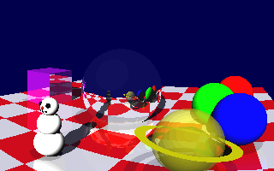
Figure 1. Example Ray Traced Image

Ray tracing has been used in art and optics for centuries [GLAS89]. In 1637 Descartes used ray tracing to explain how the shape of a rainbow is caused by light refraction in raindrops. Artists used rays to develop perspective drawing techniques. Rays were traced on paper to model the paths of light rays through systems with lenses, mirrors and prisms. Computers are now used instead of paper to model the design of telescopes and other optical instruments.
Appel [APPE68] was the first to use ray tracing for computer graphics, for shading and shadows. He used a limited ray tracing technique to produce architectural diagrams on a pen plotter. Whitted [WHIT80] was the first to describe the complete ray tracing algorithm, combining earlier separate techniques for visible surface determination, shadows, reflection and refraction in a single elegant method. His paper forms the foundation of modern ray tracing and suggested many ideas later pursued by other investigators.

Geometry
Some mathematical terminology is necessary to understand ray tracing. The 3D coordinate system has X, Y and Z axes perpendicular to each other. Each point has an (x,y,z) location in this coordinate system. A vector has (x,y,z) coordinates that represent a direction. The length of a vector is called its magnitude, and unit vectors are normalized to a magnitude of one. A surface normal vector represents the direction perpendicular to a surface at a given point. Two vector multiplication operators are defined, the dot product and cross product. The dot product of two unit vectors is the cosine of the angle between them. The cross product of two unit vectors gives a vector perpendicular to both. A ray has an origin point and a direction vector.
Figure 2 shows an example of ray tracing geometry. A fixed point is chosen for the center of projection, called the eye or camera. A view direction vector points in the direction the camera is looking. An imaginary image plane perpendicular to the view vector represents the image pixels. Primary rays are traced from the camera through the center of each pixel in the image plane into the 3D scene. This arrangement defines the viewing projection that determines how 3D locations are projected onto the 2D image plane. The process is backwards from actual photon motion, but saves time by tracing only rays that contribute to the image.

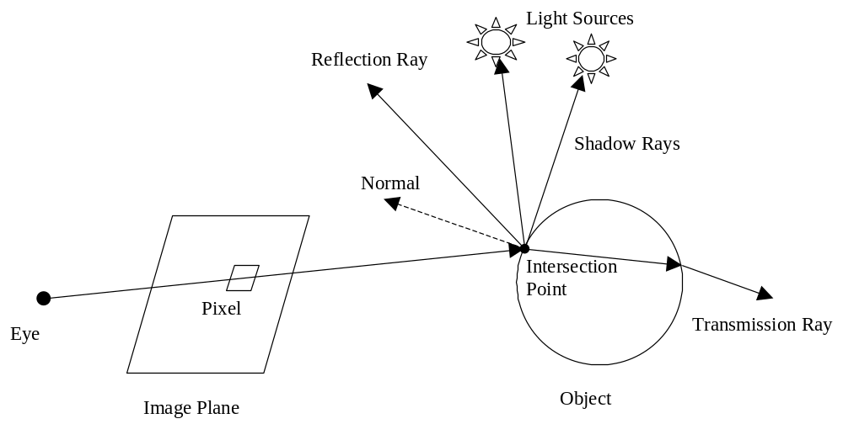

Figure 2. Ray Tracing Geometry

Each primary ray is algebraically tested for intersection with objects in the scene, the closest intersection is the object visible at that pixel. Once the closest intersection point is found, secondary rays, called illumination or shadow rays, are traced to each light source. If a shadow ray intersects any object closer than the light source, the object intersection point is in shadow with respect to that light, otherwise the light intensity is included in the shading calculation. If the object is reflective or transmissive (refractive), additional secondary rays for reflection or refraction are traced recursively and included in the shading.

Shading
Shading is performed by accumulating the total light intensity at the intersection point and combining with the object color at the point to obtain the pixel color. Several illumination models have been developed with varying levels of realism [FOLE96]. The Lambert cosine law defines the intensity coefficient as the cosine of the angle between the surface normal and the light source direction, which can be computed using the vector dot product. The Gouraud shading model interpolates polygon vertex colors, while the Phong model interpolates vertex normals and adds a specular exponent.
The Whitted shading model [WHIT80] shown in Figure 3 is commonly used for ray tracing and includes terms for ambient, diffuse, specular and refractive light. The ambient light term is an approximation of indirect background lighting. Diffuse reflection models a dull surface that reflects equally in all directions. Specular reflection models a smooth, mirror-like surface that reflects in only one direction. Refraction occurs when light is bent while passing through a boundary between different transparent materials. Common extensions to the Whitted equation include an ambient coefficient k_{d} for each object and a Phong term for specular highlights.

I = I_{a} + k_{d} _{Σ} (N • L_{j}) + k_{s}S + k_{t}T

where
I = total reflected intensity
I_{a} = ambient light intensity
k_{d} = diffuse reflection coefficient
N = surface normal vector
L_{j} = direction of jth light source
k_{s} = specular reflection coefficient
S = reflected light intensity
k_{t} = transmission coefficient
T = transmitted light intensity

Figure 3. Whitted Ray Tracing Shading Equation

Aliasing
Aliasing is an undesirable phenomenon caused by digital undersampling of an analog signal which causes high frequencies to alias as lower frequencies. Pixels are digital samples of continuous shapes and show spatial aliasing defects such as jagged edges, called “jaggies”. Animation frames are digital samples over time and have temporal aliasing artifacts such as rotating wheels appearing to spin backwards.
Antialiasing methods sample the signal at higher frequencies to reduce aliasing errors. The ray tracing approach for antialiasing is to fire several primary rays through each pixel and average the results. Distributing several rays across the area of a pixel may hit multiple objects that partially cover the pixel, resulting in a blended color that more closely approximates the correct value. Whitted [WHIT80] describes adaptive supersampling, a technique that shoots more rays in areas of varying color to reduce aliasing errors caused by undersampling.

Extending ray tracing limitations
Cook [COOK84] extended the antialiasing technique to distributed ray tracing. His terminology is unfortunate, since it suggests distributed processes across a computer network but really refers to rays distributed in space or time. The method is usually called distribution (or stochastic) ray tracing now to avoid confusion. It extends supersampling to produce several useful effects, including motion blur, penumbra (soft shadows), gloss (blurred reflection), translucency (blurred refraction) and depth of field (blurred focus). Parameters such as angle, location and time are varied, or “jittered,” for each ray and several rays are averaged together for each pixel.
The popular early 1980s ray traced images of reflective spheres on checkerboards represented a startling jump in realism compared to earlier techniques. However, ray traced images tend to look “too real,” with sharp shadows and reflections. Distribution ray tracing helps make more realistic images, with real-world blur and fuzziness.
The use of infinitesimally thin rays is another weakness of ray tracing and does not model the real world well. Antialiasing and distribution ray tracing reduce this problem by using several rays statistically instead of just one sample. Another approach is the use of generalized rays, bundles of rays or wider rays, including beam, cone and pencil tracing [GLAS89]. Monte Carlo ray tracing and path tracing [JENS01] have also been used to distribute rays statistically.
With Whitted’s recursive algorithm, supersampled antialiasing and Cook’s distribution algorithm, ray tracing is a powerful rendering method. However, traditional ray tracing does not handle some optical phenomena, such as global illumination (interreflectance) and caustics [WATT92]. Global illumination refers to light bouncing around the scene, such as color “bleeding” onto nearby objects, and gives soft, realistic lighting to a scene. Caustics are irregular bands of light reflected off specular surfaces or distorted refraction such as sunlight through water. These effects cannot be modeled by traditional means of tracing rays backwards, but require forward tracing.
Several methods, including bidirectional ray tracing [ARVO86], radiosity [WATT92] and photon mapping [JENS01] have been used to extend ray tracing to include such effects. Ray traced images look impressive but do not model light as accurately as radiosity by not accounting for some illumination effects, such as caustics. Hybrid methods that combine ray tracing with global illumination modeling hold the promise of greater realism in the future, but are currently too complex and slow for wide use.

Acceleration
Ray tracing is slow since a typical image may require tracing millions of light vectors. The majority of time in a ray tracer is spent intersecting rays with objects. In an often-quoted statistic, Whitted [WHIT80] estimates that ray-object intersection tests may take over 95% of execution time for complex scenes. The traditional brute-force approach tests every ray with every object for possible intersections.
Many techniques have been developed to speed up ray tracing [GLAS89, SHIR00], some of these involve complex algorithms and data structures. Most acceleration schemes reduce the number of intersection tests by skipping cases where it can be determined that the ray cannot intersect the object. Arvo and Kirk [GLAS80] divide ray tracing acceleration methods into faster/fewer intersections, fewer rays and generalized rays. Custom hardware and parallel processing [PARK99, REIN00] have also been used and ray tracing is easy to parallelize, unlike some algorithms.

Bounding volumes
The bounding volume technique was described by Whitted in his classic paper [WHIT80]. A bounding volume is a simple shape, usually a sphere or box, that encloses a more complex object to provide a faster intersection test. If the ray does not intersect the bounding volume, the intersection tests against the objects in the volume can be skipped. This can save significant time for complex algebraic surfaces or composite objects composed of many smaller objects.
Even greater savings are provided by bounding volume hierarchies, which group sets of bounding volumes and objects inside larger bounding volumes. Each ray is tested for intersection with the outermost volumes. Only if the ray hits the volume is it tested against inner volumes and objects recursively.

Spatial subdivision
Another approach is spatial subdivision, which partitions the scene into a grid of volumes called voxels. The voxels may be uniform or nonuniform size. Figure 4 illustrates a uniform spatial subdivision grid. Each voxel has a list of the objects that are contained in it or intersect it. An object may intersect one or many voxels. Rays are propagated along their paths from voxel to voxel, checking for intersections with the object list in each voxel. This restricts the object intersection tests to only objects near the ray’s path. Also, the voxels are checked in nearest to farthest order, which can further speed rendering of complex scenes with many densely clustered objects. When an object intersection is found, it must be ignored if it is not in the current voxel to avoid missing possible closer intersections with other objects. If a valid intersection is found, the remaining objects in that voxel must still be checked in case there is a closer intersection in that voxel.

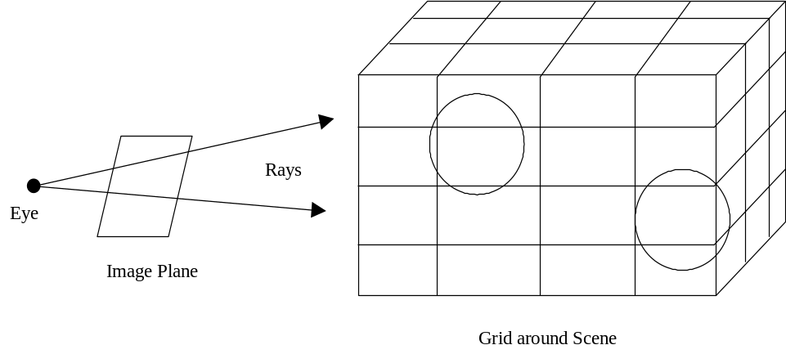

Figure 4. Uniform Spatial Subdivision Grid
Glassner [GLAS84] used the octree structure for ray tracing spatial subdivision. The scene volume is recursively divided into 8 sub-volumes called octants until there are less than a maximum number of objects intersecting each voxel. This results in a nonuniform subdivision that has smaller voxels in areas with more objects. He notes that spatial subdivision always saves time unless grid traversal is very slow.
Fujimoto [FUJI86] compares uniform and octree spatial subdivision in a hybrid method called Accelerated Ray-Tracing System (ARTS). A 3D digital differential analyzer (3DDDA) traversal algorithm is defined to propagate rays through voxels, based on Bresenham’s famous 2D line generator. The approach is rather complex and later papers simplify the uniform subdivision traversal.
Amanatides and Woo [AMAN87] compare bounding volume and spatial subdivision methods. Bounding volumes take less memory, while spatial subdivision has easier grid traversal. Unlike the Fujimoto 3DDDA, their traversal has no required dominant axis that is always incremented. They note that to check if an intersection is inside the current voxel, the ray distance can be used instead of checking the six voxel walls.
Cleary and Wyvill [CLEA88] describe a similar traversal method, claiming that uniform spatial subdivision is typically faster than nonuniform adaptive subdivision and only a few hundred voxels are usually needed. They note that polygon intersection tests can be limited to edges inside the voxel.
Jevans and Wyvill [JEVA89] recursively subdivide voxels into a hierarchy of nested grids. The algorithm is parameterized to act as octree, uniform or adaptive. They use the Cleary [CLEA88] voxel traversal with a more compact XYZ array notation, and a 1D voxel array instead of 3D for faster indexing performance.
Reinhard [REIN00] presents two useful ideas for spatial subdivision. If an object moves outside the grid, it can be wrapped to a larger logical grid size to avoid rebuilding the whole grid. The locations of such objects are wrapped to fall within a voxel and tagged as wrapped. A larger logical grid space is traversed by wrapped rays using the original grid as a hash table to store objects outside the grid. He also describes an octree-style structure that allows objects at any level, not just leaf nodes. This provides fast insertion and deletion of large objects at higher level nodes. The leaf nodes are traversed and parent nodes are searched up the tree and tagged with the ray ID.
Glassner [GLAS89] uses a space-time approach that considers moving 3D objects as static 4D objects intersected by 4D rays. A hybrid bounding volume and spatial subdivision method is used. Motion blur is easily handled by varying the ray start times.
Several authors [AMAN87, SEMW87, CLEA88, JEVA89] note the “mailbox” or ray ID technique. Multiple intersection tests of a ray with the same object can be avoided by saving the ray ID from each intersection in each object and checking this ID before intersection. If the ray ID matches, the ray has already been intersected with the object in an earlier voxel and the saved intersection data can be used.
Semwal [SEMW87] describes a spatial subdivision method called the Slicing Extent Technique (SET). Axis-aligned planes, or slices, are used to bound each object. The intersection of slices creates rectangles, or cells, on each slice. Each 2D cell has a list of associated objects, and each object is associated with at least 6 cells that surround it. During ray traversal the object list of each encountered cell is tested for possible intersections. A large number of objects may create too many cells to handle effectively. To avoid SET limitations, the Modified SET (MSET) method was developed [LOGA89]. MSET uses a uniform spatial grid that supports a large number of objects and allows easy traversal by incrementing through evenly-spaced slices. Each cell has “up” and “down” lists for objects on either side of the cell. Unlike most grid methods, 2D cells are used instead of 3D voxels. A benefit is that no duplicate ray-object intersection tests are performed because each object is assigned only to cells on six slices surrounding the object.

Other techniques
Directional techniques [GLAS89] such as light buffers, ray coherence, ray classification and proximity clouds make use of direction during the preprocessing voxel build. They use a directional cube with six faces that may be subdivided. Each face has a list of objects which lie in that face’s direction, allowing rays to be checked for intersection with smaller lists of objects based on the ray’s direction. The ray classification method [ARVO87] uses 5D representations of rays and bounding volumes, extending space subdivision to include ray direction. The 5D rays (origin and two direction angles) are compared with 5D partitions to retrieve presorted lists of candidate objects for intersection tests.
Coherence refers to local similarity, or smooth, gradual change in space or time. Nearby things tend to have similar properties, which provides opportunities for acceleration. There are dozens of names for various types of coherence, but they all involve spatiotemporal locality. Spatial coherence refers to 3D object space, while image coherence follows from this because the same objects are projected onto 2D image space. Ray coherence provides acceleration by processing generalized bundles of rays together and includes methods such as beam, cone and pencil tracing [GLAS89]. Temporal coherence uses spatial or image similarities between adjacent animation frames in the time domain. Memory coherence [PHAR97, WALD01] is a recent development that is not based on scene geometry, but reorganizes algorithms and data structures to improve CPU instruction pipelining and memory cache performance for modern computer architecture. This thesis focuses on image space view coherence, using temporal coherence for field of view changes from a fixed camera location.
Reprojection [ADEL95, WALD01] is an object space view coherence method using image-based rendering (IBR) that allows pixels to be reused after camera location changes. The previous frame pixels are projected onto the new view plane using 3D geometry. This requires the pixel Z depth or distance to be saved during ray tracing so the 3D transform to the new viewpoint can be performed, along with other data such as surface normal and diffuse color. Intersection tests are performed to detect possible intervening objects, if none, the reused pixel is reshaded as needed for reflection and refraction. Due to geometric inaccuracy, this method can lead to image errors but Adelson [ADEL95] describes how exact sub-pixel accuracy can be maintained and all types of animation change can be handled. Light source changes are problematic and the method requires a large amount of memory.

Animation
Animation gives a feeling of realism and life to still images by adding motion. The human eye sees the appearance of continuous motion when a series of images are shown in rapid succession at around 20 frames per second or faster. To produce animation, the attributes of some of the objects in the scene are changed slightly from frame to frame. These attributes include position, rotation, size, shape, color, texture and other features. In addition, the position and color of light sources and the camera field of view may be changed between frames.
Typically, most of the pixels in a frame are the same as in the previous frame, with changes localized to a few areas where objects are moving, and the shadows and reflections of these moving objects. Simple ray tracers regenerate the entire image for each frame, ignoring the potential acceleration benefits of frame coherence. Much time could be saved by reusing the unchanged pixels or saved rays from the previous frame and ray tracing only the changed pixels. Animations can be generated much faster by fully rendering only the first frame and then only the pixels that are different in each successive frame.

Image Space versus Object Space
Consider a single moving 3D object from one frame to the next, shown in Figure 5. It is easy to determine the old and new locations of the object on the image and redraw these pixels. However, it is difficult to determine which pixels are affected by the object’s shadow, reflection and refraction.

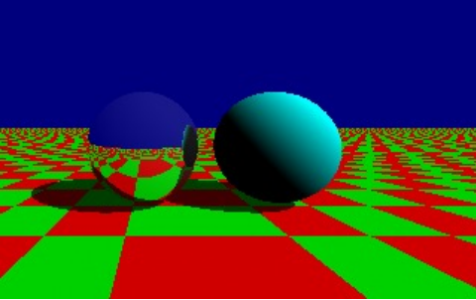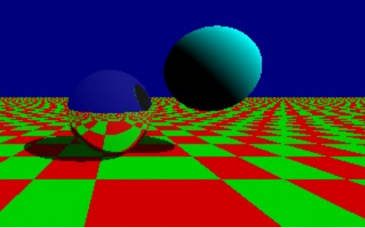
Figure 5. Moving Object Shadow and Reflection

To handle these problems, two types of animation acceleration algorithms have been developed, image space coherence and object space coherence. Image space algorithms render some frames and interpolate in-between frames, but may cause image errors. Object space algorithms track 3D changes and project these to image pixels needing redraw, and generally do not cause image errors.
Chapman [CHAP90] presents an image space method similar to 2D morphing for accelerating ray traced animation using temporal coherence. Ray tracing is performed in 4D space-time, rendering a pixel across time in multiple frames. Every n-th frame is rendered, where n is based on the maximum frequency at which pixels are expected to change. For pixels that vary in color between these frames a binary search is performed in the time domain to find the frame in which the color change occurred. Once the pixel color is found for a range of frames, it is copied to the corresponding pixel in all in-between frames. This scheme is simple and handles all types of image change, but rapidly moving objects may be rendered incorrectly due to aliasing if the value of n is set too large.
Murakami [MURA90] uses object space coherence with a static view to accelerate ray tracing by redrawing only the changed parts of the image. The ray tree for each pixel is saved, along with additional intersection data. A list of traversed voxels is saved for each ray so that only rays passing through changed voxels are updated. Changed pixels are detected by checking whether any ray in the tree passed through a changed voxel. If so, the pixel is reshaded, reusing much of the previous ray tree data. Applications involving animation, interaction and parallel processing are discussed. The method is complex and requires a large amount of memory.

Object Space Temporal Coherence (OSTC)
Jevans [JEVA92] describes a simpler object space method using spatial subdivision and temporal coherence to accelerate animations with a static camera view. The data structure works backwards from the Murakami approach, each voxel keeps track of rays that traversed through it. The mapping between changed pixels and changed voxels can be done in different ways. Jevans uses a spatial subdivision grid in which each voxel has an associated 16x16 bitmap that represents the 256 corresponding sections of the image plane, independent of image resolution.
Each ray is tagged with the image area index of its origin. The bit corresponding to the image area is set in each traversed voxel’s bitmap as the ray moves through the scene. Each voxel then contains a bitmap of which screen areas are dependent on rays passing through the voxel. These voxel bitmaps are populated when the first frame is fully traced, and updated for changes on subsequent frames. Both primary and secondary rays are included in the bitmap, so the technique correctly handles shadows, reflection and refraction. When the scene changes, the bitmaps of changed voxels are checked to determine which image areas are affected and only those areas are recomputed. This can greatly accelerate image generation, since only the rays for image areas in which changes have occurred need to be recalculated. This OSTC technique is shown in Figure 6.

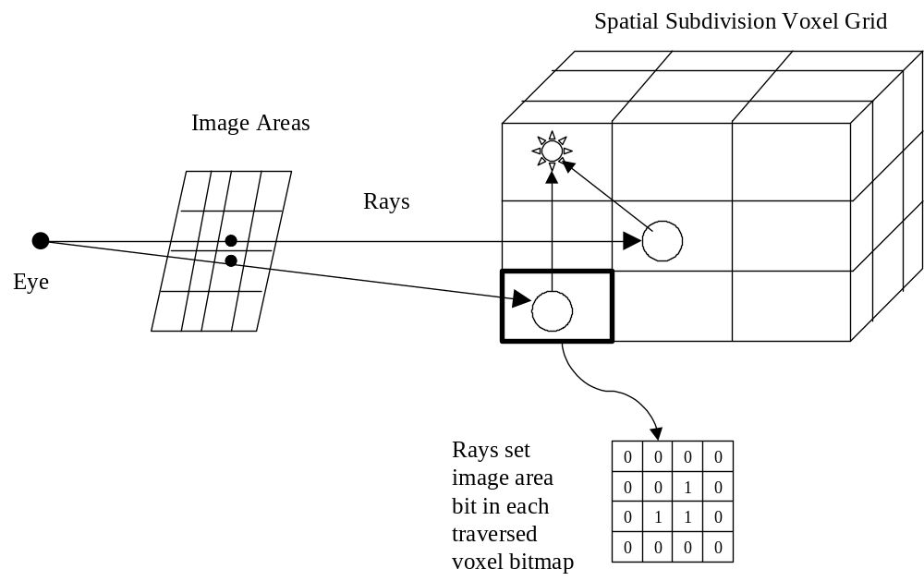

Figure 6. Object Space Temporal Coherence

The Jevans method handles object animation well and can handle light source animation also, but less efficiently since changing a light typically affects most of the image. If a light is moved or changes color, only the image areas that are in shadow from both the old and new light location will not be retraced. He suggests keeping the shadow rays in a separate bit set in each voxel to improve light animation performance.
Jevans allows no camera motion in his algorithm and presents an analysis showing the high percentage of static camera shots in an example set of animations. Improving this static camera limitation is the major motivation of this thesis.

Interaction
The fast ray tracing capabilities needed for animation can also be used for interactive scene changes to a previously rendered image. Either a human operator or an algorithm (e.g., a simulator or video game) can drive the interaction. Potential uses include scene editing, virtual reality, video games and simulators.
Sequin [SEQU89] describes a ray tracing method that allows light source and object surface colors to be changed and rendered interactively. For each pixel, a parameterized expression that includes light intensities and surface properties contributing to the pixel’s color is saved during the initial ray tracing. Then the user can interactively modify light and surface colors with the results displayed in a few seconds by reevaluating the expressions. This method does not allow motion or other geometry changes in the scene.
Briere [BRIE96] presents a more advanced approach that allows both color and geometry changes, but requires more complex data structures and algorithms. Saved ray trees and color trees are used to retrace changed parts of an image after interactive update. The ray trees save visibility data to accelerate geometry changes, while the color trees save shading data for light source changes.
Parker [PARK99] discusses interactive ray tracing using multiprocessing with 60 parallel processors, allowing the user to move the camera viewpoint while rendering fairly complex scenes with interactive frame update rates. Such fast hardware schemes are beyond the scope of this thesis, which concentrates on software acceleration methods for single processor systems.

CHAPTER III

DESIGN

This section explains the design philosophy for the new pan and zoom algorithms. Image space acceleration algorithms, such as Chapman [CHAP90], handle object animation but are limited by 2D interpolation, require a static camera and may cause image errors. Object space algorithms such as the Murakami [MURA90] and Jevans [JEVA92] methods accelerate light and object animation, but require a static camera. The reprojection method [ADEL95, WALD01] handles camera motion but is complex, requires a large amount of saved data and may cause image errors.
Reprojection could be simplified to support only pan and zoom without allowing the camera to move through the scene. However, this would be a trivial simplification of a well-established, more general method. This thesis pursues a new and completely different approach to accelerating pan and zoom.
Table 1 shows a rough categorization of animation acceleration algorithms with the two approaches: image and object space, and the three types of change: light, object and view. Image space algorithms tend to be simpler but less accurate. This classification is not precise or complete, but is intended to show that there is a lack of image space view acceleration algorithms. This thesis explores new algorithms to fill this apparent gap in animation acceleration techniques.

 | Image Space | Object Space
Lights | Saved light and surface parameters [SEQU89] | Saved ray trees [BRIE96]
Objects | Frame interpolation [CHAP90] | Temporal coherence [MURA90, JEVA92]
View |  | Pixel reprojection [ADEL95, WALD01]

Table 1. Animation Acceleration Algorithms

There seems to be a need for a simple image space method to support field of view changes without retracing the entire image. There is much coherence during slow view changes such as pan and zoom. These slight changes cannot be handled by most animation acceleration algorithms, which require exact alignment between frames to determine differences. This suggests that new image space techniques might be effective to handle field of view changes separately, and could be added to any ray tracer and animation acceleration scheme.

New Pan Animation (Panimation) Algorithm
The obvious way to reuse previous frame data and accelerate pan is to shift the image and redraw only the newly exposed area. For example, to pan right, the image could be shifted left by the appropriate amount and the newly visible area at the right could be ray traced. Typically, the new area scrolling into view is a small fraction of the image and only a few rows or columns of pixels need to be traced. In this way, slow pan can be performed with little increase in execution time.
Figure 7 shows the new shift and retrace technique, called the Panimation algorithm. Simultaneous horizontal and vertical pan can be performed by shifting the image once diagonally. Care should be taken that the newly exposed corner where the new horizontal and vertical areas overlap is not updated twice but only once.

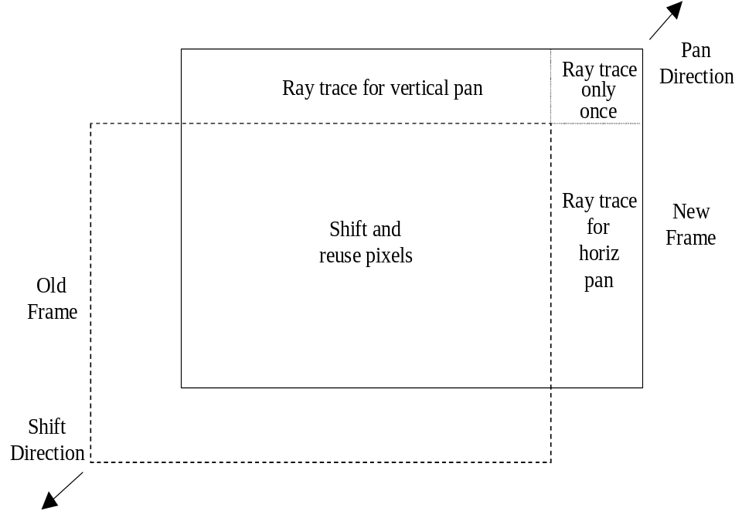
Figure 7. Pan by Image Shift and Retrace

Standard viewing projection
Unfortunately, this pan by shift idea fails with the standard viewing projection used in ray tracing because the view angle varies per pixel. The standard view projection geometry is shown simplified to 2D in Figure 8. The advantage of this projection is that straight lines in the scene appear straight in the image [EBER01]. The flat rectangular view plane causes pixels near the edge of the image to cover less angular area than pixels near the center, causing objects near the edge to appear squashed if a wide field of view is used. This is a common problem in film photography with wide angle lenses also, since the film is the same kind of flat rectangular view plane used in ray tracing.

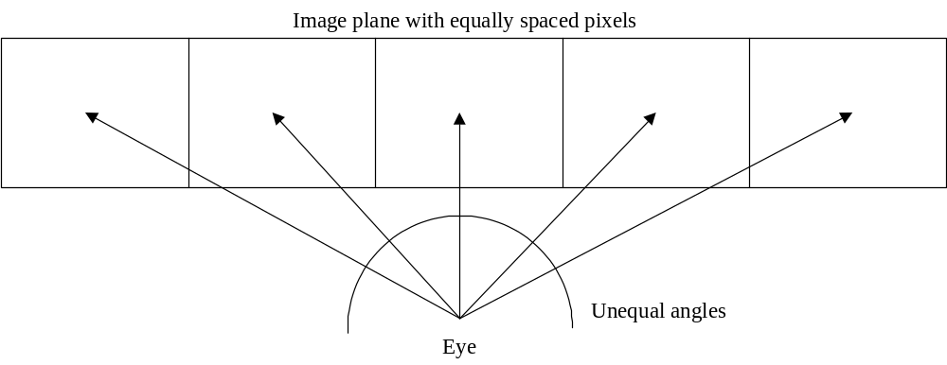

Figure 8. Standard View Projection

Because the image plane grid is evenly spaced, rays from the eye make increasingly smaller angles near the edge. Since a pixel near an image edge represents a smaller view angle, it is equivalent to a higher resolution than near the image center. This means that pixels cannot be shifted away from center toward an edge, or lower resolution data would be used to replace higher resolution data, causing image degradation. This greatly complicates using pixel shift to accelerate pan with a standard view projection. This is a major problem with the Panimation approach, and probably the reason it has apparently not been used before. The problem can be avoided if the viewing projection uses equal angular area per pixel across the field of view. To allow panning, pixels must cover an equal angle in both directions, implying a spherical projection with equal angle pixels in both azimuth and elevation as shown simplified to 2D in Figure 9.

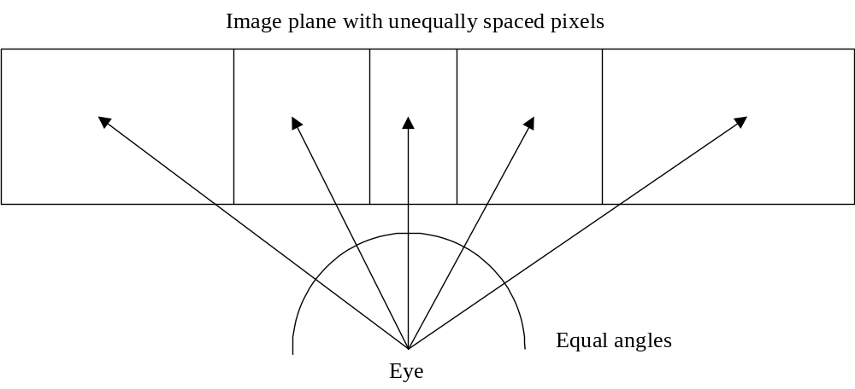

Figure 9. Spherical View Projection

Cylindrical viewing projection
Similar projections are widely used for geographic world maps [PAET90], and several were studied for this application. A spherical surface like the world or the imaginary “celestial sphere” seen by an observer cannot be mapped to a flat surface without distortion. The type of distortion varies depending on the projection used.
The Cylindrical Equirectangular projection [MUSG92] shown in Figure 10 was selected as a suitable technique. The eye is at the center of a virtual sphere enclosed in a cylinder. This is a trivial map projection of spherical latitude/longitude points onto an infinite height cylinder of Earth radius centered along the north/south pole axis and tangent at the equator. The cylinder is unrolled to form a flat rectangular map that can include the entire earth surface or a smaller area. Since the cylinder is tangent to the earth sphere, the tan function can be used to compute coordinates along both axes up to 180 degrees. Using the sin and cos functions to compute points around the equator extends the horizontal field of view to 360 degrees. This projection has singularities at the north and south poles so the displayed latitude cannot quite reach the –90 or 90 degree values.

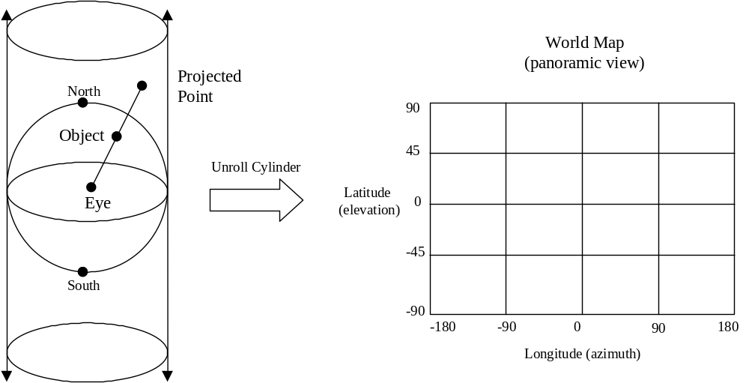

Figure 10. Cylindrical Equirectangular View Projection

Using this cylindrical projection or a similar equal-angle method allows pan to be emulated by image shift, since each pixel represents an equal area of the viewing sphere centered at the observer. Latitude and longitude correspond to the elevation and azimuth of the camera view ray. Moving a window on this virtual world map is equivalent to pan, and resizing the window is zoom, since each pixel represents an equal view angle. Vertical lines remain vertical in the image, like longitude lines projected on the cylinder. But other lines may appear curved if a wide field of view is used, in extreme cases following strange transcendental shapes [GLAE99].
A benefit is that the cylindrical projection allows a full 360 degrees azimuth by 180 degrees elevation panorama view of the entire scene, while the standard projection is limited to less than 180 degrees and has severe edge distortion at angles much less than this. Angles greater than 360 degrees horizontal or 180 degrees vertical produce a repeating periodic pattern.
This type of projection has some curvilinear distortion if a wide field of view is used, but is similar to the standard viewing projection for a narrow field of view, around 30 degrees or less. However, this may mean putting the eye point further away from the scene, like a telescope or telephoto lens. This may cause problems with objects blocking the view. The cylindrical distortion can be corrected as explained later in this thesis (see section on Integration). Figure 11 compares the standard and cylindrical projections with narrow 30 degree and wide 100 degree fields of view. Both projections have noticeable distortion at wide angles, but the type of distortion is different.

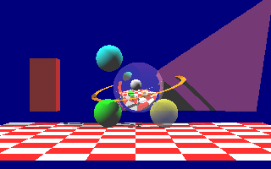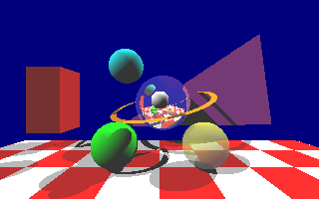
a) Standard Projection 30° Angle b) Standard Projection 100° Angle

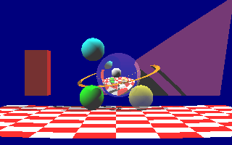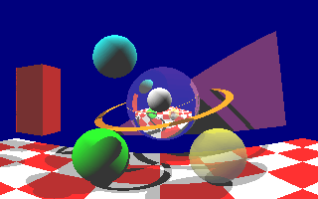
c) Cylindrical Projection 30° Angle d) Cylindrical Projection 100° Angle

Figure 11. Standard and Cylindrical Projections

As the eye recedes an infinite distance from the image plane, both the cylindrical and standard projections approach the same orthographic projection with parallel rays. This indicates that the difference between the cylindrical and standard projections is indeed reduced by narrowing the view angle, which can be confirmed visually. The orthographic projection has equal-area pixels that work with the Panimation algorithm, but gives no perspective effect for depth. Objects appear the same size regardless of distance. This looks odd for typical ray tracing scenes, but is useful in some application areas, such as computer-aided design (CAD) and data visualization.

New Zoom Ray Sample Viewport (RSVP) Algorithm
The Panimation algorithm does not support accelerated zoom, although zooming by an integer multiple n:1 or 1:n can be performed while reusing 1/n² of the pixels. If the zoom factor is 2 then ¼ of the pixels can be reused by mapping one pixel to a 2x2 block in the other image. Figure 12 shows a simple example of this 2:1 mapping with a 16x16 pixel image. A single pixel can be used from each 2x2 block (the upper left pixel in this example) or the four pixels could be averaged.

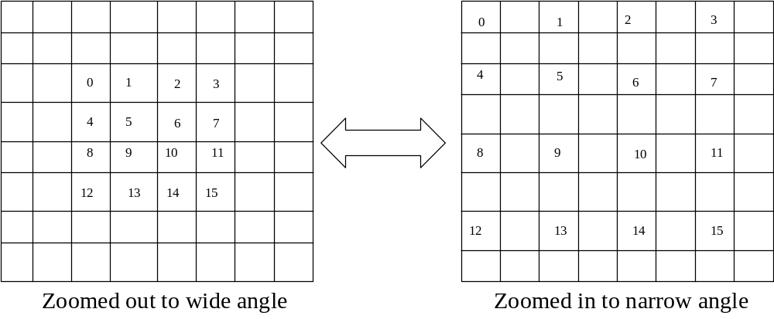

Figure 12. Zoom 2:1 Mapping
It would be useful to find a better zoom algorithm to allow smooth zoom at any factor while reusing the maximum number of previous frame pixels and retracing the minimum number of pixels for each frame. This is the same philosophy used in developing the Panimation algorithm.
Consider zooming out to a slightly wider field of view. This could be accomplished by rescaling the image smaller towards the center and ray tracing only the new pixels around the edges of the image. However, after a few frames the scaled image data would begin to degrade due to sampling and aliasing errors. Also, the process is not reversible to zoom back in, because the original higher resolution image data has not been preserved.
A better approach for zooming out is to draw the new pixels around the edges of the image at the same resolution as the original image and resample the whole area down to a lower resolution for each frame. This avoids degradation by performing a single resampling of a higher resolution image to a lower resolution image for each frame. The process is reversible, the view can be zoomed in until the original image resolution is reached without ray tracing any new pixels in this case. This implies that a frame buffer larger than the final image size is needed. This approach is called the Ray Sample Viewport (RSVP) algorithm.

Viewports
The smaller image is a viewport onto a portion of the larger, and could be considered another eye point and view plane as a second level of view projection, or merely a 2D transform. The viewport algorithm itself allows any view projection to be used, standard, cylindrical or other. As the viewport grows larger, not all pixels in the parent camera frame buffer need to be ray traced since only some will be sampled, assuming one sample per pixel and no color interpolation or antialiasing. This means that full ray tracing of the entire larger frame buffer can be disabled with the viewport requesting that individual scattered pixels be ray traced on demand as needed. The number of traced pixels required is the smaller viewport size or less, not the larger frame buffer size.
Pixel tracing on demand means that each pixel in the camera frame buffer must be tagged whether it is current or needs to be retraced. Rather than allocate more storage for these tags, a special null color value can be defined and used to indicate invalid pixels. When temporal coherence or panning causes a screen region to be marked as changed due to object movement or pan operations, the region is overwritten with the null color. When a viewport samples a null color pixel, it is ray traced. If the whole image ever needs to be updated, all null color pixels can be retraced. Figure 13 shows a buffer with such viewports, which can be positioned, rotated and warped as needed.
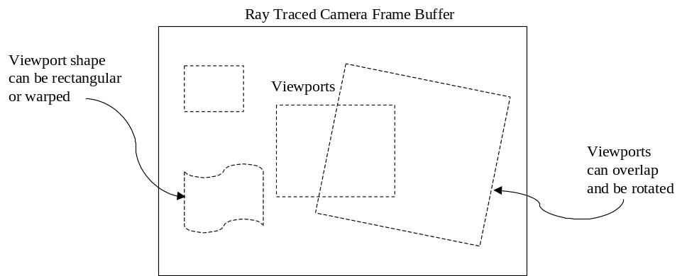

Figure 13. Example Viewports
Other useful effects are supported by the RSVP method. Rotate, scale, shear and more unusual changes can be produced by simple 2D transforms. Any pattern of pixels in the camera frame buffer can be resampled into the viewport image. This could allow special effects normally done during postprocessing to be performed at run time.
Multiple viewports can be attached to a single camera, each requesting a different set of pixels from the same camera frame buffer. Some of these pixels may already have been rendered by a previous overlapping viewport, so the camera frame buffer acts as a pixel cache for all viewports on the camera. This can accelerate pan, zoom and other transforms within the frame buffer view area. Thus, there may only be a slight performance penalty for multiple overlapping viewports. Viewports can be switched to different cameras as desired, or can sample multiple cameras simultaneously for fade and multi-view effects.
Although the RSVP technique allows unlimited 2D image space transforms, the range of motion is somewhat limited by the image buffer size. Pixels sampled off the buffer edge could be set to black, or ray traced but not saved in the camera buffer with a loss in caching efficiency. This suggests that the Panimation and RSVP algorithms could be combined together for complementary functionality.

Integrating the Algorithms
Three main algorithms are used in this thesis, the Jevans OSTC animation acceleration method [JEVA92], the new Panimation algorithm and the new RSVP algorithm. These are different algorithms that may be used separately or together in any combination and are easily added to most ray tracers. Each performs a different type of acceleration, but they operate similarly and work well when integrated together. A combined approach allows each algorithm to handle deficiencies in the other algorithms and produces a more robust approach without many of the weaknesses of the individual algorithms.

Algorithm Summary
The OSTC algorithm [JEVA92] tracks object (and possibly light) changes during animation and uses a rectangular grid on the image to determine which areas need retracing. Object animation is unlimited but a static camera must be used with no panning or zooming.
The Panimation algorithm developed in this thesis accelerates panning by shifting the previous image and ray tracing only the new area. This requires a cylindrical equal-angle view projection that allows panoramic views but has curved distortion at wide angles. Unlimited range of pan and zoom is supported with pan greatly accelerated, but zoom can only be accelerated slightly by using an n:1 zoom ratio and reusing 1/n² pixels.
The Ray Sample Viewport (RSVP) algorithm developed in this thesis uses a viewport to sample pixels from a ray traced buffer according to any 2D image transform. RSVP accelerates pan, zoom, rotate and other effects but the range of motion should be limited to the sample buffer area. If pixels are sampled off the buffer area, they can be set to a default color such as black, causing an image defect, or ray traced but not saved for reuse, causing potential decrease in acceleration.

Integrating OSTC and RSVP
Integrating the OSTC and RSVP algorithms is trivial. Instead of ray tracing the OSTC updated image areas, they are erased to the null color. When a viewport samples a null pixel, it is ray traced at that time.

Integrating Panimation and RSVP
Integrating the new Panimation and RSVP algorithms is similar, new areas exposed by panning are drawn in the null color. The cylindrical projection must be used to support accelerated pan, which introduces the cylindrical distortion problem. An interesting benefit of integrating these two algorithms is that a viewport transform can be used to undo the curved distortion of the cylindrical projection needed for Panimation. Since the tan function is used for the cylindrical projection, the arctan (or atan2) function can be used for the inverse transform, restoring the standard projection appearance. This fixes a major problem with the Panimation algorithm. Figure 14 shows the cylindrical projection geometry and equations. This integrated Panimation/RSVP approach is shown in Figure 15.
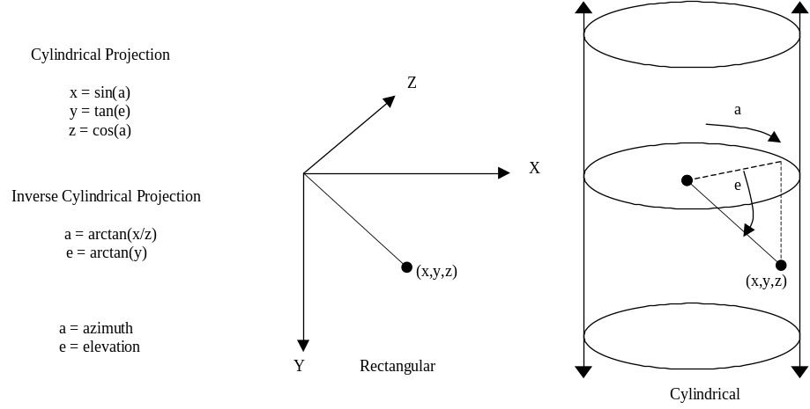
Figure 14. Cylindrical Projection and Inverse

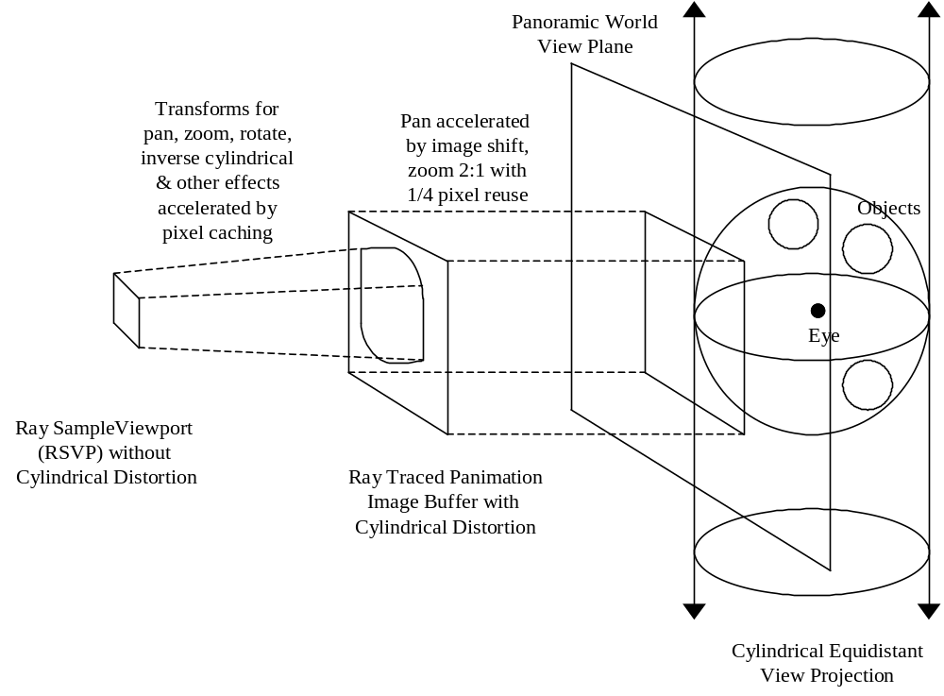
Figure 15. Integrated Panimation and RSVP Algorithms

Panimation provides fast large-scale pan but causes unwanted curvilinear distortion. Adding RSVP provides fast small-scale pan, zoom and other effects. When a RSVP transform is used to correct the cylindrical distortion, the integrated method gives accelerated pan, zoom and other features without the unwanted distortion.
Figure 16 shows an image with the cylindrical distortion and the warped set of viewport sample pixels that generated the resulting standard projection image with the cylindrical distortion removed. The upper image is less distinct because only the sampled pixels were ray traced. The straight lines in the checkerboard grid have been restored in the corrected image, but the spheres exhibit stretching away from the image center due to the wide 100 degree field of view. All view projections have distortion of some kind, in this case cylindrical distortion has been traded for rectangular distortion, which is more familiar and acceptable.

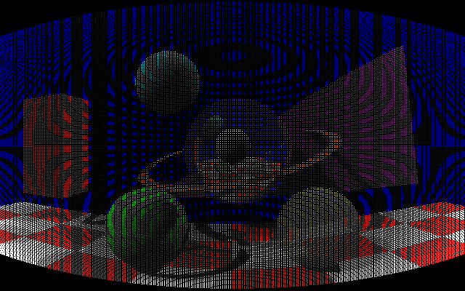
a.) 640x480 camera image sampled pixels

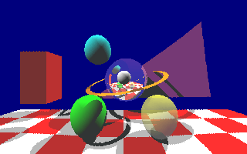
b.) 320x200 viewport image from sampled pixels

Figure 16. Correcting Cylindrical Distortion

Integrating OSTC and Panimation
To integrate the OSTC and new Panimation algorithms, rectangular image areas invalidated by either algorithm are set to the null color. The pan is done first to avoid wasting time by updating areas already scrolled off the image. To make the temporal coherence bits refer to the same scene areas after pan, the cumulative pan offset in pixels is saved and used to offset the bit areas.
The bit correspondence must be wrapped as the image is panned, so that bits that represented areas now scrolled off the image are reused for new areas that scroll onto the opposite side. An extra row and column of bits is allocated to handle partial areas on both sides of the image. When a row or column is wrapped and reused, the corresponding bits are cleared in all voxels to start collecting new data. After a complete image buffer redraw, all bits are cleared in all voxels to start over.

CHAPTER IV

IMPLEMENTATION

The code developed for this thesis does not have robust error checking, full OO encapsulation with get/set methods, extensive optimization or other nonessentials. The intent is clarity and simplicity for testing new animation acceleration algorithms. Not all features of a typical ray tracer are supported, but could be added in the future as necessary.
Only a single ray per pixel is used, no pixel color interpolation, antialiasing or distribution ray tracing is performed. Images may be sampled from higher to lower resolution, but not vice-versa. The goal is generation of the same image produced by full ray tracing while maximizing the reuse of previous frame pixels.

Development Process

Java
Java is a new object-oriented (OO) programming language that was selected for the implementation. It supports classes, packages, multithreading, exception handling, automatic garbage collection and many other features [ARNO98]. Libraries are provided for a wide range of functionality, including graphics. Java is portable and runs on a bytecode interpreter instead of being compiled to native machine code. The original Java interpreter seemed slow for number-crunching applications like ray tracing, but newer just-in-time (JIT) compilers allow Java to run almost as fast as compiled languages.
Java classes encapsulate methods (code) and fields (data). A Java object is an instance of a class, not the same as a 3D object. Inheritance allows classes to be extended to new subclasses. Polymorphism means that subclass objects can be mixed and the appropriate subclass methods are called at run time.
Java was selected for this thesis because of its OO features, graphic libraries and portability. Both Java 1.2 and 1.3 running on a PC were used. There are two graphics libraries, the Abstract Windowing Toolkit (AWT) and Swing. The AWT was used because of its simplicity and because it supports applets running in web pages.
The OO features of Java provided good design flexibility and allowed extension of the software architecture beyond its original scope. Java proved to be a good language for ray tracing development, its extensive libraries and simple object referencing model reduced development time compared to other candidate languages such as C++. Java array element references were natural for leaving unused voxels null until accessed. Java’s lack of pointers made for fast development and readable code. The OO flexibility allowed easy implementation of multiple cameras and viewports, capabilities not originally planned.

Ray Tracer
The core of the ray tracer used in this thesis came from a C++ ray tracer and 3D morphing program that was written by me for the Topics in Computer Graphics course in Spring semester 1999. The code is based loosely on an example C ray tracer by Paul Heckbert from one of the course texts [GLAS89]. The core ray tracer was rewritten in Java and extended to test and demonstrate the thesis acceleration algorithms. The original C++ ray tracer contains approximately 500 lines of code, the expanded Java code for this thesis has approximately 1500 lines of code.
Only simple objects are supported, planes, polygons and spheres. Two view projections were tested, standard and cylindrical. Output is written to TGA files, in a simple 24-bit uncompressed RGB format. Animation is handled by writing a separate TGA file for each frame. A viewer program was written that loads a set of TGA files into memory and flips through them in rapid succession. An interactive version of the ray tracer was also written, allowing real-time VR-style interaction and proving very handy for testing.

Uniform Spatial Subdivision Grid
A uniform spatial subdivision method was chosen, rather than nonuniform. The uniform approach is simpler and works better for animation, since moving objects may require adaptively updating a nonuniform scheme. Cleary [CLEA88] suggests that uniform subdivision may be near optimal in general.
Three spatial subdivision algorithms were considered for implementation, Fujimoto [FU86], Amantides and Woo [AMAN87], and Cleary [CLEA88]. The Fujimoto ARTS 3DDDA algorithm is the oldest and is a little more complicated and less efficient than the newer versions. Jevans [JEVA89] presents a simple variation of the Cleary algorithm and this was chosen for implementation.
In the thesis implementation, the user must define the spatial region and voxel dimensions of the grid. Automatic sizing based on the range of object locations would be easy but is not used for simplicity and to allow objects to move outside the initial scene volume during animation.
A getExtent method is provided by each object to return a bounding box around the object’s current location. This is used to add the object to all the voxels the box overlaps [SHIR00]. This may add the object to some voxels it does not actually occupy and reduce efficiency, but it is difficult to determine exactly which voxels are intersected. To prevent these extra voxels from slowing performance excessively, the ray ID check described earlier is used to reuse intersection test results for the same ray and object.

Temporal Coherence Animation Acceleration
The OSTC method [JEVA92] was implemented with a uniform spatial subdivision grid rather than the adaptive nonuniform grid used by Jevans. It was extended to support multiple cameras by putting a temporal coherence bitmap grid in each camera, rather than one bitmap in each voxel of the single spatial grid. All these grids are dimensioned the same size and correspond to the same spatial region. This duplicates the 3D array overhead, but empty voxels are not allocated until used in both the spatial grid and the camera bitmap grids. Also, more voxels are allocated in the bitmap grid because empty spatial voxels with no objects may still need the temporal bitmap to track traversing rays. Thus, separating the grids avoids allocation of empty spatial grid voxels just for the temporal bitmap. The java.util.Bitset class is used for the OSTC bitmap in each voxel. A changed flag was added to each voxel to indicate when an object in the voxel had been changed.

Pan and Zoom
Finally, the Panimation and RSVP algorithms were implemented and tested separately, then integrated with the OSTC code. The integration required some fairly complex code for panning to handle wrapping the image areas represented by OSTC bits.

Java Classes
The FrameBuffer class handles images and pixel manipulation. Each camera has a framebuffer for image storage that acts like the film in a real camera and captures an image. Methods are provided to set and get pixel colors, to read and write TGA files and to return a java.awt.Image object for display. Gamma correction [FOLE96] is not performed but could be added easily.
Figure 17 shows the class hierarchy for 3D scene objects. Inheritance is used for the AbstractObject class and subclasses. This is the major use of inheritance in the system. Possible inheritance was considered for classes Color, Point, Vector and Ray, but they were finally made separate classes. AbstractObject is at the top of the hierarchy and defines abstract getExtent and intersect methods provided by each object. The default animate method does nothing but can be overridden to produce animation by moving or changing the object. The getColor method uses a simple 3D texture map for surfaces to provide surface textures like the checkerboard.
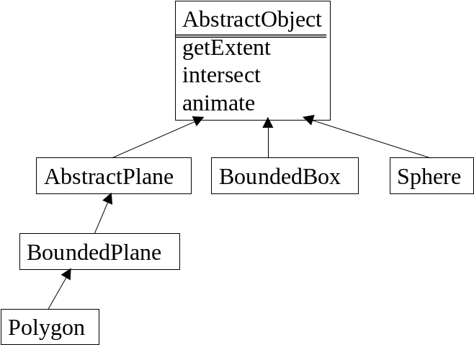
Figure 17. Class Hierarchy

The Light class implemented for this thesis contains a color and direction vector for each light source, assuming a directional source at an infinite distance with no distance attenuation. The direction vector could be changed to a point to allow point light sources in the scene. If the voxels are marked changed when objects or lights change, the OSTC method will provide acceleration for light animation. Since most of the image pixels will be affected by light animation, little speed would be gained and this was not tested.

The Panimation camera
The AbstractCamera class handles the image buffer and controls the ray tracing using the Panimation algorithm. This class is extended by StandardCamera and CylindricalCamera to define the view projections. Additional view projections can be defined by extending the AbstractCamera class.
The camera class originally handled only the view projection, but became more critical, smarter and bigger than expected, handling incremental ray tracing, fast pan and zoom, and temporal coherence bitmaps. The view projection code could be split off into a separate Lens class, allowing different projections at run time. Much of the ray tracing code was pulled into the camera as acceleration code was added. The typical main ray tracing loop to render all pixels was moved to the camera and modified to render rectangular blocks of pixels on demand.
Each camera has an OSTC bitset to track object animation changes. The pan method sets the view azimuth and elevation angles in degrees, which differs from the usual “look” vector used in ray tracing but is convenient for pan and zoom testing. The zoom method sets the horizontal field of view angle in degrees. The vertical field of view angle is computed from the horizontal, assuming square pixels (aspect ratio could be added easily). The translate method moves the camera location and forces a complete image redraw since this is not accelerated.
Multiple cameras can be used, for example, two could be used for stereo or three could be used for computer-aided design (CAD) top, side and front views. Cameras can be idle but track both pan and animation changes for fast reactivation, allowing switching between multiple viewpoints with little execution time overhead. A camera can be sampled by one or more viewports whether it is active or idle.
Figure 18 shows the code for the camera panImage method, which implements the Panimation algorithm. Figure 19 shows the image geometry for this pan algorithm. The framebuffer image is shifted by the specified number of x and y pixels. Then the horizontal and vertical rectangles brought into view are rendered by calling renderArea (x,y,width,height) with the coordinates of the upper left corner and size of the rectangle.
void panImage (int xshift, int yshift) {
framebuffer.shift(xshift,yshift);
if (xshift > 0) {
renderArea (0,0,xshift,height);
if (yshift > 0)
renderArea (xshift,0,width-xshift,yshift);
else
renderArea (xshift,height+yshift,width-xshift,-yshift);
}
else {
renderArea (width+xshift,0,-xshift,height);
if (yshift > 0)
renderArea (0,0,width+xshift,yshift);
else
renderArea (0,height+yshift,width+xshift,-yshift);
}
}

Figure 18. Camera panImage Method

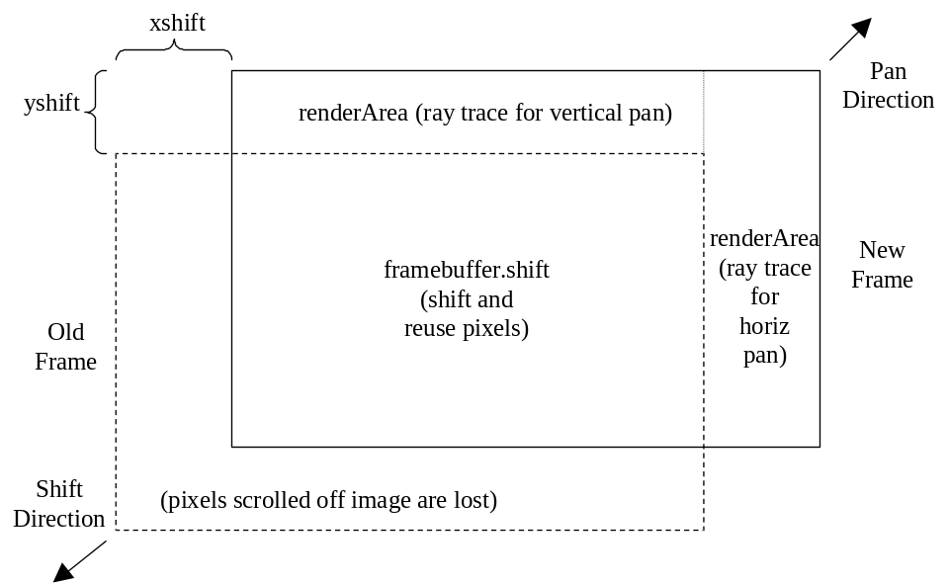
Figure 19. Camera panImage Geometry
Figure 20 shows the pseudocode for the renderArea(x,y,width,height) method, which either ray traces the area or sets it to the null color if the camera is idle. It also sets the OSTC screen area ID to be saved in bitmaps as the rays are traced. This routine is the main interface to the ray tracer instead of the typical “for every pixel” loop.

For each camera pixel in rectangular area
If camera is idle
Erase pixel to null color in camera framebuffer
Else
Get view projection ray from eye through pixel
Tag ray with temporal coherence screen area index
Trace ray to get color, set screen area bits in voxels
Set pixel color in camera framebuffer

Figure 20. Render Area Pseudocode

Figure 21 shows the pseudocode for the camera render method that updates the image using both the Panimation and OSTC algorithms. If the whole image is obsolete, it is rendered, otherwise the Panimation and OSTC algorithms perform a faster partial image update. Finally, the image is saved to a TGA file or displayed on the screen.

If this is the first frame or the camera location changed
Render whole framebuffer
Else
If camera panned, shift image and render new areas
Get changed screen area bits from changed voxels
Clear all bits for the changed screen areas
Render the changed screen areas
Save or display camera framebuffer

Figure 21. Camera Render Pseudocode

The Ray Sample Viewport (RSVP)
The Viewport class implements the RSVP algorithm and contains a framebuffer, but does not directly perform ray tracing. Pixels from a camera framebuffer are sampled according to the current viewport transform. This sampling may cause the camera to trace a requested pixel if it is not current.
Basic 2D transforms [FOLE96] are used to sample pixels from a camera framebuffer. Any 2D transform may be applied, rotation, scaling and translation are implemented, while shearing, warping and other effects could be added easily. One such transform fixes the equal-area projection distortion and restores the standard view appearance. Methods are defined to set the rotate, scale and translate factors, which are applied in that order. For each viewport pixel, the camera pixel for the current set of transforms is sampled, and ray traced if the null color, then copied to the viewport pixel.
Figure 22 shows the pseudocode for the viewport render method that updates the image using the RSVP algorithm. This also shows how automatic pan and zoom could be performed if the viewport moves off the camera area, although these features were not fully implemented (see autopan and autozoom description later in Chapter VII).

If viewport zoomed beyond camera size range
Zoom camera by factor of 2, reuse 1/4 pixels
For each viewport pixel
Transform to camera pixel coordinates and sample
If pixel off edge, pan camera to include pixel
If pixel is erased to null color, ray trace pixel
Set pixel color in viewport framebuffer
Save or display viewport framebuffer
Figure 22. Viewport Render Pseudocode

Lights, Cameras, Action!
The top class, World, contains the entire scene and contains references to other classes as show in Figure 23. It uses java.util.Vector to maintain lists of lights, objects, cameras and viewports. This predefined Vector class handles dynamic arrays and is not the same as the ray tracing Vector3 class that was written to handle mathematical vectors for ray tracing. Each entity has an animate(frame) method that is called once per frame to update the entity to its state at the current frame number time. Methods are provided to add and delete each type of entity. Objects are added to the appropriate voxels in a uniform spatial subdivision grid and their voxel locations are updated during animation.
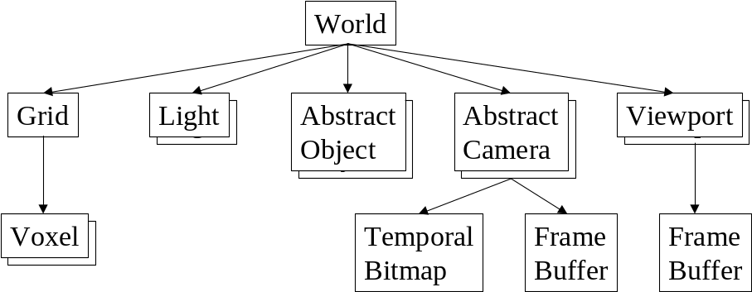

Figure 23. World Data Structure
The World animate method is called repeatedly by the user program to render each frame. Figure 24 shows the pseudocode for this process. It calls the animate method for each light and object to move them to their location and state for the current frame. Then each camera is animated to update its pan and zoom state, and the camera image is rendered. Finally, each viewport is animated to update its transform state, and the viewport image is rendered by sampling a camera image.
Boolean flags are used to determine what types of changes occurred and perform the most efficient update. Additional flags allow acceleration options to be turned on and off for testing.

Animate lights, update changed voxels
Animate objects, update changed voxels
Animate cameras, update images
Animate viewports, update images
Clear all voxel changed flags

Figure 24. World Animate Pseudocode
Table 2 shows the names and descriptions of all the classes developed for this thesis.

Name | Description
AbstractCamera | View projection and ray tracing acceleration
AbstractObject | Root of hierarchy for 3D objects
AbstractPlane | Unbounded plane
BoundedPlane | Bounded plane with extent
Box | Axis-aligned hexahedral parallelopiped
CheckerMaterial | Checkerboard texture map
Color | RGB color
Constants | Global constants
CylindricalCamera | Cylindrical equirectangular view projection for Panimation
Extent | Bounding box extent
FrameBuffer | Image buffer for rendering and TGA files
Grid | Uniform spatial subdivision
Interact | Interactive virtual reality test program
InteractWorld | Scene data for virtual reality test program
Intersection | Data for ray-object intersection
Light | Light source
Material | Surface color, properties and 3D texture mapping
Point | 3D location
Polygon | Concave or convex polygon with any number of points
Ray | Ray with origin point and direction vector
RayTrace | Core ray tracer methods
Ring | Planar ring with inner and outer radii
Show | Program to view a TGA file
ShowMovie | Program to animate a set of TGA files
Sphere | 3D sphere
StandardCamera | Standard ray tracing view projection
Statistics | Maintains counts and timing for results
TemporalBitmap | Temporal coherence animation acceleration bit set
Test | Test program for results
Vector3 | 3D vector class, named differently than java.util.Vector
Viewport | Ray Sample Viewport (RSVP)
Voxel | Uniform spatial subdivision grid cell
VoxelIndex | Uniform spatial subdivision 3D index
World | Top class for entire scene

Table 2. Class Names and Descriptions

CHAPTER V

RESULTS

Animation
Several animation programs were written with hard-coded scenes. These programs loop for several frames, calling the object, camera and viewport animate methods and writing a TGA file for each frame. These animate methods are designed to be overriden by user-defined subclasses to allow each entity to change its state for the current frame. This mechanism is simple and flexible for testing.
The Test program generates a sequence of animation frame TGA files and provides Boolean flags to control animation and acceleration features. Table 3 shows results from a 1.1 GHz PC with 256 MB of memory and Java 1.3.1. The sequences are 1, 10 and 100 frames at 320x200 resolution. The spatial grid is 15x15x10 voxels, the vertical dimension is smaller. The OSTC method uses 16x16 screen regions with 256 bits in each bitset, the same as Jevans [JEVA92]. The scene contains a checkerboard ground plane, 12 polygons, 19 spheres and 2 light sources. A cylindrical camera is used with field of view 100 degrees.
The table shows that panning 3.6 degrees per frame was accelerated using Panimation by about a factor of 10. Zooming by a 2:1 ratio was accelerated using RSVP by about a factor of 10. Animation of a small bouncing ball in this scene was accelerated using OSTC by about a factor of 2. Simultaneous pan, zoom and animation caused complex view changes and was accelerated by about a factor of 2. Unlike most earlier approaches, these techniques can be used to accelerate pan, zoom and animation simultaneously. The resulting 100 frame animation sequences were converted to animated GIF files and are available for review. These results are very encouraging and indicate that even greater performance can be achieved for slower pan and zoom or longer animation sequences.

 |  | Traditional Algorithm |  | Accelerated Algorithm
Type of Operation | Number of Frames | Number of Rays | Execution Time (sec) | Number of Rays | Execution Time (sec)
Pan | 1 | 64000 | 1.2 | 64000 | 1.1
Pan | 10 | 640000 | 9.4 | 83800 | 1.7
Pan | 100 | 6400000 | 69.6 | 281800 | 6.9
Zoom | 1 | 64000 | 1.3 | 63922 | 1.8
Zoom | 10 | 640000 | 12.1 | 154616 | 4.4
Zoom | 100 | 6400000 | 120.8 | 165957 | 18.9
Animate | 1 | 64000 | 1.1 | 64000 | 1.5
Animate | 10 | 640000 | 9.8 | 222160 | 5.8
Animate | 100 | 6400000 | 96.2 | 1633360 | 43.6
Pan, Zoom and Animate | 1 | 64000 | 1.3 | 63922 | 2.0
Pan, Zoom and Animate | 10 | 640000 | 11.5 | 221384 | 6.4
Pan, Zoom and Animate | 100 | 6400000 | 71.3 | 880475 | 31.8

Table 3. Acceleration Results

Figure 25 shows a test image where the black areas are rectangles erased to the null color by pan and object animation. The narrow black strips at the top and right are caused by the camera panning slightly up and right, shifting the image down and left. The irregular black area at the bottom center of the image is caused by OSTC screen areas invalidated by a small moving object in that area. Only the black areas need to be ray traced, the majority of the image is reused from the previous frame, showing the potential for image space acceleration even with simultaneous pan and object animation. The field of view angle is wider than usual at 100 degrees and shows the cylindrical distortion of the square checkerboard.

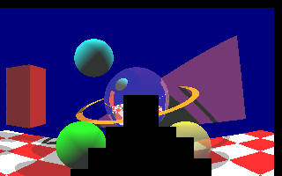
Figure 25. Simultaneous Pan and Animation Image

Figure 26 shows a camera image and two smaller viewport images extracted from the camera image. In the camera image, only the pixels sampled by the viewports were ray traced, the black areas are null pixels not traced. This demonstrates how a large camera buffer traces rays as needed, with many pixels shared between the two viewports and traced only once. The rotated viewport illustrates how scattered pixels may be sampled and has one corner slightly off the camera image. This missing corner shows a case where autopan could have panned the camera slightly and prevented the image defect.

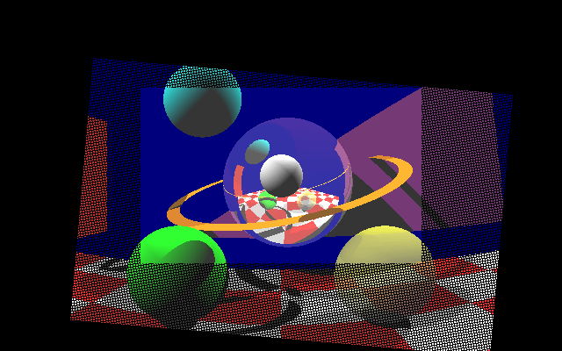
a.) 640x480 camera image with sampled pixels

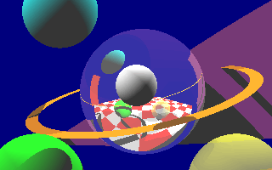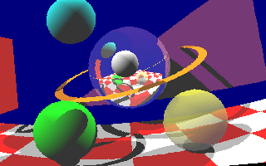
b.) 320x200 sampled zoom viewport c.) 320x200 zoom and rotate viewport

Figure 26. Camera and Viewport Images

Virtual reality
An interactive test program was written to provide virtual reality style interaction. Figure 27 shows the interactive test program windows, with a camera image and control buttons on the left and a viewport image and buttons on the right. Buttons are provided to control panning, zooming and other effects, to control acceleration options and to select a standard or cylindrical projection for the viewport. The viewport in the figure is set to standard to correct the cylindrical distortion and has been zoomed to show the hourglass shape resulting from sampling a rectangular cylindrical image. Normally, the viewport would not be zoomed this way and would have a complete image with no black edge, similar to Figure 16.
In addition to the square checkerboard ground plane shown, a checkerboard-textured circular disk was also tested, providing a flat horizon with the cylindrical projection. The camera supports accelerated pan using the Panimation algorithm, while the viewport provides accelerated pan, zoom and rotate using the RSVP algorithm. The user can move the viewpoint through the scene, although the entire image must be ray traced. The resulting interaction is similar to virtual reality and panoramic image systems, allowing the user to scan around the scene and zoom in on details. Unlike panoramic bitmapped images, zooming with this method shows exact detail using ray tracing. The viewport allows very fast pan, zoom and rotate on the camera image using the RSVP algorithm with little or no additional ray tracing. This program demonstrates the major features of the algorithms presented in this thesis. The interaction program is valuable for testing, provides good demonstrations and is fun to use.

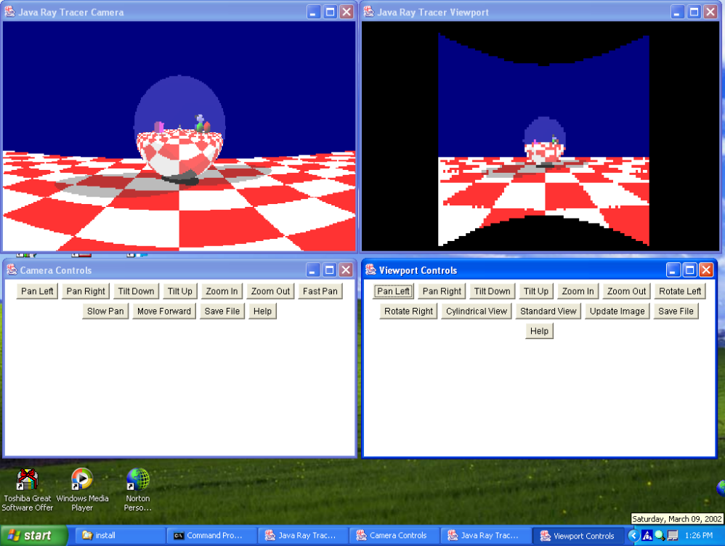
Figure 27. Interactive Camera and Viewport Windows

CHAPTER VII

FUTURE WORK
This thesis has focused on acceleration, but many other features could be added. Realism could be improved by interpolating sampled pixel colors, antialiasing, distribution ray tracing and improved texture mapping. Not all the possible features mentioned earlier are fully implemented. Although these acceleration techniques are intended for ray tracing, some of them could be applied to other rendering methods, such as z-buffer or scan-line.

Autopan and Autozoom
When a viewport hits a buffer edge or size limit, it can trigger an autopan (automatic pan) or autozoom (automatic zoom) event, as shown in Figure 28. Autozoom could double or halve the buffer scale and reuse ¼ of the pixels as described earlier. Careful alignment of primary rays or supersampling can reduce visible “popping” when the scale is changed by a factor of two.
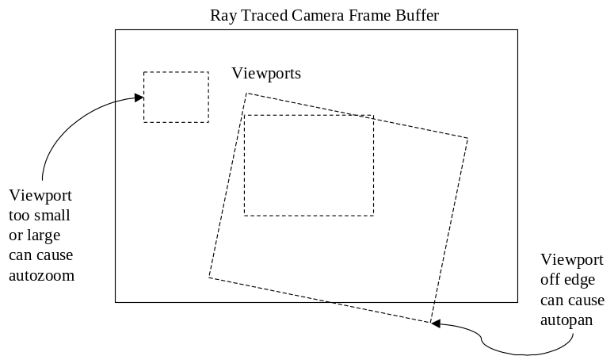
Figure 28. Viewport Autopan and Autozoom
Autopan could use many different strategies, such as moving the minimum or maximum amount, recentering the viewport or moving the four viewport corners onto the buffer. The application could set the general strategy for each scene, for example, if a large pan is planned, the autopan scroll amount could be the maximum amount. If one viewport causes a pan or zoom, any other viewports must account for the camera change. Multiple viewports complicate autopan and autozoom, perhaps not all viewports should be allowed this capability.
Autopan or autozoom could cause “thrashing,” similar to operating system paging problems. Thrashing may occur if a viewport or set of viewports continues to sample pixels off the frame buffer, causing the camera to be automatically panned or zoomed back and forth inefficiently. This can be reduced by zooming out to the largest field of view for the current viewports, allocating a larger frame buffer, and other techniques. The order that multiple viewports on the same buffer are processed could also be ordered to process nearby viewports together for more coherence.
The screen x,y order of ray tracing pixels does not matter much for the camera or ray tracing in general, but a localized pixel rendering order for the viewports can reduce thrashing. To avoid repeated buffer panning back and forth, the viewport pixel scan order could be localized rather than sweeping across the whole area for each scan line. The viewport area could be divided into a checkerboard grid with each grid square traversed separately. Perhaps another pixel traversal method like the quadtree algorithm might be effective.
To avoid thrashing with warped viewports, such as the inverse cylindrical mapping, a set of smaller buffers could be allocated instead of a single large buffer. The arrangement of allocated buffer blocks would adapt to any well-behaved sampling pattern, reducing memory usage and thrashing. A least recently used (LRU) or similar scheme could be used to select blocks for reuse.
By requesting that pixels be ray traced as needed, and automatically panning or zooming the parent camera, the viewport does much more than simple image postprocessing. It is a dynamic part of the ray tracing that controls the camera during the animation and acts as an extended camera at a higher level of abstraction.

View projections
Other view projections that give equal area per pixel could be used instead of the cylindrical equirectangular projection. The simple orthographic projection with parallel rays has no depth perspective but is useful in fields such as CAD and data visualization. Fisheye projections [GLAE99] map equal angles from the center of view to concentric circles, giving a circular panorama image instead of rectangular. The radial symmetry of fisheye projections might not be suited to rectangular pixels though. Bourgoin [BOUR99] describes a “bowlic” projection that maps the image area to a sphere surrounding the scene with view rays pointing to the sphere center. This gives an unusual perspective that shows the scene from every direction simultaneously, outside-in instead of the usual inside-out spherical projection.

Command language
An input scene definition file format could be defined for ease of use. Java code proved adequate and flexible for hard-coded initial test cases, but text command files might be preferred by some people, especially non-programmers. However, these formats tend to limit flexibility unless full expression parsing and control structures are provided, in effect creating a new programming language and returning to the same situation. Many useful techniques, such as object-oriented inheritance and polymorphism, would be difficult to implement in a command language.

Interaction
The interactive test program could be enhanced for virtual reality, interactive scene editing and other applications. It could easily be changed to an applet running in a web page. Progressive rendering [GHAN99] can be used to accelerate an interactive application by first ray tracing and displaying a low resolution image, then tracing and displaying the in-between pixels in increasing detail. This provides a quick preview of the whole image while rendering continues. The scheme could work well with the 2:1 zoom technique mentioned before, reusing ¼ of the previous pixels.

Compression
Data compression could be added by saving the shift offset and redrawn rectangles for each frame instead of the whole image. This is a form of delta compression, where only the differences between frames are saved. The entire first frame image could be written to a file, followed by shift commands and retraced blocks for each successive frame. The decoder program can load the first frame and play back the differences, reusing previous frame data the same as the acceleration scheme does. Yoon [YOON00] combined ray tracing and data compression in a similar way using reprojection. The Motion Picture Experts Group (MPEG) video format performs compression similarly using differences between frames and motion compensation for moving objects [GHAN99].

Postprocessing
A program could be written to read and average a set of TGA files into a single TGA file. Antialiasing and distribution ray tracing could then be performed by jittering rays differently in each frame. The final average image could have motion blur, depth of field and other blur effects. This could be extended to a sliding window that averages small sets of adjacent frames over an entire animation.

Testing
A more rigorous test suite could be used to check performance. Haines [HAIN87] produced the Standard Procedural Database (SPD) test cases for ray traced still images. He defined a simple Neutral File Format (NFF) for the scenes. The test cases are fairly simple and not too typical of real scenes, containing hundreds of objects to test acceleration schemes. Lext [LEXT01] extended this idea to a Benchmark for Animated Ray Tracing (BART), a set of three animation scenes. The scenes are complex and large to stress animation systems and are fairly typical of modern animation cases.

Cached image blocks
Instead of the Panimation camera image buffer, viewports could sample smaller blocks of pixels that are dynamically allocated as needed. This could eliminate any duplicate pixels across cameras and adapt to warped viewport sampling patterns. It could also simplify processing of OSTC bits by avoiding wrapping. Zoom presents the problem of blocks at different resolutions, which could be handled as a quadtree for greater pixel reuse. Hierarchical multiresolution encoding could be used for efficiency with a range of resolutions [GHAN99].

Spatial subdivision
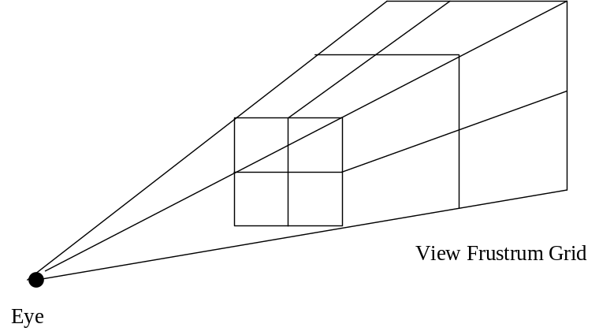
Other spatial subdivision methods could be tried, including adaptive, octree and BSP tree [GLAS89]. A camera-centered view frustrum grid [MOLL99] as shown in Figure 29 could provide some advantages. This aligns 2D image space and 3D object space nicely, the voxel grid projects to a 2D grid similar to the OSTC screen areas. Primary ray traversal is simplified to incrementing an index along one axis of the voxel array. Distant voxels are larger, providing a better object distribution and combining advantages of uniform and non uniform grids. However, initialization and secondary ray traversal are somewhat more complicated, and the grid is view dependent.

Figure 29. View Frustrum Grid

Generalized acceleration
Saved ray trees [BRIE96] or saved shading parameters [SEQU89] could be used for faster image update after light source changes. This would be especially useful for interactive scene editing, allowing light color and location changes, and object color and texture changes with very fast response time. The OSTC method can accelerate light changes, but not as efficiently.
Reprojection [ADEL95] could be used to accelerate camera location changes, which is the one animation category not accelerated by the techniques in this thesis. This technique exploits another form of view coherence and works effectively for small changes. The OSTC bits would probably have to be cleared to start over, since all rays will differ.
A combination of the techniques in this thesis with reprojection (and possibly saved ray trees and/or saved shading parameters) would be able to accelerate all types of animation change. This suggests that it may be possible to develop a standard animation acceleration approach that unifies earlier separate algorithms in the same way that Whitted [WHIT80] defined the standard ray tracing algorithm. This would be a major advance, but there may not be a universal acceleration solution for many years.

CHAPTER VI

CONCLUSION

This thesis has presented the history and theory of ray tracing and animation acceleration. The static camera limitation of Jevans [JEVA92] and other earlier work was noted and the lack of an image space view acceleration algorithm was identified. New image space algorithms were developed to accelerate pan, zoom and other effects from a fixed viewpoint. Fast pan is performed using image shifting with an equal-angle view projection. Fast zoom and other effects are performed using a sampling viewport and 2D transforms.
A Java ray tracer was implemented to test the new algorithms both for animation and interaction. An object space temporal coherence animation acceleration method based on the Jevans [JEVA92] technique was also implemented and integrated with the new algorithms. The resulting system supports ray traced animation with acceleration for both object changes and camera field of view changes. A generalized animation methodology was developed that could be extended to include reprojection, saved ray trees and other accelerations.
The timing results show performance gains of an order of magnitude for the new pan and zoom algorithms. This work has been successful, personally rewarding, and has many applications and possibilities for future work. Possible uses include animation, interactive scene editing, virtual reality, video games, simulations, computer-aided design and 3D data visualization.

BIBLIOGRAPHY

[ADEL95] Adelson, S., Hodges, L., “Generating Exact Ray Traced Animation Frames by Reprojection,” IEEE CG&A, May 1995, pp. 43-52
[AMAN87] Amantides, J., “Realism in Computer Graphics,” IEEE Computer Graphics & Applications, January 1987, pp.44-56
[AMAN87] Amantides, J., Woo, A., “A Fast Voxel Traversal Algorithm for Ray Tracing,” Proceedings of Eurographics, 1987, pp. 3-10
[APPE68] Appel, A., “Some Techniques for Shading Machine Renderings of Solids,” Proceedings of AFIPS JSCC, 1968, Vol. 32, pp. 37-45
[ARNO98] Arnold, K., Gosling, J., The Java Programming Language, Addison-Wesley, 1998
[ARVO86] Arvo, J., “Backward Ray Tracing,” SIGGRAPH 86 Developments in Ray Tracing Course Notes, Vol. 12, August 1986
[ARVO87] Arvo, J., Kirk, D., “Fast Ray Tracing by Ray Classification,” Computer Graphics, July 1987, Vol. 21, No. 4, pp. 55-64
[BOUR99] Bourgoin, V., Farenc, N., Roelens, M., “Creating Special Effects by Ray-Tracing with Non Classical Perspectives,” ligwww.epfl.ch/~nathalie, 1999
[BRIE96] Briere, N., Poulin, P., “Hierarchical View-dependent Structures for Interactive Scene Manipulation,” Computer Graphics Proceedings, 1996, pp. 83-90
[CHAP90] Chapman, J., Calvert, T., “Exploiting Temporal Coherence in Ray Tracing,” Proceedings of Graphics Interface 90, 1990, pp. 196-204
[CLEA88] Cleary, J., Wyvill, G., “Analysis of an Algorithm for Fast Ray Tracing Using Uniform Space Subdivision,” The Visual Computer, July 1988, Vol. 4, pp. 65-83
[COOK84] Cook, R., Porter, T., Carpenter, L., “Distributed Ray Tracing,” Computer Graphics, July 1984, Vol. 18, No. 3, pp. 137-144
[EBER01] Eberly, D., 3D Game Engine Design, Morgan Kaufmann Publishers, 2001
[FOLE96] Foley, J., Van Dam, A., Feiner, S., Hughes, J., Computer Graphics Principles and Practice, Addison-Wesley, 1996
[FUJI86] Fujimoto, A., Tanaka, T., Iwata, K., “ARTS: Accelerated Ray Tracing System,” IEEE Computer Graphics & Applications, Apr 1986, pp. 16-26
[GHAN99] Ghanbari, M., Video Coding, The Institution of Electrical Engineers, 1999
[GLAE99] Glaeser, G., Groller, E., “Fast Generation of Curved Perspectives for Ultra-Wide-Angle Lenses in VR Applications,” The Visual Computer, July 1999
[GLAS84] Glassner, A., “Space Subdivision for Fast Ray Tracing,” IEEE Computer Graphics & Applications, Oct 1984, Vol. 4, No. 10, pp. 15-22
[GLAS88] Glassner, A., “Spacetime Ray Tracing for Animation,” IEEE Computer Graphics & Applications, March 1988, Vol. 8, No. 2, pp. 60-70
[GLAS89] Glassner, A., An Introduction to Ray Tracing, Academic Press, 1989
[HAIN87] Haines, E., “A Proposal for Standard Graphic Environments IEEE Computer Graphics & Applications, Nov 1987, Vol. 7, No. 11, pp. 3-5
[JENS01] Jensen, H., Realistic Image Synthesis Using Photon Mapping, A. K. Peters, 2001
[JEVA89] Jevans, D., “Adaptive Voxel Subdivision for Ray Tracing,” Proceedings of Graphics Interface 89, 1989, pp. 164-172
[JEVA92] Jevans, D., “Object Space Temporal Coherence for Ray Tracing,” Proceedings of Graphics Interface 92, May 1992, pp. 176-183
[LEXT01] Lext, J., Assarsson, U., Moller, T., “BART: A Benchmark for Animated Ray Tracing,” IEEE Computer Graphics & Applications, March 2001, Vol. 21, No. 2, pp. 22-31
[LOGA89] Logan, J., “The Modified Slicing Extent Technique for Space Subdivision While Ray Tracing,“ MS thesis, University of Colorado at Colorado Springs, 1989
[MOLL99] Moller, T., Haines, E., Real-Time Rendering, A K Peters, Ltd, 1999
[MURA90] Murakami, K., Hirota, K., “Incremental Ray Tracing,” Proceedings of Eurographics Workshop on Photosimulation, June 1990, pp. 15-29
[MUSG92] Musgrave, K., “A Panoramic Virtual Screen for Ray Tracing,” Graphic Gems III, Academic Press, 1992, pp. 288-294
[OROU98] O’Rourke, M., Principles of Three-Dimensional Computer Animation, WW Norton & Co, 1998
[PAET90] Paeth, A., “Digital Cartography for Computer Graphics,” Graphic Gems, Academic Press, 1990, pp. 307-325
[PARK99] Parker, S., et al, “Interactive Ray Tracing,” Symposium on Interactive 3D Computer Graphics, Apr 1999
[PHAR97] Pharr, M., et al, “Rendering Complex Scenes with Memory Coherent Ray Tracing,” Proceedings of SIGGRAPH 97, 1997
[REIN00] Reinhard, E., Smits, B., Hansen, C., “Dynamic Acceleration Structures for Interactive Ray Tracing,” Proceedings of Eurographics Workshop on Rendering, June 2000
[SEMW87] Semwal, S., “The Slicing Extent Technique for Fast Ray Tracing,“ PhD dissertation, University of Central Florida, Orlando, 1987
[SEQU89] Sequin, C., Smyrl, E., “Parameterized Ray Tracing, “Computer Graphics, July 1989, Vol. 23, No. 3, pp. 307-314
[SHIR00] Shirley, P., Realistic Ray Tracing, A K Peters, Ltd, 2000
[WALD01] Wald, I., Slusallek, P., Benthin, C., Wagner, M., “Interactive Rendering with Coherent Ray Tracing,” Proceedings of Eurographics, 2001
[WATT92] Watt, A., Watt, M., Advanced Animation and Rendering Techniques, Addison-Wesley, 1992
[WHIT80] Whitted, T., “An Improved Illumination Model for Shaded Display,” Communications of the ACM, June 1980, Vol. 23, No. 6, pp. 343-349
[YOON00] Yoon, T., Neumann, U., “IBRAC: Image-Based Rendering Acceleration and Compression,” http://graphics.usc.edu/cgit/pdf/papers/hp.pdf

APPENDIX A. PROGRAMMER’S REFERENCE

This is the Read_Me.txt file for the Gage thesis. This code is a Java ray tracer used to study animation acceleration. It was tested with Java 1.3.1 and should be portable.

This code was written by Philip Gage in partial fulfillment of the requirements for the degree of Master of Science, Department of Computer Science. This work was performed at the University of Colorado in Colorado Springs under the direction of Dr S. Semwal from Jan 2000 to May 2002. Refer to the thesis paper "View Coherence Acceleration for Ray Traced Animation " by Philip Gage, 2002, for more information.

Operation
To compile and run the animation test program, enter:
javac Test.java
java Test

To compile and run the animation viewer program (with optional delay in integer msec) to display TGA files from Test, enter:
javac ShowMovie.java
java ShowMovie [delay]

To compile and run the image viewer program (with optional filename, default “frame0.tga”) to display a TGA file, enter:
javac Show.java
java Show [filename.tga]

To compile and run the interactive test program, enter:
javac Interact.java
java Interact

Examples
For coding examples, refer to the Example*.java and Movie*.java program files.
The simple Example3.java file is shown below.

public class Example3 {

/** Main program for example */
public static void main (String[] argv) {

// Define and populate scene
World world = new World();

// Define a light source
world.add(new Light (
new Vector3 (-100.0, -100.0, -50.0), // XYZ direction
new Color (1.0, 1.0, 1.0))); // RGB color

// Define a red sphere object on Z axis
world.add(new Sphere (
new Point (0.0, 0.0, 500.0), // XYZ center
100.0, // radius
new Color (1.0, 0.0, 0.0))); // RGB color

// Define a 320x200 camera, default view (0,0,1) along Z axis
world.add (new CylindricalCamera (world, 320, 200));

// Perform ray tracing and write frame0.tga
world.animate ();
}

}

