NETWORK AVAILABLE BANDWIDTH MEASUREMENT
By
XiaoLong He
University Of Colorado at Colorado Spring
Department of Computer Science, 2000

ABSTRACT

Network measurement is critical and the basis for meaningful network control in the Internet. Network available bandwidth between two network points is a very important dynamic network parameter that can be utilized by applications to optimize the use of network resources. Available bandwidth in network exhibits very dynamic behavior. It is determined not only by the physical capacity of the network, but also by the network traffic situation. Available bandwidth can be measured by ICMP echo packets. In this thesis, a set of network available bandwidth measurement algorithms is developed that can be used in the wide area web system. A discrete event simulator was designed to simulate the performance of these proposed algorithms using different network traffic patterns. Based on our simulation result, we evaluate the impact of the hop number, the link length, the packet sizes and the link bandwidth on the performance of the algorithms.

INTRODUCTION
Network measurement is critical and the basis for meaningful network control in the Internet. Measurement is necessary for selecting server/ISP/equipment. One such application is load balancing where one server with better performance from a set of servers will be selected based on network/server measurement. Measurement is necessary for designing some Internet applications. For instance, real-time continuous multimedia applications, such as RealPlayer [Real99] and InternetPhone [Net2Phone00], need to tolerate and adapt to Internet network delay and jitter. According to the result of network measurement, Internet Video/Audio applications adjust to operating environment by error concealment (drop late packets), destination buffering and adjusting application parameter (packet rate and resolution) and continuous monitoring directional path delay/jitter [fcp 1889], Measurement is necessary for accounting. Telecommunication companies can provide services that charge a specified customer based on traffic the customer generated. Such accounting requires a precise measurement to the transmitted packet. The information to be measured, such as, the reachability, the hop count, the packet delay, the bottleneck bandwidth, the available bandwidth [carter96], and packet loss among machines in the Internet can be used for selecting better routes or for achieving better system throughput, and thus improving the network performance. The measured information can be used to diagnose the network problems, or to verify the network configurations. It can also be used for network planning by identifying the hot spots, or congested links. We will narrow our focus on estimating the available bandwidth of the end-to-end connections.

Bottleneck Bandwidth vs. Available Bandwidth
What is bottleneck bandwidth and available bandwidth? Vern Paxson in his PH.D thesis [Paxson 97] provided the following discussion for the definition of the bottleneck bandwidth and the Available bandwidth: "Each element in the end-to-end chain between a data sender and the data receiver has some maximum rate at which it can forward data. Because sending data involves forwarding the data along an end-to-end chain of networking elements, the slowest element in the entire chain sets the bottleneck bandwidth, i.e., the maximal rate at which data can be sent along the chain". "if we know that a connection is competing with k other connections, then its fair share of the network bandwidth is 1/(k+1). This simple notion, however, quickly run into difficulties. First, during the life time of a connection, competing connections come and go, so there is no single value to assign to k. Second, the competing connections do not in general compete along the entire end-to-end path, but only for a portion of it, so there may in fact be a great number of competing connections, but each competing for different resources. Finally, "fairness" itself is an elusive notion, the simple each-gets-an-equal-share division of the resources is deemed inappropriate".
"We must make a crucial distinction between bottleneck bandwidth and available bandwidth. The former gives an upper bound on how fast a connection can possibly transmit data, while the less-well-defined latter term denotes how fast the connection in fact can transmit data, or in some cases how fast it should transmit data to preserve network stability, even though it could transmit faster. Thus, the available bandwidth never exceeds the bottleneck bandwidth, and can in fact be much smaller. Bottleneck bandwidth is often presumed to be a fairly static quantity, while available bandwidth is often recognized as intimately reflecting current network traffic levels (congestion)." [Paxson 97].
For different connections, the available bandwidth maybe different. If there is no congestion in a connection, packets can be sent throughout without any delay, we can think we own the whole bandwidth of the connection. Once the congestion occurs, packets will be queued at the slowest link in one connection. The available bandwidth for a sender are related to the competition where the packets sent by the sender competes with these queued packets to go through the slowest link in one connection. We suggest a formula here to present the available bandwidth for a sender is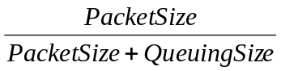 where PacketSize is the probing packet size and QueuingSize is the total queued packet size in bottleneck link.
We use this formula in our simulation to represent the real available bandwidth of the network at an instant moment.

How to measure the available bandwidth
The available bandwidth can be measured by having a sending machine, called probing agent, sending a probing message to a receiver, called probing responder, the probing responder sends back an response message. A commonly used method is to utilize ICMP echo packets as probing messages to measure the available bandwidth, as ICMP echo packets require the receiver to respond with ICMP echo response message. We use information derived from the arrival time of the ICMP echo response packet to estimate the available bandwidth. We can also use higher layer protocol messages such as those in HTTP, TCP, or UDP protocols as probing messages.
The use of higher layer protocol messages yields more accurate measurement result for applications running those protocols. But they typically take a longer time and the results can not be easily applied to other applications running different types of higher layer protocols. The lower layer bandwidth results, obtained by using the ICMP packets, need to be converted to the estimated effective bandwidth on the higher layer protocol through some formula, since there are protocol header and other protocol processing overhead involved.
The available bandwidth measurement can be calculated by the probing responder or by the probing agent. The probing responder will measure the uni-directional traffic bandwidth, while the probing agent measures the round-trip traffic bandwidth. To use the probing responder to measure the uni-directional bandwidth, we need instrument the measuring software on the probing responder. The availability and accessibility of the probing responder may not be there for certain application scenarios. In those cases we rely on the echo response to measure the round trip traffic bandwidth and estimate the uni-directional traffic bandwidth accordingly.

Available Bandwidth Measurement Problems
Measuring the available bandwidth faces the following known problems. Vern Paxon’s thesis provided detailed information about his network experiments [Paxon97].

Route Fluttering
In some rare occasions, the network routes may change rapidly, called route fluttering. Under route fluttering, the first probing message go through one route while the second probing message may go through a complete different route and the available bandwidth measurement results will not converge or be meaningful.
In our simulator, we just assume that a message and its response message go through the same route between two hosts.

Packet Loss
The available bandwidth of a path between two network points is a very dynamic parameter. It is determined not only by the physical capacity of the network, but also by the network behavior. Due to congestion, buffer overflow, machine malfunction, and network disruption, the probing packets can get lost during their transmission. The probing methods rely on multiple redundant probing to recover from the packet loss.
In the real network world, each packet has a TTL(Time to live) field. It is set by the sender to a certain number, such as 64 and 256, and decrement one by the intermediate router as the packet being relayed. When the TTL field of a packet reaches zero, any intermediate router can reject this packet. The probing method needs to consider the rare cases where the destination may be temporarily disconnected from the sender’s network.

Out of order packet delivery
Internet is a datagram network and each packet can be routed in network independently via different paths. It maybe happened that first sent packet arrived at the destination later than the latter sent packet in the real network world.
In our simulator, we assume that route follows the same path, which guarantees "first sent, first arrival".

Clocks Synchronization
Undetected clock errors can result in serious systematic errors in our analysis of network measurement, since superficially a clock error is indistinguishable from variation in packet transmit times. These latter variations occur all the time due to queuing in the network. In uni-directional probing case, the sender’s clock and the receiver’s clock need to be synchronized. Network Time Protocol can be used to synchronize the clocks up to 10 milliseconds error margin. GPS clock signals can be used to synchronize the clocks to 100 nanosecond error margin.

Rate Limiting Host
Some hosts set the rate limit on the generation of ICMP message, says at most 10Kbps per second. Under this host configuration, we never can measure an available bandwidth value over than 10Kbps. With the denial of service attacks on certain important sites, we have observed more and more routers delicate not to reply any ICMP messages.
In our simulator, we assume that our probing agent is fast enough to transmit the probing packet, and probing responder is obliged to respond to probing messages.

Taxonomy of Internet Network Measurement Techniques

Sender-based vs. Receiver-based
Sender-based techniques rely on the receiver to reply or echo sender's packet. It does not require special access on the receive site, but the measurement is related to round trip, two directional paths, and is difficult to separate the contribution from each directional path, since the receiver does not put the receiving timestamp in the reply packet.
Receiver-based measurement techniques measure the uni-directional path from the sender to the receiver, and typically require the cooperation between the sender and the receiver. It is possible to get the full separation of effects due to the forward path, reverse path, and the processing delay at the sender and the receiver. Therefore it is considered to be more accurate. Ping[MUUS83], traceroute, Treno and Bprobe/Cprobe [Carter96] fall in the sender-based category. Paxon's NPD [Paxon97] fall in the receiver-based category. Our proposed algorithms SMUT and MMUT belong to this type of measurement.

Point-to-Point vs. Multipoint
Point-to-point involves two end points in measurement. Multipoint involves multiple end points in cooperative measurements. For link connected to busy router with many interfaces, multipoint measurement maybe the only way to avoid interference traffic. In our algorithms, we use point-to-point.

Passive Watch vs. Active Probe
In passive watch, measuring machine observes and measures passing traffic. Its advantage is that no probing traffic is generated to overload the network. The disadvantage is the measuring machine cannot monitor the traffic which do not pass it. Active probe generates the network traffic and thus increases the overhead. We use active probe in our algorithms.

Layer of Protocol Used
The use of the lower layer protocol enables more timing and programming control. The measured throughput reflects the upper bound of the predicted traffic, if the higher layer protocols are used. The use of the higher layer protocol such as http or ftp yields more accurate the measurement but requires complex analysis to be used for other application traffic. We use the lower layer ICMP in our algorithms.

Related Work
Available bandwidth depends on two things: 1) the underlying capacity of the path between the client and the server which is limited by the slowest or bottleneck link, and 2) the presence of competing traffic (congestion).
There are some existing Internet network measurement packages. We briefly discuss the important related packages.

Bprobe/Cprobe
Bprobe/Cprobe[Carter96] programs use the ICMP echo mechanism. Short bursts of ICMP “Echo Request” packets were sent to the destination. By measuring the time gaps of subsequent packets generated by the router of the slowest link, which is hoped to be preserved statistically, the bottoleneck bandwidth of the slowest link along the path can be computed by dividing the number of bytes in the ICMP packet with the time gap measured. Bprobe deals with these situations by sending multiple bursts of increasing packet sizes ICMP “Echo Request” packets until they are not allowed in the network.
Bprobe formula: bottleneck bandwidth = 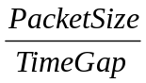
Where PacketSize is the each probing packet size. TimeGap is the time gap between probing packets.
Cprobe estimates the available bandwidth by dividing the length of the burst with the time gap between the arrival times of the first and the last ICMP “Echo Reply” packets.

Minimum
packet spacing at same spacing is
Bottleneck Link preserved on higher Speed Links
Figure 1.1: probe packets alone queued at router (adapted from [Carter 96])

The essential idea behind the probe, then, is this: if two packets can be caused to travel together such that they are queued as a pair at the bottleneck link, with no packets intervening between them, then the inter-packet spacing will be proportional to the processing time required for the bottleneck router to process the first packet of the pair.
Cprobe has limitations[Paxon97]. The first is that it requires sending a fairly large flight of packets at a rate known to exceed what the network path can support, so Cprobe can be viewed as fairly stressful to a network path. The second is that, because its probing uses ICMP echo packets, which elicit same-sized replies, the achieved throughput the probes achieve will reflect the minimum of the available bandwidth along the forward and reverse paths. As we have seen that many path properties are asymmetric, it would not be surprising to find that available bandwidth is, too and thus, for a unidirectional connection, Cprobe might produce too pessimistic estimates.

Ping
Ping [MUUS83] sends ICMP "Echo Request" packets to the destination. The destination replies with ICMP "Echo Reply" packet which copies the sequence number and data fields of original ICMP "Echo Request" packet. When the ICMP "Echo Reply" packet is received, the sequence number and the data field can be verified and the round trip delay of the ICMP packets can be calculated by subtracting the departing time from the arrival time of the packet. Ping can be used to measure the reachablility, round trip delay and packet lose rate.

Traceroute
Traceroute[Jacobson97] is a program written by Van Jacobson to trace the different routes comprising a route through the Internet. All packets sent using the Internetwork Protocol (IP) contain in their headers a Time to Live (TTL) field. In the original IP design, this field was meant to limit the amount of hops that a packet could exist inside the network, to prevent packets from endlessly circulating around routing loops (and eventually clogging up the entire network). The TTL header field is 8 bits wide and is interpreted as the hop counter until the packet must be discarded. Each internetwork router must decrement the field by one. Thus, the TTL limits packets to at most 255 hops through the network.
If upon decrementing the TTL field a router observes that the TTL has reached zero, then it must not forward the packet but instead discard it as being too old. When it discards a packet for this reason, it must then send back an Internet Control Message Protocol (ICMP) informing the sender of the packet that it was dropped due to an expired lifetime.
To trace the route to a remote host H, traceroute first constructs a packet with H as its destination but with the TTL field initialized to 1. When this packet reaches the first hop in the path to H, the router decrements the TTL field, notices that it is zero, and sends back an ICMP message to this effect. The ICMP message includes in its own header the address of the router sending the message, which let traceroute identify the hop 1 router as that address. Traceroute then sends a packet to H with the TTL field initialized to 2, and similarly, gets back an ICMP message identifying the hop 2 router. It proceeds in this fashion until it receives a reply from H itself, and at that point it has elucidated the entire path to H.

Treno
Treno is a tool developed by Matt Mathis [MM96]. It also uses ICMP echo packets to probe network paths, but it sends them using an algorithm equivalent to that used by TCP congestion control. In addition, Treno can probe hop-by-hop statistics by using increasing TTL values in the IP headers of the echo packets it sends, just as does traceroute. When doing so, it receives in response from each hop (except the last) not a full-sized echo reply, but a short ICMP Time Exceeded message. Thus, even if the available bandwidth along the return path is less than that along the forward path, Treno will still primarily observer the forward-path available bandwidth. It was suggested to run 10 seconds for slow start and window control mechanism to reach equilibrium.

Important Internet Network Measurement Activities
There are two important activities related to Internet network measurement effort. IETF IPPM-IP Performance Metric Study Group tries to come up with metrics for comparing ISP services. CAIDA-Cooperative Association for Internet Data Analysis tries to serve as a depository for sharing network traffic data and tools, and to encourage research and development effort in the area.

Usage of Internet network Measurement
- Integrate it to the client browser programs for displaying status/load of hyperlink connections. For example, Ned.Medic in IE4.0 Plus and Netscape.
- As a probing component in servers for dynamic server selection (shared by local clients). For example, Sonar and Anycast Name Resolver.
- Network management utility for traffic flow. For instance: OC3Mon.
- Load balancing components for system performance.

Our Approach
Our concern will focus on the efficient method for estimating the available bandwidth. One possible method is based on the round trip time of the packet and the arrival times of individual packets. First, we sent a sequence of small size packets to estimate the smallest round trip time. Based on the estimated shortest round trip time, the round trip time of the probing packet are used to calculate the estimated available bandwidth. With a single message, we try to derive available bandwidth. We will investigate this and other efficient probing methods for the estimation of available bandwidth.
Another way to do this is try to improve the Cprobe measurement. We keep the history of measured available bandwidth. We use the same mechanism as Cprobe to measure the available bandwidth. The only difference is when we begin to probe the network available bandwidth, we first refer to the latest history value. Using the history value as the base sending speed, we add a positive margin on the base sending speed to send the probing message. If we cannot get the bandwidth, we just use the fastest speed of your machine to do Cprobe again.
In Chapter 2, we describe SMRT (Single Message Round Trip Time Measurement), MMRT (Multiple Messages Round Trip Time Measurement), SMUT (Single Message Uni-Trip Time Measurement), MMUT (Multiple Messages Uni-Trip Time Measurement), and ACB (Adaptive Cprobing Measurement) probing methods. We will explain the theory behind each measurement. In Chapter 3, we represent the architecture of a network simulator, which is used to evaluate the performance of each proposed measurement method. In order to evaluate each proposed method reliability, we generate three kinds of traffic pattern, Flat/Static, Slope and Web. We explain how to generate the traffic patterns in Chapter 3 too. In Chapter 4, We represent how reliable the result of each measurement in different traffic pattern and our explanation to simulation result. In Chapter 5, we represent some problems met in the simulator development and explain how to design and overcome these problems. In Chapter 6, we conclude with a discussion of ongoing and future work. In Chapter 7, we show you our implementation tool for SMRT and its manual.

PROBING-BASED NETWORK AVAILABLE BANDWIDTH MEASUREMENTS
The probing systems have the following common design factors:
- timing patterns (departure times and gaps) of the probing messages
- packet sizes of the probing messages
- timing patterns (arrival times and gaps) of the response messages of the probe.
We intend to investigate the how these design factors can be used to improve the accuracy and efficiency of the probing methods, and how these parameters are related to the available bandwidth.
As introduced in the previous Chapter, the available network bandwidth may be proportional to the round trip time of the probing packet. In Cprobe, we use a burst of packets to make sure they attempt to fully utilize the available bandwidth. Cprobe then computes from the timing of the ICMP echo replies the achieved throughput, and considers the ratio between this and the bottleneck bandwidth to be the availability, 1 - utilization is availability, which indicates how much of the bottleneck bandwidth was actually available. [Paxson 97]
Cprobe has a big impact on the network performance because its purpose is to generate the traffic so as to get the round trip time difference. SMRT first sends a sequence of small packet size probing messages, called RoundTripTime (RT) probing messages, to get a relative accurate round trip time (using the average value RT), then only sends single probing packet, whose size is the same as the RoundTripTime probing messages. If the network are not congested, the round trip time should be the same or within a tiny margin of RT. If the congestion exists, the probing round trip time will increase. Because congestion is caused by packets competing on the slowest link, we give a formula
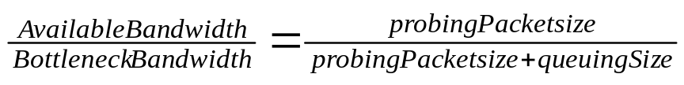 (1)
where BottleneckBandwidth is the original bandwidth of the bottleneck link, probingPacketsize is the packet size of each probing packet. Assume that the round trip delay is proportional to the available bandwidth. The following formula is derived.
ProbeB * PMRoundTripTime = BottleneckLinkBandwidth * PMNoTrafficRoundTripTime (2)
where ProbeB is the probing result bandwidth, PMRoundTripTime presents the probing packet round trip time, BottleneckBandwidth is the original bandwidth of the bottleneck link, PMNoTrafficRoundTripTime is the round trip time of a probing packet without traffic competition. This formula is used to estimate the available bandwidth of the whole connection.
  - SMRT (Single Message Round Trip Time Measurement)
Instead of sending a burst of large size probing packets, we just send single small size "ICMP" echo requirement packet in each probing round. Before we start the traffic generation, we first send round trip time probing packets to get a mean round trip time (A) of a probing packet. When we probe the available bandwidth of a connection in a real environment, theoretically, the same size probing packet should take longer round trip time (B) to return the sender machine. We apply these two round trip times A and B in formula 2 get an estimated network available bandwidth.
  - MMRT (Multiple Messages Round Trip Time Measurement)
In Chapter 4, we find that single probing packet result is influenced by some random factors dramatically. Instead of sending only one probing packet each round, we send a couple of probing packets in each round. The idle time between probing packets in one round is long enough to make sure that each packet result does not be affected by its previous or behind probing packet. We use the average as the estimated available bandwidth. The advantage of this method is to reduce the random characteristic influence in the result. The more packets we send, the less the random characteristic influence.
  - SMUT (Single Message Uni-Trip Time Measurement)
Since round trip measurement can not be used to predict available bandwidth on unidirectional route, we propose the unidirectional trip probing measurement, in which the probing packet does not require an echo packet.
Like the round trip time measurement, the sender sends uni-trip time probing packets to find the smallest uni-trip time of a probing packet. When the destination receives the probing packets, it saves the mean uni-trip time of these packets. In this environment, the destination has the responsibility of calculating the estimated available bandwidth after it gets a probing packet. SMUT and MMUT are such methods. SMUT sends single probing packet each probing round. MMUT sends a couple of probing packets each probing round.
The drawback of unidirectional trip measurements is that it requires heavy participation of the destination machine It is impossible in the Internet to have access to each possible destination machine.
  - MMUT (Multiple Messages Uni-Trip Time Measurement)
SMUT has the same random characteristic as that of SMRT. Instead of sending only one probing packet each round, MMUT sends multiple probing packets in each round. The idle time between probing packets in one round is long enough to make sure that each packet result does not be affected by its previous or behind probing packet. MMUT uses the average of measured available bandwidth as one estimated available bandwidth.
  - ACB (Adaptive Cprobe Measurement)
In Cprobe, the sender sends a sequence of large size probing packets, which are intended to cause the congestion in the bottleneck bandwidth. Cprobe estimates the available bandwidth by dividing the length of the burst with the time gap between the receipt times of the first echo packet and the receipt times of the last ICMP “Echo Reply” packets. If the current connection has very low available bandwidth, the probing packets will make the network performance worse, even cause some useful packets discarded due to the finite buffer size of routers and hosts. A good probing method should impact the network performance as less as possible.
You can say ACB is a variant of Cprobe. ACB (Adaptive Cprobe Measurement) involves the history concept. We use the latest measured available bandwidth to do the probe. We use the speed (the previous measured available bandwidth plus a small margin) to send two probing packets one by one in each probing round. Because of the influence of network traffic, the time gap between two probing packets has a small difference even though you send them one right after the other. We can define a tolerable range of the difference. If the time difference is over the tolerable range, network congestion must be the cause of the time difference. We apply Cprobe calculation formula to get the available bandwidth. If the time gap is in the tolerable range, we think that there are no congestion in the current connection. We then use Cprobe to measure the available bandwidth with the full speed that the sender supports to do. Cprobe can be carried out one more time to estimate the available bandwidth.

NETWORK SIMULATOR
A discrete event network simulator, call NABM, is developed for this paper. It is implemented with a simple model for testing the probing methods.
Figure 3.1 show you the topology of network used in our model.

Intermediate Link
Router1
Bottleneck
Source Receiver
Router3
Traffic agent Traffic Packet Destination

Figure 3.1: Topology of network

In our test topology, the intermediate link is comprised of 12 routers and 13 links. The receiver is the destination of a probing packet sent by the source. A traffic packet originates from traffic agent and is discarded at traffic packet destination node.

The network model in this paper consists of six main objects, a probing agent, a traffic generation agent, messages, bottleneck link, an event queue and a chart. In NABM, there are two kind of packets. The traffic packets are those generate the network load. The probing traffic packets are those used to measure the available bandwidth. Before any traffic or probing packet generation, the probing agent first generates a round trip time measurement packet to get the round trip time (or Uni-trip time) of a probing packet based on the same transmission route. The traffic generation agent generates traffic packets periodically. The probing agent makes periodic probing and waits for a response. To reduce the impact of the probing packet, we use ICMP kind of message to do the probing. The minimal size of an ICMP message is 46 bytes in NABM. Generated packets follow the probing or traffic route from source to destination. The packets of regular traffic do not require a response. If our measurements are Round trip time measurement, the probing packet requires a response. If our measurements are uni-trip time measurement, no probing response packet is generated.
The simulator follows the OOP design, each Internetwork node along a packet transmission route is an object. In our design, each Internetwork node, which is router or link, is an independent object in the simulator. Each packet is an object too.
The link or router object contains a unique identifier, which is used to call the correct object to handle a packet object. The bottleneck link is a special link object with its BottleneckLink field value set to true. The bottleneck link also keeps track of the total number of bits transferred within one traffic reporting period. The link or

router object maintains its own local clock, which is modified by the arrival time of a packet and the execution time of the packet going through the node.
The route object contains a unique identifier and an array, which is consists of the link and router object. Each route object represents a unique transmission route of a packet propagation. The first router object of route 0 is the probing agent. The first router object of route 1 is the traffic generation agent. We discuss how the probing agent and traffic generation agent work in the next section.
The packet is the instance of Message object, which contains a message number, message type, message size, route number and a wakeup time. There are a couple of different message types for different traffic pattern. There are some common message types for all traffic pattern: The "Simulation-end" message tells the simulator to stop the simulation thread and close all the open files; the "Probe-start" message tells the probing agent to generate a new probing packet and set the next probing packet generation time; the "Traffic-start" message tells the traffic generation agent to generate a new traffic packet and create the "New -TrafficMess" message. The "New-TrafficMess" message is in charge of generating traffic packet periodically. Each time it generates a new traffic packet and it resets its own next wakeup time. The "Traffic-report" message causes a real available bandwidth record output to the log file, meanwhile, it reset its next reporting time. The traffic packet message type is "HTTP-request". The probing message type is "ICMP-request". The probing acknowledge message type is "ICMP-response". Except "ICMP-request", "ICMP-response", "HTTP-request" and "HTTP-response" type messages, the rest of message types are called control messages, since they do not need to invoke link or router object to handle them. It also means that they are not transferred in the network. We give the function description of "ICMP-response" and "HTTP-response" in the "how to generate traffic" section. Figure 3.2 shows how a packet is handled.
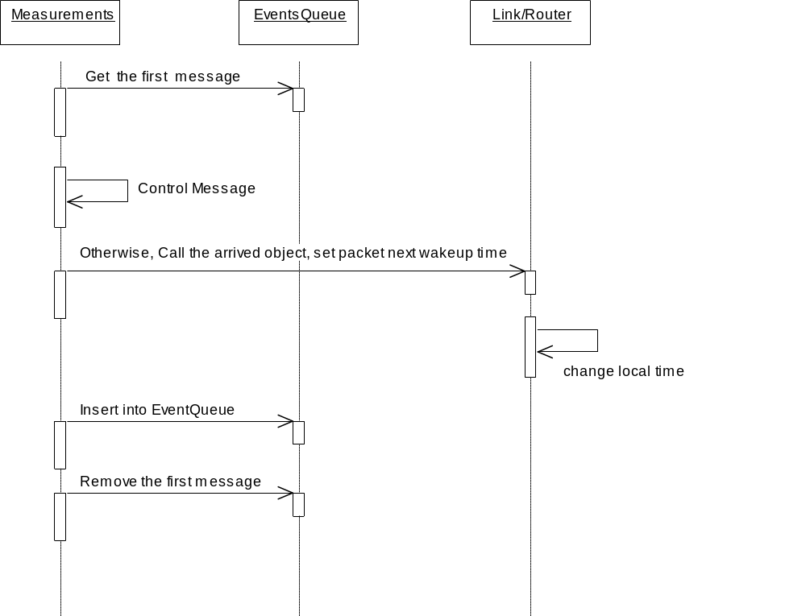

Figure 3.2: How a packet is handled

The simulator uses an event scan time management technique. When a packet arrives at a node, it means an event happens. We need to call the corresponding node to handle this packet. When the packet leaves the node, it means this event is finished. A priority queue is maintained by the simulator. All the live packets are placed into the queue which orders all the packets according to their wakeup time, i.e., when a packet arrives at the next object along its transmission route. If the queue has an event already scheduled for that event time, then the new event will be inserted into the front of the first found event with the same event time.
Each packet proceeds through a series of events where state of the each object on its route is changed appropriately as each event occurs. The maximum size of each packet is assumed to be 1500 bytes (12000 bits) in NABM, related to the Ethernet packet payload.
  - How to generate traffic
In this simulation, we implement these traffic patterns to measure the efficiency of the probing methods. For the flat/static and slope traffic pattern, we set the sending interval time between two neighboring traffic packets according to the available bandwidth the user hopes to get in the simulator. We use the following formula to calculate the interval time:
First, we calculate the queuing size needed to generate the available bandwidth
(3)
(Note: BottleneckBandwidth is the original bandwidth setting of the bottleneck link, probingPacketsize is the packet size of each probing packet.)
Second, we use the following formula to calculate the interval sending time between two neighboring traffic packets.
(4)
where ProbingPeriod is how often we want to report the available bandwidth, BottleneckBandwidth is the original bandwidth setting of the bottleneck link, QueuingSize comes from formula 1. The description of configure file can be found in Appendix A.
    - Flat/Static Traffic
In order to calculate the interval sending time between two neighboring traffic packets, we need to read the available bandwidth value from the configure file (it is the first value at the first line in configure file). We get the constant interval time from the formulas defined in last section.
The constant interval time tells the traffic generation agent how often it needs to generate a new traffic packet.
For example, if the user wants 8MBps available bandwidth, he just write a value 8 at the first position of the first line in configure file. If the probing packet size is 46*8 = 368 bits, then the QueuingSize value from formula 1: 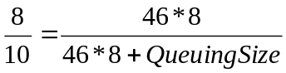 is 92.
If the reporting period is 0.0064 seconds and the bandwidth of bottleneck link is 10MBps, then the interval time from formula 2: 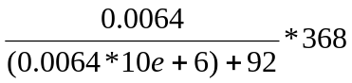 is 0.000127816.
    - Slope Traffic
Slope traffic pattern captures the situation where the network available bandwidth changes from a relative big value to a relative small value in the whole simulation. Slope traffic can help us to verify the feasibility of proposed measurements in different network traffic load (light or heavy traffic).
First we need to calculate the largest interval sending time and the smallest interval sending time. The less the traffic generation interval time, the heavier traffic. This is an off-line work for user to do. For example, if we want the range of available bandwidth change is from 8MBps to 100KBps and the other parameters are the same as the example in 3.1.1, the largest interval time is 0.000127816, the smallest interval time is 0.000081568.
Figure 3.3 show you how the slope traffic is created:
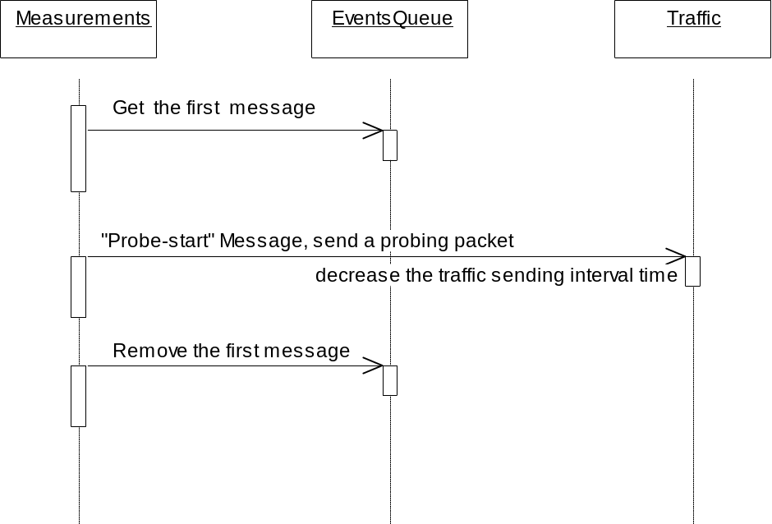

Figure 3.3: how to create slope traffic

The traffic arguments are set in Traffic object. First we need to get the times that the probing agent probes the available bandwidth in the whole simulation life, say segmentNum: segmentNum = (int) 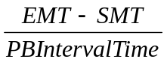 where EMT is the ending time of simulation, SMT is the time when the measurement begins and PBIntervalTime is the time how often the measurements probe the available bandwidth. Next we need to calculate an interval time decreasing unit, say segmentValue: segmentValue=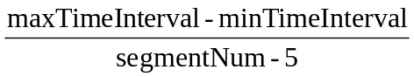 where maxTimeInterval is the largest time interval between traffic packets and minTimeInterval is the smallest time interval between traffic packets. The reason segmentNum minus a small positive integer is to let the traffic sending interval time decrease faster, so we can observe what happen under the heavy traffic load.
    - Web Traffic
Unlike flat/static or slope traffic pattern, web traffic is not a regular traffic pattern. It is a more realistic workload in Internet. We use a synthetic approach to generate simulation workloads for modeling Web traffic. A synthetic approach uses mathematical models that model empirically measured web server trace data. Mathematical models are more difficult to implement and verify, but once a model is created it is more flexible for varying workload characteristics. A synthetic approach is chosen for this study because the possibility of broader application beyond studying the characteristics of the World Wide Web. [Blais 2000]
Early studies of Web workloads used traditional mathematical models for modeling workloads. Arrivals processes where typically modeled with Poisson distribution [5][6]. Poisson distributions work poorly in modeling the behavior for traffic patters in both Ethernet networks and on the Web. Ethernet traffic and the Web traffic have unpredictable patterns of high request rates (burstiness) and low request rates (idleness). The request sizes also have a high degree of variability. It is the high degree variability in these workloads that makes Poisson models fail because Poisson models are using constant rates. In more recent studies analyzing the characteristics of the Web workloads, it was observed that the workload distributions of the Web were heavy tailed [1] [2]. The heavy tail distributions are characteristic of the high variability of network traffic workloads.
To avoid probing web traffic during the idle period, the probing process is triggered by the client traffic generation. The traffic generation agent (client) sends a "HTTP-request" packet to server (the last object in a route), meanwhile, it triggers the probing agent to send n probing packets, in which the idle time between probing packets is two times of the current sending time between traffic packets. When the server receives the request, it decides how big the return file size is. If the size, say S, is greater than the maximal limitation of a packet, 1500 bytes, server generates several "HTTP-response" packets, whose size is 1500 bytes except the last one, whose packet number is 0 for single request packet. The last packet size is (S mod 1500). If the client finds an echo packet number is 0, it knows this is the last packet from single request packet. Next it needs to find how many references are embedded in this return page. For each embedded reference, the client sends a "HTTP-request" packet to the server again. The server does the same work as that on the request packet before. Figure 3.4 shows you how the web traffic is generated.
In this simulator workloads will be modeled by the file sizes, client idle time, the number of embedded references and the idle time between references.
The following data and description until to the end of section 3.1 come from [Blais 2000].
First we will look at the file size distribution. Analyzing the data on the file size shows that the majority of the files requested from Web servers are less than 10,000 bytes and a large proportion of those are less than 1,000 bytes. Table 1 shows the file size frequency distributions of various studies.

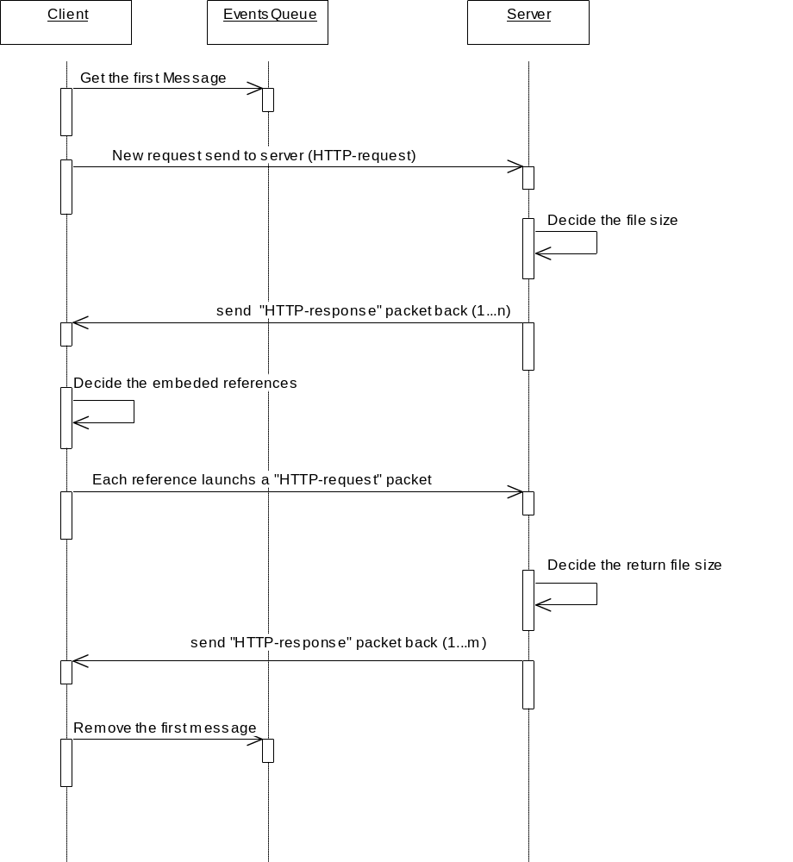

Figure 3.4: how to generate web traffic
Table 1 fails to show the impact of file size greater than 100 kilobytes. In [AW97], even though file sizes of greater than 100 kilobytes were accessed less than 1 percent of the total requests, they accounted for 11 percent of the total bytes transferred. Similar observations were also made in [CBC95], [BC97],[CFH99] and [PF94], therefore leading to the conclusion that file size distributions are heavy-tailed.
Table 1: File Size Frequency Distributions
File Size | SPECweb99 | AW97 | CBC95 | CFH99
< 1 KB | 35% | - | 62% | 23%
1 – 10 KB | 50% | 76% | 31% | 70%
10 – 100 KB | 14% | 23% | 6% | 6%
> 100 KB | 1% | <1% | 1% | 1%

In modeling the distributions for file sizes the distributions were broken into two distinct distributions, the body and the tail. The body includes approximately 93% of all the distribution with files' size less than 9020 bytes. This part of the distribution is modeled with a lognormal distribution shown in Figure 3.5. We create a lookup table to store the file size for a certain possibility value. The tail containing the remaining 7% of the distribution with file sizes greater than 9020 bytes is modeled with a Pareto distribution shown in Figure 3.6.
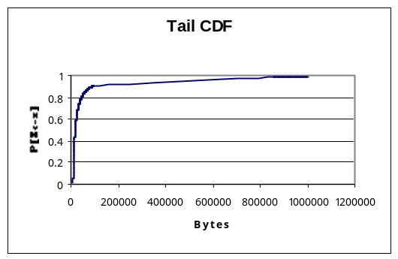
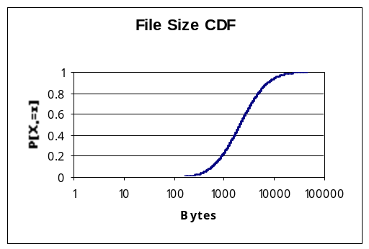
Figure 3.5: File Size Distribution – Body Figure 3.6: File Size Distribution - Tail
Next is client idle time, which is the time between requests. A Pareto distribution was found to be a good fit for modeling the distribution. Figure 3.7 shows the user idle time distribution.
Next is the embedded reference number, which is the number of embedded references in the requested document. A Pareto distribution is found to be fit for modeling the distribution.
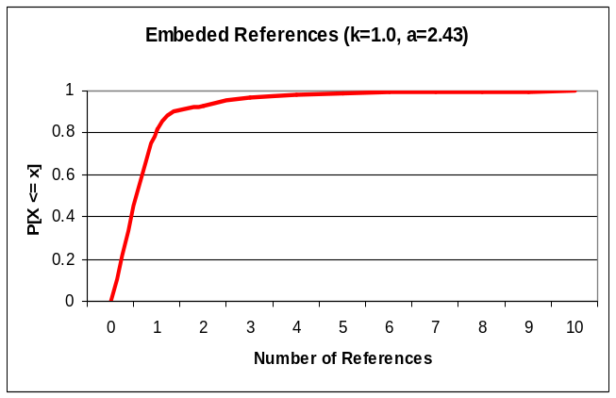
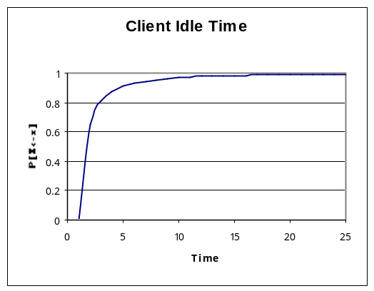Last is the idle time between embedded references. Weibull distribution is found to match the distribution.
Figure 3.7: Client Idle Time Distribution Figure 3.8: Embedded References Number
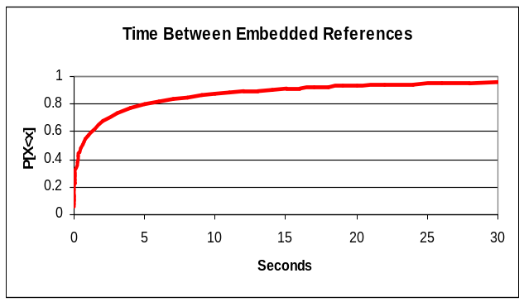
Figure 3.9: Time between Embedded References
  - How to report a real available bandwidth log record
"Traffic-report" message triggers the reporting. There is a counter in the bottleneck link. The counter is existed as a field "bottlenecklink_transferedbit" in the bottleneck link. Once a packet goes through the bottleneck link, the counter accumulates the packet size. After generating a log record, the counter is reset to zero. The counter is used to calculate the queuing size:
queuingSize = bottlenecklink_transferedbit - reportingPeriod*BottleneckAvailableBandwidth (5)
where BottleneckAvaiableBandwidth is the original bandwidth of the bottleneck.
  - How a packet is transmitted
Figure 3.5 show you the procedure.
If the current message is not a control message, program invokes the next arrival object, say B from the packet transmission route to process this packet. B processes this packet and checks if the packet get to its destination, which is the last node of a route for a request packet and the first node of a node for a response packet. If a request packet gets to its destination, which contains "ICMP-request" and "RoundTripTime-ProbingRequest" in round trip time measurement and "HTTP-request" in Web traffic, and need a response packet. The called object changes the packet type to its corresponding response type and inserts it into the event queue. If the processed packet does not arrive at its destination, the packet is inserted back the event queue. If the packet arrives at its destination, the probed available bandwidth is calculated if it is a probing packet, "ICMP-response" and "HTTP-response" in round trip time measurements, or "ICMP-request" and "RoundTripTime-ProbingResponse". In unidirectional trip time measurement, the processed packet is not backed into the event queue any more.
Note: "HTTP-request" in flat/static and slope traffic pattern does not require a response packet.

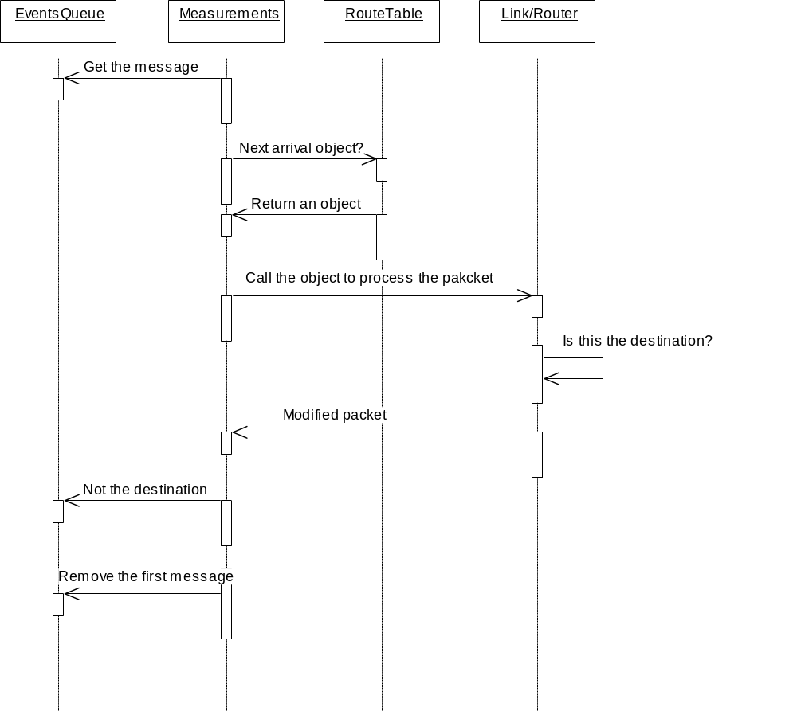

Figure 3.5 how a packet is transmitted

The simulator model is validated with the comparison of the output data of the formula 1 and formula 2 explained in section 2.
The figure 3.8 shows the final design of the simulator.

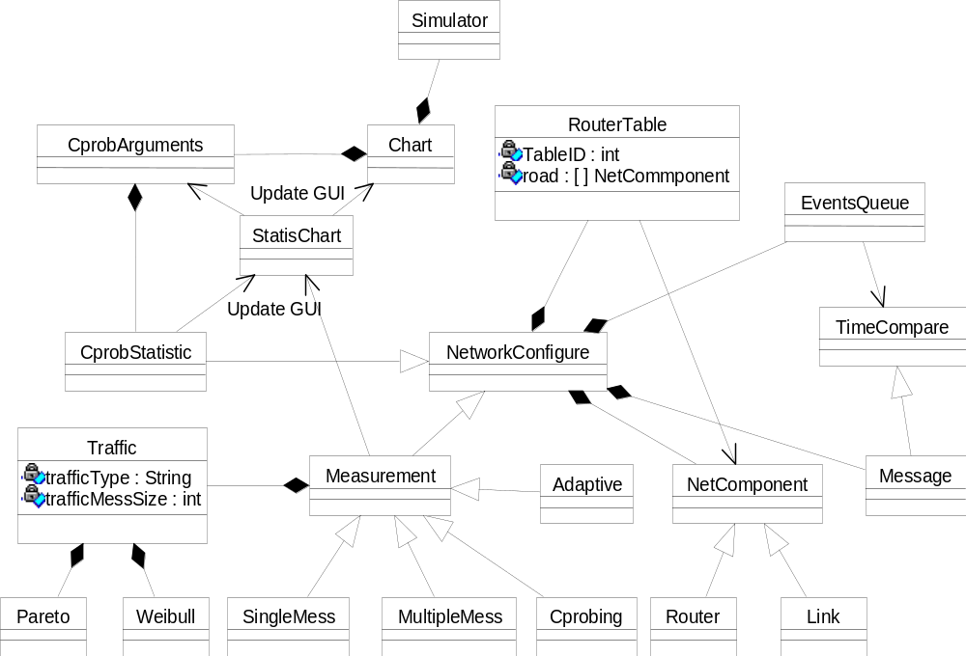

Figure 3.8: Final Design of the simulator

SIMULATION RESULTS AND ANALYSIS
To validate the results of our measurements, we define a metric called Difference and there is its description formula:
Difference = 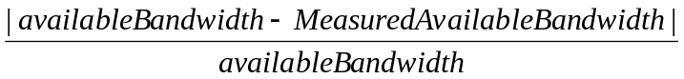 (5)
The absolute value of the subtraction value between available bandwidth and measured available bandwidth is divided by the available bandwidth. The equation represents how far the measured available bandwidth is from available bandwidth. From the equation, the less the Difference value, the more accurate the measured available bandwidth.
The other metric is increased Delay Time and its definition:

Increased Delay Time = RoundTripTimeInTraffic - RoundTripTimeNoTraffic (6)

Where RoundTripTimeInTraffic is the round trip time of a packet in a traffic pattern, RoundTripTimeNoTraffic is the round trip time of a packet without any traffic.
In the rest sections of this chapter, we apply the metric to evaluate the effective of each measurement in the slope traffic pattern.

  - SMRT
Figure 4.1.1 shows the results of single message round trip time measurement.
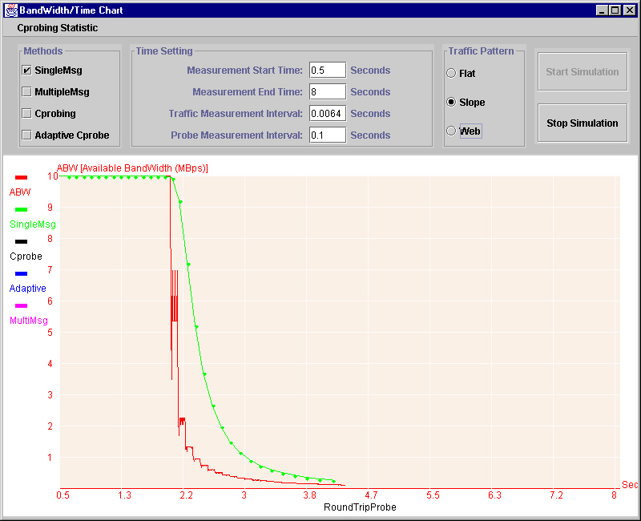
Figure 4.1.1: Available Bandwidth vs. Measured Available Bandwidth (SMRT)
In this picture, red line curve represents the trend of real available bandwidth and green line curve follows the measured available bandwidth. Roughly, the deviation of the measured available bandwidth follows the trend of the real available network bandwidth. In this simulation, the bottleneck link bandwidth is 10MBps, the hop number is eighteen. The following Figure 4.1.2 shows the Difference value when the traffic gets heavier and heavier.
From Figure 4.1.2, we found that the Difference value is changing dramatically with the traffic increasing. We sample multiple points under 10MBps available bandwidth.

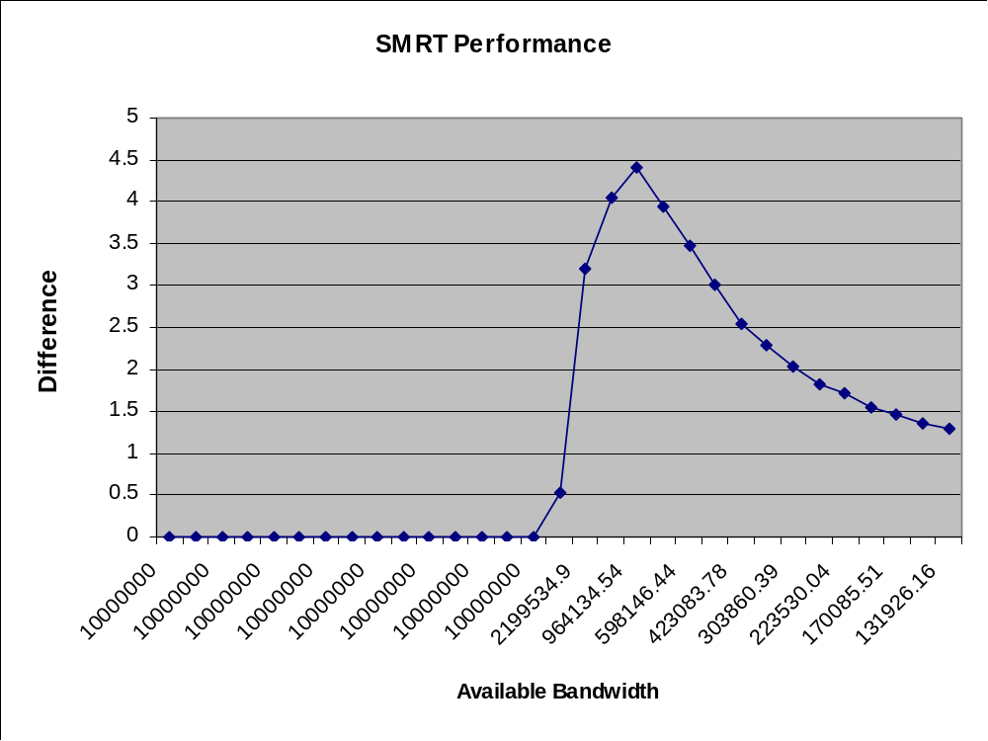
Figure 4.1.2: SMRT Performance
As mentioned in Chapter 2, all our proposed measurements in this paper are based on the round trip time or unidirectional trip time of probing packets. First we look at the composition of the trip time of probing packets:
TripTime = PropagationTime + TransmissionTime + QueuingTime (7)
In the network, there are many factors to affect the trip time of a packet. In the above formula, we divide the trip time into three independent delay times. We categorize the contributing factors. Table 2 shows you the category.
Next we will discuss the impact of each factor on the trip time, respectively.
Hop Number
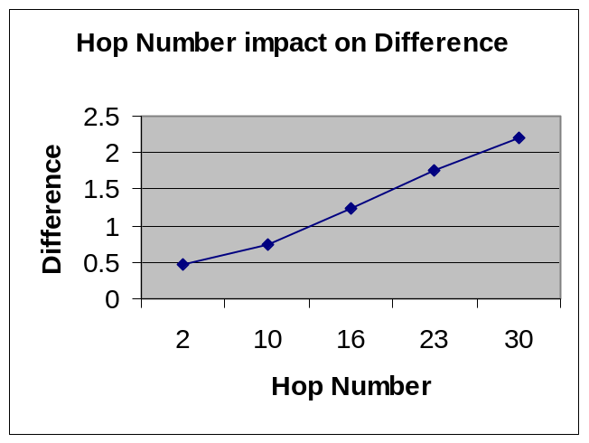The network configuration for the above curve: packet size 46 bytes, traffic packet size 20 bytes, link length 100000 meters and bottleneck bandwidth 10MBps. From this picture, we found that the Difference value increases as the hop number increases. More hops mean that a packet needs to be transmitted by more intermediate nodes before it reaches its destination. More hops means more opportunities of a packet to compete a connection with other traffic packets, which results in longer queuing time. The increased queuing time results in larger Difference value, that is why we found that the more hops, the larger Difference value.
Figure 4.1.3: impact of Hop Number on Difference
Table 2: Delay contributing Factors
Time Category | Factors
Propagation Time | Link length
Transmission Time | Router Speed, Link Bandwidth
Queuing Time | Packet size, Hop Number

Link Length
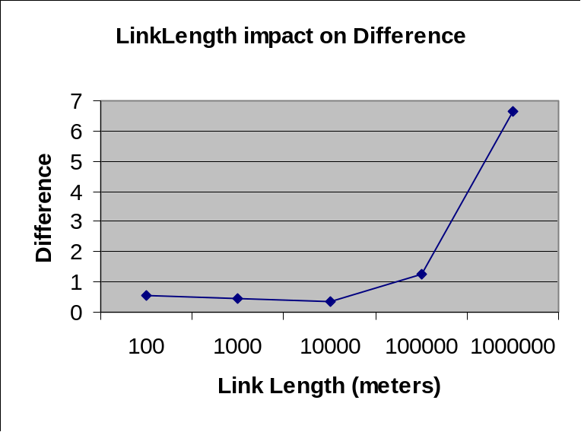
We see the impact of link length on the propagation time now.
Figure 4.1.3: Impact of Link Length on Difference
Table 3 shows the data of the above chart based on. Except for the link length, all the data come from the following network configuration: Hop number 16, router speed 1GBps, bottleneck bandwidth 10MBps, probing packet size 46 bytes and traffic packet size 20 bytes.
Table 3: Impact of Link Length on Difference
Link Length (meters) | Difference
100 | 0.560186067
1000 | 0.461196328
10000 | 0.372903889
100000 | 1.246685111
1000000 | 6.636471365

From Table 3, there are a threshold that triggers the Difference changing trend.
What happens before the threshold? Why the trend is opposite to the link length changing trend? Let us look at the following table to see the propagation time and queuing time + transmission time changing trend.
Table 4: PropagationTime/(Average TransmissionTime+QueuingTime)
Link Length (meters) | Approximated  Propagation Time (Sec) | Average increased Transmission+QueuingTime(Sec)
100 | 0.00001 | 0.13088954436231923
1000 | 0.0001 | 0.065673402893731
10000 | 0.001 | 0.08064477289268737
100000 | 0.01 | 0.0947725000926319
1000000 | 0.1 | 0.22191062617182175

In Table 4, approximated propagation time ≈ 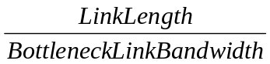 , where bottleneck link bandwidth is 10MBps.
Average increased Transmission+QueuingTime ≈ TripTimeTraffic - TripTimeNoTraffic, where TripTimeTraffic is the trip time of a packet in a traffic pattern and TripTimeNoTraffic is the trip time of a packet without traffic.
From Table 4, we found that the longer the link length, the longer propagation time. Let us examine the ratio between approximated Propagation Time and Average increased transmission+queuing time in Table 5.
Table 5 shows the contribution of the propagation time on the trip time of a packet. We found that it is the transmission and queuing time that dominate the trip time of a packet when the link length is short. With link length rising, propagation time of a packet dominates the trip time gradually.
Table 5: Ratio between Propagation and TransmissionTime+QueuingTime
Link Length (meters) | Ratio = (Propagation /Transmission+QueuingTime)
100 | 0.00001/0.13088954436231923 = 0.00764%
1000 | 0.0001/0.065673402893731 = 0.15226%
10000 | 0.001/0.08064477289268737 = 1.24%
100000 | 0.01/0.0947725000926319 = 10.55%
1000000 | 0.1/0.22191062617182175 = 45.06%

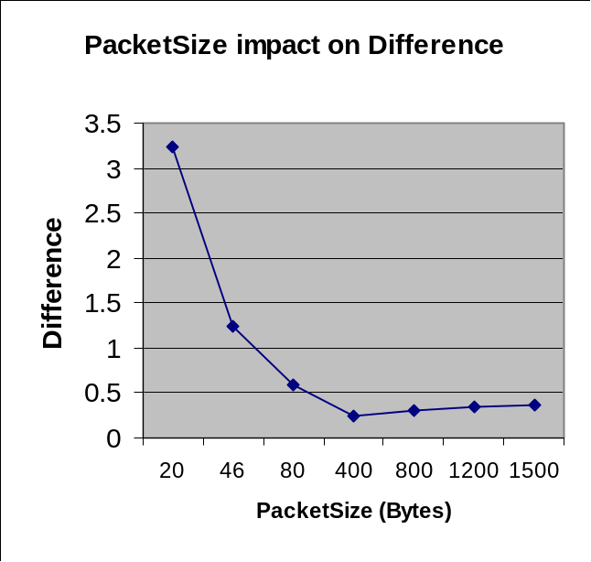
Packet Size
Figure 4.1.4: impact of Packet Size on Difference
Except for the probing packet size, all the data come from the following network configuration: Hop number 16, router speed 1GBps, bottleneck bandwidth 10MBps, link length 100000 meters and traffic packet size 20 bytes.
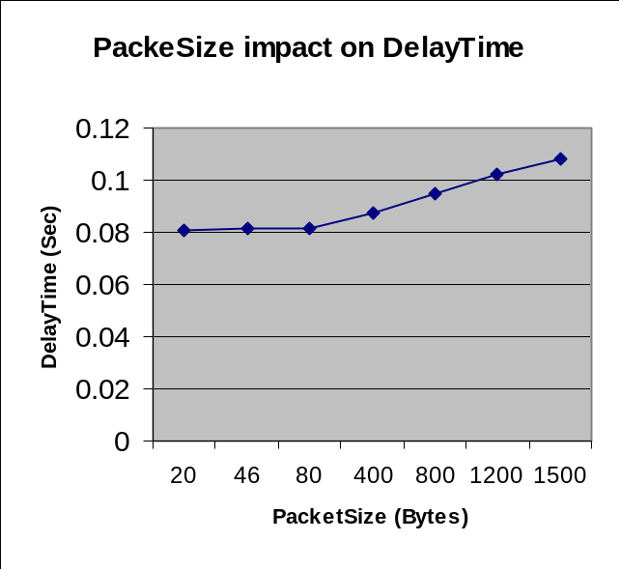
From figure 4.1.5, we found that the less the probing packet size, the bigger the Difference value. It means the measured available bandwidth accuracy is worse when the probing packet size increases. Figure 4.1.5 shows you the relationship between the increased round trip time of a packet with the probing packet size increment.
Figure 4.1.5: impact of Packet Size on Increased DelayTime
With the probing packet size increases, the increased Delay time increases too. The increased Delay Time results from the queuing time increase. The queuing time is the result of competing the connection between traffic packets and probing packets.

Figure 4.1.6: Queued Packets in a router
The traffic packet size is 20 bytes in the test. If at a router, a 20 bytes probing packet is queued by a 20 bytes traffic packet, and the queuing time is Q1. We assume that a 1500 bytes probing packet is queued by the same size traffic packet at the same router, and the queuing time is Q1 also. You can imagine that the same queuing time Q1 has more impact on the round trip time on a smaller probing packet than that of a bigger probing packet. Absolutely, Figure 4.1.6 indicates the bigger size probing packets experience more competition because the larger size packet needs more time to be transmitted in the network. There are more traffic packets to compete the connection with the probing packet. In the heavy traffic, the smaller size probing packet still has the possibility to plug into the time gap between traffic packets so as to go through the connection without delay, then such result generates a big Difference value.
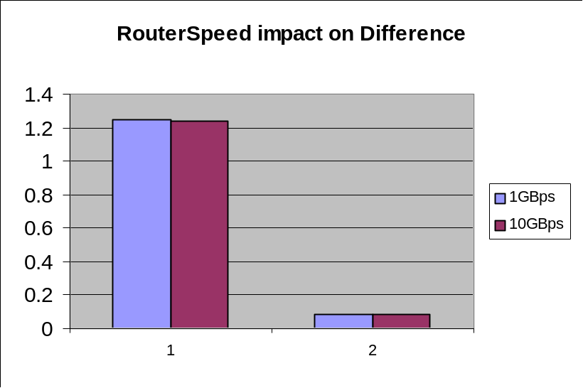
We can say that the larger size probing packet gets a relative better results in SMRT.
Router Speed
Figure 4.1.7: impact of Router Speed on Difference
Except for the router speed, all the data come from the following network configuration: Hop number 16, bottleneck bandwidth 10MBps, link length 100000 meters, probing packet size 46 bytes and traffic packet size 20 bytes.
Two values for different router speed are tested: 1GBps and 10GBps. In Figure 4.1.7, the title 1 at x axis represents the results of Difference, the title 2 at x axis represents the results of increased delay time. We found that there has not apparent difference between the two router speed settings.
The router speed influences the time of a packet passing through a router so that the time gap between packets will be changed if the passing time for a packet is longer than the original time gap between packets. This character affects the traffic generation (see detail discussion on Section 5.2).
Figure 4.1.7 tells us that 1GBps and 10GBps is a feasible configuration for our simulator. Both overcome the problem caused by the router speed (see Chapter 5).
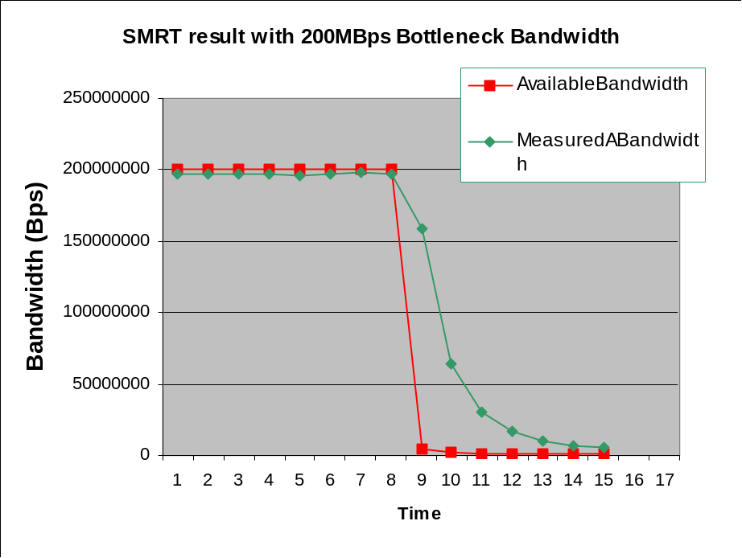
Bottleneck Bandwidth
Figure 4.1.8: Available Bandwidth vs. Measured Available Bandwidth (SMRT with 200MBps Bottleneck Bandwidth)
Now, we set the bottleneck bandwidth is 200MBps, the others network configuration: Hop number 16, link length 100000 meters, router speed 10GBps, message processing speed 2GBps, probing packet size 46 bytes and traffic packet size 160 bytes. We raises the value of the router speed and message processing speed in order to make sure that the router does not influence the time gap between traffic packets and guarantee we can get the traffic we want.
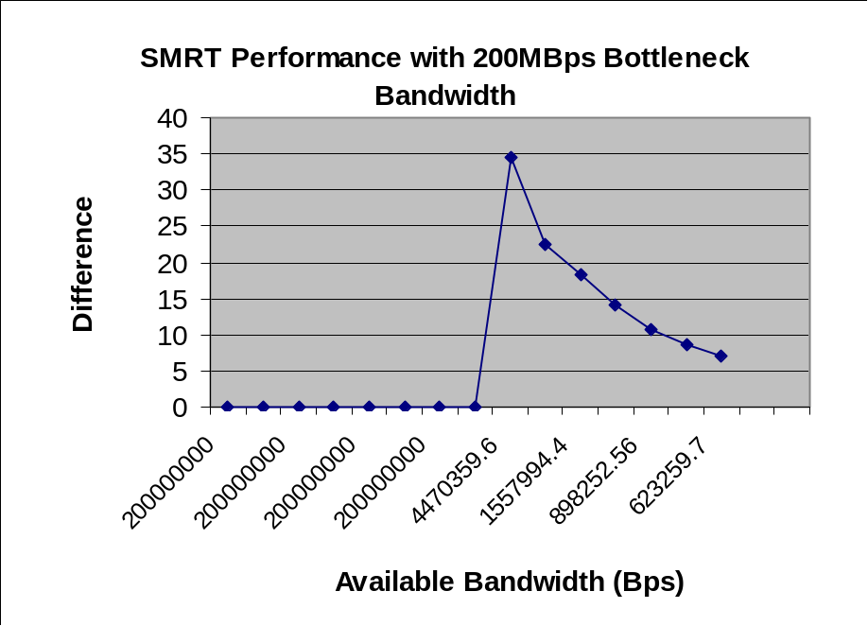
Like Figure 4.1.1, Figure 4.1.8 shows that the measured available bandwidth changing trend follows the available bandwidth trend also. Next let us to see the Difference changing trend.
Figure 4.1.9: SMRT performance with 200MBps Bottleneck Available Bandwidth
The curve is similar to the curve in Figure 4.1.2 too, so it is proved that SMRT can work properly in a diversity range of bottleneck available bandwidth. We sample multiple points with 200MBps available bandwidth.
Random Characteristic
SMRT uses a single packet to measure the available bandwidth. The single packet competes the connection with other traffic packets. In our simulator, the idle time between traffic packets or probing packets is static, but the network is a totally unpredictable in the reality. It is impossible to have so ideal traffic pattern showed up in our slope traffic pattern. Even in a regular traffic pattern, SMRT is easier to be influenced by any occasionally happened situation in the simulator.
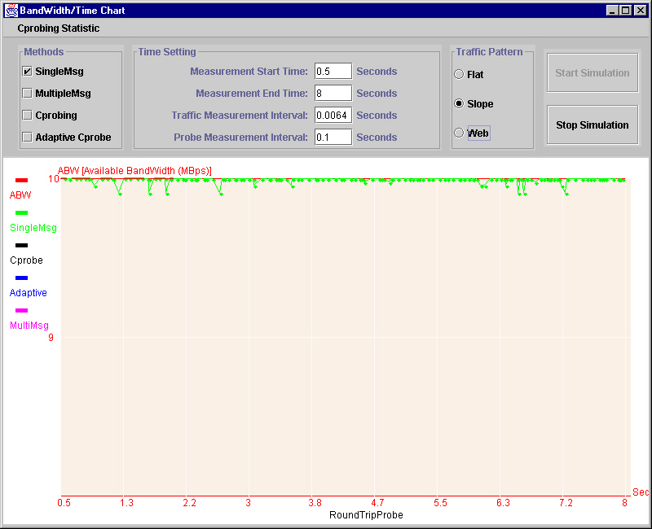Figure 4.1.10: SMRT Random Characteristic with 10MBps available bandwidth
In Figure 4.1.10, the traffic generation did not result in 100% utilization. It means there is idle time when the bottleneck link transmits two neighboring traffic packets. Our probing packet size is 46 bytes and traffic packet is 160 bytes. We change the idle time between probing packets to a random value instead of a constant. There are three possibilities when the probing packet gets to the bottleneck link:

(1) (2) (3)
Figure 4.1.11: three cases of probing packet compete with the traffic packet
The striped rectangle represents the probing packet and the black rectangle represents the traffic packets. When the probing packet gets to the bottleneck link: In the first case, the probing packet plots in the middle between two traffic packets totally, it exploits the idle time between traffic packets and go through the bottleneck link without any delay, so its probing result is 10MBps. In the second case, the probing packet gets the bottleneck link at the same time as that of a traffic packet. They compete the connection now, the probing result is the worst if the bottleneck link passes the traffic packet first. In the third case, the probing packet arrival time is later than a traffic packet, the queuing time is the time when the bottleneck link transmit the remaining bits of the traffic packet. The probing result will fall in the middle. That is why we found in Figure 4.1.10 the results are somehow fluctuated even in a static traffic pattern.
  - MMRT (Multiple Message Round Trip Time Measurement)
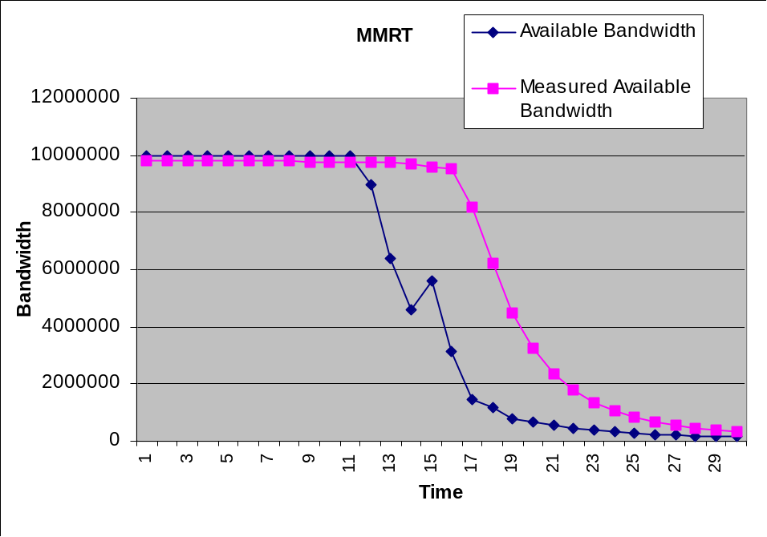
Figure 4.2.1: Available Bandwidth vs. Measured Available Bandwidth (MMRT)
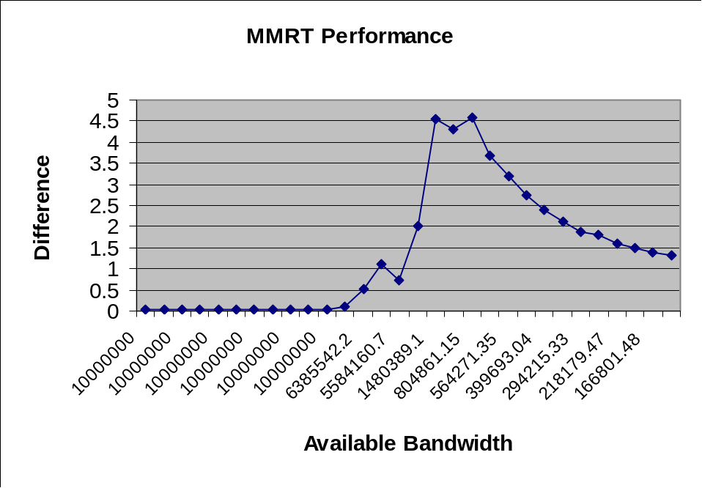
Figure 4.2.2: MMRT Performance
The random characteristics of SMRT can be alleviated by sending a couple of probing packets to measure the available bandwidth. They are not sent one after another immediately. Instead, enough time gap is maintained between them to make each one probing result indicating an independent network available bandwidth. We use the mean of the multiple probing results as one measured result.
Unfortunately, the network bandwidth in slope traffic pattern is changing with heavier and heavier traffic, even a small time gap causes the probing packets to experience big available bandwidth difference. Actually, the results of measured available bandwidth are not more accurate than SMRT results, even worse in the slope traffic pattern. Figure 4.2.2 indicates the statement when compared with Figure 4.1.2. Each sample in Figure 4.2.1 has a corresponding sample point in Figure 4.2.2.
We also try MMRT in a flat traffic pattern. In such an ideal traffic pattern, the results of MMRT is better than SMRT obviously. Figure 4.2.3 shows the comparison between their results.
As shown in Figure 4.2.3, we run both methods under 1MBps traffic, which means there are a lot of idle time for the bottleneck link. MMRT detects the traffic and give us more close value to the created traffic than that of SMRT. In such a plain pattern, we can conclude that MMRT is better than SMRT.
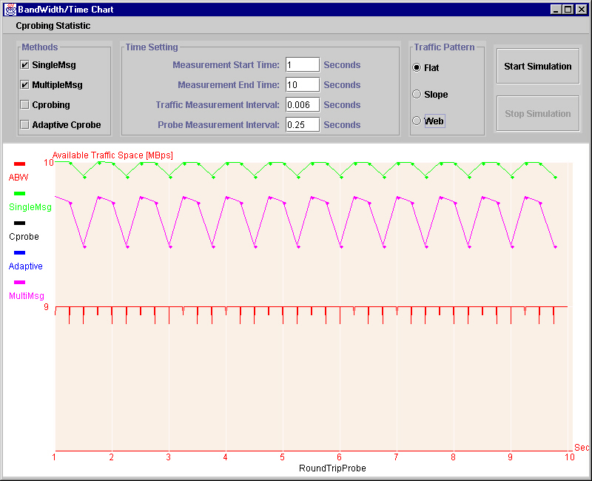
Figure 4.2.3: Comparison between SMRT and MMRT results in flat traffic
How about the effective of MMRT in real traffic pattern, the web traffic? Is it still better than SMRT or not? We run both of SMRT and MMRT with the web traffic pattern and get the mean Difference values of SMRT and MMRT, then compare the results. Figure 4.2.4 shows the result:

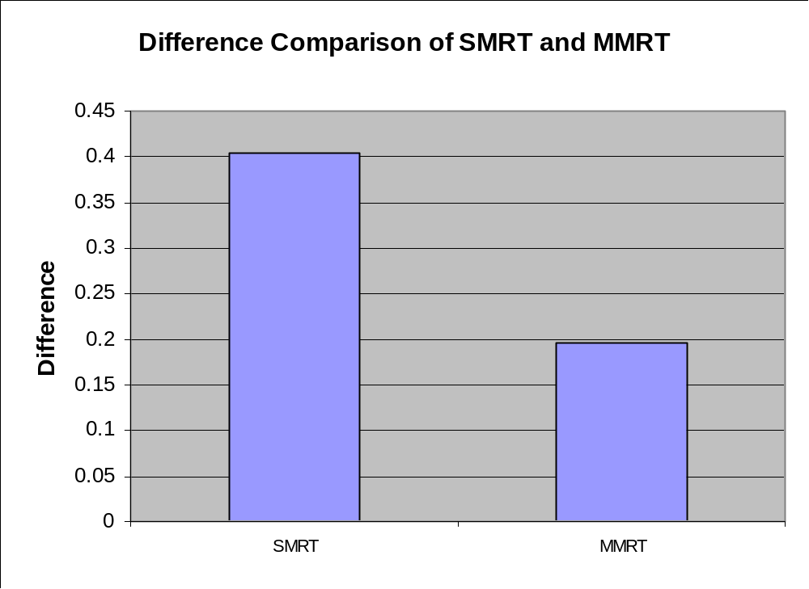
Figure 4.2.4: Difference Comparison of SMRT and MMRT
From Figure 4.2.4, we found that MMRT is really better than SMRT in the real traffic.
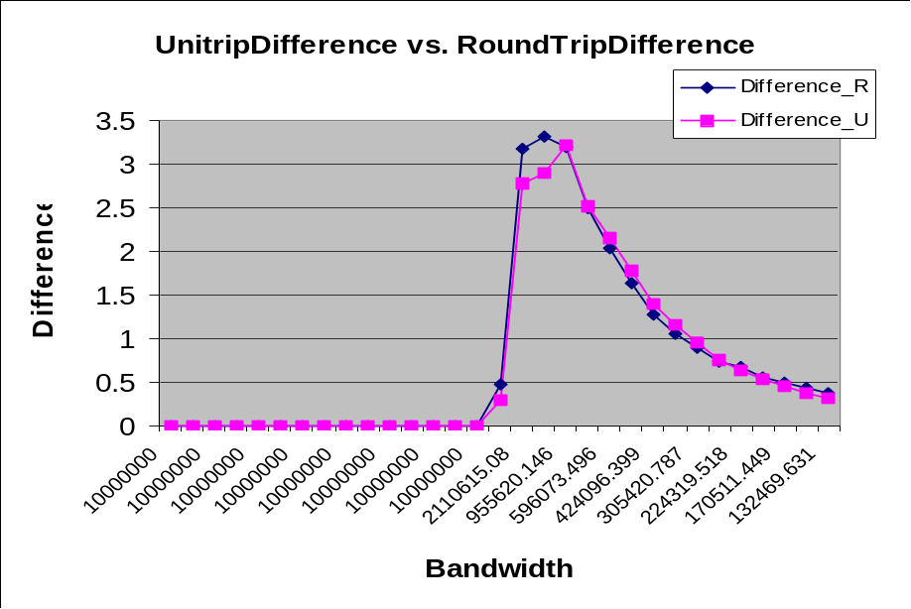
  - SMUT (Single Message Uni-Trip Time Measurement)
Figure 4.3.1: UnitripDifference vs. RoundTripDifference
Now, we get two groups of Difference data from the following network configuration: the bottleneck bandwidth is 10MBps, Hop number is 10, link length is 100000 meters, router speed is 1GBps, probing packet size is 46 bytes and traffic packet size is 20 bytes.
Because the probing packets only pass one way, it is not interfered by the backward route traffic. The unidirectional trip time is less than the round trip time under the same traffic load. It is hard to make the traffic exact equal when a packet goes through the whole route. Figure 4.3.1 can not conclude that which is better. Figure 4.3.2 compares these two probing algorithms when the available bandwidth is close to 10MBps.
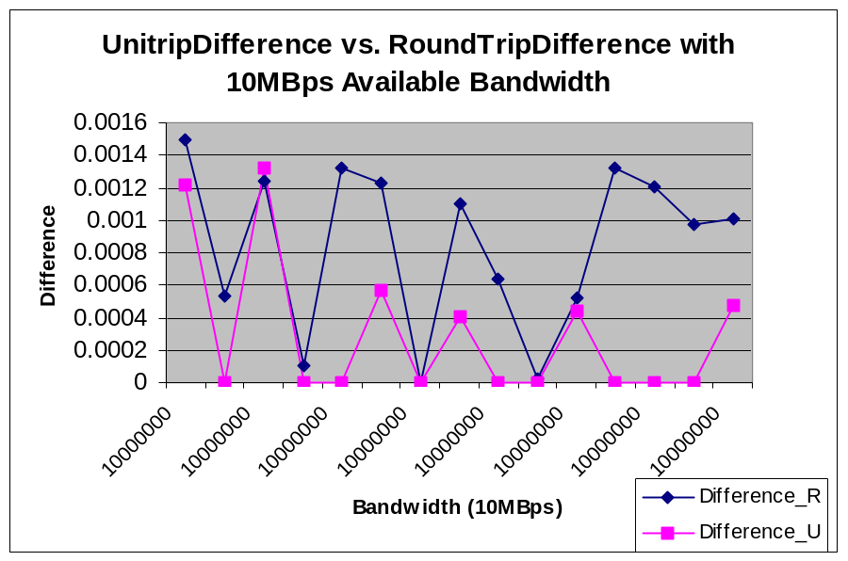Figure 4.3.2: UnitripDifference vs. RoundTripDifference with 10MBps Available bandwidth

From Figure 4.3.2, the clear conclusion is that uni-trip probing achieves the better result than the round trip probing.
The Average Difference of Uni-trip is 0.6778850645042714, while the average Difference of round trip is 0.7398196161859993.
  - MMUT (Multiple Message Uni-trip Time Measurement)
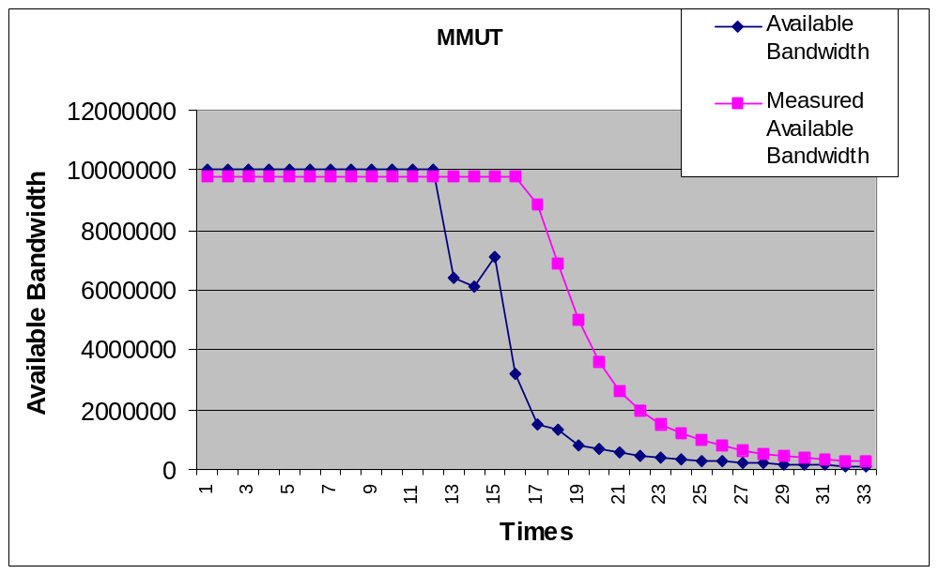It is proposed for the same reason of MMRT, which tries to alleviate the random characteristics of single unidirectional trip time measurement. For the same reason, a small time gap causes the probing packets to experience big available bandwidth difference in a slope traffic pattern. The results of measured available bandwidth are worse than SMUT. The following chart indicates a result of MMUT.
Figure 4.4.1: Available Bandwidth vs. Measured Available Bandwidth (MMUT)
The average Difference for MMUT is 1.4129570943383496, while the average Difference of SMUT is 0.6778850645042714.
Like what we do for MMRT and SMRT. The accuracy of these methods are measured in an ideal traffic pattern -- flat pattern.
Figure 4.4.2 shows the simulation run of both methods under 1MBps traffic. It shows there are a lot of idle time for the bottleneck link. The result of MMUT is closer to the created traffic than that of SMUT. In such a plain pattern, we can conclude that MMUT is a little better than SMUT.
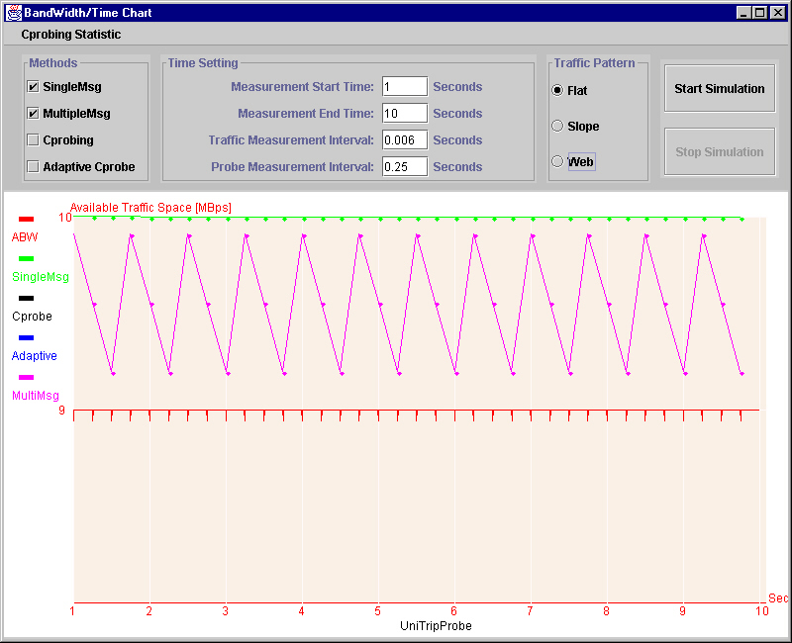
Figure 4.4.2: Comparison between MMUT and SMUT in flat traffic pattern
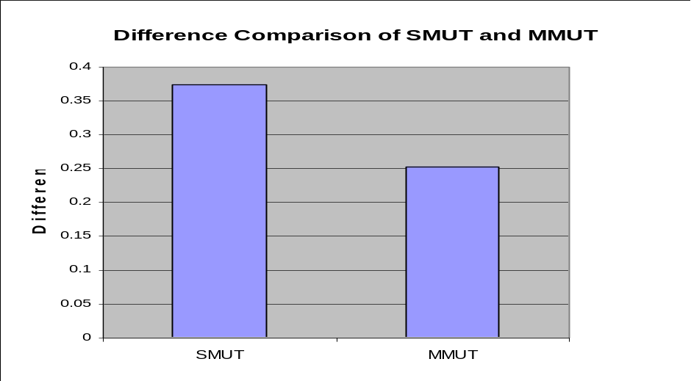
Figure 4.4.3 gives the result of both methods under the web traffic pattern:
Figure 4.4.3: Difference Comparison of SMUT and MMUT
It is obvious that MMUT can improve the effectiveness of SMUT in the real traffic.
4.5 ACB (Adaptive Cprobe)
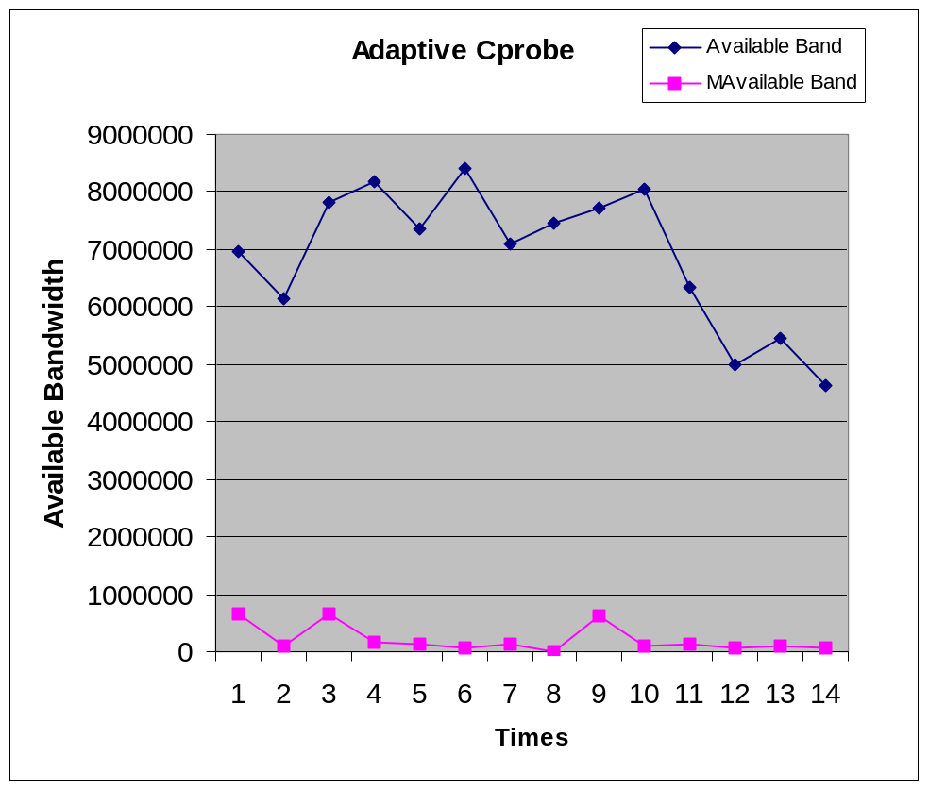ACB is proposed for improving Cprobe. Figure 4.4.1 shows ACB result.
Figure 4.4.1: Available Bandwidth vs. Measured Available Bandwidth (Adaptive Cprobe)

Preliminary results indicated that ACB is a poor method. It triggered us to examine the Cprobe carefully. Figure 4.4.2 shows a group of results with Cprobe.
The result is not so bad, but it is still far away from a satisfied measurement, which make us to research the Cprobe deeper. Section 5.3 presents our analysis on Cprobe. Because the limitations of Cprobe, any further improvement is not tried on ACB.

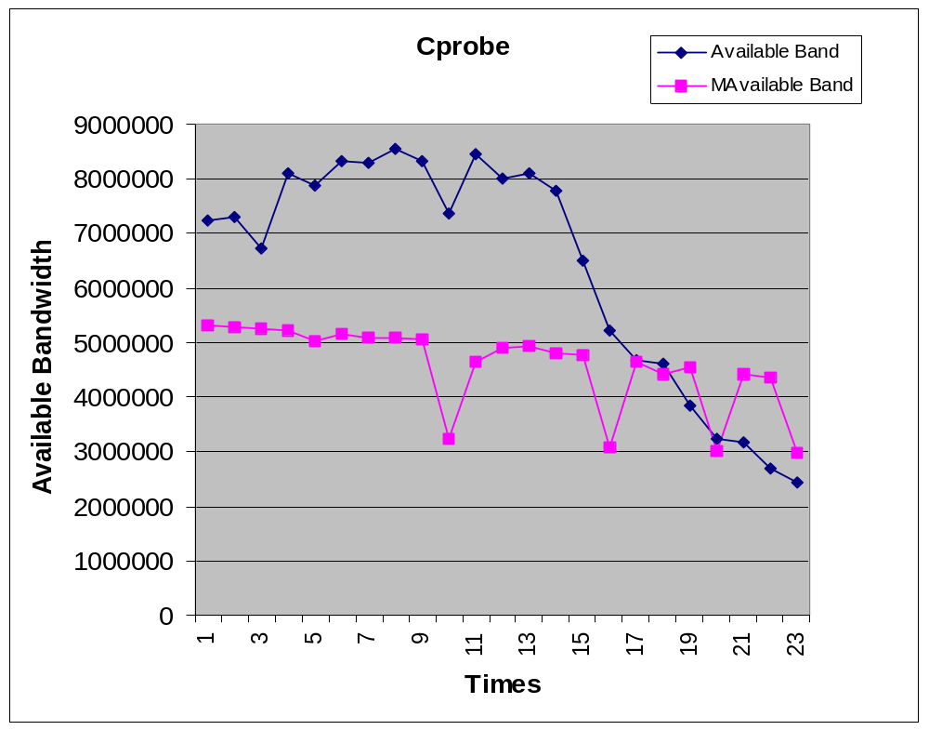Figure 4.4.2: Available Bandwidth vs. Measured Available Bandwidth (Cprobe)

LESSONS LEARNED
  - OOP Design in Java
The model is easier to be implemented in OOP design. It makes me understand OOP design better, for instance, how to design the object to make the model easier to be understood and efficient.
GUI design in this simulation let me know a lot about the graphic user interface design knowledge I never touched before. I learned how to use the swing, AWT and Java2D tools to design a GUI. To decorate the GUI to help user input data easier, which is related to the use of Jbutton, Jpanel, JradioBox, JcheckBox, Jlabel, Jtextfield and Jmenubar to compose an attractive GUI.
In order to compare the result of different measurements, we have to use the thread to execute several measurements at the same time based on same traffic pattern and plot the result of each measurement into single chart to help user visualize and analyze the tradeoff of each probing methods. It is critical to communicate between threads and swing [JFC99].
  - Parameter setting (Router Speed effect on traffic generation)
When we try to generate a certain available bandwidth, we need to set the proper sending time interval between traffic packets. We found that we can not get the expected traffic, even though the time interval setting between traffic packets is correct at the traffic generation agent, especially in the heavy traffic expectation. Later we found that actually, this phenomena are the consequence of un-proper router object parameters settings. For example, if we want the interval time is 0.0011 seconds when traffic packets arrived at the bottleneck link, and one of the router parameter "message processing speed" is set to 10MBps, and the traffic packet size is 12000 bits, the interval time is enlarged to 0.0012 after two neighboring traffic packets go through the router, because the minimal time for a traffic packet to pass the router is 0.0012 (12000/10e+6). It is impossible to get a time interval less than 0.0012, so we need to make sure the expected time interval is greater than the consumed time for a traffic packet to pass through the slowest router.
  - Cprobe limitations.
When we use ACB to estimate the available bandwidth, we found that the result does not make sense even in a light traffic situation (see Analysis of ACB section at the next chapter), which makes us interested in exploring the Cprobe.
We examine the Cprobe in terms of four aspects: Packet Size, Router Speed, Packet number in one round and Hop number. Note that we do examine its behavior when there is no traffic. The traffic generation agent does not involve in the exploration. A probing agent sends a specified number of probing packets and receives the bursts of acknowledge packets, then do the calculation to estimate the available bandwidth. The formula is B = 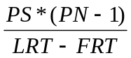 where B is the measured available bandwidth, PS represents single packet size, PN is the packet number in one probing round, LRT is the received time of the last acknowledge packet in one probing round and FRT is the receipt time of the first "Echo-reply" packet in one probing round. The link bandwidth is set to 10MBps.
First we explore the effect of packet size variant on the result of Cprobe.
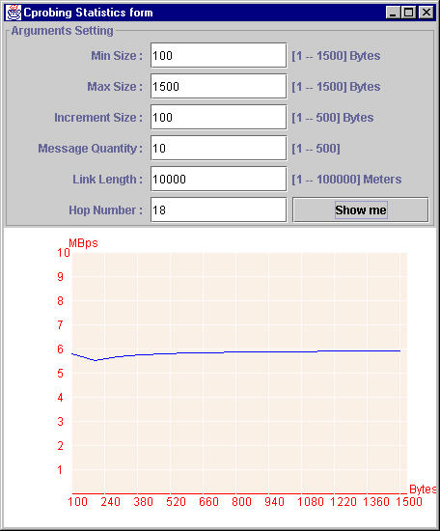
Figure 5.1: impact of packet size on Cprobe
The measured available bandwidth is shown in Figure 5.1. The range of probing packet size is from 100 bytes to 1500 bytes. There are ten packets sent in one probing round. The topology of the transmission route is composed of eighteen hops. The link length between routers is 10000 meters. If the packet size is 100 bytes, the result is only 5.9MBps in a real 10MBps bandwidth network. The larger the probing packet size, a little bit better the measured available bandwidth.
Second we explore the impact of varying packet number on the result of Cprobe.

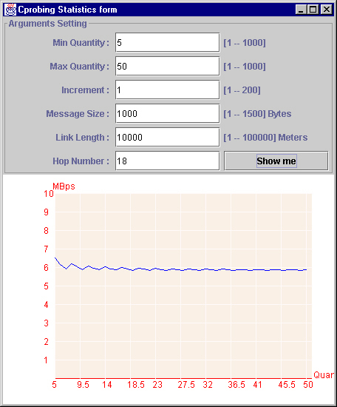
Figure 5.2: impact of packet number on Cprobe
The range of probing packet number is from 5 to 50 in one round. The packet size is 1000 bytes. The topology of the transmission route is composed of eighteen hops. The link length between routers is 10000 meters. If each time we send 5 packets, the result is only 6.5MBps in a real 10MBps bandwidth network. The larger the probing packet size, the worse the measured available bandwidth.
Next we explore the effect of router speed variant on the result of Cprobe.

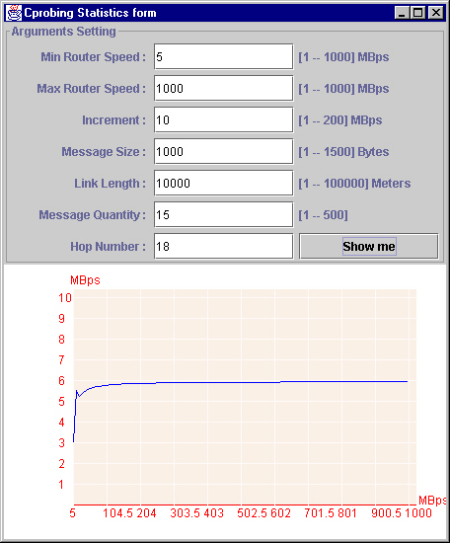
Figure 5.3: impact of router speed on Cprobe
The range of router speed is from 5MBps to 10GBps. The packet size is 1000 bytes. The topology of the transmission route is composed of eighteen hops. The link length between routers is 10000 meters. Each round we send 15 packets. If the router speed is 5MBps, the result is only 3MBps in a real 10MBps bandwidth network for the reason explained in section 5.2. The larger the router speed, the better the measured available bandwidth.
Last we examine the impact of hop number variant on the result of Cprobe.

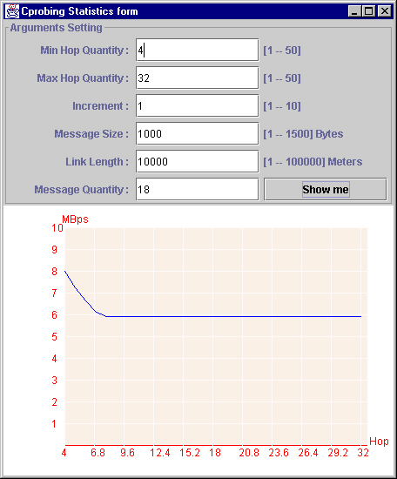
Figure 5.4: impact of hop number on Cprobe
The range of hop number is from 4 to 32. The packet size is 1000 bytes. The link length between routers is 10000 meters. Each round we send 15 packets. If the hop number is 4, the result is only 8MBps in a real 10MBps bandwidth network. The more the hop, the worse the measured available bandwidth.
Explanation: Analyzing the log files, we found that the nonsense results come from the intervening between probing packets. Since Cprobe sends a sequence of probing packets, the front probing packet acknowledge packet has intervene with the latter probing packet so that the queuing time of the packets go through the whole connection is increasing. The increased round trip time is not the result of traffic competition, but the consequence of interlace among forward and backward probing packets. Figure 5.5 gives us some hints.

Figure 5.5: interference among probing packets
Figure 5.1 tells us the increment of the probing packet size has little impact of the Cprobe results, due to the intervening between probing packets.
Figure 5.2 tells us the packet number, which has little impact of the Cprobe results.
Figure 5.3 tells us if the router speed is lower than the link bandwidth, the router enlarges the interval time between probing packets when packets go through the router, it increases the round trip time. We found there is a threshold point in the chart, after the threshold that the router speed is faster than the link speed, the router keeps the time interval between probing packets, so we see a flat line after the threshold value.
Figure 5.4 tells us the more hop along a route, the longer transmission time the probing packets in the network, the more intervening among probing packets. But the packet number is constant, so that the upper bound of intervening happen in the transmission is constant, it is why we can find a flat line after a threshold value in the chart.

  - Machine double data type precision problem
In the light traffic pattern, which means traffic do not cause any congestion in the network, we find that the round trip time of a probing packet is even less than a round trip time of same size probing packet without any traffic. The difference is usually less than 1e-8. After analyzing the log files (each node of the probe route has a log file), we find it came from the precision problem of the double data type in Java language. A decimal number can not be represented exactly. For example, double number 5.6 maybe represented by 5.5999999999 in Java sometimes. The precision problem causes a 0.001% deviation to its exact value. Actually, we can ignore the precision problem influence in heavy traffic pattern.

IMPLEMETATION OF SMRT
We implement SMRT in C. Here are the design and our solution.
How to get the maximal available bandwidth of a connection
We can use Bprobe, contained in uprobe tools, to measure it. We read each target host provided in the host list file and use Bprobe to measure the bottleneck link bandwidth of the connection between our server and each host included in list. Recording the result of each host in a file.
How to get the minimal round trip time of a connection
We use Ping to measure it. We read each target host in the host list and use Ping to measure its minimal round trip time of each host. The result of each host is recorded in the same table file with Bprobe result. The above two tasks can be done at a constant rate periodically for a long run. We just keep recording the minimal value for round trip time and maximal value for the bottleneck available bandwidth.
The Implementation
Before the user tries to use SMRT to measure the available bandwidth of a host, the user creates a host list file. We provide a tool, called HisCall, which is a history collection tool. The tool reads the list and measures the bottleneck bandwidth with bprobe and round trip time with ping for each host enclosed in list file.
The user should run the tool HisCall before he uses SMRT. SMRT will seek the host history information in the history file. If not, smrt can not do the measurement for the user. Smrt uses ping, which only sends one echo ICMP message to host, to get the round trip time and calculate a measured available bandwidth based on the history information of the host.
SMRT Data Example and User Manual
We tested some download sites which are accessed frequently for software package archives by students: metalab.unc.edu, ftp.cc.gatech.edu and ftp.redhat.com.
1) we provides a host list file siteList.txt, the format like this:
metalab.unc.edu 0 100000
ftp.cc.gatech.edu 0 100000
ftp.redhat.com 0 100000
The first data in an independent line is the host name.
The second data in a line is the bottleneck bandwidth of a connection. The unit is bps. We need to find the biggest value of Bprobe, so the initial value is 0.
The third data in a line is the mean round trip time of a probing message. The unit is millisecond. We need to find the smallest value of Ping, so the initial value is 100000 ms.
2) We use HisCall to collect some history information of each host enclosed in siteList.txt. HisCall will call Bprobe to measure the bottleneck bandwidth and Ping to measure the minimal round trip time for each host. HisCall needs a command line argument to get the host list file name. In this example, we type in "HisCall siteList.txt" at the command line. The result will overwrite the siteList.txt file. The following is an example of our result for above sites:
metalab.unc.edu 9.05134e+6 55.1
ftp.cc.gatech.edu 7.51150e+6 77.3
ftp.redhat.com 8.98917e+06 74.6
3) We use smrt to measure an instant available bandwidth of a specified host in siteList.txt. smrt needs two arguments, first is the host list file name and second is the special host name. In this example, we type in "smrt siteList.txt ftp.cc.gatech.edu" at the command line. The output on the screen is:

Available Bandwidth is : 5788440.540000

We also try to collect some history information of some local hosts. See the following table.
Table 6: History information of some local machine
Host Name | Bottleneck Bandwidth(Bps) | Round Trip Time (ms)
Frodo.uccs.edu | 9.76291e+6 | 0.6
Wetterhorn.uccs.edu | 9.785104e+6 | 2.2
Redcloud.uccs.edu | 9.870542e+6 | 2.2
Sanluis.uccs.edu | 9.77406e+6 | 2.4
SMRT Limititions
First, we need to know the target host list in advance. If we do not find a host name in the list, SMRT cannot probe the available bandwidth of the host because it has not history information, which makes the formula
ProbeB * PMRoundTripTime = BottleneckLinkBandwidth * PMNoTrafficRoundTripTime (7)
useless.
Second, we use ping to measure the round trip time of a probing packet, but some hosts do not echo ping so as not to get the necessary history information.

CONCLUSIONS AND FUTURE WORK
In this paper, we proposed several algorithms for measuring the available network bandwidth. We mainly focus on the SMRT and explore its characteristics. It is a good strategy for probing if the single message can do the job.
Based on the simulation result in Section 4.1, it can be concluded that SMRT works well when the utilization of the bottleneck link is below 100%, which means there is idle time for bottleneck link. If the bottleneck link utilization is 100%, which means probing packets must compete with other traffic packets, the measured bandwidth of our methods is deviated from the accurate value dramatically. Because we use the formula:

ProbeB * PMRoundTripTime = BottleneckLinkBandwidth * PMNoTrafficRoundTripTime (8)

where ProbeB is the measured result bandwidth, PMRoundTripTime represents the probing packet round trip time, BottleneckLinkBandwidth is the largest bandwidth of the bottleneck link, PMNoTrafficRoundTripTime is the smallest round trip time of a probing packet. Based on Figure 4.1.2, it can be concluded that the trip time is not linear proportional to the available bandwidth.

MMRT is proposed to improve the result accuracy of SMRT. As shown in Figure 4.2.3, MMRT dramatically improves the performance of SMRT, where the mean Difference of MMRT is 0.2 while SMRT is 0.4.
SMUT is proposed to measure the unidirectional route available bandwidth. The purpose of MMUT is to improve SMUT performance. From Figure 4.4.3, we can see the clear performance improvement.
The simulation results show that at very light load, the round trip time measurements can estimate the available bandwidth well. Under mediate and heavy load, the round trip time measurements is not a good indicator. Further research is needed to improve the methods.
This program is written in Java, so its executing speed is a problem. To improve the performance, one can convert it to C.
Currently, our simulator can measure the available bandwidth in a web traffic pattern, but we did not explore how to generate heavy workload as the real web traffic.

REFERENCES
[BC97] Barford, Paul, and Mark Crovella, Generating Rerepresentative Web Workloads for Network and Server Performance Evaluation, Computer Science Department, Boston University, Technical Paper BU-CS-97-006, Revised December 31, 1997.

[Blais 2000] Arthur L. Blais, Evaluation of load balancing algorithms and Internet traffic modeling for performance analysis, College of Engineering and Applied Science, University of Colorado at Colorado Springs, Master thesis, April 2000.

[Bolot93] Bolot, Jean-chrysostome, “Characterizing End-to-End Packet Delay and Loss in the Internet”, December 1993, Journal of High Speed Networks, vol.2, No. 3.

[Carter96] Robert L. Carter and Mark E. Crovella, “Measuring Bottleneck Link Speed in Packet-Switched Networks”, March 15, 1996, Boston University.
http://cs-www.bu.edu/students/grads/carter/papers.html

[CBC95] Cunha, Carlos, Azer Bestavros and Mark E. Crovellla, Characteristics of WWW Client-bases Traces, Computer Science Department, Boston University, Technical Paper BU-CS-95-010, July 18, 1995

[Downey99] Downey, Allen B., “Using pathchar to Estimate Internet Link Characteristics”, Proceedings of ACM SIGCOMM’99, 1999.

[J91] Jain, Raj, The Art of Computer System Performance Analysis, Techniques for Experimental Design, Measurement, Simulation, and Modeling, John Wiley & Sons, Inc., 1991

[Jacobson97] Van Jacobson, “pathchar – a tool to infer characteristics of Internet paths”, April, 1997, Berkeley, University of California. ftp://ftp.ee.lbl.gov/pathchar/

[JFC99] Addison Wesley publishing, "The JFC Swing Tutorial: a guide to constructing GUIs", June 1999.

[MM96] M. Mathis and J. Mahdavi, "Diagnosing Internet Congestion with a Transport Layer Performance Tool," Proceedings of INET'96, Montreal, June 1996.

[MUUS83] M. Muuss, Ping Software, U.S Army Ballistic Research Laboratory, December 1983. Available by anonymous FTP from uunet.uu.net: /bsd_sources/src/ping.

[Net2Phone00] www.net2phone.com

[Paxon97] Vern Paxson, “Measurements and Analysis of End-to-End Internet Dynamics”, April, 1997, Berkeley, University of California, PH.D. Thesis.

[Real99] www.real.com

[PF95] Paxon, Vern, and Sally Floyd, Wide-Area Traffic: The Failure of Poisson Modeling, Lawrence Berkeley Laboratory and EECS Division, University of California, Berkeley. July 18, 1995

[PKC97] Park, Kihong, Gatae Kim and Mark Crovella, On the Effect of Traffic Self-similarity on Network Performance, In Proceedings of the 1997 SPIE International Conference of Performance and Control of Network Systems, 1997

Rick Decker & Stuart Hirshfield, "Programming.java: An Introduction to Programming Using Java", PWS Publishing Company, 1998.

APPENDIX
APPENDIX A: ManPage for Simulator
NAME
NABM Project
SYNTAX
Call directly
Description
Simulator is a Java project file used to generate all the measured data for proposed methods in this paper and show you the real-time processing result in a chart. It needs a configure file to set some network parameters.
Below is a brief description for each class enclosed in Simulator project file.
  - NABM.java
SYNTAX
Call directly
Description
Simulator is the main driver of the whole Java project
  - Chart.java
SYNTAX
Call directly
Description
GUI Interface let user change some configurations before starts to run the simulator. User may choose multiple methods. Measurement Start time let user to specify when simulator begins to report the result (writing results to log.txt file and update chart). Measurement End time tell simulator when to stop the simulation. Traffic Measurement Interval sets how long simulator makes a report to the real-time available bandwidth (this will be represented as a red dot on output chart). Probe Measurement Interval sets how long methods send a probing packet to measure the available bandwidth. When sender receive the corresponding response packet of the sent probing packet, we get a measured available bandwidth value (this will be represented as a different color dot on output chart). User only can choose one traffic pattern, which means all the selected methods will run on the same traffic pattern.
There has a menu bar in this frame -- "Cprobing Statistic", which is used to analyze some characteristic of Cprobe. It invokes CprobArguments.java to do all the analysis on Cprobe.
The bottom half part of the frame is the area for the output chart.
  - CprobArguments.java
SYNTAX
CprobArguments(int I)
Description
Open another GUI Interface to let user change some parameters before starts to analyze Cprobe. All the results are achieved without traffic in the network, which means probing agent sends the Cprobe packets to measure the available bandwidth in a nontraffic network. We can find the limitations of Cprobe.
Parameter I is used to distinguish the analyzed aspect of Cprobe packet. The Arguments Setting form is a little difference based on different aspect. We just introduce the MessSize aspect form. Min Size and Max Size give the lower and upper bound of the single probing packet size. Increment is the increasing value of packet size for each output. Message Quantity give how many packets are sent each time. Link length is the link length of a link between two routers. Hub Number is the router number of the probing router (at least 4).
The bottom half part of the frame is the area for the output chart.
  - CprobStatistic.java
SYNTAX
CprobStatistic(String TestType,int argu1, int argu2, float argu3, int argu4, int argu5, int argu6, int argu7, JPanel p)
Description
Based on arguments, probing agent sends the Cprobe packets to measure the available bandwidth in a nontraffic network. It invokes StatisChart.java to update the result chart.
  - StatisChart.java
SYNTAX
StatisChart(double HStart, double HEnd, int HNum, String HCap, double VStart, double VEnd, int VNum, String VCap, JPanel p)
Description
This class is a special drawing class. It draws the chart in the given Jpanel (parameter p). HStart and HEnd give the horizontal axis range. HNum gives the number how many legacy points on the horizontal axis. VStart and VEnd give the vertical axis range. VNum gives the number how many legacy points on the vertical axis. HCap and VCap give the caption of horizontal and vertical axis.
  - NetworkConfigure.java
SYNTAX
Description
This is an abstract class. It is the parent class of the abstract class measurement and class CprobStatistic. It gives some basic network parameters' setting.
  - NetComponents.java
SYNTAX
Description
This is an abstract class. It is the parent class of Link and Router.
  - Link.java
SYNTAX
Link(NetworkConfigure simulator, double distance, int number, double LinkBandwidth)
Description
Encapsulate all the action taken by a link. It calculates the propagation time and transmission time. Only transmission time influences the local time of a link for the pipeline character of a link.
  - Router.java
SYNTAX
Router(NetworkConfigure simulator, int i)
Description
Encapsulate all the action taken by a router. It calculates the switching time and message processing time.
  - Measurement.java
SYNTAX
Description
The parent class of all the measurements. It reads the first line arguments in configure.txt file to set some network arguments.
  - AdaptiveCprobingMeasurement.java, CprobingMeasurement.java, MultipleMessMeasurement.java and SingleMessMeasurement.java
SYNTAX
Description
Measurement class. Each run in its own thread.
  - TimeCompare.java and Message.java
SYNTAX
There are different constructor for traffic packet and probing packet.
Description
Message implements TimeCompare class. Message class defines the packet used by traffic generation agent and probing agent. Its field "nextArrivalTime" is the next wakeup time of the packet.
  - EventsQueue.java and OrderedList.java
SYNTAX
Description
A queue to store ordered events. The type of each event in the queue is a Message. All the message is ordered by its next wakeup time. It delegate its function to class OrderedList.
  - RouterTable.java
SYNTAX
public RouterTable(int ID, int NodeNum)
Description
The route of a packet going and backing between source and target routers.
  - Traffic.java
SYNTAX
Different constructor for different traffic pattern.
Description
It is used to change some traffic parameters. It is in charge of changing the interval time between two neighbor traffic packets so as to get the desired traffic.
  - Weibull.java and Pareto.java
SYNTAX
Description
Used in Web traffic pattern.
  - configure.txt
Example

9|0|0.00002|0.000002188|160|46|100000
6|5|2|2|15|10
R1|L1|R2|L2|R3|L3|R4
R5|L4|R2|L2|R3|L5|R6
Description
First line:
- For flat traffic, how big the available bandwidth(Mbits) you want.
- Uni-trip measurement (1) or RoundTrip measurement(0). No uni-trip measurement for Cprobing and AdaptiveCprobing.
- The biggest interval time between two neighbor traffic packets.
- The smallest interval time between two neighbor traffic packets.
- Each traffic packet size (Byte)
- Each probing packet size (Byte)
- Link length (Meters)
Second line:
- How many routers exist in your network.
- How many links exist in your network. Always less one than router.
- How many routes exist in your network. It decides how many lines you need to contain in the following lines. In this example, because the value is 2, so there are two more lines enclosed in the rest file.
- The link number of bottleneck link. You can arbitrarily refer the link number. Of cause this link is the mutual one of all the routes.
- How many packets need to be sent in one Cprobe cycle.
- How many packets need to be sent in MultipleMessMeasurement one time.
Third line:
- The probing route.
- R represents Router. L represents Link. Number is the corresponding link or router number. Router or Link number starts from 1.
Fourth line: the traffic route.
Note: How to calculate the biggest or smallest interval time between two neighbor traffic packets?
Assume that bottleneckLink bandwidth is B, each traffic packet size is Traffic, the available bandwidth is A, Queuing size is Q, each probing packet size is P, the traffic measurement interval time is T, then from the real available bandwidth formula B*[P/(P+Q)] = A, we get Q. The interval time is [T/(Q+T*B)]*Traffic.
  - log.txt
Description
Data files generated by simulator
Example

Round Trip Time: 0.001275072
Probing start Time: 0.5 End Time: 0.5014625163636195 Measured BandWidth: 8718343.477842545
Starting Time: 0.4992000000000005 End Time: 0.5056000000000005 Available BandWidth: 1.0E7 | 0 | 2.515781818181818E-4 | 7

Usually a log file is consisted of several types output record. For the above example:
- Round Trip Time: the value is the round trip time of a probing packet without traffic.
- If a record is generated by a probing packet, the output using Probing as its prefix.
- The rest records are generated by simulator at each report time.

APPENDIX B USER GUIDE
If user has the Jbuilder3.0 or above version development environment. Double click the NABM.jpr file, the Jbuilder3.0 opens all the java source files automatically. Click the run button or choose "run 'NABM' " from the command menu Run. User will see the main frame in his screen.
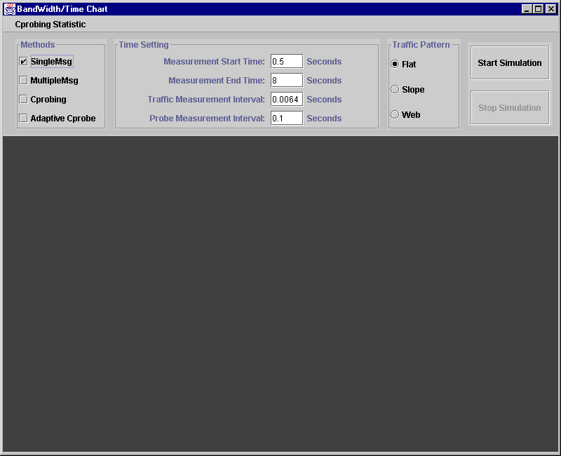
Main frame of NABM
The top half of the main frame is the control panel to set some common parameters value of the simulation. The bottom half is the output area of the result chart. This area will be updated after user click the start simulation button in the top rightmost button in the control panel.
How to choose methods
There are four parameter groups. The leftmost one is the place to set the probing methods. If user want to check multiple methods in one simulation, user just choose the corresponding method and make sure the method you want is checked. SingleMsg represents single message trip time measurement. MultipleMsg represents multiple message trip time measurement. Cprobing represents Cprobe measurements. AdaptiveCprobe represents adaptive Cprobe measurement.
How to set network arguments
The second group let user configure several network arguments. Measurement start time and Measurement end time give the time when probing starts and when the simulation end. Traffic Measurement Interval tells the traffic generation agent how often it sends a traffic packet. Probe Measurement Interval sets the idle time between probing rounds.
How to choose traffic pattern
The third group let user to choose the traffic pattern. It does not allow user doing multiple choice, which means all the checked measurements will execute on the same traffic pattern in order to compare their measured results in the output. Note: each checked measurement will execute in its own thread, which guarantee there has no interference between measurement execution.

How to start and stop simulation
Click on start simulation will start the execution of simulation. Click on stop simulation command button will stop the execution of simulation. Once the measurement result begins to update the result chart, its execution cannot be stop even though user click stop simulation button. It is the genetic problem of Java thread. Once user start the simulation, there is no way to stop single measurement execution if user run several measurements at a time.
Where to find the log file
The generated log file is located at the same directory as that of NABM.jpr project file. The file name is always "log.txt".
Where to put the configure file
How to edit the configure file, user should to refer 8.17 in Appendix A. The configure file "configure.txt" always is placed in the same directory as NABM.jpr project file location.
Run on Unix/Linux Machine
The version of JDK must be greater than 1.2.
The operation difference is that deleting the package instruction in each java source file. Do not need the .jpr file any more. NABM.java is the main driver file. Using "javac *.java" to compile all the source files. User will find all the .class files under the same directory. Using "java NAMB" to start the main frame introduced in last section. Other operation is the same as the last section.

