CHAPTER I

INTRODUCTION

It is often necessary to replicate databases and network services available over the Internet in order to serve a large number of clients more efficiently [1][2][3][6]. Additionally when servers are replicated over several geographic locations on the Internet, they reduce the congestion on backbone and international links and provide faster access to the users.
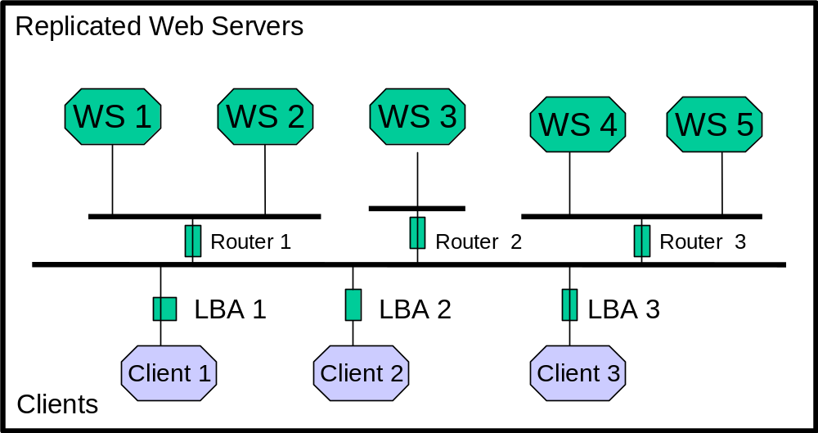
Figure 1.1. Load Balancing System

A configuration with replicated web servers is depicted in Figure 1.1. Whenever the replicated database is available, the user needs to determine which of the replicated servers will provide a “better” service. One could make the choice based on the geographic proximity of the server or simply choose the first choice offered. However, this method is static in nature and may not necessarily provide the user with the best service. The load over the networks and at any given server can change dynamically and so it would be advantageous to have the server selection be based on the dynamic nature of the network and the server load.
In this thesis we have studied the factors that affect the quality of connection or the response time of a remote server. In our study the choice of server takes into account the traffic along the network connection to each of the replicated servers, as well as the load at each of the servers.
The algorithm developed in this thesis provides the user with the IP address of the server that has the least response time. This selection is made from several statistical data collected by a Load Balancing Agent (LBA) developed in this thesis. The frequency with which the statistics about the network are collected can also be adjusted. This frequency could depend upon the required accuracy of the result as well as some other factors e.g. the time of day. For instance, during off-peak hours, the networks are not as dynamic so the statistics need not be collected as often. During high traffic some statistical data could be collected to make better decisions regarding the server. The Load balancing agent (LBA) collects three kinds of data:
- The bottleneck bandwidth or the bandwidth at the slowest link along a given path
- The available bandwidth or the bandwidth available to a user when the path is congested
- The expected delay at the web server, based on the size of the pending queue at the web server and its processing power.
The LBA collects network path statistics using two probing tools Bprobe and Cprobe [3]. The delay at the server is measured by the server itself. This was accomplished by modifying the Apache Web Server source code [19]. Once the statistics are available, the LBA calculates the ranking of each replicated server.
Normally when a user tries to access services of a remote host, a Domain Name System (DNS) server provides a mapping that converts host names into IP addresses. For this thesis, we used a modified load balancing DNS [22][23]. A cluster of servers is associated with a logical domain name, e.g. best.csnet.uccs.edu. Our modified DNS reads the file created by the LBA with the server names and their ranks, and selects the highest ranked server and uses this name to form a query response to the DNS system on the clients. Thus the DNS returns the host IP address of the server that is ranked the best. This work has been explained in [22][23].
The combination of our LBA and the modified DNS connects the user with the best-ranked server. Thus, in this thesis we have automated the dynamic selection process for the client.

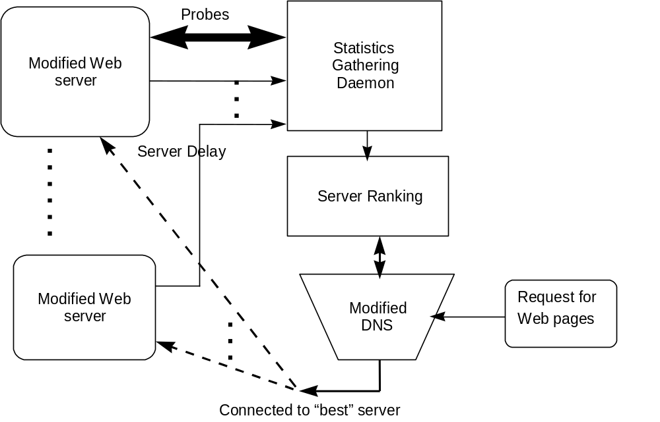

Figure 1.2. Load Balancing Agent

In the following sections of this chapter, we briefly describe the existing framework upon which we designed the Load balancing system.

I.1 The Apache Web Server. The Apache Web server [8][19] version 1.3.9 belongs to the third generation of Web servers. It uses the keep alive protocol that maintains the connection for a certain period of time and allows a client to send multiple requests per connection. Therefore it has eliminated the overhead involved in reestablishing a connection for each new request. Apache is a pre-forking model server. The parent process is responsible only for forking child processes, routing requests to child processes, and performing adaptive control of child processes. It does not serve any requests or service any network sockets. As the server is pre-forked, the overhead involved in forking a new process for each additional request is eliminated. The child processes actually process connections and serve multiple connections (one at a time) before dying out. The parent spawns new or kills off old children in response to changes in the load on the server, which it can determine by monitoring the scoreboard which the children keep up to date. Typically this is implemented using shared memory. When a shared memory implementation is not possible, the on-disk file is used by default. However, the on-disk file is slow and unreliable.
The MaxClients setting controls the maximum number of children spawned. This parameter is set based on the machine RAM size. The number of MaxClients has to be fine-tuned so that the server does not have to swap. Swapping causes latency, which often is the reason why a user hits “stop” and “reload”, which further increases the load.
In [20] the author discusses several performance problems resulting from interactions between implementations of persistent-HTTP and TCP. Explained in [20] is the reason for disabling the Nagle algorithm for the Apache Web server. They also explain why memory mapping is necessary for web servers and when it is most efficient.
As of Apache 1.3, the code has modified the one second rule to make the server more efficient, i.e., at start up time, a child is created per second till the number of children spawned satisfies the MinSpareServers setting. Apache 1.3 and later versions will spawn one, wait a second, then spawn two, wait a second then spawn four, and it will continue exponentially until it is spawning 32 children per second. It stops when it satisfies the MinSpareServers setting. With keep-alives in use, children are kept busy doing nothing waiting for more requests on the already open connections.
Details about the modifications made to the existing Apache web server code are given in Chapter 3 of this thesis report.

I.2 DNS and BIND. The other piece in the existing framework is the application for conversion of hostnames to IP addresses. The DNS [7][18] or Domain Name System, is a distributed database of host information. It allows local control of the segments of the whole database, yet data in each segment are available across the entire network through a client-server scheme. One of the most popular implementations of DNS is BIND (Berkeley Internet Name Domain). A daemon, typically called named, binds to port 53, listening for requests from clients.
It is a natural tendency for humans to easily remember “host” names of computers and type it in with ease, whereas computers address each other using numbered IP addresses. On the Internet the IP address is 32 bits long. The DNS handles mapping between host domain names and Internet addresses. In fact, DNS is the standard mechanism on the Internet for advertising and accessing all kinds of information about hosts. DNS is used by practically all internetworking software like web browsers, electronic mail, remote terminal programs, such as telnet, and file transfer programs such as ftp.

I.2.1 DNS Database tree. Each host on a network has a domain name, which points to information about the host. This information may include IP addresses, information about mail routing, hardware information etc.

“ “ root
gov
mil
com
edu

Figure 1.3. DNS Database
Domain name servers in the tree point to structural information about the domain’s children or sub-domains. Domains at the leaves of the tree generally represent individual hosts. Hosts may also have one or more domain name aliases, which are simply pointers from one domain name (the alias) to another (the official or canonical domain name). Domains are given unique domain names, so organizations are free to choose names within their domains.
Name servers constitute the server half of DNS’s client-server mechanism. Name servers contain information about a segment of the database and make it available to programs called resolvers. Resolvers are often just library routines that create queries and send them across the network to a name server. The resolver handles:
- querying a name server,
- interpreting responses,
- returning the information to the programs that requested the information and,
- some resolvers can also build up a cache of information already retrieved for the name server.
The structure of a DNS database shown in Figure 1.3 is pictured as an inverted tree. Each node in the tree represents a partition of the overall database. Each node constitutes a domain. Each domain can be further subdivided into partitions called subdomains in DNS. The depth of the DNS name space tree is limited to 127 levels. A domain has a domain name. In DNS, a full domain name is the sequence of labels from the domain to the root, with “.” separating the labels. The label can be up to 63 characters in length. Address to name mapping is complicated by the fact that domain names are written from left to right. The most specific details are at the beginning, and the least specific at the end, whereas IP addresses are written with the least specific number at the beginning and the most specific one at the end.
The DNS database files have resource records (RR) to map names to addresses called address and alias records. There are also resource records to do a reverse mapping, i.e. address to name mapping. These RR are called PTR records. To map an IP address to a name in DNS, we first reverse the IP address, append in-addr.arpa, and look up the PTR data.For example the PTR record for rangoon.movie.edu in the network 192.249.249 would be as follows:
249.249.192.in-addr.arpa. IN PTR rangoon.movie.edu
The root domain has a null (zero length) label, which is reserved. In DNS each domain can be administered by a different organization. Root name servers are authoritative for the top level US organizational domains.

DOMAIN NAMES
Most specific
Least specific
elbert.uccs.edu

Figure 1.4 a Problem with name to address mapping in DNS

IP ADDRESSES
Least specific
Most specific
152.192.16.15

Figure 1.4 b Problem with address to name mapping in DNS

Given a query about a domain name, they can provide a list of name servers authoritative for the second level domain that the domain is in. In the absence of other information, resolution has to start at the root name servers. DNS provides caching to help offload the root name servers.
Name servers generally have complete information about some part of the domain name space, called a zone. The name server is then said to have authority for that zone (or multiple zones). A zone contains the domain names and the data that a domain contains except domain names and data that are delegated elsewhere.There are several types of name servers:
- Primary master name server: gets the data for the zones it is authoritative for, from files on the host it runs on.
- Secondary master name server: gets its zone data from another name server authoritative for the zone. When a secondary starts up, it contacts the name server it updates from and, if necessary, pulls the zone data over. This is zone transfer.

“ “ root
us
net
mil
us domain
ca
il
ny
us zone
pa
mpk

ca.us domain
Figure 1.5. Multiple Domains

When a user types in a request for a web page with the URL:
http://www.apache.org/ns_main.c
The web browser parses the URL and sends a DNS request with www.apache.org to its local name server. DNS checks its database and if it is not in the local name server, DNS sends a query to a higher level server for apache.org . After a successful search, DNS provides the IP address of the host, which maps the domain name apache.org.

DNS

http://www.apache.org/ns_main.c
IP ADDRESS:199.45.212.4

Figure 1.6. Name to address mapping by DNS

The thesis report is organized as follows, in Chapter 2, we present the survey of related work. Details on the implementation of the modified web server are in Chapter 3. Chapter 4 covers the modified DNS. Implementation of the LBA is given in Chapter 5. Performance results of the Webstone benchmark on our load balancing system prototype and conclusions are in Chapter 6. Chapter 7 gives our conclusions and future enhancements that would add features to the LBA and also allow it to be used in a WAN environment.
.

CHAPTER II

RELATED RESEARCH

In the past, many static schemes for server selection have been developed. Schemes for static server selection mainly use the geographical location of the client and server or the distance measured using network hops. More recently, dynamic algorithms were developed [1]-[6]. An excellent survey and performance analysis of Load balancing Algorithms is in [26]. Some dynamic algorithms use the Round-Robin scheme to rotate through a set of identically configured servers [1]. In other dynamic server selection methods, the dynamic nature of the network is taken into account. [2] - [6]. This means that the client must have knowledge about the traffic on the path from the client to each server before a selection is made. As the load on servers also varies, the load factor must also be taken into account when making a selection [6].
Much research on dynamic server selection has been done, for example the scalable HTTP server [1], the selection techniques in [2], and the dynamic server selection in [3].
In [1], the server is selected based on a round robin mechanism. This leads to load sharing rather than load balancing. The server load is not taken into account. The technique in [1] works best when all the servers are identically configured and are located in the same subnet. In order to ensure that each system would look and feel the same to the user, i.e., to replicate and update files over each system, the authors used the Transarc’s Andrew File system®. The method provides some dynamic scalability as any number of servers can be added to the available pool of servers, dynamically increasing the load capacity of the virtual server. With each new request the round robin mechanism rotates through a list of available servers.
Here, the Domain name resolver acts as a virtual router or switch through which the request travels. All servers respond to a single name but the files are distributed over several servers. Their modified BIND+ (Berkeley Internet Name Domain) code lets “named” to rotate round robin through a list of several IP addresses. As this configuration would normally conflict with other systems which expect a different behavior for multiple address records, the authors had to ensure that the round-robin is only used if the host entry in the domain file has the WKS (Well Known Service resource record) titled “http”.
The major problem with this method is that the caching mechanism used by the DNS. Caching minimizes the redundancy and maximizes the efficiency of DNS. However, with the round-robin scheme, it is not desirable because the least used server address is cached and subsequent requests to the same subnet will result in the cached address being provided. Thus the round-robin method will not work as expected. Typically, the server cached in memory will be used more heavily until its TTL (Time To Live) expires. For this reason the authors have used the minimum value possible for the TTL parameter. The expense in doing this is the increased load on the DNS server. This forces more direct queries to the DNS, which increases the response time. This is the tradeoff in maintaining a small TTL.
Another solution, in [1], is to monitor the system closely to catch any bias towards a particular server early enough, and remove it from DNS cache tables in time, sufficient to preempt the delay in propagation, inherent in DNS. For this reason the authors have developed a tool to monitor the web servers. However, the main drawback of this setup is that the round robin scheme does not differentiate between the servers and blindly rotates through them. For it to work efficiently the system must be identically configured, the servers must be identical in terms of load capacity, and be located within the same subnet.
In [2], the server selection is based upon the load condition as well as the path characteristics. The technique in [2] provides an accurate picture of the server and path performance. A modified Apache Web server measures the performance by monitoring the servers access logs and evaluates the expected delay based on that information. The modified web server writes out this information to a file. The clients obtain the server status by sending probes to the server that requests this file. The roundtrip delay in obtaining the file is used as a measurement of path characteristics. Thus each client has path characteristics as well as information about the server load processing capacity. There are two minor drawbacks of this work. First, the server is providing its load information on the basis of its load history, which is not current and not accurate, as the load is dynamic. Changes are recorded in the access logs after a file has been transmitted in its entirety. Thus even if the server has several large requests pending, if its recent access log indicated that a file was transmitted with little delay, then the delay information recorded is inaccurate. The server might have a significant delay.
Secondly, path characteristics are being measured based on the transfer of a small file. We know that during file transfer, the file is broken up into packets and reassembled at the destination. Packets of the same file could travel through different links on the network. Packet reassembly would vary for files of different sizes. Thus path characteristics based on only the transfer of a small file does not give an accurate result.
We have used this work as a base, and developed our algorithms to measure the server load and path characteristics even more accurately.
In [22], a dynamic load-balancing algorithm was implemented. In [2], the path characteristics as well as the server load information are used for making a server selection. The roundtrip time (RTT) to send a packet to another host or the network latency was measured using the ping. Ping is a network utility that utilizes ICMP echo request and echo response. The server load was measured by using the Unix operating system utility called vmstat. Vmstat provides statistical data on the system’s performance relating to process memory, swap, IO, system calls and CPU. Compared to this work in [22], the implementation presented in this thesis uses more accurate measuring tools.
A modified DNS in Perl was implemented in [23]. The modified DNS has been configured and used in our thesis implementation. We will visit this work in Chapter 4.
In [3][4][5], bandwidth-probing tools were developed to dynamically select the best server. This work is a major improvement to the static server selection methods and their experiments improved the selection process by 50%. A valuable contribution by [3] is that they developed path-probing tools that measure path characteristics very accurately. These tools, BPROBE and CPROBE were ported in another project for use in our labs and have been used in our experiments. They are included as a part of the Load Balancing Agent in this thesis implementation.
A drawback of the implementation in [3] is that it does not take into account the server load. The criterion in [3] for server selection is based only on the bandwidth along the given path and the congestion.
The Zeus Load Balancer [24] is a commercially available load balancing solution. It has been designed to distribute complex web-applications across a heterogeneous server cluster. Their product specification indicates that the server cluster must be on the same subnet. Therefore the Zeus Load balancer does not provide load balancing for geographically distributed, replicated web sites. A significant improvement in their load balancing technique is achieved by Locality Aware Request distribution algorithms that arrange the local cache of individual backend server nodes for re-use. The effective cache size of the server cluster approaches the sum of the cache sizes of the backend server nodes, as opposed to other load balancers where the effective cache size of the server cluster is normally the minimum of the cache sizes of the backend server nodes.
In [6] a load balancing technique was implemented keeping in mind that server load information is often stale. Rather than risk extremely bad performance on one hand, or ignore the chance to use load information to improve performance, algorithms were developed to interpret server load information based on its age. As servers cannot accurately inform clients of the current load and the anticipated arrival rate, their algorithm uses a strategy to estimate the arrival rate. Another parameter that the clients need to be told is the age of the load information. The approach is to estimate the job arrival rate based on the known maximum system throughput value. If the system is heavily loaded, the estimate will be only a little higher than the actual arrival rate. According to their experiments the above algorithm is relatively insensitive to overestimates of the arrival rate. Also, overestimating the arrival rate does little harm when the system is lightly loaded.
In [12]-[17], several hardware solutions are presented to solve the load-balancing problem. In this section we use the Hydra Web solution [14] as an example of what is offered in these solutions and what their arguments are against existing software based methods. In [14], the argument is that DNS based solutions have a serious flaw, which is their inability to detect when a web server is down. Also they argue that DNS requires all IP addresses of all replicated Web servers be exposed to the Internet or anyone who needs to browse their content. This fact alone tells anyone on the Internet how many machines are available. A Load balancing DNS (LB-DNS) they claim, uses a simplistic method of measuring the performance of the remote web server. By comparison, the Hydra Web, a hardware solution, measures many other aspects of a machine serving Web content and forms an accurate measure of machine usage and overall load. Another drawback they point out is that LB-DNS requires using unsupported patches to the BIND software, which could be unreliable. The LB-DNS can detect when the network connection to a site is down, but cannot detect when the site is up but the machine serving the Web is down. This can lead to the improper assumption that the Web server is up and is behaving better than the others, thus it gets all the hits directed to it, resulting in a complete web site shutdown.
Software based load balancing makes sense with the high growth of Web traffic requiring mission critical sites needing scaleable solutions. We disagree with the claim of hardware proponents that algorithms implemented for load balancing are “simplistic”. In fact hardware based solutions have a major disadvantage that they are not scaleable. Once a traffic management solution is implemented around a hardware box, there are a finite number of servers it can manage effectively. Proponents of hardware -based traffic management contend it is much faster to install additional boxes on the network as needed. However, as hardware becomes obsolete more quickly than software, constantly adding and removing boxes can become more costly. Software, on the other hand, can be more expensive initially, but it fast becomes cost effective as sites grow and rely on its scalable management systems. When a hardware load balancing solution is implemented, it essentially gives the site a single point of failure.

CHAPTER III

APACHE WEB SERVER WITH ACCURATE
SERVER LOAD REPORTING

The Apache web server provides a server status web page which reports the history of CPU load, server throughput, and connection rate. A more accurate server load will be measured by calculating the pending queue size of requests. The queue size, divided by the server processing power, will give a more accurate delay estimation of the server. The Apache web server was modified so that the current status of the server load can be calculated more accurately, and make it dynamically available to the load balancing agents. This Chapter gives details about the Apache web server code that was modified for the load balancing implementation.

III.1 Enhancements made to the Apache 1.3.9 source code . We begin this section with a brief summary of how the Apache Web server processes incoming requests. Then we explain the role of the status handler in reporting the server-status. Following this, the changes that were made in the status handler in order to obtain extensive status reporting will be described. Finally the procedure for communicating the status of the server to the LBA, or more precisely, the expected delay at the server will be described.

III.2 Request Processing by Apache. Apache preforks several child processes that listen to incoming requests. When a child process receives a request, it does the following:
- URI to filename translation[ 28 ], convert the http address to the actual file name that serves that address,
- Authorized ID checking, is the user who they say they are
- Authorization access checking, is the user authorized here
- Access checking other than authorization,
- Determining MIME type (Multipurpose Internet Mail Extensions) of the object requested. MIME is an extension to Internet email which provides the ability to transfer non-textual data, such as graphics, audio and fax
- Check hook for possible extensions,
- Actually sending a response back to the client, and
- Logging the request.
The phases are handled by a succession of modules, each of the modules invokes a handler for the phase. The sole argument to the handlers is the request_rec structure, see appendix III. Handlers for most phases set the respective fields of this data structure. The response handler sends an actual response to the client. The primitives for this are ap_rputc and ap_rprintf, for internally generated output, and ap_send_fb_length, ap_send_fd_length, and ap_send_mmap to copy the contents of a file straight to the client. Modifications had to be made to functions ap_send_fb_length, ap_send_fd_length, and ap_send_mmap.

Each child process keeps track of its status by updating the fields of the child scoreboard, also called the short_score. The parent process keeps track of its children by reading the child’s scoreboard and updating its own scoreboard fields in the parent score. As mentioned earlier, this is implemented using shared memory. The short_score, the parent_score and a global_score are tied up in the scoreboard structure.
Typedef struct {
short score servers[HARD_SERVER_LIMIT];
parent_score parent[HARD_SERVER_LIMIT ];
global_score global;
} scoreboard ;

Code Listing 3.1

The data structures for short_score, parent_score and global_score are in the file apache/apache_1.3.9/src/include/scoreboard.h .
We needed to ensure that each child process keeps account of its dynamic queue size. The queue size at each child process can be determined by the number of bytes remaining to be transferred by this child.
bytes remaining = file size - bytes already transferred
The code for file transfer was modified. File transfers are made by either calling ap_send_fd_length(..), or ap_send_fb_length(..), or ap_send_mmap(..).
These functions are in apache/apache_1.3.9/src/main/http_protocol.c. The partial code segments are shown below:
API_EXPORT(long) ap_send_fd_length(FILE *f, request_rec *r, long length)
{
char buf[IOBUFSIZE];
long total_bytes_sent = 0;
register int n, w, o, len;
int mychild_num;
1 short_score *ss;
if (length == 0)
return 0;
2 ap_sync_scoreboard_image();
3 mychild_num = r->connection->child_num ;
4 ss = &ap_scoreboard_image->servers[mychild_num];
.........
while (n && !r->connection->aborted) {
w = ap_bwrite(r->connection->client, &buf[o], n);
if (w > 0) {
ap_reset_timeout(r); /* reset timeout after successful write */
total_bytes_sent += w;
n -= w;
o += w;
5 ss->mybytes_sent = total_bytes_sent;
6 ss->mybytes_remaining = r->finfo.st_size - total_bytes_sent ;
7 put_scoreboard_info(mychild_num, ss);
}
else if (w < 0) {
if (!r->connection->aborted) {
ap_log_rerror(APLOG_MARK, APLOG_INFO, r,
"client stopped connection before send body completed");
ap_bsetflag(r->connection->client, B_EOUT, 1);
r->connection->aborted = 1;
}
break;
}
}
}
ap_kill_timeout(r);
put_scoreboard_info(mychild_num, ss);
SET_BYTES_SENT(r);
SET_BYTES_SENT(r);
return total_bytes_sent;
}
Code Listing 3.2

In the above code segment, line 1, creates an instance of the scoreboard into which the child can write. Line 2, ap_sync_scoreboard_image() will read the current scoreboard which contains information about all child processes. When a child is given a request to process, a request_rec data structure is passed to it. The child can find out all the details of the request from the fields of this data structure as well as its own child number, mychild_num = r->connection-> child_num. The child can access its scoreboard once it knows its child_num. Lines 3 and 4 were added to find the child_num and to access the scoreboard for this child. When this write is successful, the next IOBUFSIZE bytes are read and so on. Normally the function returns when the entire file is written out.
ChildProcess n

Parent
Process
3
2

Child Process 1

Parent Score
on
child 2
Parent
Score
on
child n
C
H
I
L
D

S
C
O
R
E
1
C
H
I
L
D

S
C
O
R
E
n
Parent
Score
on
child 1
C
H
I
L
D

S
C
O
R
E
2

GLOBAL
SCORE

Figure 3.1. Reading and Writing to the Scoreboard

As IOBUFSIZE bytes are transmitted, a running score of the bytes sent is saved in the mybytes_sent field of the short_score, line 5. Similarly a running score of the bytes remaining is saved in the mybytes_remaining field of the short score, line 6. Line 7, updates the scoreboard. Line 8 updates the scoreboard again when the file transmission is complete. Similar changes were made to ap_send_fb_length() and ap_send_mmap ().

III.2 The Role of the status_handler for Status Reports. The status_handler module reads the scoreboard and outputs the server status in html format. The scoreboard fields are in shared memory and can be accessed from anywhere in the program. Some of the variables reported in the status report are:
Total access = count
where count is the sum of requests made to all the children
Total traffic = kbcount,
where kbcount is the sum of bytes served by each child.
Bytes served = kbcount
Bytes/sec = kbcount / uptime,
where uptime is the difference in the current time and time when the server started.
Bytes per request = kbcount /count
CPU load = (tu+ ts +tcu+ tcs ) /tick * uptime.............................................Eq. 3.1,
where, tu : user time in seconds
ts: system time in seconds
tcu: user time in microseconds
tcs: system time in microseconds
Request/sec = count/uptime
In order to report statistics on the web server, the status handler loops through all the child processes that are busy and calculates the above mentioned parameters, based on the scoreboard values. It then outputs these parameters in the html format.

III.3 Enhancements made for Extensive Status reporting. One of the main goals in this thesis was to dynamically obtain the status of each child. What we observed was that the bytes_left field, before our modifications, was either always equal to the size of the file or it was 0. This prompted us to check when Apache was updating the bytes_sent field. Evidently, the scoreboard is normally updated only when an entire file is written to the output buffer.
In order to dynamically obtain the “number of bytes remaining” on each request, additional fields were added to the short_score, in apache/apache_1.3.9 /src/include/scoreboard.h. Additional fields needed were bytes_left and time_to_completion. As explained in the previous section of this Chapter, the bytes_left field of the child score were updated by the child during file transfer, the modified file is src/ main/ http_protocol.c. The modified status handler mod_status.c in file src/modules/standard/mod_status.c, then reads the bytes_left value from the scoreboard and computes the time_to_completion value. The additional fields in short_score are as shown below:

struct short_score {
..................................
..................................
bytes_left;
time_to_completion;
}
Code Listing 3.3
As the scoreboard is updated with each write into the output buffer, any time the scoreboard is read by the status handler, it gets the most recent value of bytes_left. To write out the values into the scoreboard the put_scoreboard_info() function is called. This function is declared as a static function in /src/main/http_main.c . To allow this function to be called by the functions ap_send_fd_length() and ap_send_mmap(), both of which are in /src/main/http-protocal.c, the declaration of the put_short_score function had to be redefined to extend its scope for all Apache files.
Now that the status handler can read the most current value of the bytes_left, a small code segment was included in the status_handler function to print out the bytes_left for each child process. This segment also calculates the running sum of bytes_left for all the processes and outputs that.
Total remaining bytes , B =∑ B_{i}..........................................................Eq. 3.2,
where, B_{i} are the number of bytes remaining on each pending request.

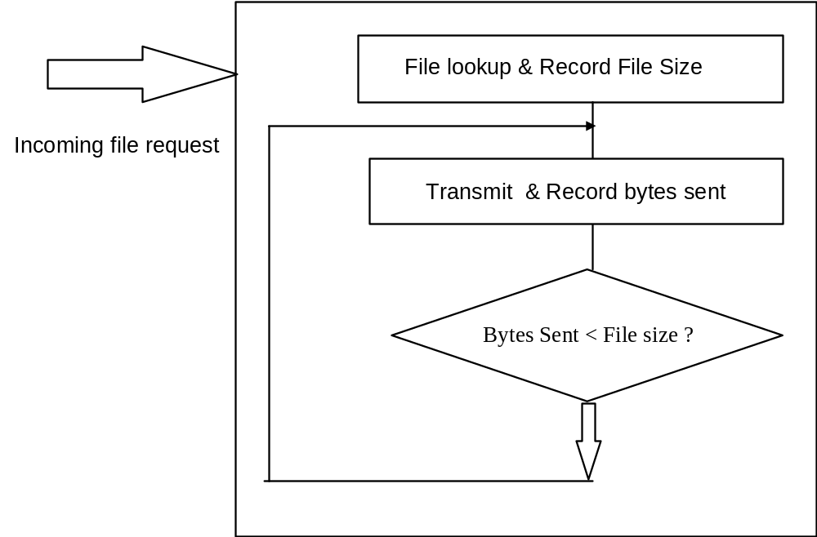
Figure 3.2. Dynamic Queue Size

Yes

Additionally we were interested in the delay that will be encountered at the server at any given time. To calculate this we need to also know the speed at which the server is processing the requests. This is determined by looking at the size of file transferred for each request and the time taken to process the request. The overhead involved in the parent process routing requests to the child processes was not accounted for in the equation. We are assuming that all web servers will have a similar overhead. Each child process keeps track of its “time taken” values from its scoreboard.
Child Speed = (ΣBytes sent /Σ time taken)/ N.........................................Eq. 3.3,
where N is the number of children with pending requests and Bytes sent is the number of bytes sent for the i-th request.
The Average speed is calculated using the speed for each child process and dividing it by the number of “alive” child processes:
Average Speed = ΣChild Speed/ Number of alive children processes....Eq. 3.4
We use the following formula to compute the time remaining for the server:
Time Left = B / Average Speed ...Eq. 3.5

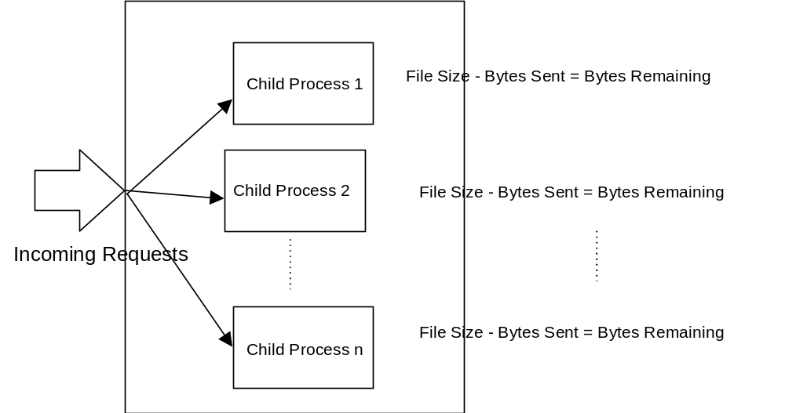

Figure 3.3. Modified Status Reporting

III.4 Sending the expected delay value at the web server to the LBA. The values that are most useful to us in determining the delay at a server are time_left and the bytes_left. These values are sent to the Load Balancing Agent by making the sendto() system call and sending these values over a socket connection using the UDP protocol.
Modifications were made in the main (), or the REALMAIN function of the Apache code to open sockets to send the delay and bytes_left information to the LBA.
The communication socket to the Load balancing agent was opened in apache/apache_1.3.9 /src/main/http_main.c. The web server must know the IP address and the port number of the LBA. For our experiments, the LBA receives messages on port 9500 and was running on the server gandalf.uccs.edu. If we run it on any other machine and if the Load balancing agent uses a different port number for receiving messages, then the Web server code must be modified accordingly. The code is as follows:
#define webport 9000
#define LBAport 9500
#define LBAaddr "128.198.192.194" /* use this when using gandalf.uccs.edu*/

char LBA_server[ ] = "gandalf.uccs.edu";
struct in_addr *LBA_addr;
float TimeLeft= 0.0;
struct sockaddr_in to_LBA;

to_LBA.sin_family = AF_INET;
to_LBA.sin_addr.s_addr = inet_addr(LBAaddr);
to_LBA.sin_port = htons(LBAport);
Code Listing 3.4

The sento( ) system call is made right after the value of time_left is calculated in the status handler in apache_1.3.9/src/modules/standard/ mod_status.c.
if (sendto(my_sock, &TimeLeft, sizeof(float), 0, &to_LBA, sizeof(to_LBA))<0)
perror("relay datagram message");
Code Listing 3.5

III.5 Apache Configuration and API. This section explains the configuration, compilation, installing and execution of the Apache source code. Once the modifications to the source are complete, we need to configure Apache. The steps required for this are:

Installing the Apache 1.3 HTTP server with APACI
================================================

$ ./configure --prefix=PREFIX
$ make
$ make install
$ PREFIX/bin/apachectl start
Figure 3.5.1

NOTE: PREFIX is not the string "PREFIX". Instead use the Unix
filesystem path under which Apache should be installed. For
instance use "/usr/local/apache" for PREFIX above.

The default prefix is PREFIX=/usr/local/apache
For our experiments prefix=/home/indira/apache_sept/apachenew.
As we could have a default server running on the same machine on which we wanted to test our modified code, we decided to run Apache from a directory that is not the default. This is the directory /home/indira/apache_sept /apachenew. The directory needs to be in the local disk to avoid overhead.
Next we compile the Apache source code from within the directory
/home/indira/sept_apache/apache_1.3.9. After this we install Apache as shown in the third step of Figure 3.5.1 above.
Before we start up the httpd daemon, some configuration parameters need to be set in the /home/indira/sept_apache /apachenew/ directory. The Apache web server version 1.3.9 is preconfigured for several parameters. Configuration parameters are set by setting the values of desired variables in the file at path sept_apache/apachenew/httpd/conf/httpd.conf . By default, the Web server listens to port 80, as specified in this configuration file. For this thesis the httpd daemon is configured to listen to port 8000.
#
# Port: The port to which the standalone server listens. For
# ports < 1023, you will need httpd to be run as root initially.
#
Port 8000

We are interested in monitoring the status of the server. To view the server status file we must first allow access to it by setting the “Location” parameter. The segment is shown as below:

# Allow server status reports, with the URL of
# http://servername/server-status
# Change the ".your_domain.com" to match your domain to enable.
<Location /server-status>
SetHandler server-status
order deny,allow
deny from all
allow from all
</Location>

After this step we are ready to run the httpd daemon. It is started up by typing:
>PREFIX/bin/apachectl start
PREFIX in our experiments was /home/indira/sept_apache/apachenew. To stop the httpd daemon we type
> PREFIX/bin/apachectl stop

The httpd daemon can also be stopped by killing the daemon process. The Apache server writes its process id “pid” in the file /var/run/`httpd.pid’. From the command line type kill -HUP `cat /var/run/httpd.pid`.
The status file for the server can be viewed once the server is up and running. Startup the web browser and type
http: //your_server_name:< server port >/server-status<?refresh= n>
This parameters <server port > and <refresh = n> are optional. If the port number is not specified, the default value of port 80 is assumed.
For example, http: //wetterhorn.uccs.edu: 8000 /server-status,
or , http: //wetterhorn.uccs.edu: 8000 /server-status?refresh = 20.
The parameter refresh = 20 means that the status file be updated every 20 seconds.
A sample listings of the status report is given in Appendix II.
The variables reported in the status file are computed by the status handler, the code for which can be found in /src/main/module/standard/ mod_status/status_handler.c. These variables are accessed through the scoreboard data structure.

CHAPTER IV

DNS WITH LOAD BALANCING ENHANCEMENT

DNS is a distributed database of host information. One of its basic functions is to provide a name to address mapping of hostnames. For our thesis implementation we configured and used a modified DNS. This chapter explains the motivation to use the modified DNS and details about configuring the modified DNS.
In this thesis, we consider the case of supporting the virtual server concept, when DNS will map a domain name to one of the mirror web sites. We have modified DNS such that when the user types in the name of any virtual server, the Load Balancing Agent will provide the IP address of the site with the least response time.

IV.2 Load Balancing DNS

MODIFIED
DNS
REPLICATED RANKS
SITES

- 20
- 10
- 27
206.114.149.79 15

WEB
BROWSER
DNS Query
Read server Ranks

199.45.212.4
IP address of best ranked web server
Figure 4.1. Modified DNS

Once we obtain the server ranking, the next phase in our implementation was getting the user to connect to the best web server. We modified and configured the lbnamed [23] application to perform our name resolving. The lbnamed script reads the configuration file. This configuration file contains the name and address records of the replicated web servers. To group the servers, a new domain “csnet” was created. For instance, wetterhorn.uccs.edu was one of the machines that we wished to include in this domain. Then the machine could be addressed by wetterhorn.csnet.uccs.edu as well. Altogether six web servers were configured within this domain in the final phase of our experiments.
The lbnamed program returns the name of the best name server whenever a request is made to the machine “best.csnet.uccs.edu ”. Whenever such a request is received by lbnamed, it calls a function that reads the configuration for the group of machines that are replicated next it reads a file with the rankings of these machines. It sorts this ranking, placing the best server at the top of its list, and returns this server name and IP address to the requesting client. Details of this query are explained in [22] and [7]. A partial code listing for configuration of static domains is as listed below:
1 LBDB::add_static("csnet.uccs.edu",T_SOA,rr_SOA (hostname,$hostmaster,time,86400, 6400,86400,86400,0));
2 LBDB::add_static("csnet",T_NS,rr_NS ("gandalf.uccs.edu"));

Code Listing 4.1
Line 1 adds a static resource record for the start of authority (SOA) of the csnet domain. Line 2 adds the name server resource record for gandalf. This indicates that host gandalf acts as the server for the csnet domain.
LBDB::add_static("wetterhorn",T_A,rr_A($hip));
LBDB::add_static("shavano",T_A,rr_A($sip));
LBDB::add_static("redcloud",T_A,rr_A($rip));
LBDB::add_static("sanluis",T_A,rr_A($lip));
LBDB::add_static("crestone",T_A,rr_A($cip));
LBDB::add_static("blanca",T_A,rr_A($bip));
Code Listing 4.2
In code listing 4.2, each line adds a new address or “A” resource record used in resolving the IP addresses for wetterhorn, shavano, redcloud, sanluis, crestone and blanca.
LBDB::add_static("217.162.198.128.in-addr.arpa",T_PTR,rr_PTR("wetterhorn"));
LBDB::add_static("64.162.198.128.in-addr.arpa",T_PTR,rr_PTR("shavano"));
LBDB::add_static("66.162.198.128.in-addr.arpa",T_PTR,rr_PTR("redcloud"));
LBDB::add_static("62.162.198.128.in-addr.arpa",T_PTR,rr_PTR("sanluis"));
LBDB::add_static("61.162.198.128.in-addr.arpa",T_PTR,rr_PTR("crestone"));
LBDB::add_static("60.162.198.128.in-addr.arpa",T_PTR,rr_PTR("blanca"));
Code listing 4.3
In code listing 4.3, static data for PTR resource records are added.
LBDB::add_dynamic("round.robin.csnet.uccs.edu" =>
\&handle_round_robin_request);
LBDB::add_dynamic("best.csnet.uccs.edu" => \&handle_best_request);
Code listing 4.4
Code listing 4.4 adds the dynamic records. All requests for round robin are handled by \&handle_round_robin_request. This function was needed to run the benchmarking and is explained in Chapter 7. All requests for “best” are handled by &handle_best _request, as shown in the above code listing.
The code listing for function handle_best_request is below:
sub handle_best_request
{
my($domain,$residual,$qtype,$qclass,$dm) = @_;
my($the_host,$the_ip,$answer,$qname,$group);
%ipArray = (
"wetterhorn" => "128.198.162.217",
"shavano" => "128.198.162.64",
"redcloud" => "128.198.162.66",
"sanluis" => "128.198.162.62",
"crestone" => "128.198.162.61",
"blanca" => "128.198.162.60"
);

$qname = $residual;
open(STATFILE, "</tmp/statFile");
$i = 0;
while($line = <STATFILE>)
{
@lineArray = split(' ', $line);
$host = $lineArray[0];
$_ = $host;
$host = $1 if (/^(\w+)\./);
$hosts[$i] = $host;
$weight = $lineArray[1];
$weight{$host} = $weight;
$i++;
}
$i = 0 ;
@hosts = sort { $weight{$b} <=> $weight{$a} } keys %weight;
foreach $hosts (keys %weight){
if ($qtype == T_A || $qtype == T_MX || $qtype == T_ANY)
{
$the_host = @hosts[0];
&write_log("Best: Using: $the_host with $weight{$the_host}");
$ipaddr = $ipArray{$the_host};
$_ = $ipaddr;
($a,$b,$c,$d) = /(\d+)\.(\d+)\.(\d+)\.(\d+)/;
$the_ip = ($a<<24)|($b<<16)|($c<<8)|$d;
$the_host .= ".best.csnet.uccs.edu" if ($the_host !~/\.csnet/i);
$answer = dns_answer(QPTR, T_CNAME, C_IN, 0, rr_CNAME($the_host));
$answer .= dns_answer(
dns_simple_dname($the_host),
T_A,C_IN,3600,
rr_A($the_ip));
$dm->{'answer'} .= $answer;
$dm->{'ancount'} += 2;
}
else
{
$dm->{'rcode'} = NXDOMAIN;
}
close(STATFILE);
return 1;
}
Code listing 4.5

Details and a line by line explanation of the code is given in [22].
The function for sorting host names by weights is given in code listing 4.6 below:
sub by_weight
{
$weight{$b} <=> $weight{$a};
&write_log("InSUBbyWeight: $weight{$a}\n");
}
Code listing 4.6

The weight calculation is done by the Load balancing agent and is explained in Chapter 5.2.
For the csnet domain “named” to work, the csnet entry had to be included in the DNS database files for the uccs.edu domain. The Computing Services Center at CU-The Springs made this entry in the primary name server for the uccs.edu domain. The entry points to a secondary name server, which should answer any request for the csnet.uccs.edu domain. The secondary server was running on frodo.uccs.edu. Frodo then forwards any request for best.csnet.uccs.edu to the lbnamed running on gandalf.uccs.edu.
An entry is made in the database of the secondary name server running on frodo, serving the csnet domain, to forward best.csnet.uccs.edu requests to lbnamed, running on gandalf . This entry was made in the file /var/named/csnet.uccs.edu on frodo.

Primary
name
server
Serving the
uccs.edu
domain
Secondary
name server
on frodo
Serving the
csnet.uccs.edu
domain
Lbnamed:
Modified
name server
on gandalf
answering
for
best.csnet.uccs.edu
Query for best.csnet.
uccs.edu

Figure 4.2. Forwarding request for best.csnet.uccs.edu

1 @ IN SOA csnet.uccs.edu. hostmaster.csnet.uccs.edu. (
2000091805 ; serial
3600 ; refresh
900 ; retry
1209600 ; expire
0 ; default_ttl
)
2 @ IN NS csnet.uccs.edu.
@ IN MX 10 csnet.uccs.edu.
@ IN TXT "CSNET lab"
3 best IN NS gandalf.uccs.edu.
4 best IN NS bilbo.uccs.edu.

Code Listing 4.7

Line 1 shows that this name server is the Start of Authority for the csnet domain. In line 1, the time to live parameter is set to 0. This means that any incoming request will not try to find the answer for the best name server from the cache but instead will do a fresh lookup each time. Line 2 indicates that this is the name server for the csnet domain. Line 3 indicates that any request to best within the csnet domain must be forwarded to the name server in gandalf.uccs.edu. Line 4 indicates that a second redundant name server for best is running at bilbo.uccs.edu.
The source code for the load balancing lbnamed is in /mpc/home/isemwal/ lbnamed-Oct. The lbnamed program is run by typing. /lbnamed.rc from the command line. As the program listens to the standard DNS port 53, one must be logged in as root to run this program.

CHAPTER V

THE LOAD BALANCING AGENT

V.1 Overview. The main task of the LBA is to dynamically collect the statistics for all the web servers that belong to the cluster of replicated servers. In our implementation the web servers need not be on the same subnet. They can be distributed all over the Internet. Testing of the LBA was done was done for servers within the uccs subnet.The statistics being collected by the LBA in this thesis are:
- Network bandwidth for each replicated web server
- Network Congestion Bandwidth
- Expected Delay at the server
Information about each server is saved in the following data structure:
1 struct mirror_servers{
2 char *server_name;
3 char *IPaddress;
4 float delay;
5 float b_Result;
6 float c_Result;
7 struct mirror_servers *next;
8 } *ms ;
Code Listing 5.1
server_name is the hostname, IP_address is the IP address, delay is the delay at the given server, b_Result is bottleneck bandwidth of the path from the LBA to the given web server and c_Result is the available bandwidth of the path from the LBA to the server. In line 7 next is a pointer to server information for the next web server in the database.
A high level algorithm of the LBA is given below:
- Start timer1, timer2 and timer3
- while(1)
- {
- If timer1 expired
- {
- receive message from web server
- Check server database
- Save server delay value in database
- }
- If timer2 expired
- {
- for each server in database
- {
- Run Bprobe /* get available banwidth */
- Save Bprobe result in database
- }
- }
- If timer3 expired
- {
- for each server in database
- {
- Run Cprobe /* get congestion banwidth */
- Save Cprobe result in database
- Calculate total for each server
- Save delay result in database
- }
- }
- }
Pseudo code for LBA

The available and the bottleneck network bandwidth are estimated using BPROBE® and CPROBE®, bandwidth estimation tools developed by Carter and Crovella [3]. A brief analysis of their work is given in Chapter 2 of this thesis. As we started our experiments, there were a few options that we considered for reading the bandwidth information that was being generated by the probes. The LBA launches the probes using the system command as given below:
system(comm);
where “comm” is the command to launch bprobe i.e.
comm = “./bprobe hostname or “comm = “./cprobe hostname
This function system () invokes the Bourne shell to execute the specified command string [11]. The syntax for this function is: int system (char *string)
Once the probes are launched, they provide a screen dump of the results, at the end of which is the number for the final bandwidth. One option to read the final bandwidth value was to write the output to a file and the parse it. This option was not implemented, as the output file could be quite large and parsing would slow down the probing process.
The second option was to modify the source code of the probes and use sockets to send the final bandwidth information to the load-balancing agent. This option has the drawback that we do not know in advance the port numbers of the Load balancing agent. The LBA could advertise its port number and the user could type it in once the probe tool requests this information. This solution was not implemented because it seemed quite awkward.
There is a simpler solution to the above problem, which we implemented. We made a minor modification to the probe tool code at bprobe.c and congtool.c, so that the probing tools, apart from doing a screen dump, would write out the final bandwidth values to a file along with the name of the probed host. The LBA then reads the hostnames and bandwidth values from the files, one file for bprobe and the other for cprobe, and saves the values in its internal data structure.
The delay value at a web server is calculated by the modified Apache source code as explained in Chapter 3 of this thesis.

V.2 Server Weight Calculation. The weights or cumulative delays at each server are computed by Calculate_weights() function of the LBA, as given below:
void Calculate_weights(void)
{
FILE *allPtr;
char my_all_probes_file[] = "/tmp/statFile";
float weight;
int i= 0;
struct mirror_servers *ms;

if ( (allPtr = fopen(my_all_probes_file, "w") ) == NULL )
printf(" Cannot open file %s \n", my_all_probes_file);

while(MainPtr[i] != NULL)
{
ms = MainPtr[i];
while( ms != NULL)
{
weight = (float) (1+ ms->b_Result + ms->c_Result)/
(( 1 + ms->delay) * 10000)
weight = weight * 100 ;
fprintf( allPtr,"%s %f\n", ms->server_name, weight);
ms = ms->next;
}
i++;
}
}
Code Listing 5.2

As shown in code listing 5.2, the weight for each server is calculated using the following formula
weight = (1+ ms->b_Result + ms->c_Result)/(( 1 + ms->delay) * 10000)
..............Eq. 5.2.1
Our main reason for coming up with this formula was to consider that there is a direct relationship between higher weight and greater bandwidth and an inverse relationship between delay and weight, i.e. higher delay means lower weight. Weight calculation has also been discussed in [22][23].
Probes to servers, returning bandwidth to LBA

Web server 1
Delay information from web server to LBA
Rank of each server, saved in file

Web Server 2
LBA

/tmp/statFile

Web Server n

Figure 5.1. Operation of the LBA

CHAPTER VI

WEBSTONE BENCHMARKING RESULTS

VI.1 System Hardware and Software Configuration. Figure 6.1.1 shows the testbed we set up for evaluating the load balancing system performance.

4 Pentium 500 MHz PCs (128MB Memory, 256 MB Swap, 8GB-IDE, 3Com 3c905B NW Interface)
1 Pentium Dual 500 MHz PC (512 MB Memory, 512 MB Swap, 9GB SCSI, Intel PCI Ethernet Express NW Interface)
1 Pentium Dual 350 MHz PC (512 MB Memory, 512 MB Swap, 4 GB SCSI, Intel PCI Ethernet Express NW Interface)
LAN: 100MB/s
Figure 6.1.1 Hardware configuration for web servers

Operating system: Redhat 6.2
Web Servers: Apache 1.3.9

We have the load balancing DNS, lbnamed, running on gandalf; web servers were run on wetterhorn, redcloud, sanluis, shavano, crestone and blanca. The webmaster for webstone benchmarking was on crestone; web clients for benchmarking were shavano, crestone, bilbo and frodo.
Hardware configuration for the Load Balancing Agent and the Load balancing DNS is shown in figure 6.1.2.

1 Pentium 240 MHz PC (128MB Memory, 128 MB Swap, IDE)
Network: AMD PLNET 32 10 Mbps
LAN: 10 Mbps Ethernet
Figure 6.1.2 Hardware configuration for lbnamed and LBA

Operating System: Redhat 7.0

VI.2 Web server benchmarking. Benchmarking was done using a modified Webstone Benchmarking tool WebStone 2.5 [27]. Modifications were made to the source code for WebStone in [22]. These modifications take into consideration that the IP address of the web server could be dynamic. Each web client in the modified webstone resolves the web server IP address dynamically. We used the modified code to further test the load balancing DNS. Benchmarking results are in the following graphs.
Figure 6.2.2.1Benchmarking with six servers
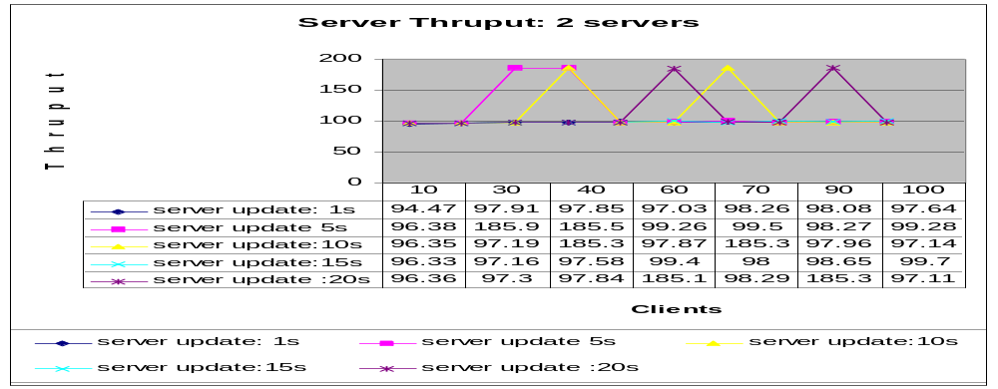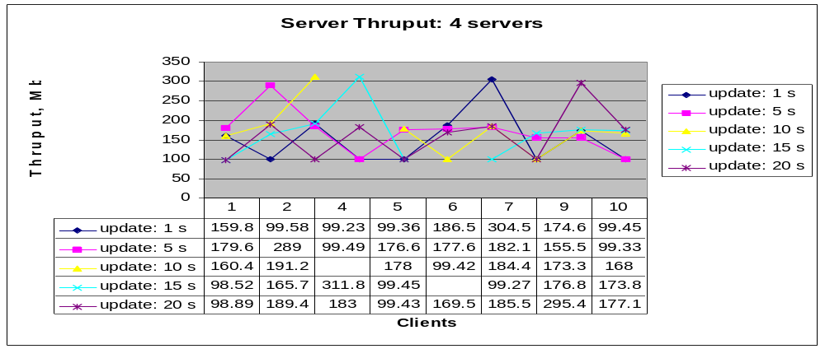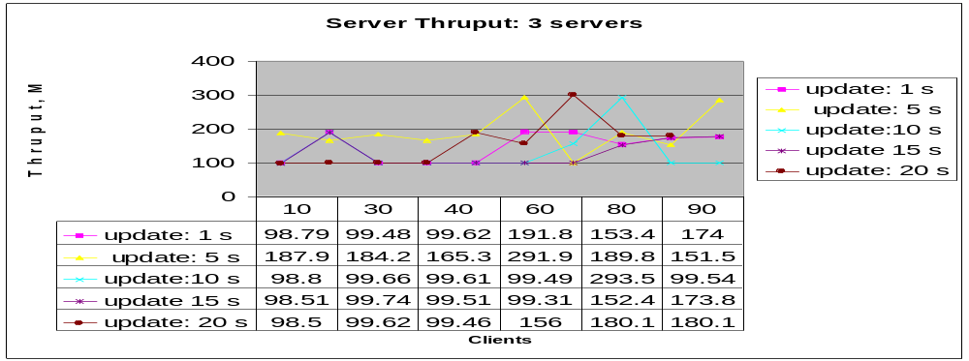
Figure 6.2.1 System thruput with 2 servers
Figure 6.2.2 System thruput with 3 servers
Figure 6.2.3 System thruput with 4 servers

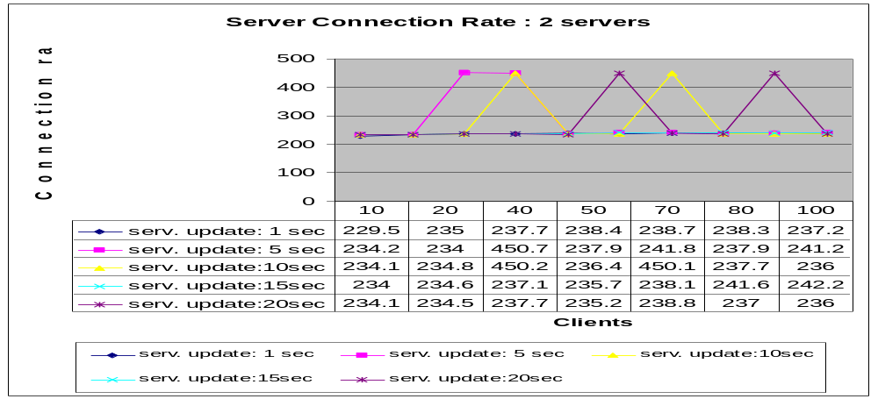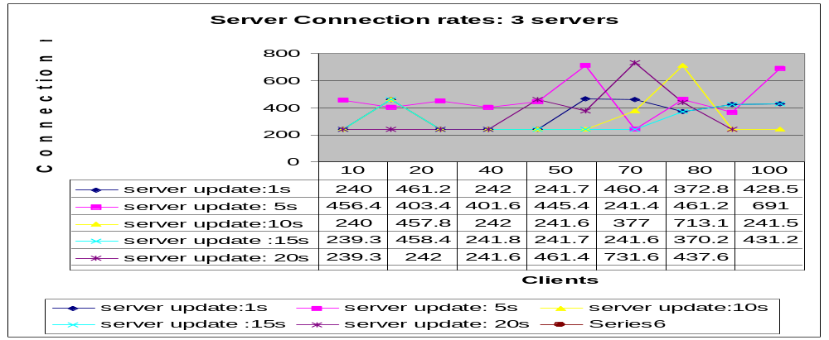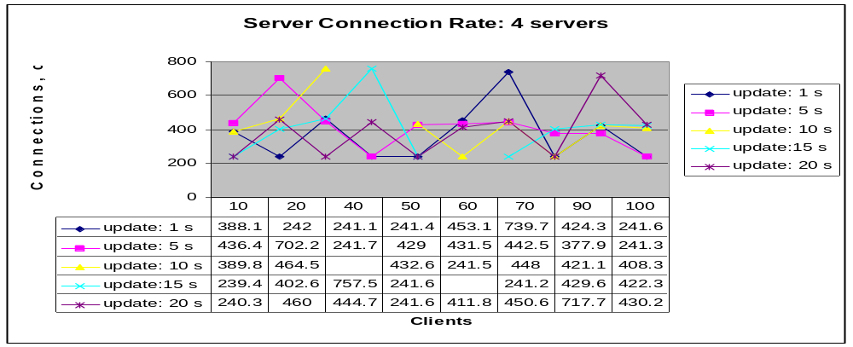
Figure 6.2.4 Connection rate with 2 servers

Figure 6.2.5 Connection rate with 3 servers
Figure 6.2.6 Connection rate with 4 servers
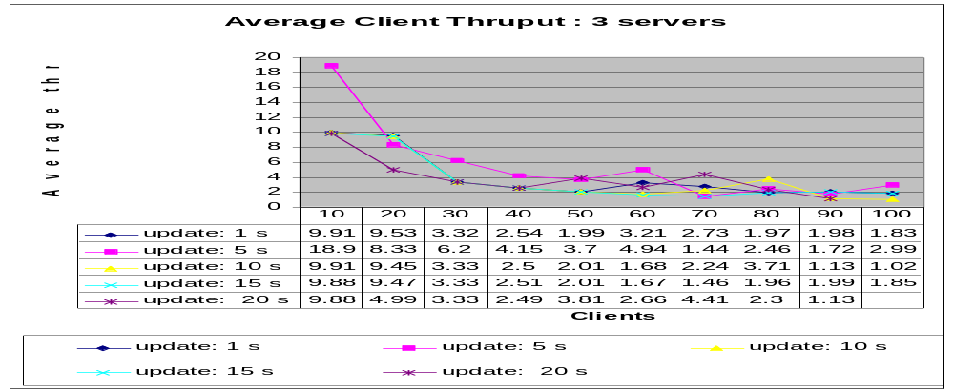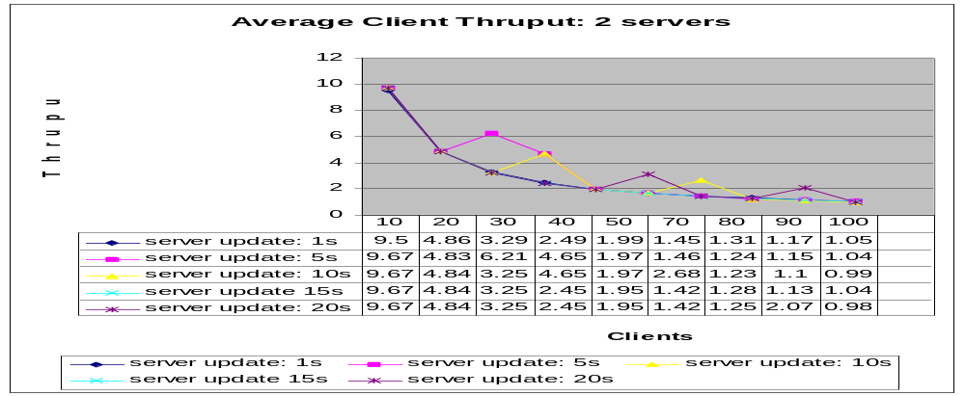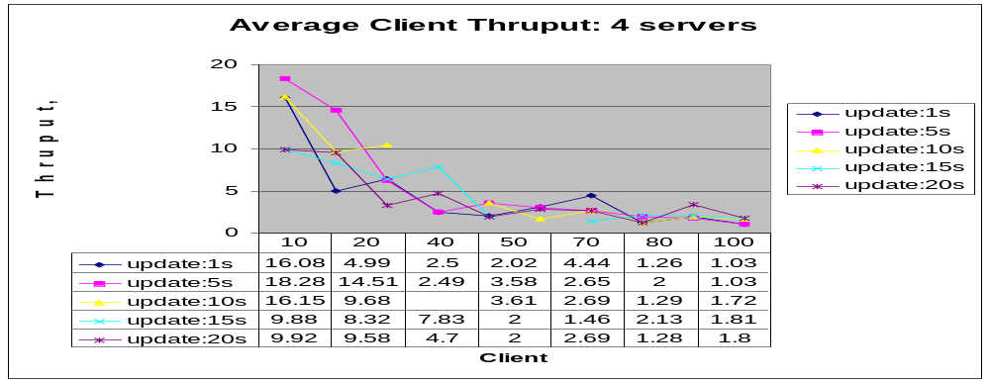
Figure 6.2.7 Client thruput with 2 servers

Figure 6.2.8 Client thruput with 3 servers
Figure 6.2.9 Client thruput with 4 servers
The LBA was tested Figures 6.1.1- 6.1.13, with sets of web servers ranging in number from one to six. With each web server configuration, the load was increased, by increasing the number of clients requesting web pages. The numbers of clients were increased from 10 to 100. Tests were also run to monitor the performance of the LBA depending on the frequency with which we update the information about server load. The frequency for updating server load information was increased from one second, then to five, ten, fifteen and finally at 20 seconds.
We observed that when the number of servers in our replicated configuration is increased from one server to six servers, the thruput increases, Fig.6.2.1- Fig 6.2.3. The system thruput fluctuates more, as the number of clients that probe the system with web page requests, is increased from 10 clients to 100 clients. The system as a whole performed better, when the LBA updated server load information every 5 seconds. This could be attributed to the oscillating effect that can occur when the best performing web server is selected, and a large number of incoming requests are sent to this server. The performance of the server degrades, and the next set of requests are routed to other servers, thus the performance of this server farm as a whole falls, but it then rises as the load is balanced.
As we increased the number of clients probing the server, for any given configuration of web servers, we noticed that the average client thruput fell more rapidly, Fig. 6.2.7 – Fig. 6.2.9, with an increase in the number of clients, when there were fewer web servers configured in the system. For example, with two web servers configured, the average client thruput fell rapidly when the number of clients increased from 10 clients to 20 clients. With five web servers configured, the average client thruput fell rapidly when the number of clients was increased from 20 clients to 30 clients. Again, a higher thruput threshold was maintained when the LBA updated server performance statistics every 5 seconds.
The connection rate in our experiments, Fig. 6.2.4- Fig. 6.2.6, increased with the addition of web servers to the system configuration. We also observed that even though the connection rate increased with the addition of web servers, the connection rate fluctuated more when we increase the number of clients requesting web pages. The most stable performance was noted when the LBA updated server load information every 5 seconds.
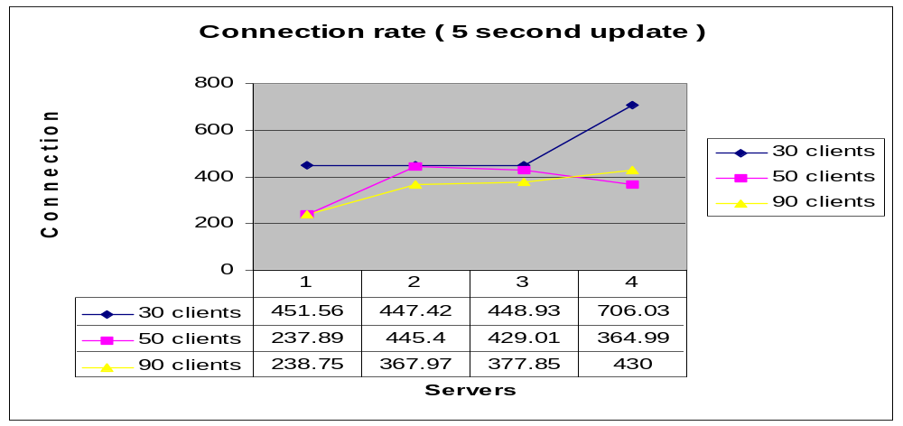The graph in Figure 6.2.10 shows a steady increase in connections per second as more servers are added.
Figure 6.2.10. Connection rates with various server configurations

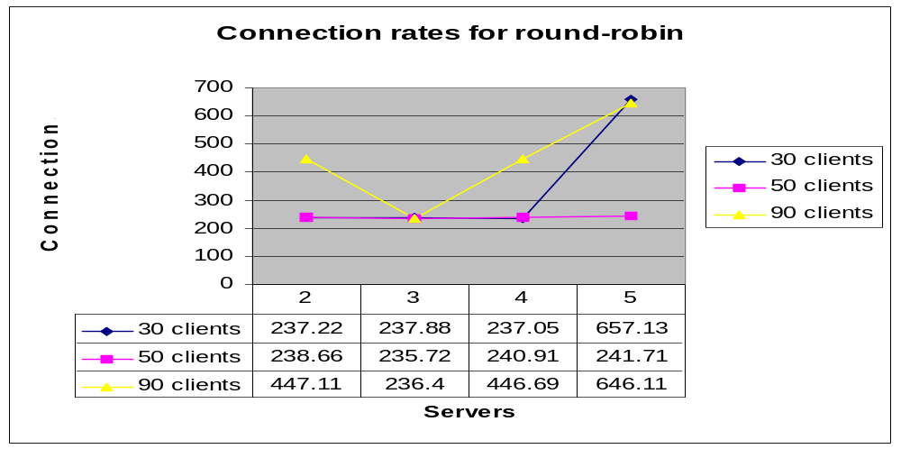

Figure 6.2.11 Connection rate for round-robin servers

The graph in Figure 6.2.11 shows the randomness in the server connection rates when the servers are selected on a round robin basis. We ran the webstone benchmark with the servers identically configured as in Figure 6.2.10. As shown in the graph, the connection rate does not increase much as more servers are added, except for some fluctuation. The connection rate varies between 237 – 240 connections per second. In the tests with the LBA configured, the connection rate hovered around 400 connections per second. On an average we see a 20% increase in connections per second. For a round-robin configuration with four servers, the connection rate was 327.6, Figure 6.2.13, whereas the average connection rate for the 4-server configuration with the LBA was 615 connections per second, which is about 85% increase over the round robin connection rate.
Server thruput, with servers identically configured as in the benchmark runs with the LBA, for the round robin experiments is shown in Figure 6.2.12. Server thruput never exceeds 190 Mbits per second, and mostly hovers around 100 Mbits per second, which is about 30% worse than the thruput obtained with the LBA, Figure 6.2.3
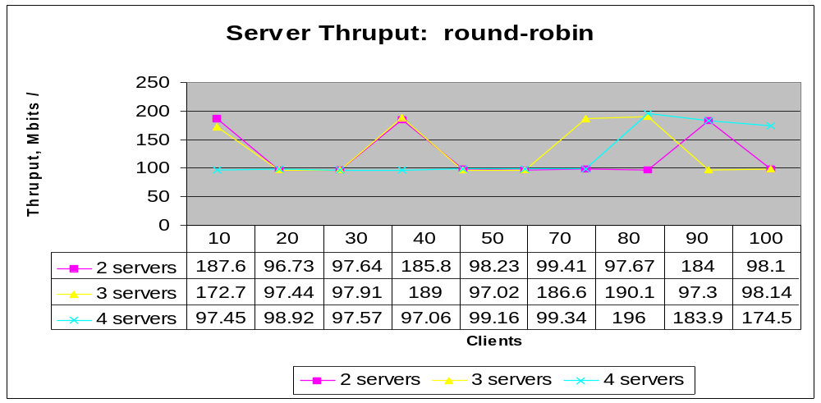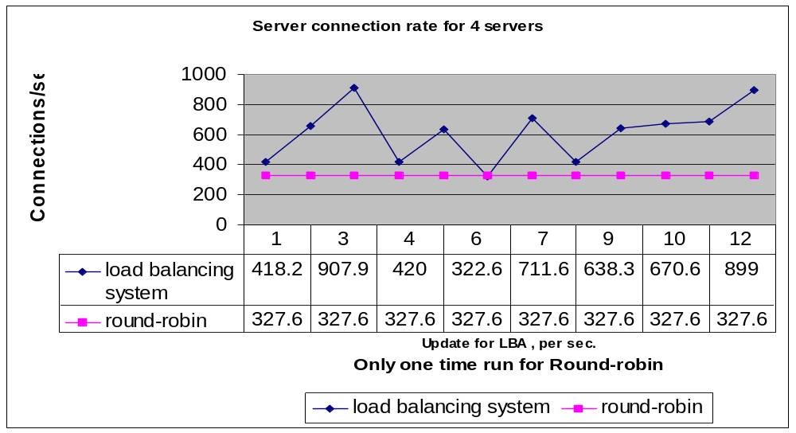
Figure 6.2.12 Server thruput for round-robin
Figure 6.2.13 Server connection rate: LBA vs. round-robin

VI.3 Bandwidth Probe Results. In the initial phase of the thesis implementation the Load Balancing Agent sent probes to the web servers and gathered network bandwidth information of the path from the server to the client. Bprobe results are saved in /thesis_Oct17/ res.txt and cprobe results are saved in /thesis_Oct17/c_res.txt.
wetterhorn 9390263.00000
crestone 9807893.00000
shavano 9689730.00000
sanluis 9797174.00000
blanca 9560422.00000
redcloud 9889881.00000
wetterhorn 3839126.50000
crestone 5484248.00000
shavano 3961832.00000
sanluis 3954038.00000
blanca 4208685.00000
redcloud 3571140.00000

Figure 6.3.1 Bprobe output Figure 6.3.2 Cprobe output
The contents of these files is read by the Load Balancing agent, which saves these values in its data structure and periodically sends out more probes and updates the data structure.

VI.4 Modified Web Server Results. The LBA also receives a floating-point value in its socket on port 9500. All the notified web servers know this port number and they send the expected delay values to the LBA. Based on the path information and server delay value, the LBA estimates the overall delay expected at each server and writes out this information to the file /tmp/statFile as shown in Fig. 6.4.1 below:

crestone 154931.187500
shavano 130693.179688
wetterhorn 171322.000000
sanluis 110209.695312
blanca 177707.015625

Figure 6.4.1 Server ranking generated by the LBA

VI.5 Load Balancing DNS Results. The next phase in the implementation was running the load balancing DNS. The lbnamed application was expected to read the file /tmp/statFile, as shown in Figure 6.4.1 above, and use the weight information to pick the best server.

VI.6 Results of the extended server status reporting. These results are shown in Appendix 5

VI.6 Lessons learned. During the thesis implementation, the design of the LBA was changed twice. Initially we designed the Load Balancing agent to send out the probes sequentially. There were about four to five servers we wanted to probe with the probing tools bprobe and cprobe, using the commands ./bprobe machinename and ./cprobe machinename executed from within a while loop. The LBA read the machine names from a file and ran the probe.
While(1)
{
Read file for machinename
Run probe
}

Figure 6.6.1 Pseudo code for running bandwidth probes

The probes, in particular bprobe could sometimes take a long time to return with a result, it was slowing down the execution of the program. It therefore made sense to run the probes for the other machines, without waiting for the result of the probe for each individual machine. It seemed a logical choice to fork child processes, each probing a different machine simultaneously. This expedited the probe processing but it created some more problems. The first was that it was difficult to estimate how much time the parent process should wait before checking which of the children had returned. It was the typical readers and writers problem. We could not read the output files generated by the child processes until they had terminated. This was solved by using the wait( ) system call as shown below:
int wait(int * status)[11]
The calling process is suspended by the kernel, until one of its child process terminates. When the parent process resumed, we know for sure that the output file generated by the child processes was now readable. This worked, but we realized that we had not solved the problem of running the probes much faster. Even though child processes were being spawned and probes were being sent simultaneously, the parent still had to wait a long time to read the output file because all the children had to return before the parent could read the output generated. We felt that a higher degree of complexity had been added to the LBA and the program was not as good. Another problem with this approach was that we needed to set timers to run the probes. We explored the possibility of having the probing program send the result directly back to the parent process using the sendmsg() system call [9], but after experimenting with it for some time, we decided to not pursue this route due to time constraints.
Another valuable lesson we learnt during this thesis was to test the communication between the web server and the load balancing agent separately by using a dummy LBA. This makes the testing much easier to troubleshoot. Initially testing the LBA for communication was hard because we did not know if the messages were arriving at the correct port number or not, or whether they were not being received because the parent process had been suspended by the kernel when the message arrived and was somehow being lost.
In our final implementation, went back to our simpler design for the LBA, in which the main process forks no children.
We avoided many of the caveats experienced by the work in [22], as we had many similar features in our implementation, especially the caveats with the implementation of a load balancing DNS.

CHAPTER VII

CONCLUSIONS AND FUTURE WORK

A load balancing system was implemented for improving web server cluster performance by collecting statistics about web server load and path characteristics, and distributing the load accordingly. An analysis was made about the performance of the load-balancing agent. The webstone benchmark results on the server cluster based on the LBA shows a consistent improvement as the number of web servers increases. The results also show an improvement over the round-robin method. The impact of the server load update frequency on the cluster was also studied.
The preliminary experiments indicate that there is a peak in performance near the 5-second update interval. Our conclusion after studying the results was that web server performance improved as additional servers were added to the configuration. However, we saw degradation in performance when the available memory on the local disk was low. Server thruput increased with the addition of more servers, and was evaluated to be most stable when the LBA was updating server information every 5 to 10 seconds.
The Load Balancing agent has been designed and implemented with limited functionality. This work could be enhanced to a system with several LBA’s that serve in a WAN environment. In such an extended system, the LBA’s could exchange information with web servers as well as with each other. Multicasting could be used for simplicity and effectiveness. The LBA’s could be designed to collect server load and path information for servers within close geographic proximity. Not only would this give an accurate picture of the load at a web site, it would reduce the congestion that probing creates over the backbone links.

WS
WS

LBA
LBA
Router

WS
WS

LAN 1
LAN 2
Figure 7.1. Enhanced LBA

During our experiments it was observed that the probing by BPROBE could be very slow. It took up to 30 minutes at times, and sometimes would hang when the packets were lost. This may be due to bugs in the program. But it does require sending long bursts of ICMP echo requests. It would be worthwhile to probe the networks using SimProbe [21], which sends fewer probes and measures the available and bottleneck bandwidths very accurately.
We could also improve our algorithm for measuring the average speed of the server. A more accurate method would be to measure the speed with which it processes one incoming request. This could be done at startup, as a benchmark. Another improvement could be to measure the delay at the server more accurately, by taking into account the overhead that the web server parent process has in routing requests.
For our implementation, in the web server source code, we hardcoded the port number and the IP address of the LBA. In future implementations these parameters could be set at run time.
Another very useful feature that could be added is the process to automate the load balancing DNS configuration files. In our experiments, each time we wished to use a different set of servers for our experiments, we had to manually change the configuration file in lbnamed, in particular the file lbnamed.conf. It would be convenient to have the lbnamed.conf file read a file with the desired server names and use that to configure the lbnamed data structure.

BIBLIOGRAPHY

- E.D. Katz et al.” A scalable HTTP server: The NCSA prototype”. Computer Networks, Vol. 27(2) (1994) pp. 155-164.
- Zongming Fei et. al.” A novel server selection technique for improving the response time of a replicated service”. IEEE Infocom ’97. 16th Conference on Computer Communication
- Carter R. L and Crovella M. “Dynamic Server selection using bandwidth probing in wide-area networks”. Tech. Rep. BU-CS-96-007, Computer Science Department, Boston University, Boston, MA, 1996.
- Carter R. L and Crovella M, “Measuring Bottleneck Link speed in Packet-Switched Networks”. Tech. Rep. BU-CS-96-006, Computer Science Department, Boston University, Boston, MA, 1996.
- Carter R. L and Crovella M. “Dynamic Server selection in the Internet”. Tech. Rep. TR-95-014, Computer Science Department, Boston University, Boston, MA, 1995.
- Dahlin M. “Interpreting Stale Load information”. UTCS Technical report TR98-20, Department of Computer Science, University of Texas at Austin, 1998.
- Albitz P. and Liu C. DNS and BIND. O’Reilly & Assoc. 1997
- Laurie B. and Laurie P. Apache: The Definitive Guide. O’Reilly & Assoc. 1997.
- Wright G.R and Stevens W.R. TCP/IP Illustrated, Vol. 2. Addison Wesley Professional computing series. 1998
- Wright G.R and Stevens W.R. TCP/IP Illustrated, Vol. 1. Addison Wesley Professional computing series. 1994
- Stevens W.R. . UNIX Network Programming. Prentice Hall 1990
- Packeteer Inc. Intellegent Bandwidth Management. http://www.packeteer.com
- Resonate Inc. E-Business Traffic Management. http://www.ResonateInc.com
- Hydraweb WEB Technologies. Http and DNS redirection. http://www.hydraweb.com
- Bright Tiger. Cluster CATS Enterprise. http://www.brighttiger.com
- Holon Tech. Clustering for High Availability. http://www.holontech.com
- RAD Data Communications. RADware. http://www.rad.com
- Red Hat Linux OS. http://www.linux.org
- Apache Web Server. http://www.apache.org
- John Heidemann ,”Performance Interactions Between P-HTTP and TCP Implementations”. University of Southern California/Information Sciences Institute. Manuscript submitted for publication in the Computer Communication review, November 1996.
- XiaoLong HE, “Network Available Bandwidth Measurement”. Thesis report. Department of Computer Science, CU-Colorado Springs, CO. April 2000.

- Emery S. M, “ Dynamic Load Balancing of Virtual Web Servers”. Thesis Report. Department of Computer Science, CU-Colorado Springs, CO. March 2000.
- Schemers R. J III. “lbnamed: A Load Balancing Name Server in Perl”. Sun Soft Inc. LISA IX Sept. 1995
- Zeus Load Balancer ver 1.1. Zeus Technologies. http://www.zeus.co.uk/products/lb1
- The Netcraft Web Server Survey. http://www.netcraft.co.uk/survey/
- Blais A. L, Chow C. E. Performance Analysis of Load Balancing Algorithms. Technical Report EAS-CS-2000-2
- Webstone 2.5 Benchmarking tool. http://www.mindcraft.com/webstone.
- RFC 2396: URI Generic Syntax. August 1998.

USERS GUIDE

The programs must be run in the following sequence for the “nslookup best.csnet.uccs.edu” queries to work:
- Startup the modified web servers
- Startup the Load balancing Agent
- Startup the modified DNS

Installing the Load Balancing Agent. Copy the source code from the directory ~chow/pub/master/isemwal/LBA

Compile the code using
>cc main.c iutil.c
- Log in as super user and run the program using
>./a.out ser 1 3600 300
where, “ser” is the file that contains the list of hostnames of machines running the modified web server code. The LBA will send probes to the web servers and receive server delay information from them. There are several files like ser_2ser, ser3_ser etc. that contain machine hostnames for different configurations of web servers we used. Create a new file like the sample ones if your configuration is different. Make sure that there is no blank line at the end of this file.
This program will pause if the modified web servers are not running, as the LBA waits to receive delay information from the web servers, even before it sends out the probes to the servers. The runtime “parameter” 1 means: receive from the web server delay information every 1-second. 3600 means: run the probes for measuring the bottleneck bandwidth every hour, 300 means: run the probes for measuring the congestion bandwidth every 5 minutes.
To stop the program execution type Ctrl+C
The LBA program receives data on port 9500. If the LBA program is run on a host machine other than gandalf, the web server code will need to be modified. The LBA program writes the results to /tmp/statFile which is read by the modified DNS. Therefore this program must be started up before the modified DNS for the best.csnet queries to work correctly.
The programs for “bprobe” and “cprobe” tools are in this directory. If any changes are made to these programs, they can be compiled from this directory using;
>make bprobe
>make cprobe

Installing the modified Apache web server. To install the modified web server, copy the modified source code in the user directory. Copy all the source code from ~chow/pub/master/isemwal/apache_sept directory to the user’s directory , for example to: /home/username/modified_server
Use the following command to configure the web server:
>cd modified_server/apache_1.3.9
>./configure --prefix=/home/username/modified_server/apachenew
To reconfigure the parameters like the port at which we would like the web server to run, open
modified_server/apachenew/httpd/conf/httpd.conf
and do the following:
- Check the port number setting to make sure it is set to 8000
By default, the Web server listens to port 80. For this thesis the httpd daemon was configured to listen to port 8000, as shown below:
#
# Port: The port to which the standalone server listens. For
# ports < 1023, you will need httpd to be run as root initially.
#
Port 8000

- Next check the server-status setting
To view the server status file we must first allow access to it by setting the “Location” parameter. The segment is shown as below:
# Allow server status reports, with the URL of
# http://servername/server-status
# Change the ".your_domain.com" to match your domain to enable.
<Location /server-status>
SetHandler server-status
order deny,allow
deny from all
allow from all
</Location>
- Close the file modified_server/apachenew/httpd/conf/httpd.conf
- If needed modify the source code.
NOTE: The modified web server sends delay information to the LBA. The hostname where the LBA is running and its port number are hard coded to gandalf.uccs.edu at port 9500. This code is in the source file apache_1.3.9/src/main/http_main.c. The port from which the web server sends information is hardcoded to 9000.
- Compile the source code
Change to directory modified_server/apache_1.3.9 and type
>make
- After successful compilation type:
>make install
This will place the binary files in /home/username/modified_server/ apachenew/bin
- After this step we are ready to run the httpd daemon. It is started up by typing:
>modified_server/apachenw/bin/apachectl start
- To stop the web server type:
>modified_server/apachenw/bin/apachectl stop

Installing and running the Load Balancing DNS. To run the modified load balancing DNS copy the source code from ~chow/pub/master/isemwal/src/DNS
There are several sub directories in this directory, each one corresponds to a different configuration of replicated web servers. The way to check which directory has what web servers configured, open the lbnamed.conf file in any of the directories and go to the function handle_round_robin( ). The machine hostnames listed in this function are the machine names for which this DNS program is configured. For example, the function handle_round_robin() in lbnamed_2_ser/lbnamed.conf contains:
@hostArray = ( "wetterhorn", "redcloud" );

$hostCount = scalar @hostArray;

%ipArray = (
"wetterhorn" => "128.198.162.217",
"redcloud" => "128.198.162.66"
);

This means that this DNS is configured for only two web servers running on wetterhorn and redcloud. Before running the program, check the lbnamed.rc directory to make sure that the path is correct. For example to run the code from /mpc/home/username/lbnamed_2_ser, the lbnamed.rc must contain this path:
cd /mpc/home/username/lbnamed_2_ser.
To run the program log in as super-user and type :
>./lbnamed.rc
To test if the program is working correctly, type from another machine
[indira@wetterhorn]$ nslookup round.robin.csnet.uccs.edu
frodo.csnet.uccs.edu
Server: frodo.csnet.uccs.edu
Address: 128.198.192.183

Name: shavano.round.robin.csnet.uccs.edu
Address: 128.198.162.64
Aliases: round.robin.csnet.uccs.edu

The “nslookup” request was answered by “frodo”. A regular DNS daemon called “named”, running on frodo , redirects all requests for the csnet subdomain to the load balancing name server program running on gandalf. The configuration file on frodo where this is specified is: /var/named/csnet.uccs.edu. To make sure that this daemon is running type:
ps aux|fgrep root
This will give a listing of all root programs and “named” should be one of them. If not, or if any changes are made to /var/run/csnet.uccs.edu, then the program can be run by logging in as root on frodo and typing:
>ndc restart

+ BIND is a distributed Network service that allows clients to retrieve resource information about various objects in the network
1 BPROBE and CPROBE were used in this thesis implementation

