Rule Editor

Design of Rule Editor

If statements in ‘C’ language are of the form
Numerical statements
If (<term1> <logical operator><term2>)
{Sequence of actions to be performed}

String statements
If (strcmp(<term1> ,<term2>)<logical operator> 0
{Sequence of actions to be performed}

When the rules are entered in the rule editor. The rule editor outputs a flag whenever a potential conflict is detected. Potential conflicts can be
1) Duplication of the condition i.e. for same condition specifying same/different actions.
2) Numerical comparison errors, these are easily committed and difficult to detect manually,
for example:
Rule111: (xml.purchase/totalAmount > 5000) { forward the packet to mini server}

Rule122: if (xml.purchase/totalAmount > 20000) { forward the packet to cray server}

When rule matching occurs and xml.purchase/totalAmount = 30000
Rule111 will be executed first rather than Rule122, which may not be the intention of user.

Similar numerical comparison conflict can occur with “<“ opertator

The Rule Editor will help you to overcome these potential conflicts using a simple algorithm
Duplication Errors can easily be detected by checking the condition with the existing conditions
Numeric Comparison Errors are detected using the following algorithm
When a new rule is being entered

- Check the logical operator, if it is of not “>”, “<” goto step 6
- Check with the existing rules whether the logical operator and term1 match, if no match is found goto step 6
- If the logical operator is “>”
Check whether match.term2 < term2 and match.ruleposition < ruleposition If true flag the user of potential conflict and goto step 6
- If the logical operator is “<”
Check whether match.term2 > term2 and match.ruleposition < ruleposition
If true flag the user of potential conflict and goto step 6
- Add rule to existing rules
- Exit

Working of Rule Editor
It helps to convert a sequence of if statements entered using the editor into native c language. Fig 1 shows the rule editor

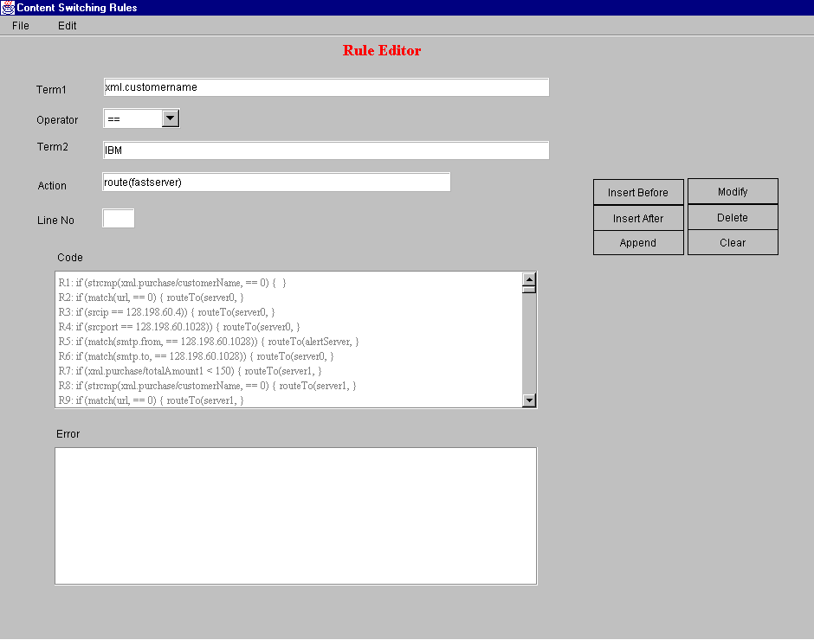Fig 1: Rule Editor
Insert Before: adds record before the Line No.
Insert After: adds record after the Line No.
Append: adds record at the end.
Modify: it asks for the Rule Number, if exists it allows for modification of the rule.
Delete: it asks for the Rule Number, if exists it deletes the rule.

The operator List box contains various options as shown in Fig 2

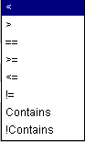
Fig2: options in Operator ListBox
The logical operators are used for numeric conditions statements. When the contents of term2 are not numeric the rule editor automatically converts the condition into a strcmp statement.
The options “Contains” and “!contains”are used for handling regular expressions.
E.g. if (term1 contains term2) {sequence of actions to be performed}
Here term2 can be a regular expression like “*.gif”

Advantages
Informs the end user of a potential conflict in if statements, which are tiring to debug when written manually.
- Automatically converts string data type into strcmp format, the native form of c string handling
- It also handles regular expression comparisons.

Limitations
- Currently it handles only one condition
- Improve performance when the conditions are too many

