ENHANCE FEATURES AND PERFORMANCE OF
CONTENT SWITCHES
by
CHANDRA PRAKASH
B.E. Computer Science
Delhi Institute of Technology, New Delhi, India, 1996

A thesis submitted to the Faculty of Graduate School of the
University of Colorado at Colorado Springs
in partial fulfillment of the
requirements for the degree of
Master of Science
Department of Computer Science
2001

This thesis for the Master of Science degree by
Chandra Prakash
has been approved for the
Department of Computer Science
By

_______________________________________________________
C. Edward Chow, Chair

_______________________________________________________
Jugal K. Kalita

_______________________________________________________Sudhanshu K. Semwal

Date _____________

Chandra Prakash (M.S.. Computer Science)
Enhance Features and Performance of Content Switches
Thesis directed by Associate Professor C. Edward Chow
Abstract
Content switches use application content to make routing decisions to select the most suitable server in a cluster of servers. TCP delayed binding is an indispensable task performed by a content switch. This report describes various schemes along with their performance comparison for improvement in TCP delayed binding of content switches. In addition, it also addresses a wide range of issues related to content switch functionality. It can handle multiple requests in a keep-alive HTTP connection, multiple packets for a single request and different data encoding schemes in XML document. Finally, it implements a setup for high-availability of content switch, considering the unique constraints imposed by it.

CONTENTS

Chapter
1. Introduction 1
1.1. Motivation behind Layer 5 Web-switches 3
1.2. Some content switch related techniques 6
1.2.1. MAC address translation (MAT) 8
1.2.2. MAC multicast 9
1.2.3. Half network address translation (HNAT) 11
1.2.4. Full network address translation (FNAT) 12
1.2.5. IP tunneling 13
1.3. Some content switch related products 14
1.4. Design Architecture of content switch 16
2. TCP Delayed Binding 21
2.1. Basic scheme 24
2.2. Pre-allocate Scheme 27
2.3. Filter Scheme 32
3. Handling multiple requests IN Keep-AliVE HTTP connection 21
3.1. Determination of new request in a given connection 25
3.2. Reuse of server side connections 26
3.3. Solution for handling keep-alive HTTP requests 28
3.4. Handling pipelined requests in a HTTP connection 33
4. Performance Results 21
5. Miscellaneous Improvements 21
5.1. Handling client request spread across multiple packets 21
5.1.1. Determine the content length 21
5.1.2. Fragmentation of application level content 23
5.2. Keeping in sync with client and server TCP 24
5.3. Handling different XML data encoding schemes 25
5.4. Referencing specific tags in a XML document 26
6. High-AvailabILITY OF Content Switch 21
6.1. Handling failure of real server 25
6.2. Handling failure of virtual server 32
7. Conclusion and Future WORK 21
Appendix A 21
A.1. Setting up configuration for Basic and Pre-allocate scheme 21
A.2. Setting up content switch cluster in filter scheme 26
A.3. Code layout 27
A.4. Webbench 29
Bibliography 21

FIGURES

Figure 1.1 A setup of MAC address translation (MAT) 9
Figure 1.2 A setup of MAC multicast 10
Figure 1.3 A setup of Half Network address translation (HNAT) 12
Figure 1.4 A setup for Full network address translation (FNAT) 13
Figure 1.5 A set up of IP tunneling with a block diagram showing 14
packet encapsulation and decapsulation 14
Figure 1.6 A High Level Architecture of Content Switch 16
Figure 2.1 A time line of typical packet exchange for 22
TCP connection 22
Figure 2.2 A time line of showing TCP delayed binding 25
Figure 2.3 A time line of steps showing pre-allocate if the guess is correct 30
Figure 2.4 A time line of steps showing pre-allocate scheme 31
if the guess is wrong 31
Figure 2.5 A timeline of steps showing filter scheme 33
Figure 3.1 Multiple requests sent in a single keep-alive HTTP connection 27
that get routed to different real servers 27
Figure 4.1 A block diagram of content switch 21
network configuration 21
Figure 4.2 Plot of processing time vs. document size of GET request 25
Figure 4.3 Plot of processing time Vs request size for POST request 27
Figure 4.4 Plot showing requests/sec plot of various schemes 31
with variation in configurable parameters of Webbench 31
Figure 4.5 Plot showing throughput plot of various schemes 32
with variation in configurable parameters of Webbench 32
Figure 4.6 Plot showing request/sec plot of various schemes vs. 33
number of rules 33
Figure 4.7 Plot showing throughput plot of various schemes 34
vs. number of rules 34
Figure 6.1 An architecture for High-Availability of Linux content switch 22

ChAPTER 1

Introduction

The tremendous growth in World Wide Web usage has become a double-edged sword for operators of large Web sites. On the one hand, increases in request volume translate into increased subscription, advertising, and hosting revenue. On the other hand, scaling Web sites to meet this increased demand has become more and more difficult as the number of requests for content exceed a particular server's ability to respond. In the best case, users will experience degraded service, in the worst case the server can be driven to collapse resulting in a complete loss of service.
One approach to alleviate handling of large volume of requests is to distribute their load among a group of servers. A master controller, that can be a dedicated host or a process, first receives the requests and delegates it to the appropriate real server. This describes a typical load balancing system. A content switch (CS) [1] is such a load balancing system that distributes load based on the content of the received requests. A Web-switch is a content switch that distributes load based on Web (or HTTP) requests.

Table1.1 shows examples of switching done at three different layers in the Internet domain.
Scope of Layer 3 Switch <---------- >
Scope of Layer 4 Switch <---------------------------------------------------------- >
Scope of Layer 5 Switch <--------------------------------------------------------------------------------------------------------- >
IP (Layer 3 Switch) | Transport (Layer 4 Switch) | Content (Layer 5 Switch)
Src 01/Dest 02 | Port 80 | http://www.yeehoo.com/news
Src 01/Dest 02 | Port 80 | http://www.yeehoo.com/sports
Src 01/Dest 02 | Port 80 | http://www.yeehoo.com/books
Src 01/Dest 02 | Port 80 | http://www.yeehoo.com/movies
Table 1.1 Switching at various layers in Internet domain
First, is the Layer 3 switch, which does the traditional routing based on the IP [3] layer. The second is Layer 4 switching which does the routing based on the transport Layer. There are also conventional ways of load balancing at the transport layer (Layer 4 of TCP/IP1 [4]). One of them is to use the port number of the incoming request and direct it to a real server responsible for handling the response for that specific port. For example, if the port number in the incoming request is 21, it is routed to machine catering to FTP requests and if the port number is 80 it is routed to a host running the HTTP [6] server. The third mechanism is the Layer 5 switching, which is based on the network layer and all the way up to application layer. Note that Layer 3 and Layer 4 switching paradigms are content blind. This is evident from the example shown in Table 1.1, where Layer 3 and Layer 4 based routing would not distinguish between four different HTTP requests with the same source and destination addresses and port. Layer 5 switches are also known as Layer 7 switches, as application layer is the seventh layer in the OSI paradigm.

Motivation behind Layer 5 Web-switches

- Efficient Load balancing based on HTTP session flows - Routing based on Layer 5 can efficiently load balance the requests based on application content, e.g., their URL. This allows a Layer 5 switch to provide an overall improvement in Web response time by directing HTTP requests to the optimum site and server, and applying policies based on the content being requested at that point in time. For example, as shown in Table 1.1, all incoming requests, if routed based on Layer 3 or Layer 4 switching, will be routed to the same real server, since they have the same source address and destination address and destination port. This may result in a situation where requests are unevenly distributed among the real servers.
- SSL and Cookiebased sticky connections for ecommerce - In any authenticated Web application, it is necessary to provide a persistent connection between a browser (the user) and the Web or database server to which it is connected. Examples of these applications include shopping baskets, financial transactions, and some forms of interactive gaming. Because HTTP does not carry any state information for these applications, it is important for the browser to be mapped to the same server for each HTTP request until a user's transaction is complete. This ensures that the user is not loadbalanced in midsession to a different server and forced to log in again. The traditional load balancers, which load-balance based on server load at transport layer, e.g., number of active connections to a real server, cannot provide such customizations. A Web-switch can provide ''sticky'' connections, per application, using session layer headers like SSL (secure sockets layer) session ID or user's cookie embedded in the HTTP header. This feature is key to enabling sophisticated ecommerce by providing sticky clientserver connections based on the information in the cookie. Further, it is the only way to ensure sticky connections for authenticated applications when thousands of users are coming into a site from a mega-proxy (e.g. AOL users), all accessing the same application and all coming from the same source IP address.
- Web site security - Since Web-switches are built to glean application content, they can help build a network security firewall that can filter specific unwanted solicitations from outside to inside of firewall perimeter. In general, security policies can be implemented based on any combination of source address, destination address, protocol type, or content URL. Content switch can also help prevent DOS (denial of service) attack by rejecting specific requests that follow a certain pattern in the client request, e.g., source IP address or specific request type.
- Provision for quality of service (QOS) and service level agreements (SLAs) - Using Web-switches, Web hosters can provide services ranging from ordinary to premium services (QOS), and services that meet minimum agreed upon standards (SLAs). Web switches can prioritize traffic by reading the URL in the HTTP header, allowing assignment of bandwidth based on specific content or user. For example, a brokerage Web site could offer premium services, giving top traders priority over individuals browsing their accounts. Similarly, in crisis situations such as flash crowd, service level agreement such a minimum bandwidth, could be achieved by Web-switch initiated replication to an overflow server or cache.
- Flash crowd management - Some of the biggest challenges for a Web site include unpredictable traffic and flash crowds caused by suddenly "hot'' content, such as the Kenneth Starr Report. Conventional load balancers distribute traffic by using information in the TCP header, including IP addresses and TCP port numbers, to direct TCP sessions to a particular server. But they have no concept of what content is being requested, and as a result, require all content to be replicated between load balanced servers. They also cannot explicitly track content requests or detect, anticipate, or replicate hot content in response to flash crowds. Web switches can dynamically track content requests and identify hot content. In such situations hot content can be replicated to an overflow Web server or cache. This replication on demand ensures capacity is available no matter how hard a Web site is hit. For example, www.znn.com/news/clinton.ram is a request for streaming audio of President Clinton testifying before the Grand Jury. Unknown to the Layer 4 switch, this will be a longlived flow and it may suddenly become a "hot" item. In this case the Web switch can initiate replication of this content to overflow servers or caches, either directly based on operator defined policies, or by sending a control message to a serverbased content management application. Once the best server or cache is selected, the return audio stream is guaranteed consistent bandwidth in the switch.
- Bidirectional load balancing of Web flows - Conventional load balancers and Layer 4 switches perform simple TCP session distribution among Web servers. These client initiated inbound flows from a Web browser to a Web server comprise about 10% of Web traffic. Web switches optimize 100% of Web traffic via bidirectional load balancing. In addition to inbound, they optimize complex serverinitiated flows (e.g. streaming media) or separate data and control channels on different ports (e.g., passive FTP). The Web switch can set up the initial HTTP request, selecting the best site and server for the content being requested. The switch then maintains the policies set up on the request or control channel, and the server initiated response or data channel, including quality of service in both directions.
- Scalability - Real servers in typical a Web-switch cluster can be added and removed seamlessly without causing any significant (if any) down time of the system.

Some content switch related techniques

This section describes some of the related technologies whose basic working principles are same as that of the content switch implemented in this work. None of the schemes described in this section look at the application content and are therefore collectively called as "immediate binding" [26] schemes, since the routing decision is made as soon as the first SYN containing client TCP packet is received. Once the SYN packet is received, a hash table entry is created at the virtual server so that all subsequent packets of that connection are routed to the same real server. In some cases where the response packets (sent from the real server) need to be routed via the virtual server for some packet transformation, e.g., half NAT and full NAT, this hash table is looked up again so that only packets belonging to the pertinent connection are transformed appropriately.
This thesis work is focused on various schemes that also look at the application content in the server selection decision process. Such schemes are collectively called as "delayed binding" schemes and are described in detail Chapter 3.
Before going into the details of the "immediate binding" schemes, here are some of the common load-balancing techniques employed by these schemes:
- Round Robin Scheduling - Round robin scheduling [2] algorithm directs the network connections to different servers in a round robin manner. It treats all real servers the same regardless of the number of connections or response time.
- Weighted Round Robin Scheduling - The weighted round robin [2] scheduling algorithm directs connections based on different processing capacities of real servers. Each real server can be assigned a weight, an integer value that indicates its processing capacity.
- Least-Connection Scheduling - The least-connection [2] scheduling algorithm directs network connections to the real server with the least number of established connections.
- Weighted Least-Connection Scheduling - The weighted least-connection [2] scheduling is a superset of the least-connection scheduling, in which a performance weight is assigned to each real server. The servers with a higher weight value will receive a larger percentage of live connections at a given instant.

MAC address translation (MAT)

In this scheme [26] all real servers are configured with a unique IP address on their physical (Ethernet interface) and with a virtual IP address (VIP) on their loopback interface. When a packet arrives at the virtual server, it selects the best server using some load-balancing algorithm and substitutes the MAC address in the client sent packet with the MAC address of the selected server.
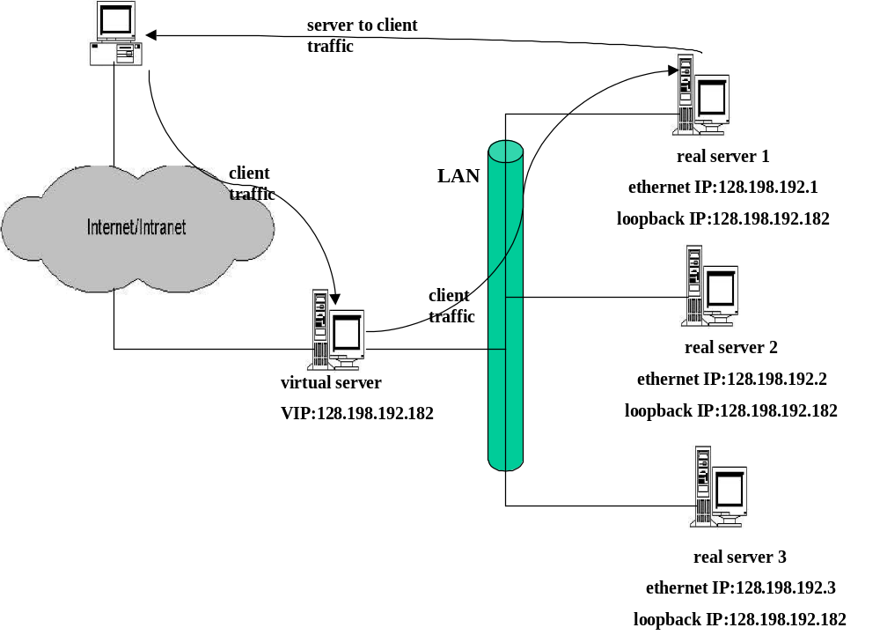

Figure 1.1 A setup of MAC address translation (MAT)

The setup of a sample MAT scheme is shown in Figure 1.1. The key advantage of this scheme is that the real server can (optionally) send response packets directly to the client, bypassing the virtual server. This alleviates the packet-forwarding overhead at the virtual server. Note that the server selection decision is not made on the application content, although client IP address and port can still be used in server selection decision. This scheme is implemented in LVS [2] direct routing.

MAC multicast

In this scheme [26] all real servers are configured to receive the client packets via an identical multicast MAC address. When the switch (or access router) sends an ARP request for the physical address mapping for the virtual IP address the MAC, the multicast address is returned.
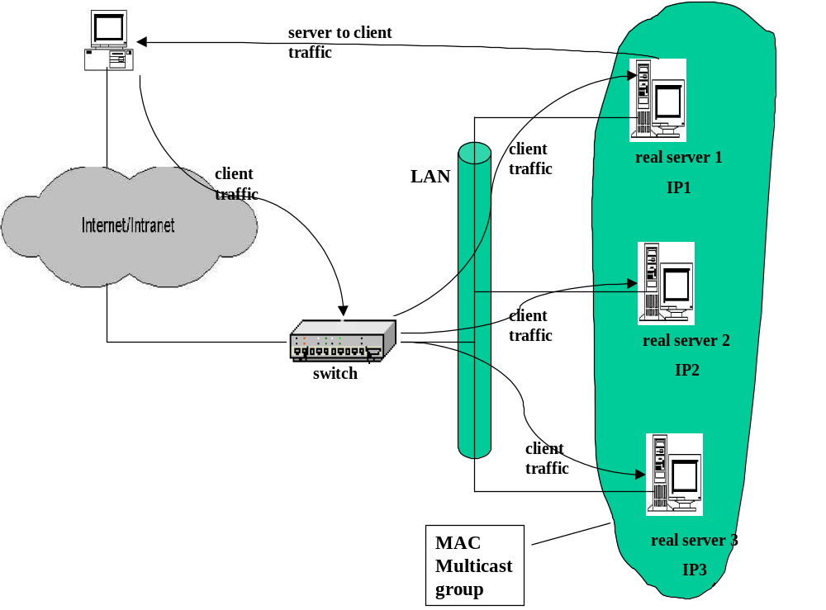

Figure 1.2 A setup of MAC multicast

The switch then substitutes the received MAC address in destination MAC address field of the client packets and hence the client packet is received by all real servers that are (configured as) part of the MAC multicast group. Next step is that of voting (or bidding) where each of the real servers decides via a suitable algorithm, which one will serve the request. Only one candidate server is selected via this voting method and it can (optionally) directly send response to the client. Note that in this approach client to server traffic has many paths but server to client traffic has only one path.

Half network address translation (HNAT)

When a client packet arrives at the virtual server, the real server is selected using some load-balancing technique and the destination IP address, and MAC address fields in the received client packet is substituted by the IP address and MAC address of the real server. On the return path, the response packets are sent via the virtual server as the default gateway, where the source IP address in the response packets is changed to IP address of the virtual server, as expected by the client. The setup of a sample half NAT (HNAT [26]) scheme is shown in Figure 1.3. In LVS [2], HNAT scheme is simply called as NAT scheme.

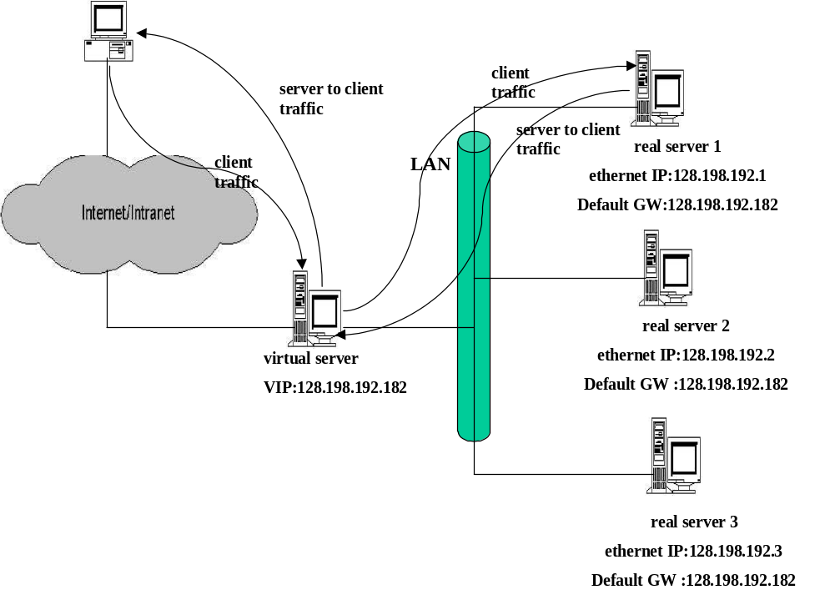

Figure 1.3 A setup of Half Network address translation (HNAT)

Full network address translation (FNAT)

In this scheme [26] both the source and destination address fields in the received client packet are changed at the virtual server as opposed to only change in destination address in HNAT. At the virtual server, the source IP address in the client packet is changed to IP address of virtual server and destination IP address is changed to the IP address of the selected real server. In this scheme, the real server can reside in a network different from that of the virtual server. When the real server generates the response, it assumes the virtual server as the client and directs all response packets to the virtual server. At the virtual server the source IP address in the response packet is changed to IP address of virtual server and destination IP address is changed to the IP address of the real client. The setup of a sample full NAT (FNAT) scheme shown in Figure 1.4. The main drawback of this scheme is real server cannot know the actual client that sent the sent the request as all the requests seem to originate from the virtual server.

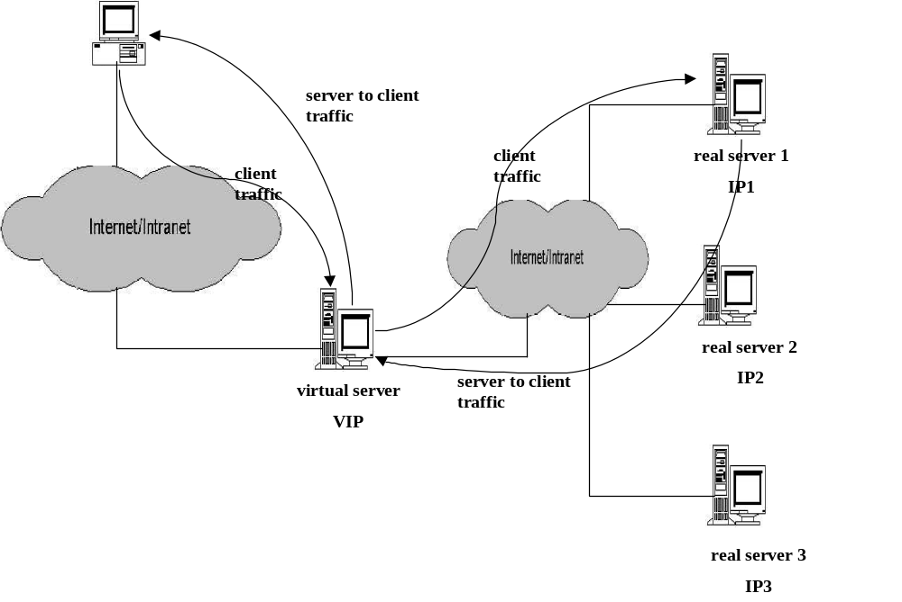
Figure 1.4 A setup for Full network address translation (FNAT)

IP tunneling

This scheme uses IP tunneling [2] to encapsulate the client payload packet in a new packet created at the virtual server. The destination address of this new packet is set as the real server, selected via the server selection process that employs some load-balancing technique. At the real server the packet is decapsulated and all server response packets are (optionally) directly sent to the client. Note that in this scheme all real servers must support IP tunneling protocol. Also the real servers can be stationed in any geographic location, i.e., they need not be on the same network as the virtual server. The setup of a sample immediate binding switch configuration using IP tunneling, along with a data flow diagram depicting packet encapsulation and decapsulation, is shown in Figure 1.5.

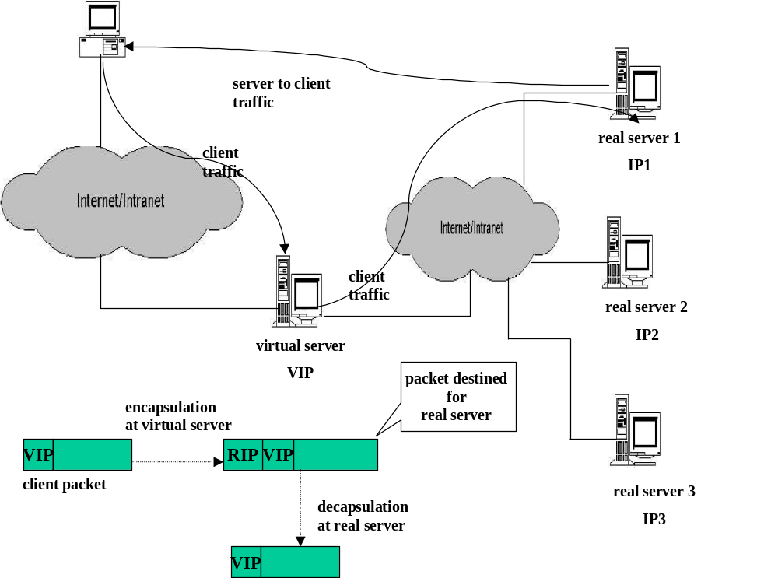

Figure 1.5 A set up of IP tunneling with a block diagram showing
packet encapsulation and decapsulation

Some content switch related products

Following are some of the products from a few vendors, who are prominent in the field of content switch related technologies. In most of these products the majority of functions related to content switching are incorporated into specialized hardware.

- Alteon's series (A180e/A184) [27] products. These support URL-based Web cache redirection and server load balancing, i.e., specific URLs or URL containing specific "sub-string" are routed to designated cache Web servers, streaming media servers and wireless application gateways. They allow content rules to be applied per Web switch, which enables separating static and dynamic content requests via URL parsing.
- F5's [28] Big-IP product, which essentially is an integrated product for load balancing, contents switching, traffic management, Gigabit Ethernet switching etc. In terms of load balancing and content switching it allows simple packet inspection (immediate binding) and insight into application packet (delayed binding). For example, it can inspect full HTTP header in order to make traffic management decisions on cookies or other information contained therein.
- Cisco's [29] CSS 11800 content switch, which provides high-speed Web content delivery by selecting the best site and server based on full URL, cookie, and resource availability information.
- Foundry network's [30] ServerIron product, which supports extended Layer 4-7 functionality including URL, Cookie, and SSL Session ID-based switching (Secure) Network Address Translation (NAT).
- Intel XML accelerator [31], which can distribute Web load based on XML tag values.

Design Architecture of content switch

The design architecture of content switch [1] implemented in this work is as shown in the Figure 1.6, which appears in [11].
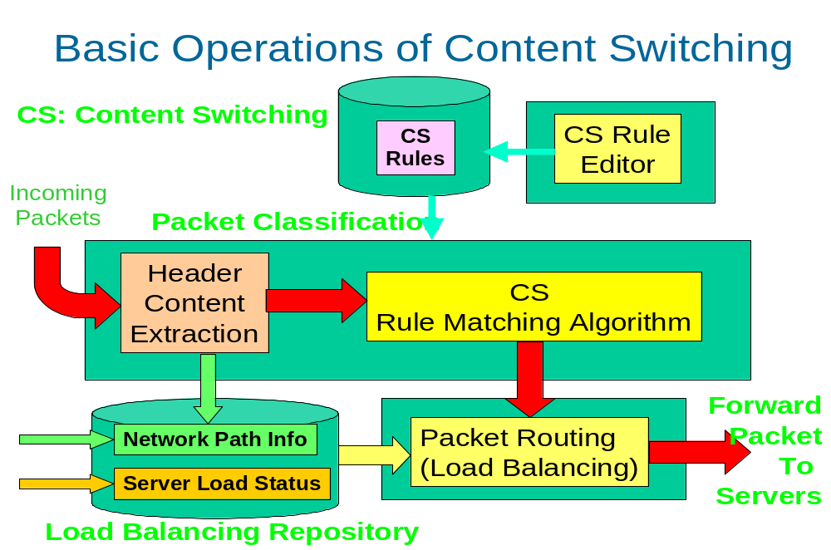
Figure 1.6 A High Level Architecture of Content Switch

Here is a description of components shown in Figure 1.6.
- Content Switch (CS) Rule Editor: CS Rule editor allows user to specify the set of rules for the content switch. The tool to create/edit CS rules is available in GUI form and can be run from a command prompt. The rule editor also performs conflict detection [13] among rules.
- CS Rules: Each rule can consist of one or more Boolean conditions on fields extracted from the incoming request. If a condition specified by a rule is satisfied the request is routed to the target server as specified by the rule. Template 1.1 shows a set of sample rules.
Template 1.1

R1: if (xml.purchase/totalAmount > 52000){ routeTo(server1, STICKY); }
R2: if (xml.purchase/customerName == "CCL") { routeTo(server2, NONSTICKY); }
R3: if (strcmp(url, "gif$") == 0) { routeTo(server3, NONSTICKY); }
R4: if (srcip == “128.198.60.1” && dstip == “128.198.192.192” && dstport == 80)
{ routeTo(LBServerGroup, STICKY); }

Here rule R1, conveys that if the "purchase/totalAmount" contained in the incoming request is greater than 52000, the request be routed to a real server identified by name "server1" in the content switch cluster in a "sticky" manner. A sticky connection implies all future requests from the same client should be routed to the same real server. A sticky connection in a way is fast lookup mechanism where no XML parsing or rule matching needs to be done on the client request. A "non-sticky" connection on the hand implies every request (current as well as future) must undergo the rule matching process.
Note that rule syntax as shown in rule R4, also allows routing to a given cluster of servers (in addition to routing to a single server), identified by a name. This syntax is not implemented in current work.
Once the rules are created they are converted to a C code file. This C file containing rules in then compiled and the object file thus obtained can be inserted into the kernel as content switch rule module (see Section A.1 of Appendix).
- Header Content Extraction: This component is responsible for extracting the rule fields and their values from the incoming requests, which comprise the Boolean conditions of the CS rules. For example, the value of the rule field "purchase/customerName" is extracted in this step.
- CS Rule Matching: The input to this component will consist of fields extracted by the content extraction module. This component's task is to evaluate the Boolean expression of rule fields for each rule (until the expression evaluates to true) and return a real server address that matches the rule.
- Load Balancing: As the name suggests this component is responsible for selecting the real server with minimal load among the set of (more than one) possible servers that can handle the request. As of this implementation, server load-balancing [25] based on "true server load" is not implemented.
- Load balancing repository: This repository will store load-balancing information, e.g., the server load and the status of network path among virtual server, real servers and client. This component is a future work item and is applicable when load-balancing [25] among multiple servers in a cluster is supported.

TCP Delayed Binding

Since a content switch makes routing decisions of incoming packets based on the content of those packets, it first has to receive the application content. In TCP [4], the client will not deliver the upper layer request content until it finishes the three-way handshake with the server. The TCP three-way handshake is a must step between any two entities that communicate via the TCP protocol. In this handshake, the two communicating entities commit their individual start sequence numbers before initiating any data transfer. Figure 2.1 shows time line of steps involved in a
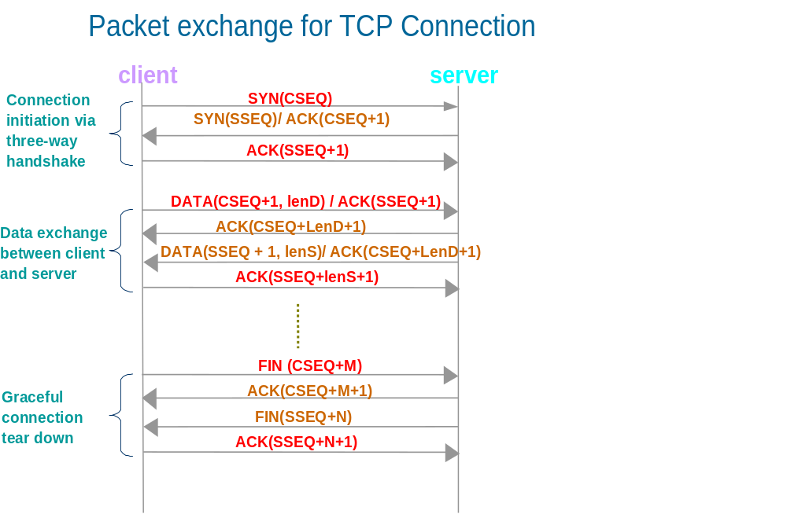
three-way TCP handshake.

Figure 2.1 A time line of typical packet exchange for
TCP connection

The content switch needs to act on behalf of the real server to commit the sequence number in the SYN/ACK packet. After receiving the upper layer request, the content switch selects the real server and establishes another three-way handshake with the selected real server and serves a bridge for relaying the data packets between the client and the real server. This is called TCP delayed binding, as the transfer of data from content switch to the real server is delayed by initial three-way handshake between client and content switch and additional server selection process (also called as rule matching). The TCP sequence number and acknowledgment number committed between client and the content switch will most likely be different from the sequence and acknowledgment number committed between content switch and the real server. The sequence number and acknowledgment number of response packets sent by real server and ACK packets sent by client have to be somehow translated correctly so that the receiving end has no confusion about it. This is needed so that the sanctity of the TCP connection at client end and the real server end is preserved. This is so-called the TCP delayed binding problem. As it is evident from the above discussion there are following additional overheads related to TCP delayed binding in a content switch, as opposed to content unaware standalone Web servers:
- A separate connection has to be established between the content switch and the real server in addition to the initial connection between client and the content switch.
- The client request is buffered until a logical point is reached where content switch can parse the rule fields in the request. There is an additional overhead associated with this buffering of client request in terms of memory and processing associated with determining the logical end point where content switch can commence its rule matching.
- The rule matching process itself has an extra overhead, as it needs to parse the rule fields from the client request.
- The sequence number and the acknowledgment number for client packets as well as server packets needs to be somehow translated correctly, i.e., packet transformation is done on both the client request and the server response packets.
- All server response packets need to go via the entity that does sequence number translation. If this entity happens to be the content-switch itself, it has to additional work in terms of forwarding the packet to the client.
Based on the above key overheads related to TCP delayed binding in a content switch, three schemes, namely, basic, pre-allocate and filter schemes, were implemented that attempt to optimize one or more of the overheads outlined above.
The basic, pre-allocate and filter scheme were built over the existing Linux virtual server (LVS) [2] functionality that provides a Layer 4 switch using NAT (see Section 1.2.3). The LVS functionality itself is built upon the foundation of IP masquerade feature provided in Linux. The common baseline among these schemes enabled us to evaluate their relative performance.

These three schemes are discussed in detail in the subsequent sub sections. For a comparison of performance metrics taken against each of these schemes refer to Chapter 4.

Basic scheme

Figure 2.2 shows time line of steps involved in TCP delayed binding in the basic scheme, which has no optimizations. In steps 1-3 the three-way handshake between the client and the content switch is completed where the two communicating entities commit there starting sequence numbers. In step 4 the client sends its request packet. In practical situations there can be more than one packet sent for a given request, e.g., for variable sized HTTP request like POST. Before step 5, rule matching is done on the received client request and a real server selected using criteria defined in the rule matching. In steps 5-7 the three-way handshake between the client and the real server is completed. In step 8 the client sent request data is relayed to the real server. Before the client data is relayed to the real server, the sequence and acknowledgment number contained in all the relayed packets are translated (or fixed) to comply with the sequence or acknowledgment numbers committed during initial three-way handshake in steps 5-7. The real server sends response data in step 9. In practical situations, there can be more than one response packets for a given request. Before the server response data is forwarded to the client, the sequence and acknowledgment number contained in all the forwarded packets are translated to comply with the sequence or acknowledgment numbers committed during initial three-way handshake in steps 1-3

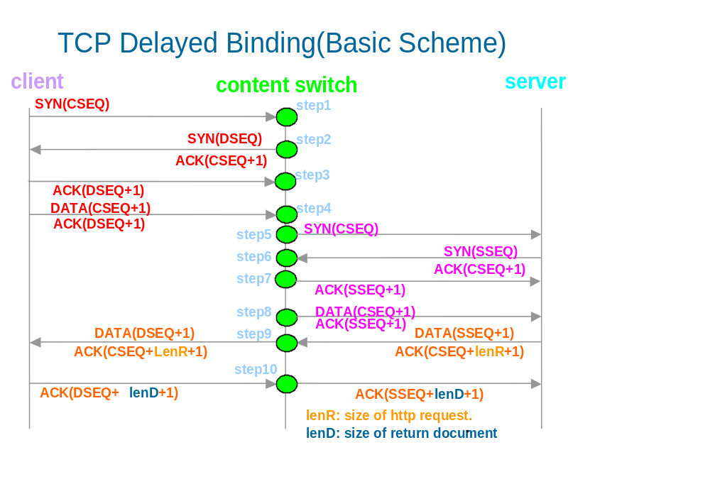
Figure 2.2 A time line of showing TCP delayed binding

Template 2.1 shows the new fields that were added for the content switch functionality to built in structure of type "struct ip_masq". The "struct ip_masq" structure contains control information per client and real server connection, for IP masquerade feature provided in Linux.

Template 2.1

- struct ip_masq
- {
- struct list_head m_list, s_list, d_list;
- /* hashed d-linked list heads */
- atomic_t refcnt; /* reference count */
- struct timer_list timer; /* Expiration timer */
- __u16 protocol; /* Which protocol are we talking? */
- __u16 sport, dport, mport; /* src, dst & masq ports */
- __u32 saddr, daddr, maddr; /* src, dst & masq addresses */
- struct ip_masq_seq out_seq, in_seq;
- struct ip_masq_app *app; /* bound ip_masq_app object */
- void *app_data; /* Application private data */
- struct ip_masq *control; /* Master control connection */
- atomic_t n_control; /* Number of "controlled" masqs */
- unsigned flags; /* status flags */
- unsigned long timeout; /* timeout */
- unsigned state; /* state info */
- struct ip_masq_timeout_table *timeout_table;
- #ifdef CONFIG_IP_MASQUERADE_VS
- struct ip_vs_dest *dest; /* real server */
- atomic_t in_pkts; /* incoming packet counter */
- #endif /* CONFIG_IP_MASQUERADE_VS */
- #ifdef CONFIG_IP_MASQUERADE_VS_CS
- struct sk_buff_head cli_req_data_head;
- __u16 cs_flags;
- __u32 tot_data_len;
- __u16 first_chunk;
- char http_mthd_nm[10];
- int expected_data_len;
- __u32 htp_cnt_len;
- char trail_data[5];
- #endif

}

where, fields enclosed within CONFIG_IP_MASQUERADE_VS_CS macro are added for content switch, and are described below,
- cs_flags - flags to keep track of the state of the connection, e.g., if real server client request is completely received, if real server is selected yet etc.
- tot_data_len - total size of client request data
- first_chunk - flag to denote condition if we are processing the first packet of client request
- http_mthd_nm - HTTP method name in the request, e.g., GET or POST
- expected_data_len - number of bytes of data yet not received. This applies to variable sized request like POST where this value can be estimated using the "content-length:" tag in the HTTP request header and size of data received till that point.
- htp_cnt_len - value of "content-length:" tag in the HTTP request header for variable sized request like POST
- trail_data - this stores the part of the trailing character sequences (the CRLFCRLF sequence) in a packet that demarcate a HTTP request header from its body data. This is helpful to determine the end of HTTP request header boundary when the trailing data itself is spanning across multiple packets
Note that in basic scheme the content switch is set up as a default gateway in all the real servers that are part of the content switch cluster. This is to make sure that all the response packets go via the content switch so that it can do the necessary packet transformation on them. Content switch has control information stored in a hash table whose entries are of type "struct ip_masq" (see Template 2.1). This control information is used to translate the sequence numbers for server packets destined for client and for client packets destined for the real server.

Pre-allocate Scheme

The pre-allocate scheme is an improvement on the basic scheme described in Section 2.1. This scheme was developed based on the heuristic that there is a mapping between a client and a real server. Specifically, it is assumed that a given client is more likely to request similar kinds of requests and hence is more likely to be served by the same real server. Using this assumption any subsequent request from the same client is sent directly to its matching real server. This cuts back the overhead of content switch setting up a TCP connection with client and rule matching on every request, and of packet transformation, where the sequence and acknowledgment number client and real server packets are translated. The preceding argument holds when the matching real server for the subsequent request from the same client happens to be the "correct" guess. If it turns out to be a "wrong" guess, complications result as described in the later part of this section.
The structure of pre-allocate hash table is as shown below Template 2.2.

Template 2.2

- struct ip_vs_cb_pa_service
- {
- struct list_head s_list;
- __u32 caddr;
- __u32 rs_addr;
- __u16 rs_port;
- atomic_t refcnt;
- };

where,
- s_list - is a variable of built in structure type in Linux kernel whose address serves as anchor for each entry of the hash table
- caddr - client IP address
- rs_addr - real server IP address mapped to client with IP address caddr
- rs_port - service port of the service that real server provides
- refcnt - the number of connections at the content switch that are currently using this entry

When a client sends request to the content switch for the first time and its real server selected using rule matching, an entry is created in a hash table. The key in the hash table is the client IP address and service port and data is the real server IP address. When the same client sends a next request at some later point in time, the hash table is looked up to find a matching entry keyed off the client IP address and port of service that it requested. If a matching entry is found, the client request is directly routed to the real server obtained from the matching entry. When server sends its response, the HTTP response code sent from the real server is examined. If the response code is 200, which means response is good and pre-allocate guess was "correct". In this case the response is forwarded to the client. If the response code is not 200, which means response was bad and pre-allocate guess was "wrong". In case of a "wrong" guess, a TCP reset (RST) is sent to the pre-allocated server and rule matching is done on the client request and the request routed to real server selected from rule matching.

Figure 2.3 shows time line of steps involved in TCP delayed binding in a pre-allocate scheme in case of a "correct" guess. In steps 1-4 content switch simply forwards the client packets to the real server whose IP address is obtained from the matching entry in the pre-allocate hash table. No TCP connection end point is created at the content-switch in this case. In step 4, the client request packet, which can be more than one, is sent directly to the real server with no sequence translations. In step 5, the server response packet, which can be more than one, is sent to client without any packet transformation.
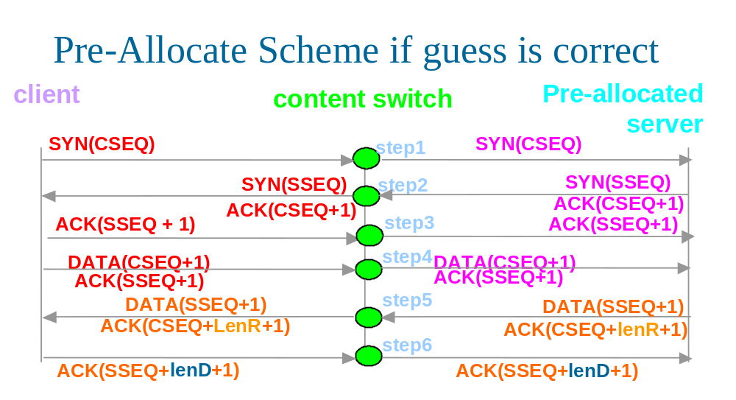
Figure 2.3 A time line of steps showing pre-allocate if the guess is correct

Figure 2.4 shows time line of steps involved in TCP delayed binding in a pre-allocate scheme in case of a "wrong" guess. Steps 1 - 5 look exactly the same as in Figure 2.3 for pre-allocate scheme with a "correct" guess. After step 4, the HTTP response code sent from the real server is examined which happens to be not 200, e.g., 404 which means the requested document is not present at the server. In this case, in step 6, a TCP reset (abbreviated as RST) is sent to real server that sent the bad response code. This reset will cause the TCP endpoint at real server that sent bad response to transition to a closed state. After TCP reset is sent, the pre-allocate scheme degenerates to basic scheme, i.e., a rule matching is done and TCP connection established to the selected real server and client request is forwarded to it, and the sequence numbers in both client and server packets are translated appropriately. This is shown in steps 7 - 12.
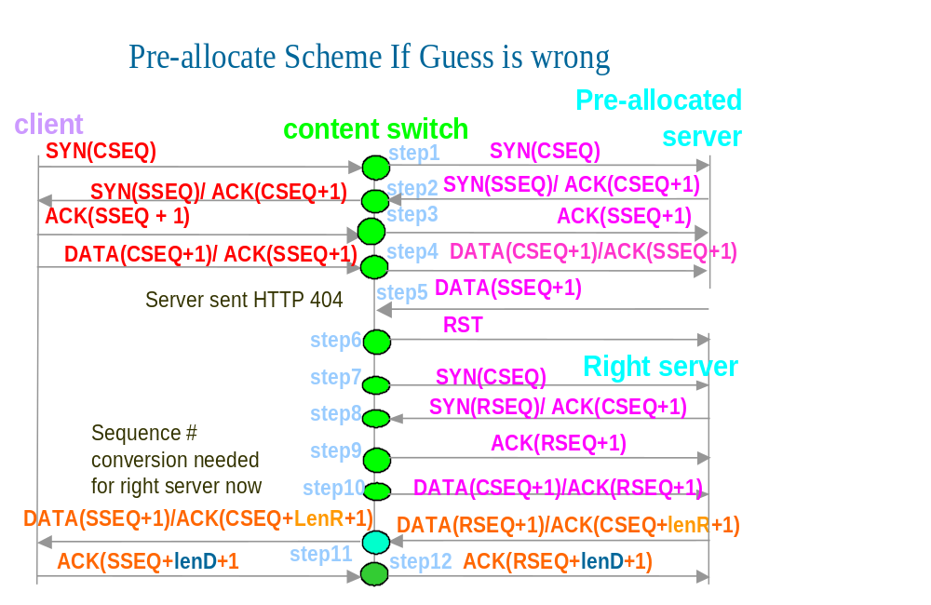

Figure 2.4 A time line of steps showing pre-allocate scheme
if the guess is wrong

Note that in the pre-allocate scheme, even if a matching entry is found in the pre-allocate hash table, the client packets are still buffered at the content switch. This is to account for worst case, when pre-allocate guess turns out to be "wrong" and rule matching (that parses out rule fields from client request) needs to be done to select the appropriate real server. When server response is examined and the pre-allocate guess happens to be "correct", all memory associated with the buffered data is freed up. Also in the current version of pre-allocate scheme when pre-allocate server guess is "wrong" and the result of rule matching after this finding, yields the same real server as the pre-allocate guess, the response packet is allowed to be forwarded to the client.
In the current version of pre-allocate scheme implementation, the pre-allocate hash table entry is deleted from hash table and freed up, after it is seen that it resulted in "wrong" guess. There can be many variations to this cleanup; e.g., one could be a timer based clean up. Further, in the current implementation of pre-allocate scheme assumes a strict mapping between client and its real server. This mapping can be further fine grained to client request, i.e., the part hash table key (in addition to client IP address and service port) in the pre-allocate hash table could be one or more fields within the request, like URL value.

Filter Scheme

This scheme was developed under the premise to reduce the packet processing overhead at the content switch by distributing some of the tasks that content switch does over to the real servers. Specifically, in this scheme 1) the sequence translation was done at the real server as opposed basic and pre-allocate schemes where it was done at the content switch and, 2) response packets are sent directly to the client without content switch being the intervening gateway. It is named as a filter scheme as some of the packet processing tasks are "filtered out" from the content switch to the real servers.
In this scheme a new layer was implemented at the real server between the IP and TCP layer which does packet transformation for both incoming client packets and outgoing server packets.
Figure 2.5 shows time line of steps involved in TCP delayed binding in a filter scheme.
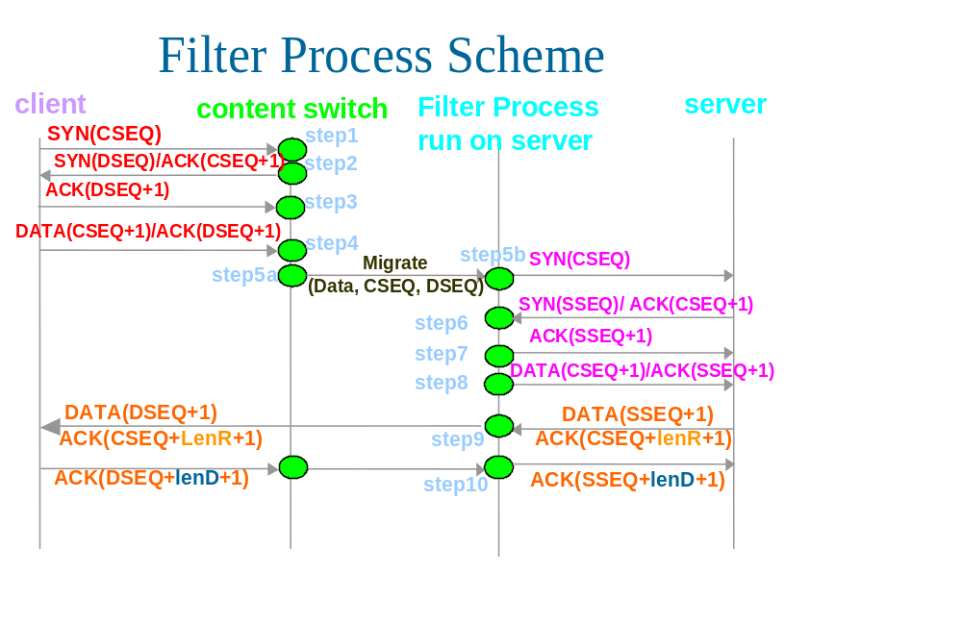
Figure 2.5 A timeline of steps showing filter scheme

In steps 1-3 the three-way TCP handshake between the client and the content switch is completed where the two communicating entities commit there starting sequence numbers. In step 4 the client sends its request packet. In practical situations there can be more than one packet sent for a given request, e.g., for variable sized HTTP request like POST. Before step 5, rule matching is done on the received client request and a real server selected using criteria defined in the rule matching. In step 5a, the packet transformation information (described in the later part of this section) is populated in the SYN packet sent to the selected real server. In steps 5-7 the three-way handshake between the client and the real server is completed. In step 8 the client sent request data is relayed to the real server. At the real server before the client data is handed over to the upper TCP layer, the sequence and acknowledgment number contained in all the packets are translated (or fixed) at a new layer implemented between TCP and IP stack. The sequence translation is done using the sequence translation information obtained from the SYN packet. The real server sends response data in step 9. In practical situations, there can be more than one response packet for a given request. At the real server before the server response data is sent to the client, the sequence and acknowledgment number contained in all the sent packets are translated appropriately at the new layer using the sequence translation information obtained from the SYN packet. The response packets are directly routed to client via a default gateway, which may not be the content switch.
In order for the real server to translate the sequence numbers, it must have necessary packet transformation control information for the TCP connection established between the client and the content switch. This control information is encapsulated in the structure shown in Template 2.3, which is populated at the content switch in a SYN packet for destined for real server and extracted at the new layer implemented at the real server.

Template 2.3

- struct cli_request_info
- {
- char filt_flag[4];
- __u32 cs_addr;
- __u32 cli_str_seq;
- __u32 cli_str_ack_seq;
- }

where,
- filt_flag - flag to delineate packet containing control information for virtual service
- cs_addr - content switch IP address
- cli_str_seq - TCP sequence number contained in first request packet of client
- cli_str_ack_seq - TCP acknowledgment number contained in first request packet of client

The filt_flag is set to have a unique value "CSFL", which in addition to the SYN flag set in the TCP packet will help the new layer at real server differentiate a packet for virtual service (in this case HTTP) and any other service (e.g., telnet, FTP etc.). Note that a TCP SYN packet in principle should not contain any data, but we have added a sequence translation control information as data to it for internal use only, between content switch and the real server.
The control information is sent only in the SYN packet, and is stored in a hash table used at the new layer implemented at the real server. The structure of this hash table is shown in Template 2.4.

Template 2.4

- struct filt_conn_table
- {
- struct list_head s_list;
- __u16 proto;
- __u32 cs_addr;
- __u32 caddr;
- __u16 cport;
- __u32 cli_str_seq;
- __u32 cli_str_ack_seq;
- struct rtable *cs_dst;
- }

where,
- s_list - is a variable of built in structure type in Linux kernel whose address serves as anchor for each entry of the hash table
- proto - protocol value of the virtual service
- cs_addr - content switch IP address
- caddr - client IP address
- cport - client TCP port
- cli_str_seq - TCP sequence number contained in first request packet of client
- cli_str_ack_seq - TCP acknowledgment number contained in first request packet of client
- cs_dst - pointer to the structure that stores destination route information to the content switch

The key in the filter connection hash table described above in Template 2.4 is proto (protocol value), caddr (client address), cport (client port) fields. This serves to uniquely capture packets that belong to a specific protocol and connection of the virtual service. If any packet sent from or received by real server has a matching entry found in this hash table, the control information in the hash table is used to translate its sequence and acknowledgment number appropriately. For SYN packets that contain the sequence translation control information the new layer strips off this control information, adjusts the TCP checksums fields before delivering the packet to the upper TCP layer. In fact, the TCP checksums need to be adjusted for both client and server packets whose sequence number gets translated.
Note that the new layer at the real sever also does the differential routing of acknowledgment and data packets sent from the real server. Specifically, TCP acknowledgments to the client request buffered at the content switch and sent to the real server has to be sent to the content switch. This is needed so that the content switch knows when to retransmit a packet.
After checking for retransmission from these real server acknowledgments, the content switch simply drops these packets and does not forward them to the client. This is because if these acknowledgments are forwarded to the client, the client TCP will get confused as content switch has already sent TCP acknowledgments for the client request packets before even real server is selected. In contrast, the response data packets emanating from the real servers are sent directly to client (after sequence translation at new layer) without being sent via content switch. This differential routing was achieved using the size of outgoing server packets. If the size of outgoing server packets was greater than zero, it implied that such packets had some response data in them, and such packets were routed directly via the normal default gateway, other than the content switch. If the size of outgoing server packets was zero, it implied they were either of ACKs, FINs or RSTs, and such packets were routed via the content switch. All server ACKs were dropped at the content switch (as content switch had already acknowledged client request), FINs and RSTs were allowed to be forwarded to the client, which is necessary because these packets ensure proper connection closure on both sides of a TCP connection. The sequence translation was also applied to these server (as well as client) FINs and RSTs packets at the new layer so the receiving end will accept them correctly.
The freeing up of a filter connection hash table entry of type "struct filt_conn_table" (as shown in Template 2.4) was tied to the freeing up of INET socket structure of type "struct sock", which is created per connection on both endpoints of a TCP connection in Linux. That is, the filter connection hash table entry was freed in the destructor callback function of INET socket structure. This ensured that all allocated memory gets freed up when connections get terminated.

Handling multiple requests IN Keep-AliVE HTTP connection

In HTTP /1.0 [5], for one TCP connection established between the client and the HTTP server, the client was allowed to send only one request, i.e., there was a one to one mapping between the client request and a TCP connection. A simple Web page like a HTML document, specified in a HTTP request by a client browser and served by a HTTP server is shown in Template 3.1. Let's assume the URL of this document is http://abc.xyz.com/test.html.

Template 3.1

<HTML>

<HEAD>

<TITLE>This is a test page - test.html with URL http://abc.xyz.com/test.html </TITLE>

</HEAD>

<BODY>

<P><!--BODY content begins here--></P>

<P> This is a igloo image </P>

<IMG SRC="home_igloo.gif">

<BR>

<P> This is a butterfly image </P>

<IMG SRC="buttefly.gif" >

<BR>

<P> This is a forest image </P>

<IMG SRC="forest.gif" >

<BR>

<P> This is a river image </P>

<IMG SRC="river.gif" >

</BODY>

</HTML>

When the client browser requests this URL, only the HTML document as shown in Template 3.1, excluding the embedded images, is retrieved in the first response sent by the HTTP server. The client browser parses this document and then requests for all the embedded objects, which happen to be 4 "gif" images in this example. In a non keep-alive HTTP connection data for each of these four embedded objects are requested via a new connection. So, in total, in a non keep-alive HTTP session there are five TCP connections (one for the main HTML document and four for its embedded objects) created to get the complete data associated with a given Web page. When client browser and HTTP server are HTTP /1.1 compliant, which allows keep-alive HTTP [6] connections, the request pattern is somewhat different. The client browser creates a pool of connections when client sends first few requests for URLs directed at the same HTTP server. For any subsequent requests, following creation of the connection pool to the same HTTP server, the connection pool is reused (typically in a round robin fashion), as opposed to creating new connections for every one of those new requests. In our example, after the first "test.html" document is retrieved and subsequent few (two to three normally) requests for the embedded objects in this document are sent, a connection pool (of two to three TCP connections) is created. All new requests following creation of connection pool, e.g., remaining embedded objects in the "test.html" document or even a different Web page requested from the same HTTP server machine, the connections in connection pool are reused. Note that keep-alive HTTP connections are also known as persistent HTTP connections.
The benefit of keep-alive HTTP connections is that they do away with the overhead associated with connection set up and tear down (see Figure 2.1) at both client and the real server. In addition, experiments [8] show that too much bandwidth is wasted in packets exchanged in a TCP three-way handshake, during connection set-up and packets exchanged for graceful tear down of a TCP connection. In some cases the bandwidth may not be used to its full capacity because of TCP slow start mechanism [32], where it takes a certain number of initial packet exchanges before the sender can get up to speed in sending its data.
There are actually two ways in which requests can be sent in a keep-alive HTTP connection. First, in which only one outstanding request is sent at a time, i.e., next request in a given connection is sent only when the response of previous request is completely received. Second, in which two or more requests can be sent simultaneously in succession, without waiting for their responses. The latter is also known as HTTP request pipelining. We found that the current versions of well known browsers (both IE 5.0 and Netscape 4.5 do not use/support pipelining of HTTP requests).
Handling of multiple requests within a keep-alive connection, in a content-switch is a tricky problem. There is only one TCP connection between client and the virtual server, but there can be more than one real server catering to those different requests in the single client connection. In this situation, each real server may have it's own set of initially committed TCP sequence numbers and acknowledgment numbers. The virtual server has to translate these sequence and acknowledgment numbers into a coherent set of sequence and acknowledgment numbers that the client expects. For example, let cseq, vseq, rseq1, rseq2 be the start sequence numbers committed by the client, virtual server and two real servers respectively during initial TCP three-way handshake. The two real servers are selected via rule matching on two different client requests on a single TCP connection. Let's say at some point in time, the client sends a request packet of sequence cseq+m and acknowledgment sequence number of vseq+n and real server 1 is chosen to reply the client request. The virtual server must appropriately translate the request sequence and acknowledgment numbers in the client request packet for the chosen real server such that real server can accept it. Similarly, in the response from the real server 1 to the client, the virtual server must appropriately translate the sequence and acknowledgment numbers that the client expects. This instance of the problem with a solution is exemplified in detail in sections that follow. Sections 3.1 and 3.2 describe the key issues in a keep-alive HTTP connection and Section 3.3 presents a solution, which was successfully implemented keeping these issues into account. The problems faced in a content switch receiving pipelined requests in a HTTP connection, with some of the possible solutions are discussed in Section 3.4.
Note that the problem of keep-alive request handling and a solution to it explained in the following sections are discussed with reference to the basic scheme. But key ideas presented in the solution, are also applicable to pre-allocate and filter scheme.

Determination of new request in a given connection

A typical HTTP Web session (with only one outstanding request) follows the sequence as shown in Template 3.2.

Template 3.2

Client sends packet 1 for request 1

Client sends packet 2 for request 1

………..

………..

Client sends (last) packet N1 for request 1

Server sends reply packet 1 for request 1

Server sends reply packet 2 for request 1

………..

………..

Server sends (last) reply packet M1 for request 1

Client sends packet 1 for request 2

Client sends packet 2 for request 2

………..

………..

Client sends (last) packet N2 for request 2

Server sends reply packet 1 for request 2

Server sends reply packet 2 for request 2

………..

………..

Server sends (last) reply packet M2 for request 2

………..

For example, here request 1 could be "GET /doc.html", and request 2 could be "GET /fly1.gif" for a "gif" image embedded in "doc.html".
When client is in the data sending (request) mode, the data size sent in its request packets will be greater than zero. In data receiving (reply) mode client will just send the acknowledgments packets for received data and hence, the data size of these packets in this mode will be zero.
A way we can determine that client has sent a new request is when we have ascertained the previous request has been completely received and the data size of the current packet sent by client is greater than zero. An approach to determine that the previous request has been completely received is discussed in Section 5.1.
Note this example assumes that in a given connection, at any instant only one outstanding request is sent, i.e., next request in a given connection is sent only when the results of previously sent request is completely received. This is a key assumption in our handling of multiple requests in a keep-alive connection.

Reuse of server side connections

Since in a content-switch packet routing is done at a request level and in a given keep-alive connection there can be many requests sent. In this situation it can happen that different requests within the same TCP connection are routed to different real server. For a request routed to a given real server a TCP connection needs to be established with that server. This can result in a situation where we have one TCP connection between client and the content switch and potentially many connections associated with that connection with the real servers as shown in Figure 3.1. The mapping for one client connection and many real server connections is maintained at the content switch. This makes the (bi-directional) sequence translation handling more complicated, since this needs to be done dynamically on a per real server basis, as requests arrive and servers get selected.

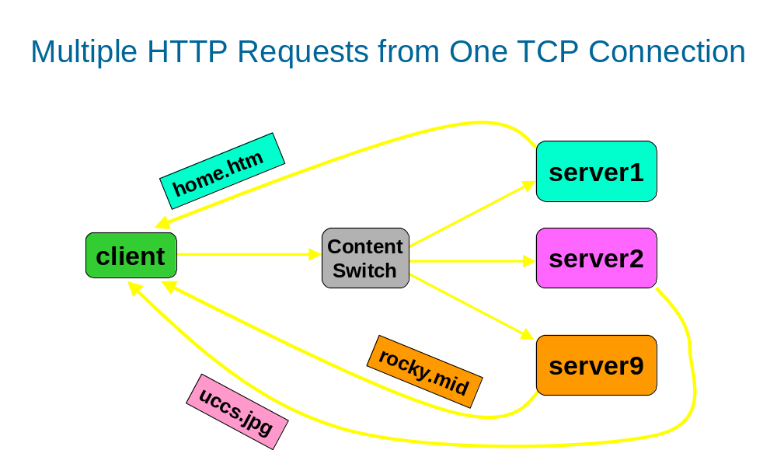

Figure 3.1 Multiple requests sent in a single keep-alive HTTP connection
that get routed to different real servers

Following were the two approaches were considered for handling this dynamic sequence translation associated with multiple requests in a keep-alive HTTP connection:
1. For each new request sent by client initiate a new connection (with three-way handshake) with the selected real server. This means closing of pre-existing connection with the selected real server and establishing a new connection. Control information for bi-directional translation of sequence and acknowledgment number of both real server and client are maintained in a "current" structure. This control information contains, for example, start sequence number of real server, start acknowledgment number sent by real server, sequence and acknowledgment number in the reply packet expected by client etc. This approach seems to have considerable overhead in terms of opening and closing of TCP connections for each new request.
2. In a new request, if a real server is selected for the first time, a three-way handshake is initiated with it to establish the connection. An entry is added to a hash table with real server address as the key for this newly established connection. The data in this table for each keyed entry contains all the necessary information for bi-directional sequence number translation. For subsequent requests when an entry is found in this connection hash table, the data in the matching hash table entry is used to appropriately translate the sequence numbers, without creating a new connection with the real server that is selected more than once. The reuse of server side connections for subsequent requests, saves overhead associated with connection initiation and cleanup as discussed in the first approach. This is the approach that we used and is described in detail in Section 3.3.

Solution for handling keep-alive HTTP requests

This section discusses a solution for handling non-pipelined requests in a keep-alive HTTP connection. Template 3.3 shows structure of hash table that stores the control information used in bi-directional translation of sequence numbers for packets in a keep-alive connection:

Template 3.3

- struct real_serv
- {
- __u32 addr;
- __u32 cli_str_seq;
- __u32 cli_str_ack_seq;
- __u32 rs_next_seq;
- __u32 rs_last_ack_seq;
- __u32 rs_cur_seq;
- __u32 rs_cur_ack_seq;
- }

where,
- cli_str_seq - TCP sequence number contained in first packet of a given client request
- cli_str_ack_seq - TCP acknowledgment number contained first packet of a given client request
- rs_next_seq - expected (next) sequence number of the first response packet that the real server will send for a new client request. This is calculated from the last packet sent by the real server as below

rs_next_seq = sequence number in last sent packet from real server + data size of last

sent packet from real server
- rs_last_ack_seq - TCP acknowledgment number in the last packet sent by the real server
- rs_cur_next_seq - TCP next sequence of the currently sent server packet. This is calculated from the currently sent data packet as below:

rs_cur_next_seq = sequence number of current packet from real server + data size of this

packet
- rs_cur_ack_seq - TCP acknowledgment of current packet sent by real server. This is copied straight away from the ACK field in the server TCP packet

This hash table entries whose structure is shown in Template 3.3, are created per client content switch connection and stored in the IP masquerading structure of type
"struct ip_masq" (see Template 2.1) maintained at the content switch.
Note that fields described in lines 4 - 7 (i.e., cli_str_seq , cli_str_ack_seq, rs_next_seq, rs_last_ack_seq) in Template 3.3 remain fixed for a given request-reply session and are not updated until the beginning of next new request. In the beginning of a new client request when its first packet is received cli_str_seq and cli_str_ack_seq are directly copied off from this packet. rs_last_seq and rs_last_ack_seq are assigned values from rs_cur_next_seq and rs_cur_ack_seq respectively which are stored from the previous request-reply HTTP session. For the very first request in a given keep-alive connection rs_last_seq and rs_last_ack_seq are set from the sequence and acknowledgment numbers in the server SYN-ACK packet that is sent by server in response to client initiated SYN.
The sequence number translation of "current" packet forwarded to ultimate receiving end (i.e., the client or the real server) in a given request-reply session is done using this premise:
Sequence number of next packet should be set relative to the last acknowledgment sent by the receiving end, with an offset beginning from the sequence number contained in the first packet sent by the sender.
Similarly, the acknowledgment number translation of "current" packet forwarded to ultimate receiving end (i.e., the client or the real server)in a given request-reply session is done using the premise:
The acknowledgment number of next packet should be set relative to the last sequence sent by the receiving end, with an offset beginning from the acknowledgment number contained in the first packet sent by the sender.
The above two premises are exemplified in the sequence translation formulae illustrated in the later part of this section.
When a new request is received in a given connection and its real server selected the keep-alive hash table is searched using real server IP address as the key. The keep-alive hash table structure is shown in Template 3.3 and is stored in IP masquerading entry created for a connection. If an entry is found in the keep-alive connection hash table, the sequence translation control information is used to translate the sequence and acknowledgment number of client packet. If no entry is found in keep-alive connection hash table for the selected real server a new entry is added to it.
At any instant when a client sent packet, including both the request data packet or zero sized acknowledgment packet, is forwarded to the currently selected real server, the sequence number and the acknowledgment number in the forwarded packet are translated as below:
- Sequence number of packet sent by client and forwarded to current real server

rs_last_ack_seq + (cli_cur_seq - cli_str_seq)

Here cli_cur_seq is the sequence number in the current packet populated by the client TCP.
- Acknowledgment number of packet sent by client and forwarded to current real server
rs_next_seq + (cli_cur_ack_seq - cli_str_ack_seq)
Here cli_cur_ack_seq is the acknowledgment number in the current packet populated by the client TCP.
When a server sends a response, the connection hash table that stores the sequence number translation control information is searched using real server address as the key. The real server address is obtained from the source address field of IP header of response packet. The real server sent packet, including both the response data packet or zero sized acknowledgment packet, is forwarded to the client, with the sequence number and the acknowledgment number in the forwarded packet translated as below:

- Sequence number of packet sent by real server and forwarded to client
cli_str_ack_seq + (rs_cur_seq - rs_next_seq)
Here rs_cur_seq is the sequence number of current packet populated by real server TCP.
- Acknowledgment number of packet sent by real server and forwarded to client
cli_str_seq + (rs_cur_ack_seq - rs_last_ack_seq)
Here rs_cur_ack_seq is the acknowledgment number of current packet populated by real server TCP.
In a scenario where there is one keep-alive TCP connection between client and the content switch and many connections between content switch and real server for that single client connection, all back-end connections are terminated only when client issues an active close. If any of the servers issue the active close, it is simply discarded as the remaining server connections may still be active. Once a client issues an active close, via a FIN sequence, the current server, which is engaged in the current request-reply session, is allowed to have a graceful connection shutdown. The graceful connection shutdown is achieved via FIN and FIN/ACK packet sequences [4]. The remaining servers are simply sent one RST each, from the content switch.

Handling pipelined requests in a HTTP connection

The previous sections presented a solution with implementation of handling multiple requests for keep-alive HTTP connection in a content switch where only one outstanding request is sent at a time. This section presents a discussion on problems with some solutions for handling multiple requests in HTTP connection, which are sent in a pipelined fashion.
In a scenario where request pipelining [6][8] is allowed, two (or more) HTTP requests can be sent in succession, where the latter request does not wait for the results of former request to complete. The order in which the requests are sent is still maintained, i.e., next request is sent only the previous request is completely sent. An instance of how requests can be sent in a pipelined fashion in a HTTP connection is Template 3.4.

Template 3.4

Client sends packet 1 for request 1

Client sends packet 2 for request 1

………..

………..

Client sends (last) packet N1 for request 1

Client sends packet 1 for request 2

Client sends packet 2 for request 2

………..

………..

Client sends (last) packet N2 for request 2

Server sends reply packet 1 for request 1

Server sends reply packet 2 for request 1

………..

………..

Server sends (last) reply packet M1 for request 1

Server sends reply packet 1 for request 2

Server sends reply packet 2 for request 2

………..

………..

Server sends (last) reply packet M2 for request 2

………..

Note that that first packet of request 2 is sent just after the last packet of request 1 and hence request 2 does not wait for the response of request 1 to be completely received. Note that when the response are sent they are also sent in a same strict order as the requests were sent, i.e., first packet of response 2 is sent only when the last packet of response 1 is completely received by the client.
Problems faced in handling pipelined requests in a content switch are more involved than those faced in a non-pipelined keep-alive connection. When requests are sent is a pipelined manner in a given HTTP connection, there can be situations where different real servers selected for each of those requests. Now when response are generated from the real servers the response should be somehow synchronized so that they are sent in the same order that the request came at the content switch. If this synchronization is not done, the client will be confused and would not be able to handle the response. Proposed below are the two ways in which the response synchronization can be achieved:
- The content switch keeps track of requests and their mapping to the real servers, and allows responses to be sent in the order of arrival of their requests. This implies the response from some of the real servers be buffered at the content switch until the response from "prior" request is completely sent out.
- The content switch buffers the client requests and sends out requests one at a time to the selected real servers. The next request buffered at the content switch is released only when it determines the response of previous request is completely sent out.

Note that re-use of server side connections at the content switch (as explained in Section 3.2) is still applicable to both the solutions presented above.
In the two solutions presented above the content switch has to delineate different requests sent in a pipelined manner in the same connection and also determine that a given response is completely received by the client. In order to delineate different requests sent in a pipelined manner, the content switch will have to parse the incoming request data stream. A way to parse incoming data stream for HTTP requests is mentioned in Section 5.1. In order to determine that a given response is completely received by the client, the content switch may have to find the response length fields. For example, the "content-length" tag value, contained in the HTTP response header, and keep track of how much of the response data still remains to be sent out.
Note that the two proposed solutions assume that the content-switch is developed using the NAT scheme, where content switch is the default gateway for all the response packets generated by the real servers.

Performance Results

This section presents the performance results that compare the relative merits of the three schemes described in Chapter 2.
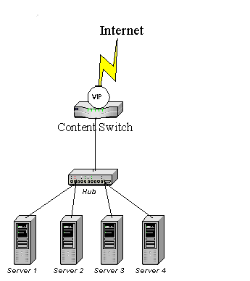
Figure 4.1 shows a block diagram of content switch configuration as seen in the test-bed.

Figure 4.1 A block diagram of content switch
network configuration

Table 4.1 shows the hardware and software configuration of machines used in the test-bed.

Machine Spec | IP Address | OS | Web Server
fladnag.uccs.edu  P5 240MHz 128MB  (Content Switch) | 128.198.192.184 | Redhat 6.2 running Linux 2.2.16-3 kernel | Apache 1.3.14
vinci.uccs.edu  P5 166MHz 64MB  (Real Server 1) | 128.198.192.193 | Redhat 6.2 running Linux 2.2.16-3 kernel | Apache 1.3.14
gandalf.uccs.edu  P5 240 MHz 128MB  (Real Server 2) | 128.198.192.194 | Redhat 6.2 running Linux 2.2.16-3 kernel | Apache 1.3.14
dlibert.uccs.edu  (Client) | 128.198.192.195 | Windows NT, 4.0 | NA

Table 4.1 Configuration of machines used in performance tests

In all these performance tests, benchmarks were also taken against the LVS NAT [2] scheme, as described in Section 1.2.3, which comes as built in feature with Linux. This was done because all three schemes implemented in this work are built upon LVS, acting as the baseline. The scheduling algorithm that was employed in all these tests for LVS scheme was simple round robin.
For instructions of how to set up these different schemes, refer to Section A.1 and A.2 of Appendix.
The first set of benchmark results taken were processing time versus document size. In this set of benchmarks two variations of pre-allocate scheme were used; pre-allocate scheme with all hits and pre-allocate scheme with all misses. The former corresponds to the case when an entry is found in the pre-allocate hash table, for all the requests, and the pre-allocate guess is "correct". The latter corresponds to the case when an entry is found in the pre-allocate hash table, for all the requests, and the pre-allocate guess is "wrong".
The processing time is measured at the client, which submitted the request and is the difference in timestamp when the request was submitted and the timestamp when complete response was received. Also in the first set of tests the number of content switch rules was fixed to 200. The requests were submitted via a perl script. In the benchmarks, two of the most frequently seen Web requests were used, e.g., HTTP GET and POST.
In HTTP GET request, the request size remains fixed, but the response size was varied by requesting documents with a wide variation in document sizes. The response size was varied because there is some overhead associated with response packet processing at the content switch in terms packet routing and sequence number translation. The document size metered with HTTP GET request does not include the size of HTTP response headers; the document size in this case is just the size of data contained in document returned in the response.
Figure 4.2 shows the plot of processing time of HTTP GET request against the document size for different schemes implemented in this work. A discussion of inferences from this graph in order of increasing processing time (increasing overhead) is below:
- It can be seen that the LVS scheme has the least processing time as it uses content unaware layer 4 switching.
- Next comes the pre-allocate scheme with all hits. The performance of this scheme is marginally poor than the LVS scheme. This can be attributed to the fact that this scheme does the buffering of client request packets until the selected real server sends the response packet back that contains the response code value (see Section 2.2).
- Next comes the basic scheme, which is just the LVS scheme, with added responsibility to buffer client request packets, rule matching, sequence translation of both incoming client packets and outgoing server response packets.
- Next comes the filter scheme, which surprisingly has more overhead than the basic scheme. This scheme was initially expected to be better than the basic scheme as the sequence translation is done at the real server. In addition, in this scheme, the response packets are sent directly to the client without being sent via the content switch, which alleviates the packet-forwarding overhead at the content switch. The poor performance of filter scheme over the basic scheme is attributed to the extra hash table lookup of both incoming client packets and outgoing server response packets at the real server. The real server does this lookup so as to appropriately translate the sequence and acknowledgment number of only the virtual service packets. For example, if telnet is not part of virtual service in the content switch cluster, then packets belonging to this service at the real server should not be modified. Additionally, in filter scheme the ACK and data packets are routed differentially (see Section 2.3), with separate routing table lookups done for ACK and data packets.
- Last comes pre-allocate scheme with all misses, which is a worst case for pre-allocate scheme. If the pre-allocate guess turns out to be "wrong", a RST is sent to the "wrong" server. The client request data then undergoes the rule matching process and a new connection needs to be established with the new server selected via the rule matching.

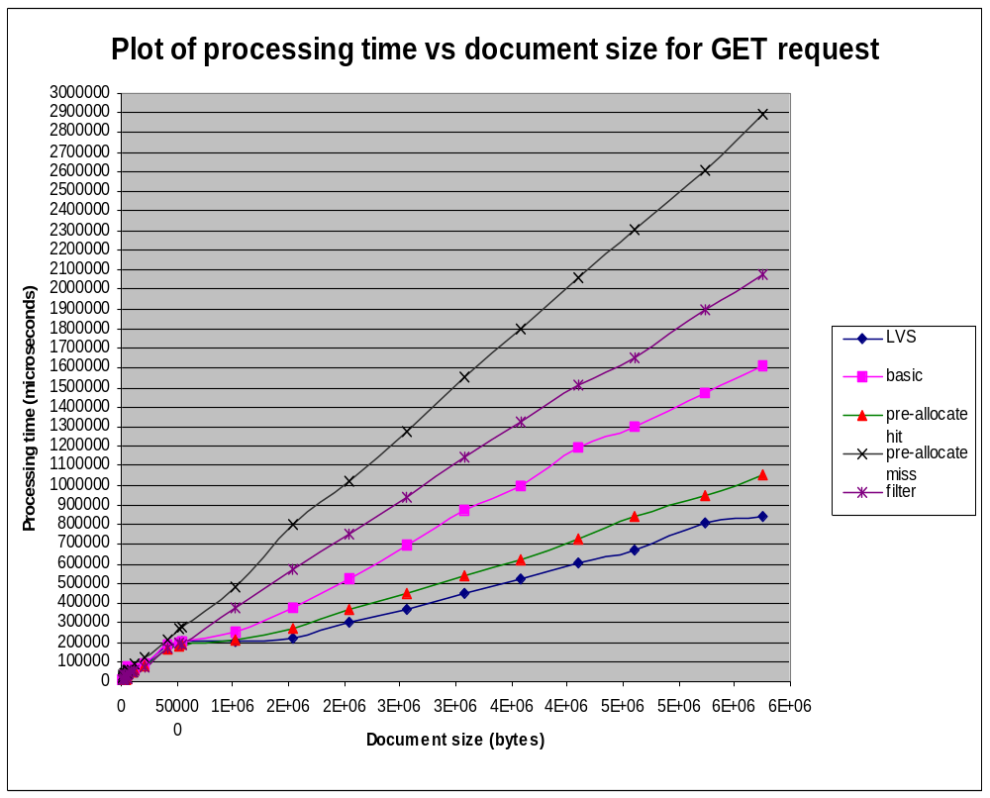

Figure 4.2 Plot of processing time vs. document size of GET request

In processing time versus document size benchmark for HTTP POST request, the response size was kept fixed, but the request size was varied by sending variable sized HTTP POST requests. The request size was varied because there is a overhead associated with request packet processing at the content switch in terms of data buffering, XML request parsing, packet routing and sequence number translation. The document size metered with HTTP POST request does not include the size of HTTP request headers; the document size in this case is just the size of data contained in the request.
Figure 4.3 shows the plot of processing time of HTTP POST request against the request size for different schemes. The graphs shown in this figure for POST requests follow similar pattern as shown in Figure 4.2 for GET requests. This clearly shows that the LVS scheme has the least overhead and pre-allocate scheme with all misses has the maximal overhead in terms of request processing time.
The next set of performance benchmarks were requests/sec and throughput. These two metrics were taken with Webbench [17] [8]. Webbench is a well-known industry standard tool for benchmarking Web servers. Webbench allows a set of tests suites to be run against a pre-defined Web server. Each set of tests, collectively called as a test mix provide a wide array of tunable parameters against which the requests/sec and throughput metrics of a Web server can be metered. Some of these parameters include, delay between consecutive requests, number of client threads that can simultaneously send request to the Web server, type of data requested (workload), i.e., static content like a ".gif" or ".jpg" file or dynamic content like the output of a perl-cgi script. The parameters that we used in the test cases, were the number of client threads and delay between consecutive requests. As the number of client threads was gradually increased (as seen in all these graphs) to throttle the Web server with large number of client requests, the delay between consecutive requests was increased appropriately so as to not bring down the Web server to a crash. Some of the key steps in installation and usage of Webbench are explained in Section A.4 of Appendix.

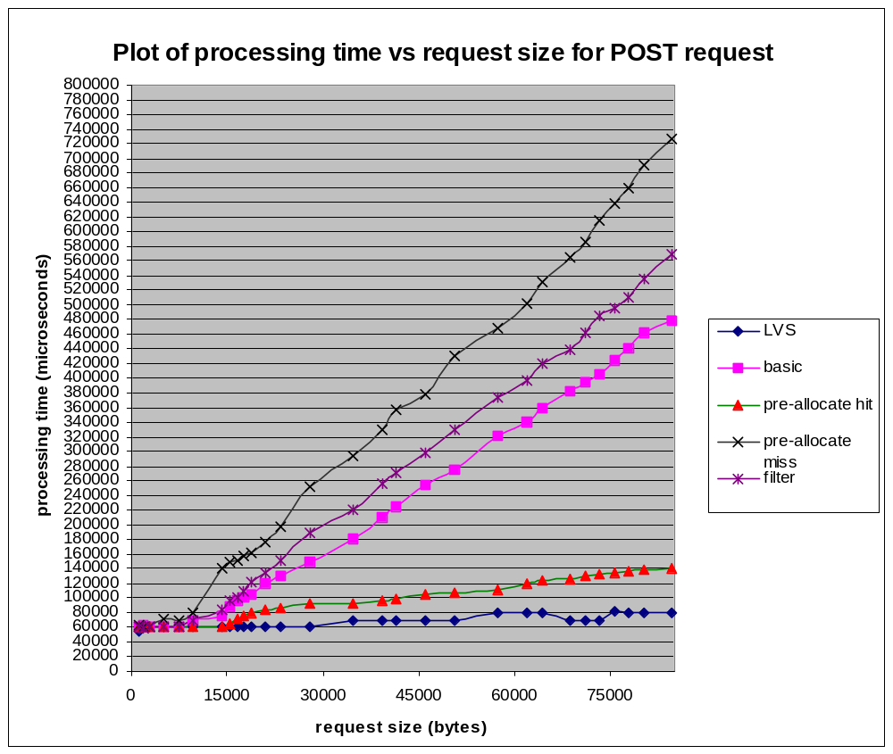
Figure 4.3 Plot of processing time Vs request size for POST request

The benchmark configuration deployed for requests/sec and throughput metrics was same as that for processing time versus document size metric.
For the pre-allocate scheme, the workload was so designed that half the requests will result in a pre-allocate hit and half the number of requests will result in a pre-allocate miss. This was done to have a near average case performance metrics for the pre-allocate scheme. The workload in the pre-allocate scheme was constructed in such a manner that half the number of requested files were deleted from one of the real server and the other half was deleted from the second real server. The deleted files at a given server will result in a pre-allocate miss for that server. In addition, the rules were set up in such a manner that the request, which causes a pre-allocate miss, will be routed to the "correct" real server.
Note that the same Webbench test suites were used in all these graphs except in case of pre-allocate where the workload data was tampered (as discussed before) to achieve the average case scenario for it.
Figures 4.4 and 4.5 show the requests/sec and throughput metrics of all the schemes against the number of operational client threads (when number of rules at the content switch was kept fixed to 200)
It is seen from these graphs that LVS, basic, pre-allocate nearly same performance variations in terms of both requests/sec and throughput. The filter scheme has the poorest performance in terms of requests/sec and throughput. This can be attributed to the extra hash table lookup for client request and server reply packets in filter scheme, as discussed in processing time versus document size plots of this scheme (see Figure 4.1 and Figure 4.2).
Note that LVS, basic, pre-allocate have nearly same performance variations as the number of client threads was varied. This was because the number of rules in all these tests was only 200, which does not introduce much overhead. For this reason, the effect of number varying the number of rules on the requests/sec and throughput metrics was studied. For each of the schemes, except LVS, the number of rules were varied from 200 - 120000 and requests/sec, throughput metrics were sampled at the point when there were maximum number of client threads operational. The maximum number of client threads configured in the tests was 8.
Figure 4.6 shows the max. requests/sec metric for all the schemes as the number of rules were varied. A discussion of inferences from this graph in order of decreasing requests/sec is below:
- For the LVS scheme, varying number of rules has no effect as it does switching at layer 4 and does not look at application content at all.
- Next comes the pre-allocate scheme. The relatively better performance of pre-allocate scheme as the number of rules was varied can be attributed to the fact that it is almost like the LVS scheme in case pre-allocate guess is correct. If a pre-allocate guess is correct no TCP connection needs to be established between client and the content switch and the content switch and real server. All client request packets are directly forwarded to the real server with no sequence translation and all server response packets are forwarded to the client with no sequence translation. This caused pre-allocate scheme's requests/sec metric not to degrade as poorly as for the basic or the filter scheme.
- Next comes the basic scheme for which the request/sec metric falls somewhat steeply as the number of rules are increased.
- Finally, comes the filter scheme, for which requests/sec metric starts at lowest point even when there are least number of rules and ends up at a lowest point when max. number of rules are set up. The reason for the poorest performance of this scheme are same as that discussed in the processing time versus document size metrics for this scheme. See Figure 4.1 and Figure 4.2.

Figure 4.7 shows the max. throughput metric for all the schemes as the number of rules were varied. The graphs shown in this figure follow similar pattern as shown in Figure 4.6 for requests/sec metric.

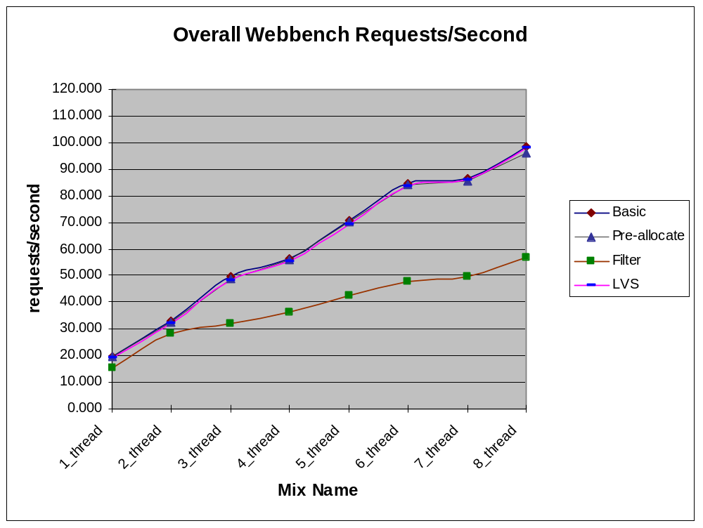

Figure 4.4 Plot showing requests/sec plot of various schemes
with variation in configurable parameters of Webbench

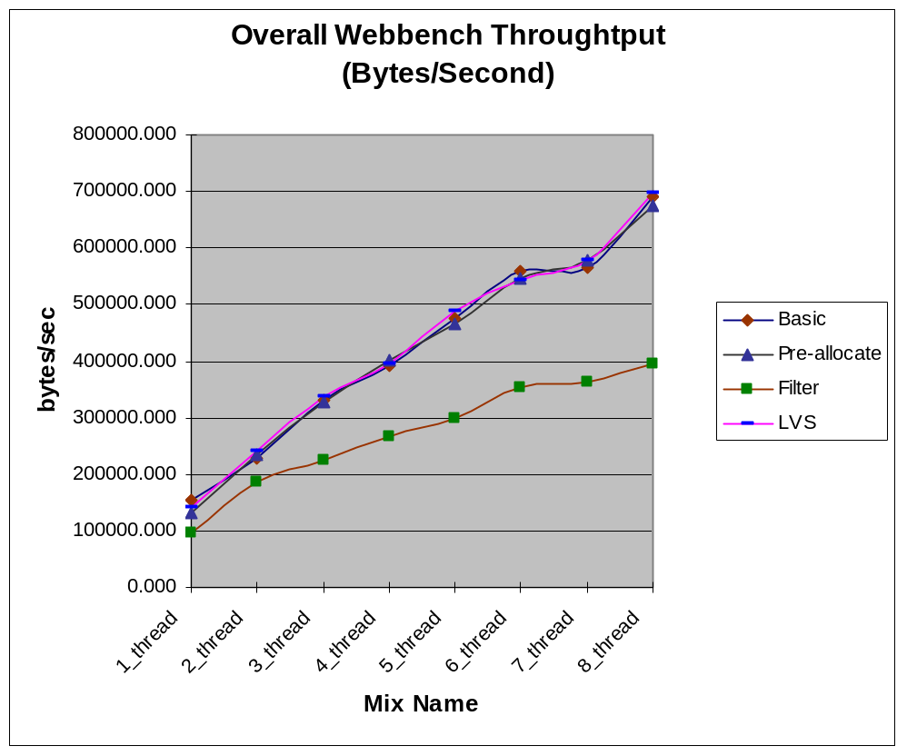

Figure 4.5 Plot showing throughput plot of various schemes
with variation in configurable parameters of Webbench

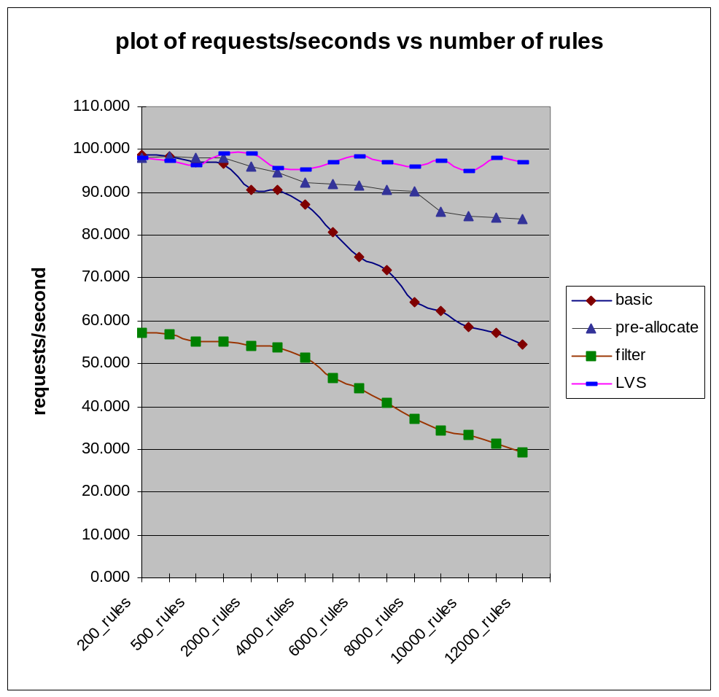
Figure 4.6 Plot showing request/sec plot of various schemes vs.
number of rules

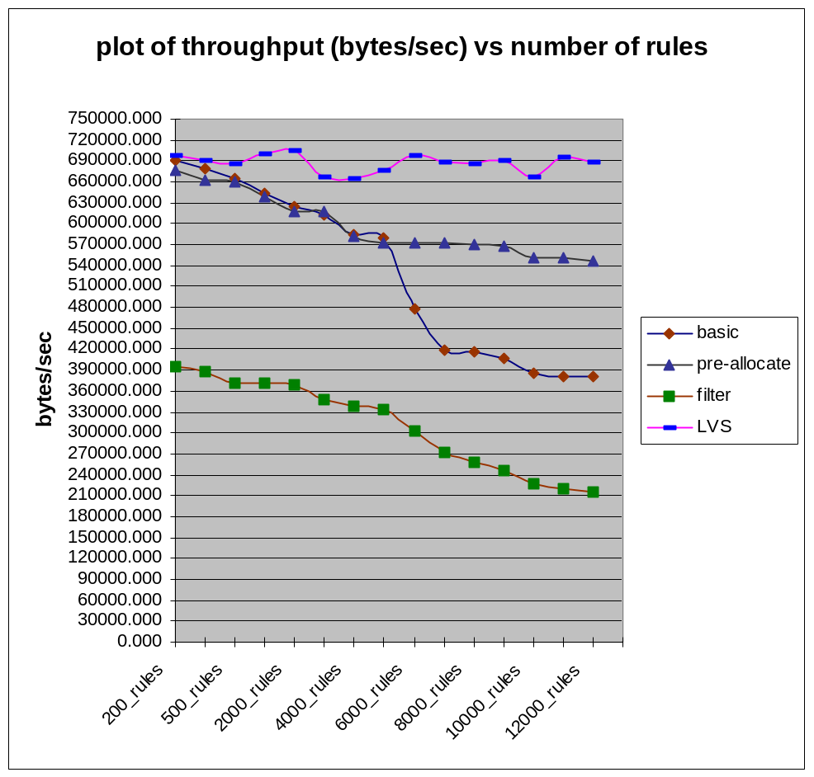
Figure 4.7 Plot showing throughput plot of various schemes
vs. number of rules

Miscellaneous Improvements

This section describes some of the issues that were faced during design and development of content switch. It also describes some of the solutions that were implemented to address those issues along with some alternate suggestions. Majority of the issues addressed in the sub-sections that follow, are the improvements over a version of content switch developed earlier [12].

Handling client request spread across multiple packets

If the client's request is too big to fit in one TCP segment, the content switch has to wait for all the segments that comprise that request before commencing the rule matching. This is especially true of non-idempotent HTTP requests like PUT and POST, and for e-commerce applications with large XML request. This further gives rise to the sub-problems that we had to account for. These sub-problems are illustrated in the sub-sections that follow.

Determine the content length

The content length of the variable incoming data stream had to be determined in order to flag the end of a variable length client request. The content length information of such request can be obtained from the "Content-Length" fields in the HTTP header. However, the value of the content length itself can span across multiple segments as shown in Template 5.1

Template 5.1

Here is a sample HTTP POST request, with HTTP request headers followed by data. The entire request (including headers and data) is sent over multiple TCP segments, where, TCP Segment n contains:

POST /cgi-bin/cs622/purchase.pl HTTP/1.0\r\n
Referer: http://archie.uccs.edu/~acsd/lcs/xmldemo.html\r\n
Connection: Keep-Alive\r\n
User-Agent: Mozilla/4.75 [en] (X11; U; Linux 2.2.16-22enterprise i686) \r\n
Host: viva.uccs.edu\r\n
Accept: image/gif, image/x-xbitmap, image/jpeg, image/pjpeg, image/png, */*\r\n
Accept-Encoding: gzip\r\n
Accept-Language: en\r\n
Accept-Charset: iso-8859-1,*,utf-8\r\n
Content-type: application/x-www-form-urlencoded\r\n
Content-length: 7

TCP Segment n+1 contains:

53\r\n
data (753 bytes)

As seen in the above example of Template 5.1, the individual bytes of the content length are split across two consecutive TCP segments, the first segment contains 7 and the next segment contains the remaining two byte, i.e., 53. This is true for any field within the HTTP request header, even for the sequence of data bytes that form the "Content-Length" string.
In content switch that was developed in this work, the "Content-Length" tag value was unambiguously parsed out for variable sized HTTP requests like POST, covering one of the many cases as described in the example above.
The key idea behind parsing the "content-length" tag value was that in a given HTTP request, the request headers are delimited by "\r\n\r\n" sequence ('\r', abbreviated as CR, is a carriage return and '\n', abbreviated as LF, is a line feed character), also known as CRLFCRLF sequence. Once this CRLFCRLF sequence was found, any tag value can easily be found. Note that parts of this CRLFCRLF sequence itself can span across multiple TCP segments, i.e., end of nth segment contains CR and beginning of (n+1)th segment contains LFCRLF.

Fragmentation of application level content

After the content length is determined, the content switch can then wait for all the packets of that request. Until the last packet of a given request is received all the intermediate packets have to be stored somewhere. These intermediate packets are actually queued as is, without any modification, in sk_buff data structure. The queue head pointer is of type "struct sk_buff_head" is named as cli_req_data_head (as seen line 24 in Template 2.1). The sk_buff structures nodes are linked by doubly linked list (note that each of these structures are Linux specific and may not be part of other OS). A node of sk_buff data structure contains the timestamp, TCP/IP headers, followed by the content payload. Therefore, the actual content is fragmented and spread out in various network buffers. Extracting URL field in the HTTP request is easy, since it is in the first packet. But for extracting other meta-headers and especially the XML tag values in the content field of the HTTP request, the fragmentation of the HTTP content post difficult challenging problem for the content switch designer. One approach is to concatenate all individual non-contiguous TCP segments back to back into one coherent buffer, that can then be used for XML parsing, or pattern matching. We used this approach for XML parsing of client request. This approach requires expensive memory copying and uses additional memory. The original TCP segments are not freed up after the concatenation of their payload content, since once the real server is selected, these TCP segments will be modified and sent to the chosen real server. The modification includes the destination IP address field, possibly the TCP port field, the ACK sequence number, and very importantly, the IP checksum. The other approach is to redesign the XML parsing or pattern matching so that they can work with data that is spread across several segments. As an alternate solution, a specialized memory address mapping hardware similar to the translation look-aside cache used in virtual memory system can provide help to speed up the packet processing.
Hence, in any of the approaches considered above, we cannot assume any restrictions on the size of incoming client request.

Keeping in sync with client and server TCP

This content switch was implemented at the IP layer of the virtual server. Client request buffering, rule matching and forwarding of client data to the selected real server along with bi-directional sequence translation was done at the IP layer of the real server.
While buffering client data, the content switch has to send ACKs for the segments that comprise the client request, otherwise the client TCP will assume the server is dead or is very slow, and will not send subsequent packets. This is achieved by invoking appropriate ACK sending routines from the IP layer of the content switch.
For large sized (> 40K) client requests, we also observed some of the relayed segments were dropped by the chosen real sever. Further analysis indicated that the problem was due to data forwarding of client packets, which was done continuously from the queued buffers, without considering the window size advertised by the TCP stack of the real server. This flooding of data caused the real server to drop some of the received TCP packets. It was observed that the acknowledgment number sent by real server was held constant, even though the content switch had emptied all buffered data. The result was that there was no response seen from real server, as it had not acknowledged receipt of all data. This problem was solved by having the content switch keep track of the real server acknowledgment number along with buffering of last packet sent to it. When the acknowledgment sent by real server was less than the next sequence number of the packet to be sent subsequently, the last sent packet was retransmitted. The next sequence number is computed from the sequence number of the last packet and size of data in it. This retransmission helped alleviate packet flooding at the real server and ensure all client data are properly received.

Handling different XML data encoding schemes

There are two basic ways for submitting the XML-based request to the Web server. One is to use the form with text input or text area input. The other is to submit it as XML document. When submitting it with form, the XML request data is encoded using the x-www-form-urlencoding method and the "Content-Type" HTTP meta-header will have the value of "x-www-form-urlencoded". The content following the HTTP headers in this case will be in encoded form. When submitting it as XML document, the "Content-Type" HTTP meta-header will have the value of "text/xml" and the content following the HTTP headers will be just plain text with no encoding. With the "text/xml" encoding type, all special characters like line feed (\n), carriage return (\r), left anchor (<) and right anchor (>) etc. retain their ASCII representation. In the "x-www-form-urlencoded" encoding type the special characters have encodings like "%XX", where XX is the hexadecimal representation of ASCII value of that special character. For example, for the "x-www-form-urlencoded" encoding type, the values for the exemplified special characters will be "%0A", "%0D", "%3C" and "%3E" respectively. Hence, the rule matching module should correctly parse the XML content of the client request depending on the value of "Content-Type" HTTP meta-header.

Referencing specific tags in a XML document

The rule specification scheme should be flexible enough to account for exact tag name or rule field indicated in the rule specification. Template 5.2 shows an example that illustrates this point.
Template 5.2

<purchase>
<customerName>CCL</customerName>
<customerID>111222333</customerID>
<item>
<productID>309121544</productID>
<unitPrice>5000</unitPrice>
<subTotal>50000</subTotal>
</item>
<item>
<productID>309121538</productID>
<unitPrice>200</unitPrice>
<subTotal>2000</subTotal>
</item>
<totalAmount>52000</totalAmount>
</purchase>
<purchase>
<customerName>CDL</customerName>
<customerID>111222444</customerID>
<item>
<productID>30913555</productID>
<unitPrice>3000</unitPrice>
<subTotal>20000</subTotal>
</item>
<totalAmount>20000</totalAmount>
</purchase>

In the XML document shown in Template 5.2, some of the tags are repeated, e.g., purchase, item, totalAmount. Hence, a rule syntax is needed to allow for selecting a particular set of tags in the rule set. Here is an example of a scheme that addresses this problem. To specify a rule based on subTotal value present in the second item tag within the first purchase tag, the rule will be specified as 'purchase:1.item:2.subtotal > 5000". As another example, 'purchase:2.totalAmount < 15000' specifies a rule based on the totalAmount tag present within the second purchase tag.
This scheme of rule specification based on a particular set of tag values was implemented in the content switch rule-matching module. For detailed information on rule-matching module, refer to Section 1.4 and Section A.1 of the Appendix.

High-AvailabILITY OF Content Switch

This section describes the set up of a fault tolerant (highly available) architecture of a content switch system, which we found to have slightly different operational requirements as compared to a fault tolerant LVS system. A fault tolerant architecture for LVS is already described in [2]. A fault tolerant architecture for content switch based cluster system, as described in what follows, is built upon the LVS fault tolerant architecture.
The fault tolerant architecture is set up to account for each failure point in a content switch cluster, i.e., the virtual server, the real servers, the services at the real server and data files located at the real server. Figure 6.1 shows schematic representation of such an architecture in a content switch cluster system. It consists of two virtual servers, one is primary and other acts as its back up. On the real server side there is a set of servers that serve the requests on behalf of the virtual server. The real servers also act as clients to a set of Coda file system servers, which actually contain the data files.

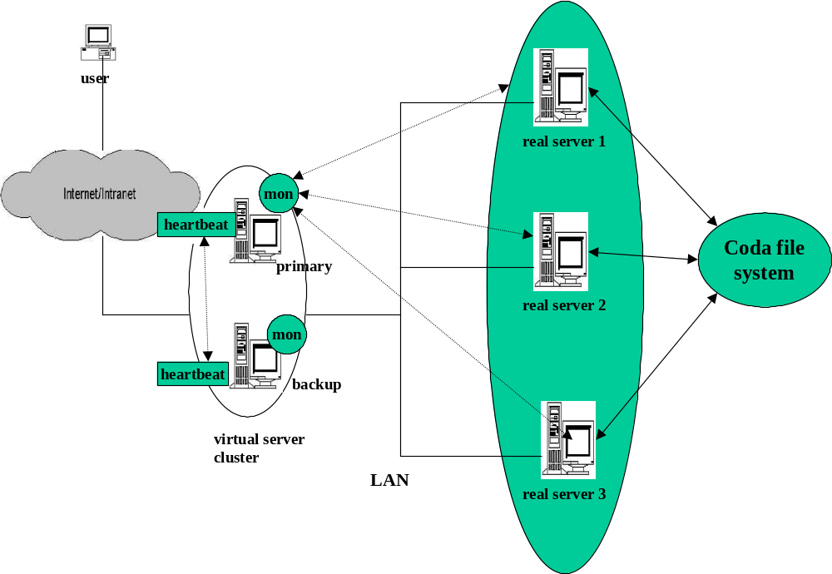
Figure 6.1 An architecture for High-Availability of Linux content switch

The fault tolerance is provided by mon[20], heartbeat[21] and Coda[22] incorporated in the content switch cluster system. Each of these software components has roles as described below:
- Mon - It is a monitoring software for both the real server and the services that it provides. The mon daemon runs on the virtual server to monitor services and server nodes that host the services in the cluster. For each service there are monitoring daemons available that come with standard mon package. For example, http.monitor can be used to check the http services; ftp.monitor is for the ftp services, and so on. The mon daemon constantly monitors the resource(s) that it is configured to monitor, and invokes user defined alert scripts upon detecting failure condition at the monitored resource. The scripts can be any runnable program, which can interpret parameters that are of form "-option value", e.g., a perl script or a UNIX shell script. Actually there are two types of alerts. First type of alert is simply called as "alert", which are invoked when the service actively monitored becomes unavailable from a prior available state. Hence "alerts" are in a sense down alerts. Second type of alerts is called "uplalert" which are invoked when the service actively monitored becomes available from a prior unavailable state.
- Heartbeat - It is also a monitoring software for the virtual server or the load balancer. It actually runs on both the primary and the backup virtual server. Through this software, the primary and the secondary send messages of "I'm alive" to each other at regular intervals to know each others operational status. When one of the machine, let's say primary goes down and the backup does not get a response from the primary in a configurable interval, the backup machine takes over the primary. The backup will take over whatever resources the heartbeat software was configured to manage, which in case of a content switch cluster would include the virtual IP, mon software and the content switch cluster setup scripts as described in Section 6.2. Note that IP address of the virtual server is considered as a resource here, and its takeover is needed when primary virtual server failed so that client remains transparent to virtual server failure. The IP address takeover in heartbeat software is actually implemented via gratuitous ARP mechanism, where the requester machine broadcasts a ARP message to machines in its network to update their ARP cache, which contains the IP address to physical address mapping, with a changed IP address to physical address mapping. In a heartbeat setup, the machine that detected its peer's failure will send such ARP messages so that all future client requests get directed to it. Also with a heartbeat setup when primary comes back up again, it will again take back all the resources that secondary took over from it, when the primary went down. The current version of heartbeat does not allow take over of already established connections at the failed machine. Such connections have to be re-established with re-submission of requests that could not be completed because of failure at the active virtual server.
- Coda - It is a distributed file system that stores files on one or more computers called servers, and makes them accessible to other computers called clients, where they appear as normal files. As the data files in a Coda file system are actually stored on the server, if one of the real server fails, the data files can still be accessed via the a new server that replaced the failed server or servers that were still operational. Hence, a Coda file system provides fault tolerance of data files. Template 6.8 lists some issues observed during Coda installation in this work.
Based on the architecture of Figure 6.1, Table 6.1 shows the machines involved with their respective roles in the Linux content switch high-availability setup.

Machine Name | IP Address | OS | Role
calvin.uccs.edu | 128.198.60.22 | Redhat 6.2 running Linux 2.2.16-3 kernel | Primary virtual server
walden.uccs.edu | 128.198.192.203 | Redhat 6.2 running Linux 2.2.16-3 kernel | Secondary virtual  server
vinci.uccs.edu | 128.198.192.193 | Redhat 7.1 running Linux 2.4.2-2 kernel | Real server1 (Coda client)
gandalf.uccs.edu | 128.198.192.194 | Redhat 7.1 running Linux 2.4.2-2 kernel | Real server2 (Coda client)
wait.uccs.edu | 128.198.192.202 | Redhat 7.1 running Linux 2.4.2-2 kernel | Coda server

Table 6.1 Machines in Linux content switch high-availability setup

Sub-sections that follow show configuration examples that explain handling failure of real servers and the virtual server in a content switch cluster system.

Handling failure of real server

In a content switch system the constraints in handling of a real server failure are somewhat different that those imposed in LVS [2]. LVS operates at transport layer and is content blind where content switches operate at application layer and have routing rules based on application content.
In the content switch implemented in the current work, the routing rules are fixed and incorporated in the form of a kernel module. In such a scenario, where the routing rules are fixed and a real server goes down, then all the rules, which route the request to the failed server are invalidated. This situation requires replacing the old kernel module containing the old routing rules, with a new kernel module containing new routing rules that exclude the failed server. The new routing rules should exclude the failed server so that no future request is routed to it until it comes back up again. After the failed server comes back up again, the old kernel module that contained old routing rules needs to be re-introduced by replacing the new one. Note that the rule module replacement on a server failure should be automated, where routing rules get changed without any user's intervention.
On the other hand in LVS, when a real server fails, it is simply removed by a single UNIX command ipvsadm (see Section A.1 of Appendix), which is much simpler than the steps taken to handle failure in a content switch as discussed above.
The fault tolerance of real servers in a content switch was achieved by setting up mon on the primary and backup virtual servers. There is a configuration file named "mon.cf", which convey the resources that are to be monitored and specific alerts that are associated with those resources. The "mon.cf" that was set up, is shown in Template 6.1.

Template 6.1
#
# The mon.cf file
#
#
# global options
#
#cfbasedir = /etc/mon
alertdir = /root/mon-0.99.1/alert.d
mondir = /root/mon-0.99.1/mon.d
maxprocs = 20
histlength = 100
randstart = 30s

#
# group definitions (hostnames or IP addresses)
#
hostgroup vinci 128.198.192.193

hostgroup gandalf 128.198.192.194

#
# Web server 1
#
watch vinci
service http
interval 10s
monitor http.monitor
period wd {Sun-Sat}
alert mail.alert cprakash@cs.uccs.edu
upalert mail.alert cprakash@cs.uccs.edu
alert wk_up.ksh -S 0
upalert wk_up.ksh -S 1

#
# Web server 2
#
watch gandalf
service http
interval 10s
monitor http.monitor
period wd {Sun-Sat}
alert mail.alert cprakash@cs.uccs.edu
upalert mail.alert cprakash@cs.uccs.edu
alert wk_up.ksh -S 0
upalert wk_up.ksh -S 1

There were two real servers named gandalf.uccs.edu and vinci.uccs.edu that were monitored and assigned hostgroup names of gandalf and vinci respectively. Let's consider the hostgroup vinci as described in Template 6.1, where:
HTTP service was monitored
At intervals of 10 seconds
Using http.monitor tool
On all days of the week
On alert a mail was sent to cprakash@cs.uccs.edu and a script invoked wk_up.ksh with argument -S 0
On upalert a mail was sent to cprakash@cs.uccs.edu and a script invoked wk_up.ksh with argument -S 1
The wk_up.ksh is a script to which "-S" is a status option, with value 1 meaning the server came up and with value 0 meaning the server went down. The wk_up.ksh script as, shown in Template 6.2, was written to handle real server failures keeping in view the constraints imposed by a content switch.

Template 6.2

#!/bin/ksh
#
#script wk_up.ksh
#

set -- `getopt s:g:h:t:l:S:u $*`
# check result of parsing
if [ $? != 0 ]
then
exit 1
fi
while [ $1 != -- ]
do
case $1 in
-h)
hostNmDt=$2
shift;;

-S)
stat=$2
shift;;

-g)
grp=$2
shift;;
esac
shift
done

RULEDIR=/usr/src/linux/net/ipv4/rule
IPVSADM=/usr/sbin/ipvsadm
INSMOD=/sbin/insmod
RMMOD=/sbin/rmmod
#path to program that converts IP address in dotted decimal form to hexadecimal form
DTOX=/home/cprakash/progs/dtox
VIRTUAL_SERV=128.198.192.184

makeNewModAndIns()
{
set -x

cd $RULEDIR

#edit rule file
vi -n rule_template.c << EOF 2>&1 1> err.out
^[^[^M^M^M
:%s/{\"$1\".*}/{\"$1\", $2}/g
:wq
EOF

rm -f ip_cs_curr_rule.o
make ip_cs_curr_rule.o

if [ -e ip_cs_curr_rule.o ]
then
$RMMOD ip_cs_curr_rule
$INSMOD ip_cs_curr_rule.o
else
exit 1
fi
}

if [ $stat = 1 ]
then
#up alert

hostNmHx=`$DTOX $hostNmDt`

makeNewModAndIns $grp $hostNmHx

#compile and insert of new module was a success.
#Now, add this server to the lcs server group
$IPVSADM -a -t $VIRTUAL_SERV:www -r $hostNmDt -m

else
#down alert
set -x

#remove the host from the virtual service setup
$IPVSADM -d -t $VIRTUAL_SERV:www -r $hostNmDt

#get IP address of a server which is working
actHostNmDt=`$IPVSADM -ln | grep -i masq | awk '{if(NR >1) exit; print $2}' | awk -F ":" '{print $1}'`

#convert host name to hex
actHostNmHx=`$DTOX $actHostNmDt`

makeNewModAndIns $grp $actHostNmHx
fi

Note that when this script is invoked by mon, the "-h" and "-g" (that stand for the hostname and hostgroup values respectively) are provided by default. Any additional options (e.g., the "-S" option) specified in the mon.cf file are appended to the defaulted options.
When a real server goes down (on a "alert"), this script replaces the failed server with one of the active servers. This is done under the assumption the active server can access the data files provided by the failed server, which would hold true if the data files provided by the failed server are placed on a Coda server, to which all real server act as clients. Specifically, this script replaces the IP address of failed server in the rule module code file with the IP address one of the active servers, saves that code file, recompiles changed rule module code, and replaces the old rule matching kernel module with the object (C ".o" file) file of new rule module..
When the failed server comes back up (on a "upalert"), this script puts the old rule module back into the content switch cluster. This is done by modifying the rule module code file, such that the now available server is incorporated in the routing rules as in the normal condition. The re-modified code module file is saved, then compiled and original rule module object file generated. The original rule module is then inserted back into the kernel, replacing the transient module that was inserted earlier, to handle failure of the now available server. All of the above is done from the script.
The example illustrated above, essentially gives a basic approach to handle real server failures in a content switch. There can be many other variations to basic approach, which can be employed to deal with real server failures that have more specialized constraints in a content switch cluster system. For example, if there is only one real server in a content switch cluster, which provides a unique service, like SSL secure HTTP transactions, and it fails. Since, the remaining active real servers cannot provide SSL secure HTTP transactions, all future requests for such specilized service have to be rejected. This is possible by changing the rule module on a alert, after the specialized real server failure, such that all SSL requests are rejected.

Handling failure of virtual server

The failure of virtual server is handled by providing a backup to the primary virtual server and installing heartbeat on both the primary and the backup virtual servers. First, the high-availability configuration file, named as ha.cf (which can be found in "/etc/ha.d/" directory after heartbeat installation), should be set up as described in Template 6.3. The ha.cf is set up on both the primary and the secondary virtual servers.

Template 6.3

# ha.cf - heartbeat high-availability configuration file
#
# File to wirte debug messages to
debugfile /var/log/ha-debug
#
# File to write other messages to
logfile /var/log/ha-log
#
#
# Facility to use for syslog()/logger
logfacility local0
#
#
# keepalive: how many seconds between heartbeats
keepalive 2
#
# deadtime: seconds-to-declare-host-dead
deadtime 10
#
#
# Very first dead time (initdead)
initdead 20
#
# hopfudge maximum hop count minus number of nodes in config
hopfudge 1
#
# What UDP port to use for communication?
#
udpport 694
#
# What interfaces to heartbeat over?
udp eth0
#
# node nodename ... -- must match uname -n
node calvin.uccs.edu
node walden.uccs.edu

After the ha.cf file is setup, the haresources (high-availability resources file, also located in "/etc/ha.d/" directory) file should be set up as shown in Template 6.4. The haresources file is also setup on both primary and secondary machines.

Template 6.4
#
# haresources - heartbeat high-availability configuration file
#
calvin.uccs.edu 128.198.192.187 httpd lcs mon

The haresources file specifies the resources that are failed over and failed back between the primary and secondary machines. The resources as specified in Template 6.4 include the virtual IP address, the HTTP server, content switch configuration settings and the mon utility. Note that the virtual IP address listed in the haresources file is a floating IP address and should not be configured anywhere outside the haresources file. Any resource specified in the haresources file should have a corresponding control script with that name located in "/etc/rc.d/init.d/" directory. For example, the control script of HTTP server is "/etc/rc.d/init.d/httpd" and manages HTTP server as described in Template 6.5

Template 6.5
To start the HTTP server type

$ /etc/rc.d/init.d/httpd start

To stop the HTTP server type

$ /etc/rc.d/init.d/httpd stop

In fact all control scripts for resources specified in the haresources file must follow the "start" and "stop" convention as described in Template 6.5. The control script of IP address resource is by assumed as "/etc/rc.d/init.d/IPaddr" by default and need not be explicitly specified in the haresources file.
The control scripts for Linux content switch configuration ("/etc/rc.d/init.d/httpd/lcs") and monitor utility ("/etc/rc.d/init.d/httpd/mon") are shown in Template 6.6 and Template 6.7 respectively.

Template 6.6

#!/bin/sh

# control script for configuring Linux content switch. This script name
#is specified in the haresources file
# You probably want to set the path to include
# nothing but local filesystems.
#
PATH=/bin:/usr/bin:/sbin:/usr/sbin
export PATH

IPVSADM=/usr/sbin/ipvsadm
IPCHAINS=/sbin/ipchains
INSMOD=/sbin/insmod
RMMOD=/sbin/rmmod
RULEPATH=/usr/src/linux/net/ipv4/rule
RULEMOD=ip_cs_curr_rule
MAKE=/usr/bin/make

case "$1" in
start)
if [ -x $IPVSADM ]
then
echo 1 >/proc/sys/net/ipv4/ip_forward
echo 1 >/proc/sys/net/ipv4/ip_always_defrag

$IPCHAINS -A forward -j MASQ -s 128.198.192.0/24 -d 0.0.0.0/0

$IPVSADM -A -t 128.198.192.187:80 -s rr
$IPVSADM -a -t 128.198.192.187:80 -r 128.198.192.193 -m
$IPVSADM -a -t 128.198.192.187:80 -r 128.198.192.194 -m

if [ -d $RULEPATH ]
then
cd $RULEPATH
$MAKE $RULEMOD.o
$INSMOD $RULEMOD.o
fi
fi
;;
stop)
if [ -x $IPVSADM ]
then
$IPVSADM -C
$RMMOD $RULEMOD
fi
;;
*)
echo "Usage: lcs {start|stop}"
exit 1
esac

exit 0

Template 6.7

#!/bin/sh

# control script for mon utility. This script name is specified in the haresources file
#

MON=/root/mon-0.99.1/mon
MONCONFIGDIR=/root/mon-0.99.1/etc
MONSTATEDIR=/root/mon-0.99.1/state.d
MONLOGDIR=/root/mon-0.99.1/log.d
MONCMD=/root/mon-0.99.1/clients/moncmd

case "$1" in
start)
if [ -x $MON ]
then
$MON -B $MONCONFIGDIR -D $MONSTATEDIR -L $MONLOGDIR -f
fi
;;
stop)
if [ -x $MONCMD ]
then
$MONCMD term
fi
;;
*)
echo "Usage: mon {start|stop}"
exit 1
esac

exit 0

Template 6.8
Notes on Coda installation:

1. When creating a Coda volume on server as described in the INSTALL.linux help file, available at the Coda download site one should use the following command:

createvol_rep coda:root E0000100 /vicepa

where, "coda:root" is root volume.

But, the online documentation available at the Coda web site[22] says, specify the Coda root volume as "coda.root". So, one should use correct root volume name to createvol_rep command, the same as that specified during server installation, to avoid any unwanted problems caused due to this root volume name discrepancy.

2. For creating Coda admin during server installation, do not specify Coda admin user id as 1, even though instructions say you can use any Coda admin user id other than 0. On specifying Coda admin user id of 1, it is seen using pdbtool that Coda admin was not created because user id of 1 was already assigned to System user. Under this circumstance any login attempt to Coda server (using clog) from a client under Coda admin will fail, perhaps because user id 1 is already used by System user.

Conclusion and Future WORK

This work on content switch gives a deeper insight in some of the issues faced in their design and implementation. Specifically, reducing overhead in TCP-delayed binding, handling of multiple requests in a keep-alive HTTP connection, handling multiple client packets in a request, to name a few. From performance results of the three TCP delayed binding approaches, it can be concluded that pre-allocate scheme has better performance in average case as compared to basic and filter schemes. This work also highlighted the unique constraints imposed in designing a fault tolerant content switch system, as discussion in Section 6.1.
Here is another variation of TCP delayed binding, which can be taken as a future work item. This scheme transfers both rule matching and sequence number translation to the real servers. The client request will be multicast to all real servers. Until the appropriate real server is chosen, the virtual server TCP will send ACK to client like the basic scheme, but there will be no data buffering at the virtual server. Each real server will respond with a response code indicating its alacrity for the client request. The real server may also send some load balancing information to assist real server selection at the virtual server. The virtual server will use the response code from each of the real server to issue a final "voting" decision as to who will serve the client request. The selected real server will be allowed to send its response and information about client expected sequence number will be sent to it. A TCP reset will be sent to the rejected real servers. The chosen real server can send its response to client directly without virtual server being a gateway. As another variation to the above scheme all the real servers can make voting decision among themselves using a agreed upon load balancing algorithm without even sending any solicitation packets to the virtual server. Note that this approach is highly distributed and transfers processing to all components in the content switch cluster. In contrast, in the basic, pre-allocate and filter schemes implemented in this work, majority of computation intensive tasks are done at the virtual server.
The content switch in this work is implemented at the IP layer of the virtual server, which buffers incoming client request at the IP layer. The buffering is done so that rule matching could be initiated when the client request is completely received. Since IP provides an unreliable, non-sequenced service, the buffered data may not always be consistent, i.e., some buffers may be duplicated, lost or out of order. In such situations rule matching may fail or return inaccurate results. The same also applies to data forwarded to the selected real server from the IP stack of the content switch. To prevent this we must allow the client request data to be buffered at the end point of content switch TCP (stack) and then delivered to the real server from TCP stack of content switch to the TCP stack of the real server. Once the client request is sent to the real server and real server sends the response, the sequence and acknowledgment numbers should be translated appropriately in the response packets at some place. For example, in case the content switch is built using NAT scheme, before packets are sent to the client they are transformed appropriately at the virtual server. Note that the content switch is acting as a application proxy while forwarding the client request, whereas for response packets and client acknowledgments (sent for response packets) it is acts as a forwarding agent with added task to change the source IP address, and sequence and acknowledgment numbers as appropriate. There is no need for it to work as a application proxy for response packets, which has overheads in terms of copying the packets to the application layer. The sequence translation information can be maintained per connection in a hash at the IP layer, the same way as hash table entries are created in IP masquerade feature implemented in LVS [2].
Another challenging task, which can be taken as a future work item is to enable content switch to handle pipelined requests in a HTTP connection. Pipelined requests in a HTTP connection with some solutions to handle them are discussed in Section 3.4.
The content switch implemented in this work requires the virtual server and the real server reside in the same network. This restriction can be relaxed by allowing real servers to reside in a different network than the virtual server.
The routing in current version of content switch is done solely based on application content. A scheme that considers routing based on application content as well as server load [25] can also be developed. For example, the server selection process can be split into two sequential steps. In the first step a cluster of servers is selected, which is identified by a unique name. In the second step, a specific server among the servers that comprise the cluster group is selected by using load-balancing techniques such as least used connection, weighted round robin etc.
To remove the overhead associated with connection establishment and tear down (see Figure 2.1), a set of connections between content switch and real servers can be set up ahead of time and reused. This has definite advantages especially when the request and response size together is very small and majority of packet traffic is that of SYNs/ SYN ACKs and FINs. In a TCP connection, it is seen that due to TCP/IP slow start algorithm [32], the bandwidth used around initiation of a TCP/IP connection is very little as compared to what can be achieved during steady state.
Here is a rough sketch of a content switch cluster that uses latest protocols, specifically applicable to name based cluster systems that also address high- availability issues. Each real server will be part of one or more cluster groups. Each cluster will have a unique logical name assigned to it. During initial set up the real server will register with the content switch. In the registration request the real server will provide the cluster name it belongs to and the set of IP Addresses at which it can be contacted, if it is multihomed. In addition to the cluster specific information the real server can also supply its load-balancing policy. This mechanism allows dynamic addition and removal (via de-registration request) of a real server from a cluster group. This scheme of dynamic endpoint name registration is described in ENRP [15].
As regards the server selection, the incoming request from the client will be parsed, and a broad classification of the request type will be determined by the content switch Rule Matching algorithm [13]. Once the type of request is determined it can be mapped to a logical cluster that can serve this request. The elected cluster name will be used by the content switch load-balancing module to pick the optimal choice among the members of the chosen cluster. The IP address information of the final selected real server can obtained from a name to IP address mapping table. This table can be either in memory or possibly stored in a database. Note that this mapping information is populated from the registration request sent by real servers. The cluster having many real servers for a given logical name can also provide the fault tolerance in case the selected server has failed, without client knowing about it. This entire mechanism of cluster based service provisioning is described in ASAP/ENRP [14] [15] scheme.
As regards the load-balancing information gathering, the static information like CPU processing power etc. can be obtained during real server startup. To collect dynamic load balancing information during steady state, the content switch can proactively send requests to real servers for their load at configurable heartbeat intervals. The real server will send replies containing their load information to content switch for such requests. One potential way to obtain this information is use information provided system-monitoring tools like vmstat or sar (system activity report).

  - Setting up configuration for Basic and Pre-allocate scheme

Since both filter and pre-allocate schemes for content switch implemented in this work are based on LVS, same setup steps apply to the both these schemes as in LVS.
As an example to set up content switch cluster for either basic or pre-allocate schemes, listed below are the IP addresses of machines involved with their roles in the setup of content switch cluster.
Role | Machine Name | IP address
Content switch (virtual server) | fladnag.uccs.edu | 128.198.192.184
Server 1 | vinci.uccs.edu | 128.198.192.193
Server 2 | gandalf.uccs.edu | 128.198.192.194
Table A.1 A set of machines used for setting up various
delayed binding schemes
To set up content switch architecture as described in Table A.1, Template A.1 lists the set of command need to be a executed on the virtual server.
Template A.1

$ echo 1 >/proc/sys/net/ipv4/ip_forward
$ echo 1 >/proc/sys/net/ipv4/ip_always_defrag
$ /sbin/ipchains -A forward -j MASQ -s 128.198.192.0/24 -d 0.0.0.0/0
$ /usr/sbin/ipvsadm -A -t 128.198.192.184:80 -s rr
$ /usr/sbin/ipvsadm -a -t 128.198.192.184:80 -r 128.198.192.193 -m
$ /usr/sbin/ipvsadm -a -t 128.198.192.184:80 -r 128.198.192.194 -m

Additionally, the default gateways on each of the real servers that are part of the content switch cluster, needs to be set as the virtual server. This is done so that all outgoing response packets are sent via the virtual server, which will enable the virtual server to intercept all the response packets for the virtual service and apply appropriate transformation to them. The command to set up default gateway as virtual server on each of the real servers is listed in Template A.2.

Template A.2

$ route add default gw 128.198.192.192

After invoking above command, the default gateway on each of the real servers should be checked via command "netstat -rn". If after running "netstat -rn" command on a real server, some other host, let's say whose IP address is 128.198.192.60, is still seen set as the default gateway, it should be removed as default gateway using following command:

Template A.3

$ route del default gw 128.198.192.60

Note that there should be only one default gateway on all the real servers, which should be the virtual server in content switch cluster.
The next step is to install the kernel module (or rule-matching module) for content switch rules. The rule file is a C code file and can be generated via rule editor [13] GUI. This file can also be created manually, without using rule editor GUI. An example of a rule file is shown in Template A.4. In this file in line 11 - 12 are specified the set of fields whose value will be determined during XML parsing, if they are present in the incoming request document. For interpretation of this rule field format see Section 5.4. Rule R1 at line 18 conveys that if the value of rule field 1 (which is the "purchase:1.totalAmount:1." field at line 11) is >= 50000 then the request be routed to real server identified as vinci. As an other example, rule R4 at line 31, conveys that if the URL in the incoming request contains the sub-string "lcs2" it should be routed to real server identified as gandalf. If the incoming request does not match any of these R1 - R4 rules match, the request will be routed to the "default" server. The "default" server actually is the server chosen via the LVS [2] scheme.
Template A.4
/*
* A sample rule file rule.c, containing some rules based on application request fields.
*/

- #include <linux/kernel.h>
- #include <linux/types.h>
- #include <linux/malloc.h>
- #include <linux/mm.h>
- #include <linux/string.h>
- #include <net/ip_masq.h>
- #include <net/ip_mycs.h>
- #include <net/rule_match.h>

- struct ip_vs_cb_rule_field rule_fields [] =
- {
- {"purchase:1.totalAmount:1.", ""},
- {"purchase:1.item:2.subTotal:1.", ""}
- };

- int num_rule_fields = sizeof(rule_fields) / sizeof(struct ip_vs_cb_rule_field);

- #define atoi(arg) simple_strtol(&(arg[0]), (char **) NULL, 10)

- __u32 rule_configure( __u32 saddr, __u32 daddr, __u16 sport, __u16 dport, __u8 protocol)
- {

- R1: if(atoi(rule_fields[0].value) >= 50000)
- {
- return route_to("vinci", NON_STICKY, saddr);
- }

- R2: if((atoi(rule_fields[1].value) > 0) &&
- (atoi(rule_fields[1].value) < 50000))
- {
- return route_to("gandalf", NON_STICKY, saddr);
- }

- R3: if(strstr(url, "lcs1") != NULL)
- {
- return route_to("vinci", NON_STICKY, saddr);
- }

- R4: if(strstr(url, "lcs2") != NULL)
- {
- return route_to("gandalf", NON_STICKY, saddr);
- }

- return route_to("default", NON_STICKY, saddr);
- }

Once the rule file is ready an entry needs to be created in the Makefile, which is used to create the rule module object file. A sample Makefile is shown in Template A.5. In order to create a new rule module with name ip_cs2.o, which has a associated, rule file rule2.c, new entries are created as shown in line 5 and lines 9 - 10 of Template A.5.
Template A.5
#
# Makefile for rule module
#
- CC=gcc

- INCLUDEDIR=/usr/src/linux/include

- CFLAGS= -D__KERNEL__ -DMODULE -O -Wall -I$(INCLUDEDIR)
- OBJS2 =ip_cs1.o
- OBJS1 =ip_cs2.o

- all: $(OBJS2)

- ip_cs1.o: rule_match.o rule1.o
- $(LD) -r $^ /usr/src/linux/lib/lib.a -o $@

- ip_cs2.o: rule_match.o rule2.o
- $(LD) -r $^ /usr/src/linux/lib/lib.a -o $@

- clean:
- rm -f *.o

Once entries are created in the Makefile, the rule module object file, let's say ip_cs2.0, can be created by running the command shown in Template A.6.
Template A.6

$ make ip_cs2.o

A rule module, e.g. ip_cs2.o, can be inserted into the kernel by running command as shown in Template A.7.
Template A.7

$ insmod ip_cs2.o

A rule module, e.g. ip_cs2.o, can be removed from the kernel by running command as shown in Template A.8.
Template A.8

$ rmmod ip_cs2.o

  - Setting up content switch cluster in filter scheme

This section describes the setup steps for setting up content switch cluster for filter scheme. The filter scheme is described in detail in Section 2.3. First, note that at the virtual server, same set of commands needs to be executed as described in Section A.1, to set up all candidate real servers and rule matching module.
Filter scheme differs from basic and pre-allocate scheme in that the response data containing packets are sent directly from the real servers to the client. The ACK packets generated by the real server in response to the client request should still be routed to the virtual server as client request is delivered to the real server from the virtual server. In fact it will be an error if ACK packets sent from the real server for client request are sent directly to the client, as ACK packets for client request are already sent by the virtual server. Hence, there needs a way to get route to the virtual server for packets that contain ACKs (only for virtual service related packets). For that reason even though the default gateway need not be changed on the real servers as in the setup of basic and pre-allocate schemes, the a new route should be added at all the real servers that are part of the content switch cluster. The command to add the new route is shown in Template A.9.
Template A.9

$ route add -host 128.198.192.184 gw 128.198.192.184

The above command conveys that for packets destined for host 128.198.192.184, which is the virtual server, the default gateway is host 128.198.192.184. This is required at the real servers to get the route to the virtual server for the ACK packets sent for the client request.

  - Code layout

For the basic scheme code files that were changed and those that were newly added at the virtual server are described in Template A.10.
Template A.10

under /usr/src/linux/include/net/

ip_mycs.h (new file)
ip_masq.h

under /usr/src/linux/net/ipv4/
ip_forward.c
ip_input.c
ip_masq.c
ip_mycs.c (new file)
ip_vs.c
tcp_input.c
tcp_ipv4.c
tcp_output.c

For the pre-allocate scheme code files that were changed and those that were newly added at the virtual server are Template A.11.
Template A.11

under /usr/src/linux/include/net/

ip_mycs.h (new file)
ip_masq.h
ip_vs_cb_pa.h (new file)

under /usr/src/linux/net/ipv4/
ip_forward.c
ip_input.c
ip_masq.c
ip_mycs.c (new file)
ip_vs_cb_pa.c (new file)
ip_vs.c
tcp_input.c
tcp_ipv4.c
tcp_output.c

For filter scheme Linux networking code was changed both at the virtual server and at the real server. All code files that were changed including new code files at both virtual server and the real server are described in Template A.12.
Template A.12

under /usr/src/linux/include/net/ of virtual server
ip_mycs.h (new file)
ip_masq.h

under /usr/src/linux/net/ipv4/ of virtual server
ip_forward.c
ip_input.c
ip_masq.c
ip_mycs.c (new file)
ip_vs.c
tcp_input.c
tcp_ipv4.c
tcp_output.c

under /usr/src/linux/include/net/ of real server
ip_vs_cb_filt.h (new file)

under /usr/src/linux/ net/ipv4/ of real server
ip_input.c
ip_output.c
tcp_ipv4.c
ip_vs_cb_filt.c (new file)

For all schemes (basic, pre-allocate and filter) implemented in this work the rule module code is common. Its layout is described in Template A.13.
Template A.13

under /usr/src/linux/include/net/
rule_match.h

under /usr/src/linux/net/ipv4/rule
rule_match.c
rule1.c (an example rule specification code file)
Makefile (makefile for creating rule-matching modules)

File rule_match.c contains the routines for XML parsing and its code is never changed. File rule1.c listed in Template A.13 is a rule specification file, and allows rules based on fields in application content (i.e., XML tags), transport header (source or destination port) and network header (source or destination IP address).
  - Webbench

Webbench [17] is a well-known industry tool for benchmarking Web servers. WebBench uses PC clients to send requests to the server for a set of files placed on the server. Note that, as of now, Webbench's benchmarking software can be run on only windows based systems (windows NT and windows 2000). Although it can benchmark Web servers on a wide range of operating systems. It has two main software components, the controller and the clients. There is only one controller in a Webbench set up. There can be as many clients as desired. The clients simulate users sending HTTP requests to the Web server. A Webbench controller coordinates the requests sent by the clients to the Web server, which is benchmarked. For example, it sends notifications to the clients when to commence and stop a test suite. A Webbench controller also collects information from all the clients at the end of test suit runs. At the end of bencmarking tests, when all clients are done sending requests, the controller also collects information from all clients and prepares a consolidated report of the benchmarking test results in a Microsoft Excel spreadsheet. The key metrics reported in the benchmarking results are request rate (requests/sec) and throughput (bytes/sec). The relative performance of a set of Web servers benchmarked is adjudged by the maximum number of requests/sec (or throughput) they can sustain under similar conditions of very high volume of requests. The Web server with the highest requests/sec (or throughput) metric is deemed as the best server. Here are key setups steps for Webbench usage:
- First install the Webbench controller software. Note that the installation software executables for controller and clients are different. The controller needs to be installed only on one machine. After installing Webbench controller there is a compiled HTML help file present in IntallRootDir\Controller directory of name "webbench". Here IntallRootDir (which is typically C:\WEBBENCH) is the path specified to the Webbench controller setup software during installation. This help file is very comprehensive and explains nicely all aspects of Webbench, e.g., its purpose, installation steps, usage etc.
- Install the client software. The client software needs to be installed on each machine that will participate in sending benchmark requests to the target server. The client software can also be installed on the same machine where controller is installed.
- Modify the client IDs file (C:\WEBBENCH\CLIENTIDS\CLIENT.CDB, which is just a sample file) on the machine where controller is installed. The client IDs file contains an entry for each client included in the testbed. For each client, add an entry that contains the client's IP address and a unique ID number.
- Modify the HOSTS file on each client machine to include the name and IP address for the Web server (that is benchmarked) and the controller. There can be more than one Web servers that can be specified in this host file. Refer to Webbench help for details on multiple Web server bencmarking settings. The HOSTS file is typically located in:
<NT-INSTALL_DIR>\system32\drivers\etc\hosts
This file has same purpose as that of well known "/etc/hosts" file in UNIX systems. Following two lines needs to be added to the HOSTS file:
xxx.xxx.xxx.xxx controller
yyy.yyy.yyy.yyy <server-name>
where,
xxx.xxx.xxx.xxx represents the controller's IP address and "controller" is the name of the PC where controller software runs.
yyy.yyy.yyy.yyy represents the IP address of machine that hosts the Web server. One can choose any name he likes for the <server name>, however, the standard test suites use the name "server". If one uses <server name> of his choice, then the test suite setup needs to be changed to reflect this.
- Install the data files on the machine that hosts the Web server (to be benchmarked). The data files are bundled in a single compressed file, which can be downloaded from the same location where controller and client installation software are downloaded. For UNIX systems, the data files should be installed under the directory that is set up as document root of the Web server.
After the controller and client software are installed appropriately and data files placed correctly on the Web server, the next step is to set up the test suites. Two key test suites are static and dynamic. In static test suites static content like, ".gif", ".jpg" etc. are returned. In dynamic test suites, dynamic content as generated from a program that runs on the Web server machine, e.g., cgi-bin programs, is tested. There can be test suites that have a combination of static and dynamic content. A test suite itself can consist of many mixes. Note that both test suites and mixes are created/edited via the controller window. With each mix, are associated a number tunable parameters, e.g.:
- Number of clients
- Length (duration) of the mix
- Delay the client waits before starting the tests in the mix once signaled by the controller
- Think time, which is the time gap between consecutive requests in a mix
- Percentage of persistent requests
- Percentage of pipelined requests
- Percentage of SSL requests
There is a work load file associated with a mix, a sample of which is shown in Template A.14.
Template A.14

DEFINE_CLASSES

CLASS_DYNAMIC: 25
CLASS_223.gif: 15
CLASS_735.gif: 7
CLASS_6040.htm: 40
CLASS_11426.htm: 8
CLASS_404: 5

DEFINE_REQUESTS

CLASS_DYNAMIC:
GET /cgi-bin/simcgi

CLASS_223.gif:

GET /wbtree/223_1.gif
GET /wbtree/zdwb_1/223_1.gif
GET /wbtree/zdwb_1/zdwb_1/223_1.gif
GET /wbtree/zdwb_1/zdwb_1/zdwb_1/223_1.gif

CLASS_735.gif:

GET /wbtree/735_1.gif
GET /wbtree/zdwb_1/735_1.gif
GET /wbtree/zdwb_1/735_2.gif

CLASS_6040.htm:

GET /wbtree/6040_1.htm
GET /wbtree/6040_2.htm
GET /wbtree/6040_3.htm
GET /wbtree/6040_4.htm
GET /wbtree/6040_5.htm

CLASS_11426.htm:

GET /wbtree/11426_1.htm
GET /wbtree/11426_2.htm

CLASS_404:

GET /wbtree/zdwb_7/zdwb_1/zdwb_2/zdwb_2/223_1.jpg
GET /wbtree/zdwb_19/zdwb_2/zdwb_2/6040_3.html

The workload file, associated with a mix, defines distribution of various files accessed in that mix. In the sample workload file shown in Template A.14, 25 percent of the request sent in the mix will be from the dynamic class, 15 percent of the requests will be from CLASS_223.gif class and so on. The real workload files in practical are very huge, with several hundred requests in each class. Note that the request data files are of different sizes. Further details on setting up several other mix parameters can be found in Webbench help and by actual use of controller software.
There are several example test suites that come with controller installation software and are located in InstallRootDir\Controller\Suites\WebBench directory, with each test suite file having a ".tst" extension. There are also several sample workload files with ".wl" extension, located in the same directory.
Once the test suites are set up, the benchmark tests are ready to be commenced. To start the benchmarks first the controller should be started. After the controller is started, all clients (on all the machines that are setup as clients) have to be started separately. One can see a message on the bottom of client window if it was able to connect properly to the controller. Once all clients are connected to the controller, the tests can be finally be started by selecting an appropriate menu option on the controller window.
Once all the tests are completed the results can be seen by clicking the Results menu and choosing the appropriate option.

Bibliography

- George Apostolopoulos, David Aubespin, Vinod Peris, Prashant Pradhan, Debanjan Saha; “Design, Implementation and Performance of a Content-Based Switch.” http://cs.uccs.edu/~chow/pub/contentsw/paper/contentsw/apostolopoulosum.pdf.
- Linux Virtual Server (LVS) documentation, http://linuxvirtualserver.org/Documents.html.
- RFC 791, Internet Protocol (IP), ftp://ftp.isi.edu/in-notes/rfc791.txt.
- RFC 793, Transmission Control Protocol (TCP/IP), ftp://ftp.isi.edu/in-notes/rfc793.txt.
- RFC 1945, Hypertext Transmission Protocol (HTTP) / 1.0, ftp://ftp.isi.edu/in-notes/rfc1945.txt.
- RFC 2068, Hypertext Transmission Protocol (HTTP) / 1.1, ftp://ftp.isi.edu/in-notes/rfc2068.txt.
- RFC 792, Internet Control Message Protocol (ICMP), ftp://ftp.isi.edu/in-notes/rfc792.txt.
- Jeffery C. Mogul, The Case for Persistent Connection HTTP, Digital Western Research Laboratory, http://www.research.compaq.com/wrl/publications/abstracts/95.4.html.
- RFC 2096, Stream Control Transmission Protocol (SCTP), IETF proposed standard, ftp://ftp.isi.edu/in-notes/rfc2960.txt.
- Douglas E. Comer, Internetworking with TCP/IP, Principles, Protocols and Architecture.
- C. Edward Chow, “Introduction to Content Switch”, Proceedings of international Conference on Parallel and Distributed Computing , Applications and Techniques (PCDAT). PP. 204 - 211.
- C. Edward Chow and Weihong Wang, “Design and Implementation of a Linux-based Content Switch,” UCCS Tech Report EAS-CS-2001-3, submitted to the Second International Conference on Parallel and Distributed Computing, Applications, and Techniques, http://cs.uccs.edu/~chow/pub/contentsw/status/chow1.doc.
- C. Edward Chow, Ganesh Godavari, and Jianhua Xie, “Content Switch Rules and their conflict Detection,” Proceedings of international Conference on Parallel and Distributed Computing , Applications and Techniques (PCDAT). PP. 325 - 330.
- Aggregate Server Access Protocol (ASAP), IETF draft standard for highly available data transfer mechanism in pool of servers using a name based communication model.
- Endpoint Name Resolution Protocol (ENRP), IETF draft standard to provide a fully distributed fault-tolerant real-time translation service that maps a name to a set of transport addresses pointing to a specific group of networked communication endpoints registered under that name.
- White paper on network load balancing (NLB), http://www.microsoft.com/serviceproviders/whitepapers/Network Load Balancing.doc.
- Webbench, Webserver software performance measurement tool, http://www.etestinglabs.com/benchmarks/webbench/webbench.asp.
- Webstone: The First Generation in HTTP Server Benchmarking, http://www.mindcraft.com/webstone/paper.html.
- Scalable Content-aware Request Distribution in Cluster-based Network Servers, http://www.cs.rice.edu/~vivek/ASPLOS-98/.
- Mon , the service monitoring daemon, http://www.kernel.org/software/mon/.
- High-Availability Linux Project, http://www.linux-ha.org/.
- Coda File System, http://www.coda.cs.cmu.edu/.
- Linux Source Code Browser, http://lxr.linux.no/source.
- Index of Documentation for People Interested in Writing and/or Understanding the Linux Kernel, http://jungla.dit.upm.es/~jmseyas/linux/kernel/hackers-docs.html.
- Indira Semwal, Improving Web server cluster performance using load balancing agents.
- Acuity reports on key technologies, tricks of the trade and application requirements, verson 3.0.
- Alteon's 180 series Web-switches, http://www.nortelnetworks.com/products/01/alt180/index.html.
- F5 Networks, http://www.f5.com.
- Cisco Systems, http://www.cisco.com.
- Foundary Networks, http://www.foundrynet.com.
- Intel NetStructure XML accelerators, http://www.intel.com/network/idc/products/xml_accelerators.htm.
- Challenges to Reliable Data Transport over Heterogeneous Wireless Networks, Hari Balakrishnan's Doctoral Dissertation, http://nms.lcs.mit.edu/papers/hari-phd.

1 Since WWW systems primarily use HTTP protocol, which is built on top of TCP/IP. When we refer to a protocol layer, we mean it in the context of TCP/IP (which has 5 layers) and not OSI (which has seven layers), unless explicitly stated.

