AVAILABLE NETWORK BANDWIDTH MEASUREMENT
C. Edward Chow and XiaoLong He
Department of Computer Science
University Of Colorado at Colorado Spring
1420 Austin Bluffs Parkway
Colorado Springs, CO 80933-7150, USA

Tel: (719)262-3110
Email: chow@cs.uccs.edu, xhe@cs.uccs.edu
ABSTRACT
In this paper, a set of algorithms is developed for the network available bandwidth measurement. Network measurement is a very important activity and is the basis for meaningful network control. The available network bandwidth between two network end points is a very important dynamic network parameter that can be used for optimizing the network resource usage, selecting mirror servers, network planning and accouting. It is related not only to the bottleneck bandwidth of the network path, but also to the network traffic situation. In Internet, the available network bandwidth can be measured by sending ICMP echo packets and measuring the receiving time gaps of ICMP responses. A discrete event simulator was developed for evaluating the performance of these proposed algorithms with different network traffic patterns, including flat, slope, and self-similar web traffic. The impact of the hop count, the link distance, the probing packet size and the link bandwidth on the performance of the algorithms are analyzed..

Index Terms: Network Measurement, Available Network Bandwidth, Simulation, Algorithms, ICMP Probing.

INTRODUCTION
Network measurement is critical and the basis for meaningful network control in the Internet. Measurement results can be used for selecting servers, ISPs, or network equipment. In conjunction with server load measurement, they are important decision factors for WAN load balancing, where requests can be efficiently allocated to a set of geographically separated servers. Measurement is also necessary for the design and operation of some Internet applications, such as RealPlayer [Real99] and InternetPhone [Net2Phone00], where there is a need to tolerate and adapt to Internet network delay and jitter. According to the result of network measurement, Internet Video/Audio applications adjust to operating environment by error concealment (drop late packets), destination buffering and adjusting application parameter (packet rate and resolution) and continuous monitoring directional path delay/jitter, Measurement is necessary for accounting. Telecommunication companies can provide services that charge a specified customer based on traffic the customer generated. Such accounting requires a precise measurement to the transmitted packet.

Vern Paxson's dissertation discussed the results of large network measurement experiments using NPD and provides one of the most significant work done in this field [Paxon97]. It indicated the problems encountered by the measurement techniques, including route fluttering, packet loss, bandwidth changes, out of order delivery, rating limiting response imposed by the hosts or routers, and clock synchronization. He and Mark Allman also discussed a receiver-side algorithm for available bandwidth estimation in their SIGCOMM99 paper [Paxon99]. Pathchar developed by Van Jacobson was used and improved by Allen Downey of Colby College for estimating the Internet link characteristics [Downey99]. It provides a detailed analysis of the probing method and is a very important paper that looks into the impact of various techniques utilized in pathchar. Mark Stemm's dissertation on "An Network Measurement Architecture for Adaptive Applications" discussed details on SPAND, a passive network measurement techniques and it also includes strategies and techniques for selecting mirror sites [Stemm99]. Paul Barford and Mark Crovella's "Measuring Web Performance in the Wide Area" paper describes a project framework called Wide Area Web Measurement that integrate server and network measurement, and analyze the relationship between active and passive measurement in Internet. They presented the result of a small prototype between a server cluster at Boston University and a distributed client at University of Denver [Barford99]. Probably the most significant and big effort in terms of network measurement architecture effort is that of NIMI under IPPM. The paper "Creating a Scalable Architecture for Internet Measurement," by Andrew Adams, Jamshid Mahdavi, Matthew Mathis and Vern Paxson, presents an architecture for facilitating a "measurement infrastructure'' for the Internet, in which a collection of measurement "probes'' cooperatively measure the properties of Internet paths and clouds by exchanging test traffic among themselves.

Bob Carter and Mark Crovella of Boston University developed bprobe and cprobe for estimating the network bottleneck and available bandwidth [Carter96]. Bottleneck bandwidth is decided by the link segment with the lowest transmission speed and can be calculated as the probing message size divided by the time gap of back-to-back probing messages. The tricky thing is to form back-to-back probing message queue on the congestion bottleneck link. Kevin Lai and Mary Baker [Lai99] improve accuracy of the bottleneck bandwidth estimation by using better filtering technique called Potential bandwidth filtering and kernel density estimator.

The information to be measured, such as, the reachability, the hop count, the packet delay, the bottleneck bandwidth, the available bandwidth [Carter96, Paxson97], and packet loss among machines in the Internet can be used for selecting better routes or for achieving better system throughput, and thus improving the network performance. Vern Paxon in his thesis provides The measured information can also be used to diagnose the network problems, or to verify the network configurations in routers or switches. It can also be used for network planning by identifying the hot spots, or congested links. Recently some companies, such as www.keynote.com and www.porivo.com, started to provide measurement results as services. In this paper, we will narrow our focus on estimating the available bandwidth of the end-to-end connections.

The available bandwidth is often recognized as intimately reflecting current network traffic levels [Paxson 97]. For different connections, the available bandwidth maybe different. If there is no congestion in a connection, packets can be sent throughout without any delay and the whole bottleneck bandwidth of the connection is available. Once the congestion occurs, packets will be queued at the slowest link in one connection. The available bandwidth for a sender are related to the competition where the packets sent by the sender competes with these queued packets to go through the slowest link in one connection. A formula for the available bandwidth is as follows:
AvailableBandwidth=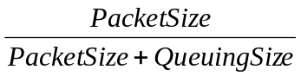 --(1)
where PacketSize is the probing packet size and QueuingSize is the total queued packet size in bottleneck link. This formula is used in our simulation to represent the real available bandwidth of the network at an instant moment.

The available bandwidth can be measured by having a sending machine, called probing agent, sending a probing message to a receiver, called probing responder, the probing responder sends back an response message. A commonly used method is to utilize ICMP echo packets as probing messages to measure the available bandwidth, as ICMP echo packets require the receiver to respond with ICMP echo response message. We use information derived from the arrival time of the ICMP echo response packet to estimate the available bandwidth. We can also use higher layer protocol messages such as those in HTTP, TCP, or UDP protocols as probing messages.

The use of higher layer protocol messages yields more accurate measurement result for applications running those protocols. But they typically take a longer time and the results can not be easily applied to other applications running different types of higher layer protocols. The lower layer bandwidth results, obtained by using the ICMP packets, need to be converted to the estimated effective bandwidth on the higher layer protocol through some formula, since there are protocol header and other protocol processing overhead involved.

The available bandwidth measurement can be calculated by the probing responder or by the probing agent. The probing responder will measure the uni-directional traffic bandwidth, while the probing agent measures the round-trip traffic bandwidth. To use the probing responder to measure the uni-directional bandwidth, we need instrument the measuring software on the probing responder. The availability and accessibility of the probing responder may not be there for certain application scenarios. In those cases we rely on the echo response to measure the round trip traffic bandwidth and estimate the uni-directional traffic bandwidth accordingly. In this paper, we propose several network available bandwidth estimation techniques using short sequence of ICMP messages. We also present a Java-based SimProbe simulator for evaluating these techniques.

In Section II, we describe SMRT (Single Message Round Trip Time Measurement), MMRT (Multiple Messages Round Trip Time Measurement), SMUT (Single Message Uni-Trip Time Measurement), MMUT (Multiple Messages Uni-Trip Time Measurement), and ACB (Adaptive Cprobing Measurement) probing methods. In Section III, we present a network simulator, which is used to evaluate the performance of each proposed measurement method. In order to evaluate each proposed method reliability, three kinds of traffic pattern, Flat/Static, Slope and Self-Similar Web Traffic are modeled. Section IV discusses the simulation results. Section V is the conclusion remarks with discussion on future research directions.

NETWORK AVAILABLE BANDWIDTH MEASUREMENTS
In a probing-based network bandwidth measurement systems, the designer can send a probing message sequence with different timing patterns and different the probing message sizes, and then derive the available network bandwidth from the timing patterns of the received message sequence.

We investigate how the different probing message sequences impact on the accuracy and efficiency of the probing methods, and how these parameters are related to the available bandwidth. In Cprobe, a burst of packets is sent with the attempt to fully utilize the available bandwidth. Cprobe then computes from the timing of the ICMP echo replies the achieved throughput, and considers the ratio between this and the bottleneck bandwidth to be the availability, which indicates how much of the bottleneck bandwidth was actually available.

SMRT first sends a sequence of small packet size probing messages, called RoundTripTime (RT) probing messages, to get a relative accurate round trip time (using the average value RT). It then sends single probing packet, whose message size is the same as the RoundTripTime probing messages. If the network are not congested, the round trip time should be the same or within a tiny margin of the round trip time. If the congestion exists, the probing round trip time will increase. Because the congestion is caused by packets competing on the slowest link, we give a formula
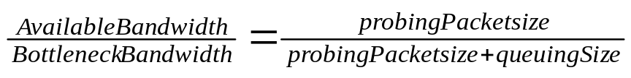 ---(2)

where BottleneckBandwidth is the original bandwidth of the bottleneck link, probingPacketsize is the packet size of each probing packet. Assume that the round trip delay is proportional to the available bandwidth. The following formula is derived.
ProbeB * PMRoundTripTime = BottleneckLinkBandwidth * PMNoTrafficRoundTripTime ---(3)
where ProbeB is the probing result; PMRoundTripTime presents the probing packet round trip time; BottleneckBandwidth is the original bandwidth of the bottleneck link; PMNoTrafficRoundTripTime is the round trip time of a probing packet without traffic competition. This formula is used to estimate the available bandwidth. The following are the five probing methods we analyzed.

SMRT (Single Message Round Trip Time Measurement)
Instead of sending a burst of large size probing packets, we just send single small size "ICMP" echo requirement packet in each probing round. Before we start the traffic generation, we first send round trip time probing packets to get a mean round trip time (A) of a probing packet. When we probe the available bandwidth of a connection in a real environment, theoretically, the same size probing packet should take longer round trip time (B) to return the sender machine. We apply these two round trip times A and B in formula 2 get an estimated network available bandwidth.

MMRT (Multiple Messages Round Trip Time Measurement)
In Chapter 4, we find that single probing packet result is influenced by some random factors dramatically. Instead of sending only one probing packet each round, we send a couple of probing packets in each round. The idle time between probing packets in one round is long enough to make sure that each packet result does not be affected by its previous or behind probing packet. We use the average as the estimated available bandwidth. The advantage of this method is to reduce the random characteristic influence in the result. The more packets we send, the less the random characteristic influence.

SMUT (Single Message Uni-Trip Time Measurement)
Since round trip measurement can not be used to predict available bandwidth on unidirectional route, we propose the unidirectional trip probing measurement, in which the probing packet does not require an echo packet. Like the round trip time measurement, the sender sends uni-trip time probing packets to find the smallest uni-trip time of a probing packet. When the destination receives the probing packets, it saves the mean uni-trip time of these packets. In this environment, the destination has the responsibility of calculating the estimated available bandwidth after it gets a probing packet. SMUT and MMUT are such methods. SMUT sends single probing packet each probing round. MMUT sends a couple of probing packets each probing round.

The drawback of unidirectional trip measurements is that it requires heavy participation of the destination machine It is impossible in the Internet to have access to each possible destination machine.

MMUT (Multiple Messages Uni-Trip Time Measurement)
SMUT has the same random characteristic as that of SMRT. Instead of sending only one probing packet each round, MMUT sends multiple probing packets in each round. The idle time between probing packets in one round is long enough to make sure that each packet result does not be affected by its previous or behind probing packet. MMUT uses the average of measured available bandwidth as one estimated available bandwidth.

ACB (Adaptive Cprobe Measurement)
In Cprobe, the sender sends a sequence of large size probing packets, which are intended to cause the congestion in the bottleneck bandwidth. Cprobe estimates the available bandwidth by dividing the length of the burst with the time gap between the receipt times of the first echo packet and the receipt times of the last ICMP “Echo Reply” packets. If the current connection has very low available bandwidth, the probing packets will make the network performance worse, even cause some useful packets discarded due to the finite buffer size of routers and hosts. A good probing method should impact the network performance as less as possible.

ACB is a variant of Cprobe. ACB (Adaptive CproBe measurement) involves the history concept. We use the latest measured available bandwidth to do the probe. We use the speed (the previous measured available bandwidth plus a small margin) to send two probing packets one by one in each probing round. Because of the influence of network traffic, the time gap between two probing packets has a small difference even though you send them one right after the other. We can define a tolerable range of the difference. If the time difference is over the tolerable range, network congestion must be the cause of the time difference. We apply Cprobe calculation formula to get the available bandwidth. If the time gap is in the tolerable range, we think that there are no congestion in the current connection. We then use Cprobe to measure the available bandwidth with the full speed that the sender supports to do. Cprobe can be carried out one more time to estimate the available bandwidth.

NETWORK SIMULATOR
A discrete event network simulator, call Simprobe, is developed for evaluating the available network bandwidth measurement method. It is implemented with a simple network model for testing the probing methods.

Figure III.1 show the network model used in our study. In our test topology, It consists of routers and links. The probing responder is the destination of the probing packets sent by the probing agent. The traffic packets are sent by the traffic source and received by the traffic sink.

The network model consists of six main objects, a probing agent, a traffic generation agent, messages, bottleneck link, an event queue and a chart. In Simprobe, there are two kind of packets. The traffic packets are those representing the network load. The probing traffic packets are those used to measure the available bandwidth. Before any traffic or probing packet generation, the probing agent first generates a round trip time measurement packet to get the round trip time (or uni-trip time) of the transmission route used by the probing packets. The traffic generation agent generates traffic packets based on the user selected traffic pattern. We have implemented four traffic patterns: flat packet, slope packet, random, and self-similar traffic. The probing agent makes periodic probing. If the probing methods require round trip measurement, the probing packet will be replied by the probing responder with a probing response packet. If the probing methods use uni-trip measurement, no probing response packet is generated.

Traffic generation
In this simulation, we implement four traffic patterns to measure the efficiency of the probing methods. For the flat and slope traffic pattern, the sending interval time between two neighboring traffic packets is set according to the selected available bandwidth for the simulation run. The following formula is used to calculate the interval time:
First, we calculate the queuing size needed to generate the available bandwidth
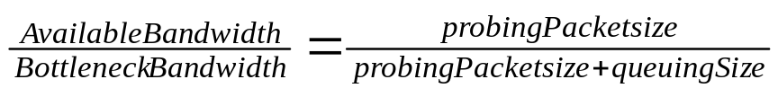 --(4)

Here BottleneckBandwidth is the bandwidth setting of the bottleneck link; probingPacketsize is the packet size of each probing packet.

The following formula is then used to calculate the sending interval between two neighboring traffic packets.
--(5)

where ProbingPeriod is how often the available bandwidth is to be reported; BottleneckBandwidth is the original bandwidth setting of the bottleneck link; QueuingSize comes from formula 1.

Figures III.2-6 shows the distributions used in generating the self-similar web traffic [AW97] [BC97],[CFH99] and [PF94],. They include that of file size, client idle time, the number of embedded references, and the time between embedded references.

SIMULATION RESULTS AND ANALYSIS
To validate the results of our measurements, we define a metric called Difference with the following definition:
Difference = 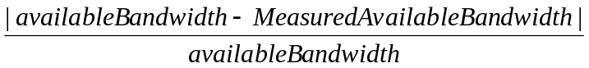 --(7)
The absolute value of the subtraction value between available bandwidth and measured available bandwidth is divided by the available bandwidth. The equation represents how far the measured available bandwidth is from the available bandwidth. The less is the Difference value, the more accurate is the measured available bandwidth.

The other metric is increased Delay Time with the following definition:

Increased Delay Time = RoundTripTimeInTraffic - RoundTripTimeNoTraffic --(6)

Where RoundTripTimeInTraffic is the round trip time of a packet in a traffic pattern, RoundTripTimeNoTraffic is the round trip time of a packet without any traffic. In the rest of this Section, we apply these metrics to evaluate the effectiveness of each measurement method in the slope traffic pattern.

SMRT
Figure IV.1 shows the screendump of Java-based Simprobe, where the results of single message round trip time measurement are plotted against that of the available bandwidth. The top panel consists of -selections and entries for selecting the method to be simulated, the probing and traffic report periods, the traffic type, the starting and ending time of the simulation.

In Figure IV.1, red line curve represents the trend of real available bandwidth and green line curve follows the measured available bandwidth. Roughly, the deviation of the measured available bandwidth follows the trend of the real available network bandwidth. In this simulation, the bottleneck link bandwidth is 10MBps, the hop account is eighteen. Figure IV.2 shows the Difference values when the traffic gets heavier. Next we will discuss the impact of each factor on the difference metric of SMRT method.
Impact of Hop Acount

Figure IV.3 show the impact of hop account on the performance of SMRT. The simulation parameters are: packet size=46 bytes, traffic packet size=20 bytes, link length=100000 meters with bottleneck bandwidth =10MBps. The Difference value increases as the hop number increases. More hops mean that a packet needs to be transmitted by more intermediate nodes before it reaches its destination. More hops means more opportunities of a packet to compete a connection with other traffic packets.

Impact of Link Length

Table 3 shows the data of the above chart based on. Except for the link length, all the data come from the following network configuration: Hop number 16, router speed 1GBps, bottleneck bandwidth 10MBps, probing packet size 46 bytes and traffic packet size 20 bytes.
Table 3: Impact of Link Length on Difference
Link Length (meters) | Difference
100 | 0.560186067
1000 | 0.461196328
10000 | 0.372903889
100000 | 1.246685111
1000000 | 6.636471365

From Table 3, there is a threshold that triggers the significant changes in the Difference value. The following table shows the contribution factors of the propagation time, the queuing time, the transmission time.
Table 4: PropagationTime/(Average TransmissionTime+QueuingTime)
Link Length (meters) | Approximated  Propagation Time (Sec) | Average increased Transmission+QueuingTime(Sec)
100 | 0.00001 | 0.13088954436231923
1000 | 0.0001 | 0.065673402893731
10000 | 0.001 | 0.08064477289268737
100000 | 0.01 | 0.0947725000926319
1000000 | 0.1 | 0.22191062617182175

In Table 4, approximated propagation time ≈ 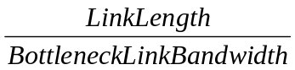 , where bottleneck link bandwidth is 10MBps. Average increased Transmission+QueuingTime ≈ TripTimeTraffic - TripTimeNoTraffic, where TripTimeTraffic is the trip time of a packet in a traffic pattern and TripTimeNoTraffic is the trip time of a packet without traffic. From Table 4, we found that the longer the link length, the longer propagation time. Let us examine the ratio between approximated Propagation Time and Average increased transmission+queuing time in Table 5. Table 5 shows the contribution of the propagation time on the trip time of a packet. This illustrates that the transmission and queuing time that dominate the trip time of a packet when the link length is short. With link length rising, propagation time of a packet dominates the trip time gradually.
Table 5: Ratio between Propagation and TransmissionTime+QueuingTime
Link Length (meters) | Ratio = (Propagation /Transmission+QueuingTime)
100 | 0.00001/0.13088954436231923 = 0.00764%
1000 | 0.0001/0.065673402893731 = 0.15226%
10000 | 0.001/0.08064477289268737 = 1.24%
100000 | 0.01/0.0947725000926319 = 10.55%
1000000 | 0.1/0.22191062617182175 = 45.06%

Packet Size

Figure IV.5 shows that when the probing packet size increases, the Difference value improves and then satuates. With the probing packet size increases, the increased Delay time increases too. The increased Delay Time results from the queuing time increase. The queuing time is the result of competing the connection between traffic packets and probing packets.

Router Speed

Figure IV.6 shows the impact of router speed on the performance of SMRT method. Two values for different router speed are tested: 1GBps and 10GBps. The value 1 at x axis represents the results of Difference, the value 2 at x axis represents the results of increased delay time. There are no apparent difference between the two router speed settings.

Through the simulation, we observed that if the router speed is too slow, it will affect the traffic pattern, especially those of the constant packet rate. The router speed influences the time of a packet passing through a router, and hence the time gaps between packet.

MMRT (Multiple Message Round Trip Time Measurement)

We have observed that when the sending time of each slope traffic packet are varied with a small random period, the measured available bandwidth will no longer a smooth curve and show random degradation. This random characteristics of SMRT can be alleviated by sending a couple of probing packets to measure the available bandwidth. They are not sent one after another immediately. Instead, enough time gap is maintained between them to make each one probing result indicating an independent network available bandwidth. We use the mean of the multiple probing results as one measured result.

Unfortunately, in heavy traffic, the MMRT degrades much quickly than than that of SMRT. We also try MMRT in a flat traffic pattern. In such an ideal traffic pattern, the results of MMRT is better than SMRT obviously. Figure IV.9 shows that with the web traffic pattern, MMRT performs better than SMRT.

SMUT (Single Message Uni-Trip Time Measurement)
In uni-trip time measurement, the probing messages are received at the probing responder without reply. Without the return reply message, there will be less interference between the probing messages and the probing response messages. It is assumed to have a better performance than that of SMRT. However, Figure IV.10 shows very slight improvement. Figure IV.11 shows obvious improvement when there are more available bandwidth.

MMUT (Multiple Message Uni-trip Time Measurement)
MMUT is proposed for the same reason of MMRT, which tries to alleviate the random characteristics of single unidirectional trip time measurement. For the same reason, a small time gap causes the probing packets to experience big available bandwidth difference in a slope traffic pattern. The results of measured available bandwidth are worse than SMUT. Figure IV.12 gives the result of both methods under the web traffic pattern. It is obvious that MMUT can improve the effectiveness of SMUT in the real traffic.

ACB (Adaptive Cprobe)
ACB is proposed for improving Cprobe. Figure IV.13 shows the simulation result for ACB. Preliminary results indicated that ACB is a poor method. It triggered us to examine the Cprobe carefully. Figure IV.14 shows the simulatoin results with Cprobe. The result is better than that of ACB, but it is still far away from a satisfied measurement.

CONCLUSIONS AND FUTURE WORK
In this paper, we proposed several algorithms for measuring the available network bandwidth. We also proposed a metric, called difference, for evaluating the impact of various network parameters on the performance of the available network measurement method. It is a good strategy for probing if the single message can do the job. To evaluate these available network measurement methods, we developed a simulator called Simprobe. Based on the simulation results, it can be concluded that SMRT works well, when the utilization of the bottleneck link is below 100%. When the bottleneck link utilization is 100%, the measured bandwidth of our methods is deviated from the accurate value dramatically. Based on Figure IV.2, it can be concluded that the round trip time is not linear proportional to the available bandwidth. MMRT is proposed to improve the result accuracy of SMRT. As shown in Figure IV.9, MMRT improves the performance of SMRT, where the mean Difference of MMRT is 0.2 while SMRT is 0.4.

SMUT is proposed to measure the unidirectional route available bandwidth. We did not see a lot measurement improvement over SMRT. From Figure IV.13, we did see the clear performance improvement of MMUT over SMUT.

The simulation results show that at very light load, the round trip time measurements can estimate the available bandwidth well. Under mediate and heavy load, the round trip time measurements is not a good indicator. Further research is needed to improve the methods. The Simprobe software package is available for education and research.

REFERENCES
[Allman99] Mark Allman and Vern Paxson, “On estimating end-to-end network path properties,” SIGCOMM99, Pages 263 – 274, http://www.acm.org/pubs/aricles/proceedings/comm/316188/ p263-allman/p263-allman.pdf
[BC97] Barford, Paul, and Mark Crovella, Generating Rerepresentative Web Workloads for Network and Server Performance Evaluation, Computer Science Department, Boston University, Technical Paper BU-CS-97-006, Revised December 31, 1997.
[Bolot93] Bolot, Jean-chrysostome, “Characterizing End-to-End Packet Delay and Loss in the Internet”, December 1993, Journal of High Speed Networks, vol.2, No. 3.
[Carter96] Robert L. Carter and Mark E. Crovella, “Measuring Bottleneck Link Speed in Packet-Switched Networks”, March 15, 1996, Boston University. http://cs-www.bu.edu/students/grads/carter/papers.html
[CBC95] Cunha, Carlos, Azer Bestavros and Mark E. Crovellla, Characteristics of WWW Client-bases Traces, Computer Science Department, Boston University, Technical Paper BU-CS-95-010, July 18, 1995
[Downey99] Downey, Allen B., “Using pathchar to Estimate Internet Link Characteristics”, Proceedings of ACM SIGCOMM’99, 1999. http://www.acm.org/pubs/articlesproceedings/ comm/316188/p241-downey/p241-downey.pdf
[J91] Jain, Raj, The Art of Computer System Performance Analysis, Techniques for Experimental Design, Measurement, Simulation, and Modeling, John Wiley & Sons, Inc., 1991
[Jacobson97] Van Jacobson, “pathchar – a tool to infer characteristics of Internet paths”, April, 1997, Berkeley, University of California. ftp://ftp.ee.lbl.gov/pathchar/
[JFC99] Addison Wesley publishing, "The JFC Swing Tutorial: a guide to constructing GUIs", June 1999.
[Lai99] Kevin Lai and Mary Baker, “Measuring Bandwidth”, Proceedings of IEEE Infocomm'99, March 1999, pp. 235-245.
[MM96] M. Mathis and J. Mahdavi, "Diagnosing Internet Congestion with a Transport Layer Performance Tool," Proceedings of INET'96, Montreal, June 1996.
[MUUS83] M. Muuss, Ping Software, U.S Army Ballistic Research Laboratory, December 1983. Available by anonymous FTP from uunet.uu.net: /bsd_sources/src/ping.
[Net2Phone00] www.net2phone.com
[Paxon97] Vern Paxson, “Measurements and Analysis of End-to-End Internet Dynamics”, April, 1997, Berkeley, University of California, PH.D. Thesis.
[Real99] www.real.com
[PF95] Paxon, Vern, and Sally Floyd, Wide-Area Traffic: The Failure of Poisson Modeling, Lawrence Berkeley Laboratory and EECS Division, University of California, Berkeley. July 18, 1995
[PKC97] Park, Kihong, Gatae Kim and Mark Crovella, On the Effect of Traffic Self-similarity on Network Performance, In Proceedings of the 1997 SPIE International Conference of Performance and Control of Network Systems, 1997.
[Stemm99] Mark R. Stemm, “An Network Measurement Architecture for Adaptive Applications”, Ph.D. Dissertation, UC Berkeley, on SPAND (Shared Passive Network Performance Discovery), 1999.

Figures
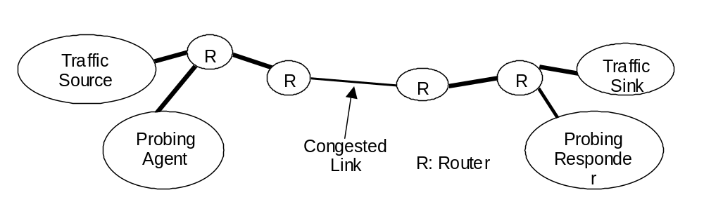
Figure III.1: The Network Model
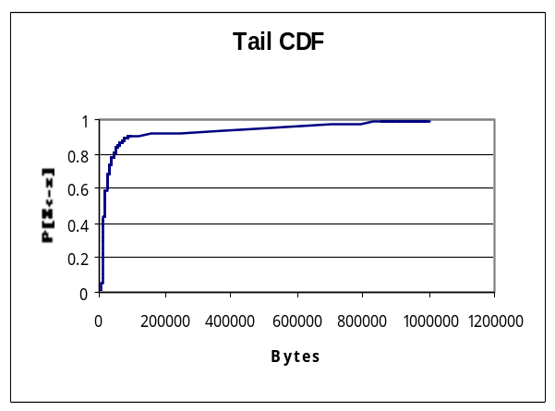
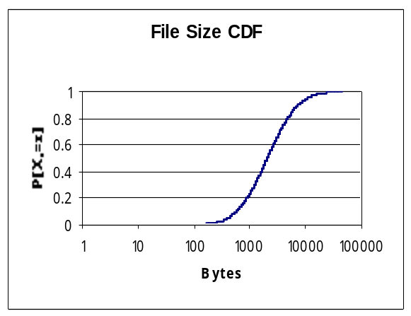
Figure III.2: File Size Distribution – Body Figure III.3: File Size Distribution - Tail

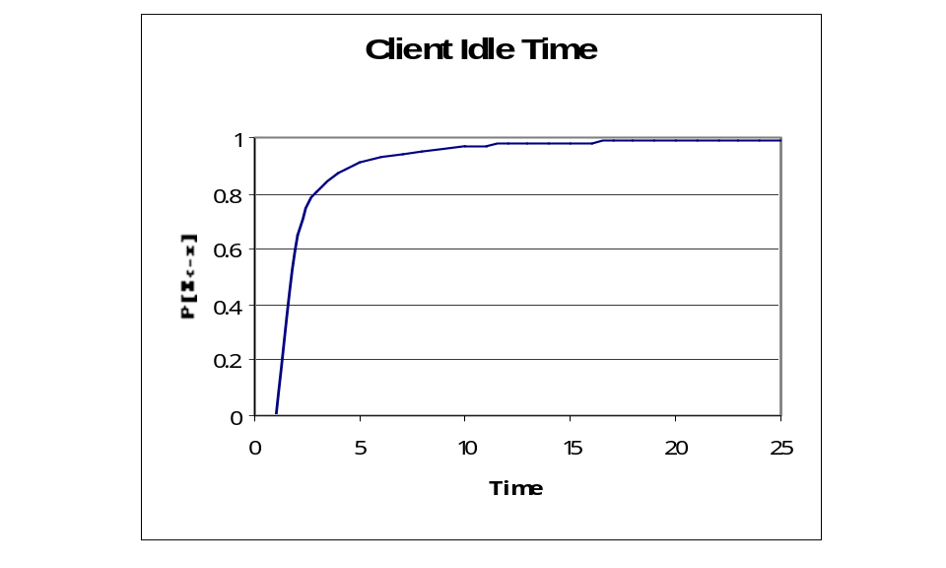
Figure III.4: Client Idle Time Distribution

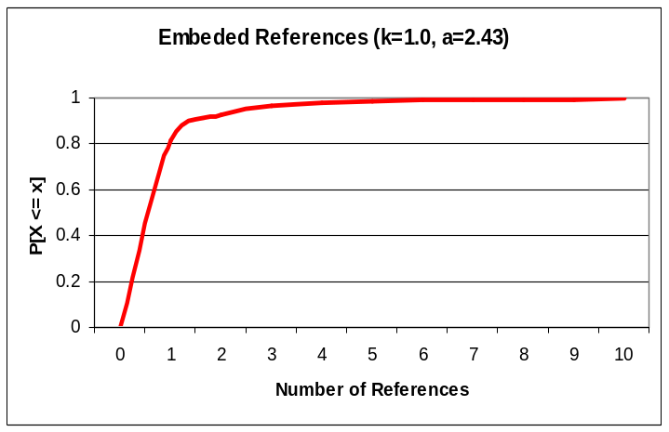
Figure III.5: Embedded References Number

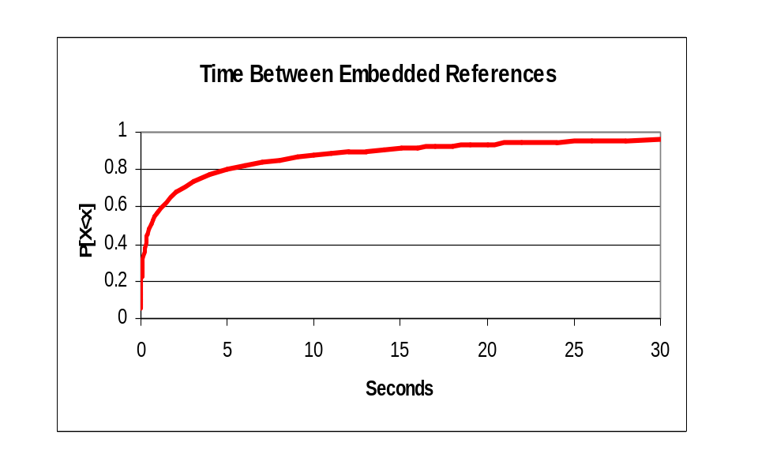
Figure III.6: Time between Embedded References

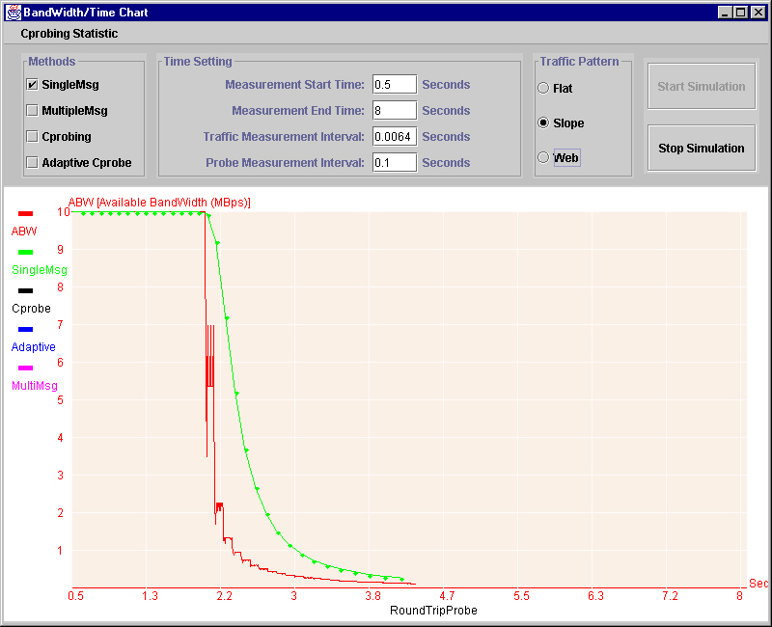
Figure IV.1 Screendump of Simprobe. Compared SMRT with ABW.
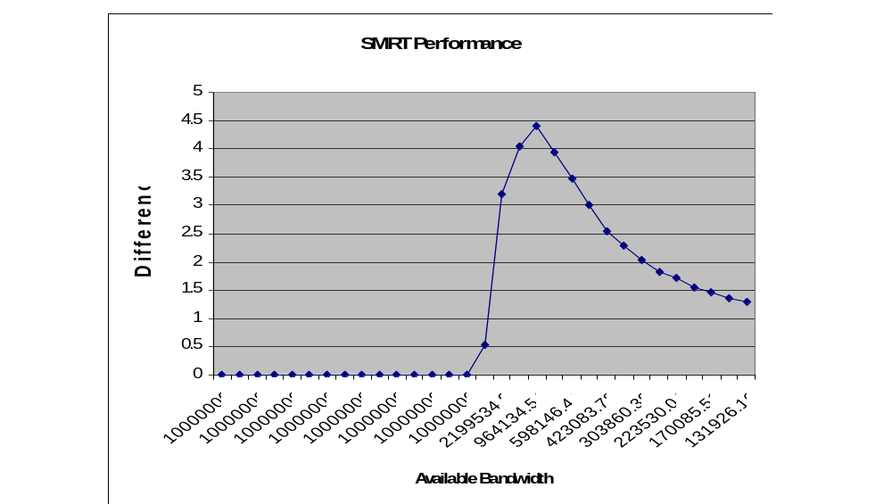
Figure IV.2. Performance of SMRT with its Difference metric vs. Available Bandwidth
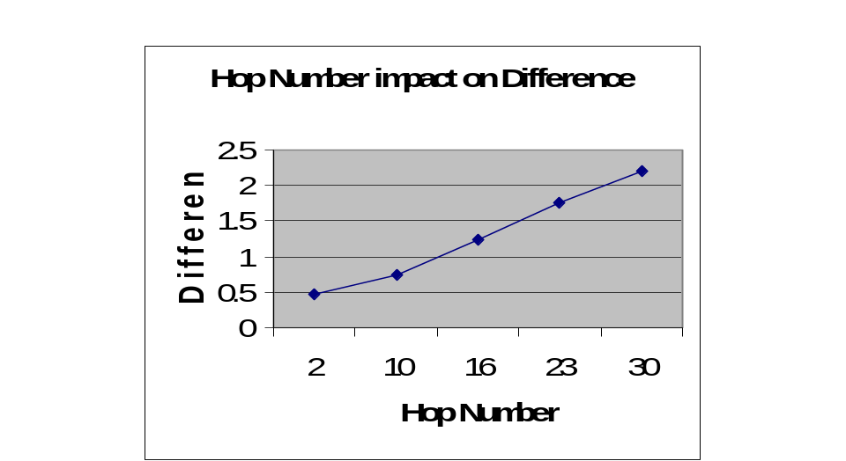
Figure IV.3 Impact of hop count on performance in SMRT method.
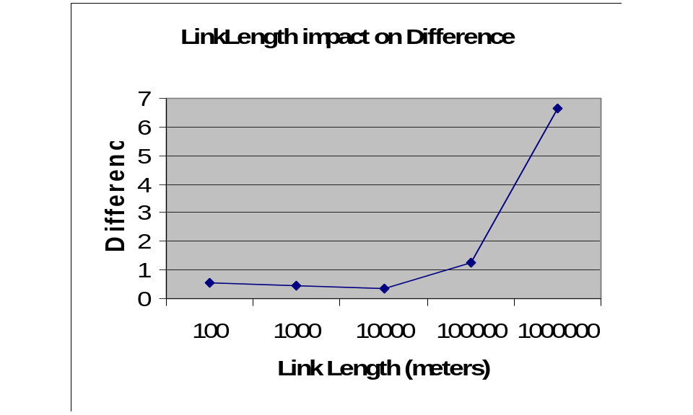
Figure IV.4. Impact of link length on the performance of SMRT method.

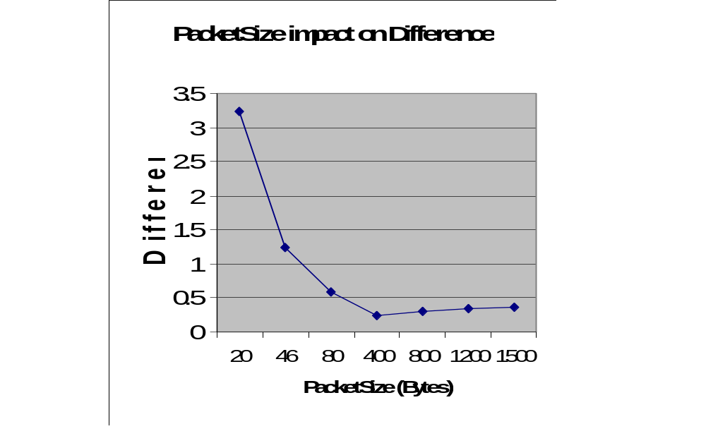
Figure IV.5. Impact of Packet Size on the performance of SMRT method.
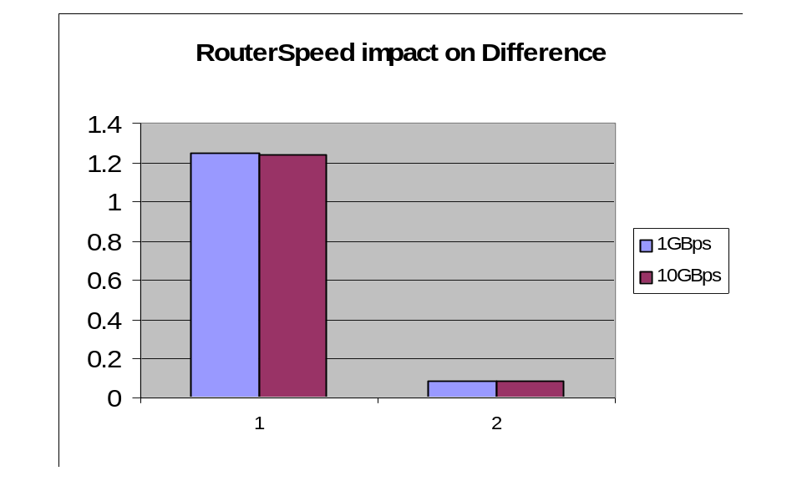
Figure IV.6. Impact of Router Speed on the performance of SMRT method.
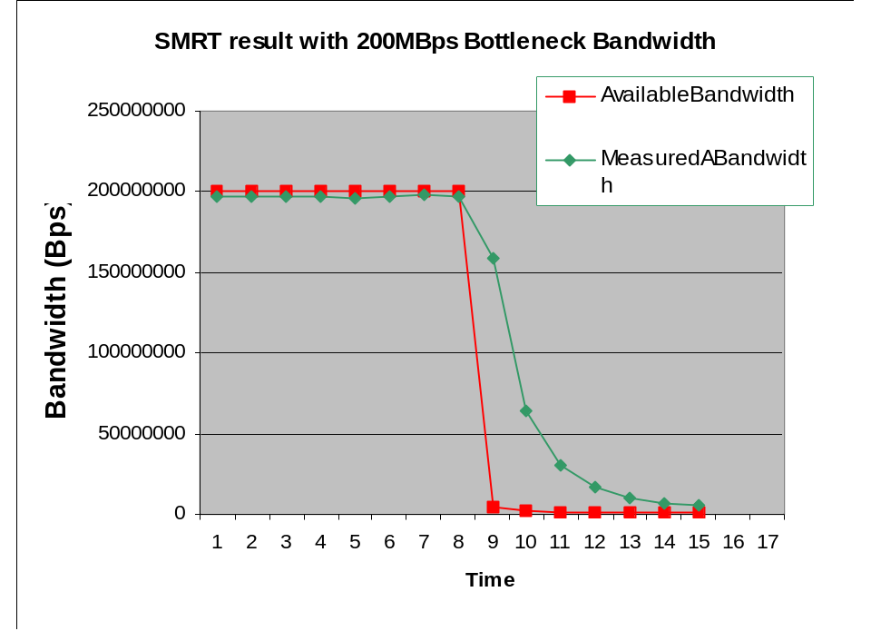
Figure IV.7. Impact of Bottleneck Bandwidth on the performance of SMRT method.
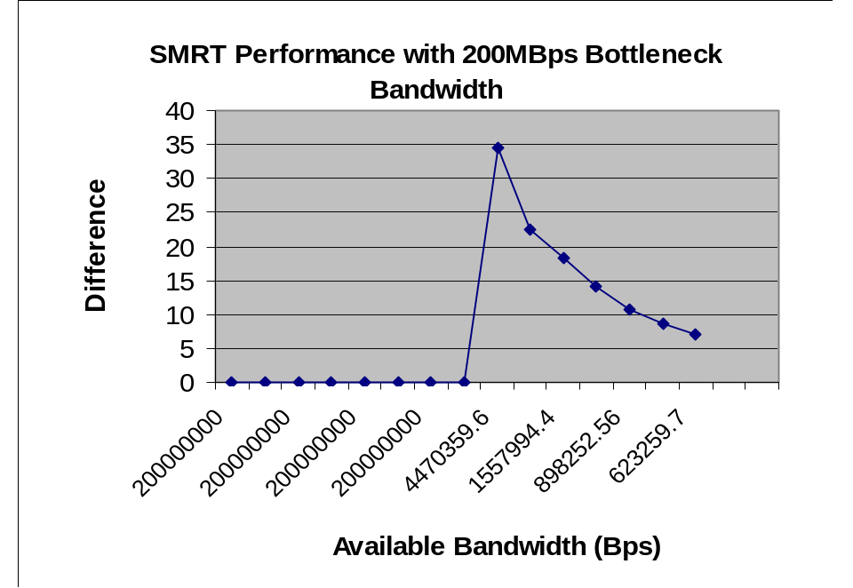
Figure IV.8. Impact of Bottleneck Bandwidth on the difference metric value.

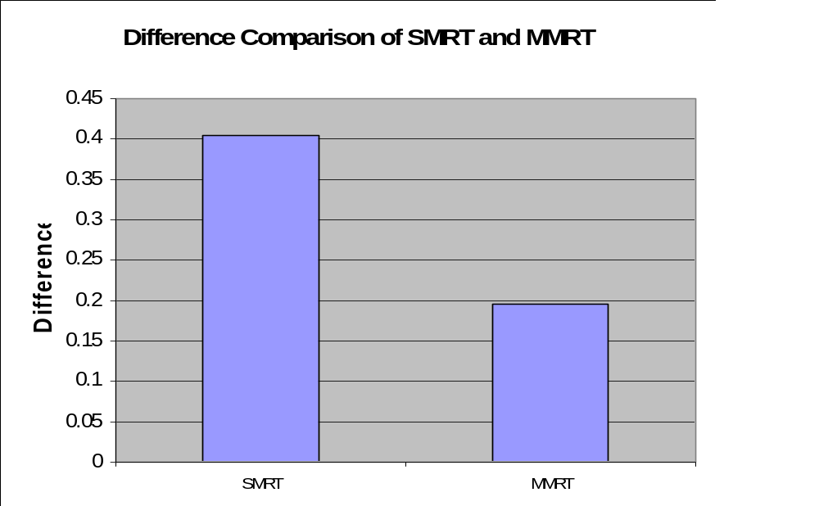
Figure IV.9. SMRT vs. MMRT with self-similar web traffic.
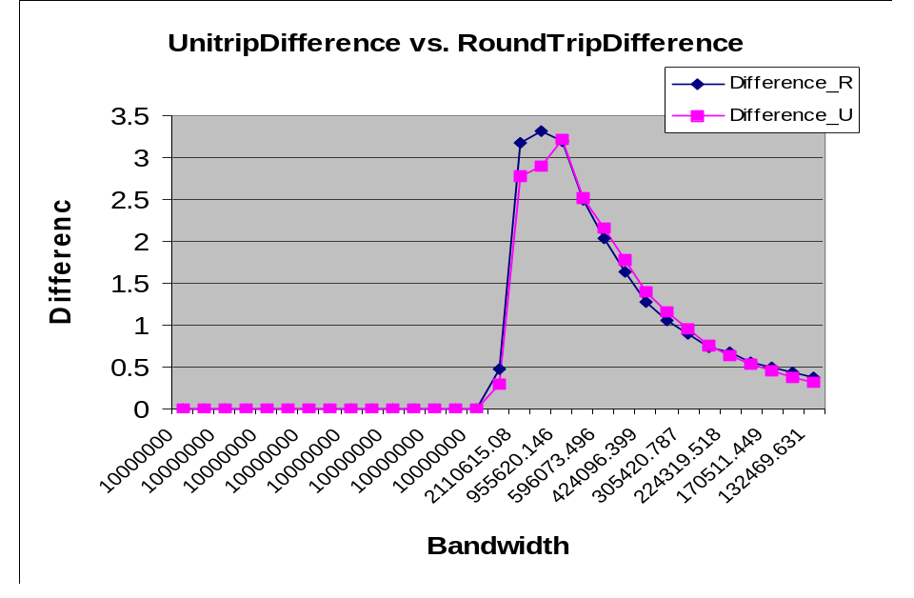
Figure IV.10. Uni-trip vs. Round-trip measurement.

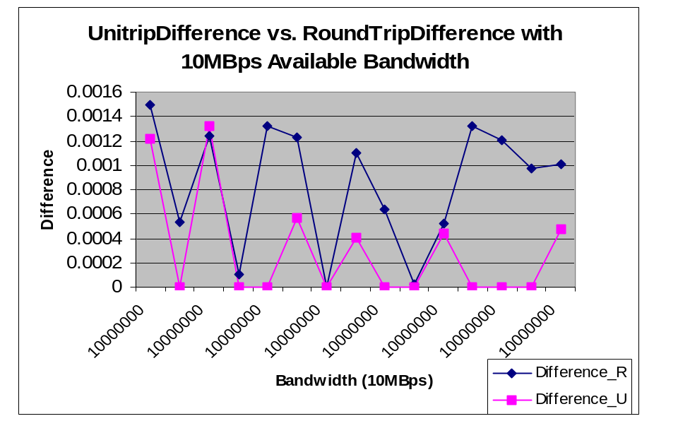
Figure IV.11. Uni-trip vs. Round-trip measurement with 10 Mbps Available bandwidth.
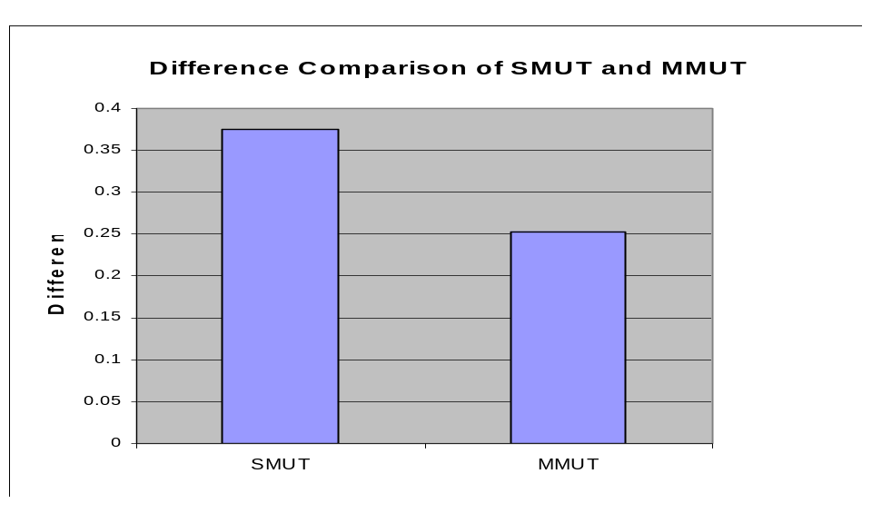
Figure IV. 12. SMUT vs. MMUT.

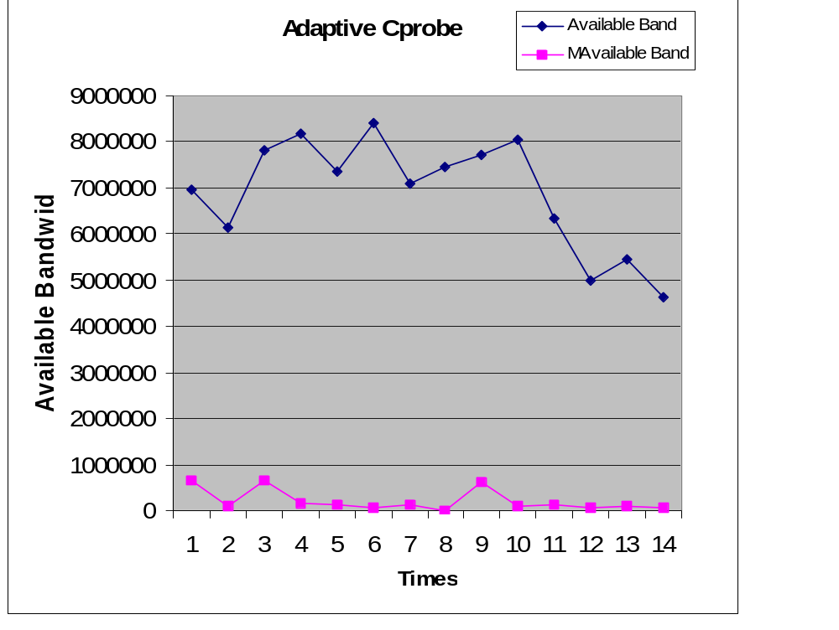
Figure IV.13. Performance of ACB .
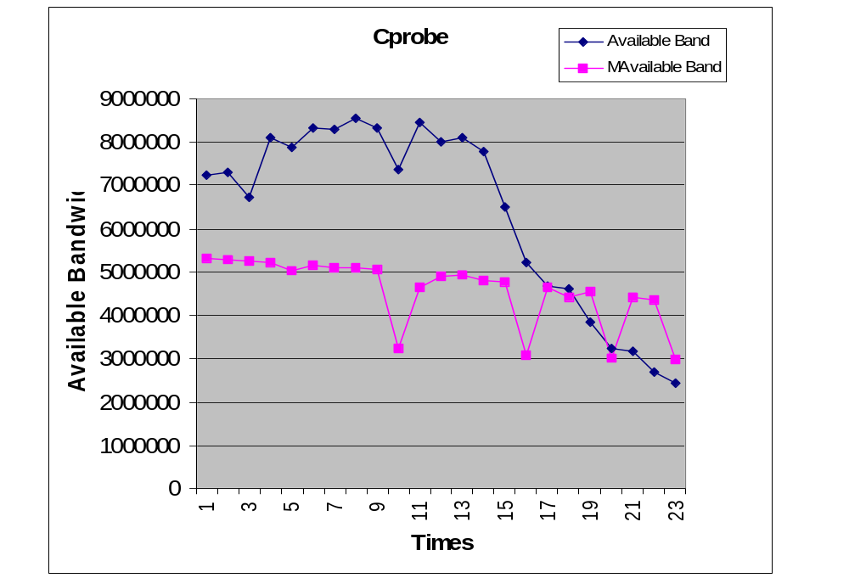
Figure IV.14 Performance of Cprobe.

