Networked Radio for Sensor Applications: Network Layer Design Considerations

by

Computer Science Department
College of Engineering and Applied Sciences
University of Colorado at Colorado Springs

Co-PI: Professor C. Edward Chow

Research Assistant: Ganesh Godavari

A Report for QDot Inc.
under contract number #123456789

July 13, 2004

1. Introduction
This document summarizes network layer design considerations for the project Networked Radio for sensor Applications, funded by QDot, Inc via an Army SBIR Phase I. Work on this project consisted of two phases: (1) design and analysis support for the Phase II proposal and (2) Follow-on analysis on key areas related to the protocol design and traffic to be incorporated into the Phase II proposal.

An extensive amount of research and funding has been devoted to addressing the unique requirements of ad-hoc networks for battery operated mobile and ground based applications. This research has included ad-hoc network formation, efficient routing approaches, power efficient networking, power aware protocols, self-healing structures, intrusion detection, and security. The result of this work is impacting commercial portable networks at this time. While many of the commercial products focus on the 802.11x protocol stack, some of the work is addressing the unique requirements of low power, resource limited, and sensor network. It is not the intention of this effort to replicate the work, but to establish a baseline approach for implementation of a highly integrated SNRadio. The SNRadio must include networking protocol software and appropriate API for user definition and sensor customization.

The focus of our investigation into the network protocol stack is to obtain a clear understanding of the requirements placed on the physical implementation. The following description of the network stack is used to ascertain the activity of sensor nodes while operating in diverse roles in supporting the operation and maintenance of the network. Unique scenarios have been defined based on these roles to determine the operation of physical hardware.

For understanding the traffic volume that could be generated by the low energy clustering protocol, we analyze the best case and worst case scenarios. An analysis tool called Sensor Network Analysis Tool (SNATool) was built to study the effectiveness of the protocol and to investigate the traffic volume in average cases. The tool is built in Perl and displays the cluster formation and sink tree formation results using Gnuplot.

2. Sensor Network Architecture and Operation
A typical wireless sensor network can be envisioned to have large number of nodes which are battery powered. Some of the primary network attributes are collision avoidance, energy efficiency, scalability and adaptively. Other attributes like latency, throughput and fairness attributes are generally application dependent. In a battery operated sensor networks energy efficiency is critical for longevity of nodes and system operations. Energy wastage is due to collisions, control packet overhead, overhearing of unnecessary traffic and idle listening. Idle listening is a dominant factor for radio energy consumption in sensor networks.

For conserving the energy, we assume that each node in the sensor network coordinates with its neighbors such that they have the same awakening period for data transmission and collision avoidance similar to that proposed by Ye et al [1]. To reduce the number of packet transmission and reception, we propose to apply LEACH protocol presented in [2] and enhance its inter-cluster communications. The networked sensors form clusters during the initialization phase of the deployment. Each cluster elects a sensor node as a leader. All inter-cluster communications are routed through leaders. Leaders and the sink node form the base of the routing tree. They also serve as fusion nodes to correlate and aggregate packets to be sent to the sink node. We assume sensor nodes are stationary after deployment.

Figure 1.a shows the example of a 100-node sensor network deployed in 50 m x 50 m area and form 10 cluster sensor networks. The coverage of a cluster depends on the signal strength of the leaders at a predetermined threshold. The role of leader is shared among nodes to maximize the overall network life. Nodes in a heavy routing path consume more energy that client nodes.
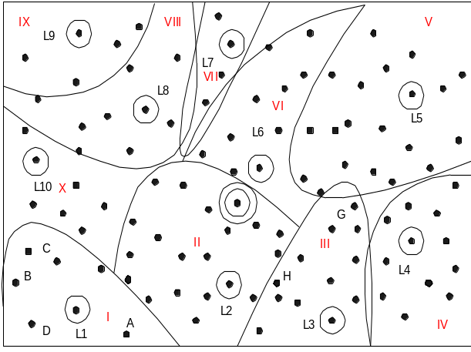
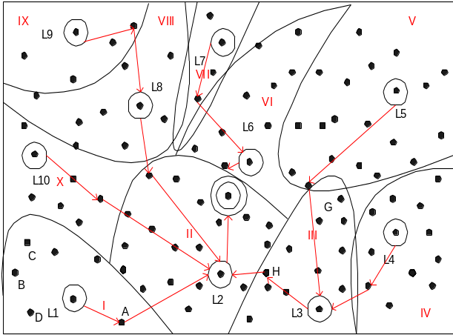
Figure 1a. Sensor Network in Cluster Format Figure 1b. Sensor Network routing in Clusters

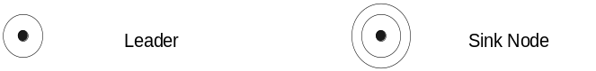

2.1 Cluster Formation and Energy Efficient Sensor Network Routing

Cluster Formation Phase. After the initial deployment, based on the configuration parameters such as the number of sensors in the cluster, the sensors decide whether they should compete as leader of the cluster. For example, the node with mod (nodeID, cluseterSize)=0 can be selected to be a leader. An advertisement message (ADV) is sent to the sensor nodes within the signal reach of the advertised node. Any node that receives the advertisement message recognizes the advertised node as the leader. If a node does not receive the advertisement message within a fixed time, it will compete in the next cycle. When a node receives multiple advertisement messages, it will choose the one with stronger signal as the leader. Sensor nodes will report to the leader and all nodes it can receive signal from with a membership report message that includes the list of leaders, which it can receive signals, their respective signal strengths, and its chosen leader.

After each node has decided to which cluster it belongs, it must inform the cluster-head node that it will be a member of the cluster. Each node transmits a join-request message (Join-REQ) back to the cluster leader. Original Leach protocol used non-persistent CSMA protocol for join-request message sending. This creates a possibility for Join-REQ message collision when multiple nodes try to send concurrently. We propose to use p-persistent CSMA protocol to spread out the Join-REQ messages within the membership reporting phase, where p is 1/clusterSize. When the leader receives Join-REQ message, it will send clear-to-send message (CTS) inform others not to collide with the selected sender. Note that a sensor node can adjust the power of Join-REQ message based on signal strength of the received ADV message. On the other hand, the leader does not know the size of its cluster at the beginning and has to use a larger power to reach all potential cluster members.

The leader then sets up a TDMA schedule and broadcasts this schedule in a TDMA schedule message (TS) to the nodes in the cluster. This ensures that there are no collision among the data messages and also allows the radio components of each non-leader node to be turned off at all times except during their transmit time slot. This minimizes the energy dissipated by the individual sensors.

The leader will also select relay nodes for inter-cluster communication with neighboring clusters. A designated-relay-node message (DRN) will be sent to each relay node. Some of these relay nodes can also be used to relay data message to the Sink node and form as part of the sink tree.

For example, in Figure 1(b) since the signal strength from L3 is stronger than that of L4, node G derives that it is in cluster III. A cluster is just a logical partition, based on the signal strength received when the clusters are formed. Some of the nodes at the border of the cluster can talk to one or more clusters. Those nodes can act as relay nodes between the clusters. For example, node H can talk to both L3 and L2 but the signal strength it receives from L3 is high compared to L2; therefore it is in cluster III.

Sink Tree Formation Phase. Based on the cluster size, within finite a time period, the clusters are formed. The sink node then sends a sink-tree broadcast message (STB) to all leader nodes in the sensor network to form the sink tree. Each leader uses selective broadcast to forward the message to other leaders in the neighboring clusters through the designated relay nodes. Duplicated sink-tree broadcast messages should not be forwarded. Note that the sink-tree messages can carry time synchronization information. The leaders of clusters will forward messages destined to the sink node along the sink-tree.

Since the sink node, the leader and relay nodes consume more energy, once their energy reaches certain threshold, alternate sensor node needs to be chosen to replace their roles. The whole sensor network goes through the leader election cycle as before. Ideally those nodes with more power are involved in the leader selection and sink tree formation process. However the ultimate goal is to maximize the network life time as a whole, therefore the threshold will be adjusted over phases and at the end it will reach zero. Once the battery power of the sensor node is reduced to a certain threshold, traffic could be curtailed to high priority only.

2.2 Security and Group Key Management
Initially a symmetric key is used to form the cluster. For this discussion, the definition of a key includes physical layer code keys, in addition to data authentication and encryption keys. It is needed to encrypt the cluster formation and sink tree formation messages. After the initial route setup every leader, relay node needs to authenticate with the sink node. The sensor nodes need not be authenticated, as we believe it adds to overhead. Over a period of time all nodes are going to be authenticated when they become a leader or relay node. The group key management system, such as Keystone, proposed by Wong et al [3] from the University of Texas at Austin, provides efficient group key distribution and efficient key tree manipulation. When the members under a sub tree join or leave, only the key in the sub tree needs to be changed. The key tree can be mapped one-to-one to the sink tree. The sink node, leaders of clusters form the root and inner branches of the key tree respectively. Other sensor nodes become leaf nodes of the key tree. Keys can be distributed and refreshed according a pre-determined schedule. In a secure groupware for first responders project (SGFR) [4], UCCS modified the Keystone key management protocol stack, and integrated it with instant messaging, remote file download, and remote display control.

We assume the sensor node is preconfigured with group key before deployment. The sink node runs the group key server. Figure 2 shows the example of the key tree for our sensor network in Figure 2. This approach supports sub-network key management if required. If at any stage say L9 is removed from the group only the key (KL9) for that branch needs to change. If node L3 is removed from the group only the key (KL3) for that group (branch) needs to change.
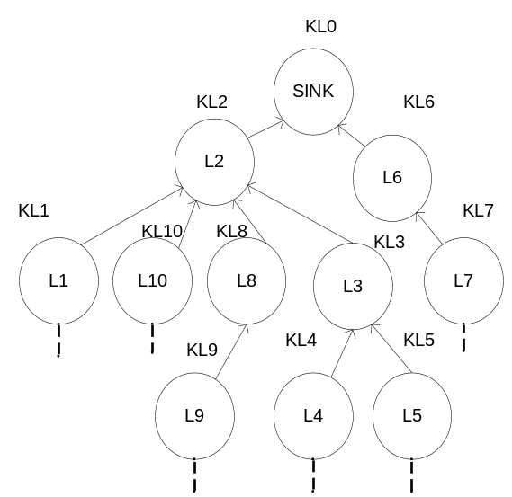
Figure 2. Mapping a Key to Sink Tree

2.3 Application Scenarios
For normal data collection or system maintenance, the sensors report to the leaders of the clusters on the scheduled time slots. The leader of a cluster then forwards the fused data to the sink node via the inter-cluster connections following the sink tree.

In urgent and low latency operation scenarios, a leader can be given the responsibility of notifying the other leaders. For example in Figure 3, when an enemy tank is detected by the sensor nodes in cluster I, the L1 leader can compute the clusters to be alerted and send a multi-destination message to the leaders of the clusters that may be involved with future actions, say L2, L3, and L4. The multi-destination message will be forwarded and duplicated following a process similar to the initial sink tree multicast. Nodes that route data can employ a second receive window reserved for low latency traffic. This could cut latency in half while reducing the power consumed during overhearing. Figure 3 shows that L1 can forward the message to the sink node and L4.

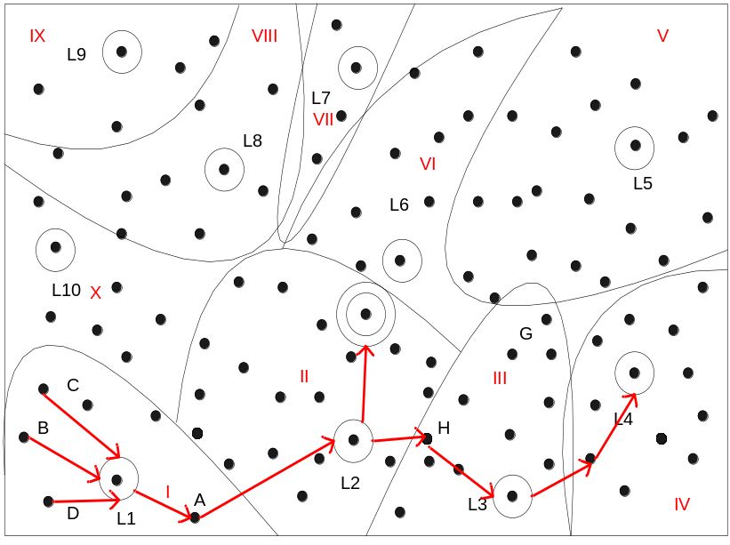
Figure 3. Low Latency Sensor Tracking Applications

2.4 Network Protocol Stack
Energy is the one of the main considerations for a sensor network. One way to conserve energy is to fuse data while relaying. The data being sent to the base station is fused at the leader when being relayed.
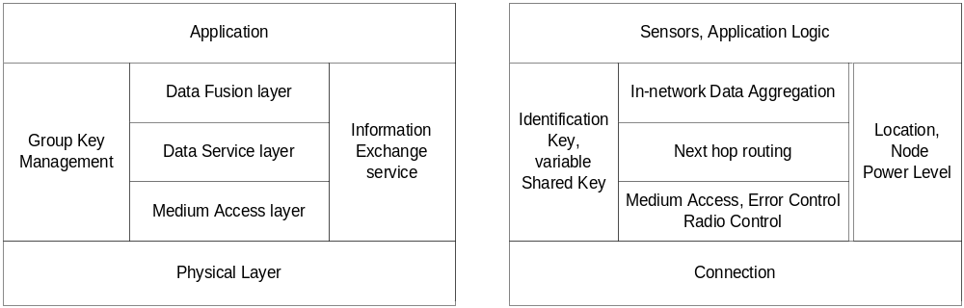
a. Protocol stack of a sensor network b. functionality of the protocol layers
Figure 4. Sensor Network Protocol Stack [5]
The power management utilizes the information exchange service for collecting node power level information. Security functions can be added to the information exchange service. The data fusion layer provides fusion operators such as threshold, averaging, concatenation and simplifies the application design and reduced transmission overhead by accumulating or reducing data at a leader node.

3. Traffic Model and Traffic Volume Estimation
A model for various sensor modes of operation has been established using these concepts as a baseline. The key modes are:
- Sensor (client) mode, whose mission is primarily collection of data, and periodically receives network maintenance data and command;
- Routing mode involves leaders and nodes whose traffic profile include receiving and forwarding messages across the network; and,
- Synchronization mode that supports network maintenance by forwarding time synchronization messages and routing information.
- Sink mode, this is a unique node(s) that forwards all outbound network traffic.

3.1 Traffic Volume Estimation

In following section we estimate the traffic volume generated in the network establishment phase and scheduled sensor status reporting phase. Since the traffic volume generated depends significantly on the sensor location distribution within the network and signal reception patterns, we will only provide an estimation which is based on the simplified assumptions. We will discuss best case and worse case scenarios using the wireless sensor network example presented in Figure 1. The SNATool is used to generate results for the same 50 m by 50 m area with randomly generated sensor locations. Simulation runs with specific network topology and sensor parameters will yield a better understanding of traffic volume and the performance of the proposed wireless sensor protocol.

Let N be the number of nodes in the wireless sensor network; s be the cluster size, i.e., the number of nodes in the cluster; and c be the number of clusters. Ideally, we would like to have same cluster size ⎡N/c⎤ for all clusters. In reality it will be challenging to achieve that.

3.1.1 Traffic Volume Analysis for Cluster Formation and Sink Tree Formation Phase

Best Case Scenario

In the beset scenario, the leaders are spread evenly in the network boundary and each covers exactly s sensor nodes. They only generate c ADV messages. The nodes in the cluster reply with Join-REQ message. Without collision, there will be s-1 Join-REQ messages and s-1 CTS messages in a cluster. With c clusters, there are c*(s-1) Join REQ messages and c*(s-1) CTS messages in the whole network. In best case scenario we assume that there is exactly one node in the cluster that receives a signal from any two adjacent clusters. Assume a cluster has n neighbors, additional n Join-REQ messages are sent to the adjacent cluster. After receiving all Join-REQ messages, the leader sends a TDMA Schedule broadcast message to all cluster members.

The leader also sends designated-relay-node (DRN) messages to the designated relay nodes of its neighboring clusters. The number of DRN messages depends on how many neighboring clusters exist. For example, Figure 1b shows cluster L1 has two neighboring clusters L10 and L2. Nodes A and C may be chosen as designated relay nodes. Cluster L2 on the other hand has five neighboring clusters L1, L10, L8, L6, and L3. Here let n be the ideal number of neighboring clusters. There will be n*c/2 designated-relay-node messages sent, assuming that the two neighboring leaders coordinate to reduce the volume of DRN messages and only a single designated relay node message is sent instead of two.

During the sink tree formation phase, the sink node will broadcast a sink-tree broadcast message (STB) to the n relay nodes within its cluster. These n relay nodes will forward the STB message to the leaders of those neighboring clusters. Those leaders then broadcast a single STB message to all its relay nodes. Ideally it takes n+ 1 message to reach n neighboring clusters. Therefore it takes (n+1)*(1-n^{l})/(1-n) messages to reach all clusters where l is the number of levels in the sink tree.

Let E be the total number of messages sent to establish the wireless sensor network. All messages are encapsulated in the payload of Physical Layer which is of the format
dstID | srcID | Type | payload | crc

Where
dstID - destination node id of 4 bytes
srcID - source node id of 4 bytes
type - payload packet type of 2 bytes
maximum payload is 32 bytes
crc is 4 bytes.
Message | Type | Number of Msgs | Direction | Payload size;Msg size
ADV | 1 | c | Leader to Member | 0;14
Join-REQ | 2 | c*((s-1)+n) | Member to Leader | 28;42 (assume a list of 4 leaders with their ID 4 byte and the signal strength 2 byte, and chosen leader ID 4 byte.4*(4+2)+4=28)
CTS | 3 | c*(s-1) | Leader to Member | 0;14
TS | 4 | c | Leader to Member | 32;46  (up to 8 sending node IDs)
DRN | 5 | n*c/2 | Leader to Relay Node | 4;18 (ID of the neighboring leader)
STB | 6 | (n+1)*(1-n^{l})/(1-n) | Sink Node to Leader | 32;46 (up to 8 upstream node IDs)

E=2cs+1.5cn + (n+1)*(1-n^{l})/(1-n)

In cluster formation phase, a leader sends one ADV message, receive (s+n) Join-REQ message, sends s CTS message, one TS message, n/2 DRN message. In the sink tree formation phase, it receives one STB message and may relay that once. So the total number of messages sent or received by a leader is L= 4+2s+1.5n.

A relay node receives one or more ADV messages, say m, depending how many leaders are within its signal range. It replies with m Join-REQ message.

For a sensor node that does not play the role of a relay node, it only receives one ADV message, sends one Join-REQ (assume no collision) message, and receive one TS message.

Consider the case of 100 node network, N=100. Let s=10. c=N/s=100/10=10. Assume n=3. Two levels of a sink tree can reach 12 leaders, but here we only have 10 leaders. The total number of messages generated to form the cluster and sink tree is E=2cs+1.5cn + (n+1)*(1-n^{l})/(1-n)= 2*10 *10+1.5*10*3+4*(1-3²)/(1-3)=200+45+4*(-8/-2)=261. The total number of messages sent or received by a leader is L= 4+2s+1.5n=4+2*10+1.5*3=28.5.

In terms of total byte transferred, B, during the cluster and sink tree formation, we multiply the number of messages in each type and their message size and we got
B=c*14+c*(s-1+n)*42+c*(s-1)*14+c*46+n*(c/2)*18+(n+1)*(1-n^{l})/(1-n)*46
=10*14+10*12*42+10*9*14+10*46+3*(10/2)*18+4*20*46=140+5040+1260+460+270+736
=7906 bytes.
On average the total byte transferred by a leader is 14+(n+s)*42+s*14+46+1.5n*18+2*46=14+13*42+10*14+46+1.5*3*18+92=919 bytes.

Worst Case Scenario

Here we assume that the nodes are at least connected. Consider the case where the nodes are spread linearly and each node can only reach two neighboring nodes. Assume in the initial round the c nodes that are competing for the leaders happens to be the first c nodes N1, N2, …, Nc on the left side of the network. With p-persistent CSMA, it is possible that the c ADV messages will collide and the nodes will wait for a random period before sensing the channel. Assume that there is only one node finishes waiting early and successfully sends an ADV message. Its neighbor(s) will receive the ADV message and reply with Join-REQ. Depending on the selection of random period, more collision could happens. To simply our calculation, let us assume that the back-off random period is well spread out and no more collision occurs. A possible outcome will be all odd number nodes, N1, N3, …, will become chosen leaders and even number nodes will become a relay node. There will be (c+c/2) ADV messages, (c/2+c/2) = c Join-REQ messages, c/2 CTS messages, c/2 TS messages, and c/2 DRN messages. c/2 clusters are formed after the initial round. The total number of messages in this round is R=4c messages. The above process will repeat for N/c times and result in (N/c)*(4c) =4N messages generated in the cluster formation phase.

In the sink tree formation phase, the worst case is where the sink node is on the edge of the network. It will generate N-1 STB messages.

Based on the above calculation, it takes E=4N+N-1=5N-1 messages to form the clusters and the sink tree.

In general, a leader generates two ADV messages, receives two Join-REQ messages, sends one CTS message, one TS message, one DRN message, receives and relays one STB message. It takes 9 messages to form the cluster and to participate the sink tree formation.

For the relay node, it generates one ADV message, sends two Join-REQ messages, receives one CTS, one TS, and one DRN message. It also receives and relays one STB message. Overall it processes 8 messages.

Consider the case of 100 node network, N=100. Let s=10. c=N/s=100/10=10. Then the total number of messages generated to form the cluster and sink tree is E=5N-1=500-1=499. Almost double that of the best case. Note that however we did not consider additional collisions in each round after the first c ADV collisions.

In terms of total number of bytes transferred, we have N/c round of cluster formation phases and each round with 1.5c ADV messages, c Join-REQ messages, c/2 CTS messages, c/2 TS messages, and c/2 DRN messages. For sink tree formation we have (N-1) STB messages. B=(N/c)*(1.5c*14+c*42+0.5c*14+0.5c*46+0.5c*18)+(N-1)*46
=(100/10)*(15*14+420+5*14+5*46+5*18)+(100-1)*46
=2100+4200+700+2300+900+4554
=14754 bytes.

For the leader, it generates two ADV messages, receives two Join-REQ messages, sends one CTS message, one TS message, one DRN message, receives and relays one STB message. It takes 9 messages to form the cluster and to participate the sink tree formation. Therefore the total number of byte transferred during the cluster and sink tree formation phase for a leader is B=2*14+2*42+1*14+1*46+1*18+2*46=282 bytes.

Random Case Generated by SNATool

Figure 5 shows the cluster formation and sink tree formation result generated by the analysis tool SNATool version 0.1 for 100 nodes randomly located in 50 m x 50 m area. It displays the locations of the nodes, the chosen leaders enclosed in square symbol, and the sink node enclosed in double square symbols. The thin edges show the link from a leader through the chosen relay node to the leader of a neighboring cluster. The thick black lines indicated the sink tree formed.

By default the leader of cluster 0 is chosen as the sink node. The chosen leaders are nodes with ID 0, 10, 20, …, 90. The nodes choose closest leaders based on signal strength and 1/(d²) simplified formula where d is the distance between the leader and the node. The relay node to another cluster is chosen based on its strongest signal to that cluster.

By default, each cluster leader selects 3 paths to reach other clusters which are closer. The number of such redundant paths can be changed as a program variable. Since a neighboring leader may not choose a cluster to be in its top three outgoing paths, we observed, in some case, additional path may be added to a cluster in order for its neighboring cluster to have three redundant paths.

The SNATool allows us to visualize the results of the cluster formation and sink tree formation. Through such observations, we are able to improve the protocol. For example, the cluster formation protocol that joins a sensor node to a cluster based on strongest signal will lead to uneven number of nodes in clusters. Possible remedy is to split the cluster with too many members, or to tell some members to join other clusters if they are reachable. The preliminary analysis result shows that such protocol improvement is achievable but not necessary yields good results in all cases. It is a challenging problem. Note that the cluster size also partially depends on how many sensor data can be aggregated and carry in the payload of the message.

The SNATool also gathers statistics about the message count for the given network configuration. For the above network, it takes 39 Sink Tree Broadcast messages to form the sink tree. Nine of them are broadcast messages from leaders, 30 of them are messages relayed by the relay nodes.

The SNATool output shows the following statistics:
Leader[0]=0 with 10 members: 1 7 12 29 57 68 72 74 76 79
Leader[1]=10 with 10 members: 9 11 18 24 31 36 41 59 62 89
Leader[2]=20 with 3 members: 23 33 51
Leader[3]=30 with 5 members: 49 55 69 77 92
Leader[4]=40 with 12 members: 6 14 21 32 43 44 54 58 65 73 83 97
Leader[5]=50 with 12 members: 13 25 26 27 34 46 53 66 67 85 87 93
Leader[6]=60 with 7 members: 5 8 16 22 39 61 84
Leader[7]=70 with 11 members: 2 17 38 42 48 52 64 71 86 88 98
Leader[8]=80 with 12 members: 4 15 19 45 47 56 63 75 81 82 91 94
Leader[9]=90 with 8 members: 3 28 35 37 78 95 96 99

leader=0 nc=40 50 10 relayNodes=72 79 68
leader=10 nc=30 20 60 relayNodes=59 11 59
leader=20 nc=30 60 10 relayNodes=33 23 33
leader=30 nc=60 20 10 relayNodes=69 77 49
leader=40 nc=0 90 80 relayNodes=43 65 97
leader=50 nc=60 10 0 relayNodes=66 34 25
leader=60 nc=30 50 70 relayNodes=16 8 5
leader=70 nc=60 80 30 relayNodes=38 48 38
leader=80 nc=70 50 60 relayNodes=45 94 56
leader=90 nc=40 0 80 relayNodes=95 95 28

Sink Tree Formed
sinkTreeBroadcastCount=9 sinkTreeBroadcastRelayCount=30
TotalSTBMsgCount=39

Assume no message collision, there are 10 ADV messages, 120 Join-REQ messages, 90 CTS messages, 10 TS messages, 26 DRN messages, and 39 STB messages. Note that compared with the best case, here instead of 25 STB messages, we have 39 STB messages. Also instead of 15 DRN messages to 15 designated relay nodes, here 26 relay nodes are chosen. From output the SNATool, relay node 59 is responsible for relaying message from cluster 1 to clusters 3 and 6; Relay node 33 is for relaying message from cluster 2 to clusters 1 and 3; Relay node 38 is for relaying message from cluster 7 to clusters 3 and 6. Relay node 95 is for relaying message from cluster 9 to clusters 0 and 4. There are 295 total messages and 9162 bytes.
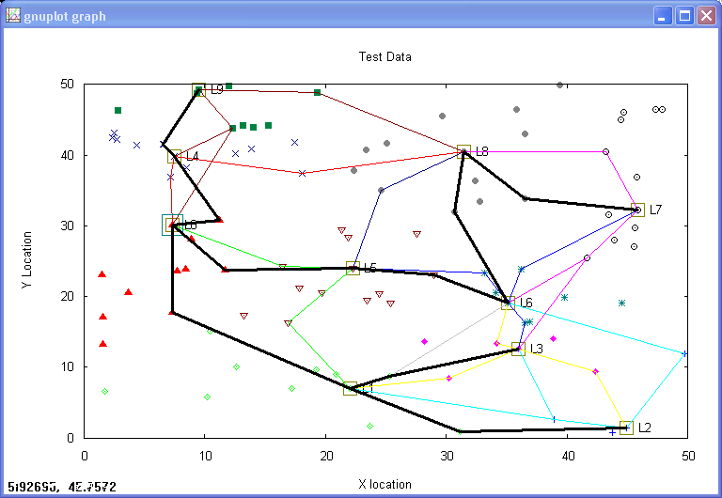
Figure 5. Cluster formation and sink tree formation results generated by SNATool version 0.1.

Table 1 shows the traffic volume comparison of the best, random case (generated by SANTool), and worst case during the cluster formation and sink tree formation phase.

Table 1. Traffic Volume (No. of Messages)
Generated in Cluster/Sink Tree Formation Phase
Msg Type | Best Case | Random Case | Worst Case
ADV | 10 | 10 | 150
Join-REQ | 120 | 120 | 100
CTS | 90 | 90 | 50
TS | 10 | 10 | 50
DRN | 15 | 26 | 50
STB | 16 | 39 | 99
Total | 261 | 295 | 499

Table 2 shows the traffic volume in terms of bytes during the cluster formation and sink tree formation phase. Note that some messages are longer than others.

Table 2. Traffic Volume (No. of Bytes)
Generated in Cluster/Sink Tree Formation Phase
Msg Type | Best Case | Random Case | Worst Case
ADV | 140 | 140 | 2100
Join-REQ | 5040 | 5040 | 4200
CTS | 1260 | 1260 | 700
TS | 460 | 460 | 2300
DRN | 270 | 468 | 900
STB | 736 | 1794 | 4554
Total | 7906 | 9162 | 14754

The above cluster and sink tree formation phase will repeat periodically to even the energy consumption among sensor nodes.

3.1.2 Traffic Volume Analysis for Sensor Status Reporting Phase

The sensor data will be collected by the cluster leader and forwarded along the sink tree to the sink node. Assume each sensor status report is 10 byte payload and the same 14 byte header is used. Also assume the leader aggregates all status reporting within the cluster in a single message to the sink node, and there is no further message aggregation done by other leaders or relay nodes. Assume in the best case scenario we have the sink tree shown in Figure 6.
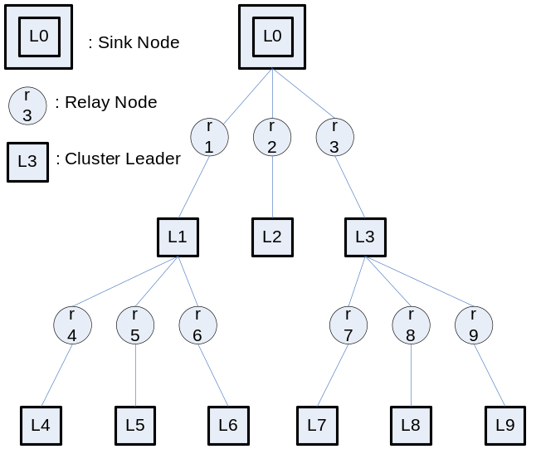
Figure 6. Sink tree in a best case scenario.

Each leader will receive 9 status report message from its members. Each status report message is 24 bytes. The leaders then aggregate the report in a single aggregate report message and send along the sink tree. The size of the aggregate report message is 154 bytes, containing 14 byte header and 10*14 byte payload. The payload contains 10 cluster member reports including that of the leader and their IDs. The six aggregate report messages from L4 to L9 in the second level of the sink tree will appear 4 times. The three aggregate report message from L1 to L3 in the first level of the sink tree will appear only twice through a relay node. In total there are 120 messages including 90 member status report messages and 30 aggregate report messages. Total number of bytes in those messages are R=90*24+30*154=6780 bytes.

For the worst case, there are 50 leaders and 50 relay nodes. Therefore there are 50 status report messages with the same 24 byte message size. The aggregate report message is 42 bytes containing 14 byte header and 2*(14)=28 bytes two reports and their related node IDs. Assume the sink node is the leader on the leftmost side of the network. The aggregate report message sent by the rightmost leader will appear 98 times and relay 97 times. The aggregate report message sent by the closest leader to the sink node will appear twice and only needs to be relayed once. In total there are 2500 messages, including 2450 aggregate report messages and 50 status report messages. Total number of bytes in those messages are R=50*24+42*2450=104100 bytes.

For the above random case generated by the SNATool, the number of member status report messages in each cluster is different. It ranges from 3 to 12. The aggregate report message sent by L7 will appear 8 times since according to Figure 5 the message is forwarded by L8, L6, L5, and four relay nodes. L7 has 11 members, therefore the aggregation message is 14+14*12=182 bytes. The aggregate report message sent by L8 will appear 6 times. Those sent by L2, L3, L6, and L9 will appear four times and those sent by L1, L4, and L5 will be appear twice. Therefore there are 126 messages, including 90 member status report messages and 8+6+4*4+3*2=36 aggregate report messages. Total number of bytes in those messages are R=90*24+8*182+6*14*14+4*(14*5+14*7+14*9+14*10)+2*(14*12+14*14+14*14)=7648 bytes.
Note that if the payload size is small, then those long aggregate report messages may need to be segmented. Tables 3 and 4 show the summary of the traffic volume generated during sensor status reporting phase for those three cases.

Table 3. Traffic Volume (No. of Messages) Generated in Sensor Status Report Phase
Msg Type | Best Case | Random Case | Worst Case
Member Status | 90 | 90 | 50
Aggregate Report | 30 | 36 | 2450
Total | 120 | 126 | 2500

Table 4. Traffic Volume (No. of Bytes) Generated in Sensor Status Report Phase
Msg Type | Best Case | Random Case | Worst Case
Member Status | 2160 | 2160 | 1200
Aggregate Report | 4620 | 5488 | 102900
Total | 6780 | 7648 | 104100

4. Conclusions

We have presented an energy efficient sensor network architecture based on cluster formation and sink tree formation. Group key management technique for enhancing the security is proposed. We also presented the formula for estimating the traffic volume generated by such sensor network operation in best case and worst case scenarios. A radio sensor network analysis tool was built to help analyze and visualize the effectiveness of the cluster and sink tree formation protocol.

5. References
[1] Wei Ye; Heidemann, J.; Estrin, D., “An energy-efficient MAC protocol for wireless sensor networks,” INFOCOM 2002. Twenty-First Annual Joint Conference of the IEEE Computer and Communications Societies. Proceedings of IEEE, Volume 3 , 23-27 June 2002 Pages:1567 - 1576 vol.3.
[2] Wendi Beth Heinzelman, “Application-Specific Protocol Architectures for Wireless Networks,” Ph.D. Dissertation, MIT, June 2000.
[3] Chung Kei Wong and Simon S. Lam “Keystone: A Group Key Management Service” Proceedings International Conference on Telecommunications, May 2000.
[4] Edward Chow and Ganesh Godavari, “Secure Groupware for First Responders,” UCCS-Tech Report 2003-01.
[5] http://www.cs.rice.edu/~santa/research/stack/sigcomm-stack.pdf.

