SECURE COLLABORATIVE WEB BROWSING AND CHAT THROUGH STANDARD WEB PAGES

by

Patricia Ferrao

B.E.E., McGill University, 1990

A thesis submitted to the Graduate Faculty of the

University of Colorado at Colorado Springs

in partial fulfillment of the

requirements for the degree of

Master of Science

Department of Computer Science

2004
ii

This thesis for the Master of Science degree by

Patricia Ferrao

has been approved for the

Department of Computer Science

by

_________________________________
Dr. Edward Chow

_________________________________
Dr. Jugal Kalita

_________________________________
Dr. Xiaobo Zhou

_______________________
Date

iii
ABSTRACT

Ferrao, Patricia (M.S., Computer Science).

Secure Collaborative Web Browsing and Chat Through Standard Web Pages.

Thesis directed by Professor Edward Chow.

This thesis researches the different Internet collaborative solutions available to users, the architectures and technologies used to build collaborative applications, and proposes a collaborative solution that surmounts some of the key limitations of existing solutions.
The limitations uncovered by the research lead to the design, implementation, and testing of a new prototype collaborative browsing and chat application, CoWebBROWSE. CoWebBROWSE makes use of lightweight, open source technology, is HTTP based, platform-independent, penetrates through firewalls, is secure and scalable, and merely requires a browser for user access. It requires no downloads, extra installations or plug-ins. There are no pop-ups, no cookies, and no applets. The application can penetrate the most restrictive corporate firewalls and is friendly to the most stringent corporate security policies for Internet usage. This capability to penetrate firewalls in a friendly manner is one of the biggest challenges facing collaborative Internet applications today [1].
The thesis concludes with an analysis and evaluation of the solution provided by the application, based on performance, scalability, functionality restrictions and possible future expansion.
iv

CONTENTS

CHAPTER

I. COLLABORATING OVER THE INTERNET ………………………. 1
How People Collaborate Over The Internet 3 ……………………. 3
Collaborative Frameworks From the Research Community ….. 7
Commercially-Available Collaborative Solutions ……………….. 12
Pitfalls Of Existing Solutions ………………………………………. 16

- TECHNOLOGIES AND TOPOLOGIES
FOR INTERNET COLLABORATION ……………………………….. 18
Load Balancing ……………………………………………………….. 19
Scalability ………………………………………………………. 20
Fail-Over ……………………………………………………….. 26
Session Persistence …………………………………………. 27
Security …………………………………………………………………. 29
Firewalls ………………………………………………………… 29
Mobile Code ……………………………………………………. 32
JavaScript ……………………………………………………… 33
Network Architecture …………………………………………………. 35
Hierarchical Client-Server …………………………………… 35
Peer-To-Peer Architectures …………………………………. 36

- COWEBBROWSE SOLUTION ………………………………………. 39
Requirements …………………………………………………………. 40
Architecture …………………………………………………………… 42
Directory Server ……………………………………………… 44
First-Order Client Servers ………………………………….. 46
Second-Order Session Servers ………………………… 48
Client ………………………………………………………… 49
Implementation ………………………………………………………… 53
Interaction Diagrams ………………………………………. 55
Client Implementation ………………………………………. 57
Directory Server Implementation ………………………… 69
Client Server Implementation …………………………….. 71
Session Server Implementation …………………………… 77
How The Solution Fulfills The Requirements ……………………. 78
Innovation And Challenges …………………………………………. 80
CoWebBROWSE Load Balancing ……………………….. 80
CoWebBROWSE Security ………………………………… 82
v

CONTENTS

CHAPTER

CoWebBROWSE Network Architecture ………………… 82
Technical Challenges …………………………………….. 84

- PERFORMANCE EVALUATION ……………………………………. 86
System Performance ………………………………………………. 86
Compatibility Tests ………………………………………………….. 96

V. LESSONS LEARNED ………………………………………………… 97

VI. FUTURE ENHANCEMENTS …………………………………………. 99

VII. CONCLUSION ………………………………………………………… 100

REFERENCES ………………………………………………………………… 101

APPENDIX

A – COWEBBROWSE INSTALLATION GUIDE …………………………. 108

B – PACKET TRACES FOR THE RESPONSE TIMES
OF LOGIN, JOIN, CO-BRWOSE, AND LOGOUT ACTIVITIES ……… 113

vi
TABLES

Table

1. Research Framework Features ………………………………….. 8

2. Commercial Product Features ……………………………………. 13

3. Server Configuration ………………………………………………… 87

4. Effects Of Session Server On Performance …………………….. 94

5. Time To Establish A New Group, Login, And Join ……………. 95

6. CoWebBROWSE Compatibility Test Results ……………………. 96

vii
FIGURES

Figure

1. Geography-Based Site Selection ……………………………….. 22

- Hardware Load Balancer ………………………………………….. 24

3. CoWebBROWSE Architecture …………………………………….. 43

4. CoWebBROWSE Page ………………………………………………. 51

- CoWebBROWSE Technology Diagram …………………………… 53

- Login Process ……………………………………………………….. 56

- Chat Event …………………………………………………………….. 57

- Login Control Flow ………………………………………………….. 58

- Response Page From Directory Server ………………………… 60

- CoWebBROWSE Frames …………………………………………… 61

- Cross-Domain Javascript Security ………………………………. 65

- Basic Pushlet Framework ………………………………………….. 72

- Modified Pushlet Framework ………………………………………. 75

- CoWebBROWSE System Test Bed ………………………………… 87

- Number of Users Vs. Client Servers ………………………………. 90

- User Wait Times For One Client Server …………………………… 91

- User Wait Times For Two Client Servers …………………………. 91

- User Wait Times For Three Client Servers ……………………….. 92

- User Wait Times Vs. Number Of Client Servers (7 Clients) …… 92

CHAPTER I

COLLABORATING OVER THE INTERNET

The Internet as we know it has been evolving for over thirty-five years, starting with the ARPANET in 1969 [3]. Its initial use was mainly for researchers to exchange information through email and UseNet groups. The 1990’s, and more specifically the introduction of the Mosaic Web browser in 1993, gave way to the commercialization of the Internet, and caused its usage to accelerate dramatically. The Internet has revolutionized how people communicate and gather information, but up until recently its use has been mostly limited to retrieving static information through Web pages, file downloads, email and newsgroups.
Today, this is no longer the case. E-Commerce, IP Video and Telephony, Chat, Instant Messaging, distance learning, collaborative team rooms, and electronic meetings are very real in today’s Internet. Computer Supported Cooperative Work (CSCW), a research branch that seeks to understand how computer technology can help groups communicate and work more effectively, has been established as a distinguishable field of research since the mid-1980’s [7]. The WWW has been designed from the beginning to become a collaborative

2

tool for the Internet [8]. Richard Bentley and Wolfgang Appelt from the CSCW Group of the Institute for Applied Information Technology state the following:

The World-Wide Web is an addressing system, network protocol, document mark-up language, and client server architecture. In a very limited sense it is also a collaboration technology, allowing people to share information in a manner which is, in contrast to most collaboration technologies, not restricted to particular organizational settings or computer platforms.

Still today, most synchronous collaborative tools are not integrated into the WWW [8]. The tools are typically stand-alone software outside of the WWW that cannot be accessed through a standard Web browser. This makes them inconvenient for the user because not only are they not using the familiar GUI of the Web browser, but an extra program needs to be downloaded and installed as well. Usually the communication protocol is something other than HTTP, and does not easily penetrate through corporate, institutional or personal firewalls. Even if the applications can be accessed through a browser, they have been designed to make use of applets, cookies, pop-ups or plug-ins, which make them a security threat that most corporations disallow either through policy or firewalls. The company that currently employs me, for example, has blocked all ports to the outside world except for HTTP and HTTPS. Collaboration products such as “Microsoft Instant Messenger” can only be utilized within the corporate firewall, and even customers that interact with us on a daily basis must use the telephone
3

system or email. Employees are strictly forbidden from downloading and installing any application from the outside without the consent of the IT department, and even then, they can only communicate with the outside over HTTP or HTTPS. A collaborative service requires communication. Such a product, no matter how great, cannot reach its full potential if a large part of the user community can only utilize it in a limited way, or cannot make use of it at all.

How People Collaborate Over the Internet

The way people collaborate over the Internet depends on the tools available for them to do so, and how easily they can access these tools. The main types of Internet collaboration are asynchronous and synchronous.
Early collaboration systems were asynchronous. They are still in common use today, and include email, newsgroups and file transfer. Asynchronous collaboration does not require immediate interaction, nor do all participants need to be present in order for collaboration to occur. One can send an email today, and it does not need to be read for days, weeks or months later. The email will be preserved in its original format regardless of when it is accessed by the recipients. The same applies to file transfer from one party to another, or to a newsgroup posting.

4

Synchronous collaboration, on the other hand, is intended for real-time, immediate response. All participants are updated with new events as soon as they occur. Typically, if a participant is not present during a collaboration session, or joins late, he misses the interactions that took place while he was away. Typical synchronous collaboration tools available today can do one or more of the following: instant messaging and presence, text chat, video and audio conferencing, team-rooms, whiteboard, collaborative editing, collaborative Web browsing, presentations, and application sharing.
Instant messaging tools allow participants to type text messages to each other over the Internet. The messages are sent and received immediately. They also allow a participant to register his location and status so that interested parties can keep track of him and be notified of changes to his status. Participants do not need to keep a chat window open for communication to occur. The recipient of an IM gets notified when a message is received. These systems are used inside the workplace to allow remotely located coworkers to communicate more effectively, or even among co-located coworkers in order to avoid a walk to someone else’s desk. They save on phone calls and long-distance charges. These tools are also active among personal users who want to chat with friends or family over the Internet.
Audio and video conferencing allow participants to see and hear each other over the Internet. These functions require extra hardware such as a video

5

cam or a microphone. Conferences of these types are useful for remote meetings in the workplace, distance learning, or a long-distance rendezvous among friends and family.
Collaborative presentation tools allow for presentations to be shown over the Internet, either for distance learning or remote meetings. Usually, there is a presenter who has control over the presentation, and participants who play a passive role. In some cases, the collaboration can be two-way, allowing a participant other than the presenter to take control. The presentation needs to be written in the format supported by the tool. Groupware features may include a telepointer or highlighter to point out or highlight different parts of the presentation.
Collaborative whiteboard applications allow participants to draw on an electronic whiteboard, and broadcast updates to all participants as soon as changes are made. Typical features include multi-colored pens, telepointers, and cursors of different shapes to identify the focus of individual users. This type of application is good for brainstorming during meetings or among members working on a common project.
Collaborative editing systems allow multiple users to edit a document over the Internet simultaneously. When a participant modifies a piece of document, that change is reflected almost instantaneously in all participants’ views. Usually, the participants take turns editing, or they each work on different parts of the document at one time. Usually, a common editor is required, one that was
6

designed specifically for collaborative editing. It is possible to modify common single-user editors to be used for collaboration, but this typically requires the source code of the single-user application. Collaborative editing is useful when a document has several authors, or in the publishing industry where several editors may need to dissect an author’s work.
Multiple users may browse the Web together through collaborative browsing tools. When one participant in a session enters a URL or clicks on a link, the other session participants view the same resulting page. With some applications, the client is a common browser such as Internet Explorer or Netscape. With others, a new browser client is required for this purpose. It may be possible for users in a session to choose different browsers, if the collaborative Web browsing application permits it. Collaborative Web browsing is useful in the field of marketing and sales. A vendor may place his catalog online and use the service to navigate a potential client to the right products. Also, the service may be used for remote presentations if the material to be presented is in HTML format, or a format that can be interpreted by the browser.
Application sharing allows a user to share all or part of his desktop with other collaborators in the session. Usually, only the windows pertaining to a specific application are shared. Generally, the application-sharing platform allows any application running on a participant’s desktop to be shared and used collaboratively. Input events to the application are captured and sent to all participants. The application-sharing platform may include groupware features
7

such as telepointers and scrollbars.
Team-rooms or virtual rooms combine multiple collaboration functions into one application to be used by anyone inside the team-room. They provide a virtual space for team members to collaborate together in a single session. Usually, the team-rooms come equipped with standard features such as whiteboard and chat, and other tools can be brought in as required: maybe an audio-conferencing application, card games, presentation tool, or post-it notes. The team-room is persistent, meaning that the objects stay around across sessions. This allows for a work group to reenter the room and continue working the next day, or for an administrator to go into a meeting room after the fact and take minutes.

Collaborative Frameworks From The Research Community

The research world has developed frameworks and libraries that can be used to facilitate the development of collaborative applications. The frameworks typically provide functionality such as session management, communication, user roles, access permissions, and floor control policies. The libraries provide API’s that a developer can use to enhance an application, such as adding a telepointer or multi-user scrollbars. Some of these frameworks also provide scripting

8

languages useful for defining and configuring a session. Table 1 summarizes key aspects of these research products.

 | HABANERO | GROUPKIT | COCA | ESIC
Technology | Java, serialized objects | TCL/TK, sockets, TCL RPC | IP multicast, own specification language | Java, XML, HTTP, ESI
Architecture | Central | Hybrid central/peer2peer | Peer-to-peer | Central or hybrid central/peer2peer
Platform Independent | yes | No (Unix/X-Windows) | yes | Yes
Firewall Friendly | no | no | no | Yes
Client | Java applet or application | Requires session and conference managers at each client | COCA VM runs at each site | Requires specialized client software to support framework
Table 1: Research Framework Features

Habanero is an example of a collaborative Internet platform developed by the National Center for Supercomputing Applications (NCSA). It is a Java platform that focuses on making Java applets and applications available in a distributed environment [4]. Its central architecture requires a Habanero server to enable collaboration. Basically, it broadcasts user actions to all participants. A Java applet or application can be converted to a Habanero application by modifying a bit of the source code.
Habanero APIs on the client side allow an application to share events with the server. The server provides functionality for arbitration, routing and networking [57]. Habanero applications communicate to a Habanero server
9

through a Habanero client framework [57]. The server then passes the information to all participating clients.
The Habanero platform comes with a few sample applications: whiteboard, chat, a tool to examine molecular structure, and a collaborative Web browsing application that runs on Mosaic. The latest version of Habanero is 3.0. It supports Java 2 and JINI 1.0 [57]. The project has been discontinued.
Groupkit is another development package for collaboration developed by Mark Roseman and Saul Greenberg from the University of Calgary, Canada [58]. Its architecture is decentralized, but a central server is required to set up a session. It is based on TCL/TK, and uses TCL’s built in socket commands for low-level networking [58]. It runs in a UNIX/X-Windows environment. It is a replicated architecture, with a session manager and conference applications running on each client machine. One session manager per participant, and one conference manager per application are required on each client. The session manager is shared across participant applications, be it whiteboard, chat, or a game.
Groupkit provides support for Remote Procedure Calls (RPC), events, and environments. It uses TCL’s RPC mechanism to allow a programmer to communicate with and trigger program execution between participants. It also has events, which provide a way for conference applications to get notified when things happen, and environments, which are shared across a user’s applications.

10

Environments allow a participant’s applications running in a single session to share data.
Groupkit has API’s for groupware widgets such as telepointers, participant status, and multi-user scrollbars. Sample applications that come with Groupkit are multi-user text editor, whiteboard, and collaborative Web browsing. The Groupkit project was started in 1992 and ran up to 1998, when development stopped. It has recently been revised in 1993.
COCA (Collaborative Object Coordination Architecture) developed by Du Li and Richard R. Muntz from the University of California at Los Angelos is a distributed framework based on IP multicast, a dual-bus collaborative architecture, and a logic-based specification language for modeling coordination policies [59]. A copy of COCA’s virtual machine runs at each client’s site. It includes a reasoning engine and an internal database. The database maintains state information regarding ongoing sessions. The reasoning engine monitors incoming events and fires off rules that match the participant’s roles.
COCA can support applications written in any programming language, since it does not provide APIs. Instead, it provides a scripting language similar in syntax and semantics to Prolog. Programmers write user roles and associated rules using this language. The roles and rules are translated by COCA into coordination policies. These polices include data distribution, access control, floor control, concurrency control, collaboration structure and agenda, and

11

exception handling [59]. COCA comes with a sample distributed whiteboard application [7].
ESIC (ESI Extensions for Collaboration) framework was recently developed by Vincent Wesley Merlin from the University of Colorado at Colorado Springs [9]. It is a framework based on Akamai’s ESI and the content delivery network. The framework includes an origin server and multiple ESIC proxy servers within a content delivery network. The proxy servers help route messages between clients and offload the origin server from some of the work.
The framework allows the programmer to use the XML markup language to define communication channels, user roles and permissions for a session. Communication is over HTTP(S). The communication can be peer-to-peer or hosted, based on the type of channels defined for a session. Peer-to-peer communication is through proxy servers, although the origin server is required to setup the session. Hosted communication forwards messages to the origin server. This is required for cases where the origin server runs part of the collaborative application’s functionality. Monitoring channels and ordered channels are also possible. Monitoring channels route all messages to a common endpoint, as well as to all participants. The functionality allows for logging of a session. Ordered channels are used when ordering of events must be strictly maintained. The events go to a common proxy server, which then routes them to all participants.

12

Vincent created a sample application that comes with the framework, a Java applet used for collaborative drawing.

Commercially-Available Collaborative Solutions

The corporate world has developed several solutions for collaboration over the Internet. Some of these solutions are available as hosted services, where the servers and applications reside at the hosted sites, and clients access the services remotely. Usually, the companies doing the hosting charge either a flat fee, or a fee per usage. The companies or individuals using the services need not purchase equipment or software. Client software may be required, and is usually included with the service. Some solutions, on the other hand, require that users purchase and install the software. Examples of hosted services are Microsoft LiveMeeting, Microsoft NetMeeting for personal use, WebEx, and Windows Messenger. Examples of collaborative products are Microsoft NetMeeting for business, Microsoft Exchange server, Cisco Collaboration Server, and Click-to-Meet. Table 2 summarizes key features of commercial products discussed in this paper.

13

 | Technology | Features | Architecture | Firewall Friendly | Client | Platform Independent
MS LiveMeeting | HTTP, LDAP | Data, text | Central | yes | Browser, plug-in | yes
MS NetMeeting | .NET, H.323, T.120 | Video, audio, text, data | Central | no | Application to be installed | Windows only
MS Messenger | SIP, .NET | Video, audio, text, data | Hybrid central/  peer2peer | no | Application to be installed | Windows only
WebEx | T.120, H.323, SIP, LDAP, HTTP, own in-house protocols | Video, audio, text, data | Central | Yes HTTPS tunneling | Browser, cookies, requires download of exe file | yes
Click-To-Meet | Active-X, H.323, T.120, SIP, HTTP | Video, audio, text, data | Central | Yes HTTPS tunneling | Web-based client that uses Active-X. Must be downloaded and installed. | Windows only
Table 2: Commercial Product Features

Microsoft LiveMeeting [22] is a web conferencing service offered as a hosted service. It includes applications for chat rooms, whiteboard, application sharing, document annotation, web polls, web tours, and PowerPoint presentations. It does not support audio or video. Participants must download any presentation material to the LiveMeeting server. The client is a browser, either Internet Explorer or Netscape. Self-installing utility plug-ins are downloaded and installed at the client browser. LiveMeeting uses HTTP(S), and thus penetrates through corporate firewalls. LiveMeeting provides security
14

through password and login authentication, SSL, access control lists, and encryption of stored material. It provides APIs for participants to be authenticated through the corporate database, using LDAP.
Microsoft NetMeeting [37] is a collaboration tool that includes video, audio, chat, Internet directory, file transfer, program sharing, whiteboard and remote desktop sharing. Microsoft provides a personal and business version. The business version integrates with Microsoft Exchange server, whereas the personal version is available on the Web, and is based on the .NET architecture. The client runs on Windows platforms only. It is an application that must be installed on the desktop. It uses H.323 technology for audio and video, and T.120 technology for video. NetMeeting is not firewall friendly, since both T.120 and H.323 require several ports to be available through the firewall. H.323 call control assigns port dynamically, requiring a range of ports to be accessible. NetMeeting uses LDAP and Microsoft User Location Service (ULS) for directory services.
MSN Messenger [39] is an instant messaging service popular with personal and corporate users. The .NET version is a hosted service whose client is integrated into Windows XP. It provides IM, text chat, video and audio streaming. Its technology is compliant with the Session Initiation Protocol (SIP). SIP is a framework for establishing, maintaining, and encoding Internet multimedia conferences and phone calls [39]. It’s a peer-to-peer technology, but a Microsoft server acts as a conduit, connecting two users directly [39]. SIP is not firewall or Network Address Translation (NAT) friendly, and does not work with all
15

network configurations. The messenger client needs a program to be installed, and runs only on a Windows platform.
Microsoft Exchange 2000 [27] server collaboration solution requires the server to be purchased and installed. It is a corporate solution. Data conferencing is based on the T.120 protocol suite, and video conferencing is based on Internet multicast protocols. Data conferencing includes application sharing, whiteboard, and file transfer. There is also a chat service based on the IRC protocol. Video conferencing includes video and audio over multicast-enabled IP networks.
Cisco Collaboration Server [29] is another corporate solution that must be purchased and installed at the customer site. A browser-based client allows the sharing of web pages, forms, and applications. The browser-based client also provides voice and text chat, collaborative web browsing, and whiteboard. It also allows for sharing of Windows applications. The browser client uses applets, but requires no other downloads or installations. Cisco Collaboration Server comes with a development kit, which allows customers to build multi-user collaborative applications using Java. The server runs on Sun and Windows platforms, and the client runs on Netscape and Internet Explorer.
WebEx [49] is a hosted service that provides web meetings, application sharing, slide show presentation, polling, chat, audio and video conferencing. Client access is through a standard client browser, either from a desktop or a PDA device. WebEx provides APIs for customers to integrate their applications with WebEx. The WebEx network has hundreds of multi-media communication
16

switches, telephony switches, and Web servers deployed at data centers around the world. The platform incorporates its own graphics language called “vectoring” and signaling called “MediaTone”. It also uses standard protocols like T.120 and H.323, SIP, and LDAP. It is firewall friendly, since it tunnels H.323 and T.120 over HTTP(S). WebEx offers four interactive services: WebEx Meeting Center for virtual meetings, WebEx OnStage for client seminars, WebEx OnCall for technical support center, and WebEx Training Center for training seminars.
“Click-To-Meet” [53] is a solution from First Virtual Communications. The product can be integrated into Microsoft Exchange Server 2000 and OutLook, Windows Messenger, or Web Pages. Web designers can integrate Click-to-Meet technology into Web pages using Active-X. Click-to-Meet comes with a Web-based client that uses Active-X technology. The client needs to be downloaded and installed. The product also comes with an application server that acts as a control center for all conferencing and collaboration activities. It needs to be installed at the customer site. Click-To-Meet supports H.323, T.120 and SIP protocols. H.323 and T.120 are tunneled over HTTP(S) for easy penetration through firewalls. Click-To-Meet supports both unicast and multicast IP.

Pitfalls of Existing Solutions

Tables 1 and 2 of Chapter I show that existing solutions impede security and ubiquitous access. Most solutions use technology that doesn’t easily work
17

through firewalls. Configuration changes are typically required at a firewall in order for them to work. Most institutions, corporations and even individual home users are unwilling to make these firewall changes because they open extra ports to the outside world that may allow unwanted intruders to penetrate the network with malicious code. As a result, they don’t use these solutions.
The client software for solutions discussed in Chapter I either work within a standard browser such as Netscape, or require an application to be installed at a client’s machine. Those that work through a standard browser make use of mobile code such as Java Applets, Active-X components, or browser plug-ins. Most users are very reluctant to trust these program installations and mobile code unless they are very familiar with their origin. They are afraid that once this code gets into their network, it has free reign and can do damage to their data and network. It’s becoming increasingly more difficult to develop collaborative solutions that users will trust and allow on their network. Firewalls and the security aspect of mobile code are discussed further in Chapter II.
Platform independence is another key issue for ubiquitous access. Solutions that are specific to a particular operating system or hardware platform limit usability, since only users with certain system requirements can make use of them.

CHAPTER II

TECHNOLOGIES AND TOPOLOGIES FOR INTERNET COLLABORATION

The research conducted in Chapter I indicates that Internet collaborative solutions that exist today are not easy to use because they use technology that isn’t trusted by users and does not work well through firewalls. This chapter researches what it would take to build a collaborative solution that overcomes these limitations. In addition, the solution should not impede usability in other ways, such as adhering only to certain software or hardware platforms. It is very helpful to have a user interface that users are already familiar with, such as a Web browser interface. This way, a user does not have to put a lot of effort into learning a new interface. A platform designed for Internet collaboration must scale well. The Internet has a very large user base, and therefore the platform has potential for a large number of users. The solution must be able to accommodate a large user base.
This chapter researches technology that can be used to build collaborative solutions. It looks for technology that can build a secure solution that users can trust. It also looks for a scalable and robust network topology. This chapter examines client-side technologies that easily penetrate through firewalls and that users can trust not to harm their network. It looks for a network topology that can
19

easily accommodate a growing user base, that can do load balancing, and that can still provide service in case of some network node failure.

Load Balancing

Load Balancing is a process by which the system distributes requests to different nodes within a server cluster in order to maximize performance [68]. A cluster is a group of servers acting as one in order to provide a service to clients. There are two aspects to load balancing: scalability and high-availability. High availability requires redundancy in the system so that one node can take over when another fails. This prevents outages and disruption in client services. Scalability requires that the system be as responsive to many clients accessing simultaneously as it is to one client at a time. Therefore, if the system can respond to a single client request in 10 ms, it should respond to 1000 clients accessing concurrently in approximately the same amount of time.
In a Web application, there is a third aspect to load balancing, which is session persistence. Web applications typically maintain session information across requests. They store session information internally and have a client pass information that identifies the session with each request. This can be done through cookies, URL rewrite or hidden fields. It is important that a client request that is part of a session be forwarded to a server that has information about the session.
20

Scalability

There are three major ways to address the scalability issue of load balancing:
- DNS load balancing
- Hardware load balancer
- Dispatcher

DNS load balancing:

A DNS service resolves domain names into IP addresses. They are located within networks of ISP’s, corporations or institutions. When a browser needs to resolve a domain name, it contacts its local DNS for the information. If the local DNS does not know the IP address, it contacts another DNS server within the Internet, and so forth until a server is found that can resolve the domain name. At worst, the request goes all the way to the local DNS of the Web application. This DNS server is known as the authoritative DNS.
DNS servers cache IP address to domain name mappings once they learn about them. So, if a browser’s local DNS server does not know how to resolve a domain name, it will cache the information once it learns about it from another DNS server. This cache entry will remain there until it expires. The next time that
21

a request comes to it for the same domain name, it can answer the request directly. This is how DNS information gets propagated across the Internet.
DNS can be used to provide load balancing. The authoritative DNS server can be configured to have more than one IP address for a local domain name. It can use a round-robin algorithm to resolve this mapping. The first time that the authoritative DNS gets a request for the domain name, it sends IP1, the next time IP2, then IP3, and so forth until it cycle back to IP1. Therefore, client requests go to different Web servers each time.
The main advantage of doing load balancing this way is that it is easy and cheap. Most modern DNS servers come with the ability to do load balancing, and no extra hardware is required. Also, the application servers can be located anywhere within the Internet. However, this method has some disadvantages. For one thing, DNS servers don’t have any feedback from the Web servers themselves about how they are doing on load, or if they went down. Therefore, a DNS server may continue to send requests to a server that has failed, or that is overloaded. Another problem is that domain name resolutions take time to propagate within the Internet. If a DNS server has a cached IP address for a domain name that has not yet expired, it will use this resolution. So, this method does not always yield the desired effect. Another issue is the session persistence. A DNS server may route two requests that belong to a single session to two different servers, one of which or both may know nothing about the session. Therefore, it is difficult to maintain sessions with this solution.
22

Figure 1 depicts an example of a DNS load balancing architecture.

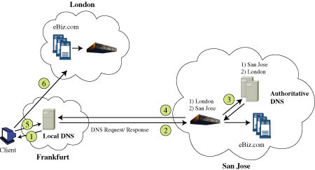
Figure 1: Geography-Based Site Selection

Hardware load Balancer:

Another approach to load balancing is to use a dedicated piece of hardware called a load balancer. The load balancer sits in front of a cluster of server nodes, and forwards requests to different nodes in the cluster. The load
23

balancer presents one IP address to the client, which is the IP address of the service. This is known as the virtual IP address. All requests go to the load balancer. It then uses IP header information, URL data, cookie information, and server load information to redirect a request to a server node [68]. The load balancer changes the source and destination IP addresses of the packets in order to forward them correctly. The load balancer and server nodes are tightly coupled, usually residing on the same network.
The advantage of this approach is that a load balancer can know when a node is not responding to a request, and redirect the request to another server. The client does not need to know about it, since all requests are directed to the load balancer. The load balancer can also not direct further requests to the failed node until it detects that node is available again. It is also possible for a load balancer to obtain metrics about the load of a server node. Since all bi-directional traffic goes through the load balancer, it can detect the response time, number of packets going back and forth, and so on. However, this is also a disadvantage for the hardware solution, since the load balancer can become a bottleneck for traffic. Also, it can be a single point of failure for the service.
Another big disadvantage for this solution is its inability to easily handle SSL traffic and maintain a session at the same time. Since SSL traffic payload is encrypted, the load balancer can’t read cookies or URL data. Therefore, it can’t send all requests pertaining to a session to the same node. Another piece of

24

hardware called an SSL decoder must be provided for this. The SSL decoder sits in front of the load balancer, and does the SSL encryption/decryption.
Figure 2 depicts a hardware load balancer architecture.

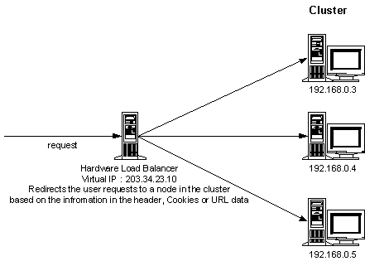
Figure 2: Hardware Load Balancer

25

Dispatcher:

The third solution is to use a front-end Web server as a dispatcher for sending requests to different server nodes. All requests go to the dispatcher, which provides clients with one IP address to the service. The dispatcher redirects requests to one of the nodes based on rules and load information. In some cases, cookies, URL data, or HTTP header information can also be used. The dispatcher can be done in several ways, some of which are HTTP redirection, packet rewriting, and packet forwarding.
HTTP redirection allows the dispatcher to respond to the client request with a redirection response. The dispatcher puts the correct status code in the HTTP response, and the new IP address in the header. This solution allows the client and real server node to communicate directly, without going through the dispatcher again. Also, since the HTTP requests must go all the way up to the application layer, session information can be taken into account.
Packet rewriting allows the dispatcher to rewrite the IP address of the packets by changing the source and destination IP addresses. All traffic goes through the dispatcher. This solution is similar to the hardware load balancer, except that a Web server is used for this purpose, and the software is modified to do the packet rewriting. This solution is slower than the hardware load balancer.
The packet forwarding approach makes use of the single IP address that the clients use to address the service, but the dispatcher works at the MAC level

26

to resolve the IP address to different MAC addresses. The service IP address and the real server node’s Mac address are used. In order for this to work, the server nodes must be on the same network. Also, the server nodes themselves must each be configured with the service IP address [69], and they must have the address resolution protocol disabled.
Except for HTTP redirection, this type of solution suffers from the single point of failure and bottleneck problem, since all bi-directional traffic flows through the dispatcher. However, it is possible for the dispatcher to take into account load information, since it can monitor traffic and response time of the server nodes. It can also redirect requests away from a failed node. However, if session information is to be taken into account in an SSL link, the dispatcher must route requests all the way up the IP stack to the application layer so that this information can be obtained, since encryption and decryption must take place. This can significantly slow things down.

Fail-Over

There are two types of fail-over, session level and request level. Session fail-over is transparent to the client. If a client is in the middle of a session on one node, and the node fails during the session, another node within the cluster takes over. The session does not terminate. In order for this to be possible, servers
27

must share session state information within a cluster. At least two nodes must be fully aware of a session at all times. One way to do this using Java is through Remote Messaging Interface (RMI). The nodes within a cluster can exchange session information through serialized objects or through multicast connections.
Request level fail-over is easier to handle. If a load balancer or a dispatcher detects that a node or the required service on a node is out of order, it just redirects the request to another server. This only works if a request is not part of a session. There are three ways to detect that a node is out of order. One way is to attempt to send a request to a failed node, and redirect it to another when the node does not respond. Another way is to have the dispatcher or load balancer periodically query the service on a node in order to check for response. A third way is to have a node periodically report to the dispatcher or load balancer that it is available. These last two approaches are known as maintaining heartbeat between the two nodes.

Session Persistence

There are two ways to ensure that requests belonging to a given session get handled correctly during load balancing. One way is to have session information replicated across all nodes. Of course, this approach is not practical for large systems.
28

A second way is to have all requests that belong to a session go to the same node. This can be done either through sticky connections, or by having the client send session information with the HTTP request. Sticky connections redirect requests coming from a common source over a given period to the same server. Session information sent either in cookies, URL query requests, or HTTP post requests can be used to redirect these requests to the server handling the session.
Version four of Tomcat uses a different approach to the ones mentioned so far, called JavaSpaces. JavaSpaces is a JINI technology that leverages RMI, java objects, and serialization. In Tomcat version four, there are cluster server processes and cluster worker processes. Worker processes can run on different tomcat instances on different machines. All these processes share a common memory space, where session objects are serialized and placed there. When a request comes into a server process, it places it in the memory space. One of the worker processes picks it up and serves it. It then replaces the updated session information back in the JavaSpace, where the server process can pick it up and respond to the client. The session information is kept in the JavaSpace and referenced by session id. It remains there for the duration of the session. The disadvantage is that there is one connector module which all clients connect to. This is a bottleneck and a single point of failure.
Tomcat version 5, on the other hand, uses session replication among all cluster nodes, where all nodes are aware of all sessions all the time. It also uses
29

a Web server front-end load balancer to dispatch to back-end servers. All traffic goes through the load balancer.

Security

Security issues with collaborative applications are three-fold: authentication and access control, encryption and transmission security, and security with regards to malicious code penetrating a user’s network. This section examines malicious code threats in more detail.

Firewalls

According to the SANS Institute:

“A firewall is software or hardware or a mix of both that is used to control access to or from a protected network by separating networks from one another AND applying certain criteria (rules) on traffic passing between them.”

Firewalls can be one of three types: packet filtering firewalls, gateways, or a hybrid of both [75]. Their intent is to stop unwanted traffic from entering the
30

private network. A packet filter network examines every packet for source and destination IP addresses and TCP/ UPD ports, and determines if the packets are secure enough to be transmitted in either direction. A gateway firewall sits between a private and public network, and works at the session layer to accept connections originating from within the network and forward them to the public network, or vice versa. It examines the validity of the TCP or UDP connection before allowing the connection to go through. It can also perform other functions such as caching or Network Address Translation (NAT). Caching is where the proxy not only requests a Web page on behalf of an internal client, but it also caches it to allow faster access to the page the next time around. NAT allows a proxy to map internal IP addresses and ports to its own IP address and a different port. This way, a network can have many IP addresses internally, but only one IP address is exposed to the outside world. The proxy server maps client IP addresses and port numbers for both incoming and outgoing traffic. Hybrid proxies perform both the functions of IP packet filters and gateways. They examine traffic on a packet-by-packet basis, but treat connections like gateways.
All traffic going from the private to public network and vice-versa must pass through the firewall, if one protects a network. A stringent security policy would block all incoming and outgoing traffic by default, and then selectively open outgoing ports and destination IP addresses in order to allow selective traffic through. Typically the outbound ports 80 and 448 are accessible through

31

any firewall that connects a private network to the Internet, since these ports are the typically ones used for HTTP and HTTPS web services. Firewalls usually allow HTTP and HTTPS connections to originate from within, but not from outside. All traffic that comes from the outside to the internal network takes the form of responses to HTTP and HTTPS client requests. In a lot of cases, this is the only type of traffic allowed to traverse a firewall. If other traffic types are required, other protocols and ports must be open through the firewall.
Firewalls pose a problem for applications that use protocols like H.323, T.120, or SIP in order to connect clients to servers. This is because these protocols use destination ports other than 80 or 443 to do their work. These ports are typically blocked by firewalls, so that clients cannot initiate a connection to services that accept connections on these ports. Also, firewalls are typically configured to disallow connections that originate from outside of the private network. Therefore, it is not possible to have these services spontaneously communicate to a client unless the client originates the connection. In addition, some of these services, like Session Initiation Protocol (SIP), do not work with NAT. A SIP client communicates its own IP address and port to its peer through a private message, but the proxy will translate the TCP source IP and port address to something else. Therefore, when the peer responds to the SIP client, it responds with the private address that the proxy does not recognize from outside. The proxy will disallow the connection [79].

32

Mobile Code

Java Applets and Microsoft Active-X controls are types of mobile code that get downloaded by a Web page when the Web page is rendered by the browser. A Web page may have one of these components embedded within it so that the request to download and run the component gets executed when the Web page gets rendered. Neither of these technologies is secure, but Active-X controls are far less safe than Java applets.
Active-X controls don’t have any security built into them. The security model is based on digital signature, like signed JavaScript, However, unlike JavaScript, once a user accepts one of them, the control gets free reign over the system. It is capable of crashing a machine, reformatting a hard drive or implanting a virus [74]. Active-X controls can be intercepted and blocked at a firewall, or they can be disabled at the browser. Some private corporations and institutions either have their employees disable them through policy, or block them at the firewall.
Java Applets have better security built into then than Active-X controls, because they run in a sandbox that prevents them from accessing dangerous resources or from connecting to a server other than the one that served the applet. This is true by default. However, it is possible to sign an applet with a digital certificate and have it request extended permissions from the user. Once the user grants the permission, the applet is allowed to leave the sandbox, and
33

can do damage. Since Java is a powerful language than JavaScript, it can do a lot of damage. It can have free reign of the system, just like an Active-X control. Even an unsigned applet can do damage, since it can hog memory and prevent a client’s system from doing other work, or it can forge and send an email [74]. Also, an applet can exploit weaknesses in a browser’s buggy JVM implementations of the sandbox, and do damage. Applets can be blocked by a firewall or at the browser.
Browser plug-ins are mobile code written to extend browser capabilities. They typically provide inline views of types of data not typically supported by the browser, like video. Browsers provide API’s that make it possible to leverage existing native code libraries or convert existing applications to take advantage of the Web [81]. They get stored on a user’s hard drive, and get loaded into RAM when a browser gets a request for a mime type requiring a specific plug-in. They can use the C language to take advantage of operating system capabilities and low-level functionality that Java does not allow. Needless to say, they are not safe. Plug-ins can be blocked either at the browser or through firewalls.

JavaScript

JavaScript is a client-side scripting language that can be embedded in HTML pages and rendered by the browser. It is very restrictive in the types of actions that it can perform. For instance, it cannot access a client disk drive. It is
34

also possible to sign JavaScript with a digital certificate and have it request extended browser permissions from the user. It is safer to extend permissions for JavaScript than for other mobile code, since JavaScript is more limited in what it can do. JavaScript can also be blocked by setting browser security permissions. However, this is not typically done because of its extensive use. JavaScript is so common that blocking it would mean a browser could only render the most basic, static Web pages. This would be difficult to live with. According to SANS, the Department of Defense (DoD) puts mobile code into three categories:

- Category 1:
Broad functionality, allowing unlimited access to a user’s computer and can do whatever a user can do. Examples are: (a) ActiveX, and (b) when used to execute mobil code: Windows Scripting Hosts, Unix Shell Scripts, DOS Batch Scripts
- Category 2:
Full functionality with limited controls by the user on what the code is allowed to do. Examples are: Java Applets, Visual Basic for Applications, LotusScript, PerfectScript, and PostScript
- Category 3:
Limited functionality, which is very restrictive in the actions it can perform. Examples of types of category 3 mobile code are: JavaScript, Visual Basic Script, PDF, and ShockWave/Flash

The DoD allows category3 code to be used freely, but restricts the other two categories [77]

35

Network Architecture

There are two main architectural models used for collaborative applications, peer-to-peer and client server. The client servers model has a client initiating a request to a server, and the server providing a response. Clients do not communicate directly with each other. For collaborative applications, the server is the bridge that passes messages from one client to another. The peer-to-peer model, on the other hand, has every node acting as a client and a server. Nodes communicate directly, without the help of a third-party. In a true peer-to-peer model, all nodes provide the same function, and all nodes are redundant. There are also several variations of these models, and hybrid models that encompass features of both. All architectures have advantages and disadvantages. This section discusses the advantages and disadvantages of the CoWebBROWSE network model, and compares it to its common rival technology, the peer-to-peer model.

Hierarchical Client-Server Architecture

A hierarchical client-server architecture is a topology composed of servers connected in a tree-like fashion. There is a root node, leaf nodes, and nodes in between. If we consider the root to be the highest level node, and the leaves to
36

be at level 1, then level 1 nodes connect to level 2 nodes, level 2 to level 3 and so forth. DNS is an example of such a topology. If a level 1 node needs to send information to another level 1 node, it must first send the information to its level 2 node. If the level 2 node cannot send the information directly to the recipient, it sends it to a level 3 node, and so forth until a common node is found that indirectly connects to both the sender and the intended recipient of the information. This is a very scalable architecture, as proved by DNS [86]. Additional nodes and additional hierarchies can be added without too much difficulty. If required, parts of the network can even be rebalanced so that nodes are more evenly distributed within the topology. However, if the root fails, than nodes can be left with no way to communicate.

Peer-To-Peer Architectures

Peer-to-peer architectures can be classified into three types: atomistic, user-centric, and peer-server [85]. In atomistic P2P, all nodes are equally server and client. This is the original and true P2P model. There is no central administrator or connection arbiter. Each node fully manages its own resources. The user-centric P2P model adds known servers to the atomistic model, which facilitate the first contact by users, and peer discovery. All nodes in the network act like atomistic nodes, except for these central directories. The peer-server model acts like a client server model in the sense that a node is either a client or
37

a server, and clients connect to servers. However, servers themselves act as peer nodes and communicate directly. Unlike the hierarchical model, all servers in the network are equal and perform the same functions. The user-centric P2P architecture has proven to be the most popular model used by services like Napster, ICQ, AOL Instant Messaging, and MSN Messenger [85]. IRC chat uses the peer-server architecture [85].
The advantage of a pure peer-to-peer architecture is robustness. Since all nodes are equal and there is no central administration or central point of contact, all nodes are redundant. Also, there is no central server to administer. However, this issue of how a user joins the group in the first place is a big one. Since there is no known address, a new node either has to be invited by an existing node in the group, or group nodes have to advertise their services to potential joiners. The first approach is not very flexible, since a user has to wait for an invitation. The second approach is difficult to manage over a large network like the Internet. Also, the issue of communicating messages within the group is complex. Either all nodes keep a current directory of node addresses that belong to the peer group and send a message to all peers, or each node has a partial list of peer addresses to send to, and they forward the message to their lists until all expected recipients have a copy of the message.
Another important concern about P2P architectures is support for concurrency. Let’s take the co-browsing functionality as an example. If user A types a URL for co-browsing at the same time as user B clicks on a new link,
38

whose URL will win the contest. Some nodes will receive user A’s URL last, and some will receive user B’s last. Therefore, not all users will be in sync. This is not an issue in the client server architecture, since all messages get sent to all clients in the same order.
Security is also a big concern for all P2P networks. It is difficult to ensure that every node that joins a group is secure and does not have malicious intentions. SSL certificates help authenticate servers in a client server model, but in a P2P model, every node would need its own certificate.
Some of the issues associated with a pure P2P model can be alleviated by going with one of the “less pure” models described in this section, but overall a peer-to-peer model is more complex than a client server model. It has been argued that P2P models are more scalable than client server models, but this is debatable. Actual trials have proven that some P2P models don’t scale well [89][86]. For one thing, not all nodes are equal in processing power, memory and bandwidth. Slow nodes in the system can make things less scalable [86]. Also, finding a peer in a P2P model may mean hopping through many nodes, which becomes less feasible as the network grows [89].

CHAPTER III

COWEBBROWSE SOLUTION

The research conducted during this thesis culminates in the architecture, design, implementation, and testing of a collaborative application prototype that incorporates the best of all worlds: a light-weight client, open-source technology, scalability, ubiquitous access, penetrates through firewalls, and secures against malicious attackers.
CoWebBROWSE, an application that does collaborative Web browsing and chat, is prototyped to provide a proof of concept. The prototype includes many requirements that a collaborative Web browsing application should have, but two main focal points are usability and scalability, where security plays a major role in the usability of the solution. First, the prototype addresses the common concern that keeps potential users of collaborative Internet applications from embracing them fully, namely safety. People are increasingly reluctant to trust anything openly available over the Internet because of the proliferation of malicious programs. Viruses, worms and Trojan horses are making their way to networks and desktops in all kinds of creative ways, through the exploitation of email, open ports, cookies, file downloads, application downloads, browser plug-ins, java applets, and Active-X components. Even with applications that are
40

purchased and installed in-house, users do not want to open additional ports through their firewall in order to collaborate with a wider audience. They feel that the risk to their corporate or personal network is too high. Additionally, when people do use these applications, they want to make sure that the information that they exchange is secure. They do not want it to get into the wrong hands, and they do not want intruders to listen in on their sessions. Also, people want convenience. If an application requires heavy installation and setup, or can only be used on certain platforms, it is less likely to be adopted.
Secondly, the prototype focuses on scalability. The ability to grow and accommodate more users is an important part of any successful collaborative Web service. The network architecture has a lot to do with how scalability is achieved. For example, different scalability considerations exist between a peer-to-peer architecture and client server architecture. The CoWebBROWSE application proposes and implements its own scalable network architecture.

Requirements

The CoWebBROWSE prototype adheres to the following requirements:

- Basic Web browsing collaboration features
- Some form of open communication among participants
- Up-to-date display of active participants
- Scalability
41

- Ease-of-use
- Security
- Ubiquitous access
- No downloads, installations, plug-ins, applets, cookies or pop-ups
- Work through firewalls
- Platform independence
- Use free, open-source technology

First, the application has to perform collaborative Web browsing functions. Namely, it must allow a user to enter a URL or click on a link within a Web page, and have all session participants see the same resulting page. There should be no restrictions as to where the Web pages reside on the Internet. All Internet pages must be co-browsable, regardless of domain. These are the basic functions that a collaborative Web browsing application must perform.
In addition, users need a way to discuss what they’re doing and seeing. Therefore, the application must allow for text chat among participants. Since it is necessary for collaborators to know who is active in the session, the application must identify participants of a session as they come and go. Needless to say, multiple sessions must be supported, since a product or service would be limited if it only allowed for one session at a time.
Other very important features are scalability, security, ease of use, and accessibility. The solution must work equally well with either two users or a thousand users. Users should not be denied service or suffer slow-down because too many people try to connect. Also, the service should be accessible
42

ubiquitously. There should not be any special installation or setup to use the service. It should work on both Unix and Windows platforms. It should protect user information through methods such as encryption and authentication. It should be safe enough to use without requiring firewall reconfigurations, special downloads, plug-ins, applets, or even pop-ups and cookies to be enabled.
The last requirement is that the implementation use only free, open-source technology. This makes it easy for others to pick up and enhance the work of this thesis, or build similar applications of their own.

Architecture

The CoWebBROWSE architecture is hierarchical. It includes a directory server with a well-known URL, a line of first-order client servers, and a line of second-order session servers. Figure 3 depicts the architecture.

43

SECOND-ORDER
SESSION SERVERS
DIRECTORY SERVER

FIRST-ORDER
CLIENT SERVERS

CLIENTS

Figure 3: CoWebBROWSE Architecture

In this architecture, the directory server is the first point of contact for clients. It performs login and authentication functions, as well as load balancing functions for the network. The client servers maintain persistent connections with the clients, and facilitate collaboration among session participants local to the servers. Session servers facilitate collaboration among session participants connected to different client servers, since a session can span multiple client servers.

44

Directory Server

The directory server serves three purposes in this architecture. First, it provides login and authentication for clients. Clients access one well-known URL, and enter a login name, group name that identifies a session, and group password. The group name and password are communicated ahead of time among participants. This is done outside of the CoWebBROWSE system. The directory server stores the association between group name and password in a database. The association is made the first time that the server hears of a group name. From then on, the session is established, and all clients that login with the same group name must know the session password.
The directory server provides load balancing at the first-order level by redirecting clients to client servers with the least load, on a least-recently used basis. All first-line servers report load status to the directory server. There are three threshold levels: low, medium and high. These thresholds are based on the number of clients each client server is currently serving. The levels are hard-coded as follows: low threshold (0-2), medium threshold (3-5), and high threshold (6-8), but it would not be difficult to make these thresholds configurable. The first-line servers keep track of when they cross these thresholds, either from higher to lower, or lower to higher. Once this happens, they report the event to the directory server, which keeps track of it in a database. The directory server also holds in the database the timestamp of the last time it redirected a client to a
45

particular server. It redirects clients to clients servers based on lowest load, in a round-robin fashion. Once clients are redirected to a first-order server, they have no more contact with the directory server. The redirect is done automatically, without the user’s knowledge.
The directory server performs a third important function. It assigns a second-order session server to each session. It keeps a list of session server URLs in a database. It assigns a server to each session, in a round-robin fashion. Second-order servers do not report load status to the directory because their connections to the first-order servers don’t stick. When a client connects to a client server, the connection persists for the duration of the session. This may be minutes, hours or even days. Careful load balancing is required at the first level, because persistent connections are heavy on resources. Second-order servers, however, establish short-term transient connections only. The connections remain open only for as long as there is data to communicate. This is less of a burden on resources, and therefore round-robin load balancing should be enough at this second level. When a new session is established in the directory server database, a session server is associated with it. This server will be the session’s second-order server for its entire duration. The session server URL is communicated to the client when the client logs-in with the directory server. The client then communicates this URL to the client server when it first establishes contact with it. All clients communicate a session URL to their client servers, even if the client server already has the information through prior clients
46

from the same session. This is all down automatically, without the user’s knowledge. The client server keeps track of the session server URL on a per-session basis, and uses it to collaborate across first-order servers.
The implementation does not include a way for the directory server to tear down a session, but the design accounts for it. The session servers keep track of participants per given session, and know when a session has no more active participants. At this point, they can communicate the information to the directory server, which can remove the session from the database.

First-Order Client Servers

When a client gets redirected to a client server, it initiates a connection with that server that persists for as long as the client remains in the session. It is the client server’s responsibility to keep the connection open until either the client logs out, or it determines that the client is no longer there. After the connection is established, the client server uses it to push collaboration events to the client. The events contain information that the browser client uses to update its view. This could be a new URL that it needs to fetch, chat text that needs to be displayed, or information that a participant is joining or leaving the session. The client server maintains a list of local users per session, so that when an event comes in for a session, it can push it to all the local participants.

47

Collaboration events originate with the client, since the client gets input from the user. A client delivers its events to its client server as soon as they occur. This is done through regular HTTP GET requests. A new connection to the server is established for each event, and lasts for as long as it takes to deliver the event. The event can be about a new chat message, URL, or participation status. The client server passes every event up to the second-order server responsible for the session. This server then propagates the event to all client servers in the session, including the one that originated the event. The client servers then push the event to all local session participants through the persistent connections, including the client that originated the event.
If the user happens to close the browser without a proper logoff, the client server will recognize this when it fails to push an event to that client because the connection is no longer there. In this case, the client server will generate a logoff event for this participant, and propagate it to the session server.
When a new client logs into the session for the first time, it will not have all the latest information about the session. It is the responsibility of the client server to update it. The session history data is kept at the session server. The client server recognizes the new participant, and asks the session server for history data. This data includes the current URL that is being browsed, as well as a list of all active participants. The client server then passes this information to the new client.

48

Second-Order Session Servers

The session servers only communicate with the client servers. The communication goes both ways. They receive collaboration events from client servers, and propagate collaboration events to them as well. This is all done in real-time, through HTTP GET requests. They maintain a list of client servers serving each session, as well as session history data.
Session servers are aware of the type of collaboration events received, and the information that they contain. When a session server receives an event for a session for the first time, it creates the session internally, adds the client server to the list of participating servers, and adds the client participant to the list of active users. Since the first event about a session has to be a “join” event for a user, it will contain all this information. When it receives an event for an existing session from a new client server, it adds the server to the session. When it receives a “join” event for a new participant, or a “remove” event for an existing participant, it updates the session user list. Also, when it receives a URL event, it updates the history. Currently, the session server does not do anything special with chat events. It just propagates them.
When the session server receives a “history” request about a particular session from a client server, it passes the history data to that server.

49

Client

The client is a browser, either Mozilla or Netscape. Internet Explorer cannot be used at this time because of its limited support for JavaScript. It does not support signed JavaScript, which is a technology that allows a developer to expand browser privileges and bypass some of the security restrictions built into JavaScript. This is done with the user’s permission only. The code that enables the expansion of privileges is signed with a certificate issued by a certificate authority like VeriSign. The certificate ensures that the code is authentic, and identifies its originator. It also warns the user that expanded privileges are being requested. If the user agrees, he accepts the certificate by clicking on a button. The next time that the same piece of signed code is executed, the browser remembers the expanded privilege. Of course, the code is verified against the certificate each time that it is uploaded by the browser, to ensure that it has not been tampered with. The process is very similar to using a HTTPS site over SSL. The certificate authority that issues the certificate performs a full background check to verify the information provided by the requestor. This way, the code gets tied back to the originator should something go wrong. This makes it very unlikely for anyone to sign malicious code with a trusted certificate. When a piece of code is signed, a digital signature is created for it and attached to the code. The signature is only valid for the code that has been signed, and becomes invalid if
50

the code is altered in any way. The browser verifies the signature against the code before rendering the code. This ensures that a third party intruder cannot tamper with the code after it has been signed.
CoWebBROWSE client code uses signed JavaScript in order to allow cobrowsing across the entire Web. Otherwise, co-browsing would be restricted to Web pages with the same domain as the CoWebBROWSE application, which would make things far less interesting. This is explained further in section “Interaction Diagrams” of this chapter.
The user interface is made up of two parts, a Login screen and a CoWebBROWSE screen. The user gets the login screen when he contacts the service’s URL. He enters a login id, group name, and group password. He enters a login id of his choice, which is used to identify the user to other participants in the session.

51

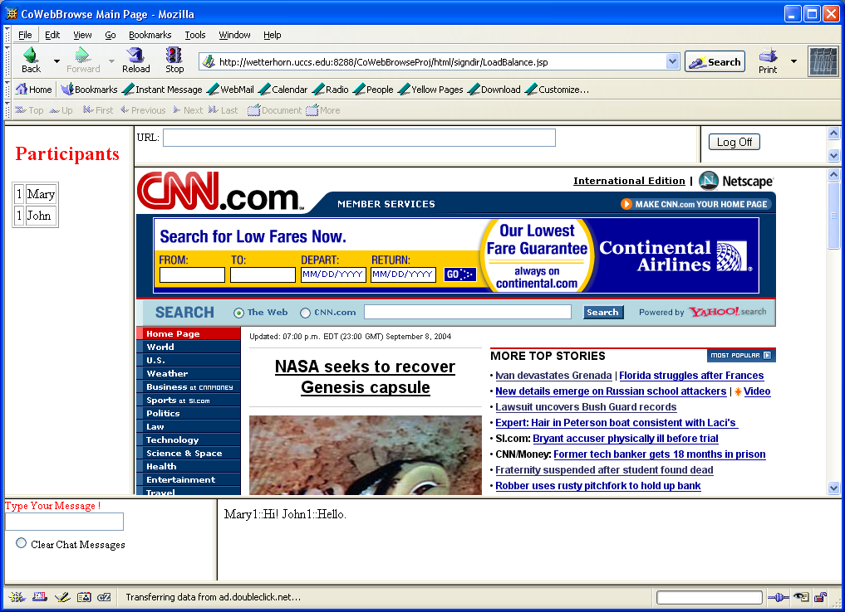
Figure 4: CoWebBROWSE Page

If the login is valid, the user is presented with the CoWebBROWSE screen, as shown in Figure 4. There is a frame where the user can type URL names, a frame that displays the co-browsed material, a text chat portion, and a frame identifying session participants. There is also a logoff button, and a button to clear the chat text. The clear button only affects the local browser. If the user wants to affect the co-browsing, he can either enter a new URL at the URL box, or click on a link inside the current co-browsed page. The co-browse frame of all participants is then updated. A user can send a text message, by typing a
52

message in the active portion of the chat box, and hitting “ENTER”. All participants will get to see the text in the inactive portion of the chat box. There is no private chat between two participants in the application, but it would not be difficult to add this support. A user can clear chat history by clicking on the clear button. The user has no control over the participant frame. It gets updated automatically as participants come and go in the session. The logoff button allows the user to indicate his intention to the system, so that the participant list can be updated.

53

Implementation

MySQL
Tomcat

JDBC
HTTP

HTTP
Tomcat
Tomcat
Tomcat

HTTP
Pushlets
HTTP
Postlets

HTTP

Netscape
Netscape
Netscape

Legend
Directory Server
Database
Client Servers
Session Server
Clients
Figure 5: CoWebBROWSE Technology Diagram

Figure 5 depicts the CoWebBROWSE technology architecture. The network technology is based on Tomcat servlets, and HTTP. HTTPS has not been implemented due to time constraints, but can be incorporated for added security. The client technology is mostly HTML and JavaScript running within a
54

Netscape or Mozilla browser. Some JSP and JSP tag libraries have been incorporated within the client software to help with the login and client redirect. The directory server communicates with a MySQL database through JDBC.
The clients communicate with the client servers through pushlets and postlets. Pushlets and postlets compose a framework that was written by a third-party, Just Van Den Broecke of Just Objects B.V. [60]. It is freeware available on the Net. Just van den Broecke states:

Pushlets enable any servlet-based server to push dynamic content into
DHTML-based browsers.

The pushlets framework is written in Java, and runs within a servlet container. The communication is through HTTP. A pushlet is a servlet that allows the server to push events to a browser as they occur. The browser initiates the connection, but the servlet keeps the connection open and ready to push information to the browser at any time. The connection does not timeout, as long as the client remains active.
A postlet is a second servlet within the framework that allows a browser to send events to the framework. A postlet connection is simply a HTTP GET request from the browser to the servlet. It only remains open for a brief time to exchange readily available information.
55

The pushlet and postlet servlets share common data within the framework. This makes it possible for a browser to post an event to a postlet servlet, and have the pushlet servlet send the event back to participating session browsers through pushlet connections. This implementation modifies the pushlets framework in order to do collaboration, and it runs on the client servers. This is described in more detail later in this chapter.

Interaction Diagrams

Figure 6 and Figure 7 show the messages exchanged between browser and servers. Figure 6 shows what happens when a client joins an existing session. Figure 7 shows what happens when a client sends a “Chat Event” to the pushlet framework on the client server. In these figures, the “session client servers” are all client servers serving the session, and the “session browsers” are all browsers active in the session.

56

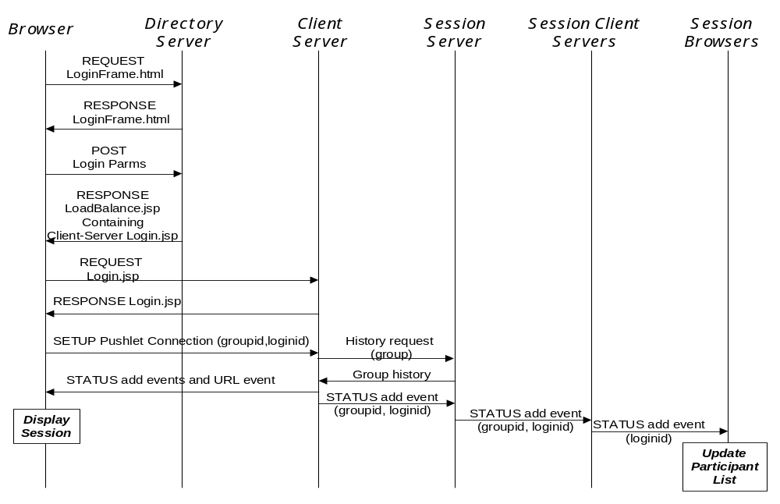
Figure 6: Login Process

57

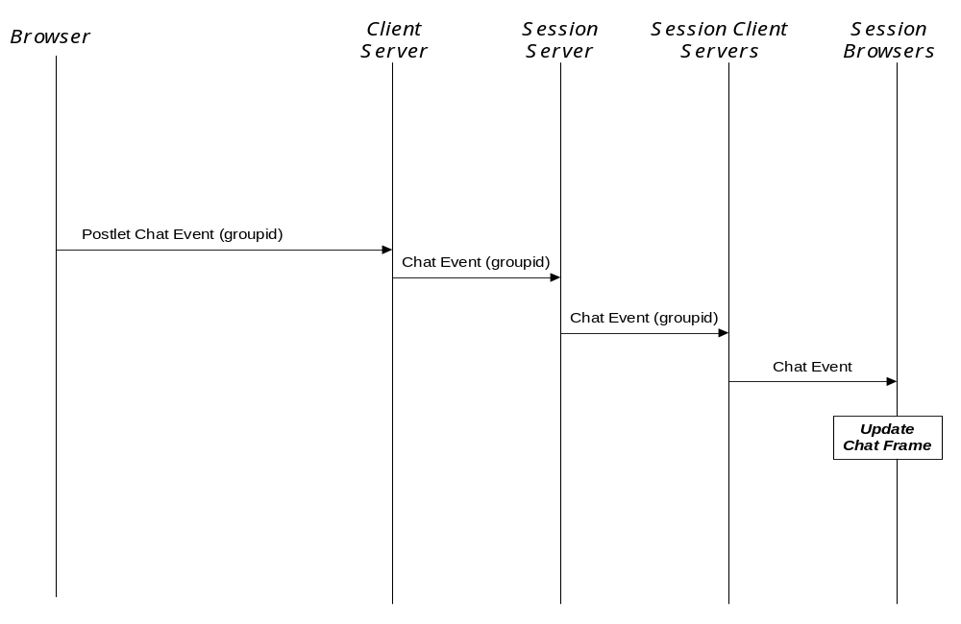
Figure 7: Chat Event

Client Implementation

Login Function

The login functionality is spread over four HTML pages, two of which are JSP. It also spans two servers, the directory server and the client server. The control flow is depicted in Figure 8.

58

On Directory Server
On Client Server
Calculates URL of client server, and adds client server page to frame
Passes login parms
LoadBalanceTag.java
Passes login parms for validation
CoWebBrowse.htm

Login.jsp
LoadBalance.jsp
CoWebBROWSE service page

LoginFrame.html
Start Here

Gets login parms from user
Figure 8: Login Control Flow

The flow starts at LoginFrame.html on the directory server. This is what gets accessed when the user types the CoWebBROWSE URL. It contains a form that prompts the user for a login id, group name, and group password. When the user clicks the “submit” button, control goes to LoadBalance.jsp, still on the directory server. The login parameters are passed to this JSP page through a HTTP POST request, since these are form inputs.

59
The HTML part of LoadBalance.jsp is a single frame that takes up 100% of the display. The frame’s URL is created dynamically by a new tag library called cowebbrowse:LoadBalance. LoadBalance.jsp retrieves the login parameters through inline JSP code, and passes them as attributes to the JSP tag. The tag library Java code verifies the login, and dynamically determines the URL of the client server, and the URL of the session server. If the login parameters are valid, the tag library code creates the new frame’s URL composed of the client server’s Login.jsp URL, login id, group name, group password, and session server URL. The directory server generates this response page dynamically. This response page is composed of a frameset, whose only frame’s URL is on the client server. Therefore, when the browser renders the response page, it automatically connects to the right client server. This is how the redirection is done. There is no need for HTTP redirect messages of any sort. Figure 9 shows the response page generated by the tag library code on the directory server. In this example, the client is being redirected to “sanluis.uccs.edu”. The client browser will display at the bottom of the page that it is currently transferring from “sanluis.uccs.edu”, but this is the only indication to the client that a redirect is actually taking place.

60
<!DOCTYPE html PUBLIC "-//w3c//DTD XHTML 1.0 Frameset//EN"
"http://www.w3.org/TR/xhtml1/DTD/xhtml1-frameset.dtd">
<html>
<?xml version = "1.0" encoding = "UTF-8" ?>
<head>
<title> CoWebBrowse Main Page</title>
</head>
<frameset rows =" 100%">

<frame src=http://sanluis.uccs.edu:8289/CoWebBrowseProj/html/signdir/Login.jsp?groupID='abc'&loginName='Pat1'&groupPassword='abc'&level2Url='crestone.uccs.edu:8289' name='LoginFrame1' />
</frameset>
</html>
Figure 9: Response Page from Directory Server

The Login.jsp page on the client server does not make use of any JSP tag libraries. It contains inline JSP code only. It creates a top frame for the CoWebBROWSE service that takes up 100% of the display. The source of the frame is cowebBrowse.htm on the client server. Login.jsp uses JSP to retrieve the input login parameters, and stores them at this root level using JavaScript.
Therefore, we now have a framework with Login.jsp as the root. It contains a single frame making up 100% of the display, called cowebBrowse.htm. This framework is now entirely on the client server, and will remain there for the rest of this user’s participation in the session.

61

CoWebBROWSE Pages

CoWebBrowse.htm

Participation
Status
Frame
URL Frame
Logoff
Frame

Frame

Cobrowse Frame

Chat Frame 1
Chat Frame 2

Figure 10: CoWebBROWSE Frames

Figure 10 depicts CoWebBROWSE frames. The main CoWebBROWSE page, cowebBrowse.htm, is composed of multiple frames arranged in rows and columns. There are eight frames in all, six of which are visible and two are hidden. The visible frames include one for participation status, one for typing URL, one for viewing co-browsed material, two for chat, and one for logoff. The two hidden frames work behind the scenes to communicate with the client server, one for pushlet and one for postlet.
62

Code Signing

CowebBrowse.htm, and all encompassing pages are signed with a digital certificate. JavaScript signing is done through Netscape signing tool, which is freely available over the Internet [61]. Netscape Communicator [62] and the signing tool must be downloaded on the client server, since this is the site that serves the signed pages.
A digital certificate is required for testing purposes. The signtool has a “–G” option that generates this certificate. The command is:

% signtool –G PatCert

where PatCert is the name of the certificate. This command creates both a certificate and public-private key pairs, which are used for signing. They all get installed in the Communicator key and certificate databases. The certificate is also output to a file named X509.cacert. In order to create this certificate, the signing tool prompts for relevant information such as organization name and address. The resulting certificate from this process is not a valid one signed by a CA (Certificate Authority). However, it can be used for testing. In order to use it, it must be downloaded and installed on every client browser intending to use the service. In Netscape and Mozilla, this is done through the Edit/Preferences menu option. This installation is not necessary if the certificate is trusted.
63

Once the certificate is obtained and installed within communicator, the JavaScript code can be signed. A new directory on the client server (signdir) must be created. In there, all .html pages that require signing are placed. This command signs the directory and all of its contents:

% signtool –k PatCert –Z testjar.jar signdir

Testjar.jar is the resulting archive containing signed code and metadata. This step completes the signing process. The same certificate and keys are used for all client servers. Please see [63] for more information on how to do all of this.
Once the code has been signed and a test certificate has been installed on the browser, the signed code can be accessed from the browser. This application uses the URL:

% jar:http://sanluis.uccs.edu:8289/CoWebBrowseProj/html/testjar.jar!/
CoWebBrowse.htm [65].

The first time that the code is accessed, the user will get a dialog box warning of the security risk and the expanded privileges requested. The user has the option of viewing the certificate, granting the request, or denying the request. If the user grants the request, the browser renders the code. The user also has the choice of having the browser remember this option, so that he is not prompted the next
64

time that the browser accesses and renders the same code signed with the same certificate.

Expanding Browser Privileges

Browser privileges are expanded twice, both times in the CoWebBrowse.htm page. The first time is when CoWebBrowse.htm obtains the login parameters from Login.jsp. Here, we have a situation where a signed page must communicate with a page that has not been signed. Once a piece of code has been signed, it can only interact with other signed code. Therefore, the browser needs the “UniversalBrowserRead” privilege in order to obtain this information for the unsigned page [65]. The second time, and the main reason for the signed code, is when CoWebBrowse.htm needs to obtain the URL of the co-browsed material. If the user clicks on a URL link within a co-browsed page, the local browser fetches the new page. However, the application needs to know the URL of this new page in order to inform the client server. CoWebBrowse.htm asks the co-browse frame for its location, but security restrictions prevent one frame from learning about another frame’s URL unless both sources come from the same domain. CoWebBrowse.htm is in the cs.uccs.edu domain. The co-browse frame can be displaying cnn.com. Therefore, The browser must have “UniversalBrowserRead” permission in order to achieve this functionality. Figure 11 shows the CoWebBROWSE cross-domain interaction that requires the expanded privileges.
65
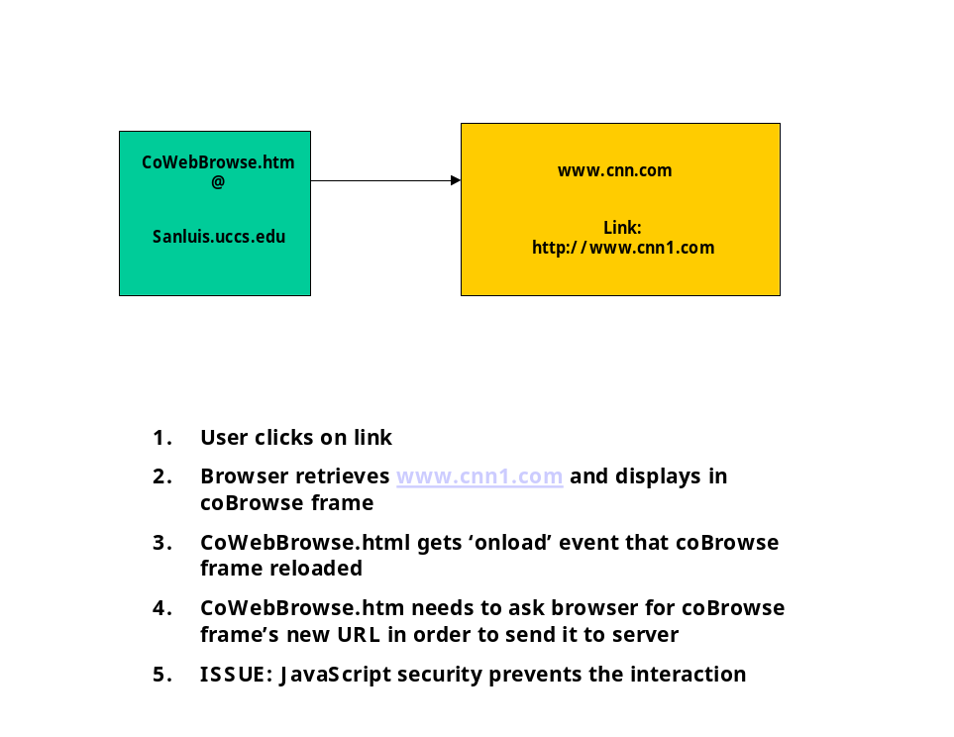
Figure 11: Cross-Domain Javascript Security

Pushlet Hidden Frame

The pushlet hidden frame is a frameset with one frame whose source is the pushlet servlet on the client server. This URL query contains the login id, group name, group password, and session server URL as parameters. The parameters are obtained from the parent frame, coWebBrowse.htm. This pushlet hidden frame established the pushlet connection with the client server, and the connection remains open to accept data from the server. This page also contains a JavaScript function, called push(). When the client server sends back
66
an event to this frame over the pushlet connection, it sends back JavaScript code calling function push(), and the event as a parameter to the function. This frame can then parse the event and figure out if it should be passed to the cobrowse frame for fetching, the participation frame for status update, or chat frame 2 from chat message display.

Postlet Hidden Frame

The postlet hidden frame is used to post events to the client server. When a frame wants to post an event, it sets the URL of this hidden frame to the postlet servlet, and passes it the event as a parameter in the query string. Session information such as group name, and login id are also sent as query parameters in order to identify the session to the client server. Session information and the postlet frame can be obtained by any child frame through the common parent, coWebBrowse.htm.

URL and cobrowse Frames

When a URL is typed at the URL frame, the URL frame sets the cobrowse frame’s location to the new link. When a link is clicked within a cobrowse page, the cobrowse frame’s URL gets set to the new link automatically by the browser. Also, when the hidden frame receives a URL request from the client server, it
67
updates the cobrowse frame’s URL. In all three cases, the browser feteches the new page and displays it in the cobrowse frame. At this point, coWebBrowse.htm gets an “onload” event from the browser for this frame. This is an event for coWebBrowseMain.htm that a new page has been loaded into the cobrowse frame, and that it must request its URL and send it to the client server through the postlet frame. However, the hidden frame lets coWebBrowse.htm know when the request comes from it, so that coWebBrowse.htm will not send the same event to the client server again.

Participation Status Frame

The participation frame is really an empty body. The hidden frame writes to it when it receives updated participation status from the client server, including the local participant information. When this frame loads for the first time, coWebBrowse.htm gets notified of it through an “onload” event. This is the cue for coWebBrowse.htm to fetch this participant’s session and login parameters from Login.jsp, as described earlier in this chapter.

68

Chat Frames 1 and 2

Chat frame 1 contains the input box for chat messages, and the clear button. Chat frame 2 is an empty body. When a user types a message in the input box and clicks enter, the browser generates an “onclick” message for the input box. Chat frame 1 catches this event and sends it to the client server through the postlet frame. When the hidden frame receives a “chat event” from the client server, it writes the message to chat frame 2. When the clear button is clicked, a JavaScript function within chat frame 1 is called to clear chat frame 2. This event does not get sent to the client server, since it only affects the local participant.

Logoff Frame

The logoff frame contains a button that, when clicked, generates an “onclick” event that allows a local JavaScript fuction to send a logoff event to the client server through the postlet frame. When the hidden frame receives a logoff event from the client server, it alerts the user that he has been logged off by the server. An alert box gets generated for this purpose, and the participant is no longer active in the session.

69

Directory Server Implementation

The directory server implementation consists of two parts: a JSP tag library class and a servlet class. The JSP tag library class is for the login verification, and the client server redirect. The servlet allows the client servers to deliver load status information to the directory. These two classes access a common database located externally to the directory server. The communication is through JDBC.
The database contains two tables, a server and a groups table. The groups table keeps track of active sessions. It stores the group username, group password, and session server URL. The server table stores client server and session server information. For client servers, the database keeps the URL, load information, and timestamp of last use. For session servers, it stores the URL and timestamp of last use. The round robin algorithm was not implemented at the session server level - the test bed for this application only contains one session server. The least load round robin algorithm was implemented, however, at the client server level, since three client servers are used in the test bed.
The tag library class obtains the login parameters from the login form, and checks the groups table for the group name and password. It the group name is in the database and the password matches, the login succeeds. Likewise, if the
70
group name is not in the groups table, the login succeeds. In this case, a new entry is created in the database. However, if the name is there but the password does not match, the login fails.
If the login is not successful, processing stops and an error page is returned to the browser. If the login is successful, the tag library class uses the least load round robin algorithm to determine a client server for the client. The algorithm is as follows:

- Check the DB for client servers with “LOW” load
- If there are some in step 1, pick the one with the least recent timestamp
- If there are none in step 1, repeat step 1 and 2 for “MEDIUM” load
- If there are none in step 3, repeat step 1 and 2 for “HIGH” load

The client server URL, group name, password, and session server URL are written out to the browser as a URL, so that the browser can continue the login with the client server.
The second part of the directory server software is the servlet class. The client servers access this class to update the directory server with load status information. The servlet updates the server table with the new load information whenever it gets accessed from a client server.
71

Client Server Implementation

The client server implementation is based on Just van den Broecke’s pushlet framework [60]. The basic framework is shown in the class diagram of Figure 12. The adaptation of it for CoWebBROWSE is shown in Figure 13. These class diagrams do not show all the details of the implementation, but only highlight the major functionality. They only show the classes and relationship that are important for describing the framework.

72

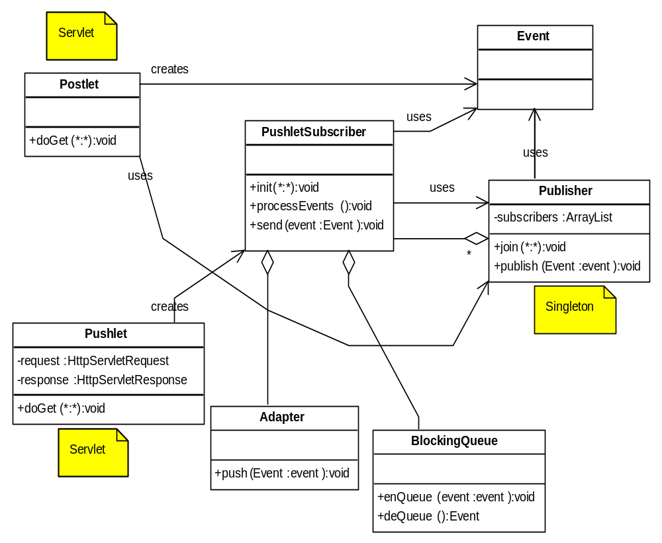Figure 12: Basic Pushlet Framework

Figure 12 highlights the major functionality of the original pushlet framework. The Publisher class is a singleton that gets created statically upon loading of the application by the client server. There is one instance of this class that multiple threads have access to. Tomcat creates a new thread every time that a postlet or pushlet servlet gets invoked from a browser. Only one instance of the application runs within the Tomcat container, but the connection thread invokes the goGet() methods of either Postlet or Pushlet, depending on the
73

invocation. Therefore, there is one instance of the Publisher class that both the Pushlet and Postlet servlets access. This is how the two servlets share data. This is also how servlet data is maintained across browser invocations. The Publisher class maintains a list of active subscribers and their associated connection data (ie: HttpServletRequest and HttpServletResponse). It has a join() method used by a PushletSubscriber to be added to this list. It also has a publish() method used by the Postlet class to have Publisher send the event to all subscribers in its list.
Pushlet creates a PushletSubscriber when it gets a connection from Tomcat. It calls PushletSubscriber’s init() method, passing it the request and response. The PushletSubscriber object creates itself a BlockingQueue and an Adapter, and then calls the Publisher’s join() method in order to add itself to Publisher’s internal data. This gives the PushletSubscriber object permanent life, since it is now held by a static instance of Publisher. The last thing that Pushlet does is to call the processEvent() method of PushletSubscriber. This method contains an infinite loop that waits on the BlockingQueue for an Event, sends the Event back to its client, and waits again for a new Event. The deQueue() method of BlockingQueue blocks the thread when there is no event to retrieve. This means that the Pushlet class never returns the connection to Tomcat, and thus Tomcat cannot close the connection. It remains open.

74

In the framework of Figure 6, Postlet creates an Event when it gets a request from a browser. Tomcat creates a thread whenever a client accesses Postlet, and invokes the Postlet servlet within this thread. Postlet passes the Event to Pubisher’s publish() method, and publish() calls every PushletSubscriber’s push() method in order to publish it. The push() method simply adds the Event to its BlockingQueue.
As soon as a PushletSubscriber gets an Event in its queue, the Pushlet thread wakes up and processes it. ProcessEvents() method gets the Event from the BlockingQueue, and gives it to the Adapter’s push() method. The push() method writes the event out to the HttpServletResponse, thus sending it back to the browser. However, it does not send back the Event in its raw form. It formats a call to the client software’s JavaScript push() function, and adds the Event information as function parameters.

75

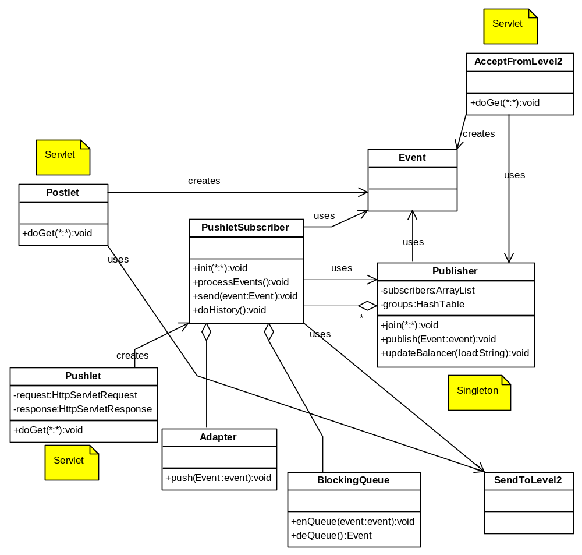
Figure 13: Modified Pushlet Framework

The modified version of the Pushlet framework that supports the client server implementation of CoWebBROWSE is shown in Figure 13. Not all of the modifications to the framework are discussed, but only those that are relevant to the understanding of it.

76

The implementation introduces two new important classes, SendToLevel2 and AcceptFromLevel2. They communicate with the session server. Now, instead of Postlet sending events straight to Publisher, it uses SendToLevel2 in order to send them to the session server. Events go first to the session server. When they come back from the session server, they get distributed through Publisher in the same way as before. AcceptFromLevel2 is a servlet that accepts events from the session server.
The PushletSubscriber also uses SendToLevel2. A PushletSubscriber is created for a new subscriber joining a session. Therefore, PushletSubscriber must create a “status add” Event in order to add this participant to the session and to browser participation windows. This event gets first sent to the session server, and then gets distributed to all clients in the session. Also, when a user logs off or goes away, he must be removed from the session and from browser participation frames. PushletSubscriber takes care of creating a “status remove” Event and sending it to the session server for distribution.
PushletSubscriber has a new method, called doHistory(). When a new PushletSubscriber is created and joins Publisher, it calls doHistory() in order to obtain session history (current URL and participant list). This method creates “status add” Events and a “url” Event, and sends them back to its browser by calling the Adapter’s push() method directly. The history information comes from the session server in XML form. This method uses the SAX parser to parse the XML and retrieve the information.
77

The Publisher is modified to handle groups of subscribers instead of just subscribers. Subscribers are now handled on a per group (session) basis. It also stores information relevant to groups, such as session server URLs.
Publisher handles the load tracking and load status reporting back to the directory server. It updates its internal version of its workload every time a new PushletSubscriber is added or removed from its list. When the load crosses a threshold, Publisher opens a HTTP connection to the directory server’s servlet, and gives it the new load information.

Session Server Implementation

The session server is composed of two servlets: Level2Post and History. Level2Post is used for one-to-many client server event propagation. History is used to format and send session history to the requesting server.
Level2Post receives event information from client servers. The information includes the group name, URL of requesting server, and the actual event to be propagated. This servlet maintains a static hash table with data pertaining to each group. It stores the groups’ user participant lists, URLs of client servers, and co-browsed URL page. This information comes from the events themselves. The servlet parses the events in order to determine if new users are being added
78

or removed, client servers are being added are removed, or if the group is browsing a new page. Once the servlet has retrieved all relevant information from an event, it sends it to all participating client servers in the group by invoking every client server’s acceptFromLevel2 servlet.
The History servlet receives requests for session history information from client servers, and responds with the information. This information is sent only to the requesting server, and is sent in XML format. When a client server requests history information, this servlet retrieves it from the group’s static hashtable, formats it into XML, and sends it back to the client server in the HTTP response.

How The Solution Fulfills The Requirements

The prototype provided by this thesis meets the requirements specified in this chapter.

Web browsing collaboration features: Participants within a session can browse Web pages together by either typing a URL or accessing a link within a Web page. The pages can exist anywhere within the Internet. Participants may join a session late or leave early. If a participant joins a session late, he gets updated with the latest session information.

79

Communication among participants: There is a chat text area of the service page where participants can type messages to each other, and an area where participants can view the messages. The chat is a real-time function.

Display of participants: There is a participant status area where all active session participant names are displayed. This area is updated in real-time as participants come and go.

Scalability: The architecture includes load balancing at levels 1 and 2. It can include as many client servers and session servers as needed to handle the load. The level 1 load balancing has been implemented, but level 2 load balancing was not implemented due to lack of time. However, it is an integral part of the design.

Ubiquitous access: Any PC with an Internet connection and Netscape or Mozilla can be used to access the service. No pre-configurations or extra installations are required. This service can be used across a firewall, without any changes required to the network.

80

Secure: The application requires no extra downloads, installations or cookies. It uses Id and Password for authentication. HTTPS has not been implemented due to lack of time, but is included in the design.

Platform independence: Netscape works on Windows, Unix and Mac OS. The server side is all Java.

Open source technology:
The technology is Java, Tomcat, Pushlets, Netscape, JavaScript, HTML, MySQL, and signtool, all available freely and openly.

Innovations And Challenges

CoWebBROWSE Load Balancing

CoWebBROWSE uses a load balancing solution similar to HTTP redirection, but the solution is integrated into the application. The dispatcher, or in this case the directory server, plays a role in setting up and maintaining a session. It also performs authentication. Since the load balancing is tightly coupled with the application, client servers report relevant load information to the directory server that is specific to the number of pushlet connections the client server has open at
81

any given time. This specificity would be difficult to achieve with a generic solution. As well, CoWebBROWSE load balancing provides load balancing among level 1 client servers and among level 2 session servers. The load-balancing algorithm is different for each of the two levels because the load balancing needs differ. At layer 1, the persistent connections are the main load-balancing factor, whereas for level 2, simple round-robin is enough. This type of two-tier load balancing would be difficult to come by in a generic solution.
CoWebBROWSE load balancing does not currently provide fail-over, but request level fail-over can easily be added to the design. There is already a feedback loop between client servers and the directory server. It would not be difficult to have them maintain heartbeat. This would not help in the case where a client is already connected to a client server, but it would keep new clients joining a session from being redirected to a failed node. A feedback loop can also be added between the session servers and the directory server. This feedback loop can be used to maintain heartbeat.
The directory server can become a single point of failure in the CoWebBROWSE architecture. This is a difficult issue to solve, however, since the other solutions examined by this thesis also suffer this same predicament. Tomcat clustering can be used at the directory server to help alleviate this issue.

82

CoWebBROWSE Security

CoWebBROWSE uses only JavaScript and only port 80 or 443. It does not even use cookies, which are disliked by some because they can be exploited to expose personal data such as social security numbers or credit card information. It uses Netscape’s signed JavaScript technology to extend browser privileges in a safe manner, and only with the user’s permission. Therefore, this application would be allowed inside the most security stringent institution.

CoWebBROWSE Network Architecture

The CoWebBROWSE network architecture is based on a hierarchical, client server model. It’s a model where clients initiate connections to servers, and servers communicate with peer servers using servers one hierarchical level up to pass information around. There is also a common directory server for users to contact when joining a session. There are multiple root (session) servers in the network, but a session has a single root that is at level two of the hierarchy. Figure 3 depicts the CoWEBBROWSE architecture.

83

This CoWebBROWSE architectural model has its advantages. It is more scalable than the traditional single-server centralized model, since there are multiple servers to serve clients. It can be expanded by adding additional servers at each level, and, if necessary, by adding additional hierarchical levels. An example of a hierarchical network is DNS, which is highly scalable [86]. Since all communication must ultimately pass through a common server, there is a central repository for storage of history information. There is also a known address for clients to connect to the service. Security is manageable. In order to secure the system, all server nodes must be secured. Concurrency is also manageable, since events can be ordered at the common server, and sent to all lower level servers and clients in an ordered fashion.
The CoWebBROWSE hierarchical network is highly robust, since there is redundancy in the system. Unlike the straight hierarchical model, the hierarchical root in the CoWebBROWSE architecture is not a vulnerable point. It has multiple roots (multiple session servers). With load balancing and heartbeat, the directory server can divert connections away from faulty nodes, thus making the architecture highly robust. However, sessions and clients already connected will be affected if a relevant node goes down during service.
The disadvantage of this architecture is the single point of failure in the directory server. If the directory server goes down, so does the service. There are ways to reinforce the directory server so that it does not become a single point of failure. One way is to use the features built into tomcat to setup a cluster
84

that can handle fail-over if a node goes down. This will add some reinforcement, but since clients must inevitably connect to one URL, there is no way to guarantee that this will work 100% of the time. The common module that accepts external connections may always fail. However, this is less likely to happen. Another way to handle this situation is to provide clients with more than one known URL for the service. If one fails, the client can try the other one. This method requires that two directory servers be setup independently of each other. This solution is not transparent to the user, however.

Technical Challenges

Two technical issues proved to be particularly challenging during the course of the thesis. The first one is the usage of signed JavaScript. Signed JavaScript is a Netscape technology compatible with Mozilla and Netscape browsers. However, its penetration has been low so far, which makes it difficult to find written examples of its usage or insight into overcoming obstacles. For example, the signed script that works well for Mozilla 1.5 does not work for Mozilla 1.7. I discovered this when the University upgraded Mozilla on its computers to the newer version. The only documentation that I was able to find about this problem is someone else having the same issue, but no answers as to why this is the case. This is an issue for further investigation.

85

The second challenging issue is with regards to Tomcat version 5.0.18. I’ve discovered during testing that Tomcat limits the number of simultaneous connections to ten. This limit is not impacted by the connector settings in “server.xml”. I have not been able to find any documentation about this issue. This also remains an issue for further investigation.

CHAPTER IV

PERFORMANCE EVALUATION

A test bed was setup to evaluate the system performance of CoWebBROWSE. Tests were executed to evaluate the performance of the system with one, two, and three client servers under light conditions and stress conditions. This chapter discusses the test bed, and test results. Also, CoWebBROWSE was tested with a variety of Web pages of varying complexity. These pages included multiple frames, SSL, cookies, dynamic content, as well as integrated Word, Adobe, and PowerPoint documents. The results of these trials are discussed here as well.

System Performance

The test bed is depicted in Figure 14. The servers all run Tomcat version 5.0.18 on Linux Red Hat release 9. They are all on the UCCS network. Table 3 shows the server configurations used in the performance testing.

87

 | Wetterhorn | Blanca | Sanluis | Shavano | Crestone
CPU | PentiumIII  598MHz | Dual PentiumIII  933.4MHz | Dual PentiumIII  1.5GHz | Dual PentiumIII  1.5GHz | PentiumIII  1.5GHz
Memory | 1GB | 1.5GB | 1.5GB | 1.5GB | 1GB
Network | 100Mbps | 100Mbps | 100Mbps | 100Mbps | 100Mbps
OS | Redhat 9 Linux Kernel  2.4.20-31.9smp | Redhat 9 Linux Kernel  2.4.20-31.9smp | Redhat 9 Linux Kernel  2.4.20-31.9smp | Redhat 9 Linux Kernel  2.4.20-31.9smp | Redhat 9 Linux Kernel  2.4.20-31.9smp
Server | Tomcat5.0.18 | Tomcat5.0.18 | Tomcat5.0.18 | Tomcat5.0.18 | Tomcat5.0.18
Browser | Mozilla 1.5 | Mozilla 1.5 | Mozilla 1.5 | Mozilla 1.5 | Mozilla 1.5
Table 3: Server Configurations

The clients are Mozilla version 1.5 running on Windows XP. The clients are external to the UCCS network, and all run from the same PC.

Legend:
Directory Server
Sanluis (MySQL)

Crestone
Database
Client Servers
Session Server
Clients

Mozilla version 1.5 for Windows
HTTP
Sanluis
Blanca
Wetterhorn
HTTP
HTTP
JDBC
HTTP
Pushlets
HTTP
Postlets
Shavano

Figure 14 CoWebBROWSE System Test Bed

88

Tests were performed using one, two and three client servers. Chat request messages were monitored and timed from the point when they entered a client server to the point when they were pushed to a client. The time that a chat message entered a client server Postlet was recorded, and compared to the time it left a client server Pushlet on its way to a client. The time difference is the time that a chat message went from a client server to a session server back to a client server and on its way to a client. It does not include the time from a client to the client server, or from a client server to the client. The same tests were performed five or six times, and averaged out over the trials. Only the averages are presented in the results.
Timing measurements were taken for
- one client on one client server
- two clients on two client servers
- three clients on three client servers
- seven clients on one, two and three client servers
- fourteen clients on two client servers
- twenty-one clients on three client servers.

The testing revealed that one client server can handle a maximum of seven Pushlet connections to clients with the test configuration of Figure 14. Tomcat version 5.0.18 will not have more than ten connections open at a given time, regardless of the configuration settings in the Tomcat “server.xml” file. The reason for this limitation requires further investigation. So in fact, Tomcat does not currently support Pushlet connections very well. Since only a maximum of ten connections are allowed open at a time, and extra connections must be kept
89

available for Postlet and communication with the session server and load balancer, this leaves seven CoWebBROWSE clients per session server at any given time.
Testing also revealed that the load-balancing algorithm worked perfectly. The loads were kept evenly distributed across all available client servers, and it was all done in a fashion that was transparent to the user.
Figure 11 compares the performance of the average wait times for one to twenty-one clients on one, two and three client servers. As we can see, seven clients on one client server does not exhaust the performance of the CPU, since it does not take any more time to serve seven clients as it does one client on a single server. However the bottleneck is the number of client servers. The more client servers participating in a session, the longer the average wait time for a client to receive the chat update. However, once the client servers are in play, it doesn’t matter if they are serving one client each or seven clients each because the average wait time is the same.

90

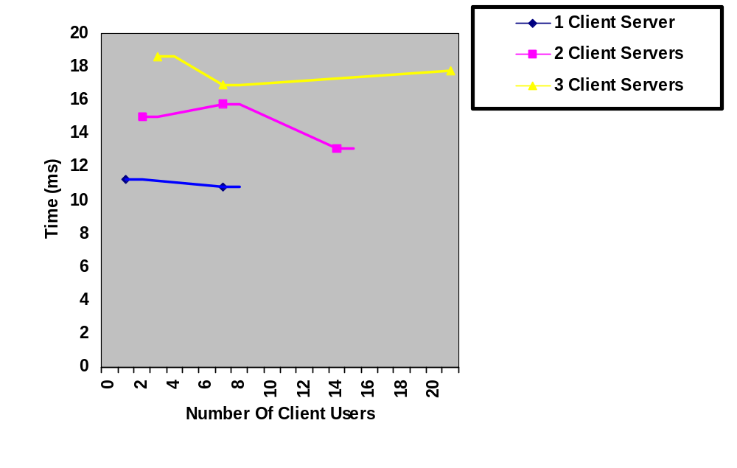 Figure 15: Number Of Users Vs. Client Servers

Figure 16 shows the minimum, average, and maximum wait times for clients to receive the chat message when there is only one client server. The minimum wait time is the wait time for the client that receives the message first, and the maximum wait time is the time for the client that receives it last. The average wait time is the average time that all clients wait to receive the message. This is the sum of all wait times divided by the number of clients. As we can see from Figure 16, the minimum, average, and maximum wait times for seven clients is very close to the wait time of one client. Figure 17 and Figure 18 show us the minimum, average, and maximum wait times for clients to receive the chat

91

message when there are two client servers and three client servers respectively. As we can see, the difference between minimum and maximum wait times increases with the number of client servers. However, these differences don’t vary much with the number of clients each client server has active. Figure 19 demonstrates this point more clearly, since it shows the results of seven clients being served by one, two and three client servers on the same histogram.

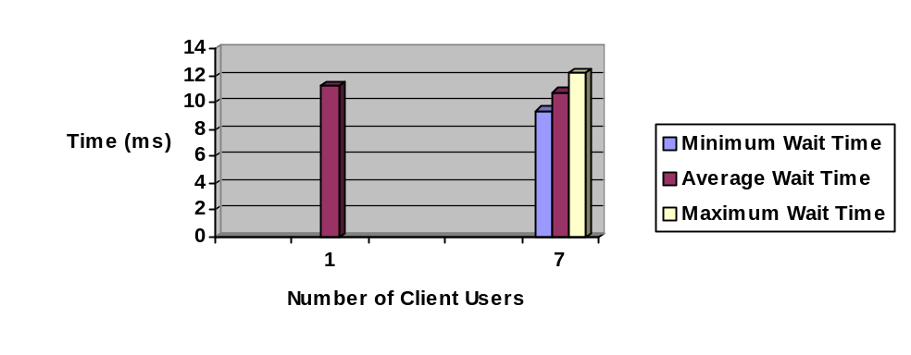
Figure 16: User Wait Times For One Client Server

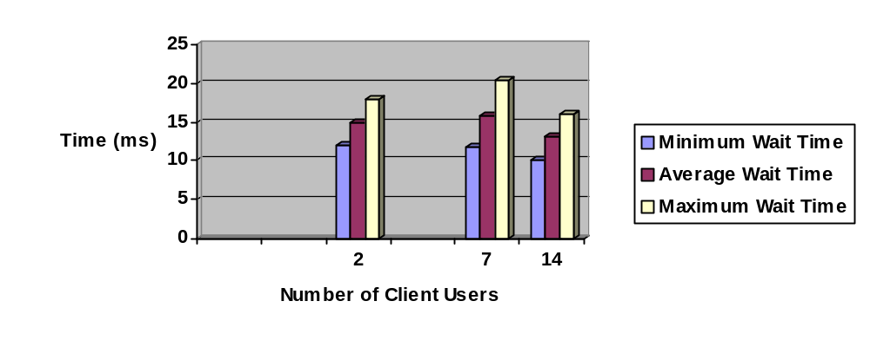
Figure 17: User Wait Times For Two Client Servers
92

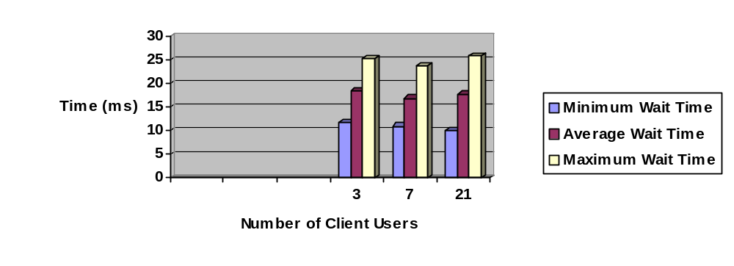
Figure 18: User Wait Times For Three Client Servers

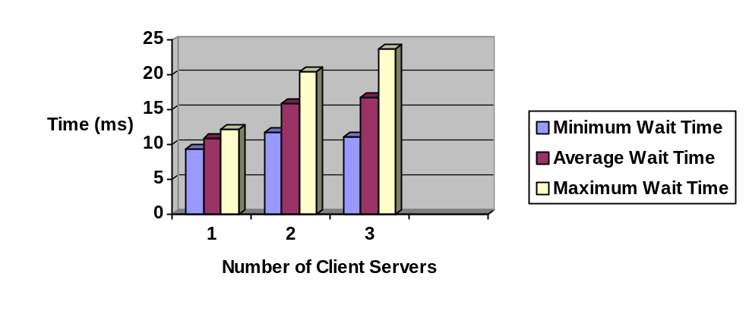
Figure 19: User Wait Times Vs. Number Of Client Servers (7 Clients)

One of the reasons for the bottleneck with multiple client servers is the algorithm used at the session server. The client server Pushlet connections are multi-threaded. A separate thread handles every client connection. Therefore, when a client server receives an event to push to its clients, there is a separate threat to handle the server-push for each client. This is not the case for the session server. When a session server receives an event to send to all client
93
servers in a session, the events are sent to each client server in a serial fashion. It may be worth re-architecting this portion of the software to make it multi-threaded. This would likely reduce the discrepancy in wait time between the first and last client to receive an event in the case where multiple client servers are in a session. Another reason for the bottleneck at the session server is that it takes time to establish a TCP connection with each client server in order to propagate an event. At the client server side, however, the Pushlet connections are already established. A client server only has to write out the event to every client HTTP response. Therefore, it can send an event to several clients very quickly, but a session server has to open a connection with each client server in order to send the event to it. This bottleneck is more difficult to overcome, since it is very expensive in resources to maintain a connection open over a long period of time. It is difficult to justify the cost of resources in order to save a few milliseconds in response time for a Web application of this type. Table 4 demonstrates the effect of the session server more clearly, since it breaks down the timing of each step as an event is propagated from a client-server to a session-server and back down to three client-servers.

94

Time For CS To Send Event To SS  (ms) | 1.3
Time For SS To Receive From CS  (ms) | 2.3
Time For SS To Send To CS1  (ms) | 2.3
Time For SS To Send To CS2  (ms) | 7.3
Time For SS To Send To CS3  (ms) | 14.7
Time For CS1 To Accept From SS (ms) | 0.3
Time For CS2 To Accept From SS (ms) | 2.0
Time For CS3 To Accept From SS (ms) | 4.3
Total Time For CS1 To Receive An Event From Initiating CS (ms) | 6.3
Total Time For CS2 To Receive An Event From Initiating CS (ms) | 13
Total Time For CS3 To Receive An Event From Initiating CS (ms) | 22.7
Table 4: Effects Of Session Server On Performance

Table 5 depicts another bottleneck in the system. This bottleneck is the login authentication, session creation, and session joining process. The table breaks down the process step by step and provides the timing at each step. The longest part of this process is the time between when the client sends login parameters to the load balancer and the time it makes first contact with the client-
95
server. This includes the time it takes for the load balancer to authenticate a client, establish a new group, redirect this client to a client-server, and for the client to make first contact with the client-server. This is the time indicated in the first row of the table.

Time For Client To Connect From Load Balancer To CS (ms) | 1159.7
Time For CS To Send To SS  (ms) | 2.7
Time For SS To Receive Event From CS  (ms) | 1.0
Time For SS To Send Event To CS  (ms) | 4.0
Time For CS To Receive Event From SS  (ms) | 6.7
Time For CS To Send Login_Complete To Client  (ms) | 35
Total Time To Join New Group  (ms) | 1202.7
Table 5: Time To Establish A New Group, Login, And Join

96

Compatibility Tests

Tests were performed to determine how compatible the co-browsing functionality is with more complex Web pages. The co-browse functionality was tested with different types of Web pages, and Table 6 shows whether or not CoWebBROWSE can co-browse these pages. The reasons for the incompatibilities and their solutions require further investigation.

 | Co-Browse
PowerPoint document integrated in Web Page | NO
Word document integrated in Web Page | YES
Adobe Acrobat document integrated in Web Page | NO
Web Page with multiple frames | YES
Web Page containing script that opens a new browser window | NO
Web Page that contains dynamic content based on time or usage | Limited usage*
Web Page that determines content based on cookies | Limited Usage*
Web page accessed over SSL | YES
* Co-Browse works, but parts of page content may be different for each client
Table 6 CoWebBROWSE Compatibility Test Results

CHAPTER V

LESSONS LEARNED

I’ve learned a lot about how to build collaborative Web application from this thesis. The main lesson that sticks out for me is how difficult it is to build an application that users can trust. There have been so many malicious attempts to infiltrate and damage private networks or individual users connected to the Internet that users have become very skeptical of software made available over the Internet. The best way to overcome this skepticism is to build software that use secure and trusted technology. That also means that the technology has to be limited in what it can do on the user’s network. Security, trust and flexibility are a difficult combination. One can only achieve so much with JavaScript and DHTML alone. If we want to add voice or video capabilities to a Web application, we need more powerful technology.
The best is to start with secure, trusted technology and do as much as possible with it. When something more powerful is needed, choose from the least intrusive technologies available. For example, in order to get voice and video to penetrate a firewall, one may want to consider tunneling H.323 or SIP over HTTP instead of just using these technologies directly. This way, no firewall configuration changes are required. The client-side code requires more than just DHTML, but a signed applet may be a better choice than a plug-in or an application. The safer the technology, the more people will use it.
98

Signed JavaScript is a safe way to open the client browser to more privileges, but it can be a difficult technology to setup and maintain. Internet Explorer does not support it, and does not have an equivalent technology. The closest thing that IE supports is signed applets and signed Active-X. These technologies aren’t as safe as signed JavaScript. Also, I’ve discovered complications with signed JavaScript and Mozilla 1.7. There could be a bug in the browser itself, or a new version of Netscape Communicator may be required to sign the code. I haven’t found any documentation on this issue. It requires further investigation.
Pushlet connections are a safe way to have the server push information to a browser because the server does not have to initiate a connection through a user’s firewall. However, persistent connections such as Pushlets strain server connection resources. I have not been able to allow Tomcat 5.0.18 to accept more than ten simultaneous connections. I wasn’t able to find any documentation on this either. It remains an issue for further investigation.

CHAPTER VI

FUTURE ENHANCEMENTS

There are two areas of improvements possible to this project. One has to do with investigating the technology limitations discovered during the course of this thesis, and the other has to do with expanding functionality.
Limitations were discovered with Netscape’s signed JavaScript and with Tomcat’s handling of Pushlet connections. More investigation is required to determine how to overcome these limitations, including the restrictions with using the signed JavaScript on Internet Explorer. Netscape has made a new version of Signtool available very recently. Maybe this new version woks with the new Mozilla browser.
The other area of possible enhancements includes adding voice and video capabilities, adding SSL, adding a group pointer, making the co-browse work with pages that integrate applications such as Adobe Acrobat and PowerPoint, and making the co-browse work with dynamic Web pages that use cookies and frequently changing content. Also, the load-balancing can be improved to add fail-over and session tear-down at the directory server. As well, some work can be done to figure out what it would take to have this solution work on a PDA or other wireless device.

CHAPTER VII

CONCLUSION

This thesis set out to study how to build a collaborative Web application that surmounts some of the key limitations of existing applications. This means an application that adheres to stringent corporate and institutional security policies and firewall restrictions, scales well, provides ubiquitous access, and does not over-burden the user with heavy installations.
It includes a study of existing applications and their limitations, both in the research and commercial worlds. It researches the architectures and technologies than can be used for Internet collaboration, and puts together a prototype for collaborative Web browsing and chat. It provides performance evaluations and outlines some of the difficulties and limitations encountered during the process. It concludes by suggesting areas of further research and enhancements for the prototype. I believe that this thesis was successful in what it set out to accomplish. The research, thesis document and prototype can be a basis for future work in the area of secure Internet collaboration.

101

REFERENCES

[1] Elizabeth Daly, Distributed Slide Show Tool, Master Thesis, University of Dublin, 2002.

[2] Mark S. Ackerman, The Intellectual Challenge of CSCW: The Gap Between Social Requirements and Technical Feasibility, University of California, Irvine.

[3] Robert E. Kahn, Chapter 11: Evolution of the Internet, Communication, Information and Informatics Sector, World Communication and Information Report, 1999-2000.

[4] Jorg Roth, CSCW Internet Tools and Environments for Distance Education, University of Hagen, Germany.

[5] John M. Carroll, The Evolution of Human-Computer Interaction, Addison Wesley, 2001.

[6] Richard Bentley and Wolfgang Appelt, Designing a System for Cooperative Work on the World-Wide Web: Experiences with the BSCW System, CSCW Group, Institute for Applied Information Technology, German National Research Centre for Information Technology.

[7] Du Li, Zhenghao Wang, and Richard R. Muntz, “Got COCA?” A New Perspective in Building Electronic Meeting Systems, Department of Computer Science, University of California, Los Angeles, citeseer.ist.psu.edu/497830.html

[8] Gabriel Sidler, Dr, Andrew Scott, Physiker Heiner Wolf, Collaborative Browsing in the World Wide Web, Proceedings of the 8th Joint European Networking Conference, Edinburgh, May12-15, 1997.

[9] Merlin Wesley Vincent, ESI Extensions for Web-based Collaboration, Master of Science Thesis for the Department of Computer Science, University of Colorado at Colorado Springs, 2004.

[10] Mark Roseman and Saul Greenberg, TeamRooms: Network Places for Collaboration, University of Calgary, Canada.

102

[11] Dieter Schmalstieg and Gerd Hesina, Distributed Applications for Collaborative Three-Dimensional Workspaces, Vienna University of Technology, Austria.

[12] David Berlind, A Firewall for IM: Just What We Needed?, Tech Update, August 12, 2003.

[13] Kundan Singh et al., Comprehensive Multi-platform Collaboration, Columbia University, New York.

[14] Mark Handel and James D. Herbsleb, What Is Chat Doing In The Workplace, University of Michigan and Carnegie Mellon University.

[15] General Dynamics, Enabling Secure Collaboration, General Dynamics Electronic Systems, September 1, 2000.

[16] Christine Perey and Travis Berkley, Working Together In Virtual Facilities, Network World Fusion, July 28, 2003.

[17] Gabriel Sidler et al., Collaborative Browsing In The World Wide Web, ETH Zurich, May 12-15, 1997.

[18] Gerardo Canfora, Can Collaborative Software Development Benefit From Sychronous Groupware Functions?,University of Sannio Via Traiano, Italy.

[19] Du Li and Rui Li, Transparent Sharing and Interoperation of Heterogeneous Single-User Applications,Texas A&M University, November 2002.

[20] Du Li and Jason Patrao, Demonstrational Customization of a Shared Whiteboard to Support User-Defined Semantic Relationships Among Objects, Texas A&M University, October 2001.

[21] Du Li et al., A New Paradigm of User Intention Preservation in Realtime Collaborative Editing Systems, University of California, Los Angeles.

[22] Microsoft Corporation, Microsoft Office Live Meeting Secure Web Conferencing White Paper, September 2003.

[23] Iconics, Participating in an ICONICS Webcast, April 2004.

[24] PC Magazine, Web Conferencing: Take a Meeting Online, January 20, 2004.

[25] Nishanth Menon, Collaborative Tools for the Next Millenium (and beyond).

103

[26] Microsoft Corporation, Exchange 2000 Instant Messaging Service, January 2002.

[27] Microsoft Corporation, Exchange 2000 Conferencing Server Downloadable Documentation, May 2001.

[28] Microsoft Corporation, Microsoft Exchange Chat Service, February 2000.

[29] Cisco Corporation, Cisco Collaboration Server.

[30] Alliance Datacom, Cisco Collaboration Server.

[31] Sun Microsystems Inc., Sunforum Features, Functions, and Benefits.

[32] Sun Microsystems Inc., Sunforum Detailed View.

[33] J.K. Lin, An Insider’s Guide to Today’s Cobrowsing Technologies, PageShare Technologies Inc, 2003.

[34] PageShare Corporation, Compare PageShare Product Features, 2003.

[35] PageShare Corporation, PageShare Product Overview, 2003.

[36] PageShare Corporation, PageShare Architectural Overview, 2003.

[37] Microsoft Corporation, Windows Netmeeting Features, April 2004.

[38] Microsoft Corporation, How To Establish NetMeeting Connections Through a Firewall, June 2001.

[39] C/NET News.com, New Microsoft Messenger Takes Aim At AOL, June 2001.

[40] James Kobielus, FCC Adds To Instant Messaging Starndards Mess, Network World, February 2001.

[41] Matt Hicks, IM Interoperability: It’s The Business Model, Stupid, eWeek, August 2004.

[42] Mark Maybury and Michael Drutsch, DII COE Multimedia and Collaboration Services, Defense Information Systems Agency, February 2001.

104

[43] Du Li et al., Operation Propagation in Real-Time Group Editors, University of California, Los Angeles, 2000.

[44] Stephan Jacobs et al., Filling HTML Forms Simulataneously: CoWeb – Architecture and Functionality, RWTH Aachen Informatik V.

[45] Lewis Ward, WebEx MediaToneTM: Delivering on the Promise of Rich Media Communications, Collaborative Strategies LLC, May 2002.

[46] Geoffrey E. Bock, Using WebEx to Revolutionize Business Communications, Patricia Seybold Group, April 2002.

[47] Michael R. Macedonia and Donald P. Brutzman, Mbone Provides Audio and Video Across The Internet, Naval Postgraduate School, April 1994.

[48] Bernard Traversat et al., Project JXTA-C: Enabling a Web of Things, Sun Microsystems, Inc.

[49] Webex Communications Inc., MediaTone: The “Dial Tone” For Web Communication Services, 2003.

[50] Hans-Peter Dommel and J.J. Garcia-Luna-Aceves, Floor Control For Mutimedia Conferencing and Collaboration, University of California, Santa Cruz.

[51] First Virtual Communications, Web Conferencing Network Designs That Preserve Corporate Security and Privacy.

[52] Saul Greenberg, Carl Gutwin, and Mark Roseman, Semantic Telepointers For Groupware, University of Calgary, Canada.

[53] First Virtual Communications, The Integrated Collaboration Environment, March 2002.

[54] First Virtual Communications, CUseeMe Web: The Next Revolution of Internet Communications, Technology White Paper, 2000.

[55] CUseeMe Networks, CUseeMe Conference Server: Technical Overview, Technology White Paper, 2001.

[56] First Virtual Communications, Firewalls: Implementing IP-Based Videoconferencing Through a Firewall, Technology White Paper, 2001.

[57] University of Illinois, Habanero 3.0: API Overview, 1996-1998.

105

[58] Mark Roseman and Saul Greenberg, Building Real Time Groupware With GroupKit, A Groupware Toolkit, University of Calgary, Canada, 1995.

[59] Du Li and Richard Muntz, COCA: Collaborative Objects Coordination Architecture, University of California, Los Angeles.

[60] Just van den Broecke, Pushlets - Whitepaper, Just Objects B.V. August 6, 2002.

[61] Object Signing Tools, http://developer.netscape.com/software/signedObj/jarpack.html

[62] Netscape Communicator, http://www.netscape.com

[63] Sun Microsystems Inc., Netscape Certificate Management System Adminstrator’s Guide, 2000.

[64] Netscape.com, Netscape DevEdge: JavaScript Security, Chapter 14, 2000.

[65] Jesse Ruderman, Signed Scripts In Mozilla. Mozilla.org, 1998.

[66] IEEE INFOCOM, Load Balancing and Stability Issues in Algorithms for Service Composition, 2003.

[67] Foundry Networks Application Note, Global Server Load Balancing With SERVERIRON.

[68] Vivek Viswanathan, Load Balancing Web Applications, On Java.com.

[69] Valeria Gardellini et al., Dynamic Load Balancing On Web-Server Systems, IEEE Internet Computing.

[70] Shyam Kumar Doddavula, Clustering With Tomcat, On Java.com.

[71] Eric Freeman and Susanne Hupfer, Make Room For JavaSpaces, Part 1, JavaWorld.

[72] Srini Penchikala, Clustering and Load Balancing In Tomcat 5, Part 1, On Java.com, March 31, 2004.

[73] Srini Penchikala, Clustering and Load Balancing In Tomcat 5, Part 2, On Java.com, April 14, 2004.

106

[74] Stephen Laird, Malicious Mobile Code Security Case Study, SANS Institute, January 6, 2003.

[75] Mohamed Yassin Badr, Hybrid Firewalls, SANS Institute, November 20, 2002.

[76] Nathan Macrides, Security Techniques For Mobile Code, SANS Institute, July 11, 2002.

[77] Jennifer M. Marek, Plain English: Risks of Java Applets and Microsoft ActiveX Controls, SANS Institute, March 4, 2002.

[78] Mark Vandenwauver et al., Why Enterprises Need More Than Firewalls and Intrusion Detection Systems, Eighth IEEE International Workshops on Enabling Technologies: Infrastructure for Collaborative Enterprises.

[79] Tom Fout, Windows Messenger in Windows XP: Working With Firewalls and Network Address Translation Devices, Microsoft Corporation, August 4, 2003.

[80] Jonathan Hassell, [SOHO Security]: How Firewalls Work, WindowsITPro, May 4, 2001.

[81] Netscape Corporation, Plug-in Basics, Chapter 1.

[82] JavaScript’s Role in the World Wide Web, Chapter 1.

[83] Patricia Ferrao, Event Application Using Pushlets, UCCS-CS526, December 6, 2002.

[84] Werner Geyer et al., Supporting Activity-Centric Collaboration Through Peer-To-Peer Shared Objects, IBM Research Division, August 14, 2003.

[85] Bo Leuf, Introduction to Peer Architectures, Addison-Wesley Professional Articles, September 6, 2002.

[86] Peer-To-Peer Computing Whitepaper, www.openp2p.com, 2002.

[87] Rudiger Schollmeier, A Definition of Peer-To-Peer Networking for the Classification of Peer-To-Peer Architectures and Applications, IEEE Proceedings of the First International Conference on Peer-to-Peer Computing, 2002.

[88] Sun Microsystems Inc., JXTATM Technology: Creating Connected Communities, January 2004.

107

[89] Elizabeth Daly, Distributed Slide Show Tool, University of Dublin Thesis for Master of Science in Computer Science, September 16, 2002.

[90] Li Gong, Project JXTA: A Technology Overview, Sun Microsystems Inc., October 29, 2002.

108

APPENDIX A

CoWebBROWSE INSTALLATION GUIDE

This appendix explains how to setup and configure the CoWebBROWSE network, and how to access the service from a browser.

Sample Configuration:

The tar file containing the setup is on
https://cs.uccs.edu/~chow/pub/master/pferrao/src/CoWebBROWSE.tar
This tar file contains the setup for one directory server, three client servers, and one session server. The setup for all Tomcat servers is included as part of the tar file. This setup is to be taken only as an example, since the signtool certificate, and server names are hard-coded in Java classes and in Web pages. These values need to be changed for the specific setup, and ideally should be read from configuration files. The html and JavaScript Web pages can be found in the Tomcat “webapps” directories that are part of the tar file.

Source Code:
A zip file with Java source can be accessed from:
https://cs.uccs.edu/~chow/pub/master/pferrao/src/srcJava.zip
109

This zip file can be downloaded, and source code altered for any specific setup. The zip file contains the Java code for the client-server (“src” directory java files), session server (“src/Level2” directory), and load balancer (“src/LoadBalance” directory). Java version 1.4.2_02 was used to compile the source for this thesis. I’ve included it on https://cs.uccs.edu/~chow/pub/master/pferrao/src/. The j2ee.jar and jdom.jar libraries from SUN are also required for compilation and installation.

Tomcat :

Tomcat version 5.0.18 from http://jakarta.apache.org/tomcat/ was used for all servers. Documentation on how to setup Tomcat can be obtained from the Jakarta website. The setup tar file includes the installation file and sample installations of Tomcat for all servers used in test bed discussed in this thesis.

MySQL:

MySQL was used for the directory server database. It can be downloaded from http://www.mysql.com/. The following two tables are required in the database:

110

Table servers (contains client-server entries: all client-server entries need to be setup ahead of time):

Column name: url (example: sanluis.uccs.edu:8289)
Column Type: varchar(80)
Primary Key: Yes
Default: None
Null: No

Column name: level
Column Type: smallint (3) unsigned (set to 1 for client server)
Primary Key: No
Default: 0
Null: No

Column name: usageLoad
Column Type: varchar(20) (either LOW, MEDIUM, HIGH)
Primary Key: No
Default: Null
Null: Yes

Column name: lastUsed
Column Type: datetime
Primary Key: No
Default: Null
Null: Yes

Table Groups (entries are setup automatically at login time – level 2 URL is hard-coded within JDBC code):

Column name: groupId
Column Type: varchar(20)
Primary Key: Yes
Default: None
Null: no

Column name: password
Column Type: varchar(20)
Primary Key: No
Default: None
Null: no

Column name: level2URL
Column Type: varchar(60)
111

Primary Key: No
Default: Null
Null: yes

Client Browser:

The client browsers used for this thesis were Mozilla 1.5 and Netscape 4.77. Mozilla 1.5 can be downloaded from http://www.mozilla.org/releases/mozilla1.5/. Netscape 4.77 can be found on https://cs.uccs.edu/~chow/pub/master/pferrao/src/. If an unauthorized certificate is used for signing JavaScript, it must be installed at the browser. Import the X509.cacert certificate file by choosing from the Mozilla or Netscape tools menu:
“Edit/Preferences/Privacy and Security/Certificates/Manage Certificates/Authorities/Import”

Netscape Communicator and SignTool:

Netscape Communication version 4.77 for Linux was used to sign JavaScript. It can be obtained from https://cs.uccs.edu/~chow/pub/master/pferrao/src/, or from http://wp.netscape.com/ja/download/download_comm.html.
Also, “signtool” is required for JavaScript signing. It can be obtained from http://developer.netscape.com/software/signedObj/jarpack.html. I’ve included a copy of signtool at https://cs.uccs.edu/~chow/pub/master/pferrao/src/.

112

The code in the “html/signdir” directory needs to be signed. If a test certificate is required, one can be obtained from the tool by issuing the following command:
% signtool –G CetName

Then, the following command must be issued from “signdir”’s parent directory in order to sign the code:
% signtool –k CertName –Z testjar.jar signdir

Accessing the CoWebBROWSE:

Use Mozilla or Netscape to access the directory server’s LoginFrame.html page. This will connect a user to the service.
113
APPENDIX B

PACKET TRACES FOR THE RESPONSE TIMES OF LOGIN, JOIN, CO-BRWOSE, AND LOGOUT ACTIVITIES

Shell scripts were written to capture related packet traffic on the test bed of Figure 14 using tcpdump. The packet traces were then correlated to derive the response times of login, join, co-browse, and logout activities of the system. The tcpdump data of each machine are in
http://cs.uccs.edu/~chow/pub/master/pferrao/doc/data/performance
with <machineName>.txt as file name. The merged and sorted data is in
http://cs.uccs.edu/~chow/pub/master/pferrao/doc/data/performance/sysort.txt

The steps of the experiment are as follows:

- Login to Blanca and create a cow session as user chow (type cow as groupID).
- Login to Sanluis and join the cow session as user pferrao.
- Login to Shavano and join the cow session as user ycai.
- Login to Wetterhorn and join the cow session as ganesh.
- At Wetterhorn, issue http://www.cnn.com/ in the URL text box. Make sure you enter the fully qualified URL. All four browsers show the same CNN home page.
- At Wetterhorn, click on Ukraine link.
- At Blanca, type “hi” in chat window.
- At Sanluis, type “welcome” in chat window.
114

- At Sanluis, hit weather link
- At Blanca, logout.
- At Sanluis, click the politics link. Now we have only three users in the session.
- At Shavano, logout.
- At Sanluis, click the law link. Now we have only two users in the session.
- At Sanluis, logout.
- At Wetterhorn, logout.
- At Shavano, rejoin the cow session.
- At Shavano, type http://cs.uccs.edu/~cs522/ as URL
- At Shavano, rejoin the cow session.
- At Blanca, rejoin the cow session as user chow
- At Sanluis, rejoin the cow session as user pferrao.
- At Sanluis type http://cs.uccs.edu/~cs522/ as URL
- At Shavano, create new session cow2 and as user ycai.
- At Shavano, type http://cs.uccs.edu/~cs301 as URL
- At Wetterhorn, join the cow2 session as ganesh.
- At Sanluis, click midterm link.

Richard Bentley, Designing a System for Cooperative Work on the World-Wide Web: Experiences with the BSCW System, CSCW Group, Institute for Applied Information Technology, German National Research Centre for Information Technology.
Foundry Networks Application Note, Global Server Load Balancing With SERVERIRON.
Vivek Viswanathan, Load Balancing Web Applications, On Java.com
SANS Institue, Mohamed Yassin Badr, Hybrid Firewalls, GSEC Practical V1.4b Option 1, November 20, 2002
Sans Institute, Jeniffer M. Marek, Plain English: Risks of Java Applets and Microsoft ActiveX Controls, GIAC Security Essential Certifications (VER 1.3) March 4, 2002.
Just van den Broecke Resume, http://www.justobjects.nl/jo/cv.html, Jan 29,2002

